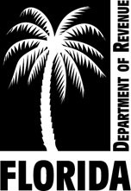
DR-488P
N. 12/09
Rule 12D-16.002
Florida Administrative Code

INITIAL CERTIFICATION OF
THE VALUE ADJUSTMENT BOARD
Section 193.122, Florida Statutes

Tax Roll Year 20

The Value Adjustment Board of __ __ County has not completed its hearings and certifies on order of the Board of County commissioners according to sections 197.323 and 193.122(1), F.S., that the

(Check one.) Real Property Tangible Personal Property

assessment roll for our county has been presented by the property appraiser to include all property and information required by the statutes of the State of Florida and the requirements and regulations of the Department of Revenue.

On behalf of the entire board, I certify that we have ordered this certification to be attached as part of the assessment roll. We will issue a Certification of the Value Adjustment Board (Form DR-488) under section 193.122(1) and (3), F.S., when the hearings are completed. The property appraiser will make all extensions to show the tax attributable to all taxable property under the law.

__ __
Signature, Chair of the Value Adjustment Board Date

