Completing the Paper Florida Business Tax Application (Form DR-1)

1. Introduction

1.1 Introduction
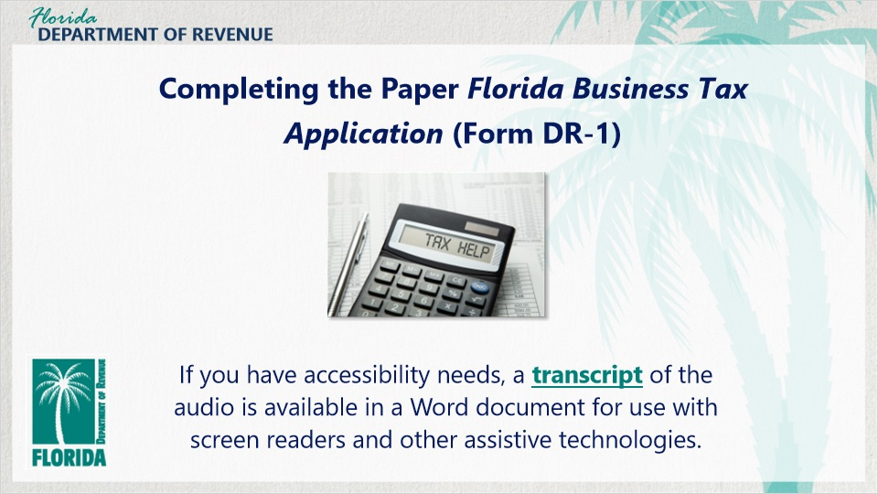
Transcript:
Welcome. This tutorial on “Completing the Paper Florida Business Tax Application (Form DR-1)” will give you the information and tools you need to complete the application properly. Completing and submitting this application is required if you are conducting taxable activities in Florida such as collecting sales and use tax or reemployment tax.

1.2 Navigating This Tutorial
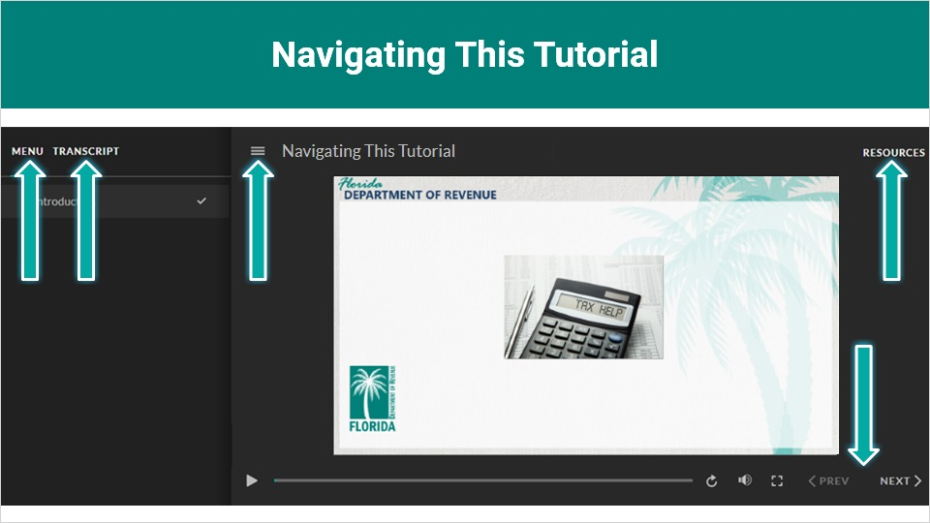
Transcript:
A transcript of the audio is available by clicking on the transcript tab in the top-left corner of your screen.
The following tabs and buttons are available to help you navigate throughout this tutorial.

Menu Tab
The menu tab displays by default when the tutorial is viewed on a computer. It allows you to navigate through the tutorial by clicking on the topic name on the menu. When viewing this tutorial on a tablet or smartphone, the menu does not display by default and must be accessed using the menu symbol.

Resources Tab
The resources tab is found on the right side of the top bar. When clicked, it displays the list of links to useful forms, documents, and webpages.

Previous and Next Buttons
The previous and next buttons are located at the bottom-right corner of your screen. These buttons allow you to move either back or forward.

1.3 Topics Covered
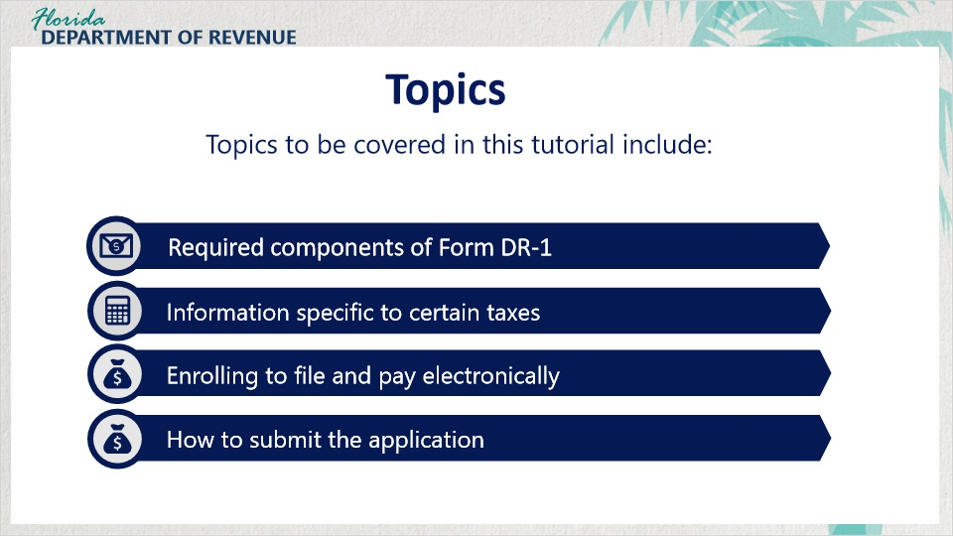
Transcript:
Topics to be covered in this tutorial include: the required components of Form DR-1, information specific to certain taxes, enrolling to file and pay electronically, and how to submit the application.

2. Completing the Required Components

2.1 Introduction to Form DR-1
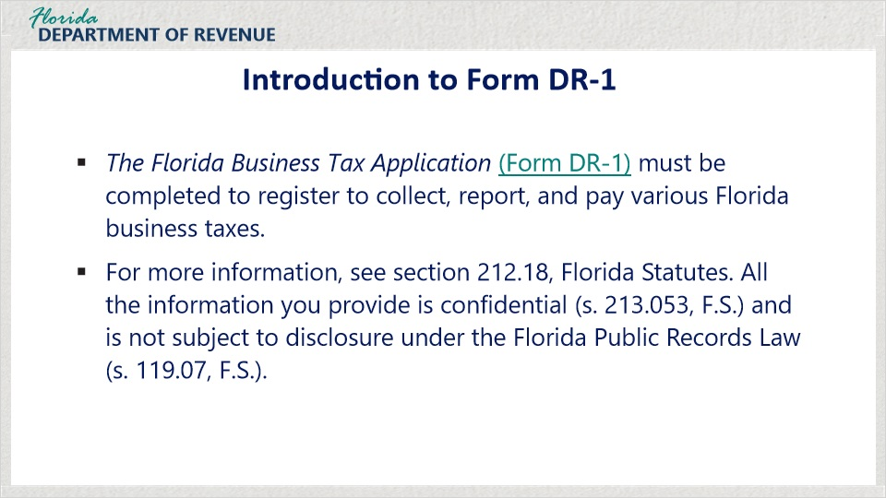
Transcript:
Before you begin collecting taxes and fees and paying taxes in the State of Florida, you must register with the Department by completing the Florida Business Tax Application (Form DR-1).

Florida law authorizes the Department of Revenue to require you to provide the information and activities about your business entity listed in this application.

For more information, see section 212.18, Florida Statutes. All the information you provide is confidential under (s. 213.053) and is not subject to disclosure under the Florida Public Records Law per section 119.07, Florida Statutes.

2.2 DR-1 and DR-1A
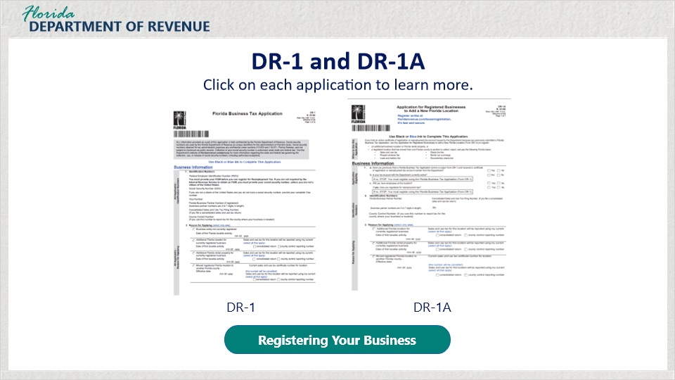
Transcript:
For the purposes of this tutorial, we will be focusing primarily on completing and submitting the paper-based Florida Business Tax Application (Form DR-1)

However, for certain business activities, there may be other applications to submit as well. For more information, download the handout Registering Your Business (DR-1N).

There are two applications that serve a similar purpose for collecting or adjusting information for your business based on the taxable activities you engage in.

DR-1
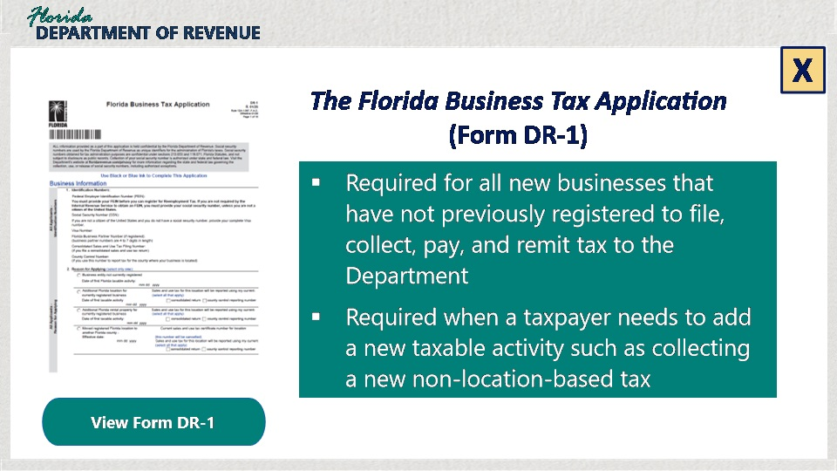

Transcript:
The Florida Business Tax Application (Form DR-1) is primarily used for all new businesses that have not previously registered to file, collect, pay, and remit tax to the Department. The DR-1 is also required when a taxpayer needs to add a new taxable activity such as collecting a new non-location-based tax. For example, if you started your business as the sole worker and then take on employees to meet the growing demands of your business, you will most likely be required to collect reemployment tax. To add this new tax, you would complete a DR-1 even if you are an existing business.

DR-1A
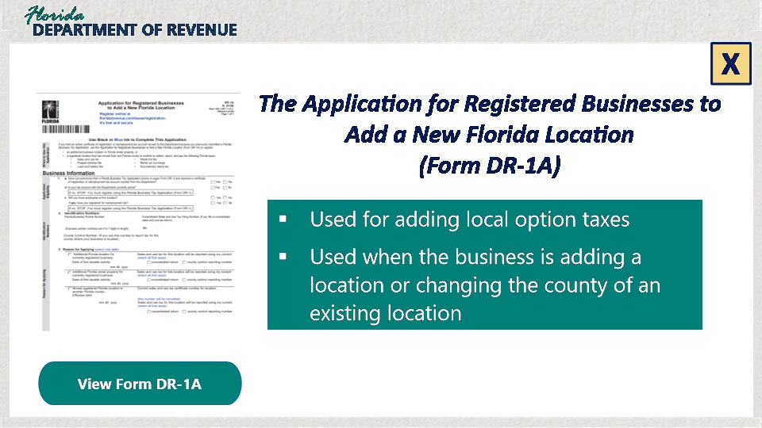

Transcript:
The Application for Registered Businesses to Add a New Florida Location (Form DR-1A) is used for adding local option taxes. If a taxpayer has a business and is adding a location or changing the county of an existing location, they will submit a DR-1A.

2.3 Registration for Taxes, Surcharges, and Fees
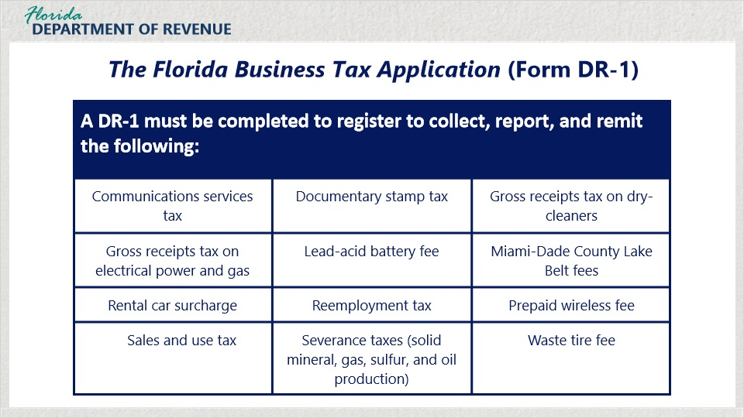
Transcript:
The Florida Business Tax Application (Form DR-1) must be completed to register to collect, report, and pay the following taxes, surcharges, and fees: communications services tax, documentary stamp tax, gross receipts tax on dry-cleaners, gross receipts tax on electrical power and gas, lead-acid battery fee, Miami-Dade County Lake Belt fees, rental car surcharge, reemployment tax, prepaid wireless fee, sales and use tax, severance taxes, and waste tire fee.

2.4 Identification Numbers
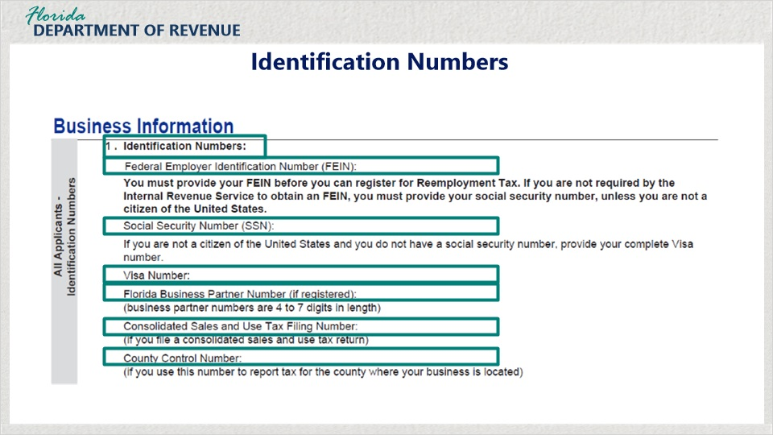
Transcript:
The first section to be completed for the application pertains to Identification Numbers. This section must be completed by all businesses regardless of the type of business entity.

The Internal Revenue Service requires any business that has employees and any partnership, corporation, nonprofit organization, most trusts, and estate to have a Federal Employer Identification Number (FEIN). You will need this number to register with the Department.

If you are a sole proprietor or an individual who is the sole member of a limited liability company, you will need a Social Security Number (SSN) to register with the Department.
If you are not eligible to obtain a Social Security Number, you must provide a Visa Number issued by the United States Department of State.

When you register with the Department, you are issued a Business Partner Number as a unique identifying number for your business. The number will be located on the back of your Certificate of Registration.

Section one also asks for a Consolidated Sales and Use Tax Filing Number, if applicable to your situation. If you own multiple business locations (including rental properties) in a single county or in multiple counties, you may submit an Application for Consolidated Sales and Use Tax Filing Number (Form DR-1CON). Obtaining this number allows you to make a single sales and tax payment for all your business locations. If you do not have this number, you can leave this item blank.

In addition, this section asks if you have a County Control Number. If you own multiple business locations (including rental properties) in a single county, you may submit an Application for Sales and Use Tax County Control Reporting Number (Form DR-1CNN) to assign a reporting number for that county. If this does not apply to your business, leave this item blank.

2.5 Reason For Applying
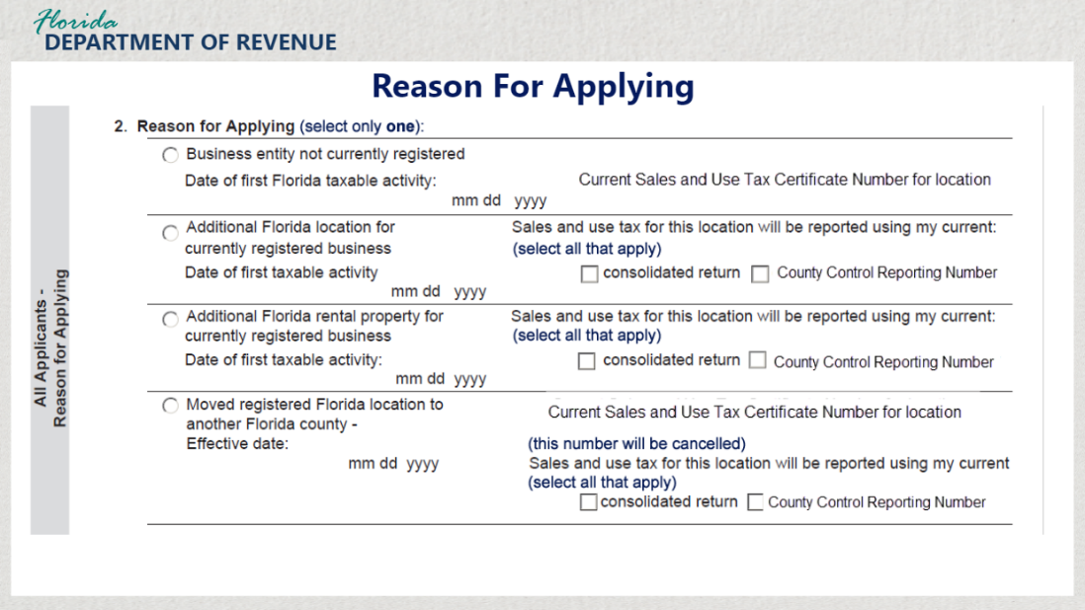
Transcript:
All applicants must complete section two, Reason for Applying. The applicant must select only one reason for applying.
The first option under section two is for any business entity that is not currently registered to collect, file, and remit tax. Include the date of the first Florida taxable activity such as collecting sales and use tax.

The second option under section two is for those businesses adding an additional Florida location for a currently registered business. Be sure to include the date of the first taxable activity for that location. Also, indicate whether you will use your consolidated return and/or County Control Reporting Number to report taxable activity for the new location.

The third option under section two is for any business entity reporting an additional Florida rental property for a currently registered business. Be sure to include the date of the first taxable activity such as collecting sales and discretionary sales surtax. Indicate whether you will use your consolidated return or County Control Reporting Number to report taxable activity for the rental property.

If you have moved one of your Florida locations to another Florida county, select the fourth option and indicate the effective date of this move. Include the current Sales and Use Tax Certificate Number for this location. Indicate whether you will use your consolidated return and/or County Control Reporting Number to report taxable activity for the new location.

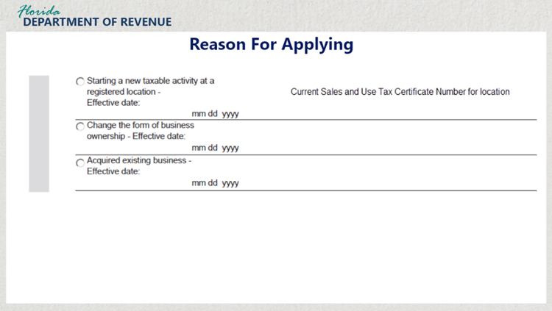

Transcript:
If you are starting a new taxable activity at a registered location, select the fifth option. An example of starting a new taxable activity at a registered location might be if you begin to sell a new category of taxable item or begin collecting reemployment tax for employees for the first time. Be sure to include the effective date of this change and your current Sales and Use Tax Certificate Number for this location.

If you are changing the form of business ownership for your business, select the sixth option and include the effective date for the change. An example of changing the form of business ownership would be bringing on a partner and changing from a sole-proprietor to a partnership or limited liability company.

Finally, if you have acquired an existing business, select the last option and list the effective date of the acquisition of the business.

2.6 Business Name, Location, and Mailing Address
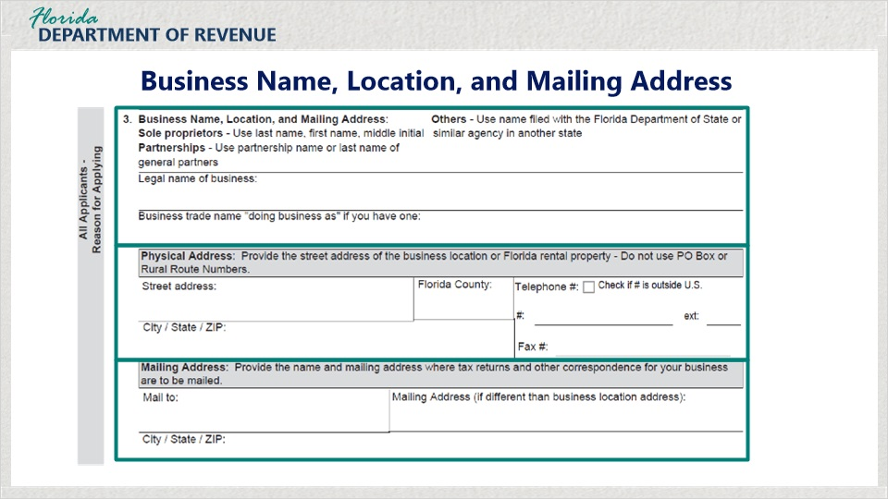
Transcript:
In section three, you will include information about your business name, location, and mailing address. Sole proprietors will use their last name, first name, and then middle initial as their business name. Partnerships will use the partnership name or the last name of the general partners. Other entities such as limited liability companies or corporations will use the name filed with the Florida Department of State or similar agency in another state.
On the next item, provide the street address of the business location or Florida rental property. Do not use PO Box or Rural Route Numbers.

Finally, on the last item of section three, provide the name and mailing address where tax returns and other correspondence for your business are to be mailed.

2.7 Seasonal Business
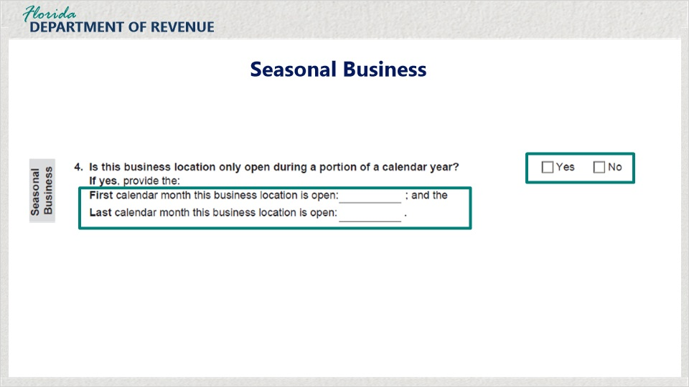
Transcript:
In section four, you will indicate whether the business is only open during a portion of the calendar year by checking “Yes” or “No.” An example of this type of business would be a costume store only open during the month before and during Halloween. If it is a seasonal business, list the first and last calendar months the business is open during the year.

2.8 Forms of Business Ownership
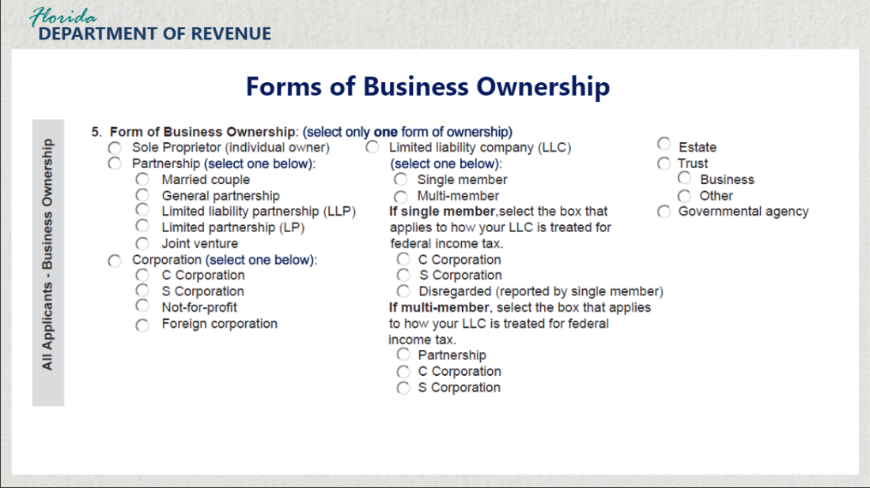
Transcript:
Sections five through nine require you to identify what form of business ownership applies to your business and provide identifying information about the people in leadership associated with that business.

All applicants regardless of their business type must complete section five. Here, you will indicate the form of ownership for your business. Certain options, such as partnerships, require you to drill down and select markers that more accurately describe your type of business entity. For example, if you and your spouse are partners and owners of your business, you would select “Partnership” and then in the choices below, select “Married couple.”
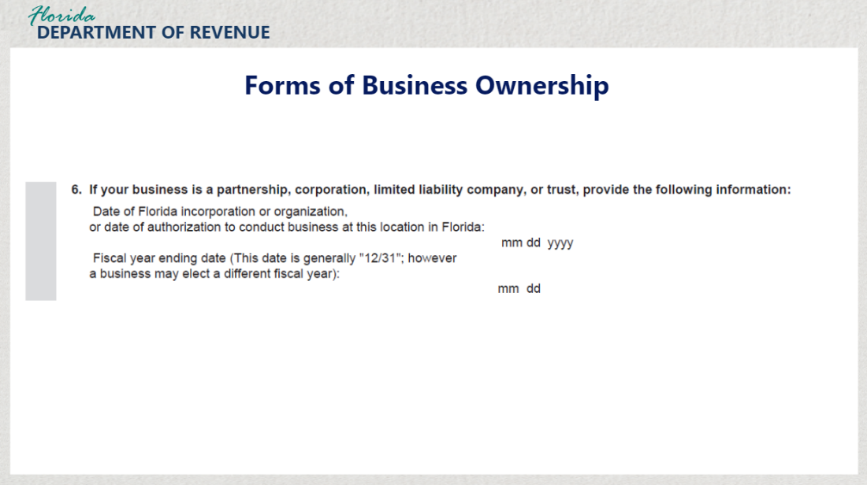
Transcript:
Section six applies to you if your business is a partnership, corporation, limited liability company, or trust. Enter the date of Florida incorporation or organization, or the date of authorization to conduct business at this location in Florida. You should also include the fiscal year ending date.

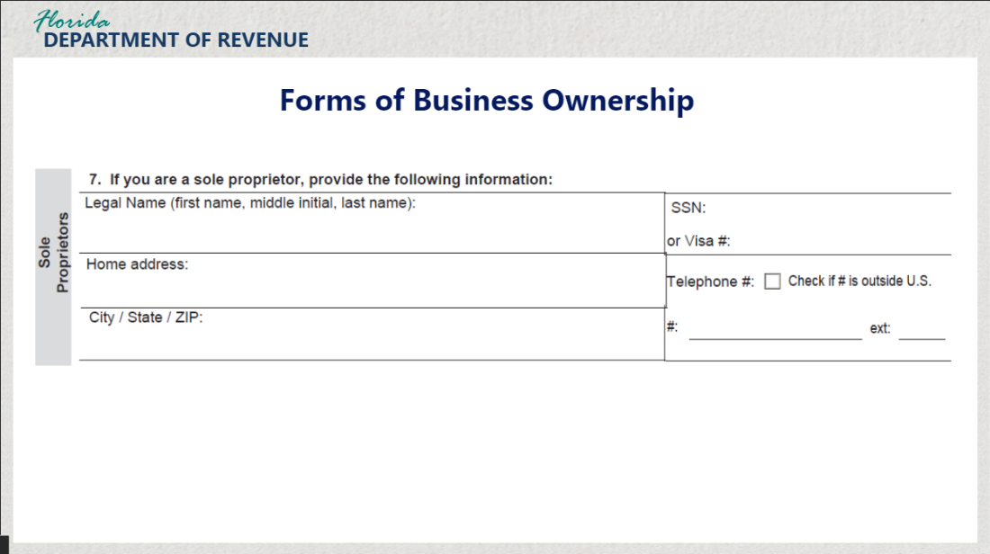
Transcript:
Section seven only applies to sole proprietors. If your business is a sole proprietorship, enter the identifying information about your business requested including your legal name, Social Security Number or Visa Number, home address, and your telephone number.

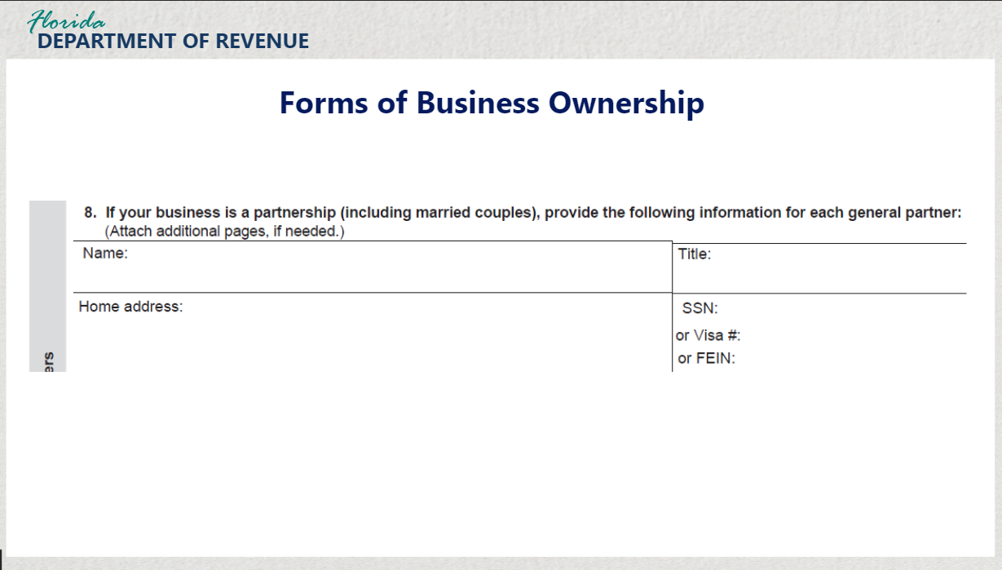

Transcript:
Section eight applies to partnerships. If your business is a partnership, you are required to list the identifying information for all partners in your business including name, title, home address, and Social Security Number or Visa Number. If there are more partners than space allows on a single form, you may attach additional pages if needed.

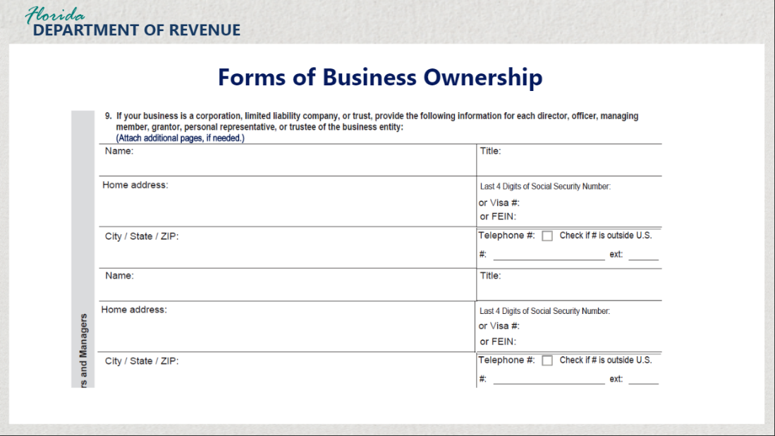

Transcript:
Finally, if your business is a corporation, limited liability company, or trust, complete section nine. This section requires you to list identifying information for all the members holding leadership positions within your organization including directors, officers, managing members, grantors, personal representatives, or trustees of the business entity. This information includes the name and title of each person and their home address. Include the last four digits of their Social Security Number, Visa Number, or FEIN.

2.9 Background and Business Activities
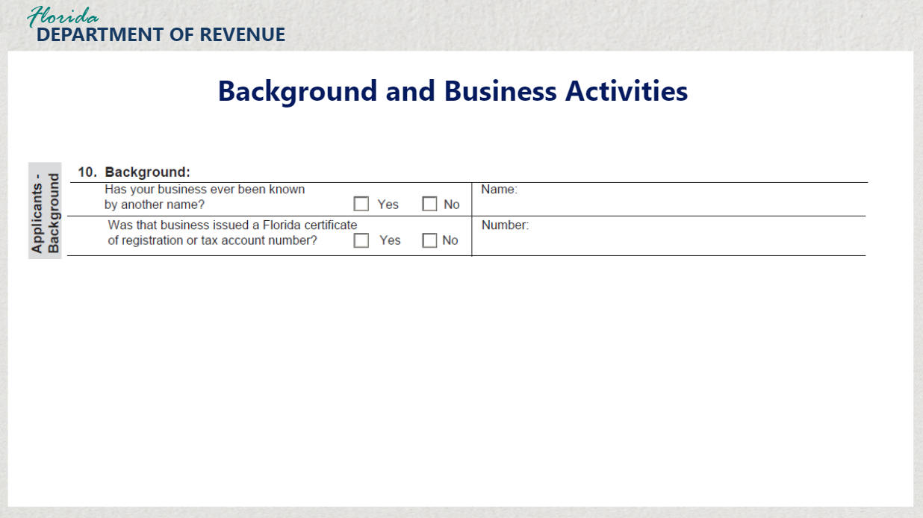
Transcript:
Section 10 under “Background” asks you if your business has ever been known by another name. If so, check the box for “Yes” and provide the original name of the business. Otherwise, check the box for “No.”

It also asks if your business was issued a Florida Certificate of Registration or tax account number. If so, check the box for “Yes” and provide the number. Otherwise, check the box for “No.”

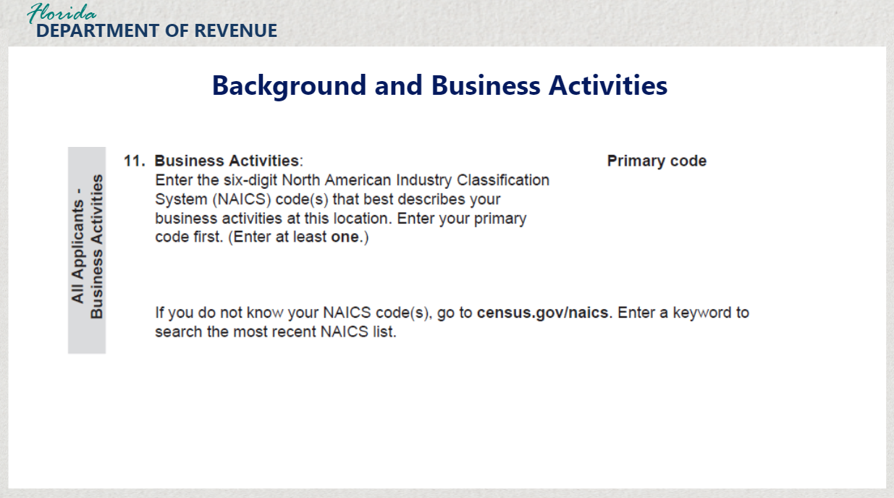
Transcript:
Section 11 under “Business Activities” requires you to enter the six-digit North American Industry Classification System (NAICS) code or codes that best describe your business activities at this location. Enter your primary code first. You must enter at least one code.

If you do not know your NAICS codes, visit the United States Census Bureau’s NAICS Search webpage. Enter a keyword to search the most recent NAICS list.
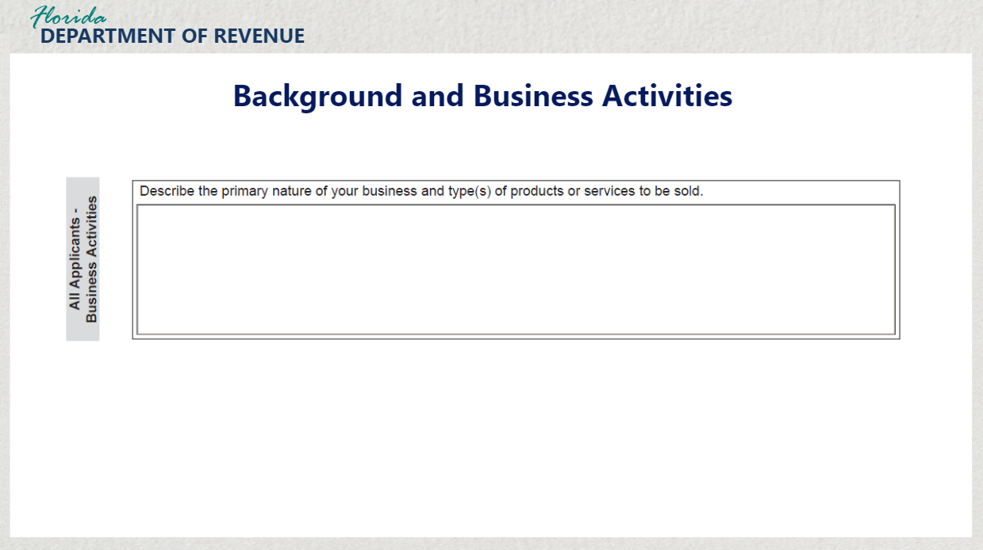

Transcript:
The last item in section 11 requires you to describe the primary nature of your business and types of products or services to be sold. Please be thorough and list all taxable activities when completing this section.

2.10 Change in Form of Business Ownership or Acquired Business
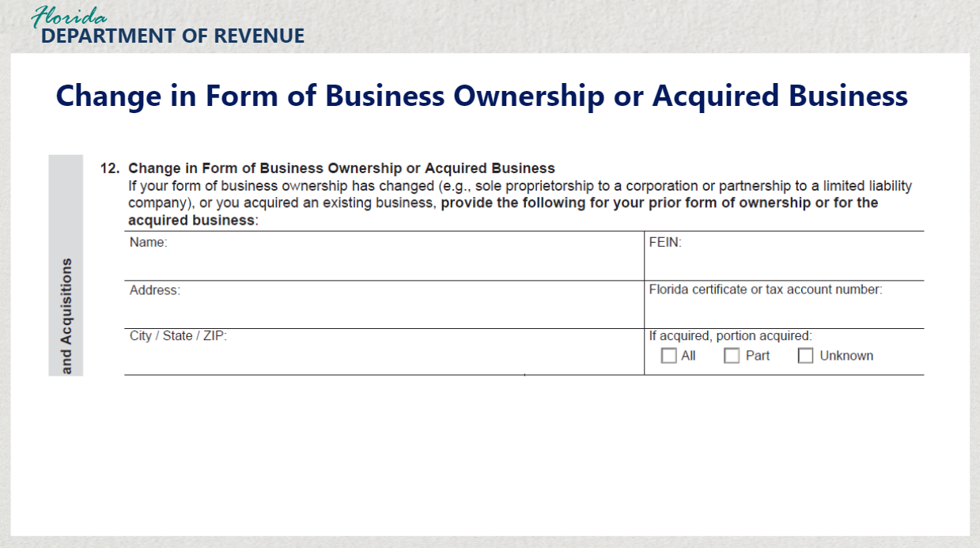
Transcript:
If your form of business ownership has changed, or you acquired an existing business, provide the following for your prior forms of ownership or for the acquired business in section 12.
Be sure to include your prior or acquired business name and address, the prior business Federal Employer Identification Number and prior business Florida certificate or account number, if you have it. Indicate if a portion or the whole business was acquired by selecting “All”, “Part”, or “Unknown.”
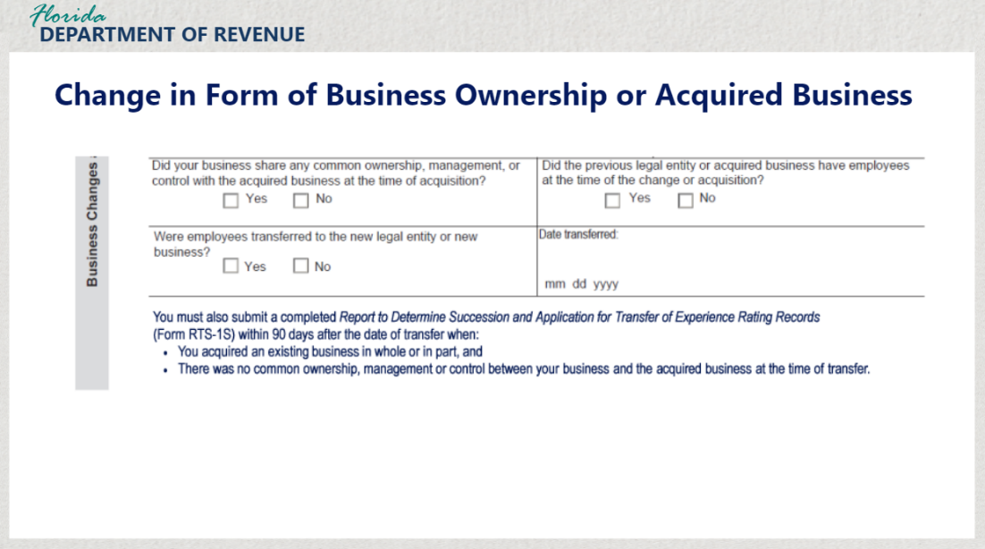
Transcript:
Next, select whether your business shared any common ownership, management, or control with the acquired business at the time of acquisition. If the previous legal entity or acquired business had employees at the time of the change or acquisition, check the box next to “Yes.” If not, check the box next to “No.”
Additionally, indicate if there were employees that were transferred to the new legal entity or new business. Be sure to state the date these employees were transferred.

Other documentation in addition to the DR-1 is required as well if you acquired an existing business in whole or in part, and there was no common ownership, management, or control between your business and the acquired business at the time of transfer. In these cases, you must also submit a completed Report to Determine Succession and Application for Transfer of Experience Rating Records (Form RTS-1S) within 90 days of the transfer.

3. Completing Information for Different Taxes

3.1 Sales and Use Tax
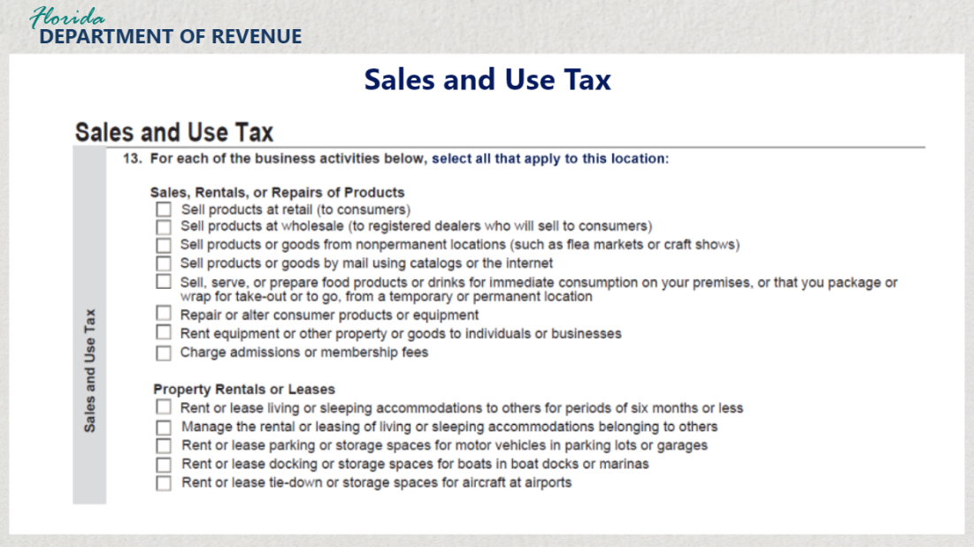
Transcript:
Items in section 13 refer to products, services, and activities your business may conduct that require sales and use tax to be collected. For each of the business activities listed, select all that apply to this location of your business under each category.
Categories include: sales, rentals, or repairs of products, property rentals or leases, real property contractors, services, fuel, secondhand goods or scrap metal, coin-operated amusement machines, vending machines, and purchases.

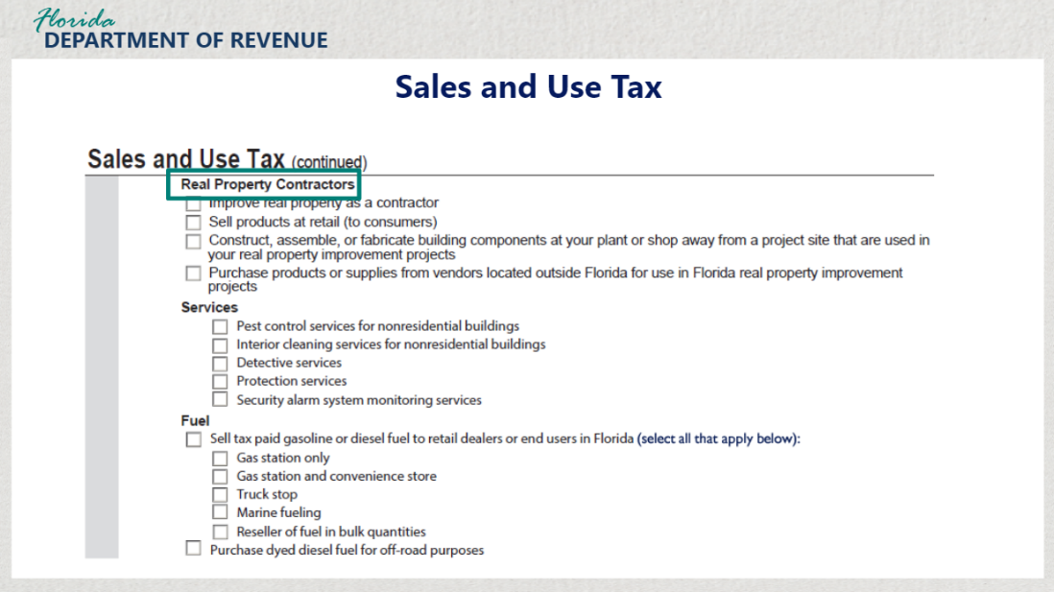

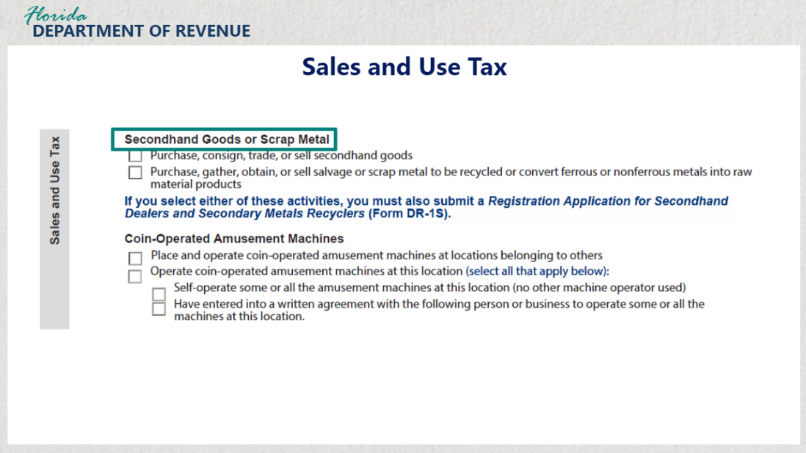

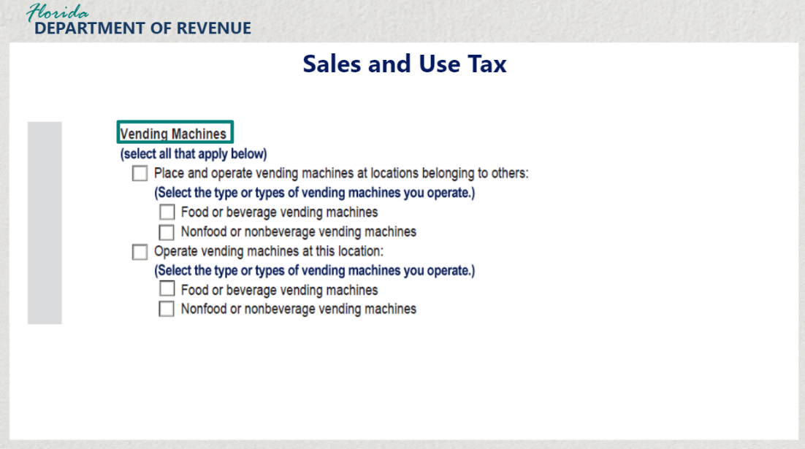

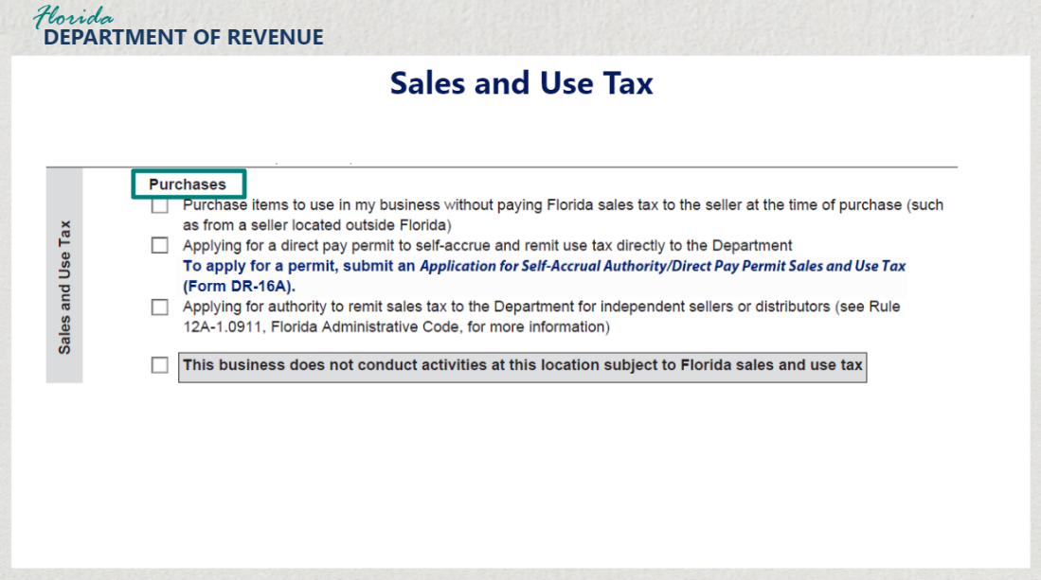

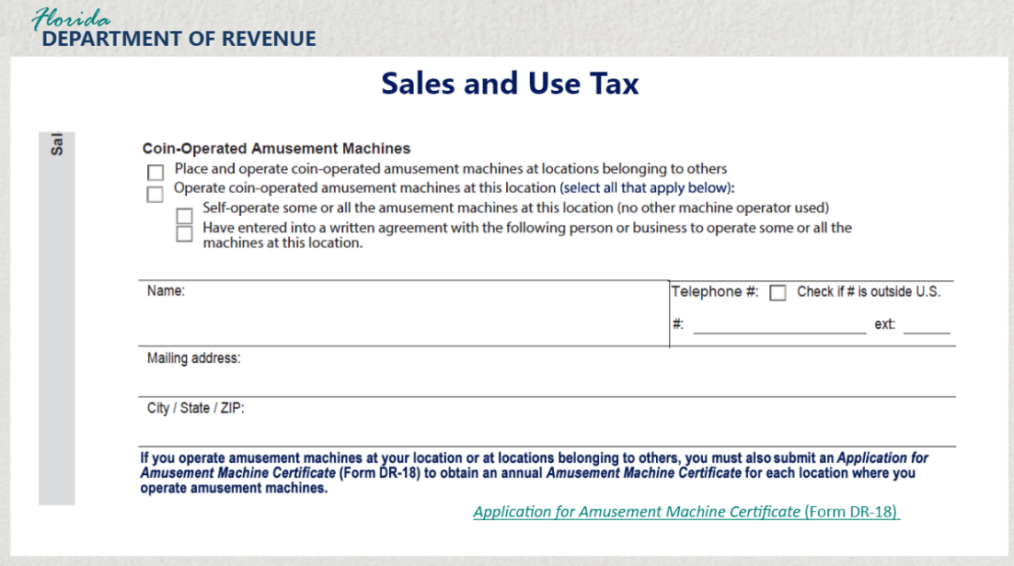

Transcript:
On page 6 of the DR-1, you will see items to check off to indicate where coin-operated amusement machines are located as well as who will be operating them. If you are selling items from coin-operated amusement machines, check off the items that apply to the location of your business.

If you check the last box stating that you have entered into a written agreement with another person or business to operate some or all the machines at this location, complete the information below including their name, telephone number, and mailing address.

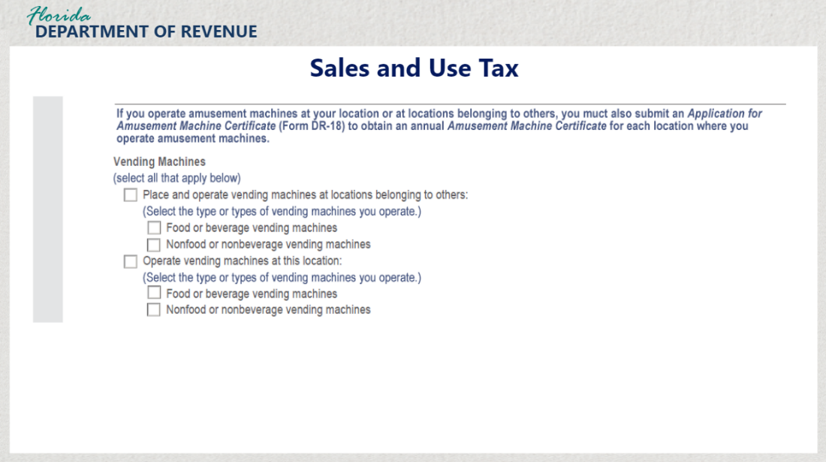

Transcript:
Please note that if you operate amusement machines at your location or at locations belonging to others, you must also submit an Application for Amusement Machine Certificate (Form DR-18) to obtain an annual Amusement Machine Certificate for each location where you operate amusement machines.

If you are selling food, beverages, or other products from vending machines, you must also check the boxes to the items that apply to your business.

3.2 Additional Fees and Surcharges
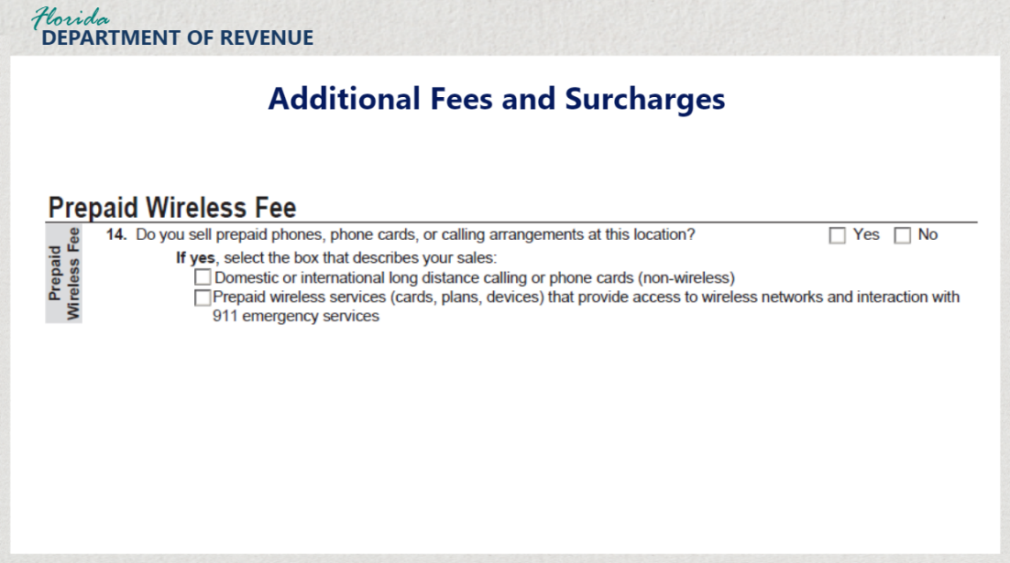
Transcript:
Sections 14 through 18 include questions pertaining to various fees and surcharges.
For section 14 for the Prepaid Wireless Fee, indicate if you sell prepaid phones, phone cards, or calling arrangements at this location. If yes, select the box below that describes your sales.

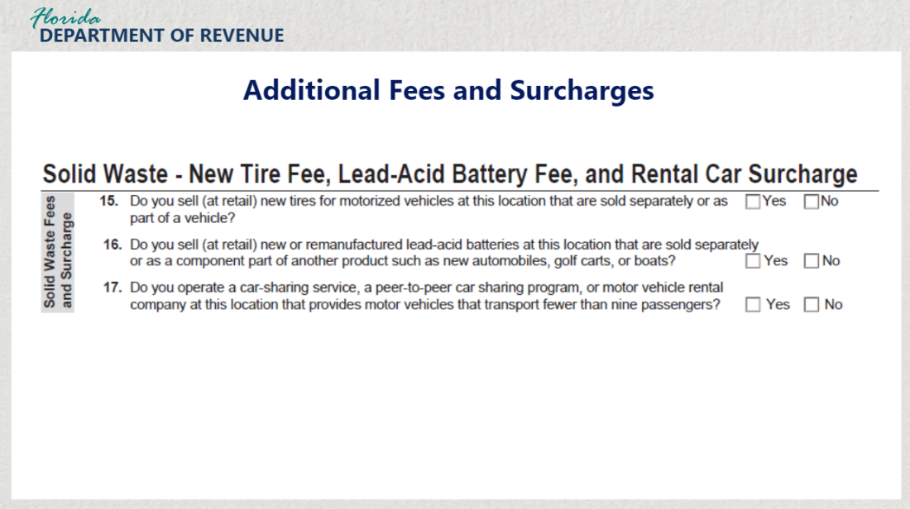

Transcript:
Sections 15 through 17 ask you questions pertaining to solid waste - new tire fee, the lead-acid battery fee, and rental car surcharge.

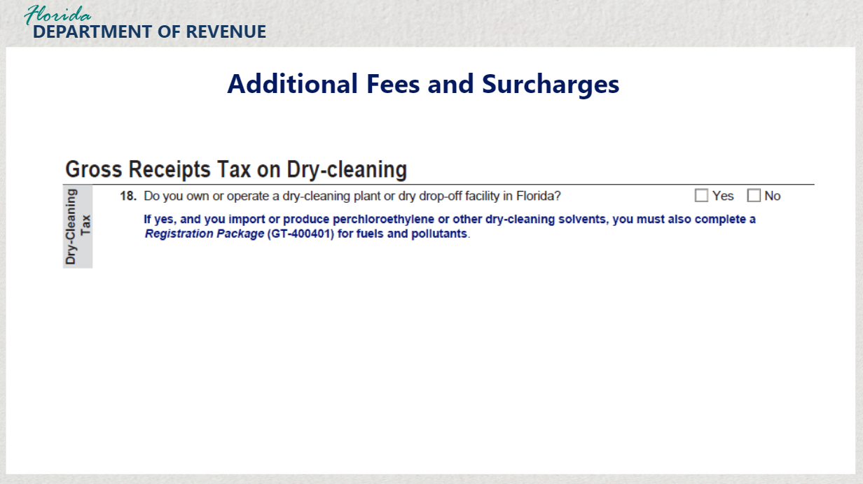

Transcript:
Section 18 asks if you own or operate a dry-cleaning plant or dry drop-off facility in Florida. Please check “Yes” or “No”. If you selected “Yes” and you import or produce perchloroethylene or other-dry-cleaning solvents, you must also complete a Registration Package (GT-400401) for fuels and pollutants.

3.3 Reemployment Tax Part 1
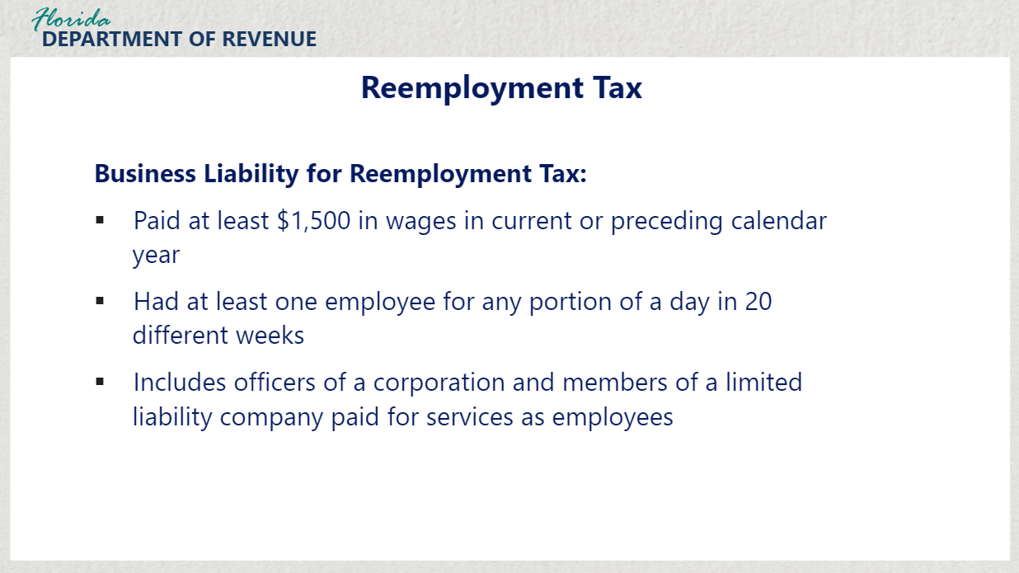

Transcript:
Reemployment tax, also known as unemployment tax in other states, provides funds for employees who lose their jobs through no fault of their own. A business is liable for state reemployment tax if, in the current or preceding calendar year the employer has paid at least $1,500 in wages in a calendar quarter or has had one employee for any portion of a day in 20 different weeks within the same calendar year.

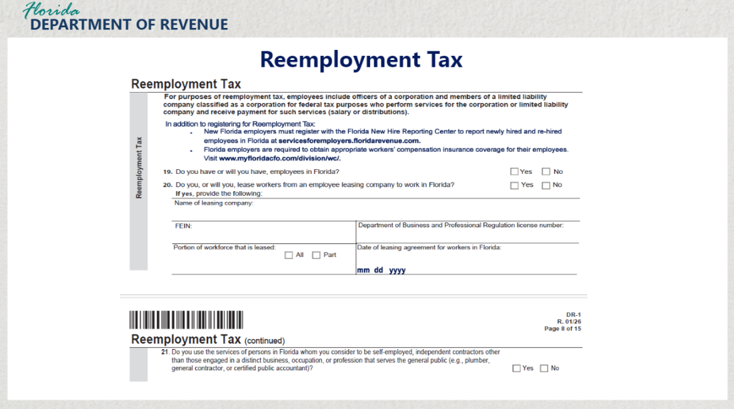
Transcript:
For purposes of reemployment tax, employees also include officers of a corporation and members of a limited liability company classified as a corporation for federal tax purposes who perform services for the corporation or limited liability company and receive payment for such services.

For sections 19 through 21 of the Reemployment Tax section of the application, answer each question pertaining to any employees you may have in your business. For section 20, if you use the services of an employee leasing company, you must complete the information requested.

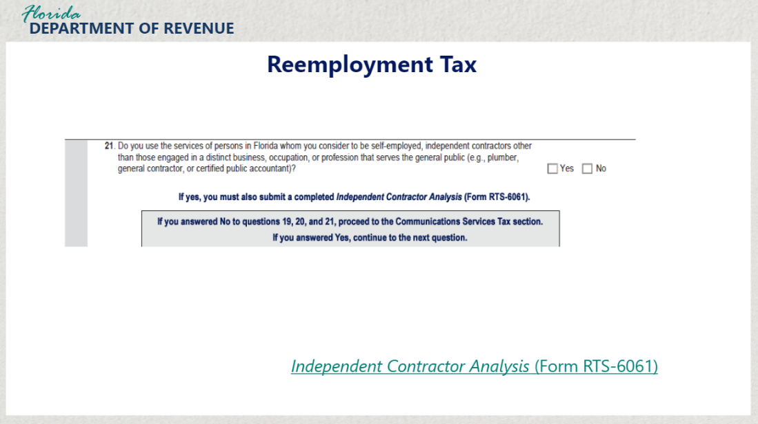
Transcript:
For section 21, check yes or no to let the Department know if you use the services of persons in Florida whom you consider to be self-employed, independent contractors, or profession that serves the general public such as a plumber or accountant.
If you answered yes for this question, you must also submit a completed Independent Contractor Analysis (Form RTS-6061).

If you answer “No” for sections 19, 20, and 21, proceed to the Communications Services Tax section. if you answered “yes”, to any of these sections, continue to the next question.

3.4 Reemployment Tax Part 2
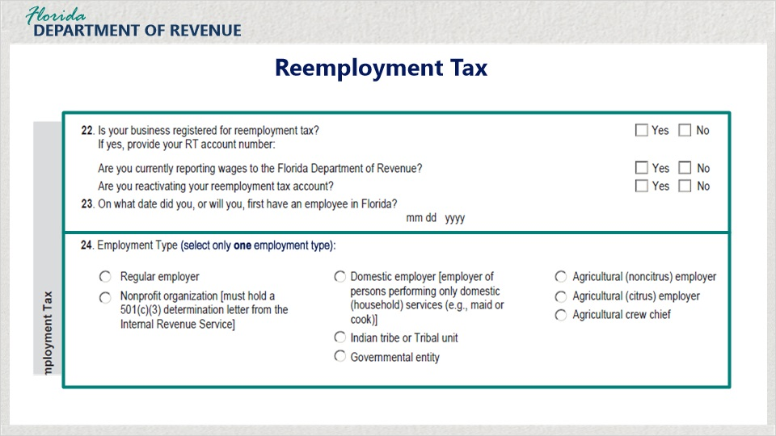
Transcript:
Sections 22 and 23 ask questions pertaining to registration for reemployment tax, reporting of wages, and the initial date of being required to pay reemployment tax based on the date you had or will have your first employee. For section 24, select the employment type of your business. Select only one employment type.

3.5 Reemployment Tax Part 3
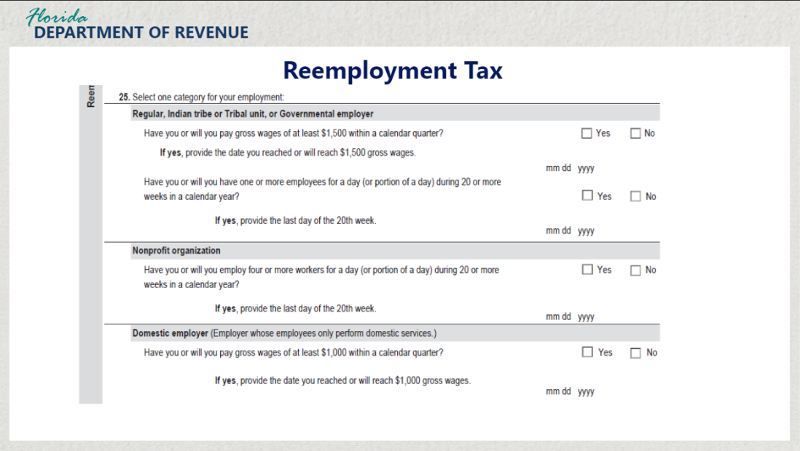
Transcript:
For section 25, select only one category of employment for your business. Options include: regular, Indian tribe or tribal unit, or government employer, nonprofit organization, or domestic employer, and agricultural employer.

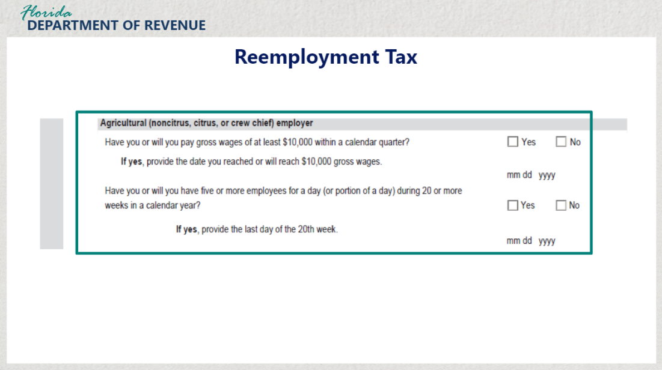

Transcript:
Once you have selected your category, answer the questions underneath that option. Don’t forget to mark “yes” or “no” and put the required dates for the category you select.

3.6 Reemployment Tax Part 4
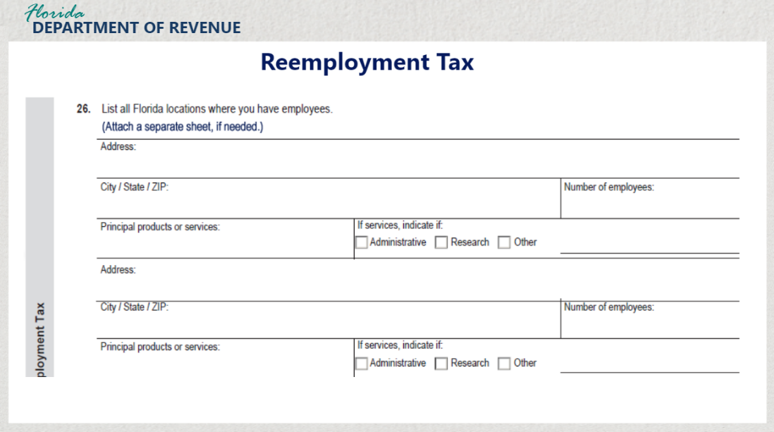
Transcript:
For section 26, list all Florida locations where you have employees. Be sure to list the address, number of employees and the principal products or services at that location. If the employees provide services, indicate if they are categorized as administrative, research, or other services. If you have multiple locations, you may need to attach additional sheets of paper.

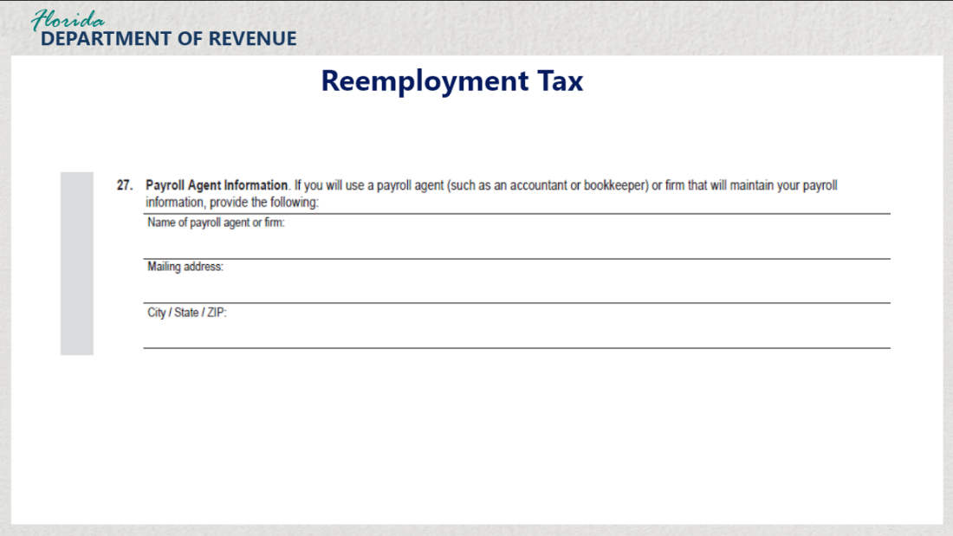
For section 27, indicate if there is a payroll agent such as an accountant or bookkeeper that will maintain your payroll. Include the name of the agent or firm, and the mailing address.

3.7 Reemployment Tax Part 5
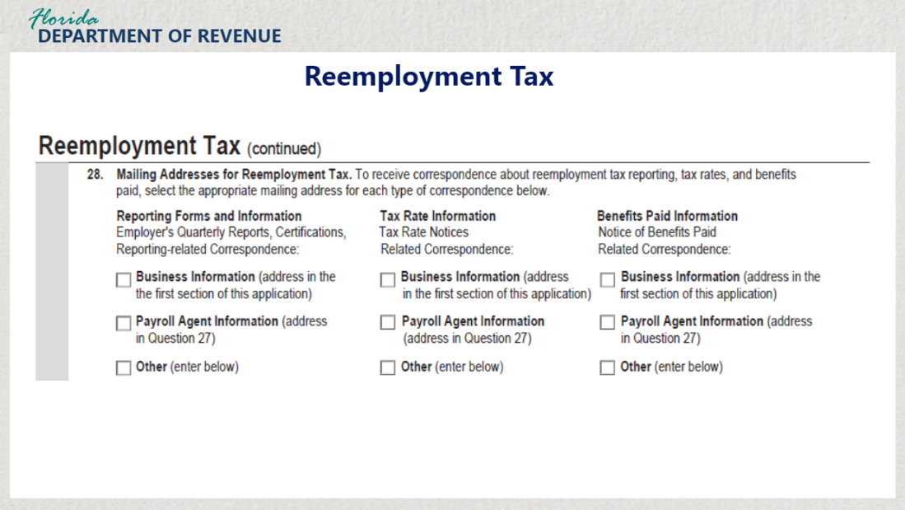
Transcript:
In section 28, check all the boxes you wish to receive correspondence about reemployment tax reporting, tax rates, and benefits. Under the first category, Reporting Forms and Information, select the address to send information such as employee quarterly reports and certifications. Under the second category, Tax Rate Information, select where to send tax rate notices and related correspondence. Finally, under the third category, Benefits Paid Information, select where to send the Notice of Benefits Paid and other related correspondence.

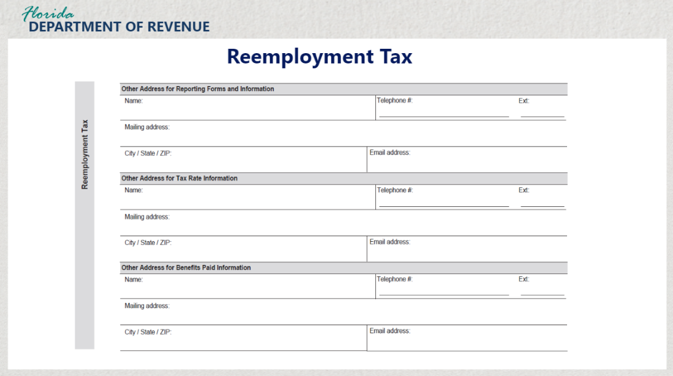
Transcript:
If you selected the “other” option for any of these categories, be sure to include these addresses and other corresponding information.

3.8 Communication Services Tax Part 1
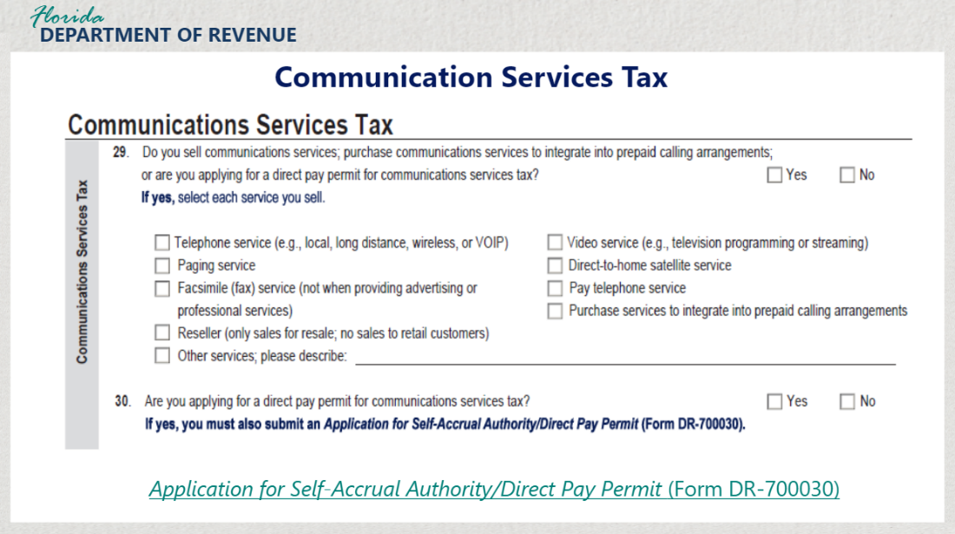

Transcript:
Sections 29 and 30 pertain to Communications Services Tax. Section 29 asks if your business sells communications services, purchase communications services to integrate into prepaid calling arrangements, or if you are applying for a direct pay permit for communications services tax. Select the appropriate checkbox. If you selected “Yes”, select each service you sell by checking the corresponding options.

Section 30 asks if you are applying for a direct pay permit for communication services tax. If you select the “Yes” checkbox, you must also submit the Application for Self-Accrual Authority/Direct Pay Permit (Form DR-700030).

If you answered “No,” skip the remaining questions in this section and proceed to the Documentary Stamp Tax section. If you answered “Yes” continue with the section 31. If you are a reseller only, sell only telephone or direct-to-home satellite services, or only purchase services to integrate into prepaid calling arrangements, go to section 34.

3.9 Communication Services Tax Part 2
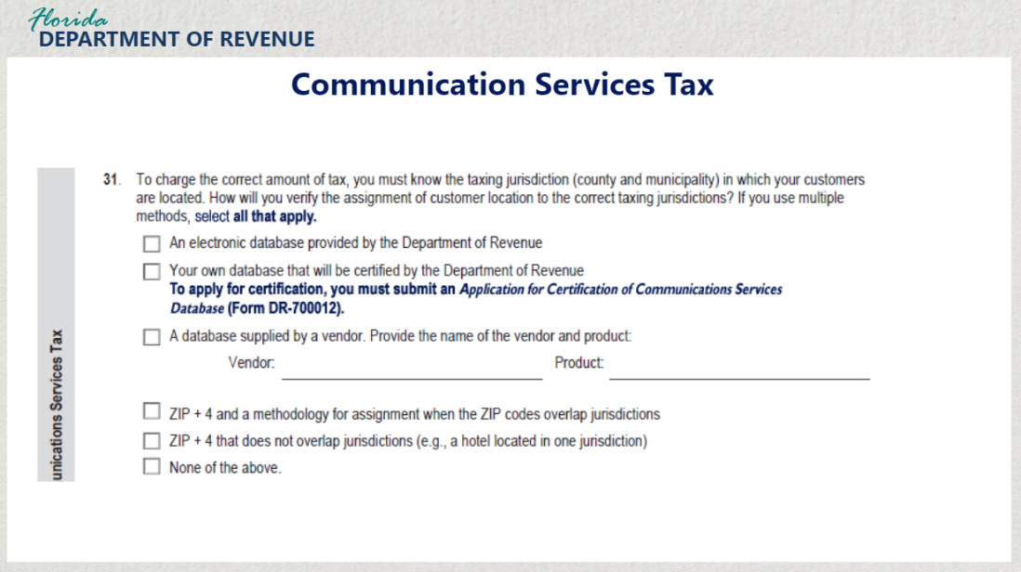

Transcript:
For section 31, you are asked how you are going to verify the assignment of customer location to the correct taxing jurisdictions in order to charge the correct amount of tax. From the options provided, select all that apply.

If you are going to use your own database, it must be certified by the Department. To apply for certification, you must submit an Application for Certification of Communications Services Database (Form DR-700012).

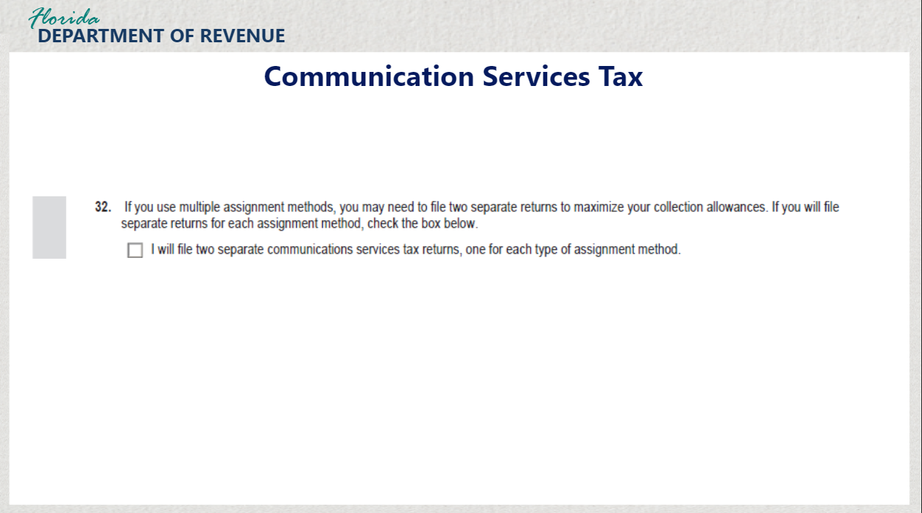
Transcript:
For section 32, the question asks if you will file separate returns for each assignment method you chose in the previous question. If so, check the box at the bottom of section 32.

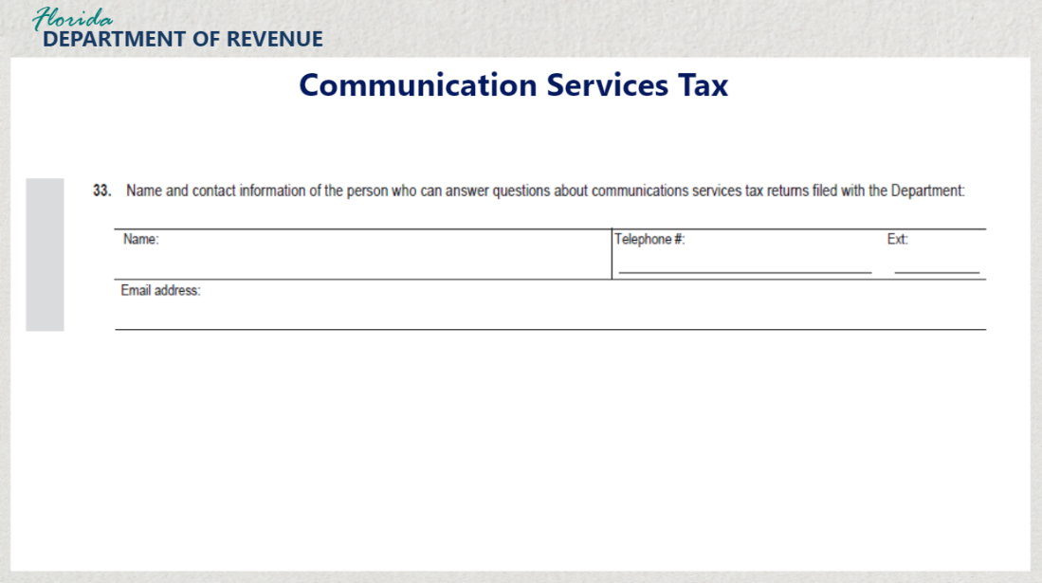

Transcript:
Section 33 asks you for the name and contact information of the person who can answer questions about communications services tax returns filed with the Department. Be sure to list the name of the person, their telephone number, and email address.

3.10 Documentary Stamp Tax
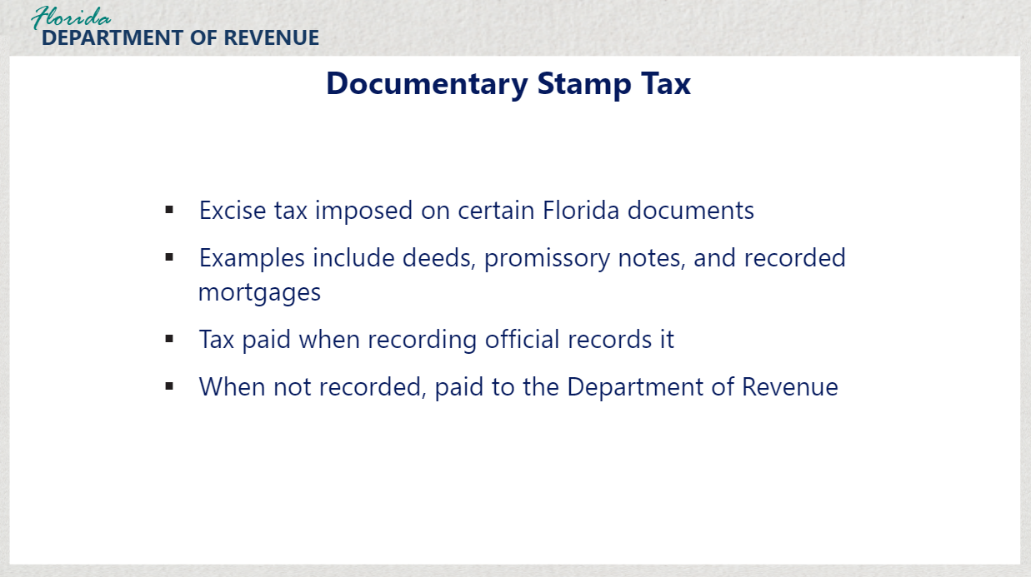
Transcript:
Documentary stamp tax is an excise tax imposed on certain documents executed, delivered, or recorded in Florida. Examples include documents that transfer an interest in Florida real property, such as deeds, as well as written obligations to pay money, such as promissory notes, and recorded mortgages.
Tax is paid to the county clerk of court or a recording official when the document is recorded. When a taxable document is not recorded, the tax must be paid directly to the Florida Department of Revenue.

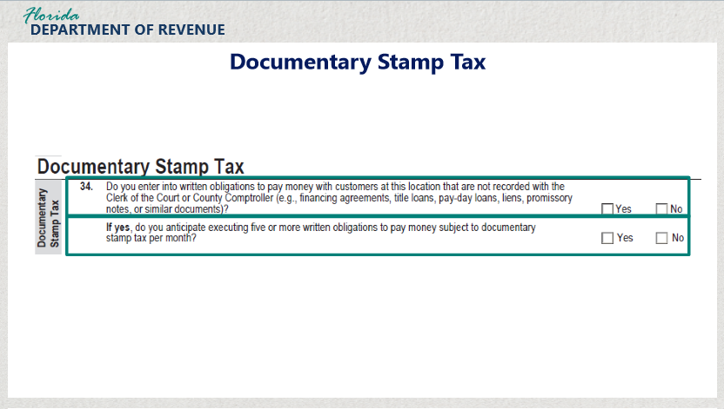
Transcript:
In section 34, the question asks if you enter into written obligations to pay money with customers at this location that are not recorded with the Clerk of the Court of County Comptroller. Check either “Yes” or “No.” If the answer is yes, it asks if you anticipate executing five or more written obligations to pay money subject to documentary stamp tax per month. Again, check “Yes” or “No.”

3.11 Gross Receipts on Electrical Power and Gas
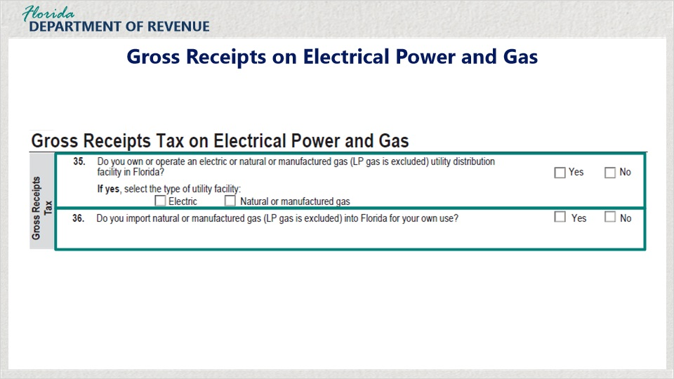
Transcript:
Gross receipts tax on utilities such as electrical power and gas is imposed at the rate of 2.5% on the sale, delivery, or transportation of natural gas, manufactured gas, or electricity to a retail consumer in Florida.

Section 35 asks if you own or operate an electric or nature or manufactured gas utility distribution facility in Florida. Select “Yes” or “No.” If yes, select the type of utility facility.

Section 36 asks if you import natural or manufactured gas into Florida for your own use. Select “Yes” or “No.”

3.12 Severance Taxes and Miami-Dade County Lake Belt Fees
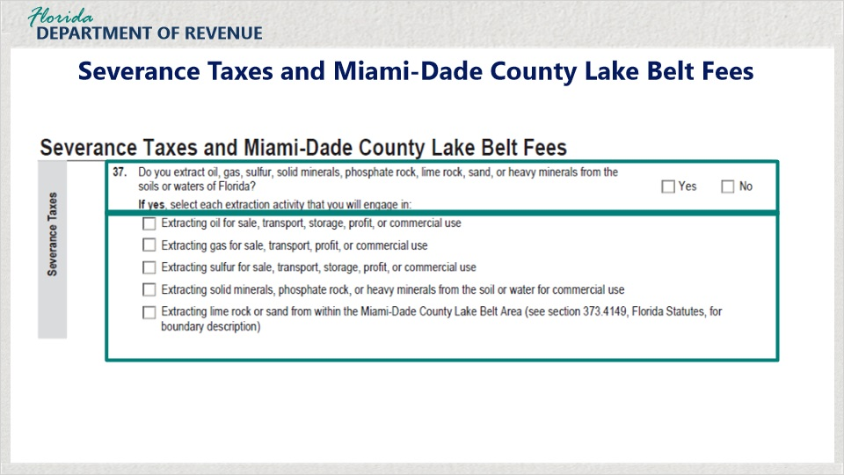
Transcript:
Severance tax is imposed on any person who severs gas, heavy minerals, oil, phosphate, solid minerals or sulfur from Florida. Additionally, a per-ton mitigation fee is imposed on any person who removes lime rock or sand from the Miami-Dade County Lake Belt Area.

Section 37 asks if your business extracts oil, gas, sulfur, solid minerals, phosphate rock, lime rock, sand, or heavy minerals from the soils or waters of Florida. Check “Yes” or “No”.
If the answer is yes, select each extraction activity that your business will engage in.

4. Authorizations and Enrollment

4.1 Enrollment to File and Pay Tax Electronically
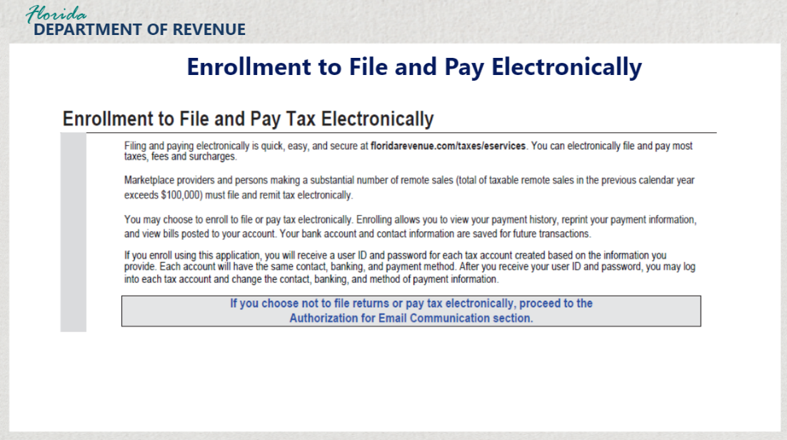
Transcript:
Florida law states that if your business pays $5,000 or more in tax in the Department’s fiscal year, you must pay taxes electronically. In addition, marketplace providers and persons making a substantial number of remote sales exceeding $100,000 in the previous calendar year must file and pay electronically.

If this describes the situation for your business or you simply want the benefits of filing and paying electronically, you may choose to enroll to file or pay tax electronically by completing the section of the DR-1, “Enrollment to File and Pay Tax Electronically.” If you choose not to file and pay electronically, skip this section and proceed to the Authorization for Email Communication section.
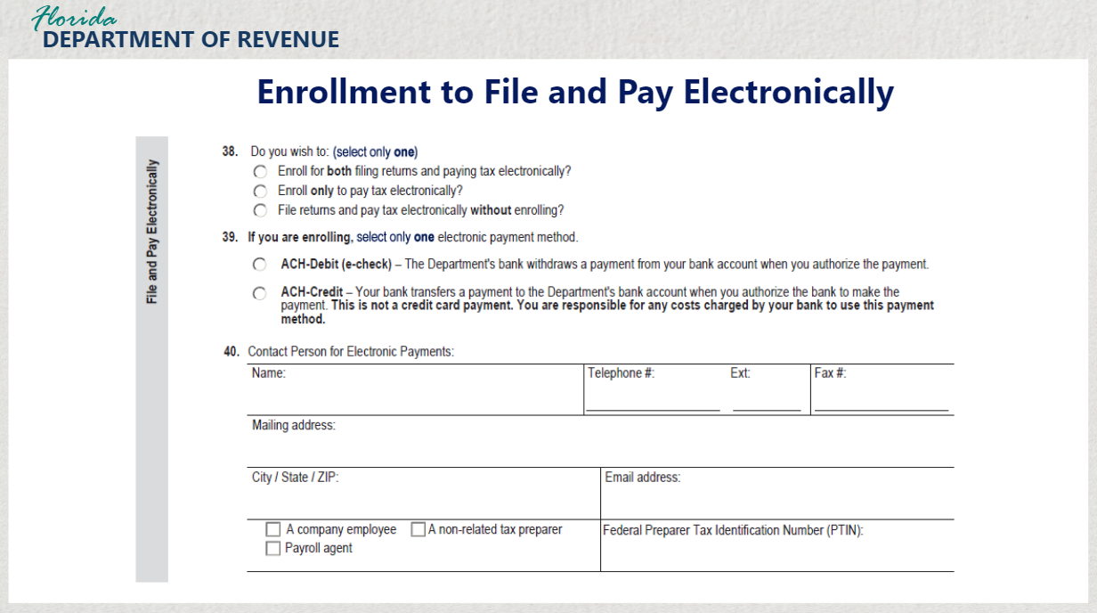
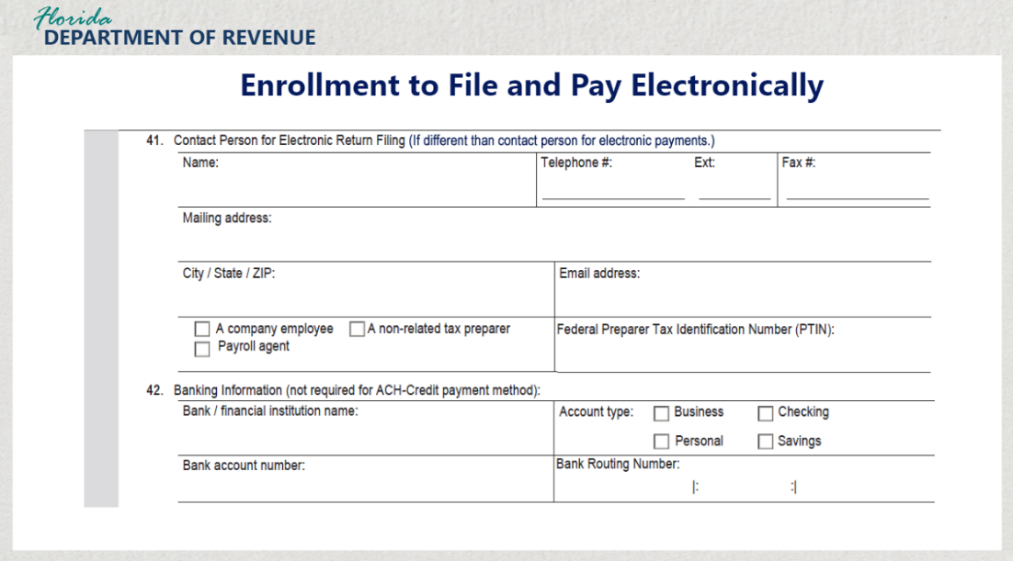
Transcript:
For those choosing to file electronically, complete sections 38 through 42 to indicate your preferences for filing, how you will make payments, and the contact person for electronic filings and payments for your business and banking information.

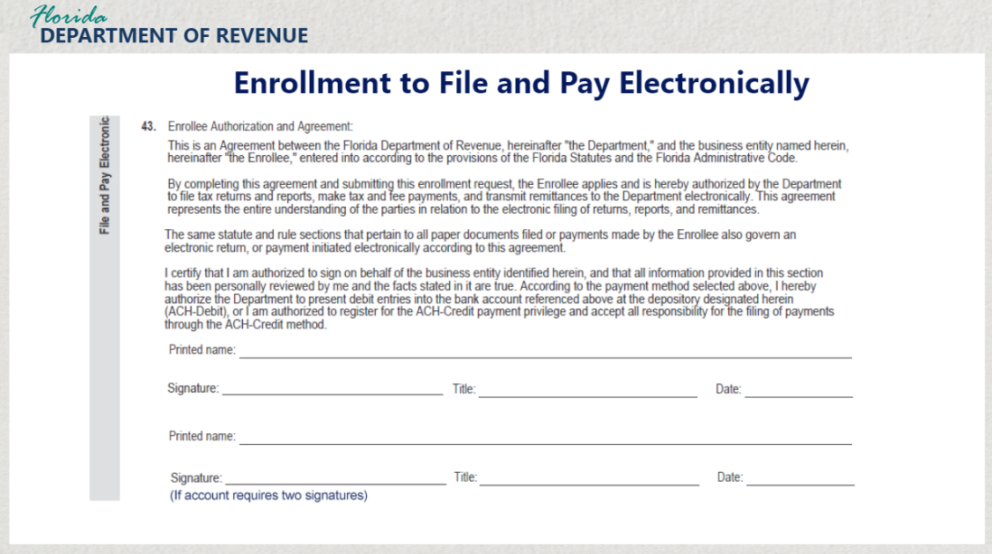

Transcript:
Section 43 consists of the Enrollee Authorization and Agreement which authorizes the business owner to file tax returns and reports, make tax and fee payments, and transmit remittances to the Department directly. Complete the agreement by providing all information including your name, the date, and your signature.

4.2 Authorization for Email Communication
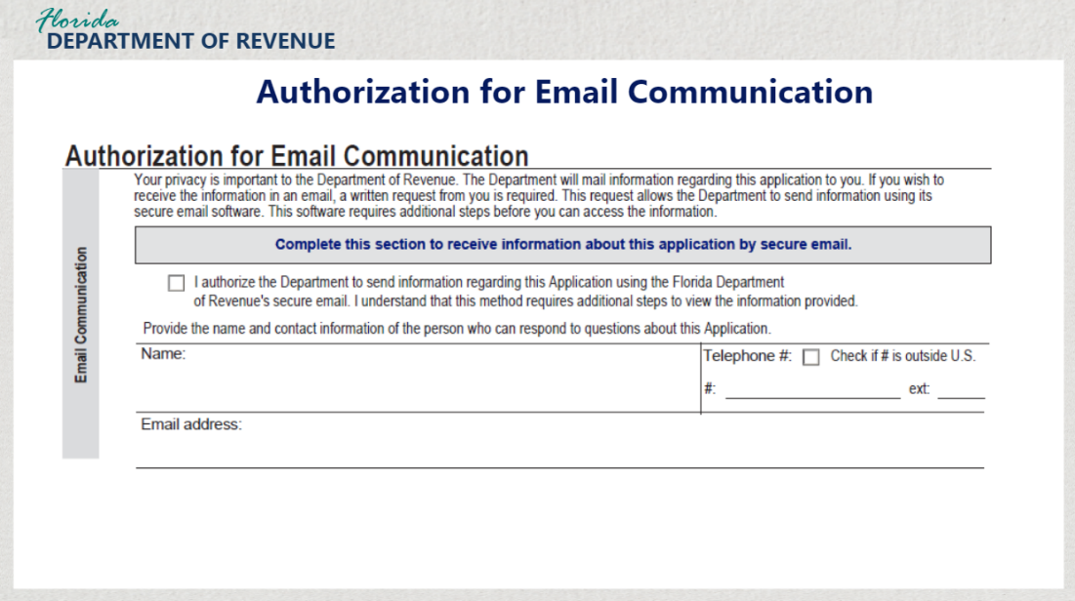
Transcript:
Because your privacy is important to the Department, information regarding the application will be mailed to you. If you wish to receive this information in an email, you must complete the “Authorization for Email Communication” section of the application.

Be sure to check the authorization message and then provide your name, telephone number, and email address.

4.3 Applicant Declaration and Signature
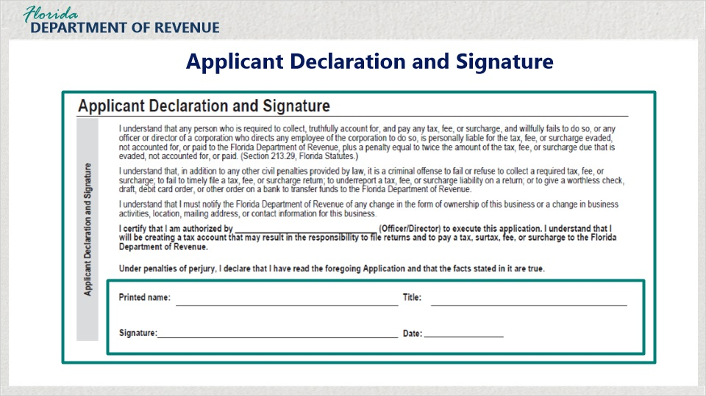
Transcript:
Finally, complete the Application Declaration and Signature section. By signing and dating this section, you are stating that you are liable for any taxes collected on behalf of the Department.

You are also attesting to being aware of other legal requirements such as the requirement to collect all taxes, fees, and surcharges and remit them to the Department.

Please read this section carefully before signing. By signing this application, you are stating that you are knowledgeable about all the requirements for collecting and paying taxes in Florida and that the information you have provided is true.

5. Submitting the Application

5.1 Submitting the Application
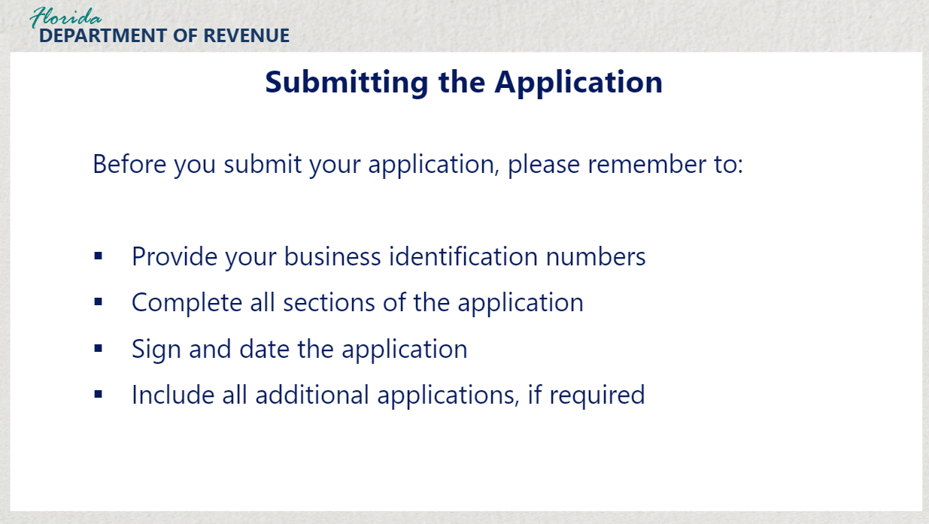
Transcript:
Once you have signed the Applicant Declaration and Signature section, you are ready to submit your completed application. Before you submit your application, please remember to:
provide your business identification numbers, complete all sections of the application, sign and date the application, and
include all additional applications, if required.

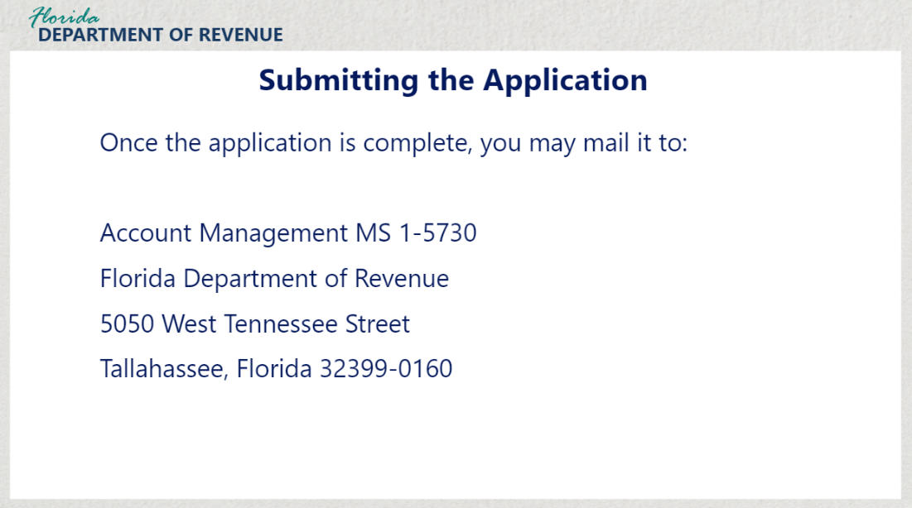
Transcript:
Once the application is complete, you may mail it to:
Account Management MS 1-5730
Florida Department of Revenue
5050 West Tennessee Street
Tallahassee, Florida 32399-0160

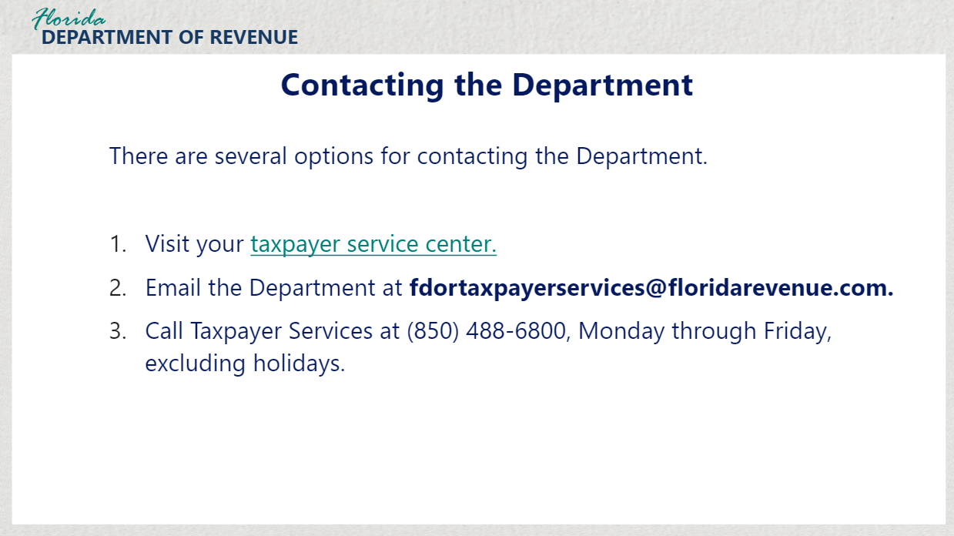

Transcript:
You also have the option to bring your completed application to your nearest taxpayer service center.

If you have additional questions, you may email the Department.

To speak with a Department representative, call Taxpayer Services at (850) 488-6800, Monday through Friday, excluding holidays.

5.2 What's Next?
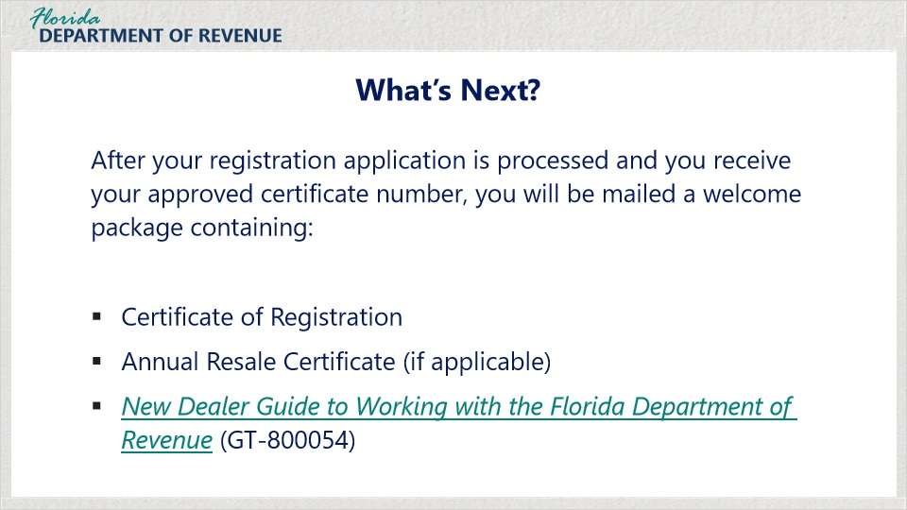
Transcript:
After your registration application is processed and you receive your approved certificate number, you will be mailed a welcome package containing your Certificate of Registration, an Annual Resale Certificate, if obligated for sales and use or communication services taxes, and a helpful brochure, New Dealer Guide to Working with the Florida Department of Revenue (GT-800054).

6. Conclusion

6.1 Summary
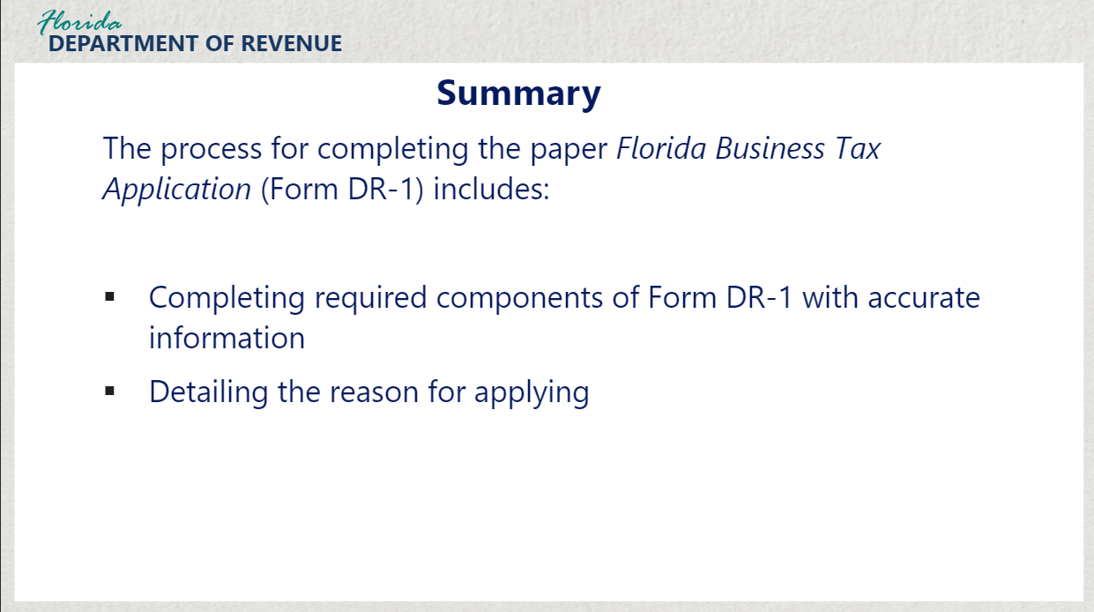
Transcript:
In this tutorial, we have reviewed the process for completing the paper Florida Business Tax Application (Form DR-1).
This process includes completing the required components of Form DR-1 including entering accurate identification information and detailing the reason for applying.

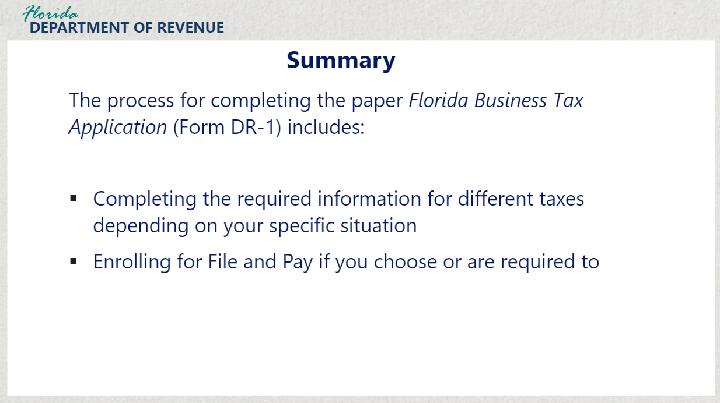
Transcript:
It also includes completing the required information for different taxes including sales and use tax, reemployment tax, fees and surcharges, and more depending on your specific situation.
In addition, enrollment to electronically file and pay is required for some and optional for others. If you choose to file and pay electronically, complete the section titled “Enrollment to File and Pay Electronically.”

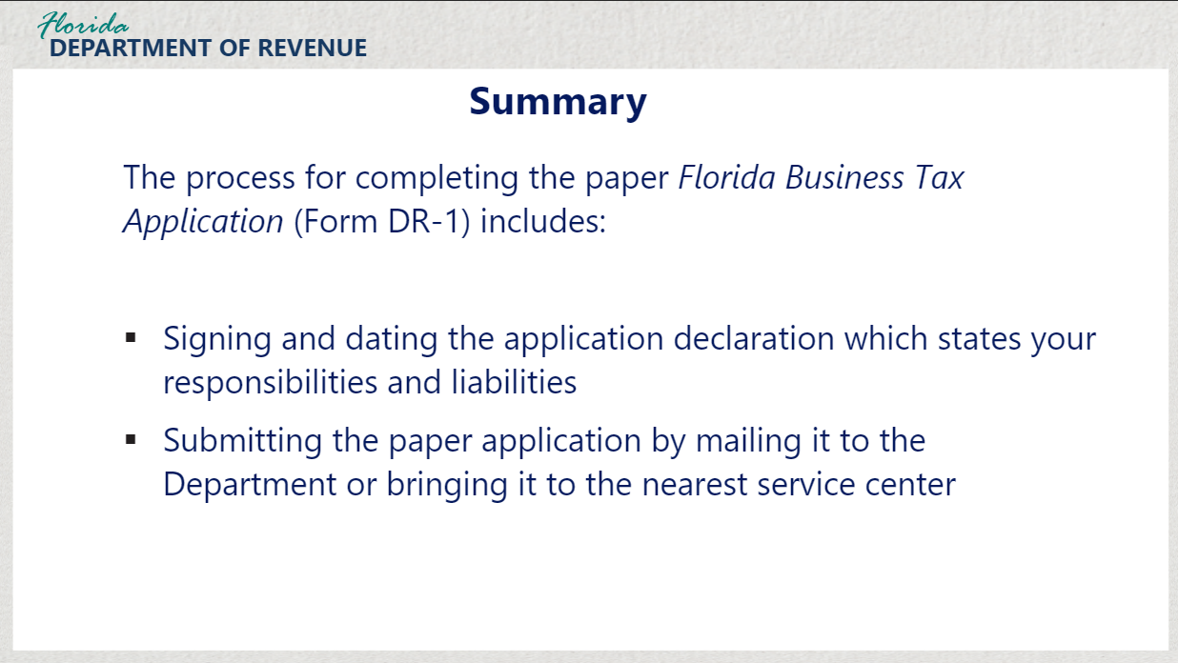

Transcript:
At the end of the application, you will sign and date the application declaration which states that you are liable for any taxes collected on behalf of the Department and attest to being aware of other legal requirements including the requirement to collect all taxes, fees, and surcharges.

To submit the paper application, you may mail it to the Department or bring it by to the nearest taxpayer service center.

6.2 Tax Page and Social Media
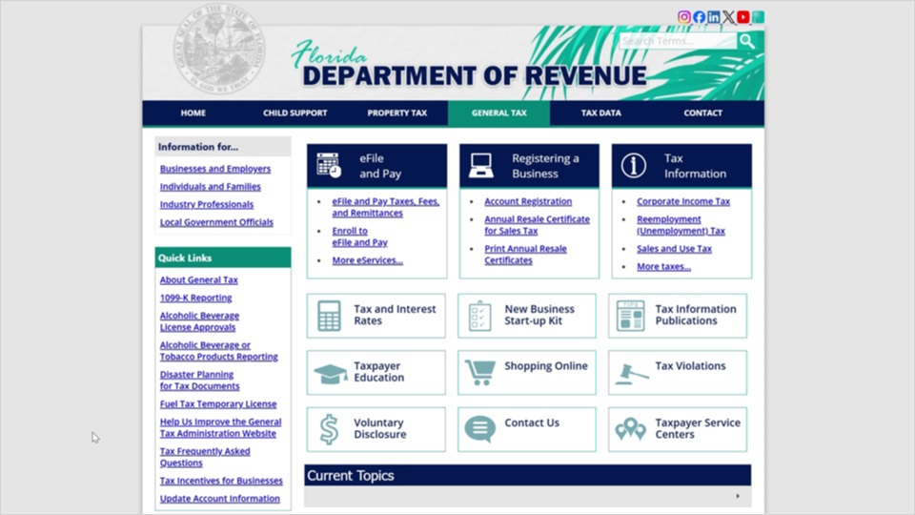
Transcript:
Visit the Florida Department of Revenue webpage for business resources such as forms, publications, and information on all tax types.

Check out our Taxpayer Education webpage for new business guides, tutorials, and other helpful tools.

And follow us on YouTube, X, Instagram, and LinkedIn using the icons at the top of our website to stay up to date on tax topics, alerts, and more.

6.3 Thank You
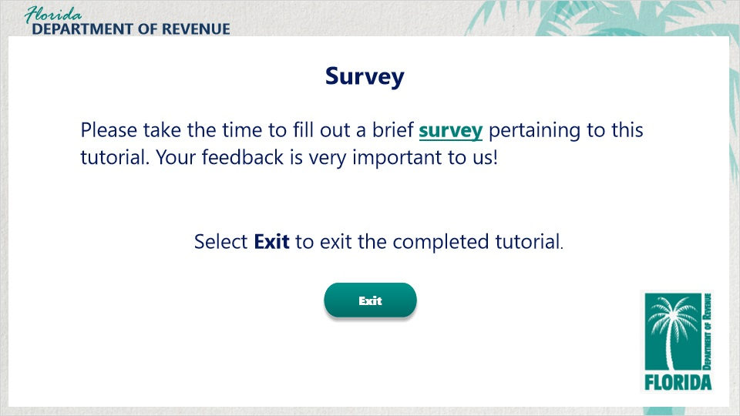
Transcript:
Thank you for completing this tutorial, “Completing the Paper Florida Business Tax Application” (Form DR-1).

Please take a short survey about the content and quality of this tutorial.

