Documentary Stamp Tax Tutorial – Accessibility Outline

1. Documentary Stamp Tax

1.1 Welcome
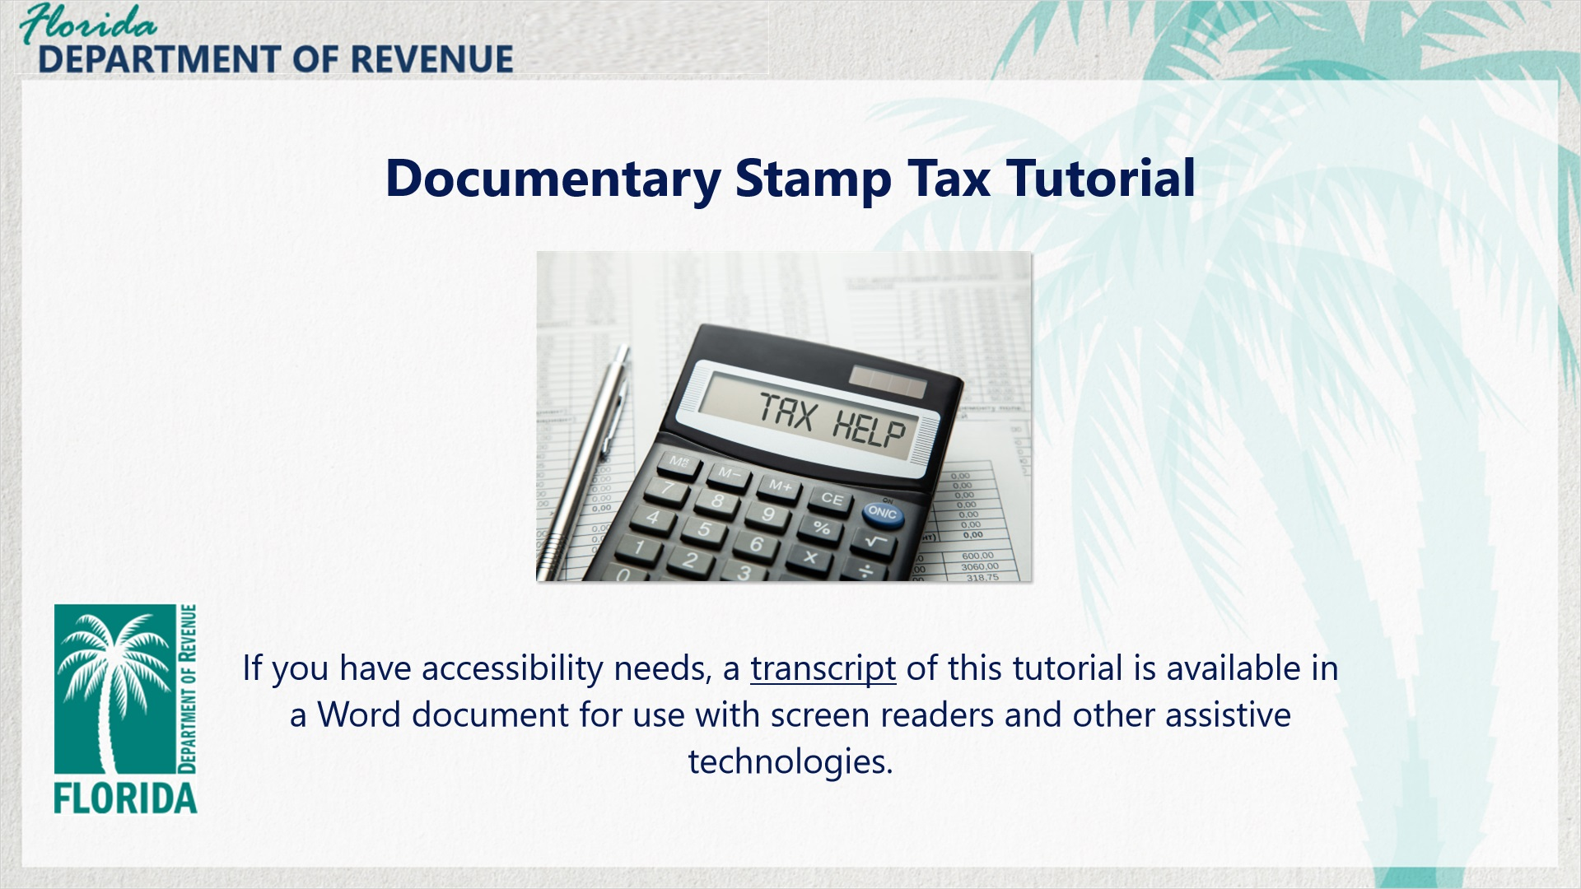
Transcript:
Welcome to the Documentary Stamp Tax tutorial. In this tutorial, we will discuss what documentary stamp tax is, documents that are and are not subject to the tax, and your responsibilities in remitting the tax.
If you have accessibility needs, a transcript of this tutorial is available in a Word document for use with screen readers and other assistive technologies.

1.2 Navigating This Tutorial
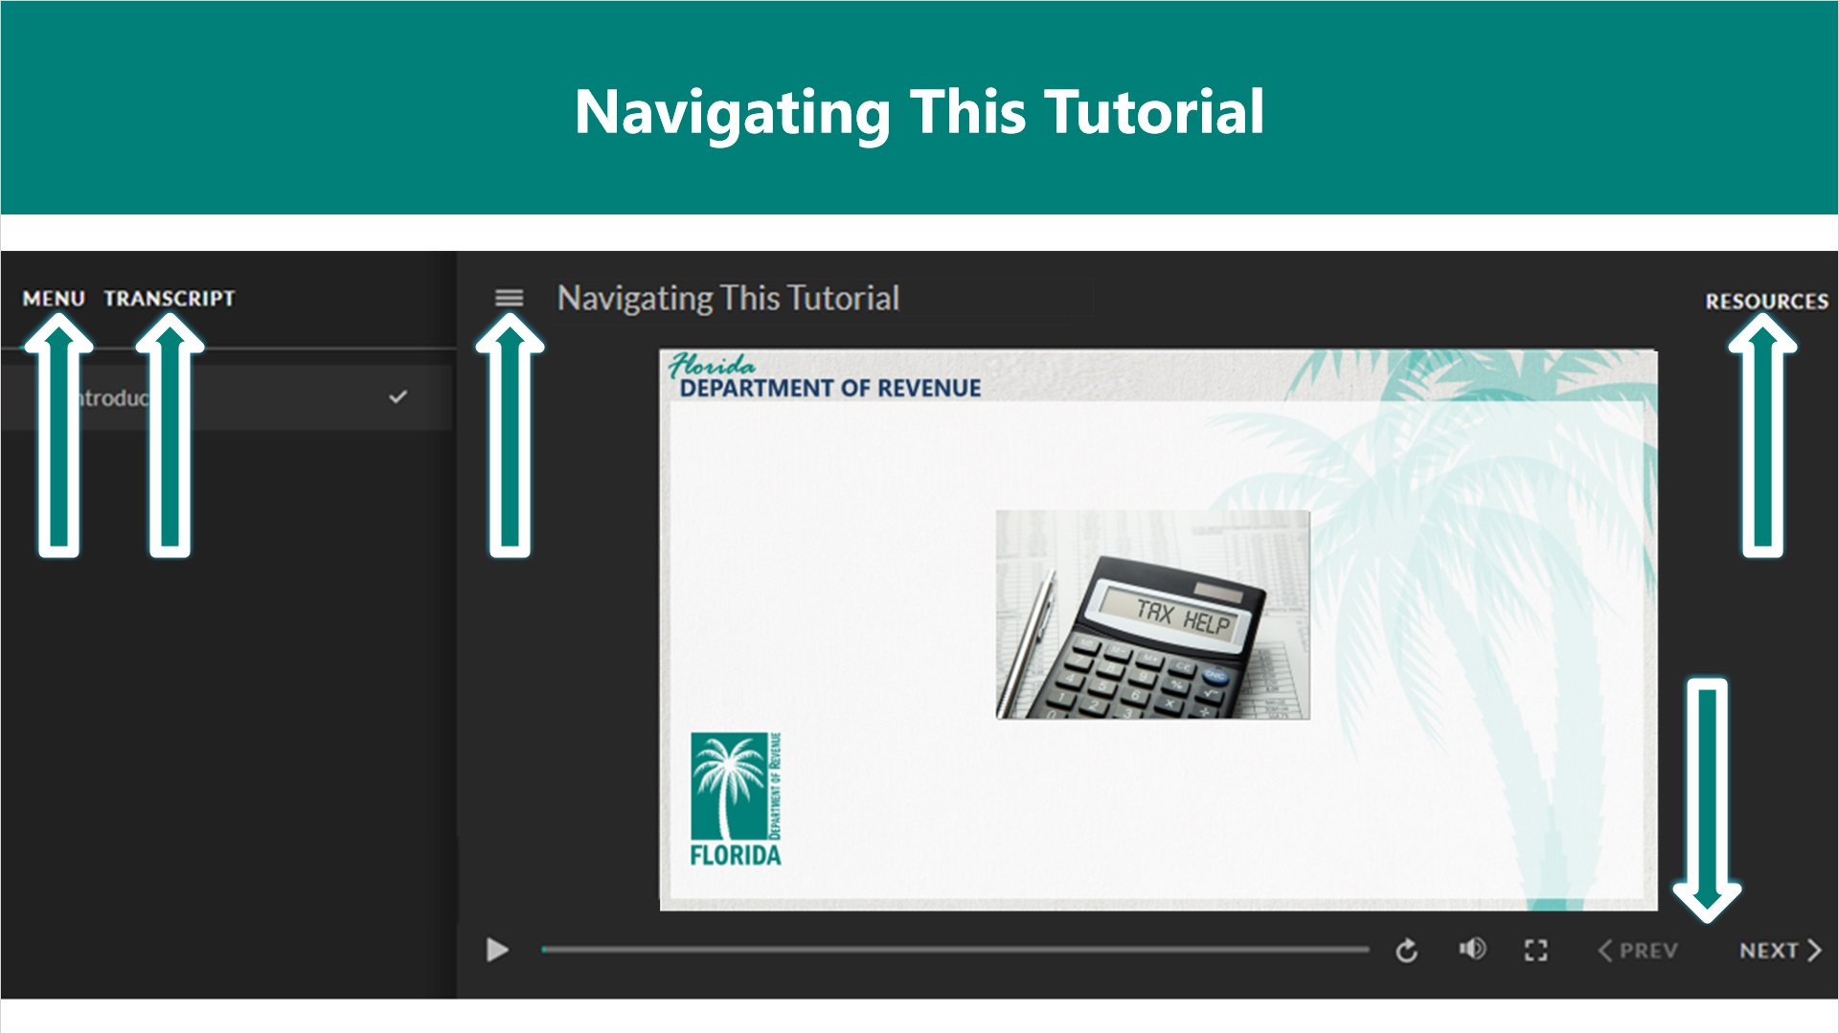
Transcript:
This tutorial will take approximately 20 minutes to complete. A transcript of the audio is available by clicking on the transcript tab in the top-left corner of your screen.
The following tabs and buttons are available to help you navigate throughout this tutorial.
Menu Tab
The menu tab displays by default when the overview is viewed on a computer. It allows you to navigate through the tutorial by clicking on the topic name on the menu. When viewing this tutorial on a tablet or smartphone, the menu does not display by default and must be accessed using the menu symbol.
Resources Tab
The resources tab is found on the right side of the top bar. When clicked, it displays the list of links to useful forms, documents, and webpages.
Previous and Next Buttons
The previous and next buttons are located at the bottom-right corner of your screen. These buttons allow you to move either back or forward.

1.3 Topics
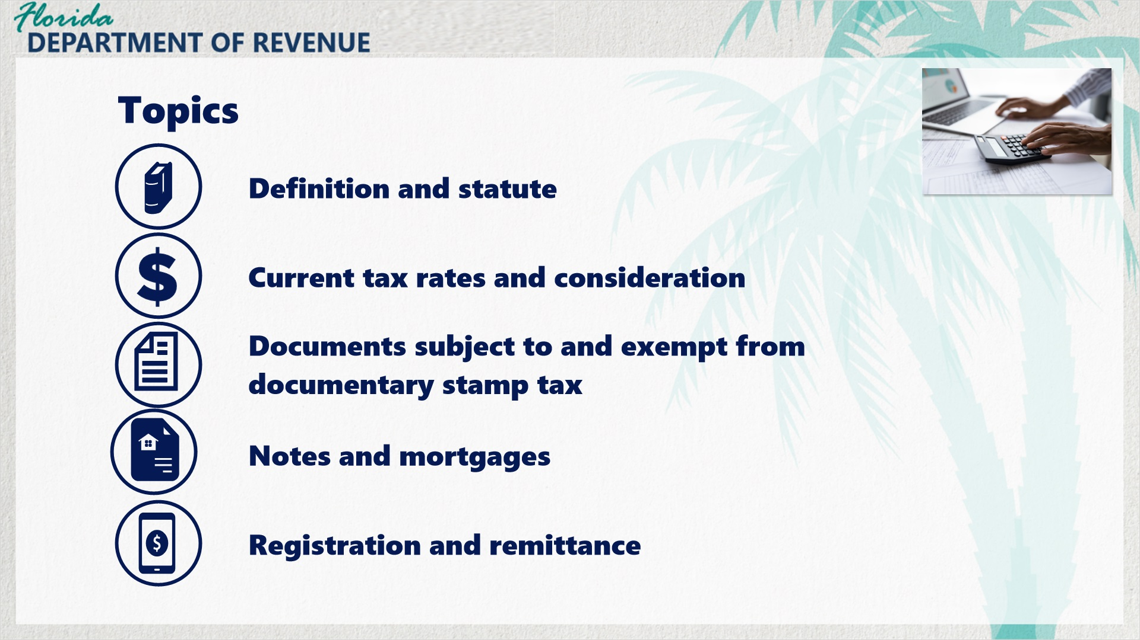
Transcript:
Topics for this tutorial include the definition and statute, current tax rates and consideration, documents subject to and exempt from documentary stamp tax, notes and mortgages, and registration and remittance.

1.4 Definition and Governing Statute
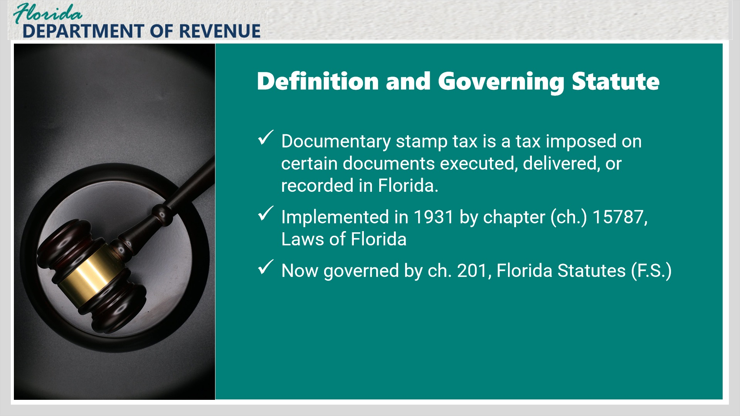
Transcript:
Documentary stamp tax is a tax imposed on certain documents executed, delivered, or recorded in Florida. Documentary stamp tax was first enacted in 1931 under chapter 15787, Laws of Florida, and is currently governed by ch. 201, Florida Statutes (F.S.).

1.5 Deeds and Other Documents
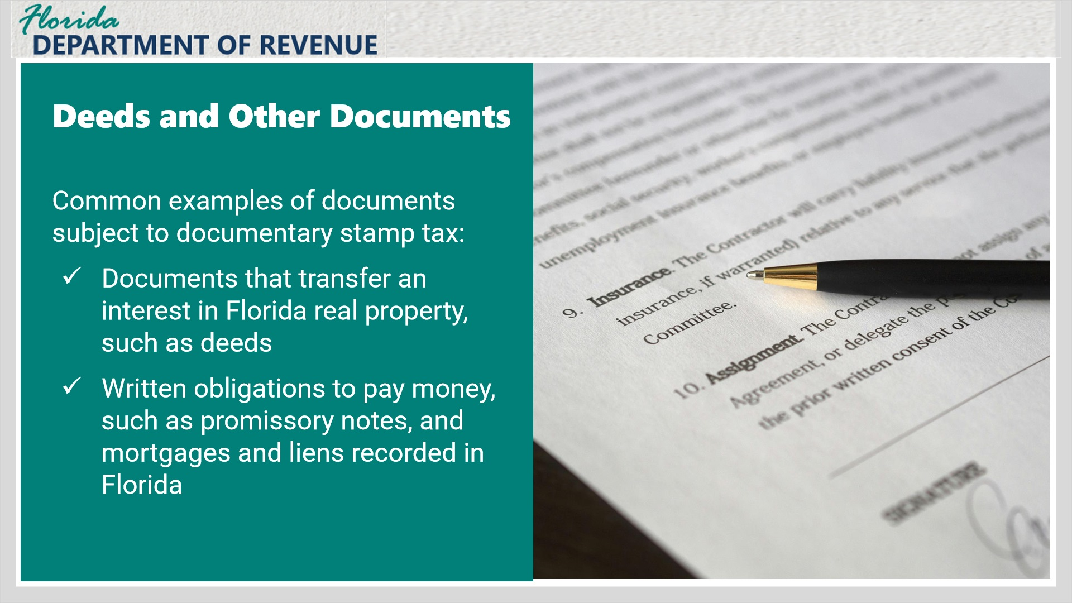
Transcript:
The most common examples of documents subject to documentary stamp tax are deeds and other documents that transfer an interest in Florida real property, agreements or contracts for deeds, mortgages recorded in Florida, and certificates of title, as well as other documents we will cover later in this overview.
For documents that transfer an interest in Florida real property, the amount of tax due is calculated based on the consideration for the transfer, and all parties are liable for the tax regardless of which party agrees to pay the tax unless a party is statutorily exempt from doing so.
We will cover consideration with examples later in this overview.

1.6 Current Tax Rates
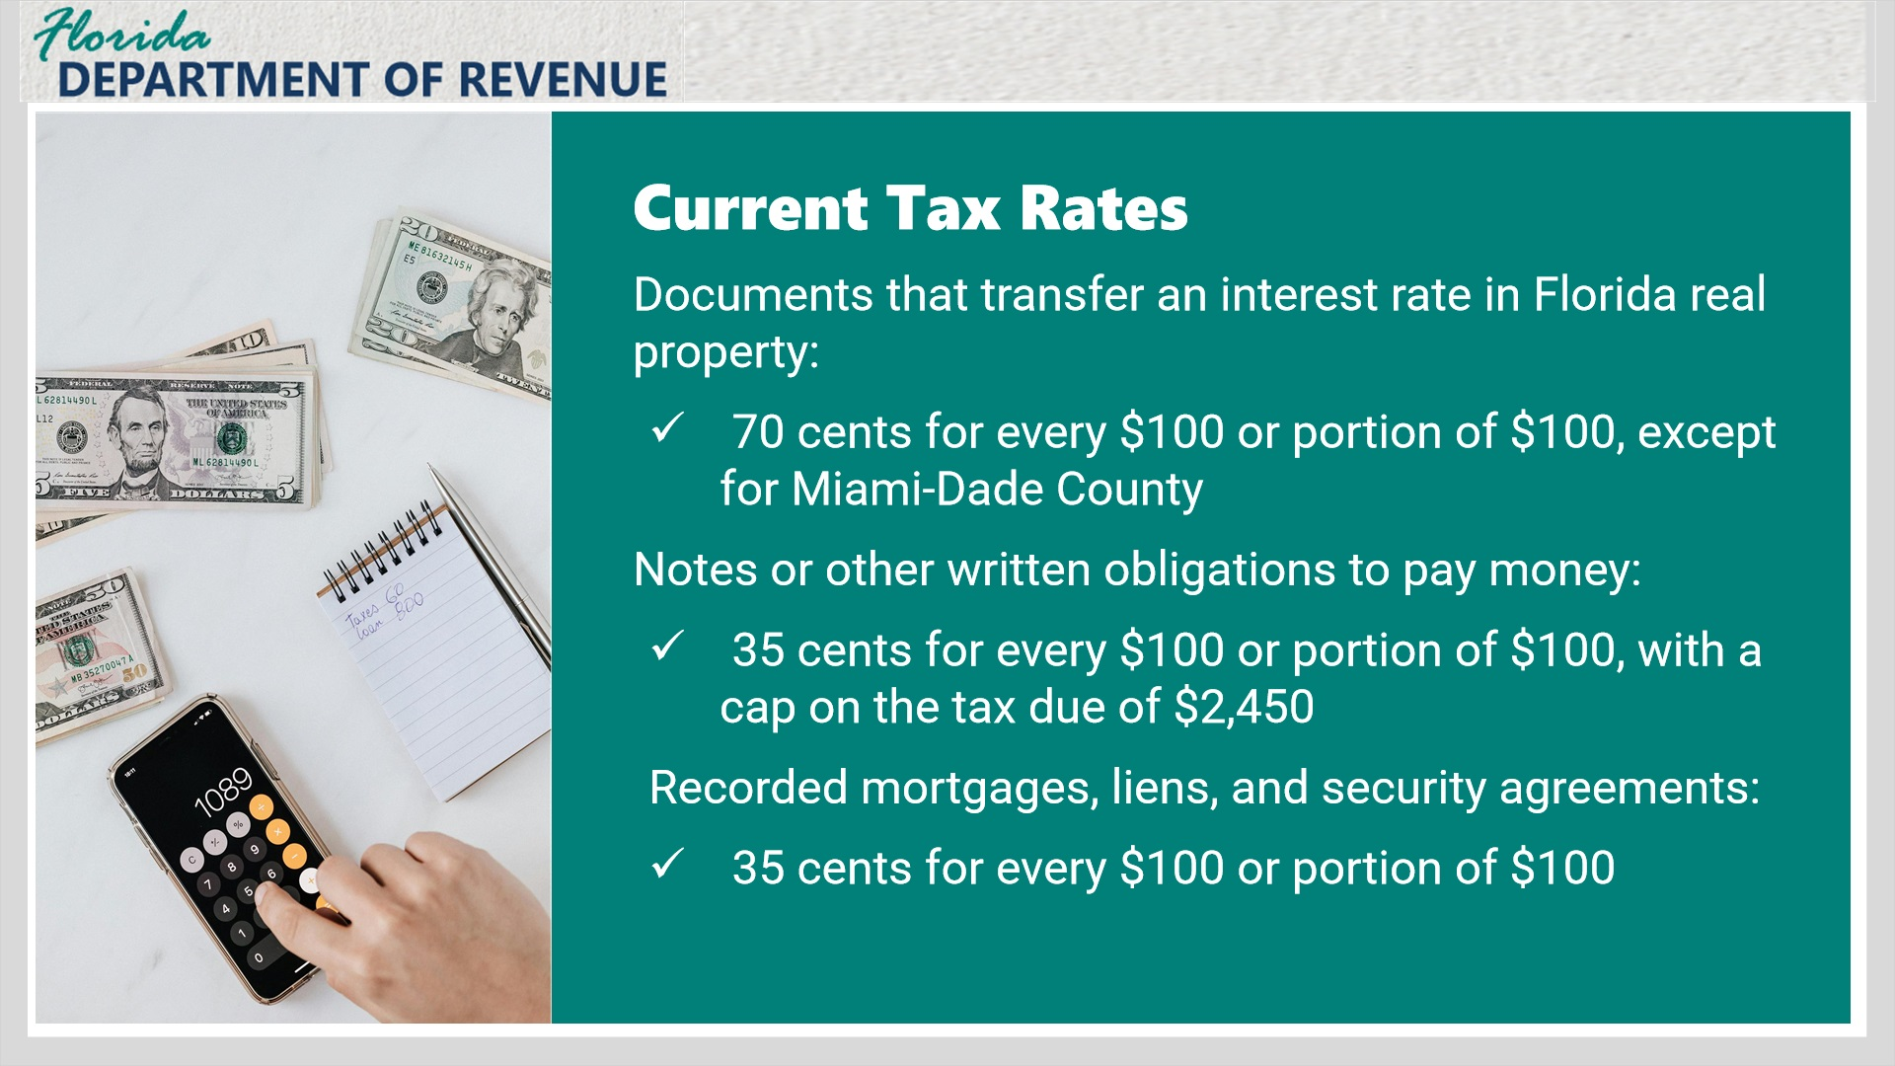
Transcript:
The current tax rate for documents that transfer an interest in Florida real property, such as deeds, is 70 cents for every $100 or any portion of $100, with the exception of Miami-Dade County (which we will discuss on the next screen).
Notes and other written obligations to pay money are taxed at 35 cents for every $100 or portion of $100, with a cap on the tax due of $2,450.
Recorded mortgages, liens, and security agreements also have a tax rate of 35 cents for every $100 or portion of $100, with no cap on the tax amount due.

1.7 Miami-Dade Tax and Surtax
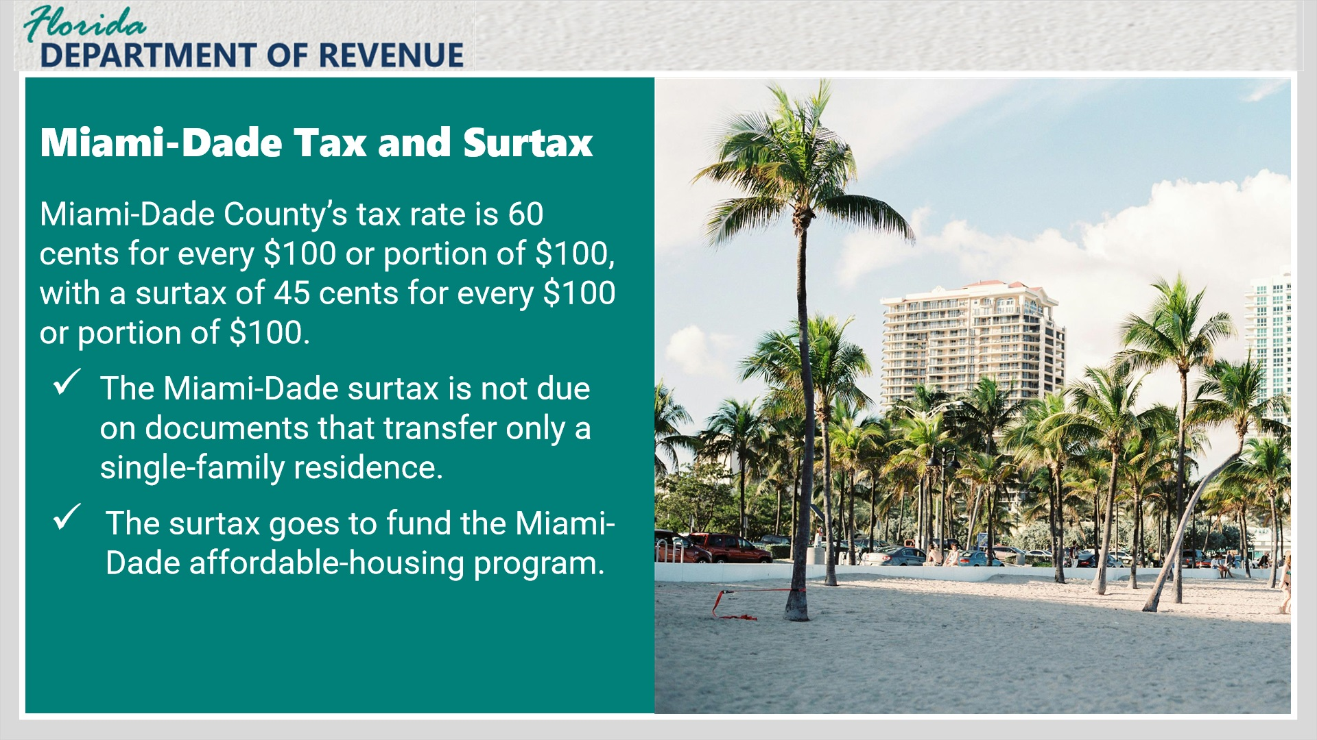
Transcript:
Miami-Dade County imposes a tax rate of 60 cents for every $100 or portion of $100, and an additional surtax of 45 cents on every $100 or portion of $100.
The Miami-Dade surtax is not due on documents that transfer only a single-family residence, and only the documentary stamp tax of 60 cents on every $100 or a portion of $100 would apply.
The surtax funds go to fund the Miami-Dade County affordable-housing program.

1.8 Knowledge Check 1
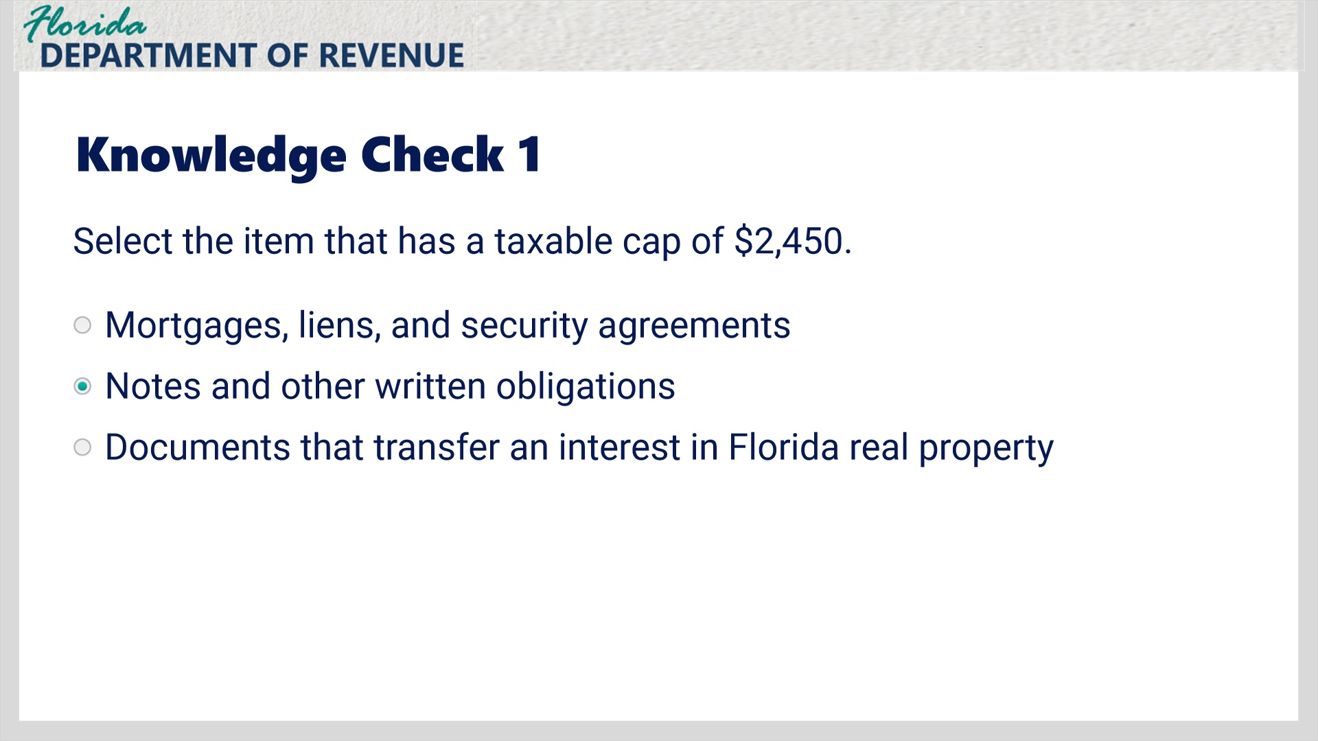
Transcript:
Select the item that has a taxable cap of $2,450.
Mortgages, liens, and security agreements
Notes and other written obligations
Documents that transfer an interest in Florida real property

Correct (Slide Layer)
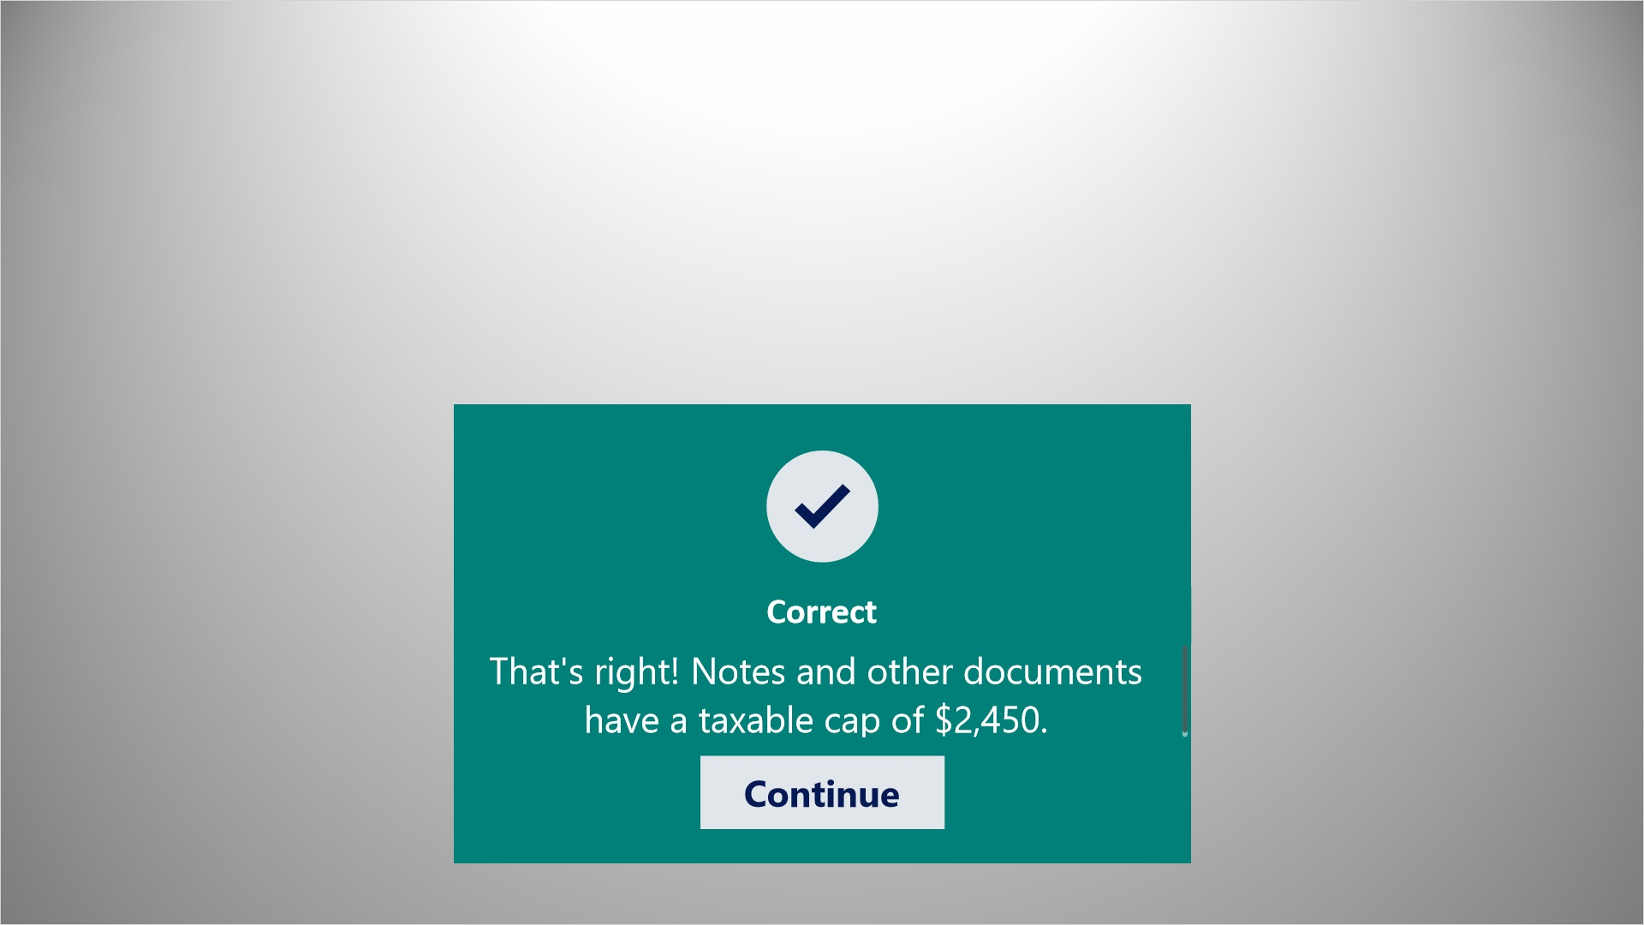
Transcript:
That’s right! Notes and other documents have a taxable cap of $2,450.

Incorrect (Slide Layer)
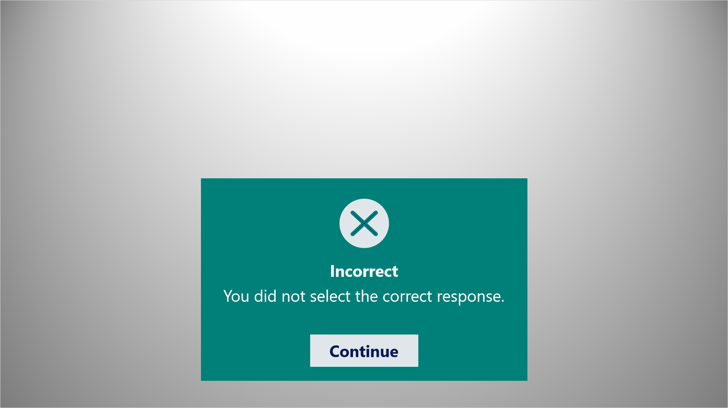
Transcript:
You did not select the correct response.

Try Again (Slide Layer)
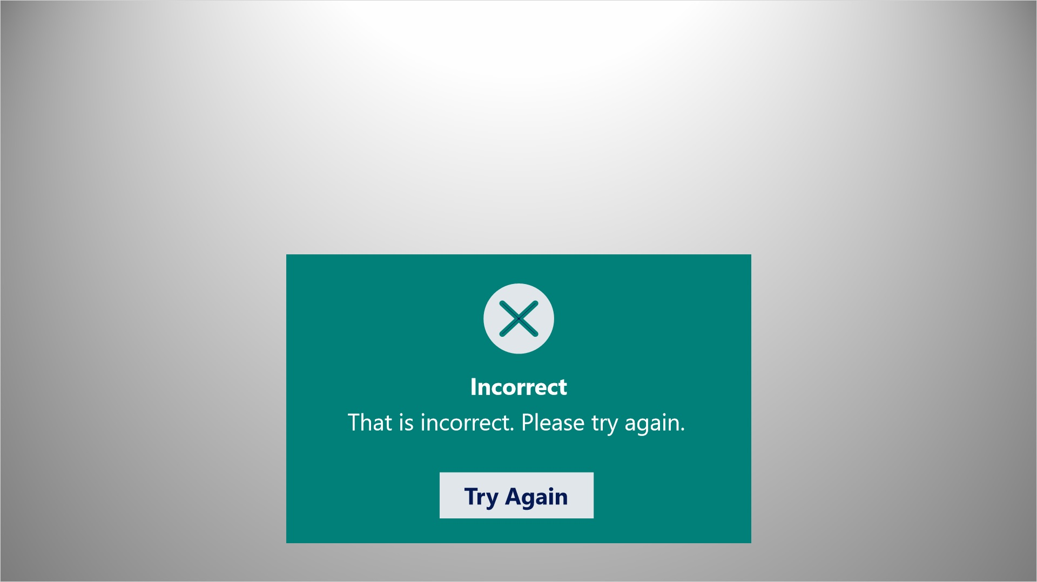
Transcript:
That is incorrect. Please try again.

1.9 Consideration
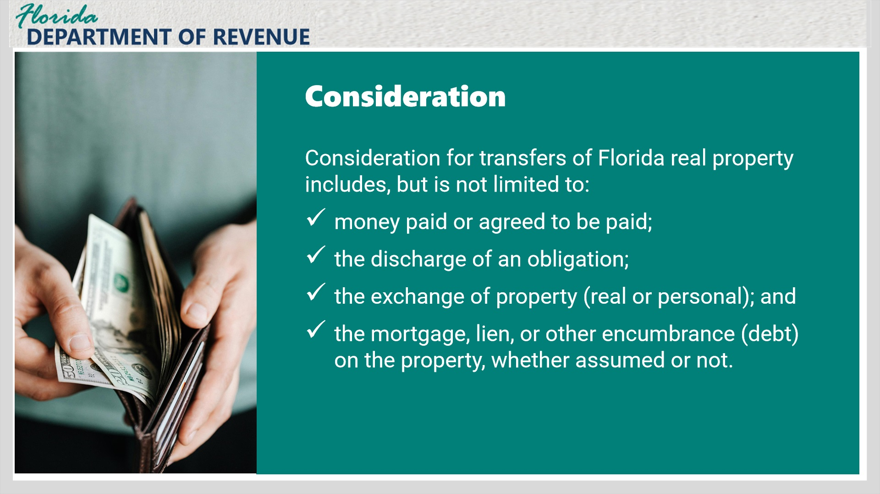
Transcript:
Examples of consideration for a transfer can be found in section 201.02(1)(a), F.S., and include, but are not limited to: money paid or agreed to be paid; the discharge of an obligation; the exchange of property, real or personal; and the mortgage, lien, or other encumbrance or debt on the property, whether the debt is assumed or not.

Layer 2 (Slide Layer)

Transcript:
For example: If the property being transferred has an active mortgage, the balance of the mortgage at the time of the transfer would be included in the total consideration for the transfer.
What if the consideration is something other than money? If someone is exchanging a vehicle for an acre of land, the vehicle’s value is presumed to be equal to the fair market value of the land in the exchange.

1.10 How is consideration determined?
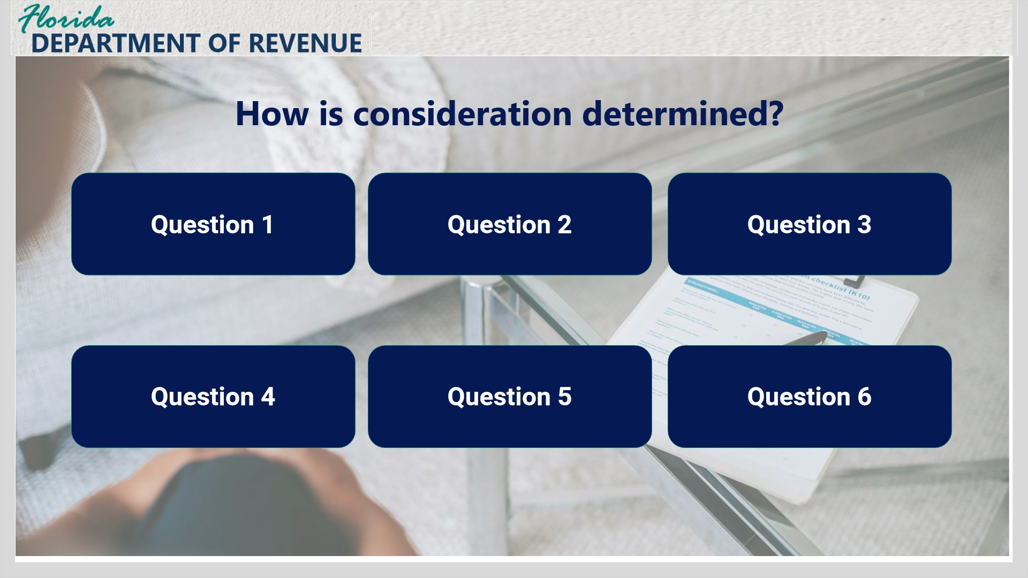
Transcript:
Here are six questions that may help in determining consideration. If any of these questions result in a yes answer, then tax may be due on the document. Click on each box for the example.

Question 1 (Slide Layer)
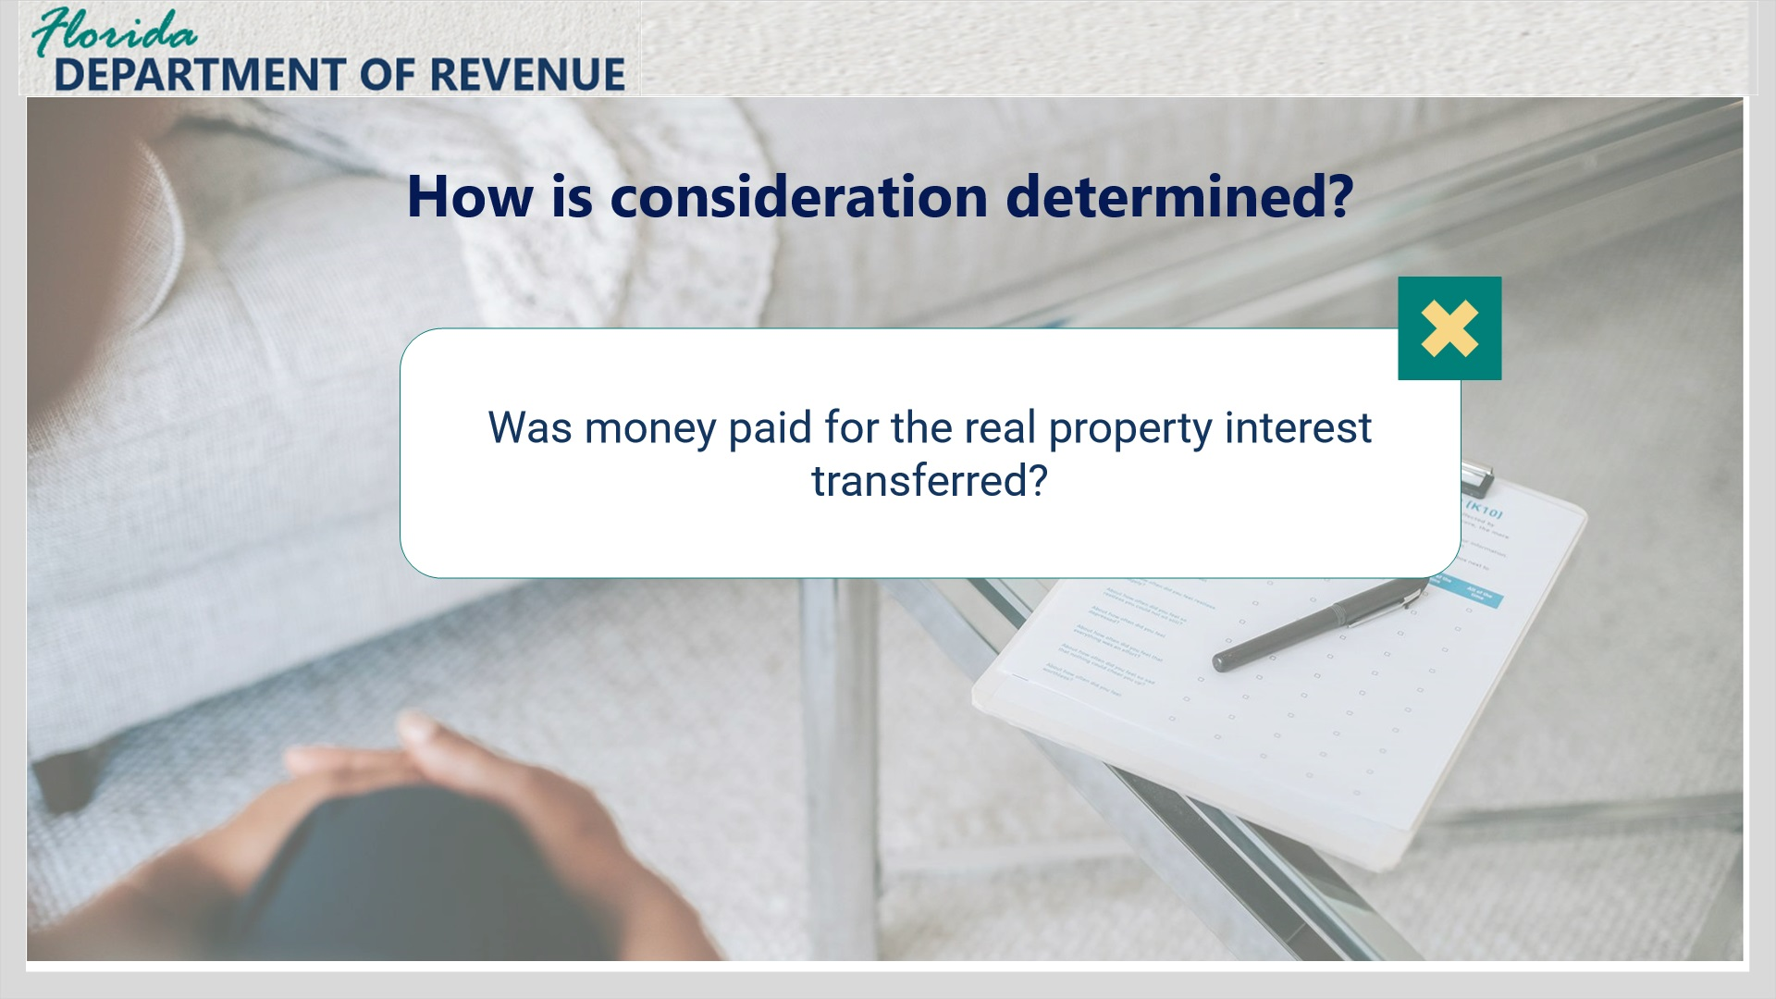
Transcript:
Was money paid for the real property interest transferred?

Question 2 (Slide Layer)
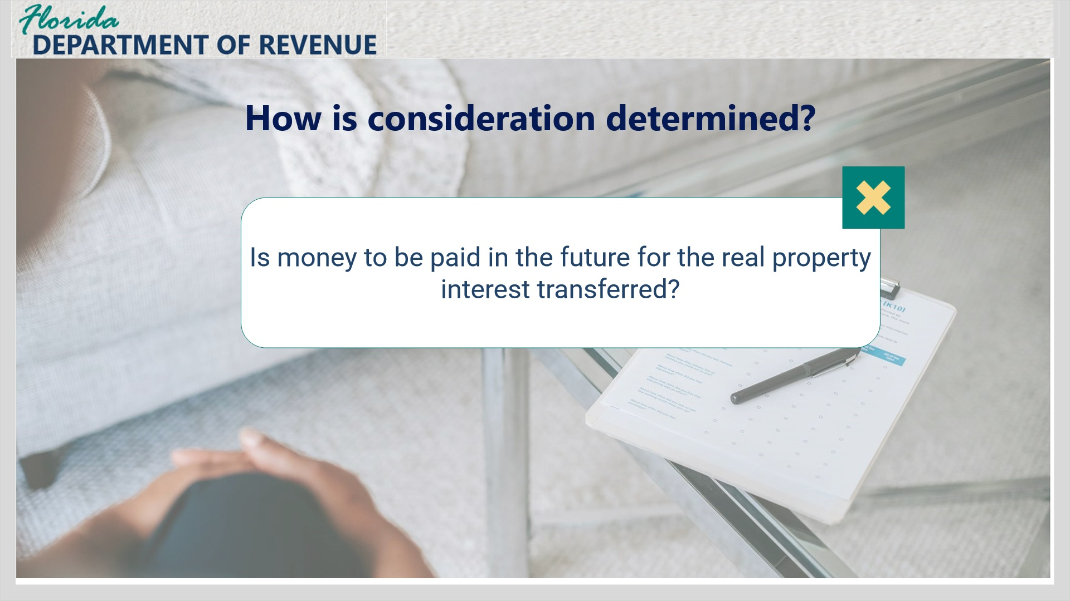
Transcript:
Is money to be paid for the real property interest transferred?

Question 3 (Slide Layer)
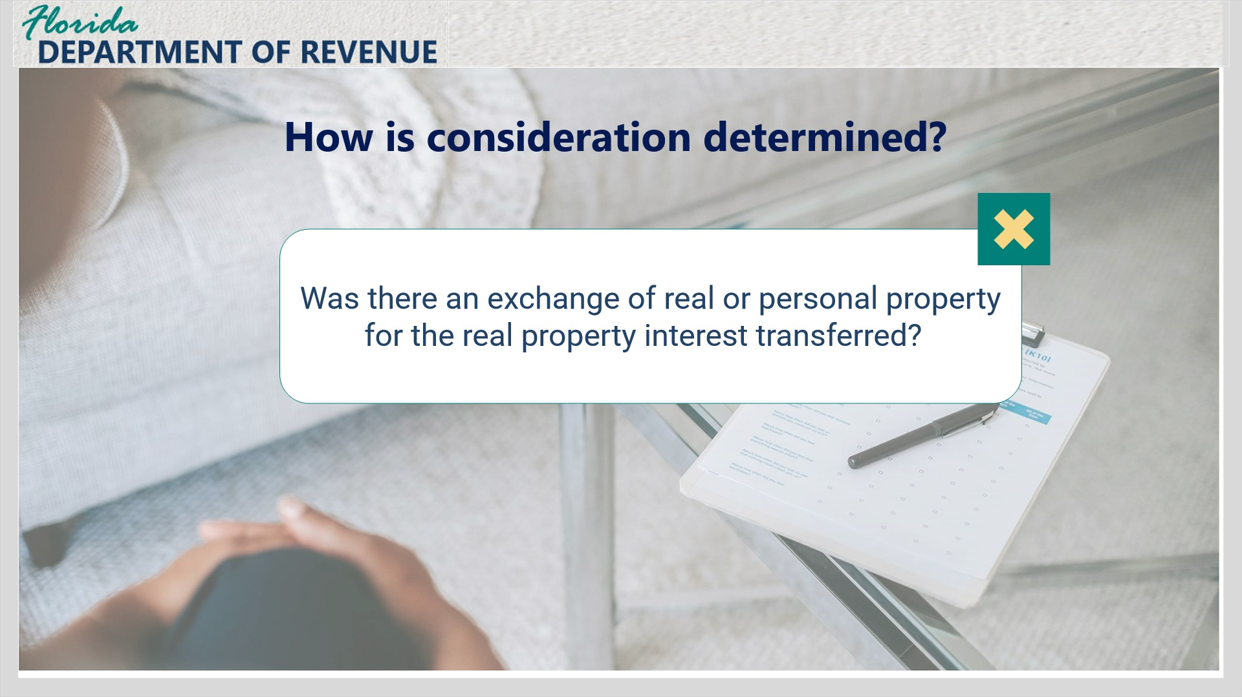
Transcript:
Was there an exchange of real or personal property for the real property transferred? For example, did you agree to trade a recreational vehicle for a parcel of real property?

Question 4 (Slide Layer)
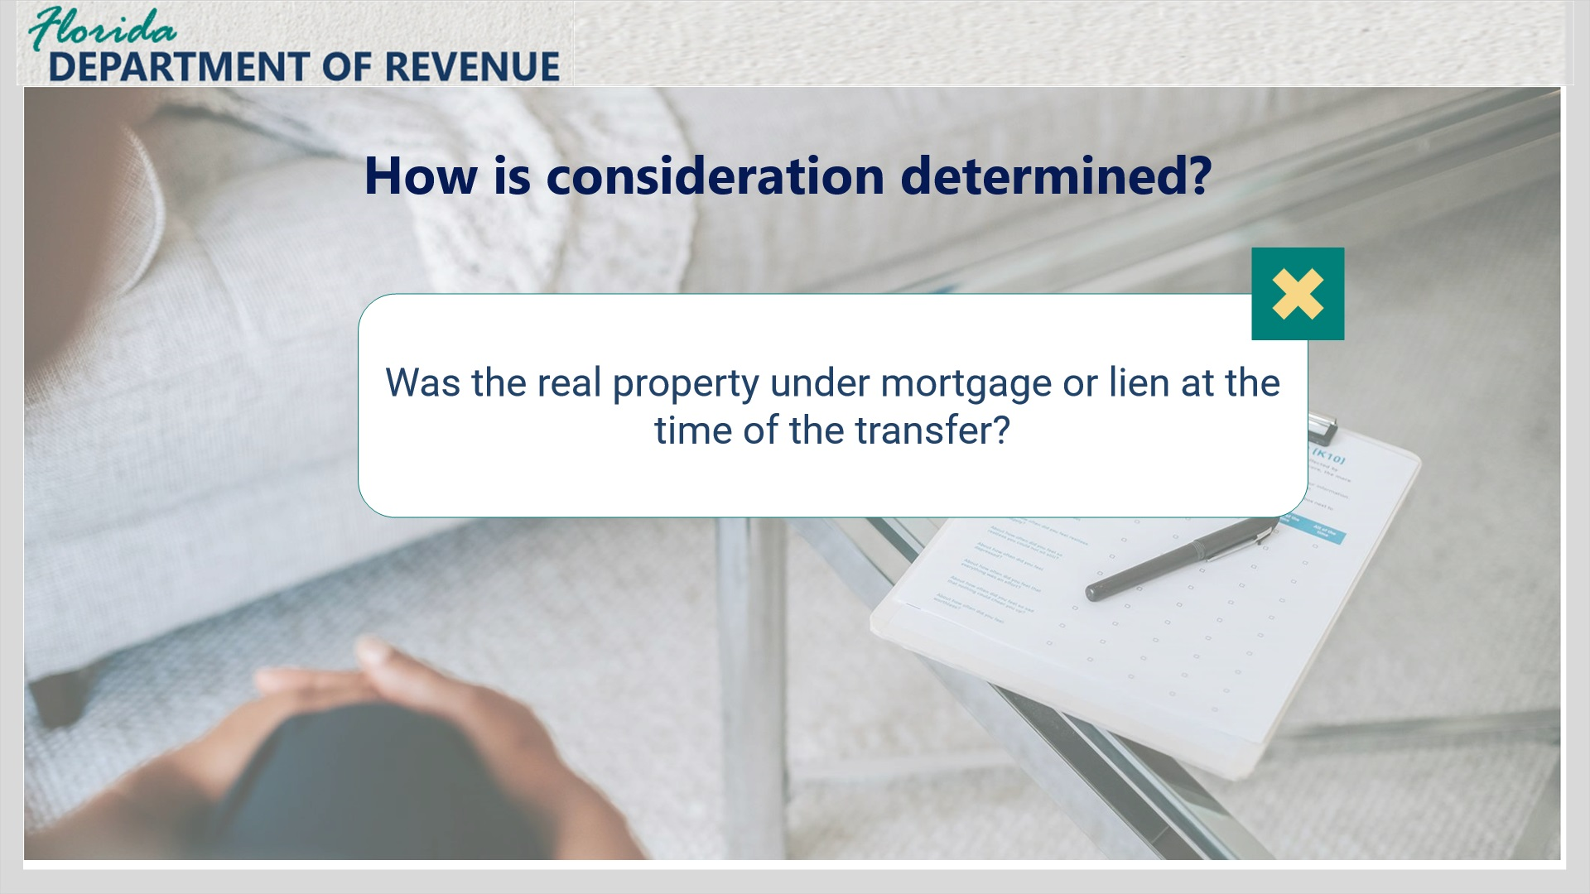
Transcript:
Was the real property under mortgage or lien at the time of the transfer?

Question 5 (Slide Layer)
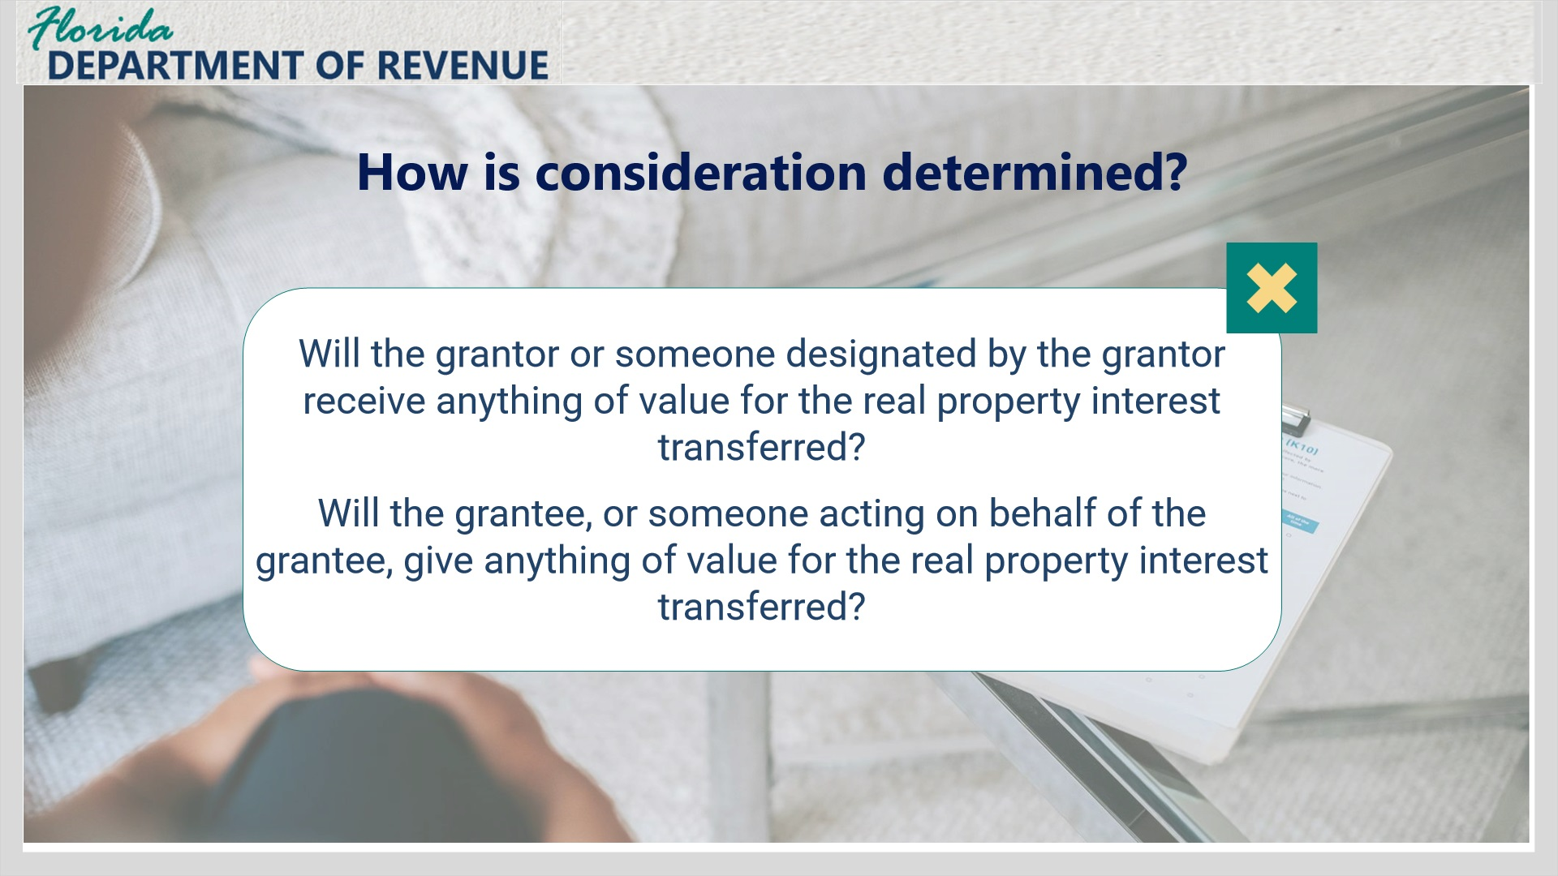
Transcript:
Will the grantor or someone designated by the grantor receive anything of value for the real property interest transferred? Or will the grantee, or someone acting on behalf of the grantee, give anything of value for the real property interest transferred?

Question 6 (Slide Layer)
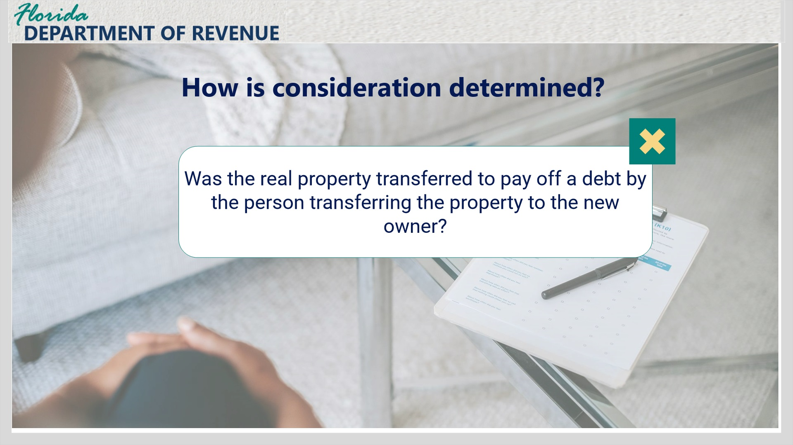
Transcript:
Was the real property transferred to pay off a debt by the person transferring the property to the new owner?

1.11 Documents Subject to Tax
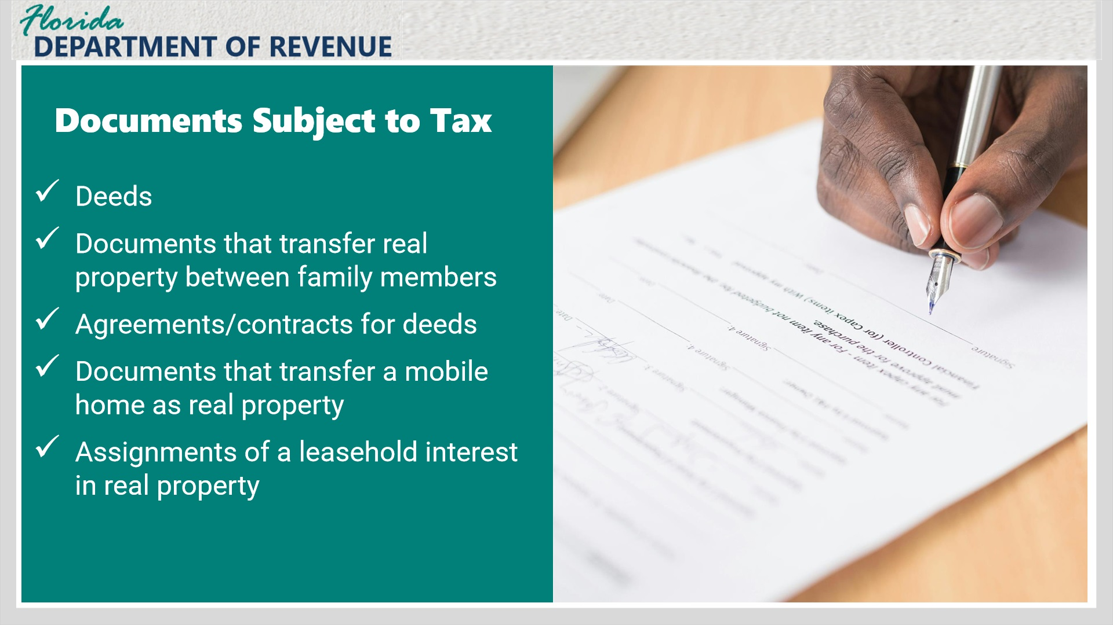
Transcript:
Examples of documents subject to documentary stamp tax include but are not limited to deeds such as a warranty, special warranty, quit claim, trustee’s deed, or a life estate deed, documents that transfer real property between family members, agreements or contracts for a deed, documents that transfer a mobile home as real property (for mobile homes, it is important to note that the mobile home be tagged as real property, and it is sold in conjunction with the land), and assignments of a leasehold interest in real property.

1.12 Document Subject to Tax continued
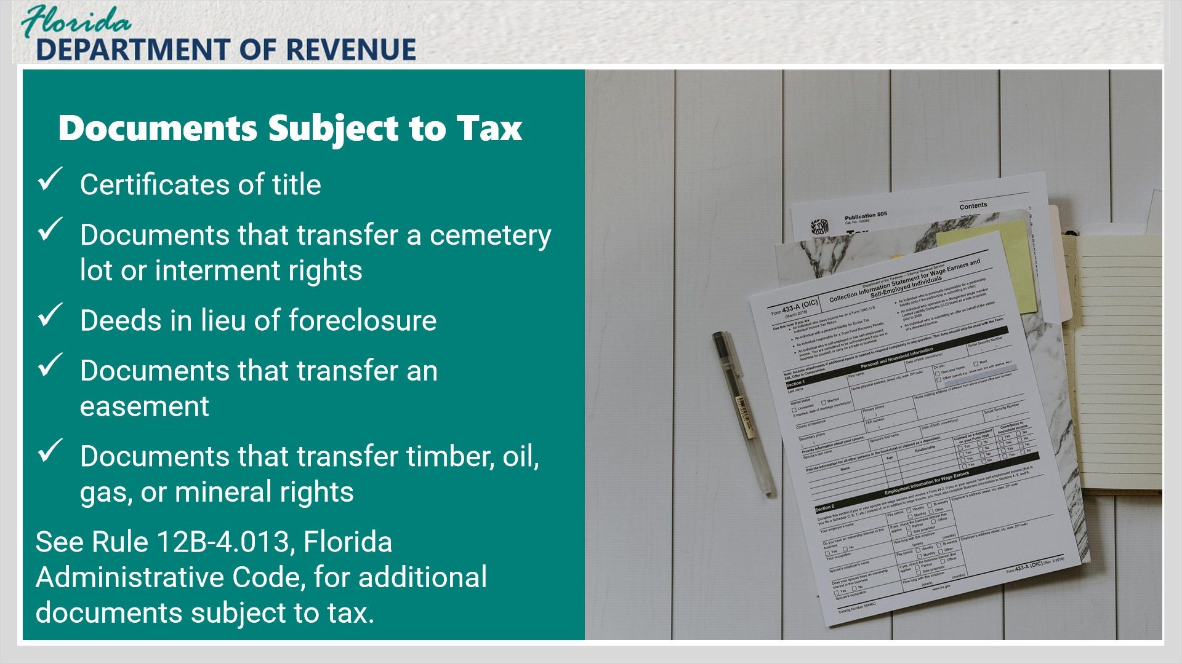
Transcript:
More examples of documents subject to tax include certificates of title, documents that transfer a cemetery lot or interment rights, deeds in lieu of foreclosure, documents that transfer an easement, and documents that transfer timber, oil, gas, or mineral rights.
See Rule 12B-4.013, Florida Administrative Code, for additional documents subject to tax.

1.13 Less Common Documents
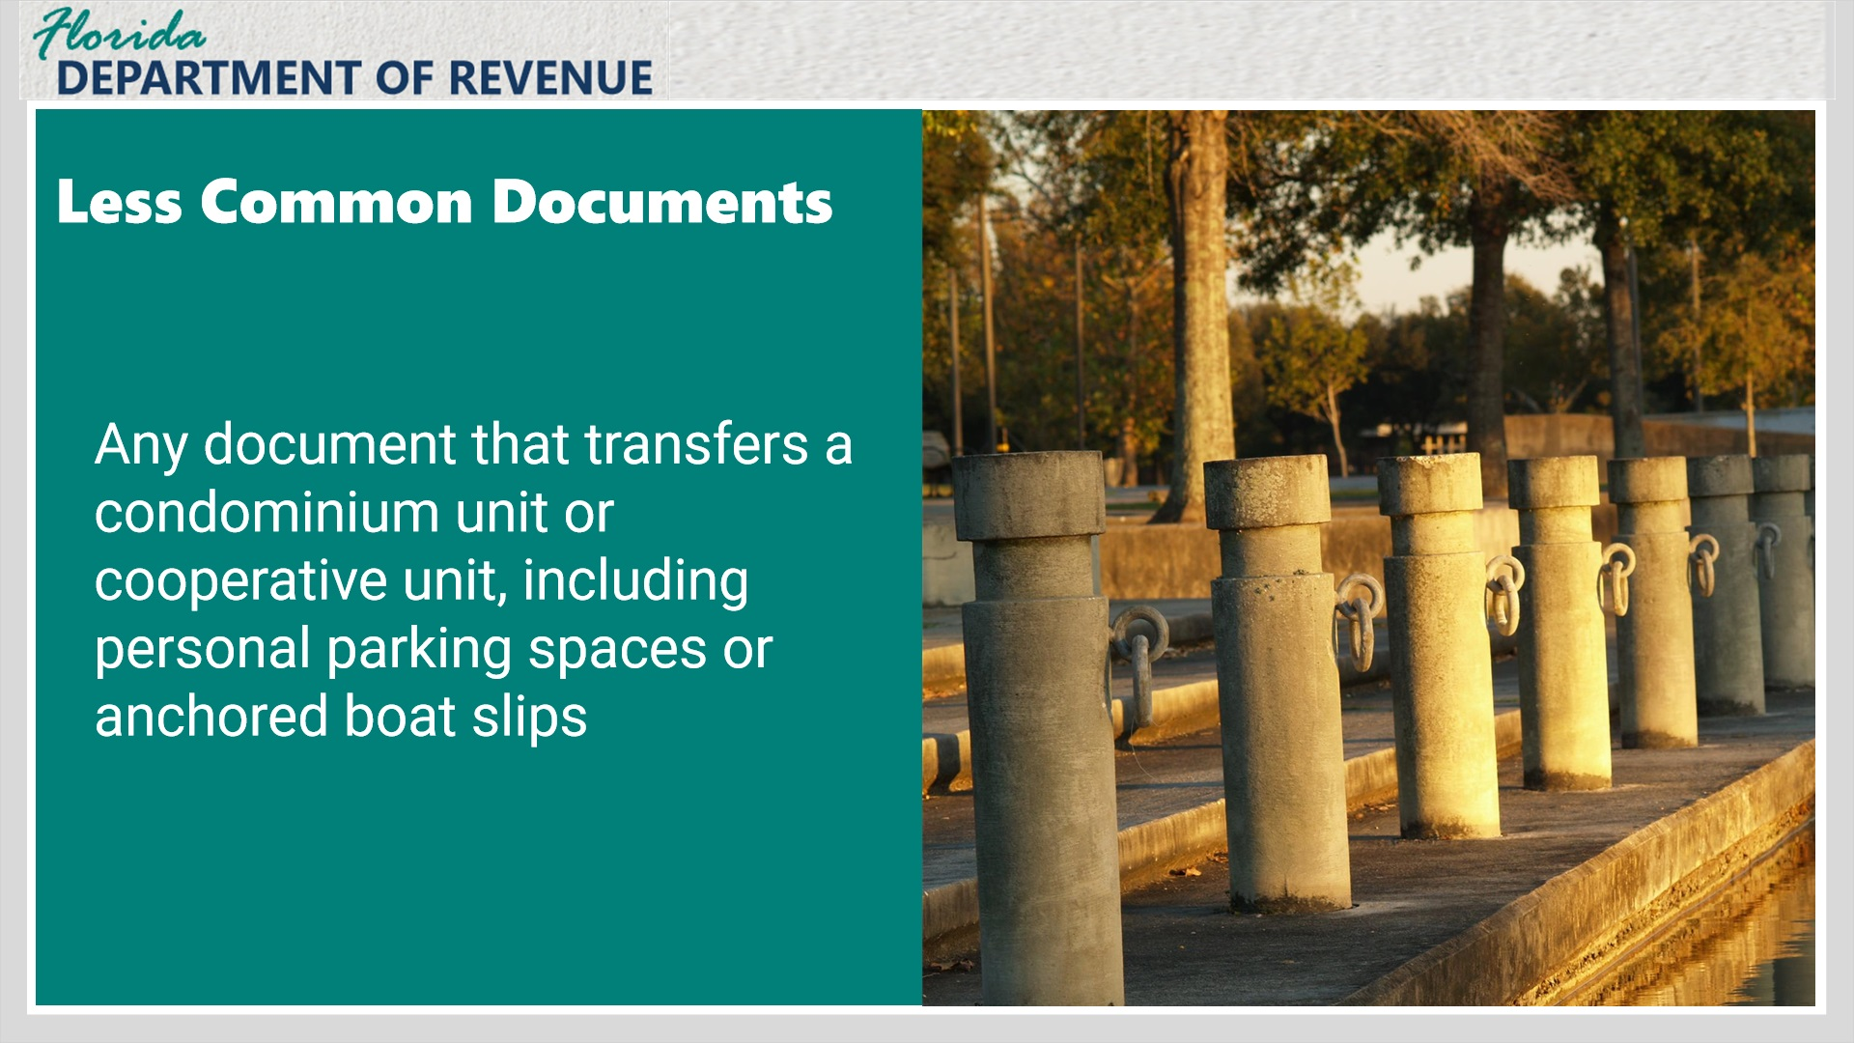
Transcript:
There are a few less common examples of documents subject to documentary stamp tax, such as any document that transfers a condominium unit or cooperative unit, including personal parking spaces or anchored boat slips. Anything permanently attached to real property becomes real property and is considered taxable.
For boat docks and slips, anything permanently anchored or attached to the ground is considered real property and therefore taxable. If the boat slip is floating and not anchored, no tax is due.

1.14 Documents Generally Not Subject to Tax
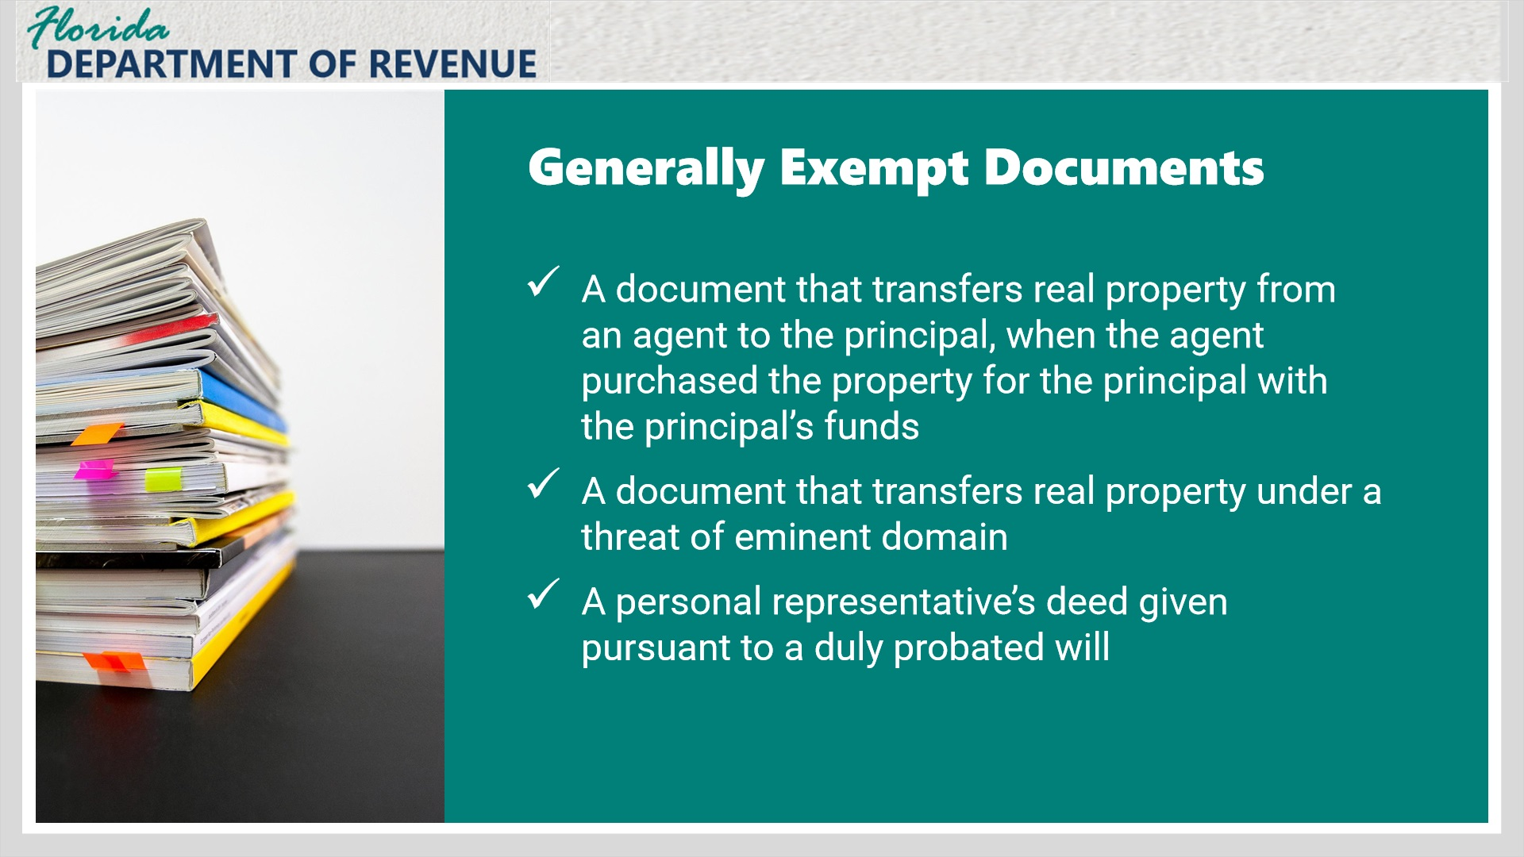
Transcript:
Now, let’s discuss documents that are generally not subject to documentary stamp tax.
A document that transfers real property from an agent to the principal, when the agent purchased the property for the principal with the principal’s funds, would not be subject to documentary stamp tax.
Another example is a document that transfers real property under a threat of eminent domain or condemnation, or a personal representative’s deed given pursuant to a duly probated will.

1.15 Documents Generally Not Subject to Tax continued
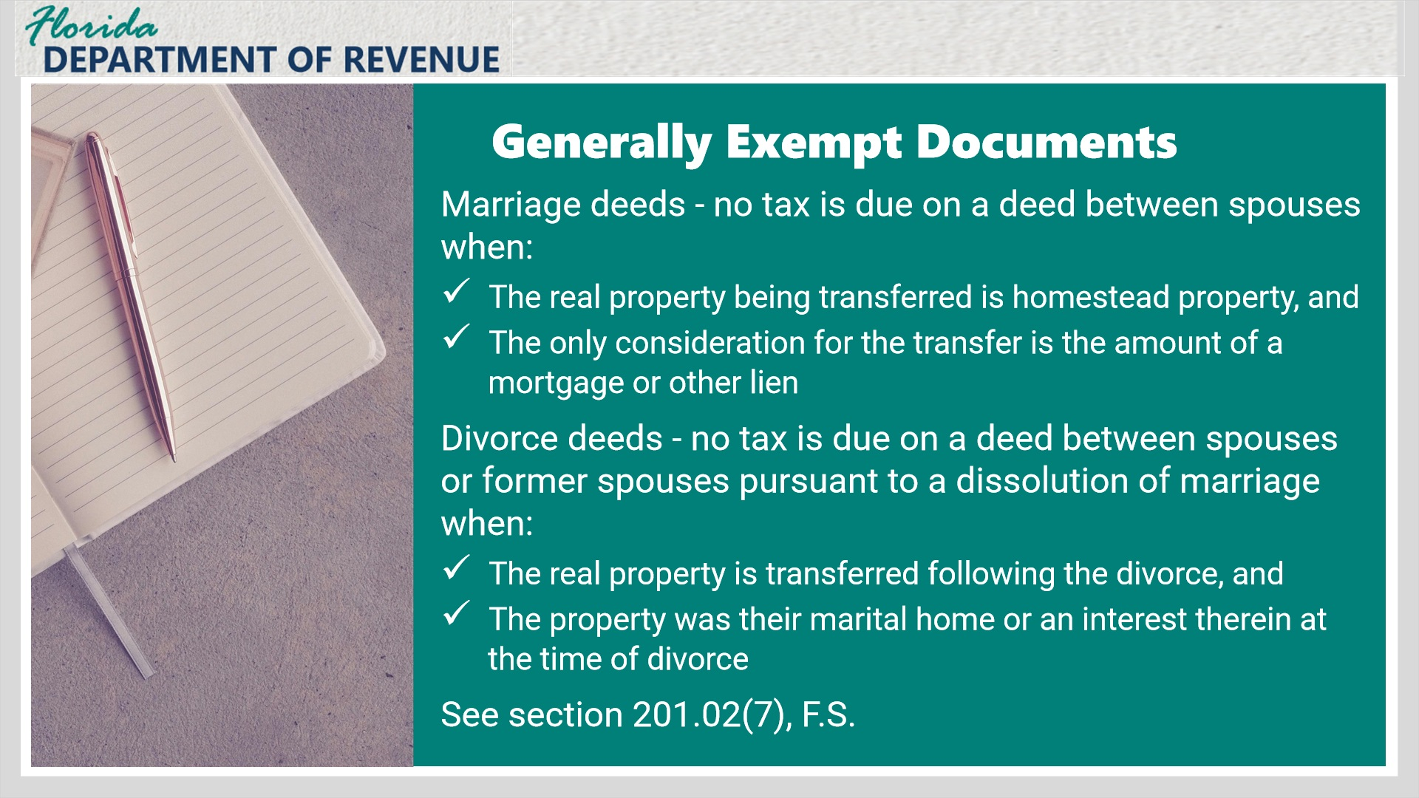
Transcript:
Other examples of documents that are not generally subject to documentary stamp tax include:
Marriage deeds - No tax is due on a deed between spouses when the real property being transferred is homestead property, and the only consideration for the transfer is the amount of a mortgage or other lien encumbering the homestead property.
Divorce deeds - No tax is due on a deed between spouses or former spouses pursuant to a dissolution of marriage when the real property is transferred following the divorce and the property was their marital home or an interest therein at the time of divorce.
Taxpayers may seek a refund of tax paid on a deed within one year of the dissolution of their marriage.
When the property is not the marital home, tax is due based on the consideration, which would include any mortgages on the property.
See section 201.02(7), F.S. for additional documents exempt from tax.

1.16 Notes
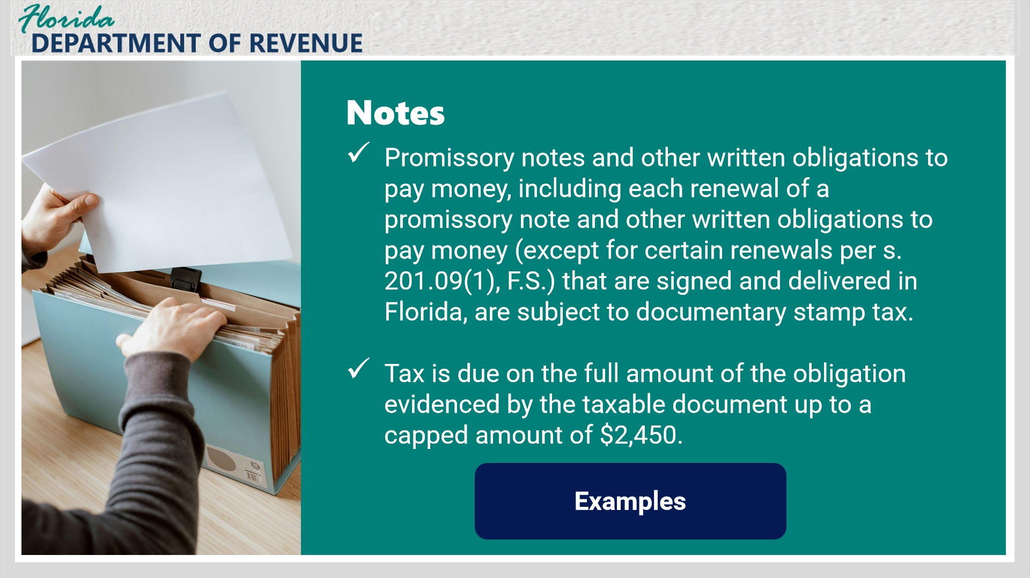
Transcript:
Promissory notes and other written obligations to pay money, including each renewal of a promissory note and other written obligations to pay money (except for certain renewals per s. 201.09(1), F.S.), that are signed or delivered in Florida, are subject to documentary stamp tax. Tax is due on the full amount of the obligation evidenced by the taxable document up to a capped amount of $2,450.
For a written obligation to pay money to be taxable, it must be signed by the borrower in Florida, or it has to be delivered to the lender in Florida. A written obligation to pay money requires a promise to pay. For example, if someone makes a note with a promise to pay another person $500 and it is signed in Florida, the note may be subject to tax.
Remember that written obligations to pay money have a cap on the taxable amount due of $2,450. So, if you sign a note for $2 million, the maximum tax due on that note is $2,450.
Click the examples button to view examples of notes and written obligations.

Notes Example Layer (Slide Layer)
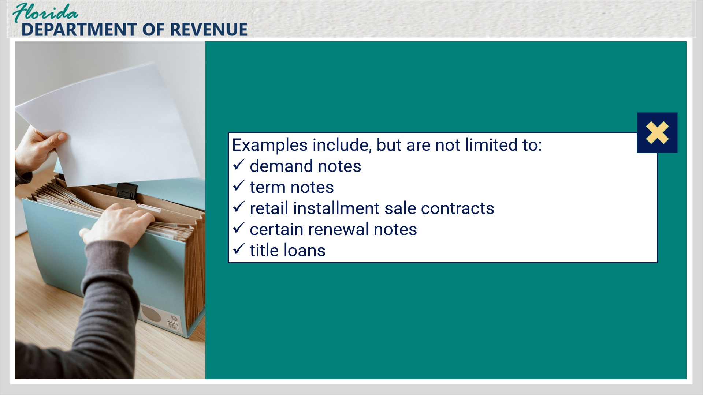
Transcript:
Examples of written obligations to pay money generally subject to tax include demand notes, term notes, retail installment sale contracts, certain renewal notes, and title loans.

1.17 Notes continued
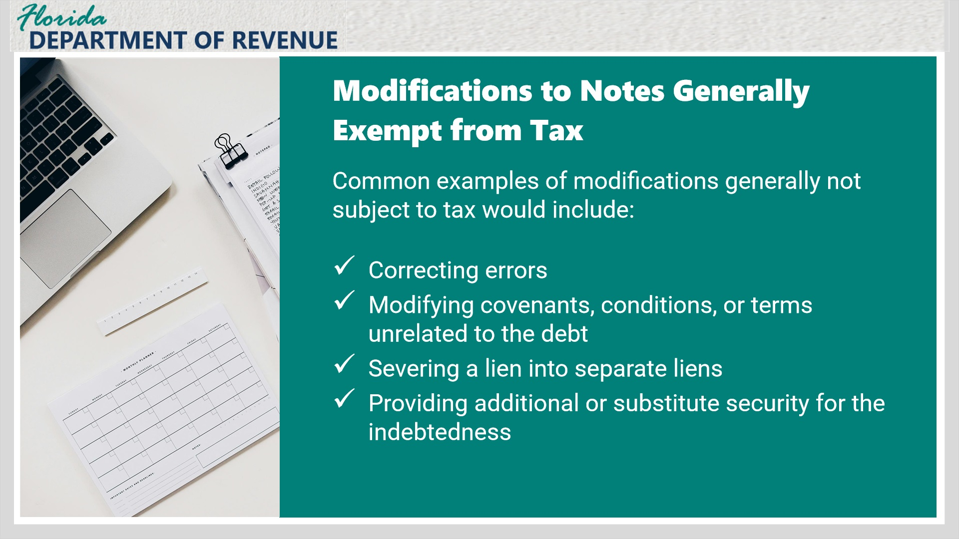
Transcript:
Sometimes documents are not renewed but are modified to correct information or make changes and may not be subject to tax if tax was previously paid. Common examples of modifications generally not subject to tax would include correcting errors, modifying covenants, conditions, or terms unrelated to the debt, severing a lien into separate liens, providing additional or substitute security for the indebtedness.

Layer 2 (Slide Layer)
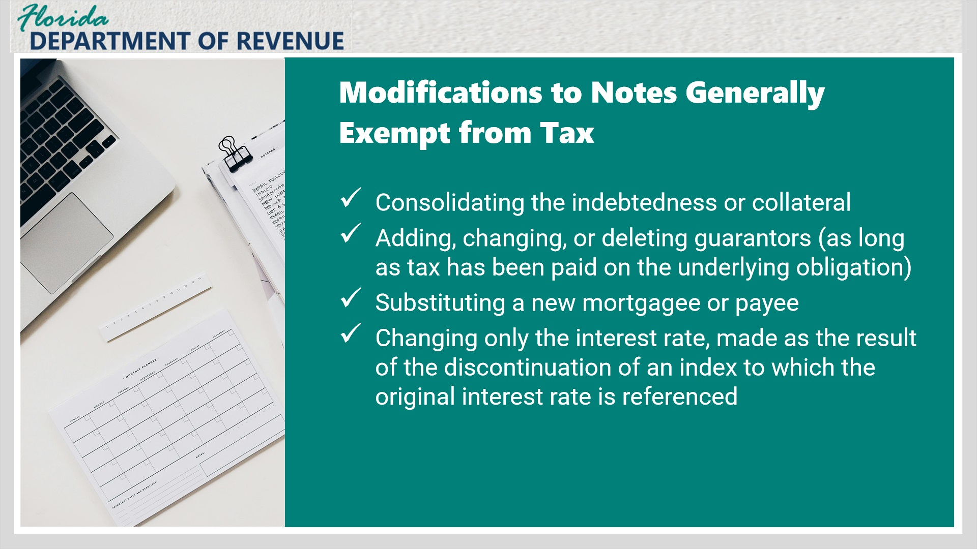
Transcript:
Continued list: consolidating the indebtedness or collateral, adding, changing, or deleting guarantors (as long as tax has been paid on the underlying obligation), substituting a new mortgagee or payee, or changing only the interest rate, made as the result of the discontinuation of an index to which the original interest rate is referenced.

1.18 Mortgages
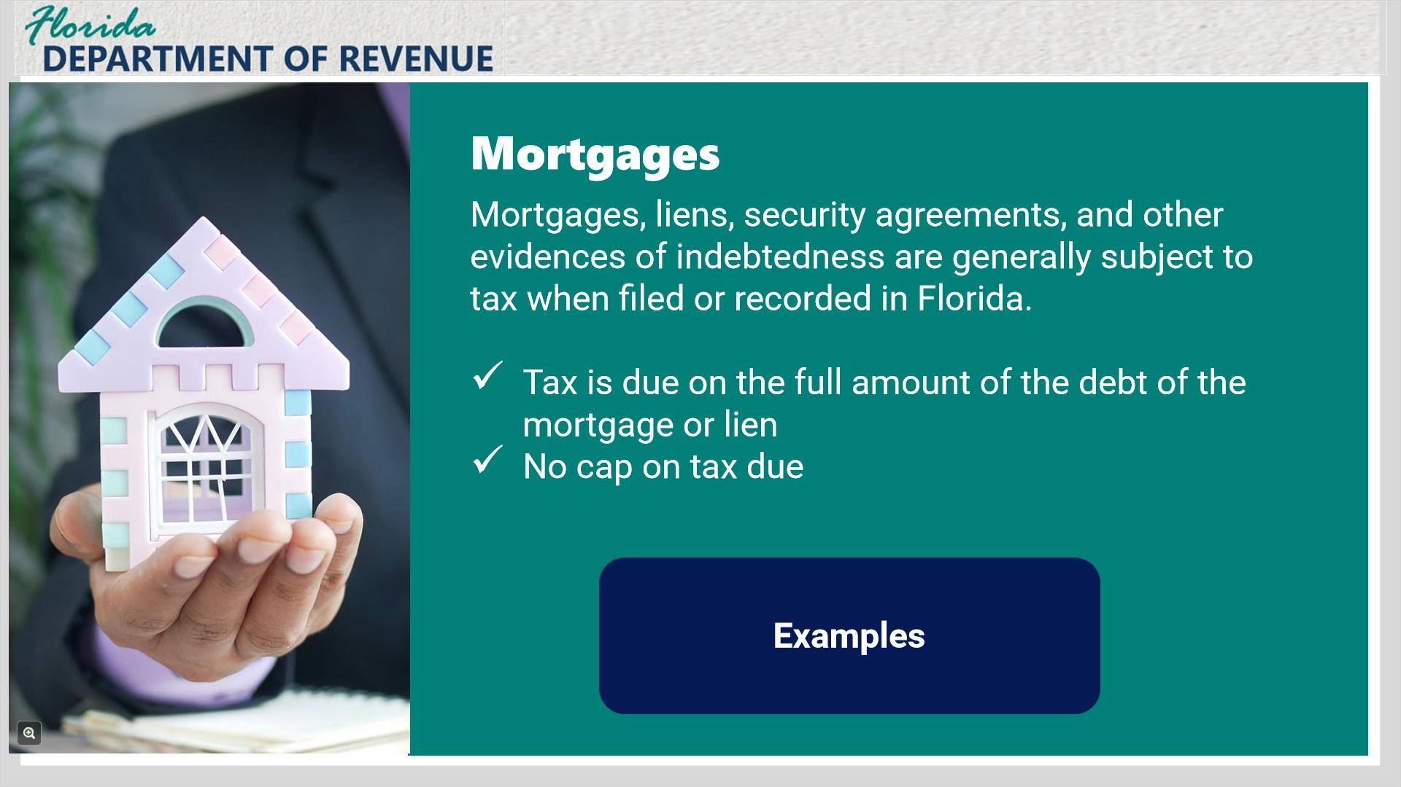
Transcript:
Mortgages, liens, security agreements, and other evidences of indebtedness are generally taxable when filed or recorded in Florida. The tax is based on the full amount of the indebtedness evidenced by the mortgage or lien regardless of whether the indebtedness is contingent or absolute.
Mortgages do not have a tax amount cap, and tax is due on the full amount of the indebtedness evidenced by the mortgage at the time of recording.
Click the examples button to view examples of mortgage documents.

Mortgage examples (Slide Layer)
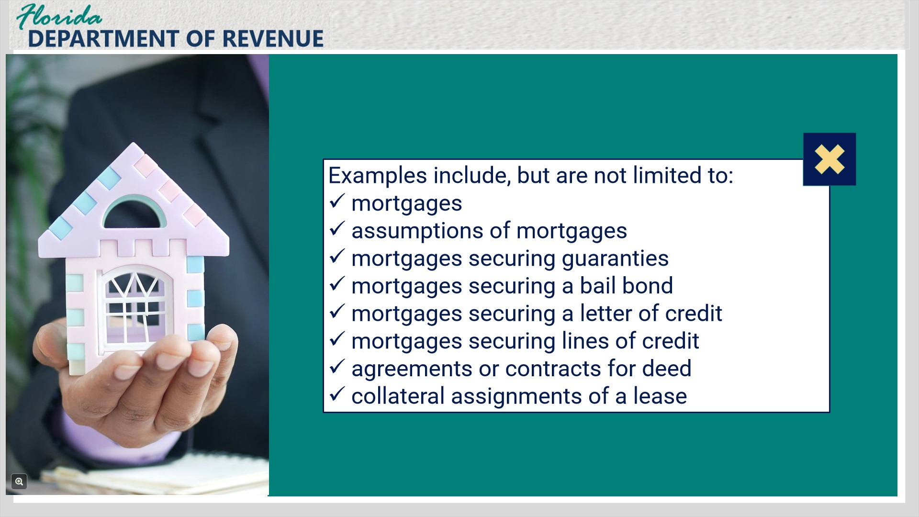
Transcript:
Examples of recorded documents that may be subject to tax include, but are not limited to mortgages, assumptions of mortgages, mortgages securing guaranties, mortgages securing a bail bond, mortgages securing a letter of credit, mortgage securing lines of credit, agreements or contracts for deed, and collateral assignments of a lease.
Effective July 1, 2024, the tax due on a reverse mortgage recorded in Florida is due on the principal limit at the time of closing as evidenced by the supporting documentation attached to the recorded mortgage.

1.19 Knowledge Check 2
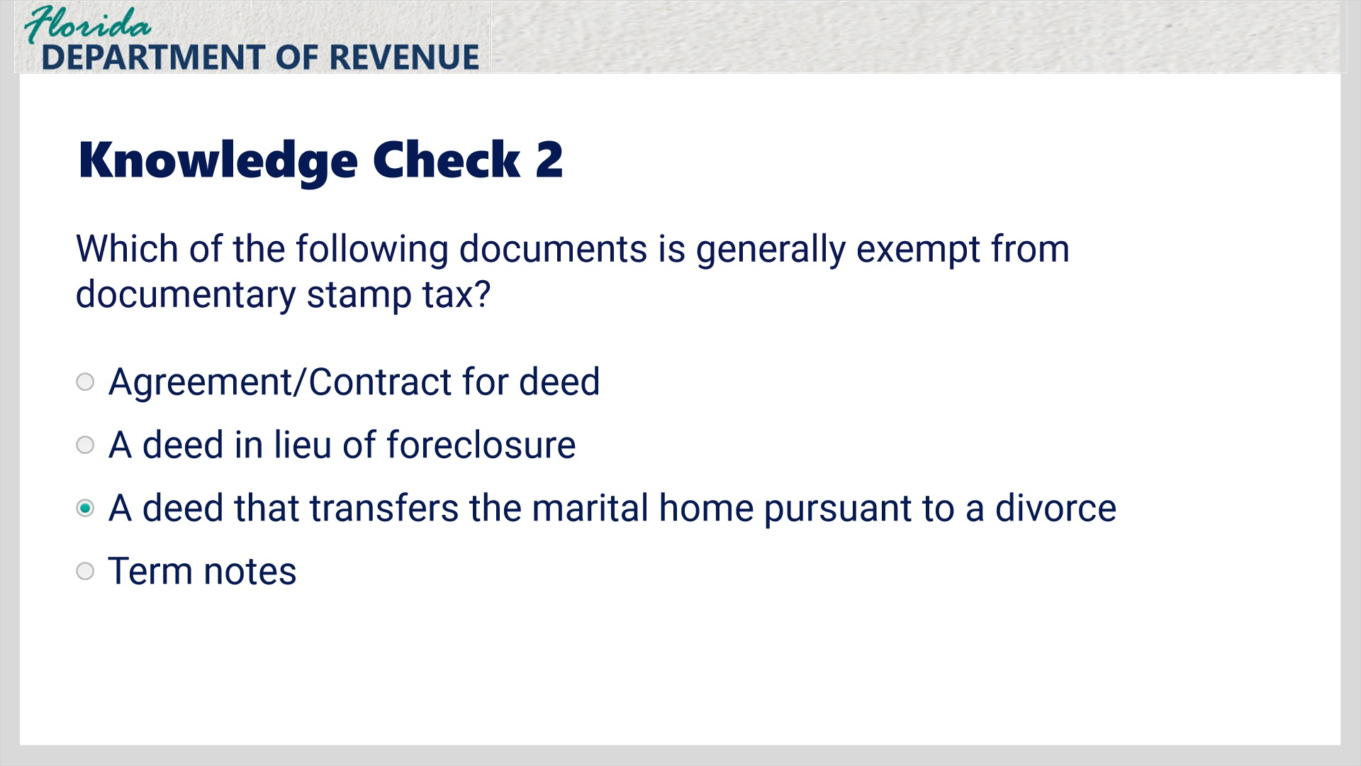
Transcript:
Which of the following documents is generally exempt from documentary stamp tax?
Agreement/Contract for deed
A deed in lieu of foreclosure
A deed that transfers the marital home pursuant to a divorce
Term notes

Correct (Slide Layer)
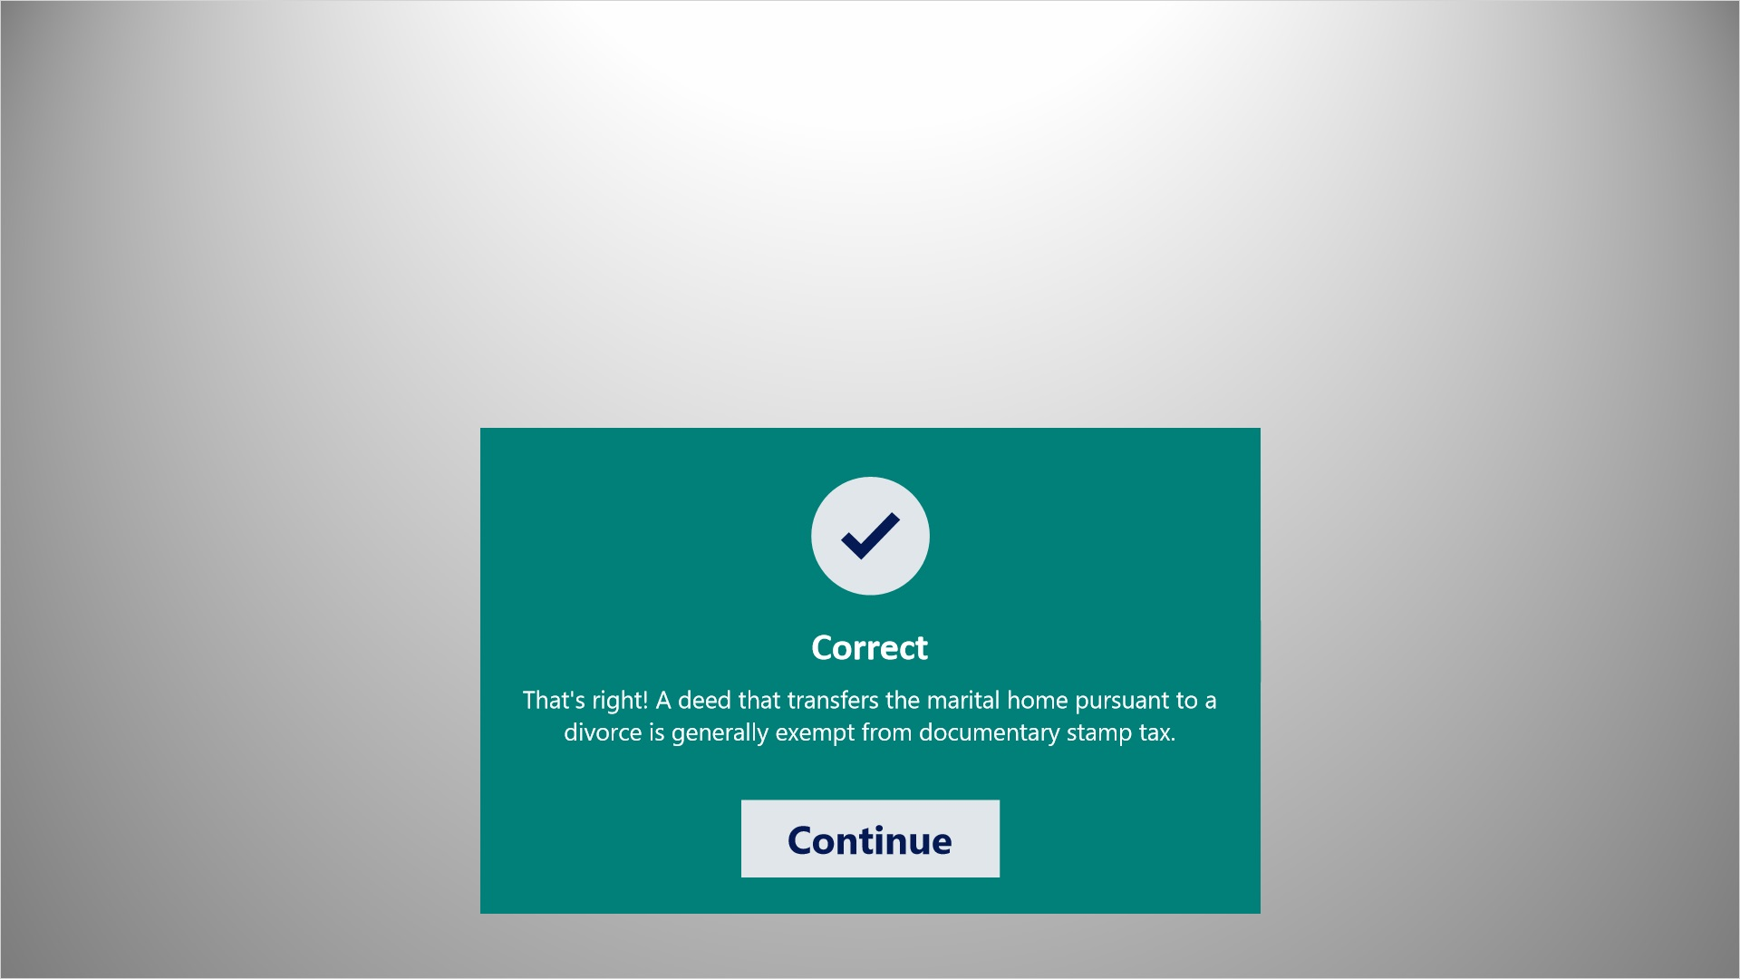
Transcript:
That’s right! A deed that transfers the marital home pursuant to a divorce is generally exempt from documentary stamp tax.

Incorrect (Slide Layer)
Transcript:
You did not select the correct response.

Try Again (Slide Layer)
Transcript:
That is incorrect. Please try again.

1.20 Tax Calculation Example
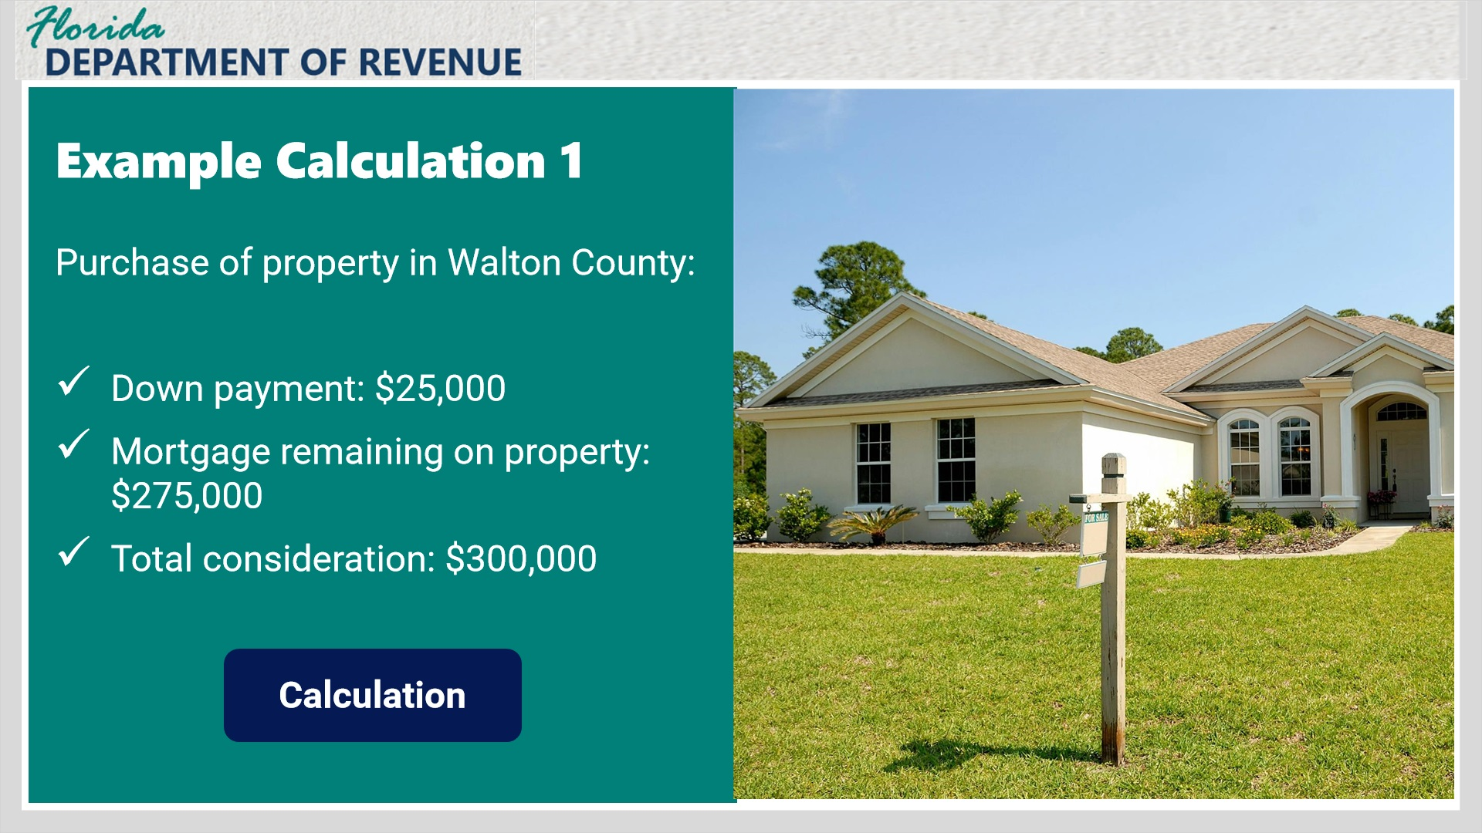
Transcript:
Now let’s cover a few sample calculations:
James purchases property located in Walton County from Debra. James gives Debra $25,000 as a down payment, and Debra takes back a note and mortgage from James in the amount of $275,000. Since there is no other consideration for the transfer, the tax is calculated on $300,000 (the $25,000 paid and the $275,000 to be paid).
Click the Calculation button to see the tax calculation.

Example 1 Calculation Layer (Slide Layer)
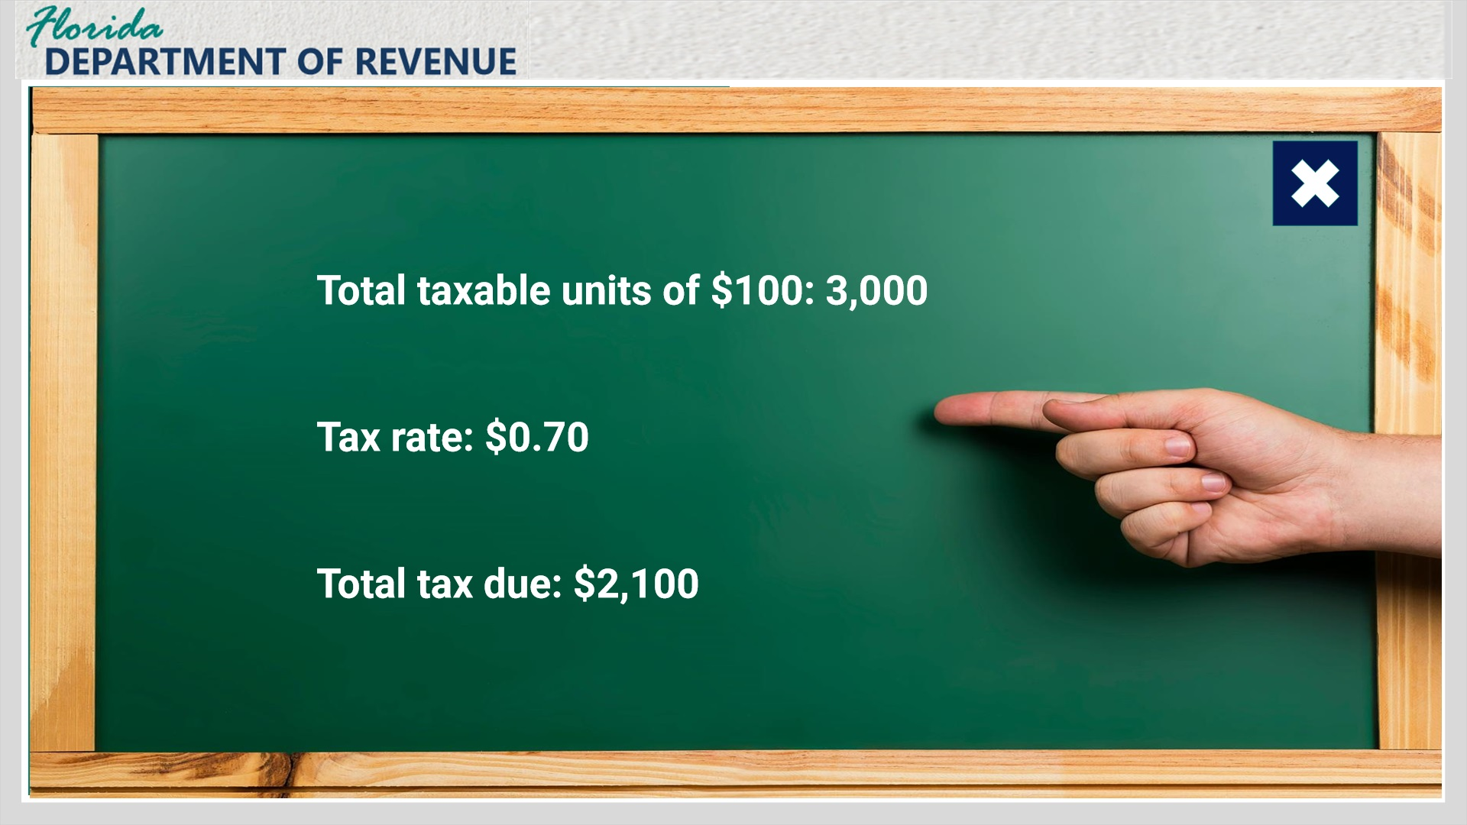
Transcript:
Tax calculation: 3,000 (the number of taxable units representing each $100 or portion thereof of the consideration of $300,000) x the tax rate of $0.70 = $2,100 tax due.

1.21 Tax Calculation Example 2
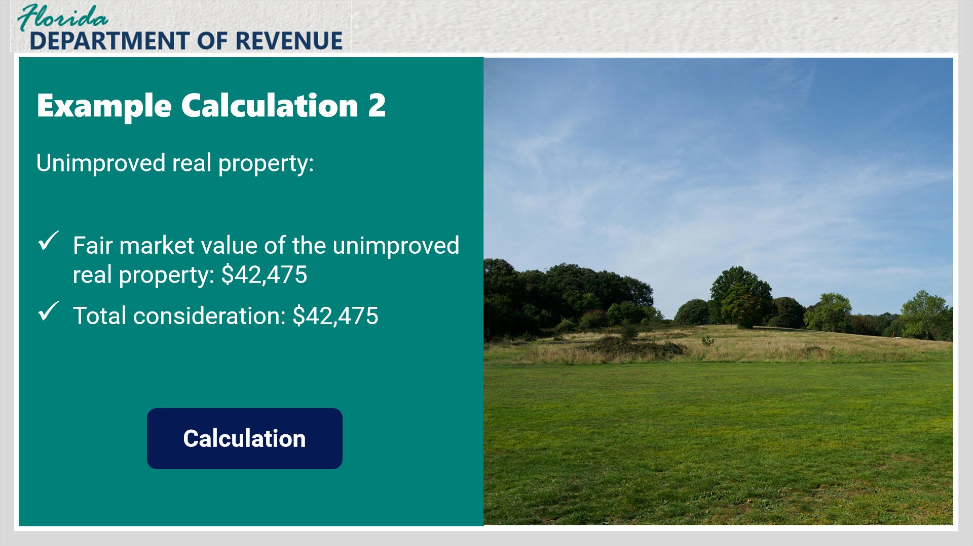
Transcript:
Raymond exchanges his unimproved real property located in Osceola County with Mark for an all-terrain vehicle and a personal watercraft. The fair market value of Raymond’s property is $42,475. The consideration for the transfer is $42,475. Since property was exchanged for consideration other than money, it is presumed that the consideration for the transfer is the fair market value of the property.
Click the Calculation button to see the tax calculation.

Example 2 Calculation Layer (Slide Layer)
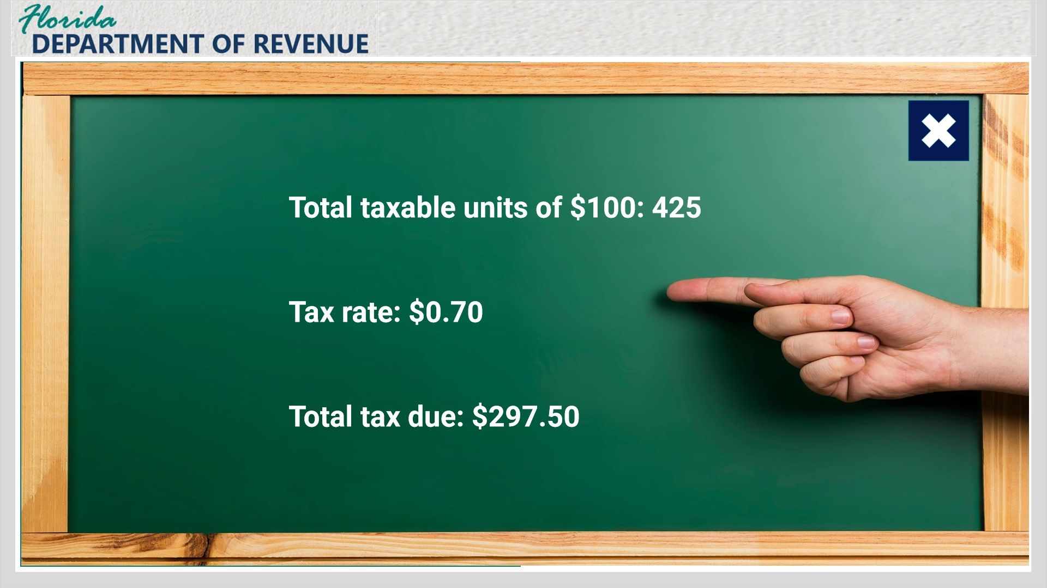
Transcript:
Tax calculation: 425 (the number of taxable units representing each $100 or portion thereof of the consideration of $42,475) x the tax rate of $0.70 = $297.50 tax due.

1.22 Tax Calculation Example 3
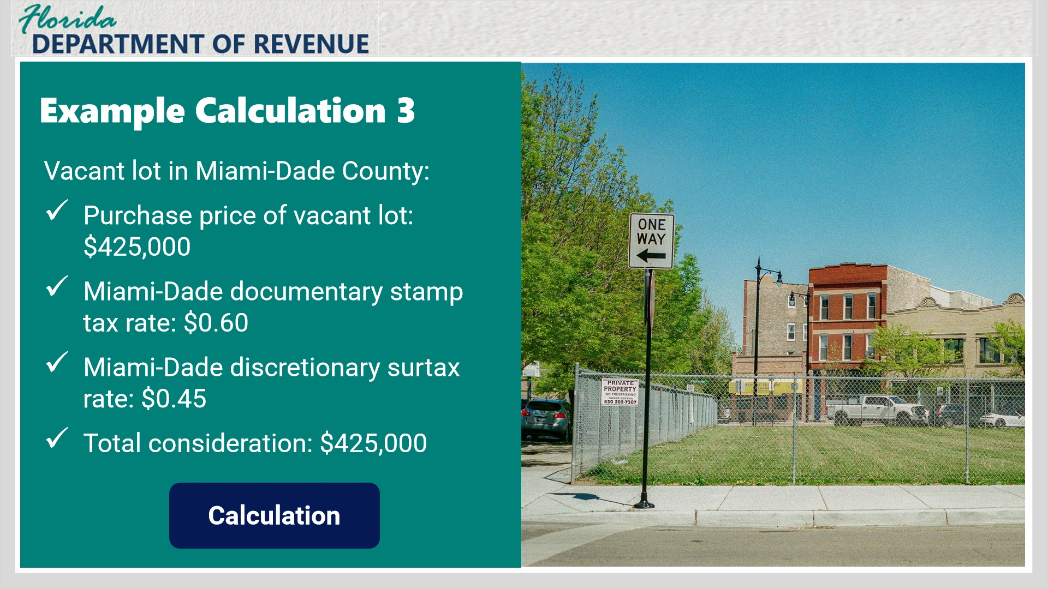
Transcript:
Charles purchases a vacant lot in Miami-Dade County for $425,000. In addition to the $0.60 per $100 documentary stamp tax, Miami-Dade County also imposes a $0.45 per $100 discretionary surtax. Since there is no other consideration for the transfer, the tax is calculated on $425,000.
Click the Calculation button to see the tax calculation.

Example 3 Calculation Layer (Slide Layer)
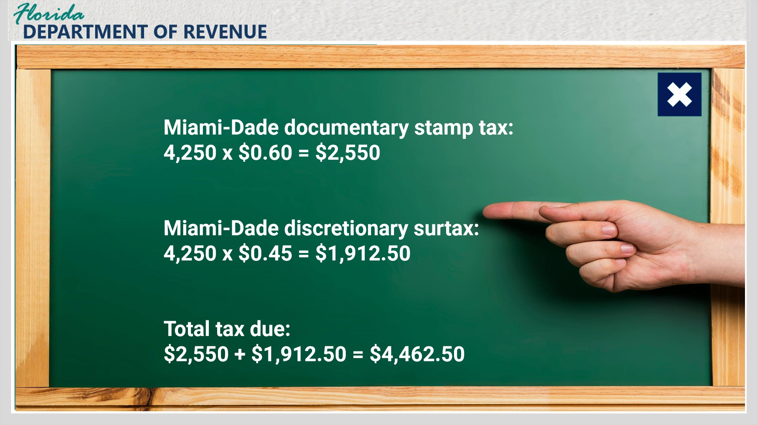
Transcript:
Tax calculation: 4,250 (the number of taxable units representing each $100 or portion thereof of the consideration of $425,000) x the Miami-Dade tax rate of $0.60 = $2,550 documentary stamp tax due, and 4,250 (the number of taxable units representing each $100 or portion thereof of the consideration of $425,000) x the Miami-Dade surtax rate of $0.45 = $1,912.50 discretionary surtax due. The total tax due is $4,462.50. There is no exemption from the discretionary surtax since the deed did not transfer a single-family residence.

1.23 Registration Requirements
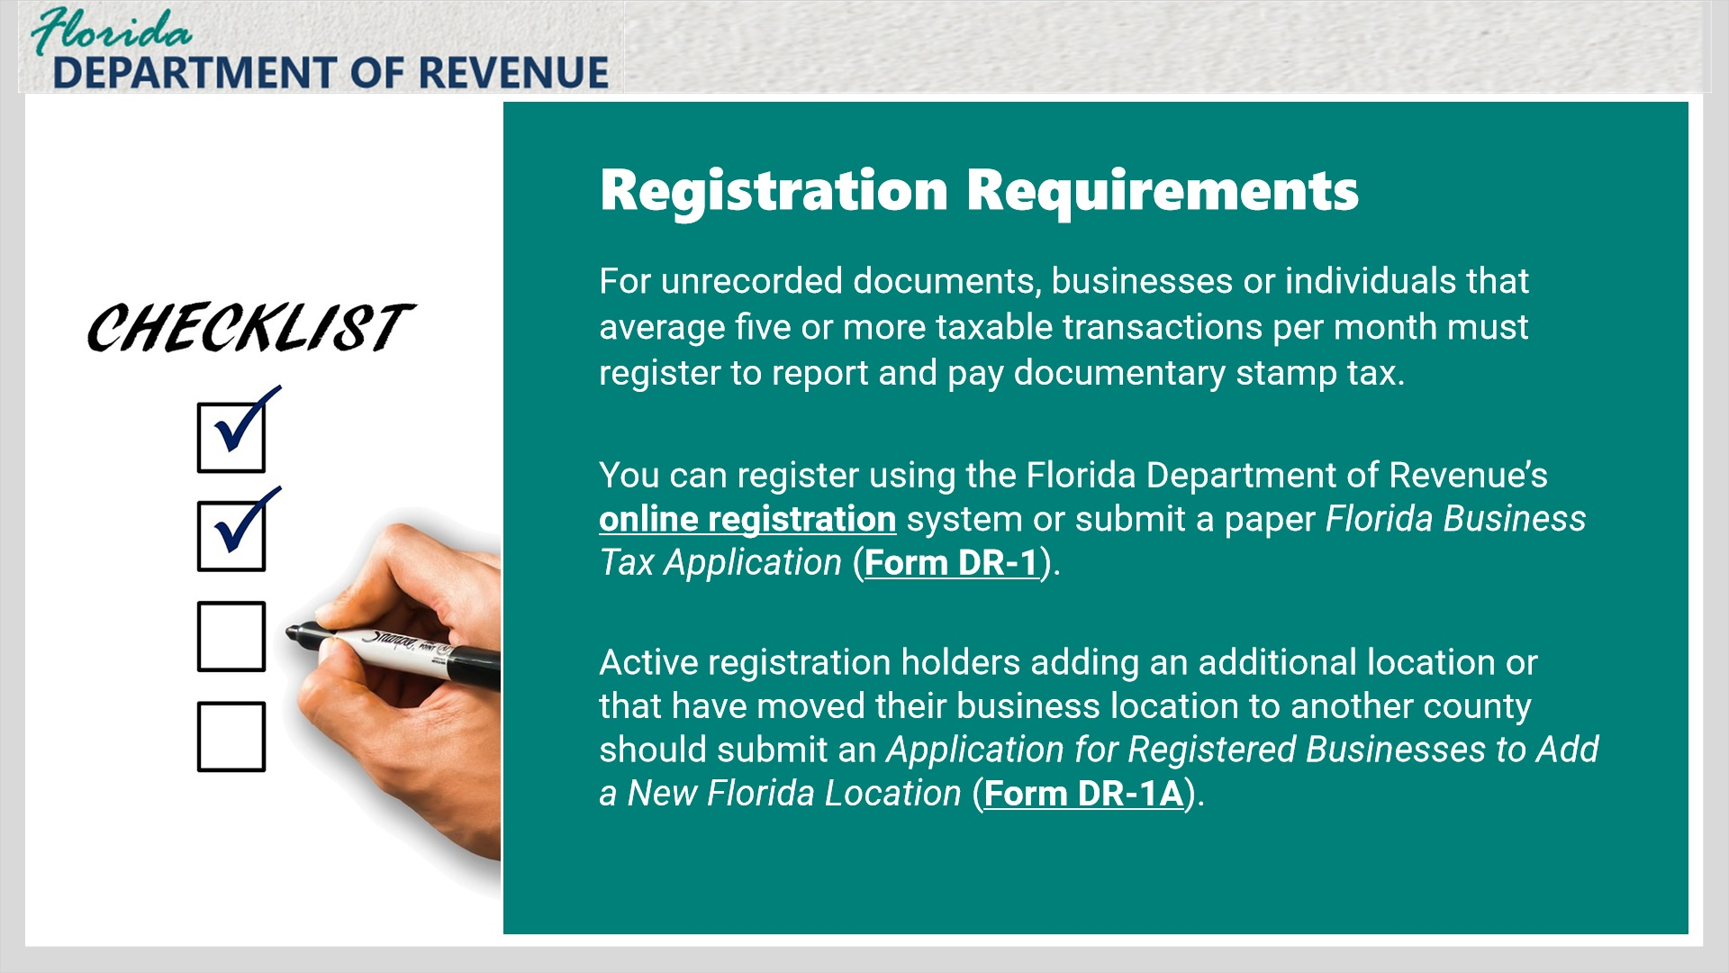
Transcript:
For unrecorded documents, businesses or individuals that average five or more taxable transactions per month must register to report and pay documentary stamp tax. You can register using the Florida Department of Revenue’s online registration system or submit a paper Florida Business Tax Application (Form DR-1).
If you hold an active certificate of registration or reemployment tax account issued by the Department because you previously submitted a Florida Business Tax Application, use the Application for Registered Businesses to Add a New Florida Location (Form DR-1A) to register an additional business location or Florida rental property, or a registered location that has moved from one Florida county to another.

1.24 How to Remit Documentary Stamp Tax
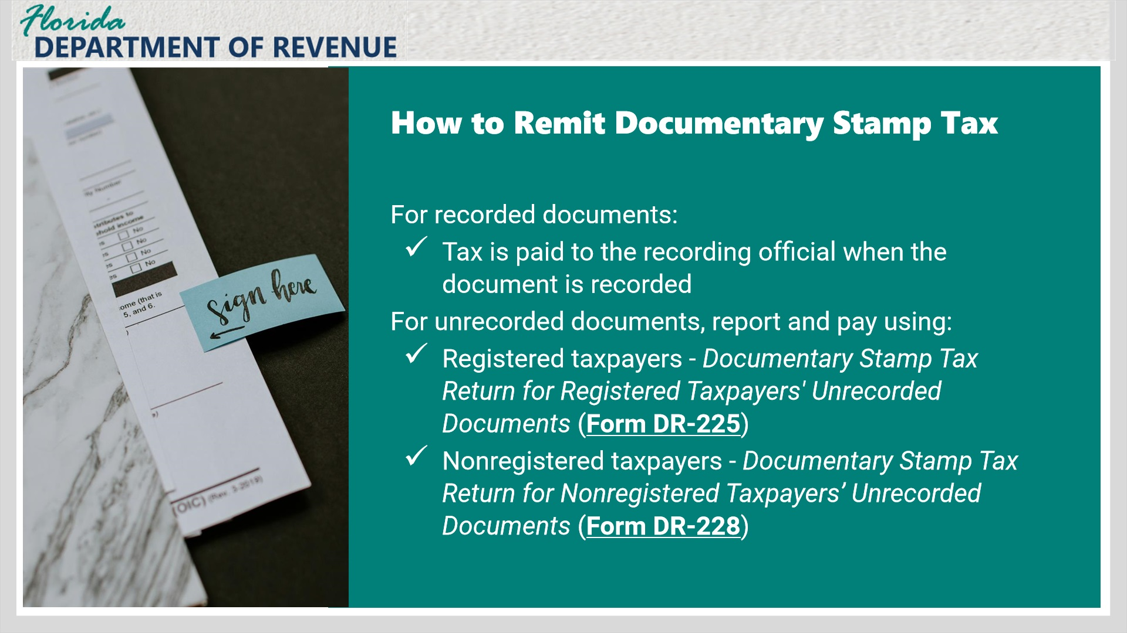
Transcript:
In most circumstances, documentary stamp tax will be remitted to the recording official in the county where the document is recorded at the time of recording.
However, if that is not the case, it is your responsibility to remit the tax for unrecorded documents directly to the Florida Department of Revenue.
To remit the taxes, registered taxpayers should use the Documentary Stamp Tax Return for Registered Taxpayers’ Unrecorded Documents (Form DR-225).
If you are a nonregistered taxpayer, you will use the Documentary Stamp Tax Return for Nonregistered Taxpayers’ Unrecorded Documents (Form DR-228).

1.25 File and Pay
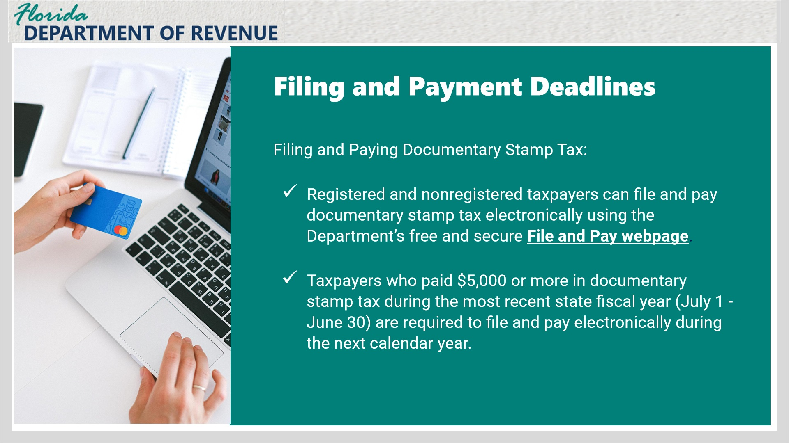
Transcript:
You may use the Department’s free and secure file and pay system to remit unrecorded documentary stamp taxes electronically, whether you are a registered taxpayer or nonregistered taxpayer. Taxpayers who paid $5,000 or more in documentary stamp tax during the most recent state fiscal year (July 1 - June 30) are required to file and pay electronically during the next calendar year.

1.26 File and Pay Deadlines
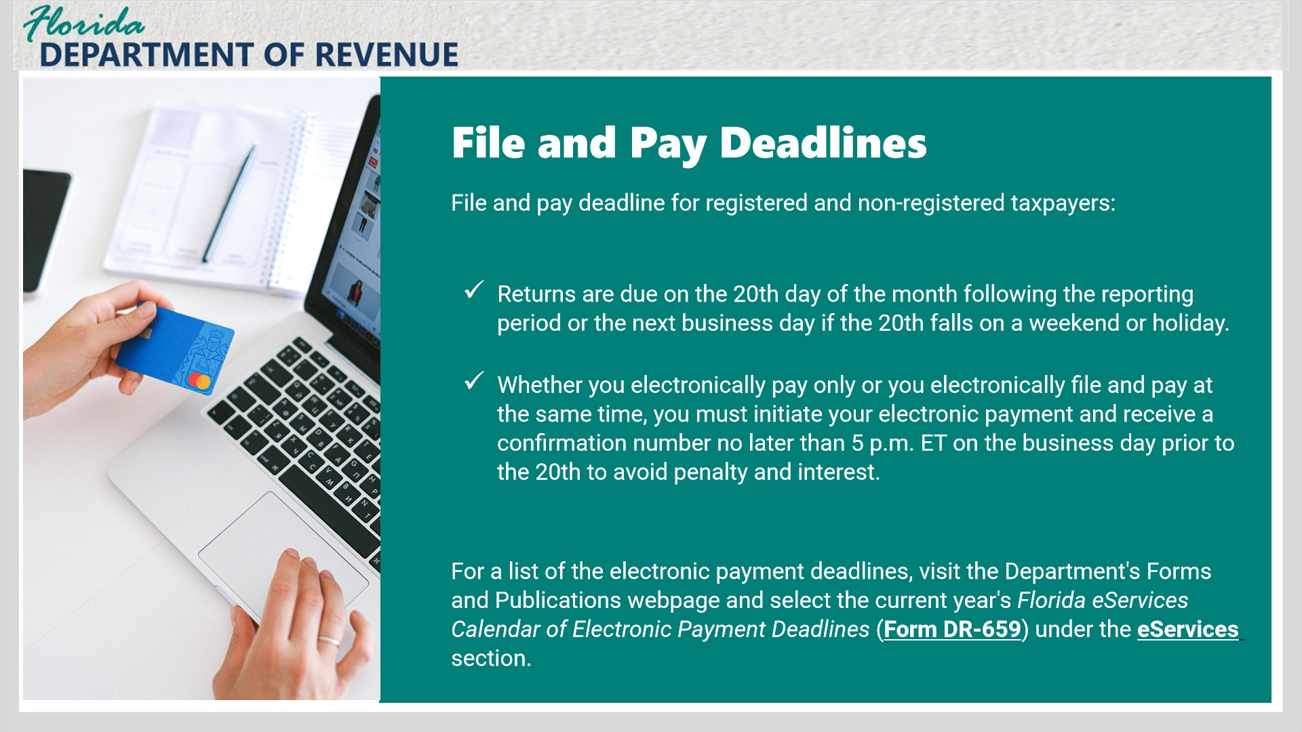
Transcript:
For both registered and nonregistered taxpayers, returns are due on the 20th day of the month following each reporting period. If the 20th falls on a Saturday, Sunday, or state or federal holiday, returns are timely if filed electronically, postmarked, or hand-delivered to the Department on the first business day following the 20th. As a reminder, registered taxpayers must file a return for each reporting period, even if no tax is due.
Whether you electronically pay only or you electronically file and pay at the same time, you must initiate your electronic payment and receive a confirmation number no later than 5 p.m. ET on the business day prior to the 20th to avoid penalty and interest.
For a list of the electronic payment deadlines, visit the Department's Forms and Publications webpage and select the current year's Florida eServices Calendar of Electronic Payment Deadlines (Form DR-659) under the eServices section.

1.27 Taxpayer Education Page and Social Media
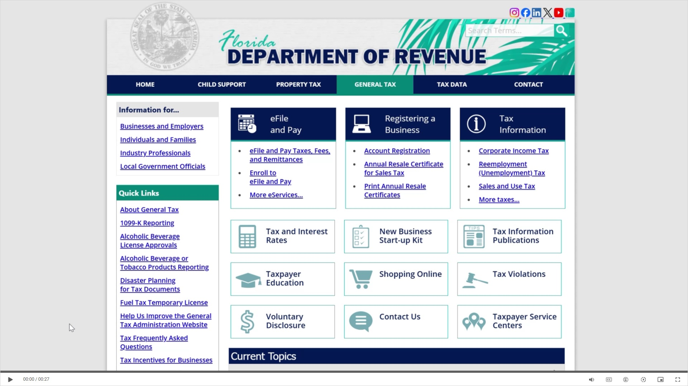
Transcript:
Visit floridarevenue.com/taxes for business resources such as forms, publications, and information on all tax types. Check out our Taxpayer Education webpage for new business guides, tutorials, and other helpful tools. And follow us on YouTube, Facebook, X, Instagram, and LinkedIn using the icons at the top of our website to stay up to date on tax topics, alerts, and more.

1.28 Conclusion/Survey
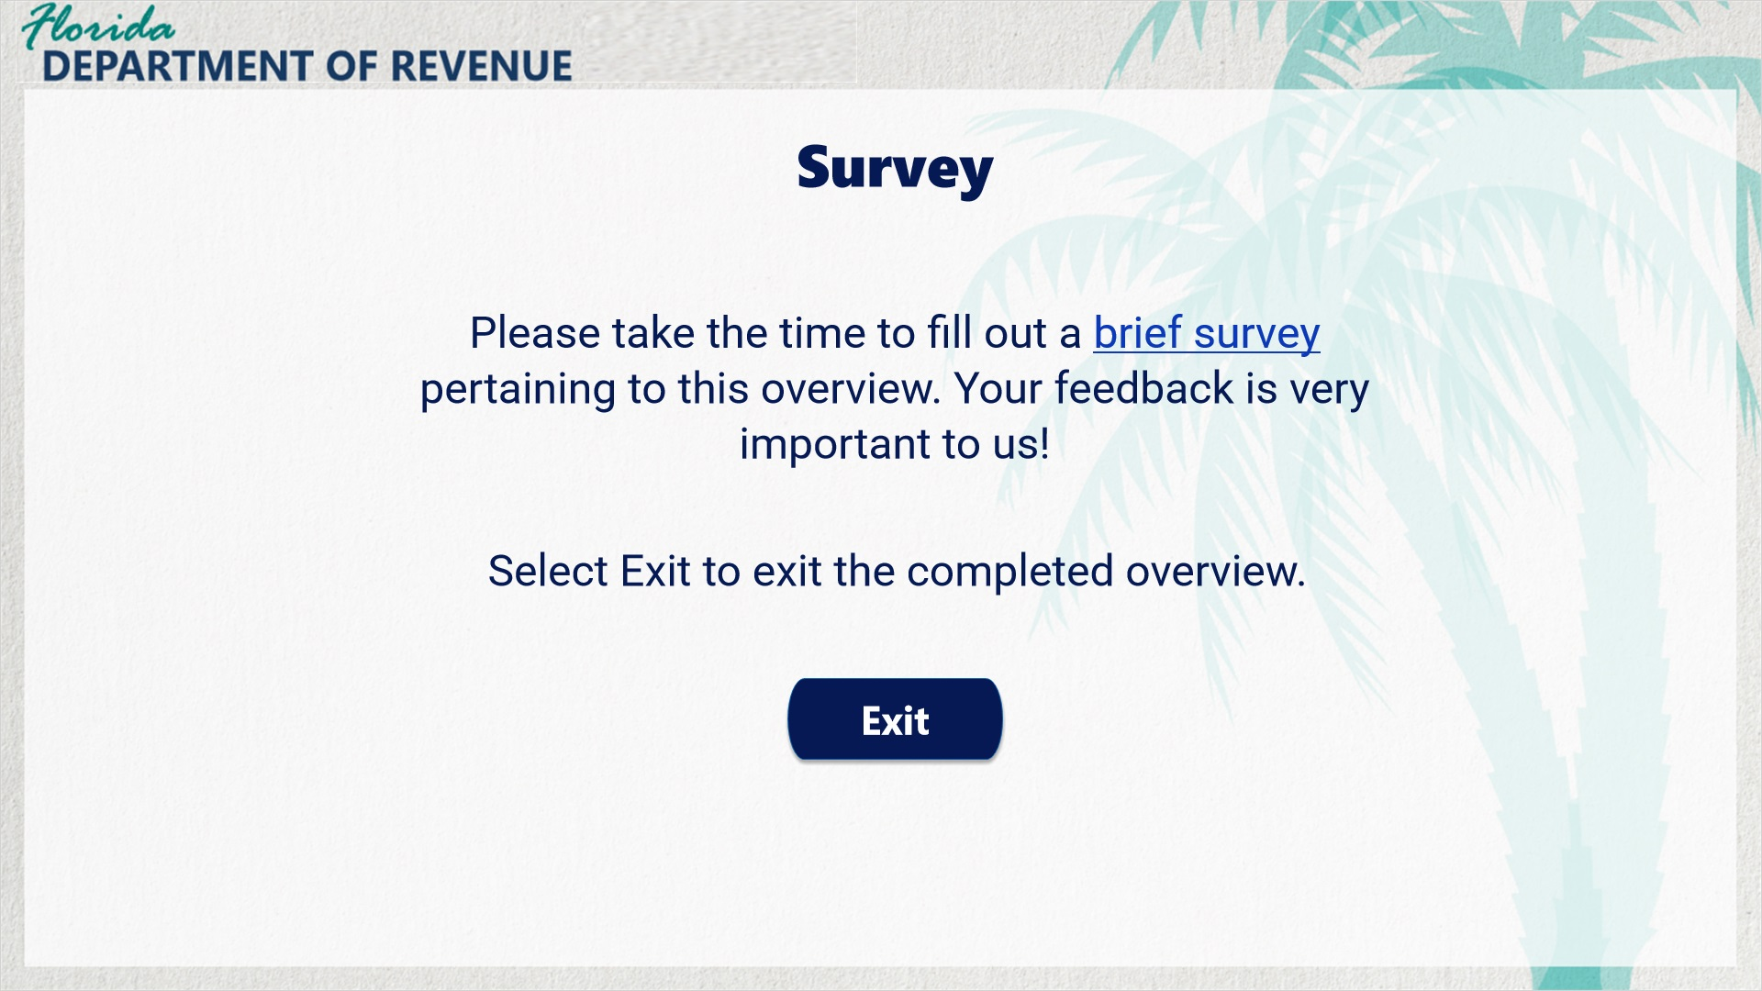
Transcript:
This concludes the Documentary Stamp Tax overview.
For more information, check out the resources available within this overview by clicking on the Resources tab in the upper-right corner of your screen.
In addition, there are several helpful guides and tutorials available on a variety of tax-related topics on the Department’s website at floridarevenue.com.
Please take the time to fill out a brief survey pertaining to this overview. Your feedback is very important to us.
To exit this tutorial, click on the Exit button.
To print a copy of this tutorial, select the Print PDF button.
Thank you.

