Discretionary Sales Surtax: The Basics

1. Introduction

1.1 Introduction
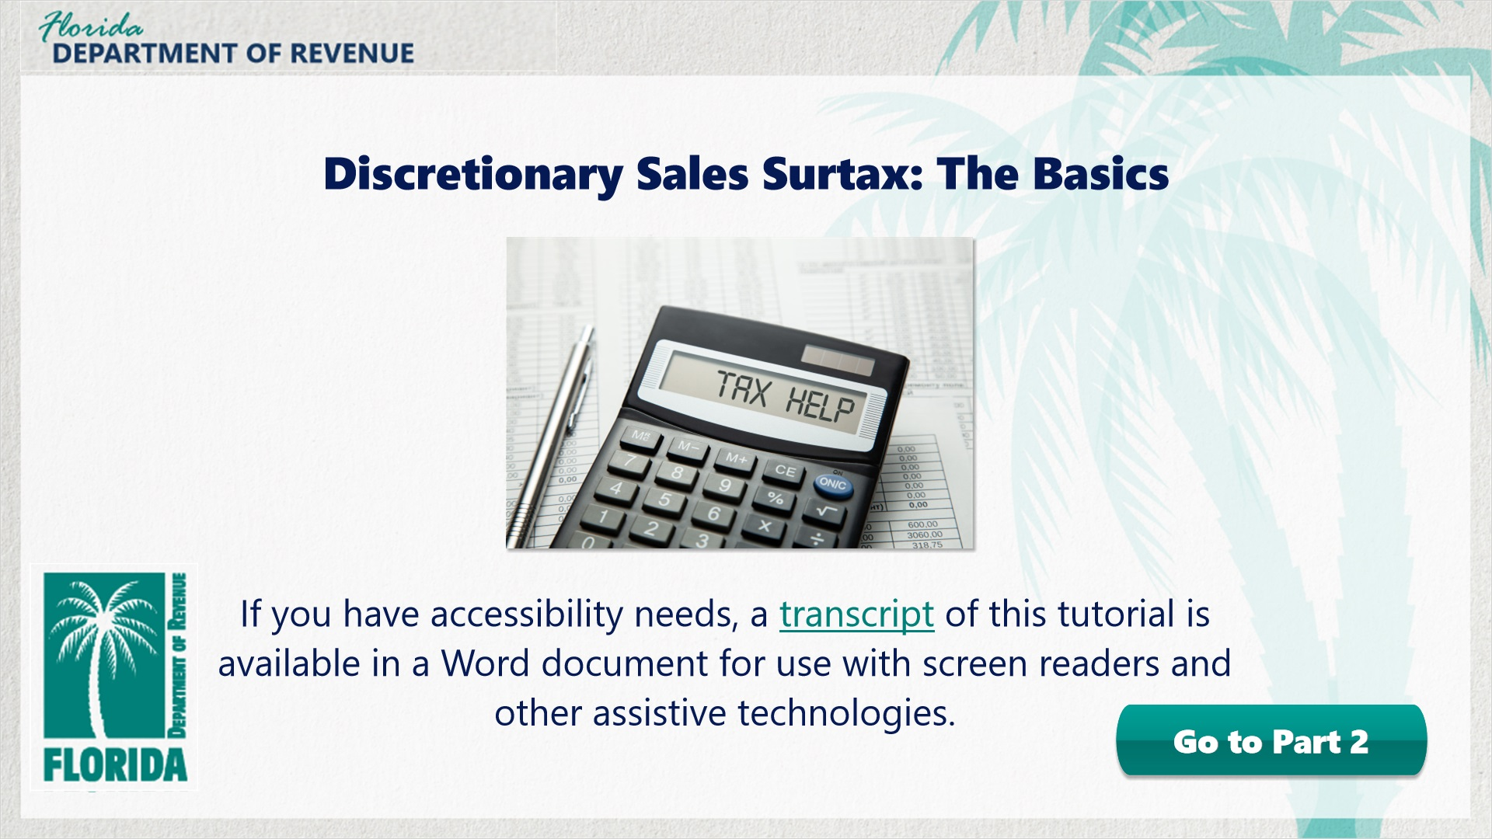
Transcript:
Welcome to Discretionary Sales Surtax: The Basics. This is the first of a two-part series on discretionary sales surtax. In this tutorial, we will focus on the basics of discretionary sales surtax and how it applies to tangible personal property.
If you are looking for information about calculating and reporting discretionary sales surtax, you can choose to skip this tutorial and move on to Part 2 by clicking on the button labeled Go to Part 2.
If you have accessibility needs, a transcript of the audio is available in a Word document for use with screen readers and other assistive technologies.

1.2 Navigating This Tutorial
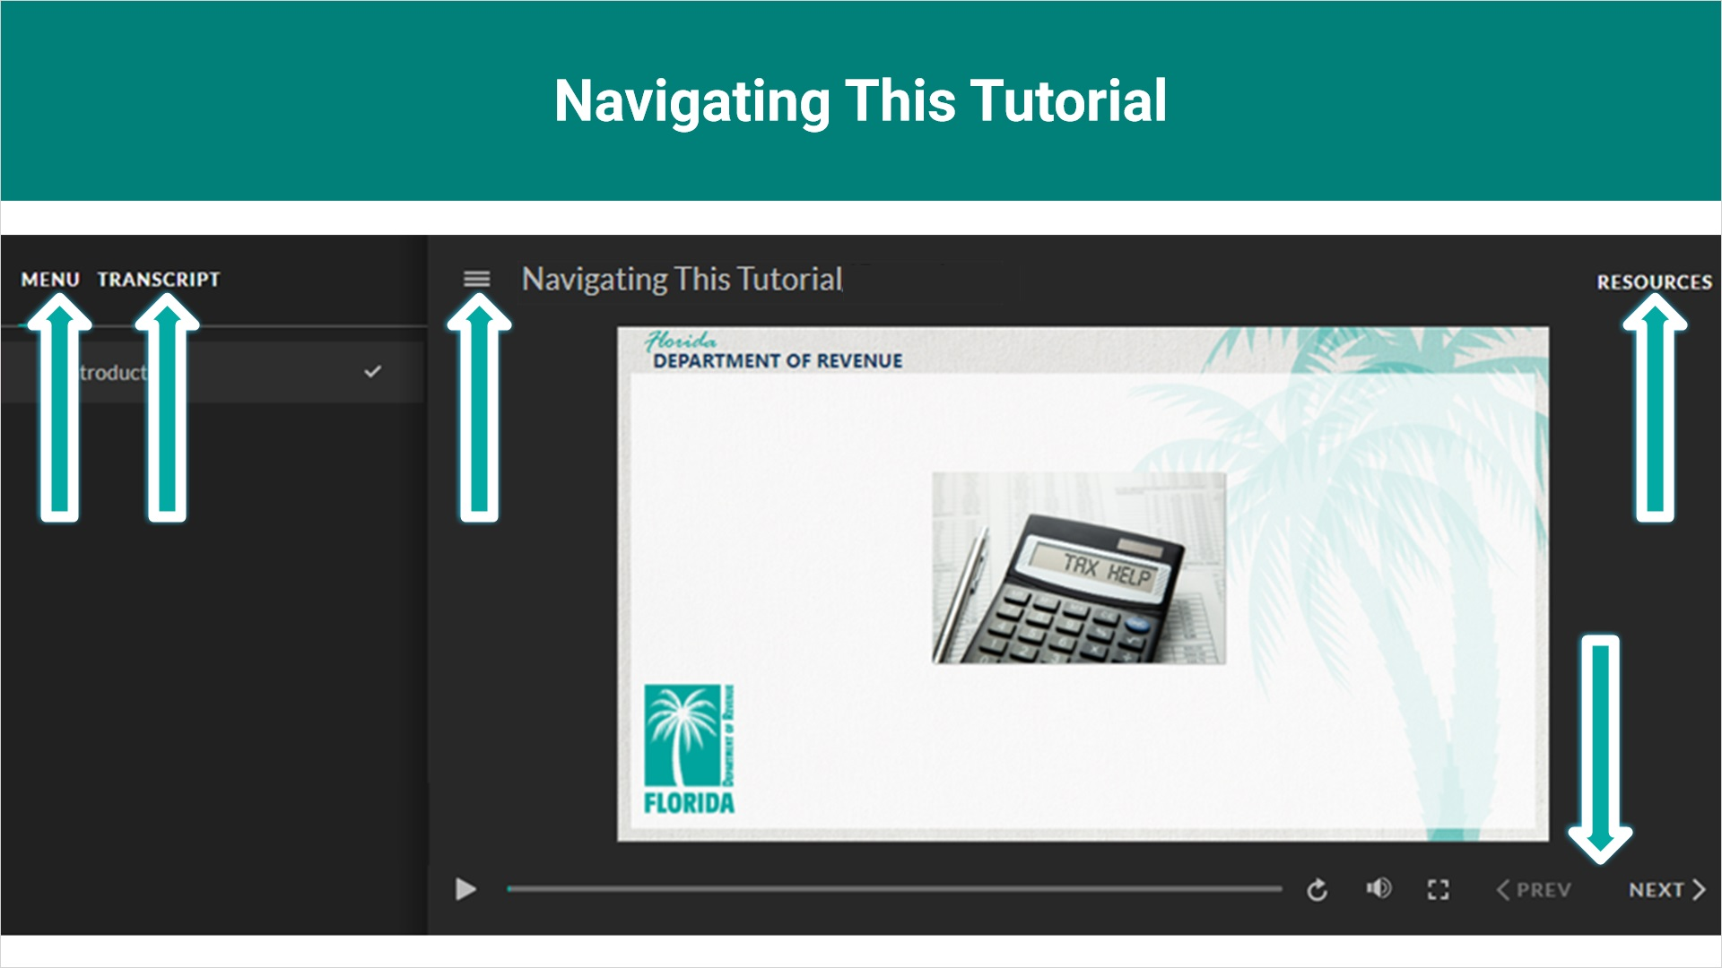
Transcript:
This tutorial will take approximately 20 minutes to complete. A transcript of the audio is available by clicking on the transcript tab in the top-left corner of your screen. The following tabs and buttons are available to help you navigate throughout this tutorial.
Menu Tab
The menu tab displays by default when the tutorial is viewed on a computer. It allows you to navigate through the tutorial by clicking on the topic name in the menu. When viewing this tutorial on a tablet or smartphone, the menu does not display by default and must be accessed using the menu symbol.
Resources Tab
The resources tab is found on the right side of the top bar. When clicked, it displays the list of links to useful forms, documents, and webpages.
Previous and Next Buttons
The previous and next buttons are located at the bottom-right corner of your screen. These buttons allow you to move either back or forward.

1.3 Topics
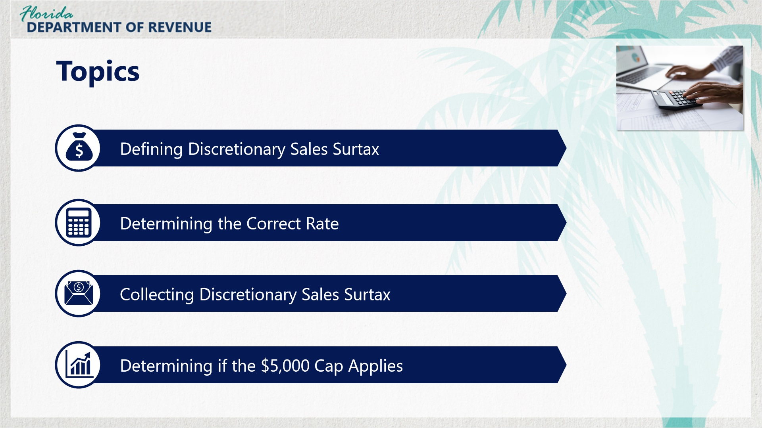
Transcript:
Topics for this tutorial include defining discretionary sales surtax, determining the correct rate, collecting discretionary sales surtax, and determining if the $5,000 cap applies.

1.4 Assessment Information
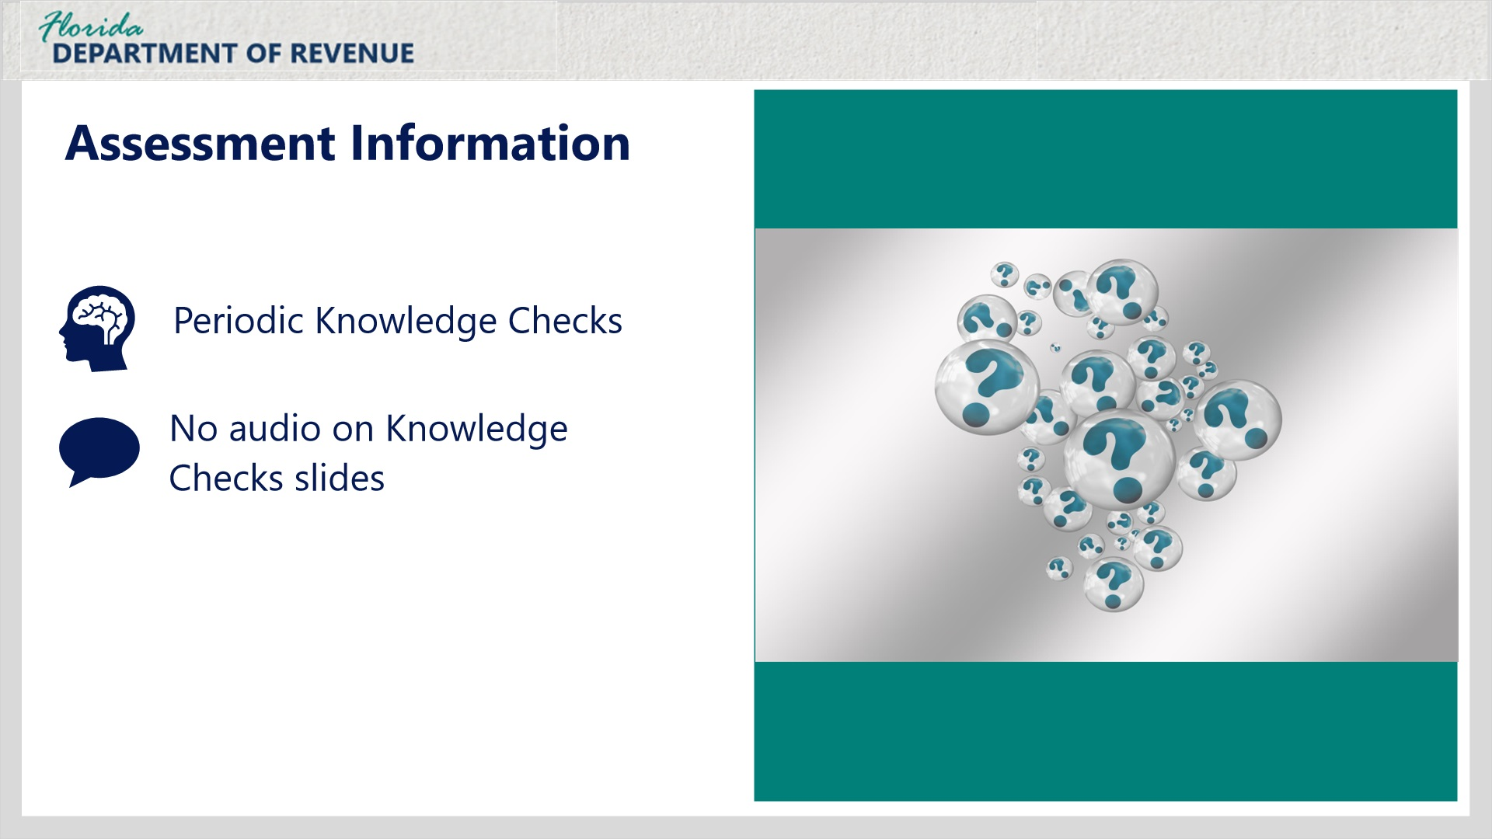
Transcript:
There will be periodic Knowledge Checks throughout this tutorial for you to practice what you’re learning. Keep in mind that there is no audio for Knowledge Checks slides.

2. What is Discretionary Sales Surtax?

2.1 Meet Janet
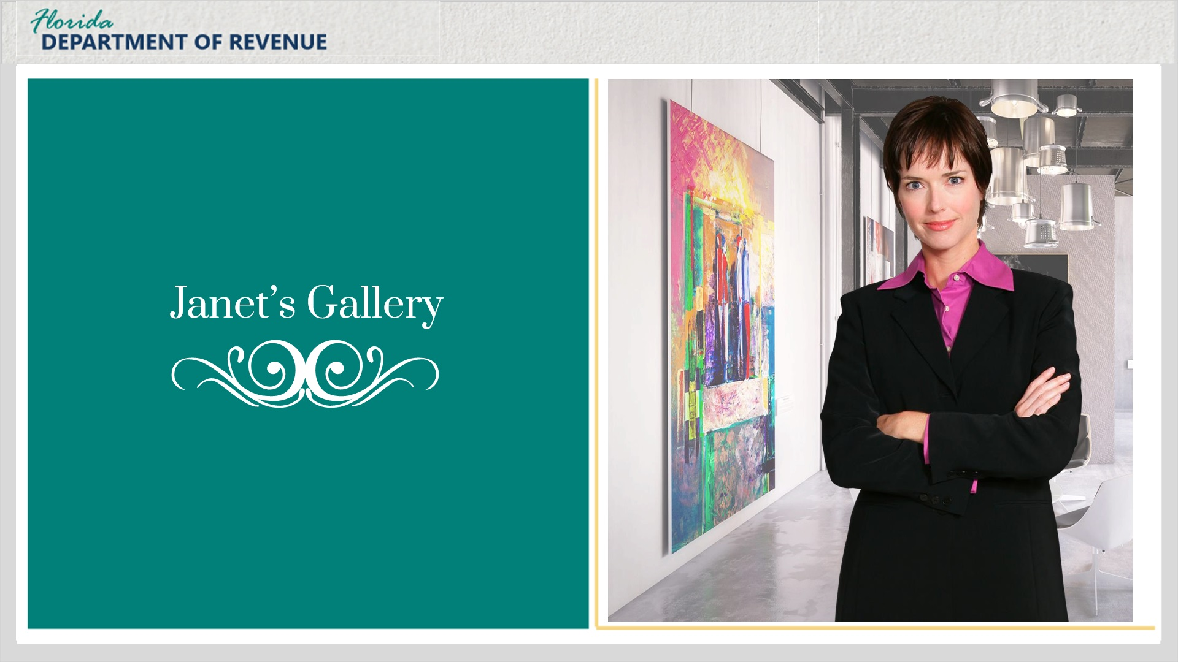
Transcript:
Let’s begin by getting to know Janet, an artist who sells her artwork and the art of other artists. She is the owner of Janet’s Gallery, a high-end art gallery and boutique. Most pieces in her gallery are priced in the thousands of dollars. Janet’s Gallery will deliver the art to customers anywhere in Florida free of charge.
Hi, Janet.
[Janet]: Hello. What brings you in today?
I heard you needed some assistance with discretionary sales surtax.
[Janet]: Oh yes! You came at the perfect time. I am getting ready to complete and submit my sales and use tax return. However, figuring out how to charge discretionary sales surtax has been confusing. Would you mind helping me with that?
I’d be happy to!

2.2 What is Discretionary Sales Surtax?
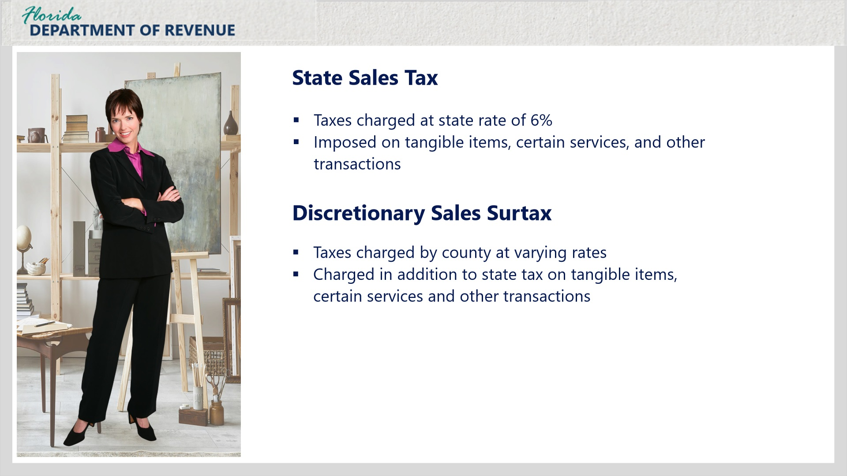
Transcript:
We’ll start by defining what discretionary sales surtax is and how it is used.
As you know, Florida imposes a state sales tax on sales of tangible items, certain services, transient accommodations, and other transactions.
Florida counties can impose an additional sales tax on the same transactions. This additional local tax is formally known as discretionary sales surtax, but you may also hear it referred to as local option sales tax, or just surtax.
Surtax is levied by counties and enacted by ordinance or resolution. Selling dealers are required to collect Florida state sales and use tax and any applicable surtax from the purchaser and remit the taxes to the Florida Department of Revenue. The Department then distributes the surtax as directed by Florida law.

2.2 What is Discretionary Sales Surtax?
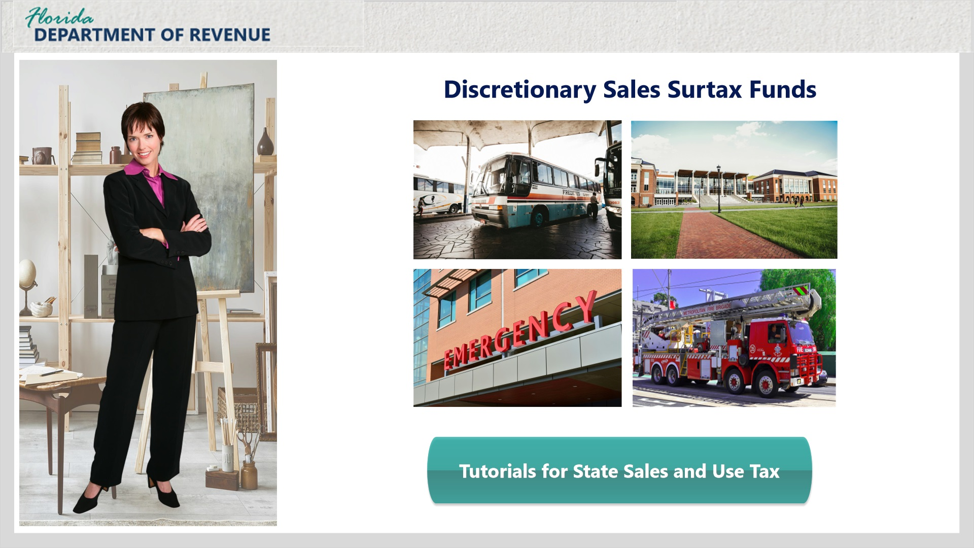
Transcript:
For more information on Florida state sales and use tax and rates, visit the Department’s tutorials on state sales and use tax by clicking the Tutorials for State Sales and Use Tax button on your screen. Then search under the tab labeled “Tutorials - Tax and Fee Overviews.”
[Janet]: How is this money being used?
Surtax proceeds are used by local governments to pay for locally authorized projects such as transportation systems, school construction, healthcare, and emergency fire and rescue services and facilities.

2.3 Knowledge Check
(Multiple Response, 10 points, 2 attempts permitted)
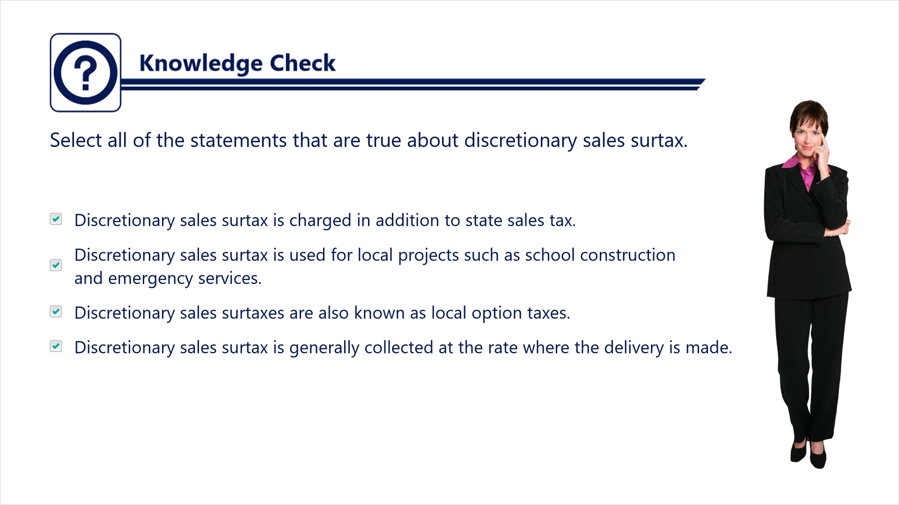
Transcript:
Question: Select all of the statements that are true about discretionary sales surtax.
Answers:
- Discretionary sales surtax is charged in addition to state sales tax.
- Discretionary sales surtax is used for local projects such as school construction and emergency services.
- Discretionary sales surtaxes are also known as local option taxes.
- Discretionary sales surtax is generally collected at the rate where the delivery is made.
Correct answer: All of these statements are true about discretionary sales surtax.

3. Determining the Correct Rate

3.1 Discretionary Surtax Rates
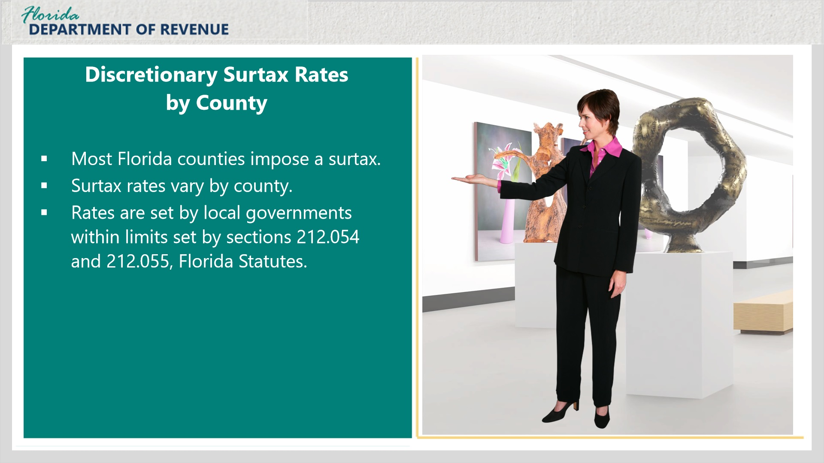
Transcript:
[Janet]: Does every county have a surtax, and if so, what are the rates?
Most, but not all, Florida counties impose a surtax. Surtax rates vary by county. The rate is set by local governments within limits defined by sections 212.054 and 212.055, Florida Statutes.
[Janet]: I deliver my art to customers all over the state. How do I know what surtax rate to charge my customers, and when I am supposed to charge it?
You can find discretionary sales surtax rates for every county listed on the Discretionary Sales Surtax Information for Calendar Year (Form DR-15DSS).
Notice that for many counties, the rate is broken down into separate surtax amounts. Each of these surtaxes for a single county has its own expiration date. The overall discretionary sales surtax rate is determined by adding all of the percentages for the taxes that have not yet expired.
When checking the surtax rate for a county using this guide, it is important to note if any of the surtaxes will be expiring and when.
Keep in mind that Form DR-15DSS is updated with changes annually.

3.1 Discretionary Surtax Rates
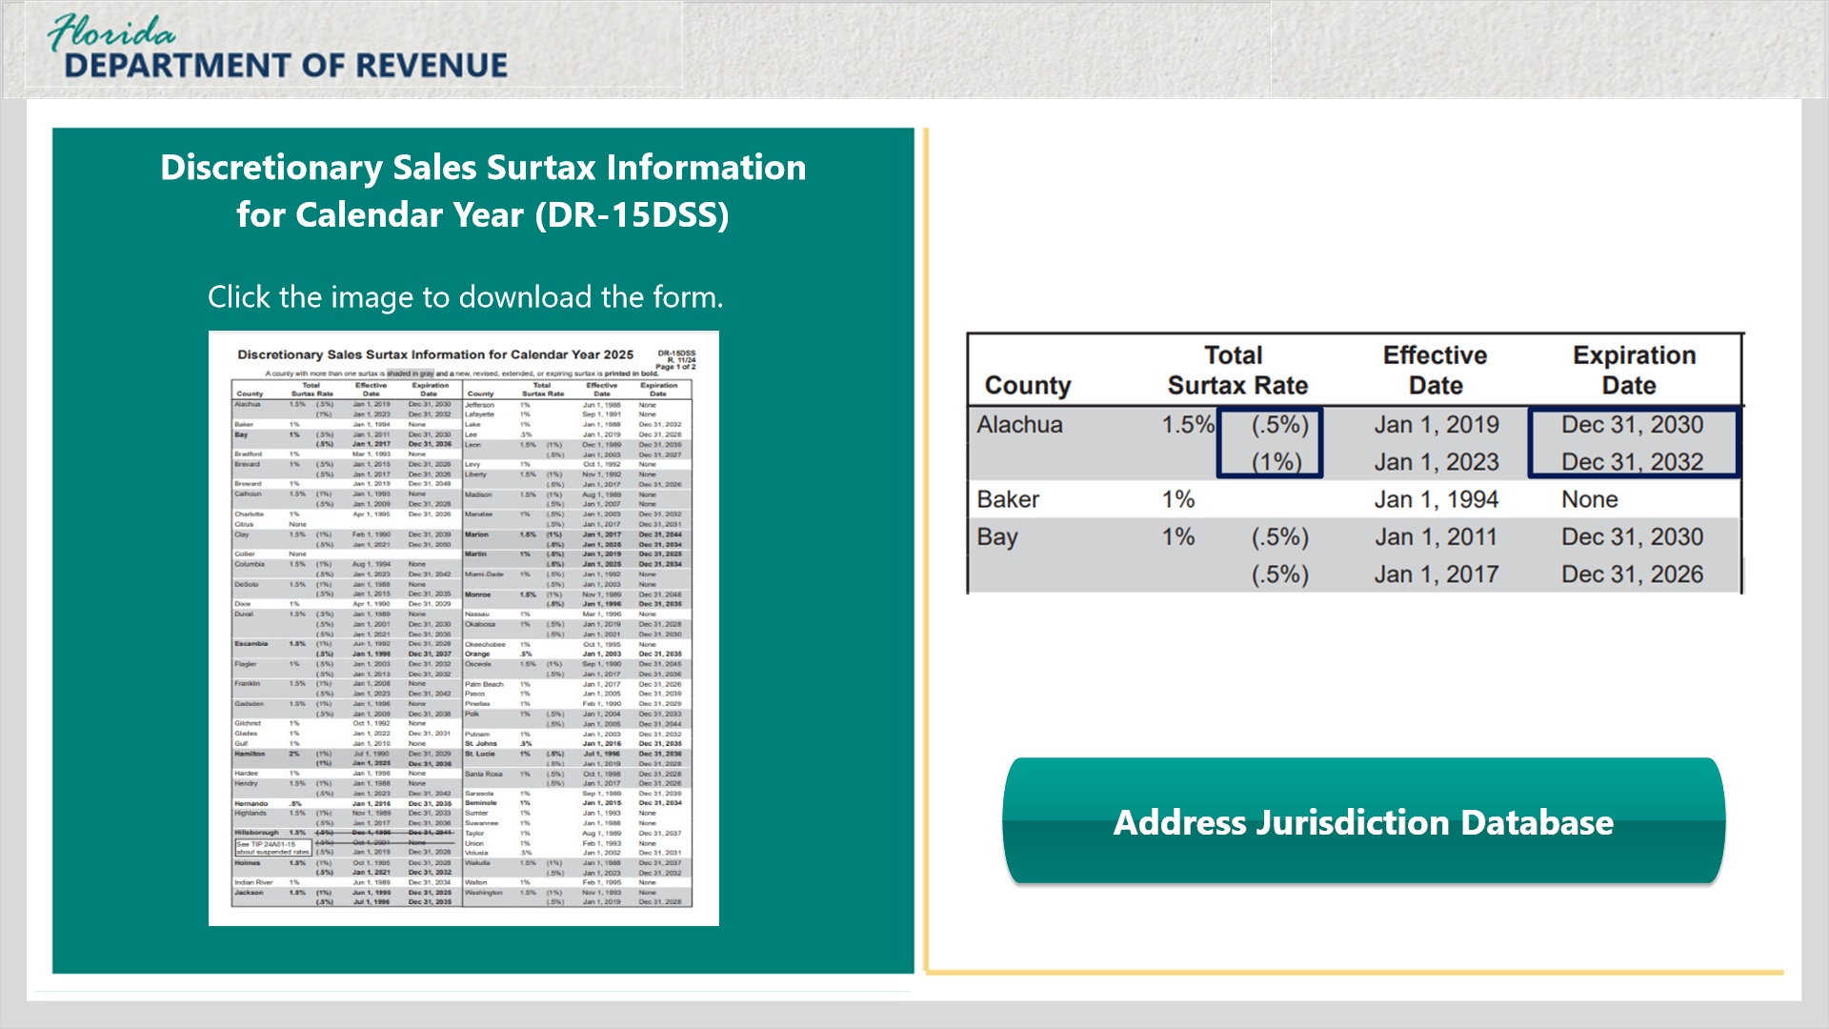
Transcript:
[Janet]: This is very helpful information to have! I would definitely like to see this form. Where can I find it?
You can access it by clicking the image on the left side of the slide. Or you can go to floridarevenue.com/forms and search for it there.
[Janet]: What if I don’t know the county for a specific address?
That’s not a problem. You can use the Department’s Address/Jurisdiction Database to find discretionary sales surtax rates for most addresses in Florida. The database is helpful if you are unsure of the county for a specific address.

3.2 Knowledge Check
(Multiple Choice, 10 points, 2 attempts permitted)
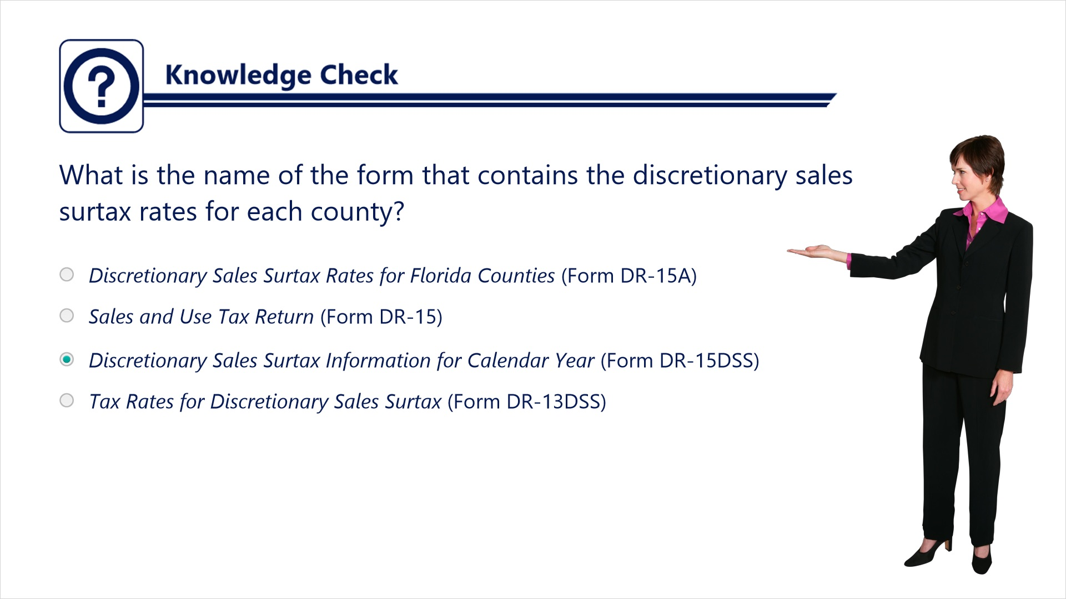
Transcript:
Question: What is the name of the form that contains the discretionary sales surtax rates for each county?
Answers:
- Discretionary Sales Surtax Rates for Florida Counties (Form DR-15A)
- Sales and Use Tax Return (Form DR-15)
- Discretionary Sales Surtax Information for Calendar Year (Form DR-15DSS)
- Tax Rates for Discretionary Sales Surtax (Form DR-13DSS)
Correct answer: The name of the form is Discretionary Sales Surtax for Calendar Year (Form DR-15DSS).

4. Collecting Discretionary Sales Surtax

4.1 Collecting Discretionary Sales Surtax
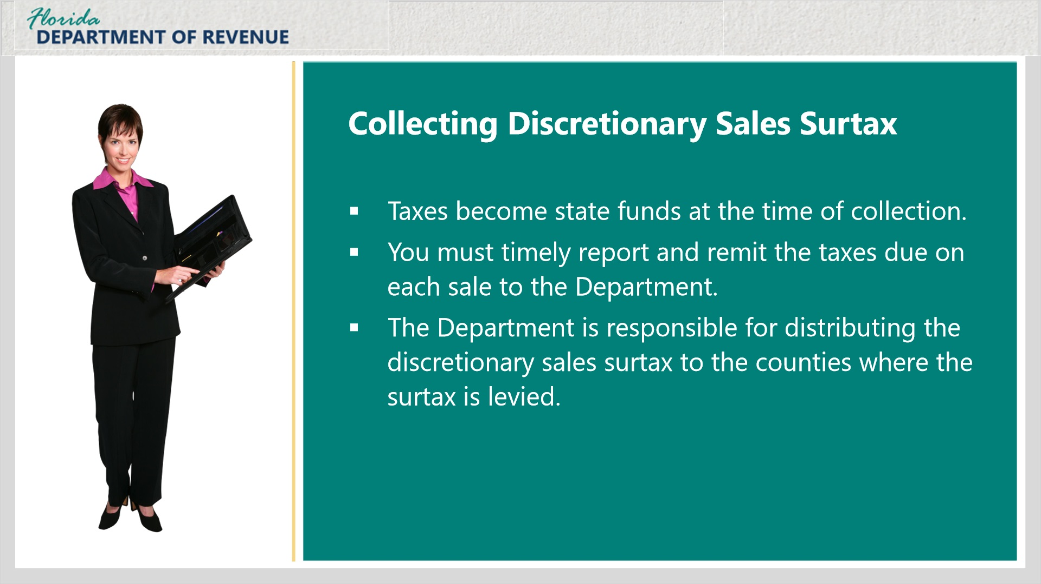
Transcript:
Now that you are more familiar with discretionary sales surtax and how it works, let’s talk about collecting it.
[Janet]: That would be very helpful.
Here are a few things you should know.
Dealers must collect Florida’s state sales tax and any applicable discretionary sales surtax from the purchaser. It is important that you collect the correct amount on each sale or transaction.
Taxes become state funds at the time of collection. Dealers like you serve as a custodian of these funds until they are remitted to the Florida Department of Revenue.
You must timely report and remit taxes due on each sale to the Department. The Department is responsible for distributing the discretionary sales surtax to the counties where the surtax is levied.

4.2 Charging Discretionary Sales Surtax
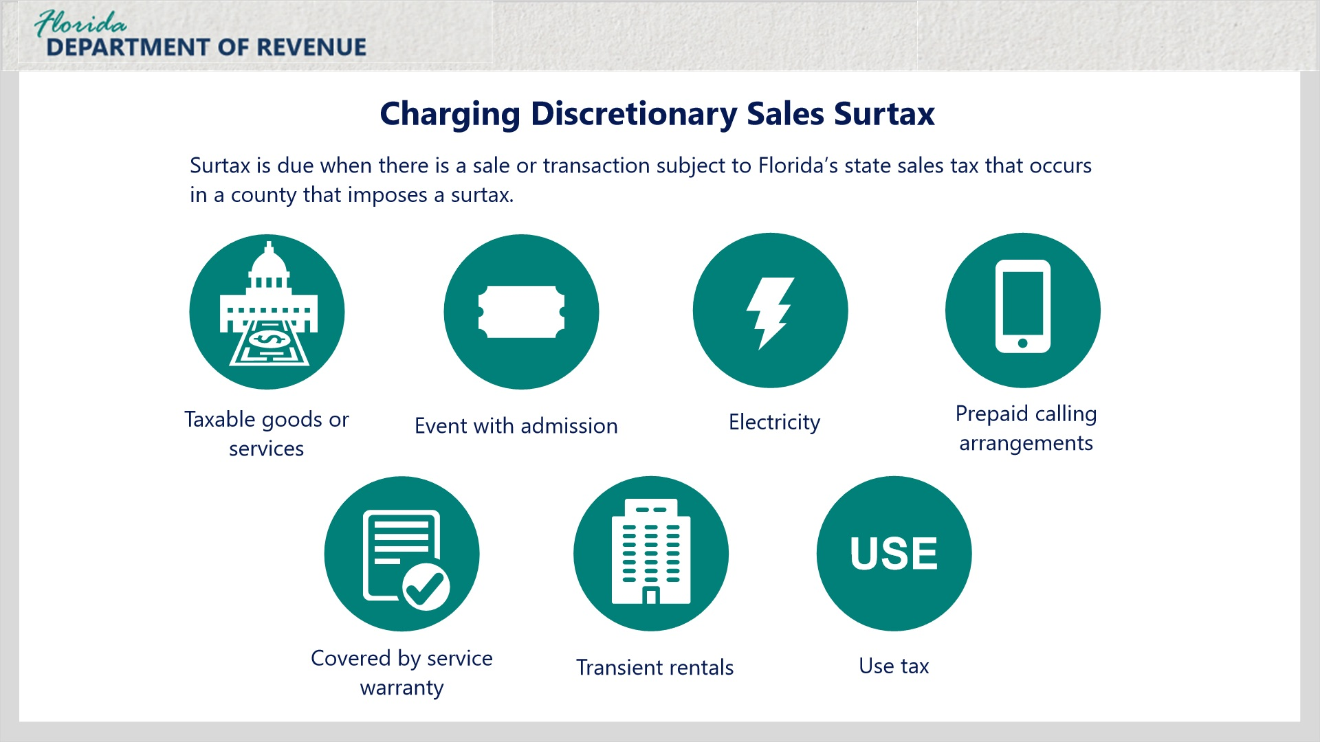
Transcript:
[Janet]: Do I collect surtax on all of my sales?
Good question. Surtax is due when there is a sale or transaction subject to Florida’s state sales tax that occurs in a county that imposes a surtax.
Most sales of tangible items are considered to occur in the county where the item is delivered to the customer. Dealers like you that sell tangible items are required to collect surtax when a taxable item is delivered to a customer within a county imposing a surtax.
Discretionary sales surtax should be collected when taxable goods or services are delivered in a county with a surtax; an event for which an admission is charged is located in a county with a surtax; the consumer of electricity is located in a county with a surtax; the sale of prepaid calling arrangements occurs in a county with a surtax; the location or delivery of tangible personal property covered by a service warranty is within a surtax county; the rental of living or sleeping accommodations known as transient rentals occurs in a county with a surtax; or a registered dealer owing use tax on purchases or leases is in a county with a surtax.

4.3 Charging Discretionary Sales Surtax
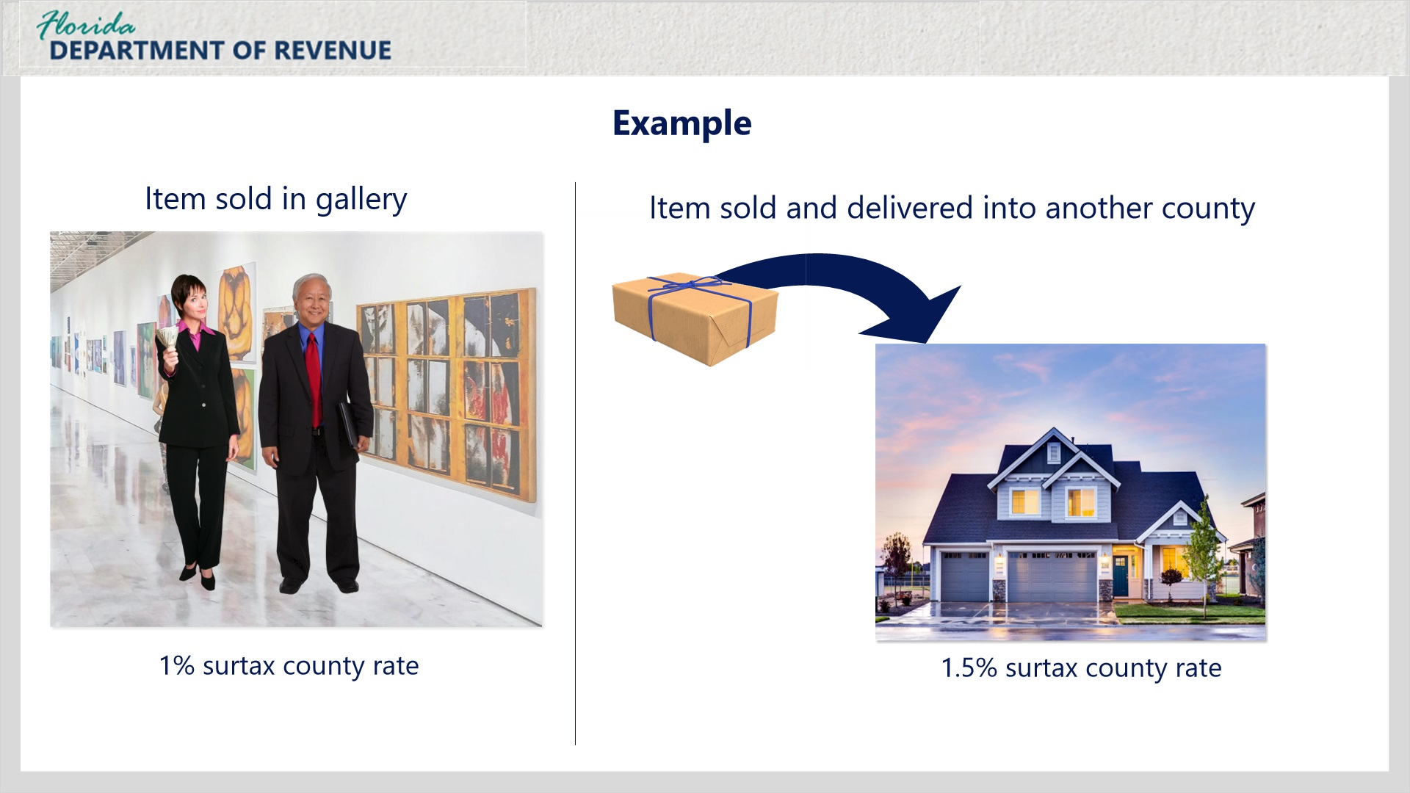
Transcript:
In your case, Janet, all art pieces purchased and delivered in-store would be charged the surtax rate for your county, which is 1%. When you deliver an item outside your county into another county with a different surtax rate, you would charge the surtax for the county where the delivery occurs.
[Janet]: Let’s go back to my store for a minute to see if I understand. If I sell an item in my gallery, and the purchaser takes it with them, I charge the surtax rate for my county. However, if I sell an item in my gallery and then deliver it to the purchaser’s county, I charge the surtax for their county.
That’s correct.
[Janet]: What happens if I deliver into a county without a surtax? Do I charge my county’s rate of 1%? Or do I not charge surtax?
If you deliver the item to the customer within a county that does not impose a surtax, you should not charge surtax. Remember, you only need to charge the rate where the delivery occurs.

4.4 When and What Rate to Collect
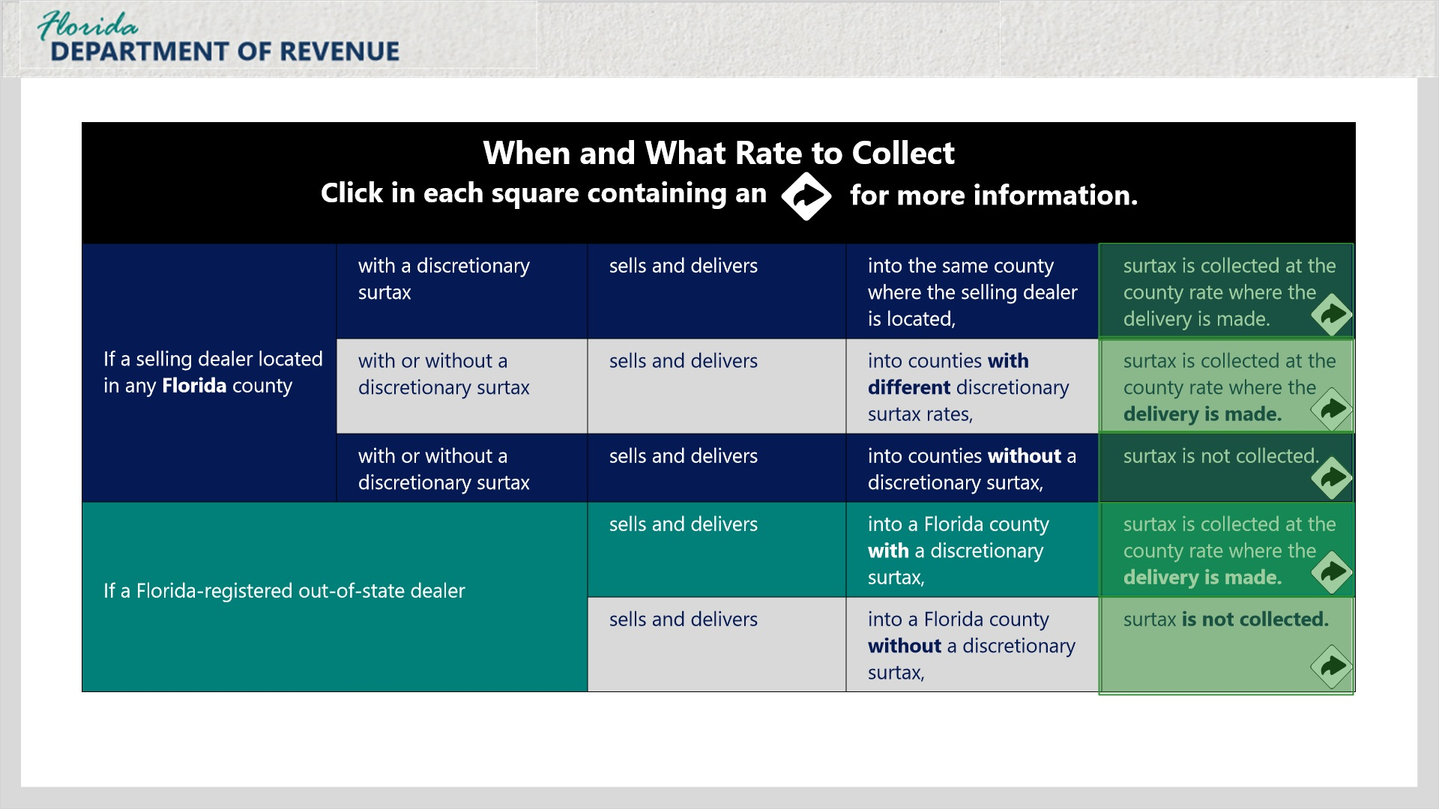
Transcript:
The When and What Rate to Collect chart should be helpful for determining when to collect surtax and at what county rate.
Click in each square containing an arrow for more information.

Same County (Slide Layer)
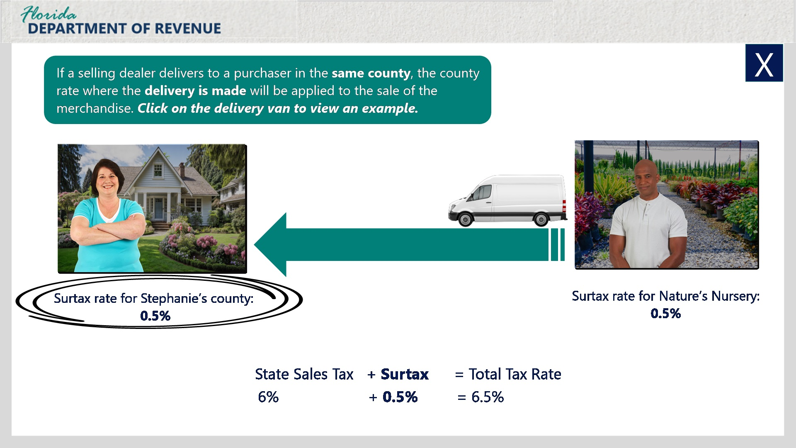
Transcript:
If a selling dealer delivers to a purchaser in the same county, the county rate where the delivery is made will be applied to the sale of the merchandise.
Click on the delivery van to view an example.
Stephanie loves gardening and is looking forward to planting some fresh flowers and bushes in her garden. She goes to see David, who owns Nature’s Nursery, a business that sells trees and plants for personal and residential properties. The nursery is located in a county with a 0.5% discretionary sales surtax rate. David sells several plants to Stephanie for her new landscaping. The nursery delivers the plants a week later to Stephanie’s home in the same county. David charges Stephanie 0.5% discretionary sales surtax plus 6% state sales and use tax for a total tax rate of 6.5%.
[Janet]: I am in a 1% county. So, if I sell and deliver a painting to a purchaser in my county, I would charge 1% discretionary sales surtax along with the 6% state sales tax, which would result in a total tax rate of 7%.
That’s right, Janet!

Different Surtax County (Slide Layer)
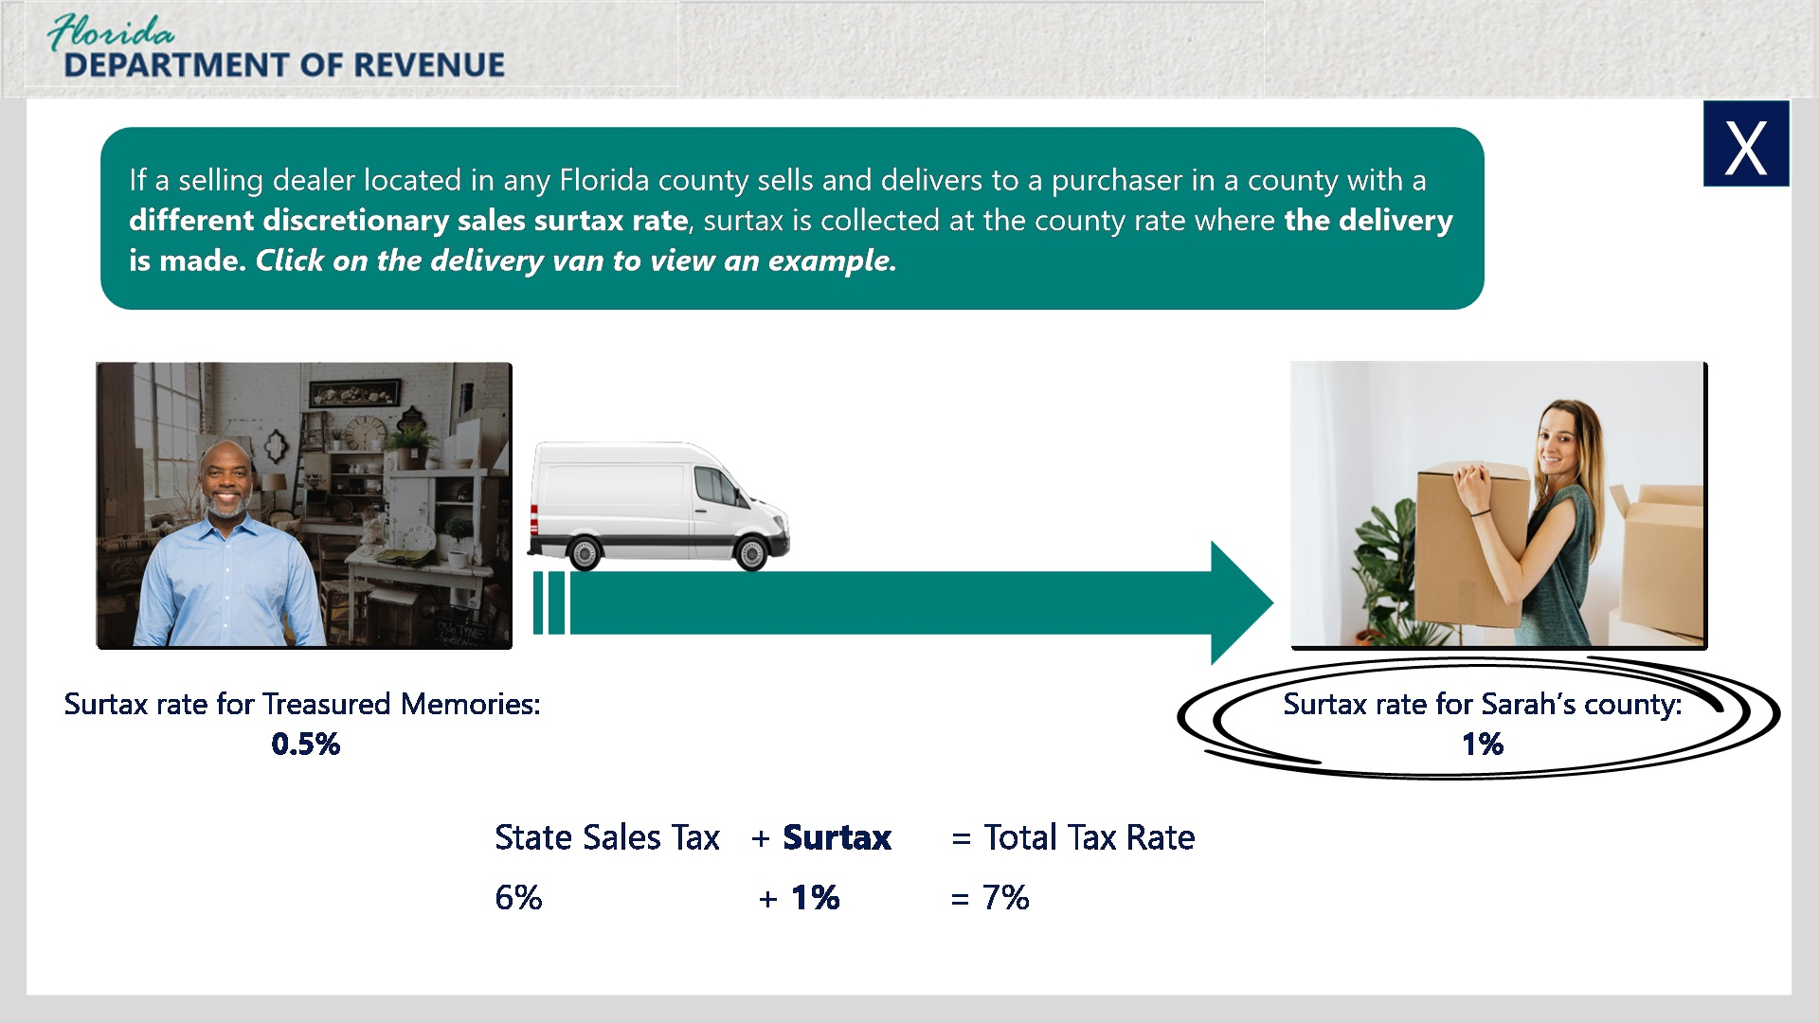
Transcript:
If a selling dealer located in any Florida county sells and delivers to a purchaser in a county with a different discretionary sales surtax rate, surtax is collected at the county rate where the delivery is made.
Click on the delivery van to view an example.
Let’s look at Thomas’s situation.
Thomas owns Treasured Memories, a collectibles shop that also does personalized engraving. His store is located in a 0.5% surtax county. He sells and delivers an engraved music box to Sarah in a county with a 1% surtax rate. Thomas charges the 1% discretionary sales surtax rate for the county where the music box is being delivered to. He also charges 6% state sales and use tax for a total tax rate of 7%.
[Janet]: I recently delivered a hand-carved dining table into a county with a 1.5% surtax rate. I charged them the 1.5% discretionary sales surtax rate for their county. My county has a 1% surtax rate. Did I charge the right amount?
Yes. You should have charged a discretionary sales surtax rate of 1.5% where the table was delivered along with 6% state sales and use tax for a total tax rate of 7.5%.

No Surtax County (Slide Layer)
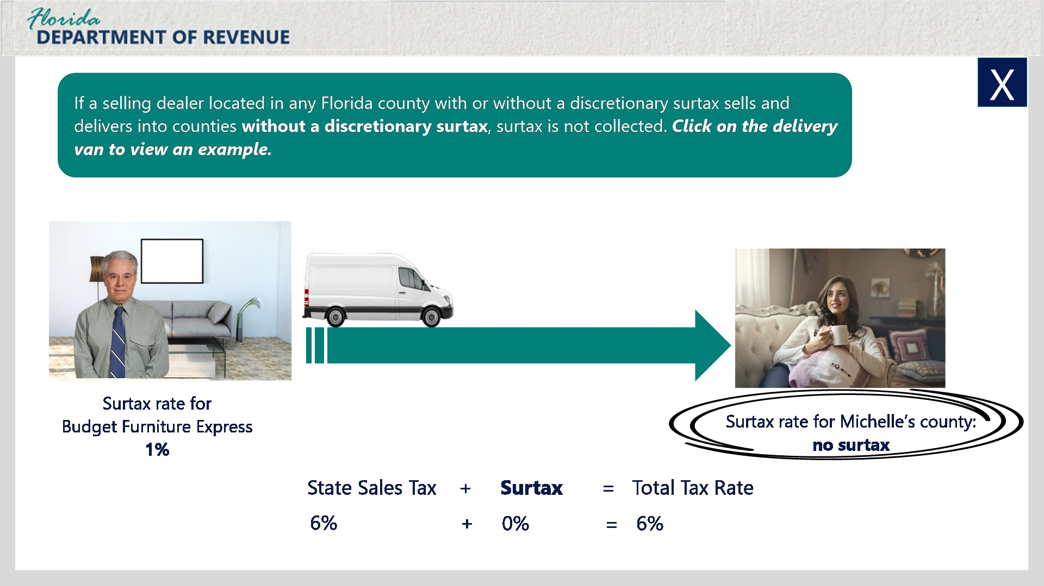
Transcript:
If a selling dealer located in any Florida county with or without a discretionary surtax sells and delivers into counties without a discretionary surtax, surtax is not collected.
Click on the delivery van to view an example.
Here’s an example of a Florida dealer delivering into a county without a surtax. Daniel owns Budget Furniture Express, a discount furniture store in a Florida county with a 1% surtax rate. He sells and delivers a couch to Michelle in a county without a discretionary sales surtax rate.
Daniel does not charge Michelle any surtax because he is delivering the merchandise into a county where surtax is not collected.

Out-of-State Dealer (Slide Layer)
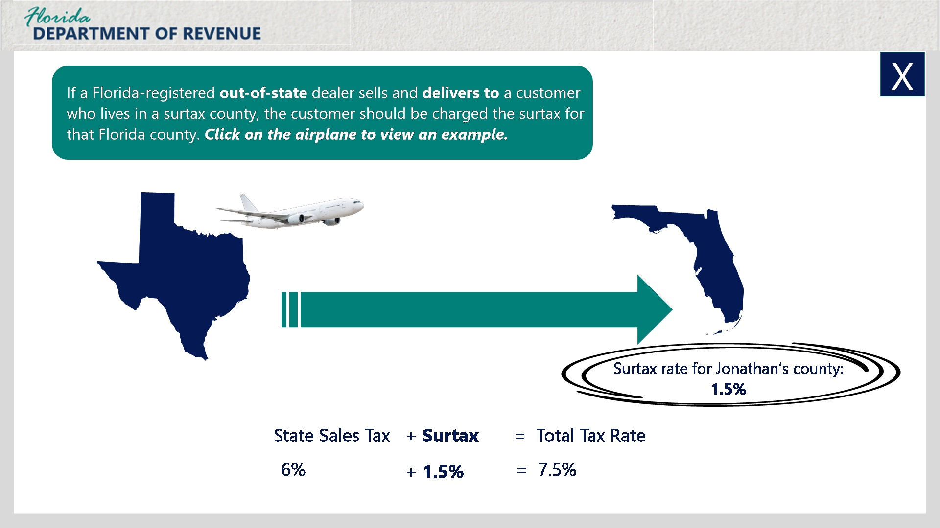
Transcript:
If a Florida-registered out-of-state dealer sells and delivers to a customer who lives in a surtax county, the customer should be charged the surtax for that Florida county.
Click on the airplane to view an example.
Here’s an example of an out-of-state business charging discretionary sales surtax in Florida.
Tailored for You is a clothing store that sells suits for men. It is located in Texas and is required to register as a dealer to collect and remit Florida sales and use tax on remote sales. The out-of-state dealer delivers a suit to Jonathan who lives in a county with a 1.5% discretionary sales surtax rate. The dealer charges the rate of 1.5%, where the suit was delivered, in addition to the 6% state sales and use tax for a total tax rate of 7.5%.
[Janet]: I’m looking to buy a display case for my gallery from a Florida-registered business in New Mexico. Would they charge me 1% surtax because my county has a 1% surtax rate?
Yes. They would charge you 1% discretionary sales surtax in addition to Florida sales and use tax of 6% for a total tax rate of 7%.

Out-of-State, No Surtax (Slide Layer)
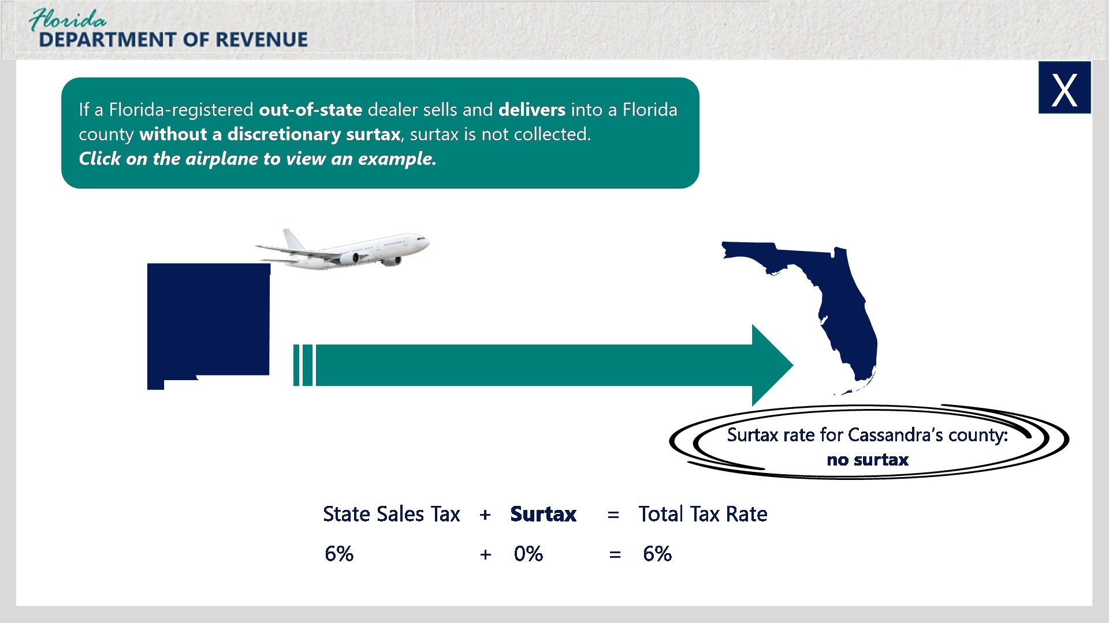
Transcript:
If a Florida-registered out-of-state dealer sells and delivers into a Florida county without a discretionary surtax, surtax is not collected.
Click on the airplane to view an example.
Let’s look at an example.
Laura owns Auntie Laura’s Antiques from a Florida-registered business located in New Mexico. Cassandra, who lives in a Florida county without a discretionary sales surtax purchases an armoire from Laura’s shop. Laura delivers the armoire to Cassandra’s home. No surtax is collected because the Florida county where Cassandra lives does not collect discretionary sales surtax. However, state sales tax would still be charged at a rate of 6%.

4.5 Knowledge Check
(Multiple Choice, 10 points, 2 attempts permitted)
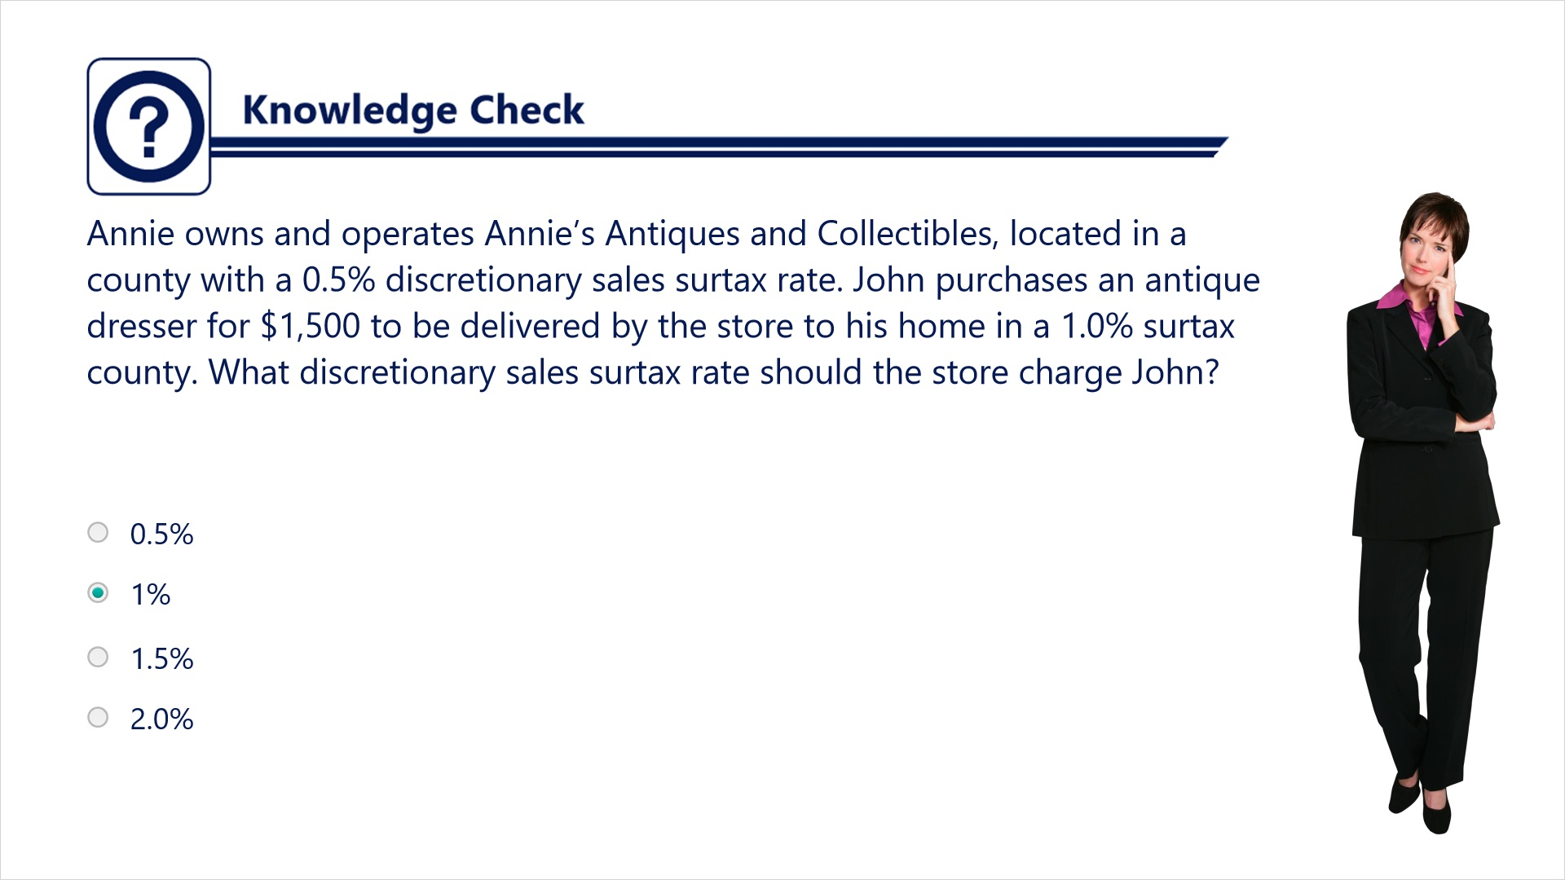
Transcript:
Question: Annie owns and operates Annie’s Antiques and Collectibles, located in a county with a 0.5% discretionary sales surtax rate. John purchases an antique dresser for $1,500 to be delivered by the store to his home in a 1.0% surtax county. What discretionary sales surtax rate should the store charge John?
Answers:
- 0.5%
- 1.0%
- 1.5%
- 2.0%
Correct answer: The store would need to charge John a 1.0% discretionary sales surtax rate.

4.6 Knowledge Check
(Multiple Choice, 10 points, 2 attempts permitted)
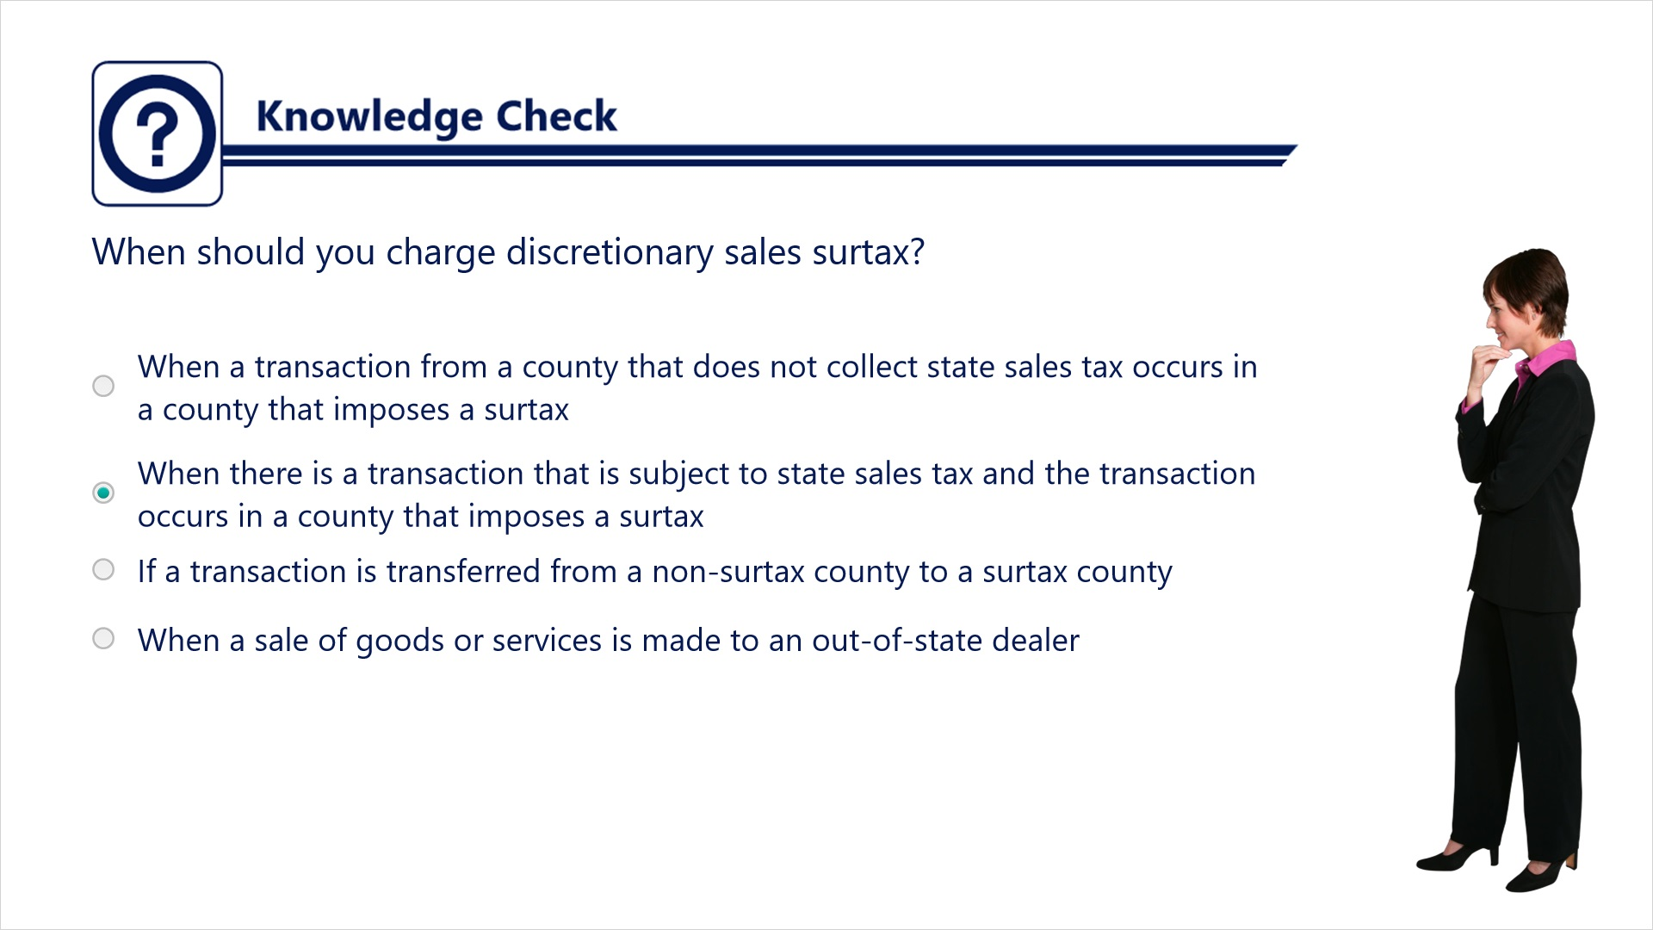
Transcript:
Question: When should you charge discretionary sales surtax?
Answers:
- When a transaction from a county that does not collect state sales tax occurs in a county that imposes a surtax
- When there is a transaction that is subject to state sales tax and the transaction occurs in a county that imposes a surtax
- If a transaction is transferred from a non-surtax county to a surtax county
- When a sale of goods or services is made to an out-of-state dealer
Correct answer: You should charge discretionary sales surtax when there is a transaction that is subject to state sales tax and the transaction occurs in a county that imposes a surtax.

5. Determining if the $5,000 Cap Applies

5.1 Discretionary Sales Surtax
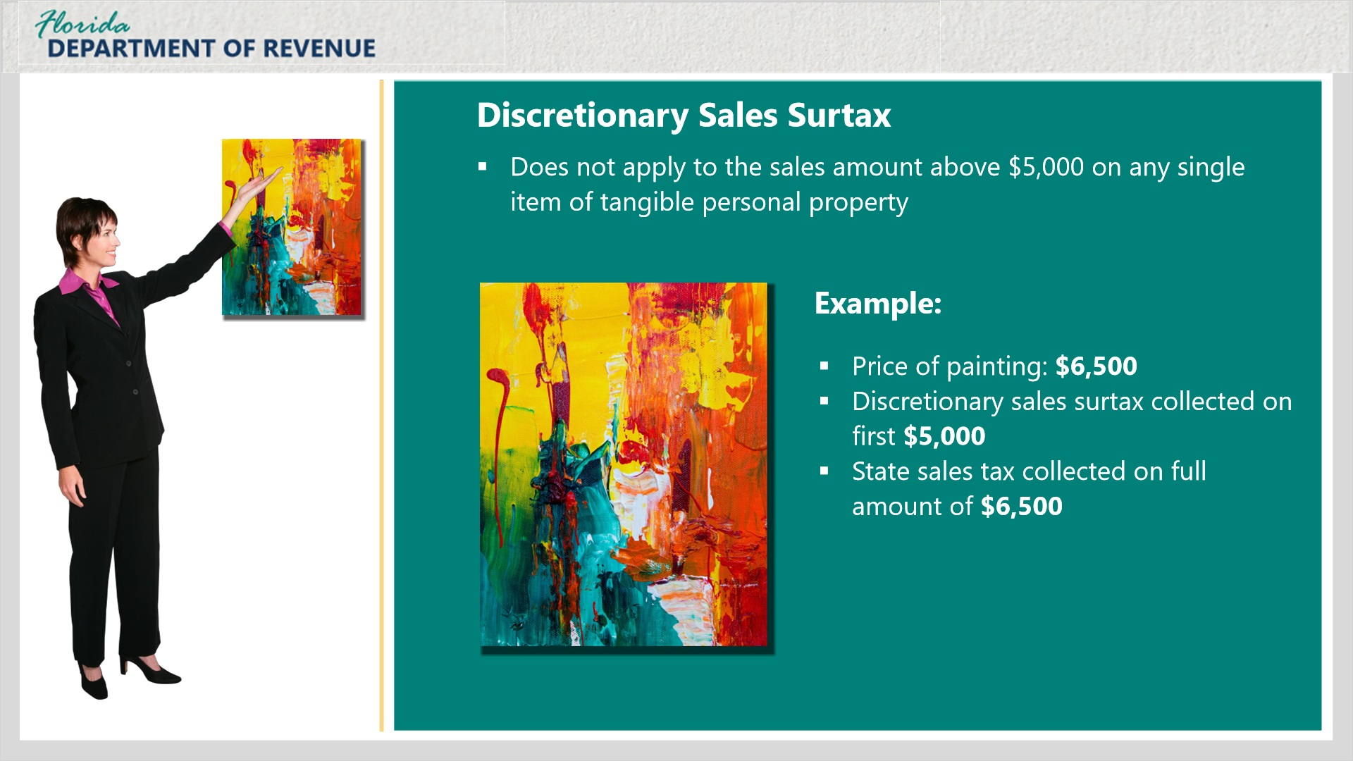
Transcript:
[Janet]: I read somewhere that there is a limit on how much discretionary sales surtax you charge. Can you explain this further?
You’re referring to the $5,000 surtax limitation or cap.
Discretionary sales surtax does not apply to the sales amount above $5,000 on any single item of tangible personal property. For example, if you sell a painting for $6,500, surtax is only collected on the first $5,000 of the sales amount. It is not collected on the remaining $1,500. Keep in mind, however, that the state sales tax of 6% is to be collected on the entire amount.
[Janet]: That seems pretty straightforward. But what if multiple items are sold to a purchaser?
We’ll cover that next.

5.2 Criteria for Multiple Items
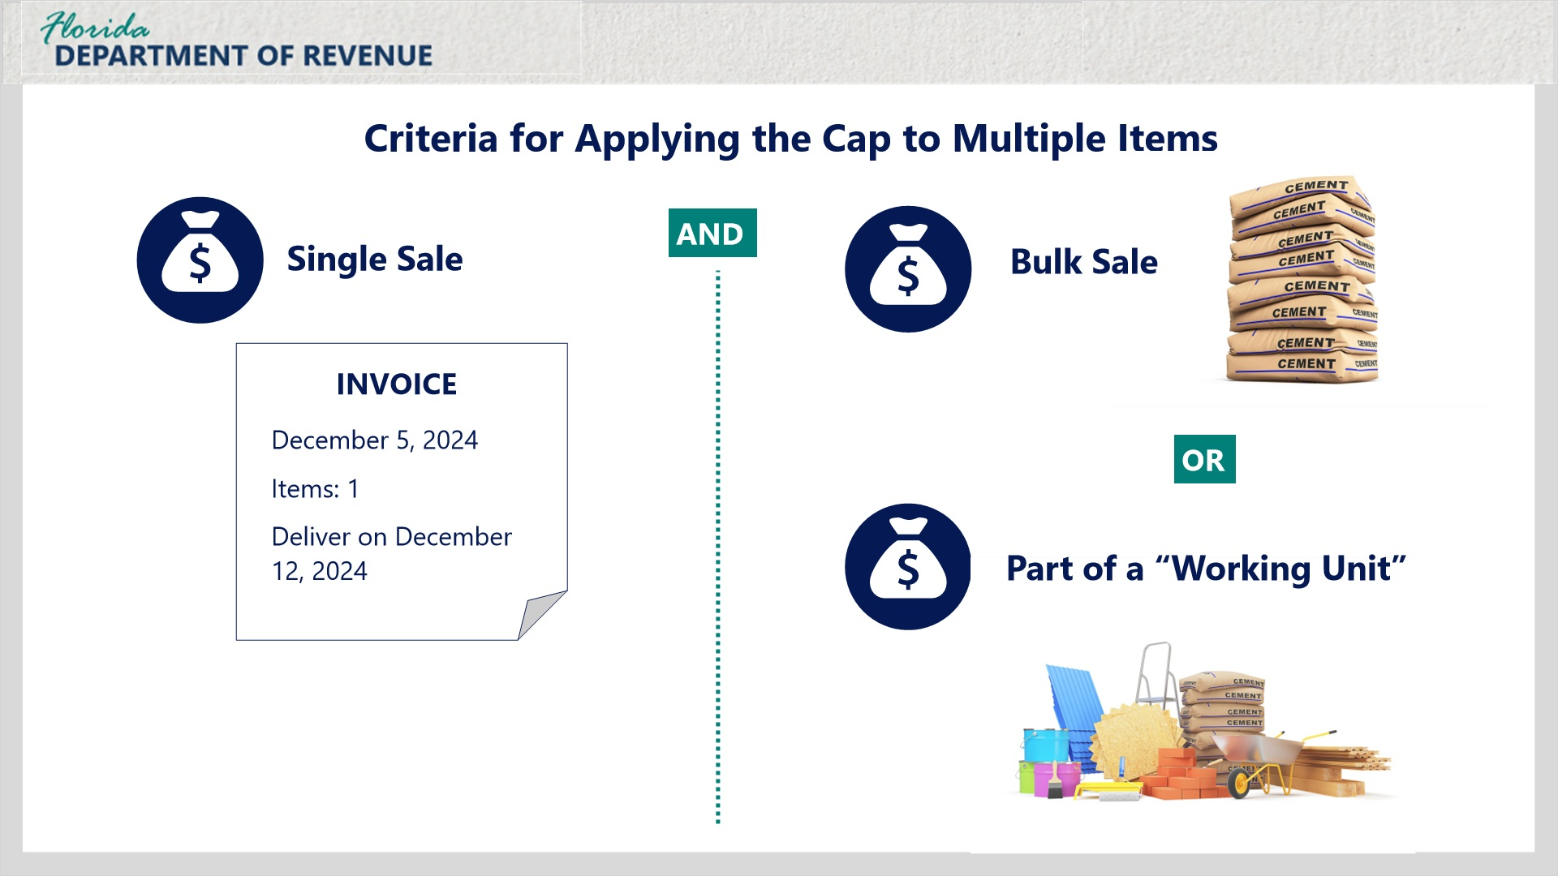
Transcript:
The surtax limitation is intended to apply to a single tangible item. For multiple items to be treated as one item for purposes of applying the surtax limitation, two tests must be satisfied: the single sale test and the bulk sale/working unit test.
Let’s discuss the single sale test.

5.3 Single Sale
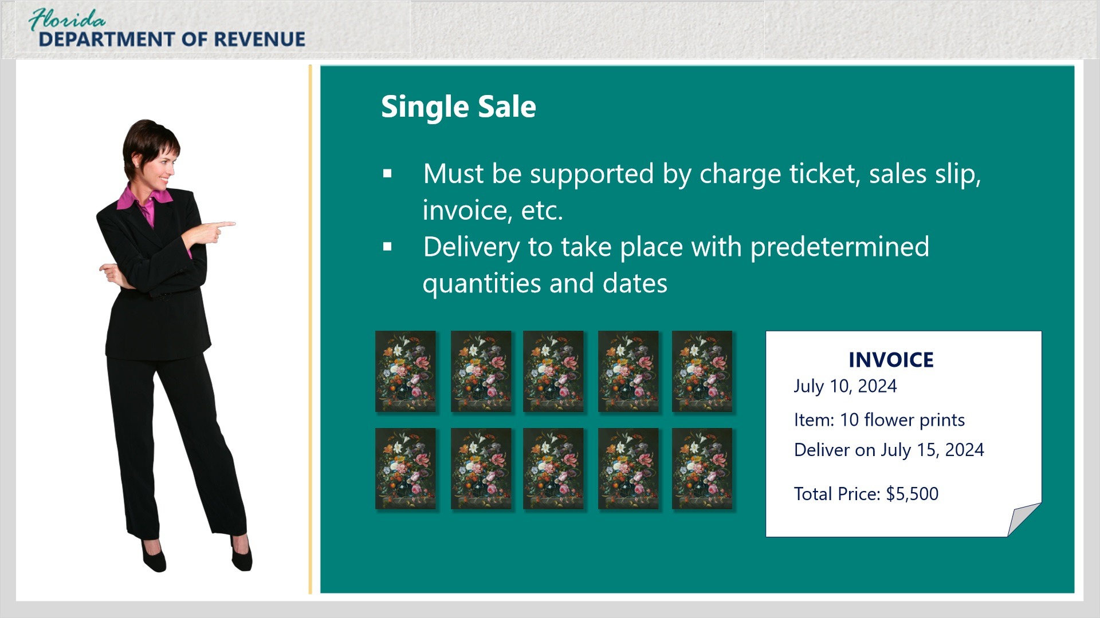
Transcript:
To qualify as a single sale, items must be sold to the same purchaser at the same time. The sale must be supported by a charge ticket, sales slip, invoice, or purchase order or other tangible evidence that establishes the items were sold in a single sale.
Janet, in the example shown, your gallery sells 10 identical prints in a single transaction to the owner of a hotel to be used as décor in its suites. They are to be delivered on a specific date to the hotel for a total price of $5,500.
Single sales documented by a purchase order or other written agreement must provide for the specific quantity of tangible items. Additionally, if delivery of the items will not occur at the same time, the purchase order or written agreement must provide for a specific date by which all items must be delivered.
When a purchase order or written agreement does not specify the quantity and time period during which delivery will occur, each delivery will be considered a single sale.

5.4 Bulk Sale
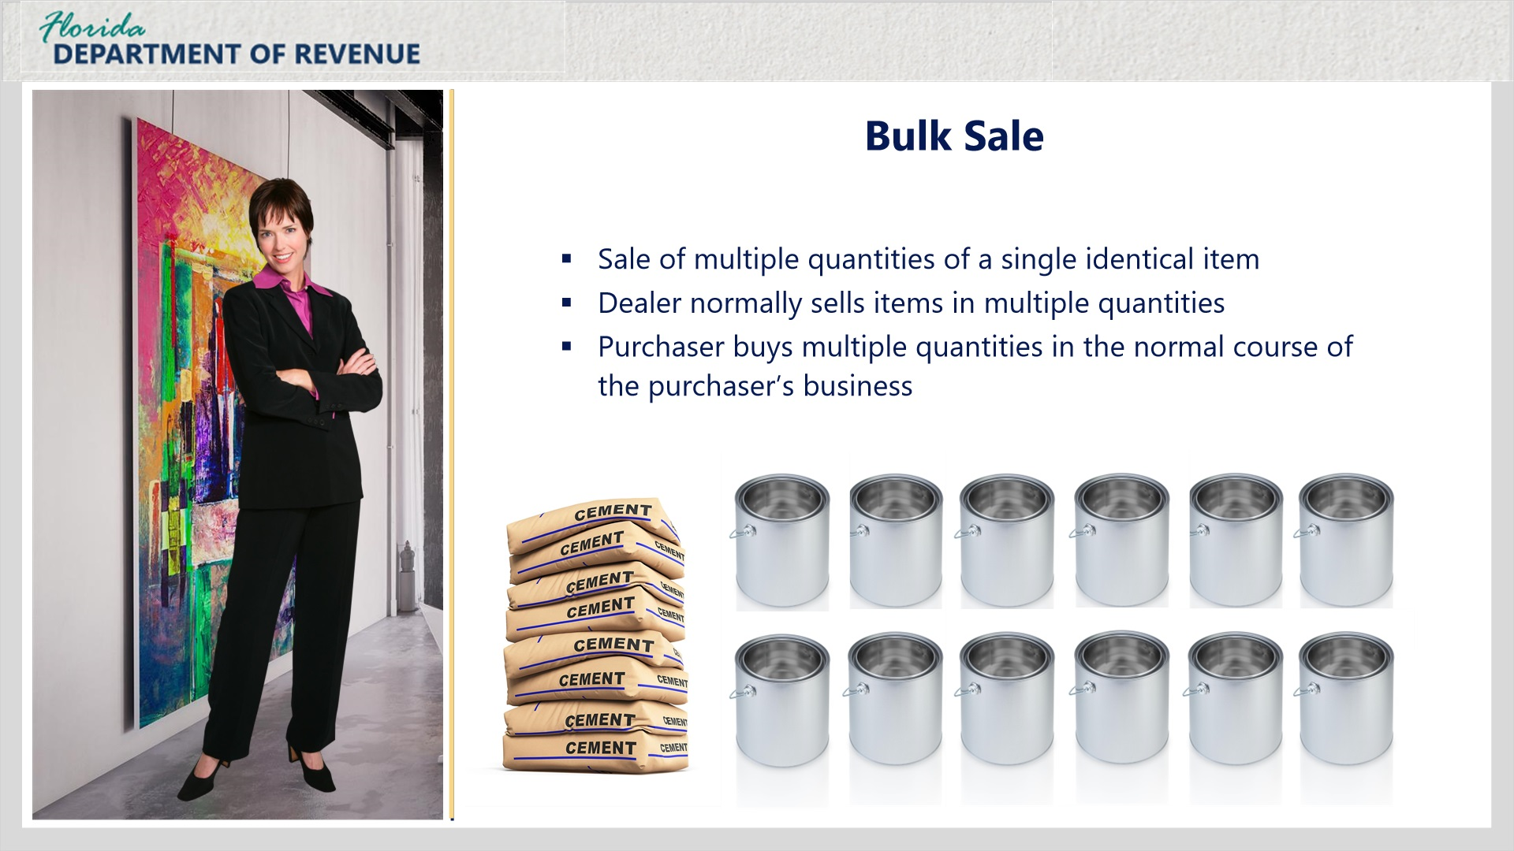
Transcript:
A transaction that meets the single sale test must also meet the bulk sale or working unit test.
[Janet]: What do you mean by bulk sale?
A bulk sale is the sale of multiple quantities of a single (identical) item the dealer normally sells in multiple quantities in the normal course of the dealer’s business or that the purchaser normally buys in multiple quantities in the normal course of the purchaser’s business.

5.4 Bulk Sale
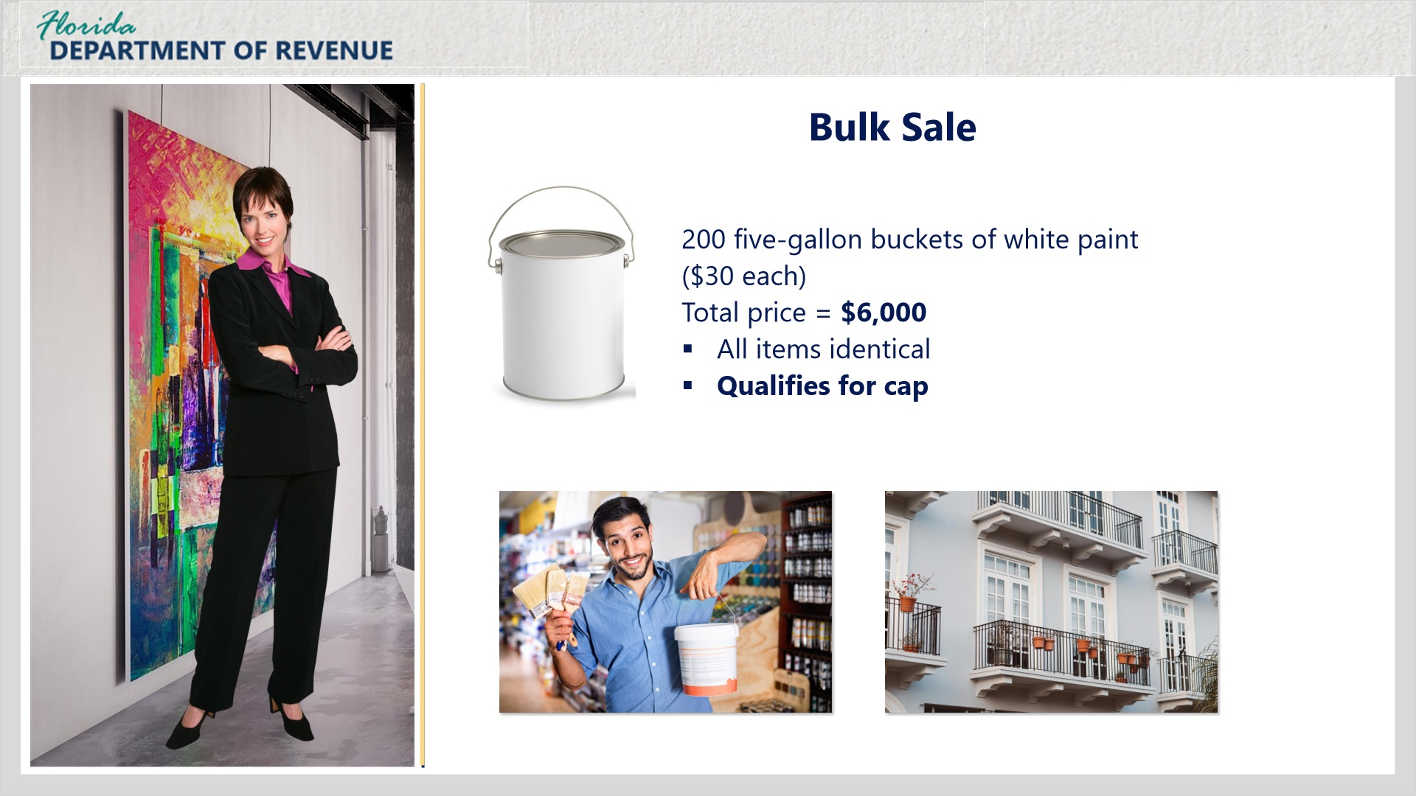
Transcript:
For example, a painting contractor wants to replenish his supply of white paint for various jobs.
He visits the local hardware store where he frequently purchases paint in bulk quantities. During this visit, he purchases and takes delivery of 200 five-gallon containers of premium white paint (same finish, item/batch number) for a total of $6,000. This would qualify for the cap because the sale met both the single sale and bulk sale test.

5.4 Bulk Sale
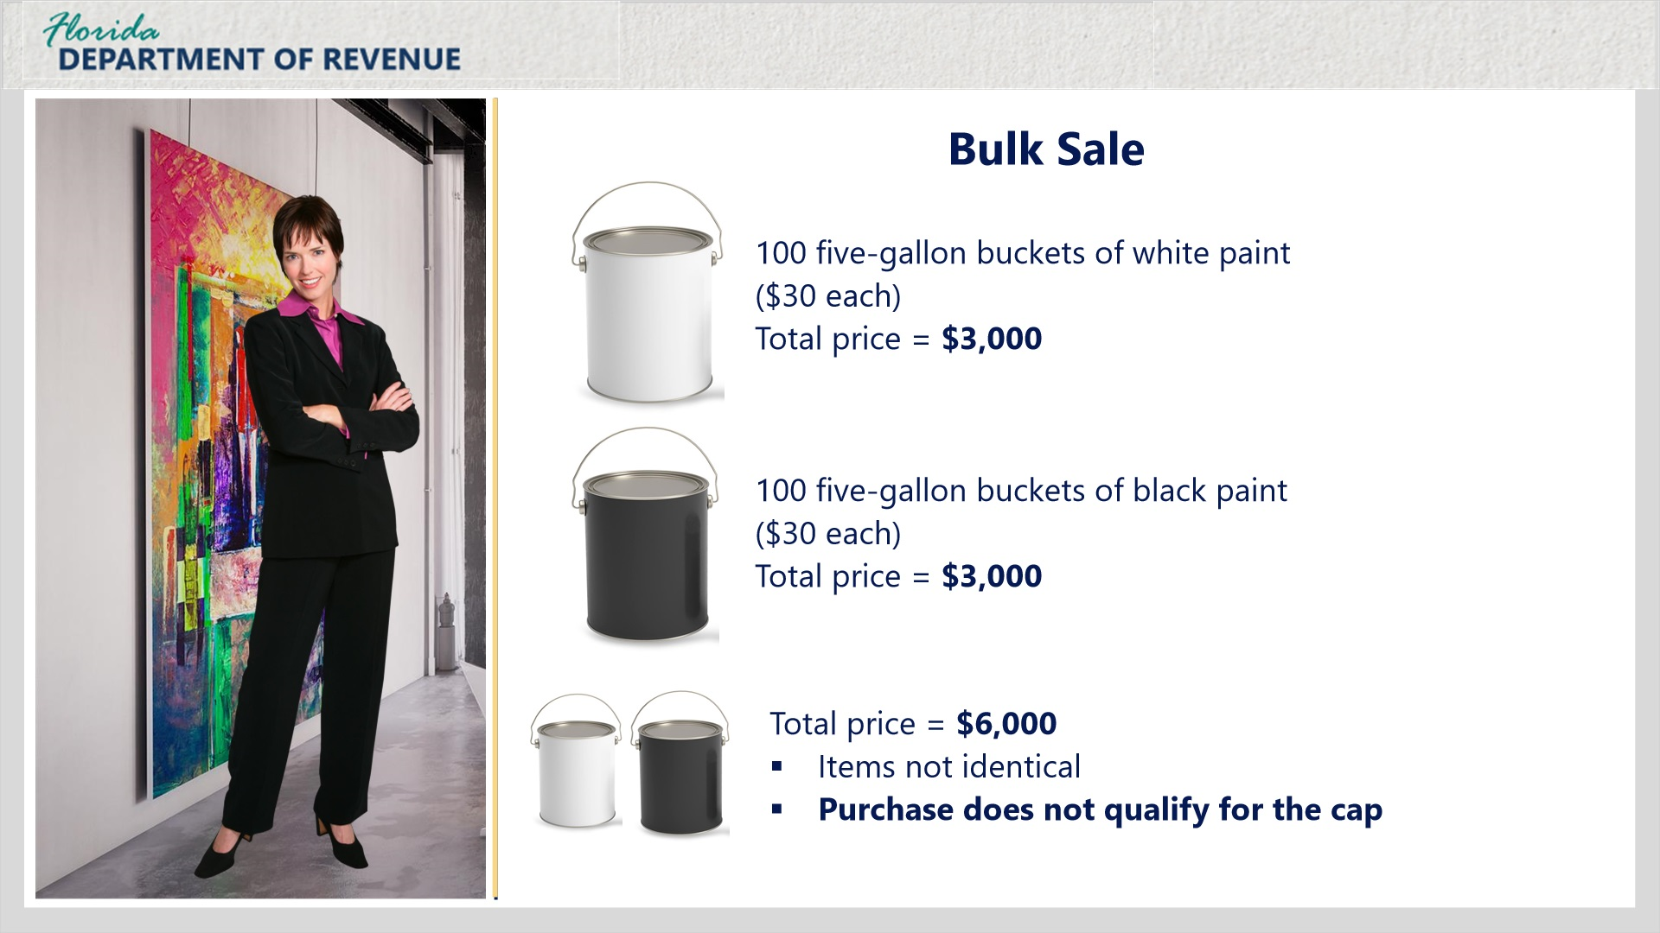
Transcript:
[Janet]: What if the contractor purchased 100 five-gallon containers of the same white paint for $3,000 and 100 five-gallon containers of black paint for $3,000 to replenish his supply?
While the total price exceeds $5,000, the sales amount of the white paint and black paint cannot be combined because they are not identical. Surtax would apply to the total sales price of $6,000.

5.5 Bulk Sale
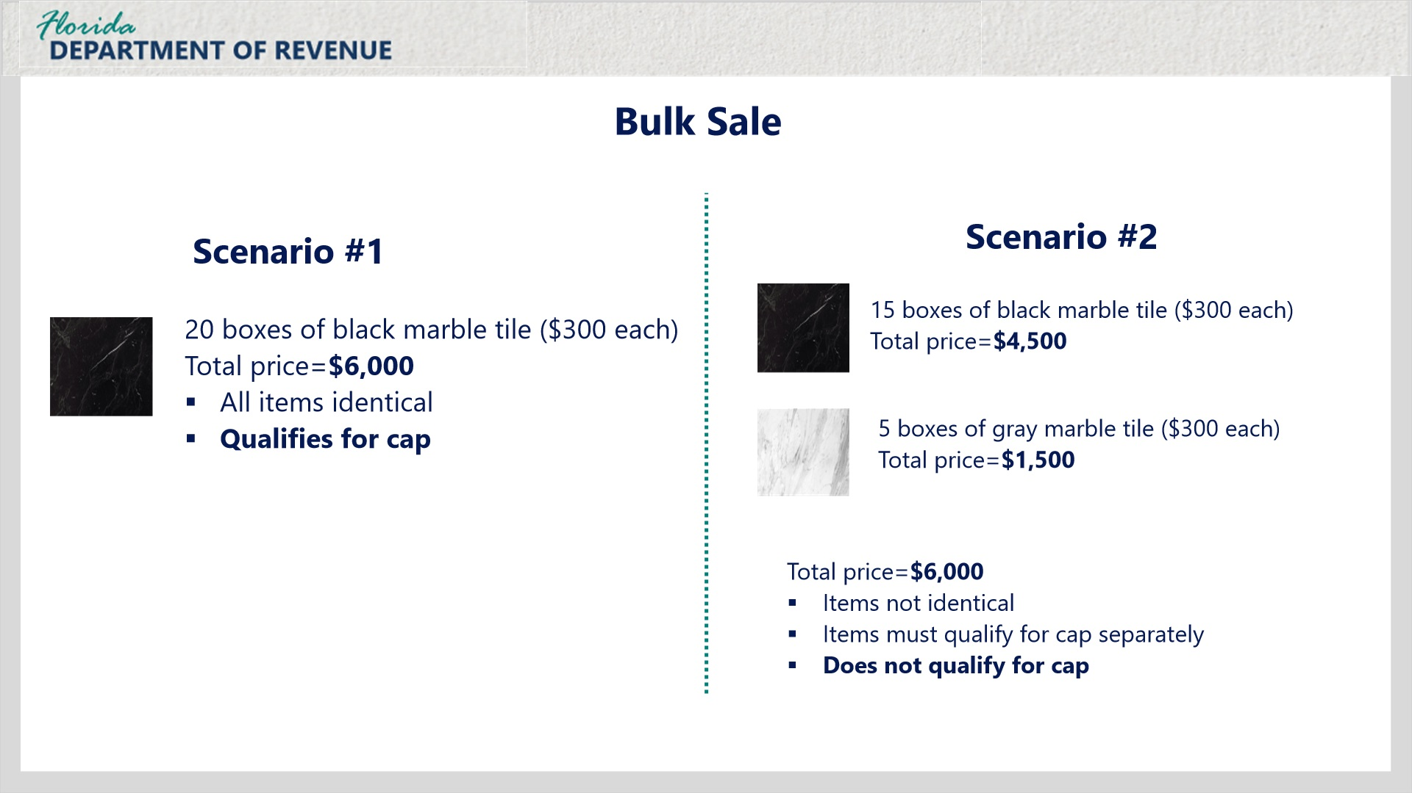
Transcript:
[Janet]: Can you give me another example?
Sure. Let’s say you are buying identical black marble tile from a seller that normally sells flooring tile in bulk quantities. You purchase 20 boxes at the same time for $300 a box for a total of $6,000. This purchase would be eligible for the cap because it was purchased in a single sale, and it is a bulk sale because you are buying several of an identical item from a dealer that normally sells in bulk.
However, if you decided that five of those boxes were going to contain a different color of marble tile such as gray, the eligibility for the cap would have to be determined separately for both types of tile since they are not identical.
While the total price is the same, you cannot combine them to meet the cap, and neither type of tile would meet the cap on its own because neither of them go over the $5,000 threshold for qualifying.

5.6 Working Unit
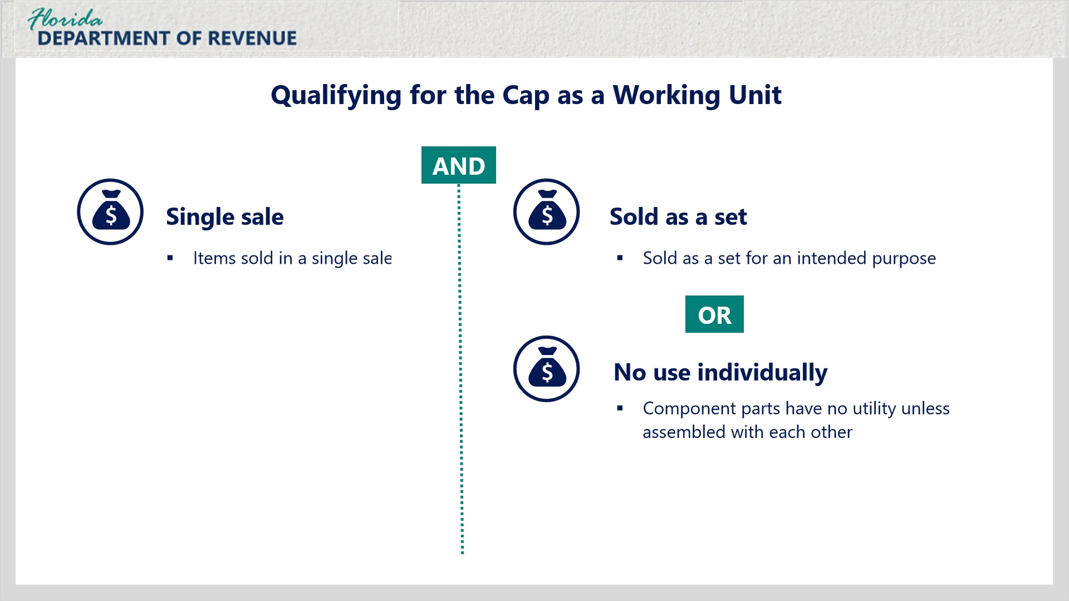
Transcript:
[Janet]: OK, I think I understand the concept of a bulk sale. Now, what about the items qualifying as a “working unit”?
To meet the working unit test, there must be a single sale and the items must be normally sold as a set, and the utility of each for its intended purpose(s) is dependent upon the set being complete; normally sold in a single sale by the seller to the purchaser for use in the normal business practice of the purchaser as an integrated unit; or the items are component parts that have no utility unless assembled with each other to form a working unit or part of a working unit.

5.6 Bulk Sale
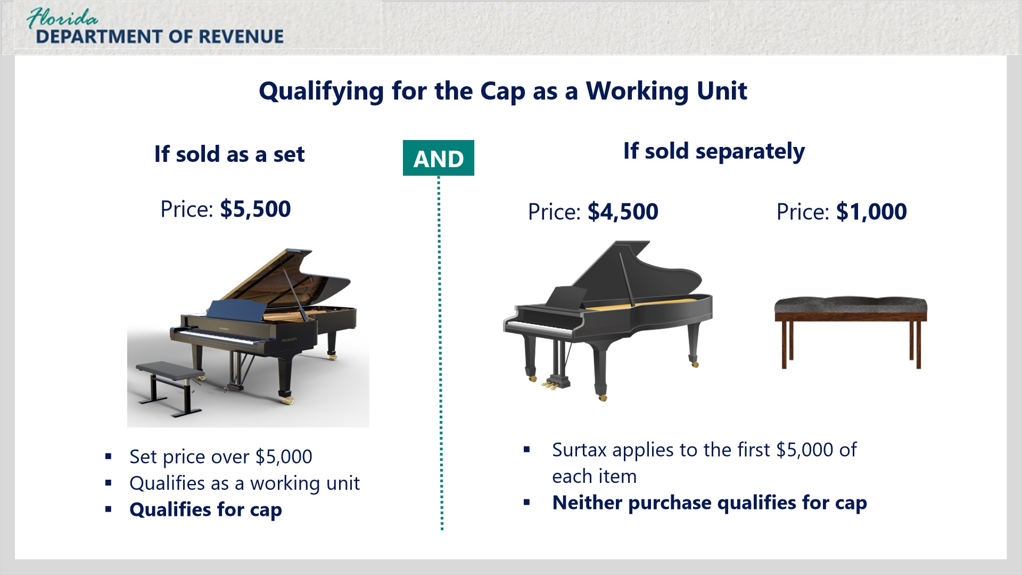
Transcript:
For example, if you owned a music store and advertised, sold, and invoiced a piano and matching bench as a set for a single price of $5,500, the surtax cap would apply because the two items are being sold as a working unit or set.
If you sell pianos and benches individually and separately itemize each item, the surtax applies to the first $5,000 of each item. Neither purchase qualifies for the cap on its own.

5.7 Working Unit
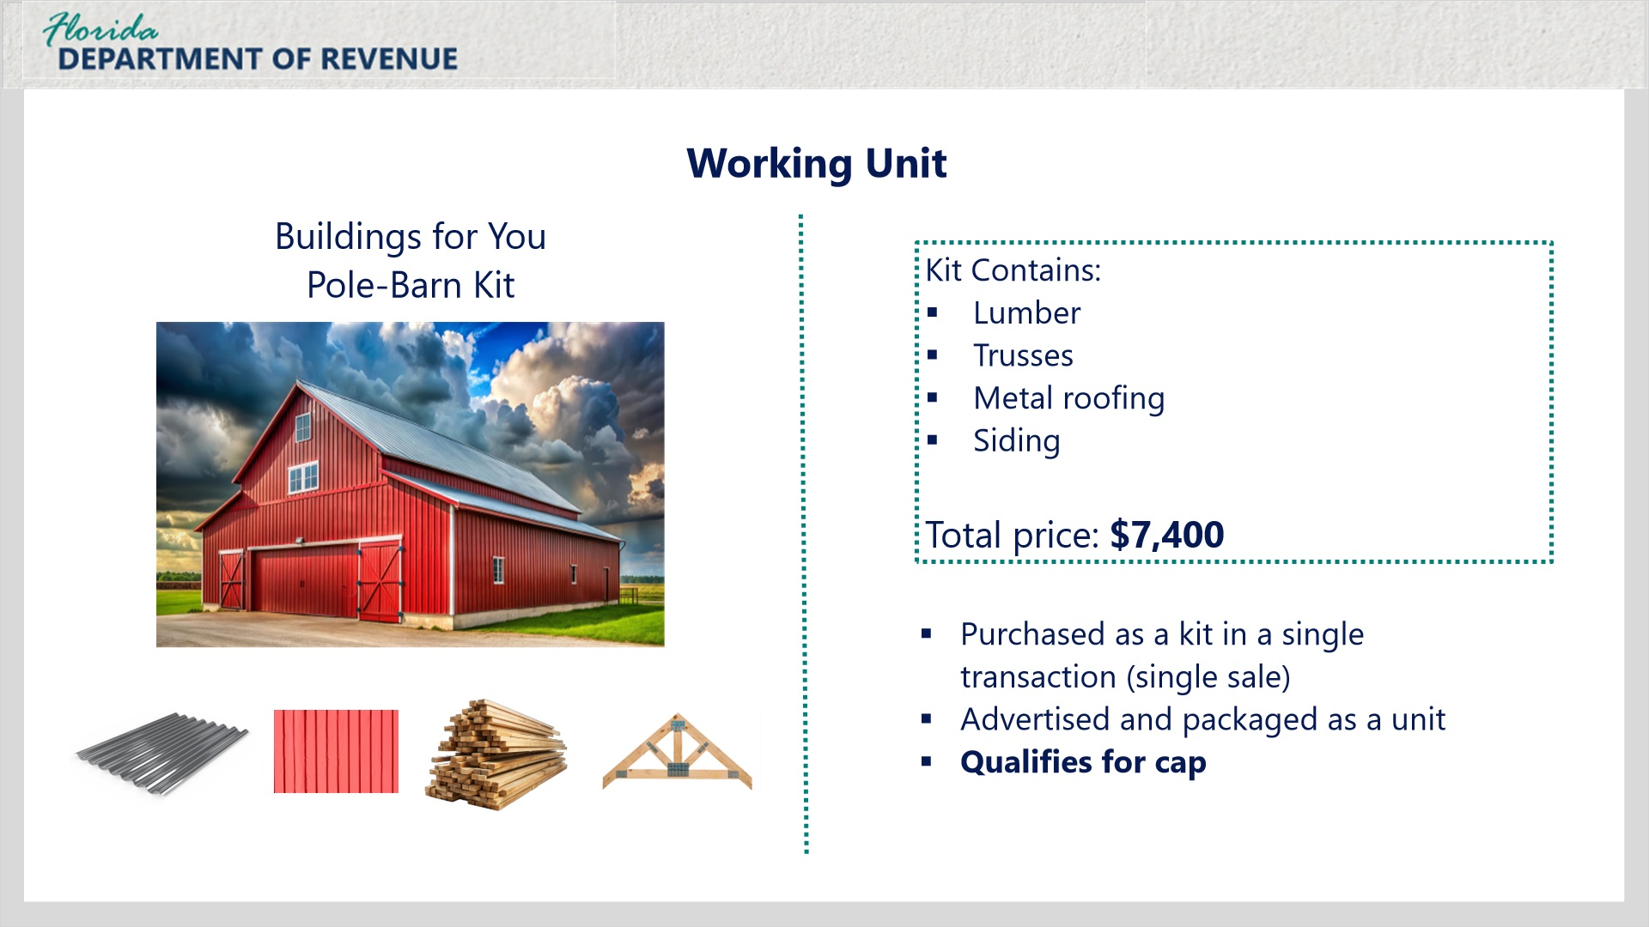
Transcript:
Here’s an example regarding a working unit sale.
The Smith family wants to buy a small pole-barn for their backyard and install it themselves. Sam owns Buildings for You which advertises and sells a pole-barn kit providing the basic components needed to build one including lumber, trusses, metal roofing, and siding. The Smiths purchase the kit from Sam in a single sale. Sam delivers it to their home located in a 1.5% surtax county.
The invoice totals $7,400. Since Sam sold them the kit in one transaction and the items making up the kit are advertised and packaged to use for a specified purpose, the transaction meets both the single sale and working unit tests.

5.8 When the Cap Does Not Apply
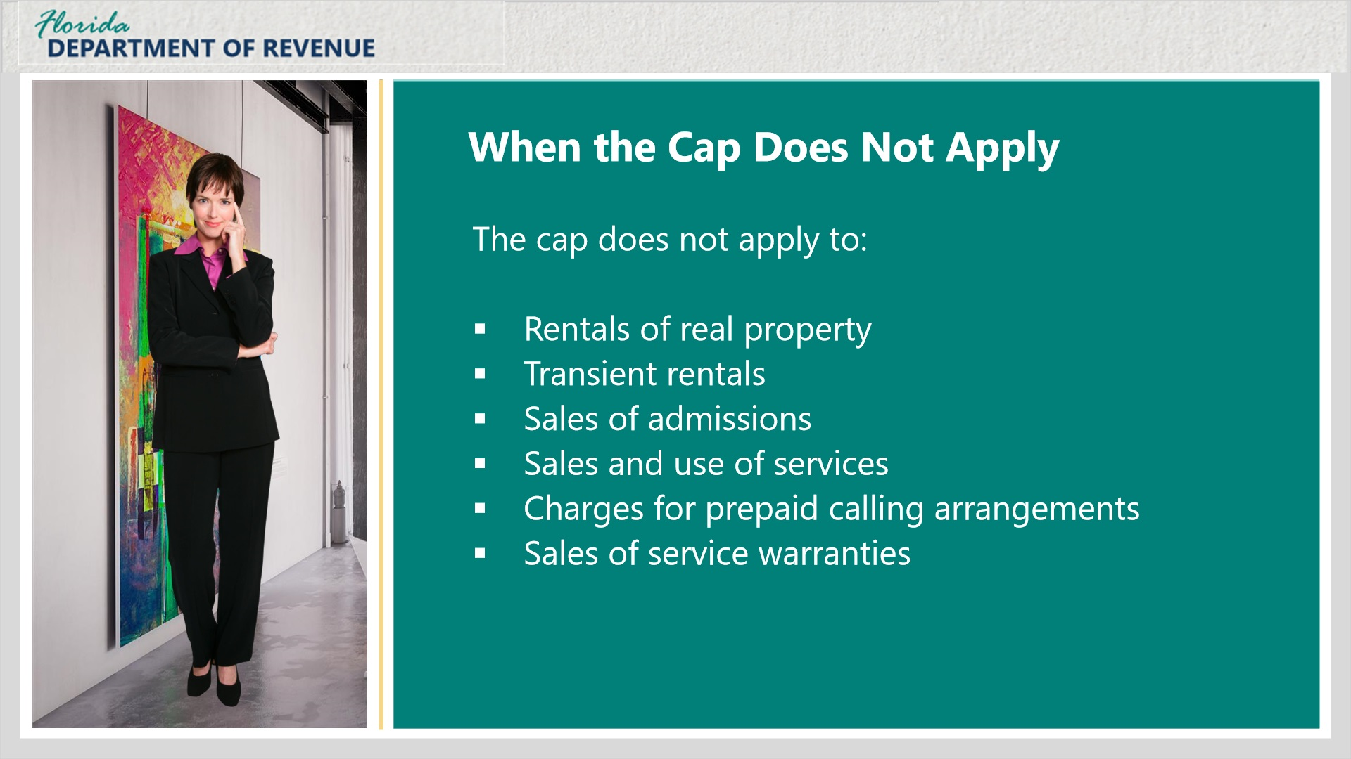
Transcript:
[Janet]: Are there sales where the cap does not apply?
There are. The cap does not apply to rentals of real property, transient rentals, sales of admissions, sales and use of services, charges for prepaid calling arrangements, or sales of service warranties.
[Janet]: That clarifies a lot for me.
I am happy to hear it.

5.9 Knowledge Check
(Multiple Response, 10 points, 2 attempts permitted)
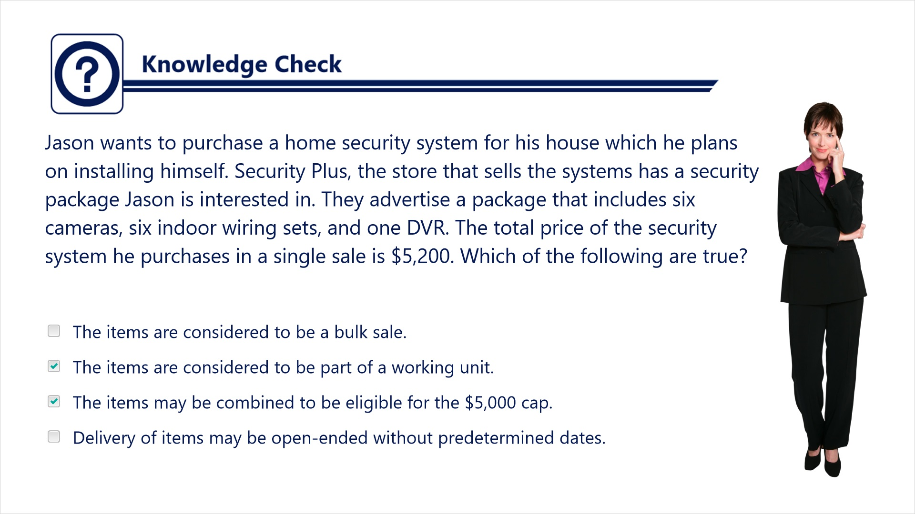
Transcript:
Question: Jason wants to purchase a hoe security system for his house which he plans on installing himself. Security Plus, the store that sells the systems has a security package Jason is interested in. They advertise a package that includes six cameras, six indoor wiring sets, and one DVR. The total price of the security system he purchases in a single sale is $5,200. Which of the following are true?
Answers:
- The items are considered to be a bulk sale.
- The items are considered to be part of a working unit.
- The items may be combined to be eligible for the $5,000 cap.
- Delivery of items may be open-ended without predetermined dates.
Correct answer: The items are considered to be part of a working unit. The items may also be combined to be eligible for the $5,000 cap.

5.10 Knowledge Check
(Multiple Response, 10 points, 2 attempts permitted)
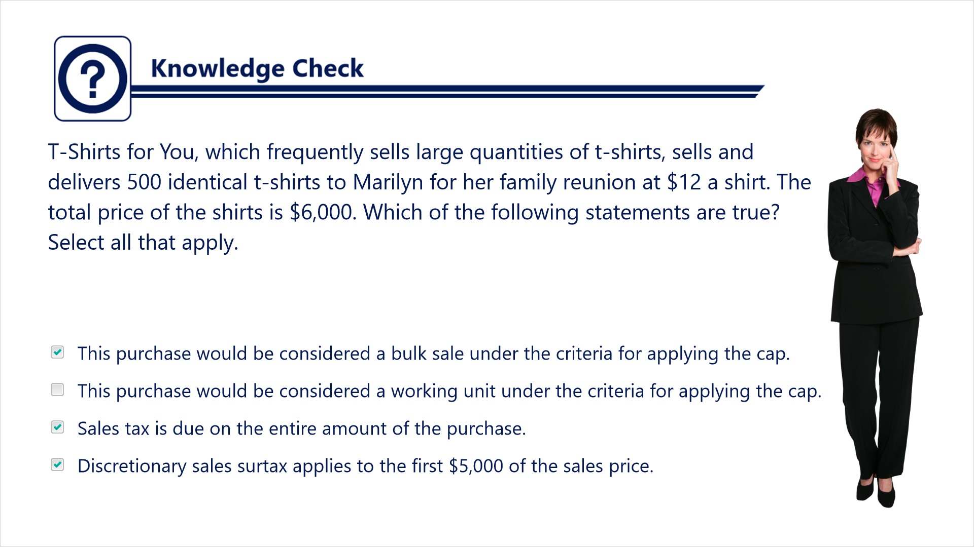
Transcript:
Question: T-Shirts for You, which frequently sells large quantities of t-shirts, sells and delivers 500 identical t-shirts to Marilyn for her family reunion at $12 a shirt. The total price of the shirts is $6,000. Which of the following statements are true? Select all that apply.
Answers:
- This purchase would be considered a bulk sale under the criteria for applying the cap.
- This purchase would be considered a working unit under the criteria for applying the cap.
- Sales tax is due on the entire amount of the purchase.
- Discretionary sales surtax applies to the first $5,000 of the sales price.
Correct answer: This purchase would be considered a bulk sale under the criteria for applying the cap. Sales tax is due on the entire amount of the purchase. Discretionary sales surtax applies to the first $5,000 of the sales price.

5.10 Knowledge Check
(Multiple Response, 10 points, 2 attempts permitted)
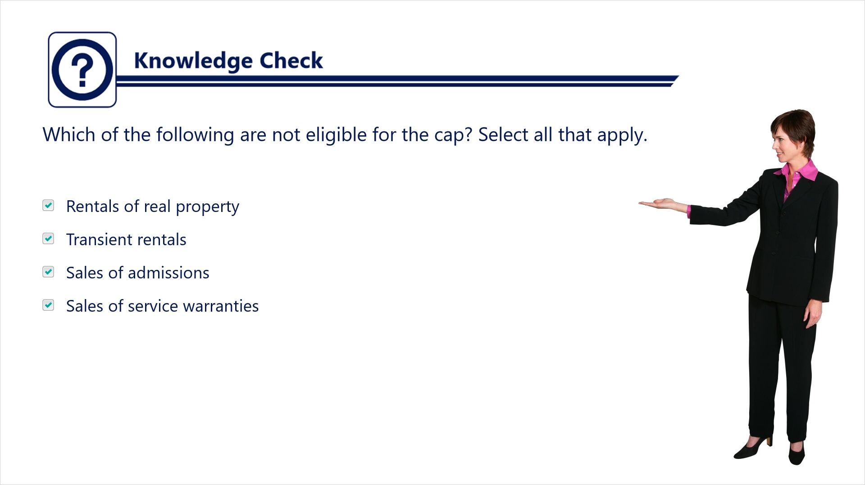
Transcript:
Question: Which of the following are not eligible for the cap? Select all that apply.
Answers:
- Rentals of real property
- Transient rentals
- Sales of admissions
- Sales of service warranties
Correct answer: None of these are eligible of the cap.

6. Summary

6.1 Summary
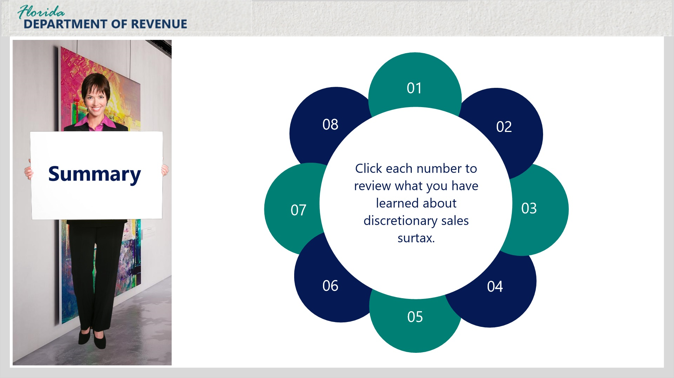
Transcript:
Well, we’ve covered a lot during this tutorial. Janet, would you mind giving a brief summary of what you’ve learned?
[Janet]: I’d be happy to.

Item 01 Discretionary Sales Surtax and Sales Tax (Slide Layer)
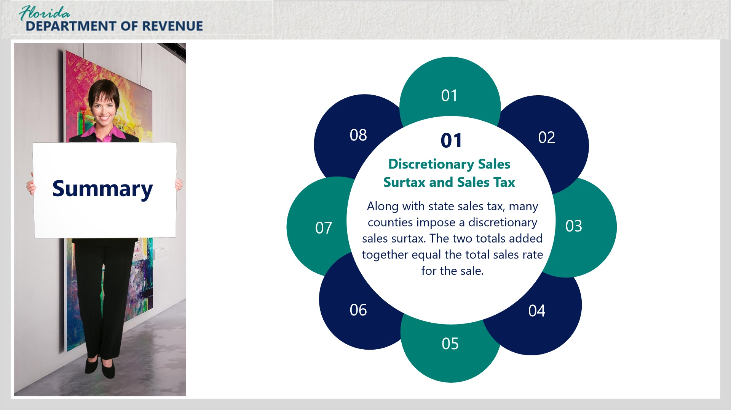
Transcript:
Along with state sales tax, many counties impose a discretionary sales surtax. The two totals added together equal the total sales rate for the sale.

Item 02 Purpose of Discretionary Sales Surtax (Slide Layer)
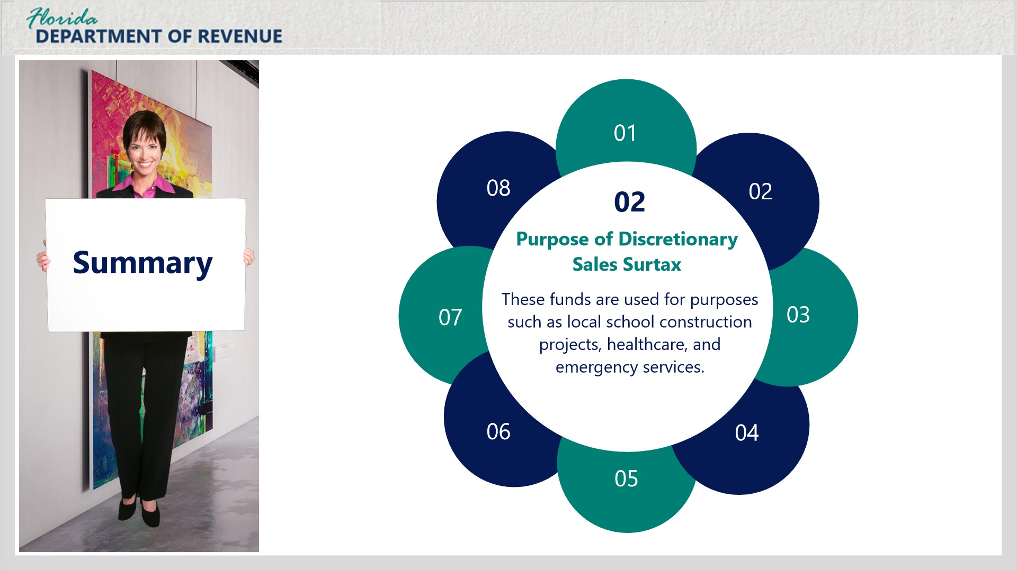
Transcript:
These funds are used for purposes such as local school construction projects, healthcare, and emergency services.

Item 03 Selling Dealers (Slide Layer)
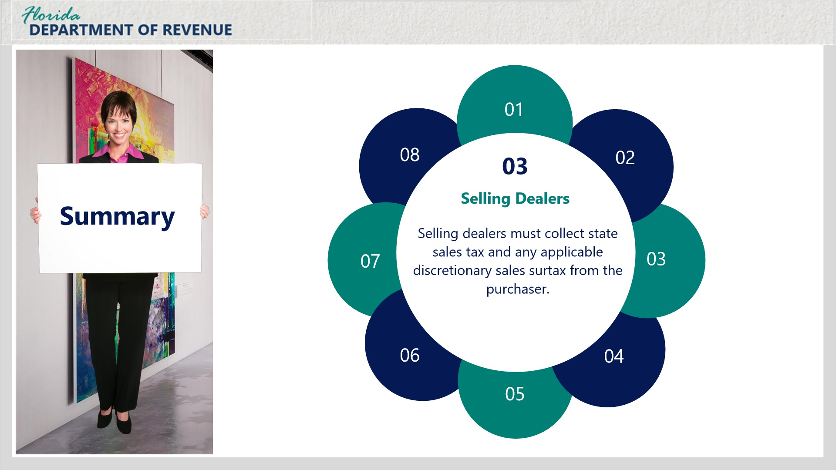
Transcript:
Selling dealers must collect state sales tax and any applicable discretionary sales surtax from the purchaser.

Item 04 When to Charge Surtax (Slide Layer)
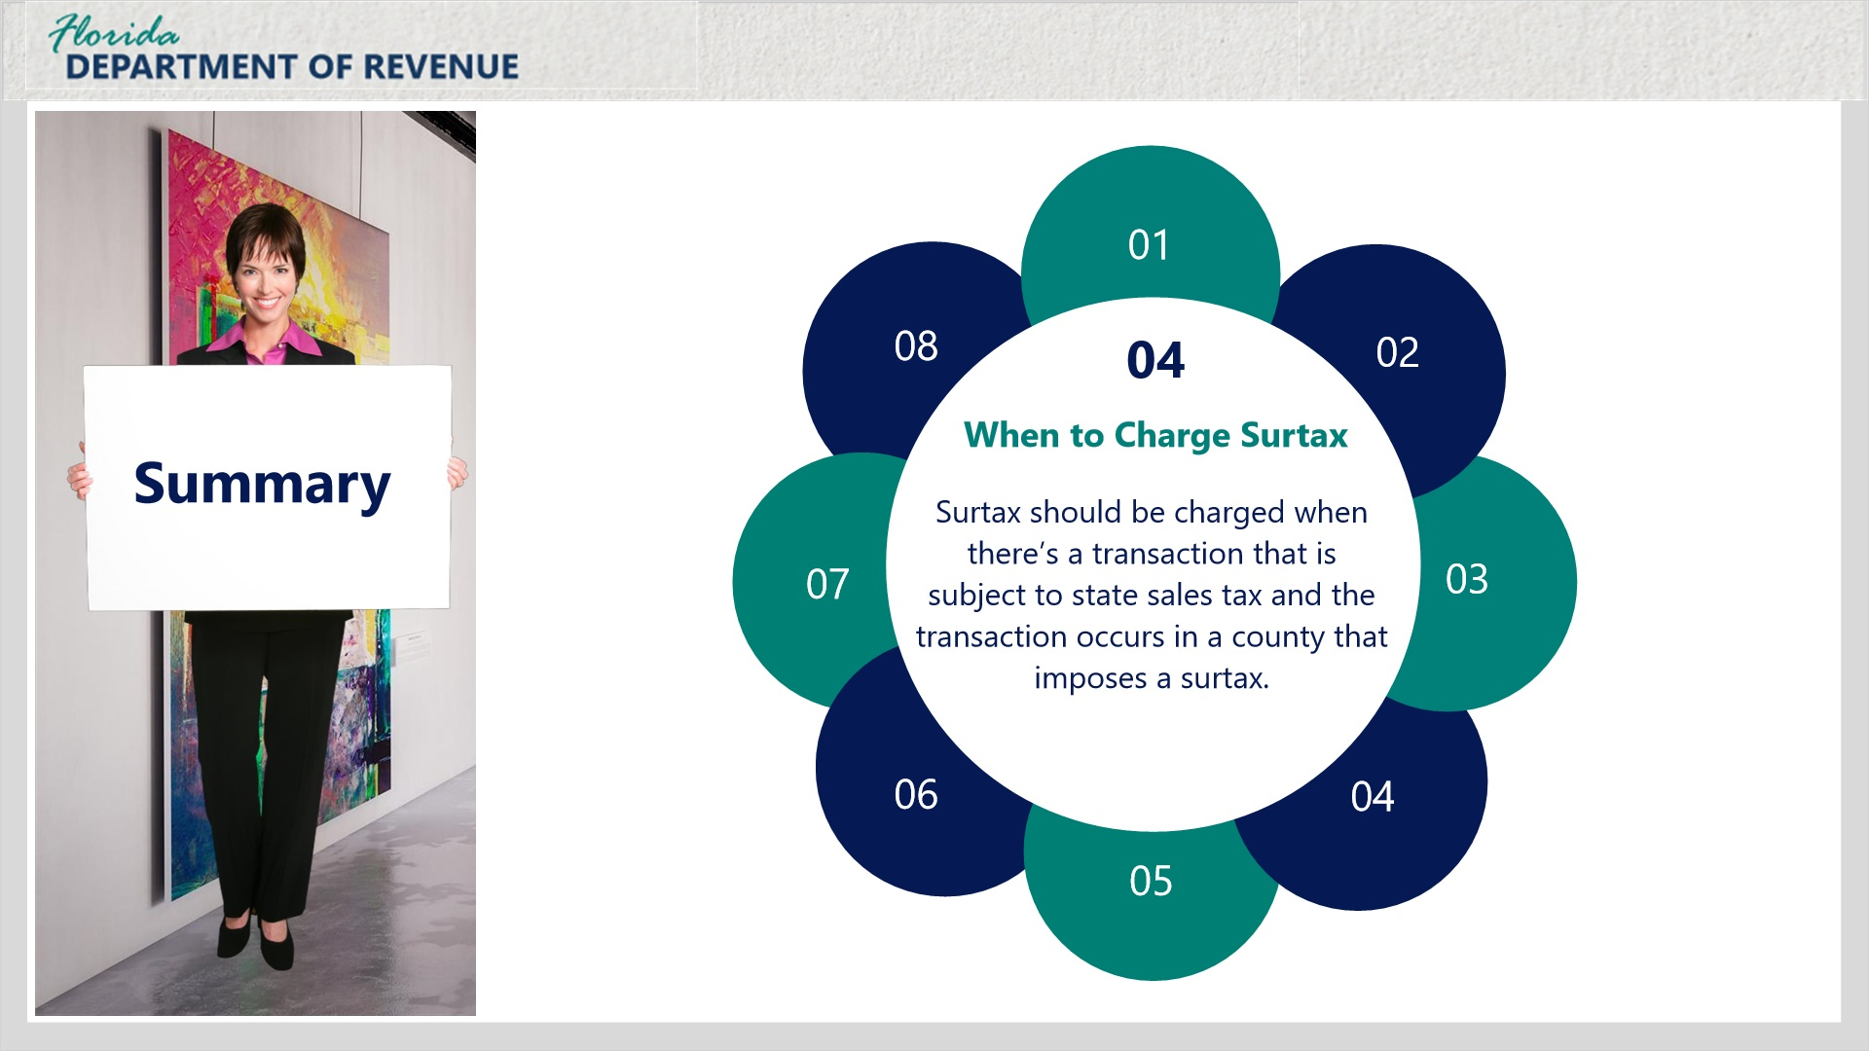
Transcript:
Surtax should be charged when there’s a transaction that is subject to state sales tax and the transaction occurs in a county that imposes a surtax.

Item 05 Surtax Rate Charged(Slide Layer)
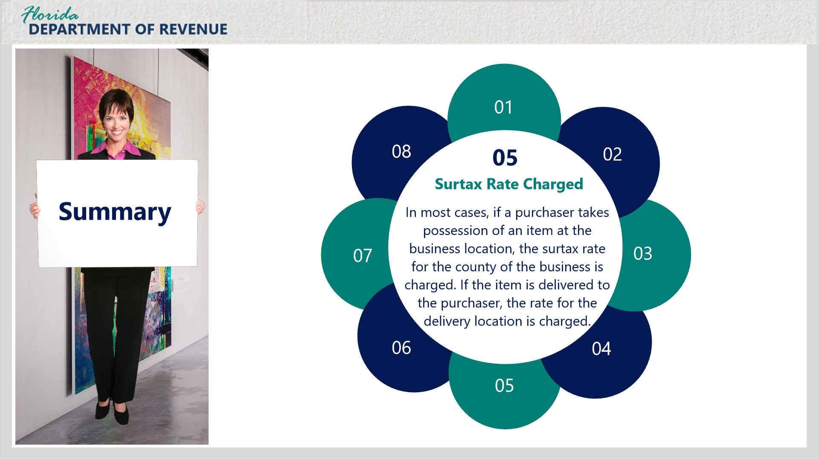
Transcript:
In most cases, if a purchaser takes possession of an item at the business location, the surtax rate for the county of the business is charged. If the item is delivered to the purchaser, the rate for the delivery location is charged.

Item 06 $5,000 Cap (Slide Layer)
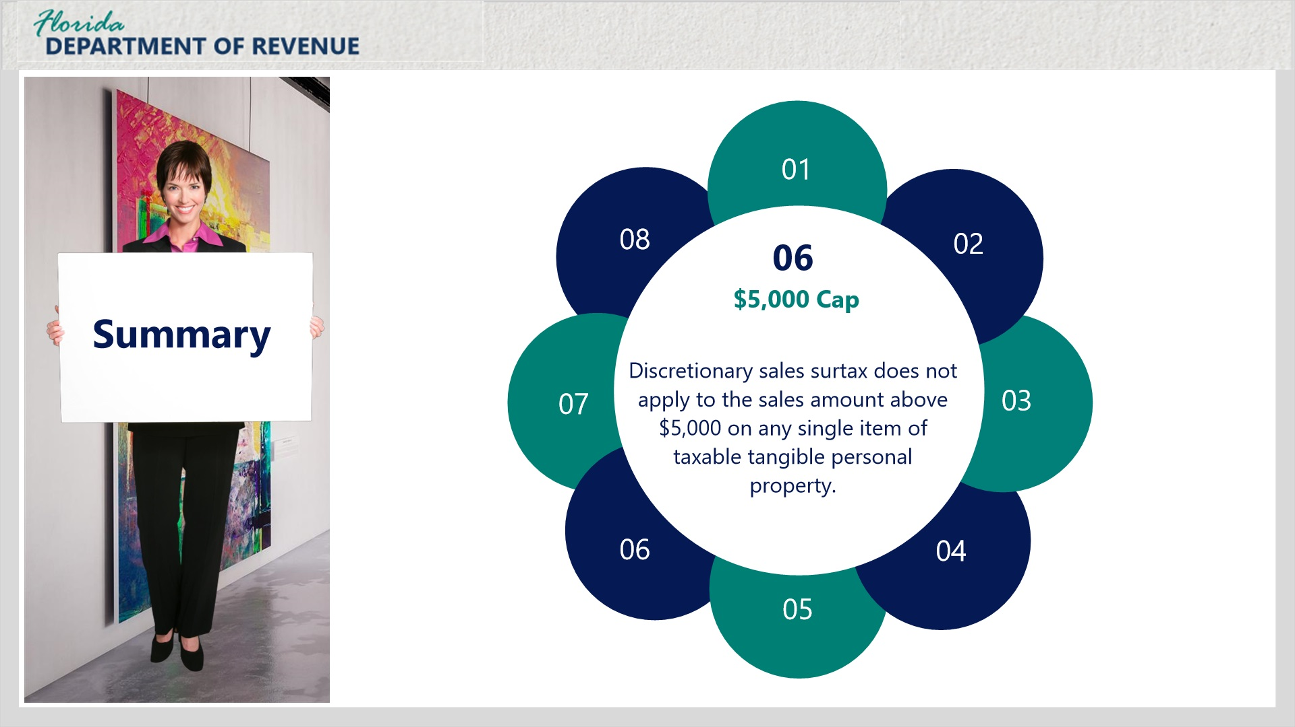
Transcript:
Discretionary sales surtax does not apply to the sales amount above $5,000 on any single item of taxable tangible personal property.

Item 07 Multiple Items (Slide Layer)
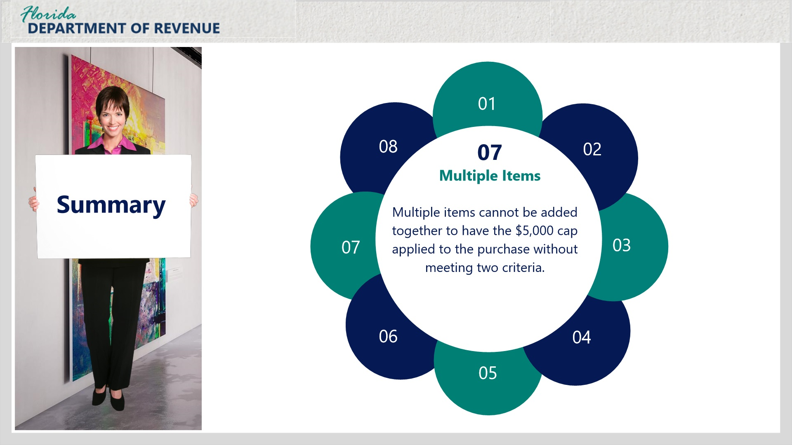
Transcript:
Multiple items cannot be added together to have the $5,000 cap applied to the purchase without meeting two criteria.

Item 08 Multiple Items (Slide Layer)
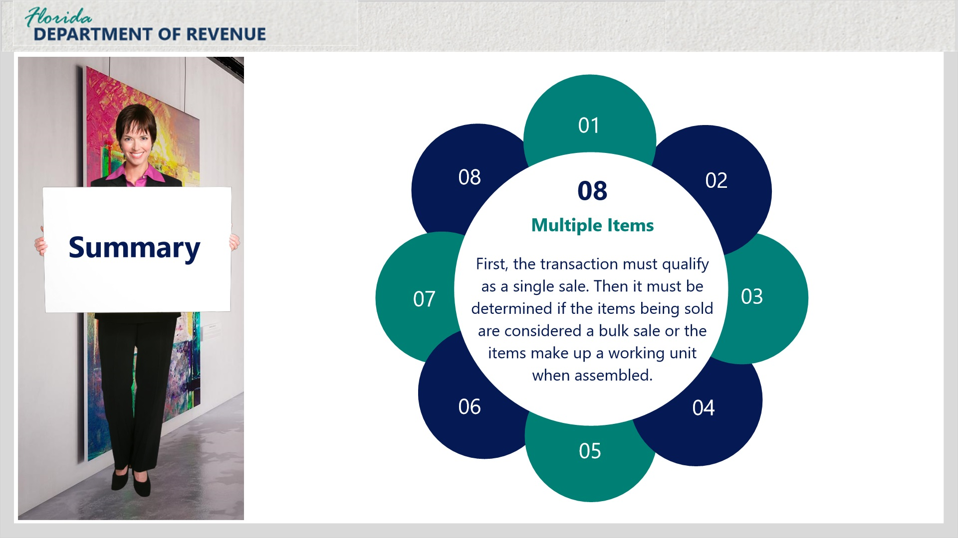
Transcript:
First, the transaction must qualify as a single sale. Then it must be determined if the items being sold are considered a bulk sale or the items make up a working unit when assembled.

7. Conclusion

7.1 Tax Page and Social Media
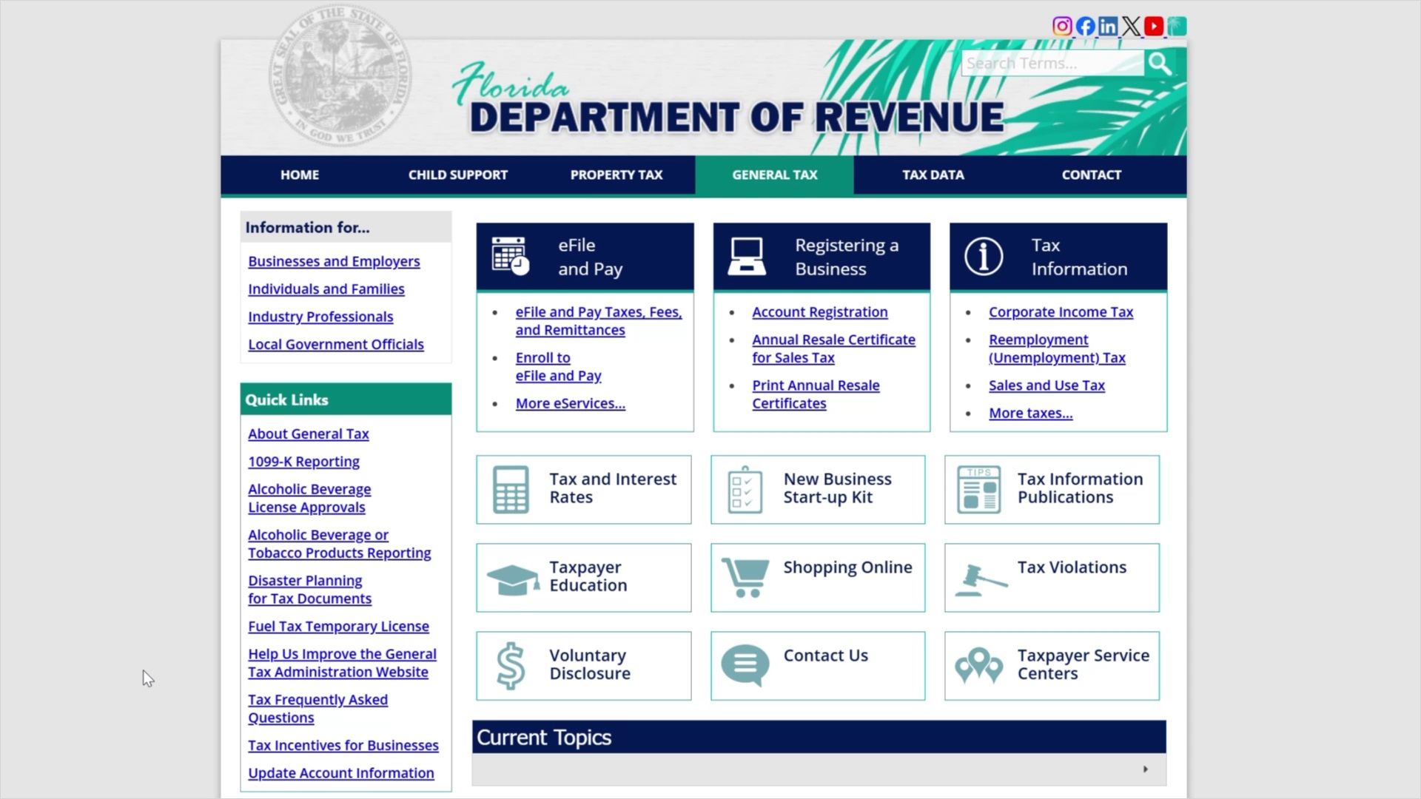
Transcript:
Visit floridarevenue.com/taxes for business resources such as forms, publications, and information on all tax types.
Check out our Taxpayer Education webpage for new business guides, tutorials, and other helpful tools.
And follow us on YouTube, X, Instagram, and LinkedIn using the icons at the top of our website to stay up to date on tax topics, alerts, and more.

7.2 Survey
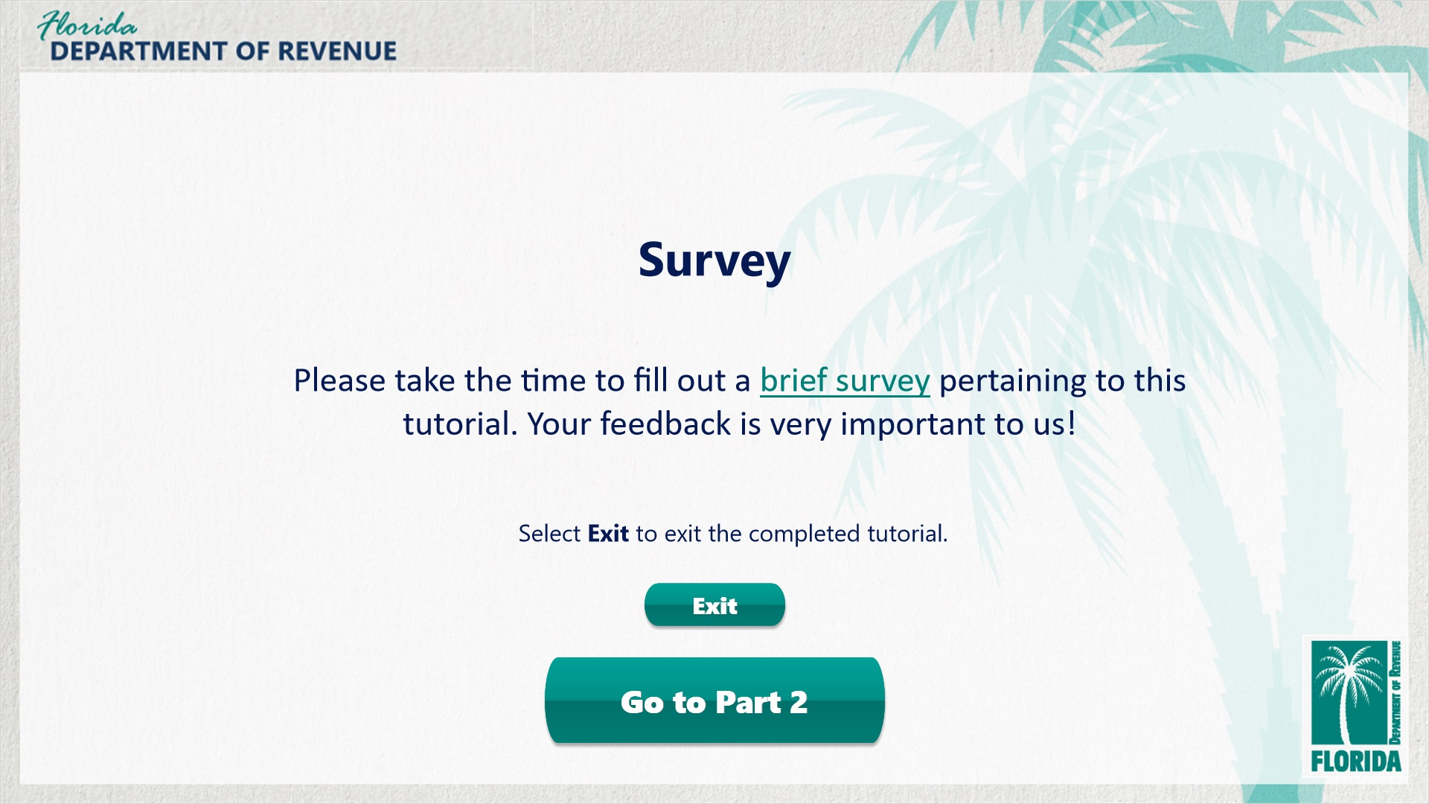
Transcript:
This concludes Discretionary Sales Surtax: The Basics.
If you would like to learn more, click on the button labeled Go to Part 2 to view the second installment of this series, Discretionary Sales Surtax: How to Calculate and Report.
Please take the time to fill out a brief survey pertaining to this tutorial/overview. Your feedback is very important to us.
To exit this tutorial/overview, click on the Exit button.
Thank you.

