How to Complete the Paper-Based Sales and Use Tax Return (Form DR-15)

1. Introduction

1.1 Title Slide
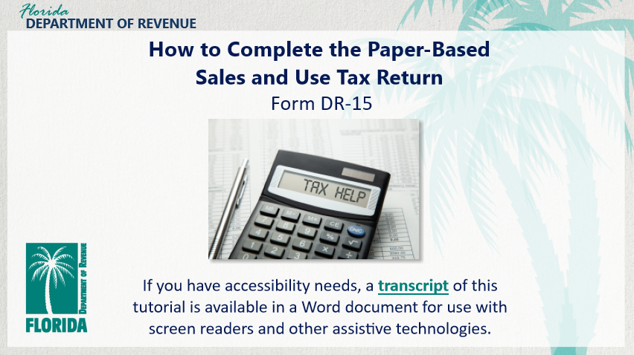
Transcript:
Welcome to “How to Complete the Paper-Based Sales and Use Tax Return (Form DR-15).”
This tutorial explains how to complete a paper-based Sales and Use Tax Return but does not cover how to complete electronic returns.
In this tutorial, we will cover basic information and terminology about the return and how to complete it correctly.
If you have accessibility needs, a transcript of this tutorial is available in a Word document for use with screen readers and other assistive technologies.

1.2 Navigating This Tutorial
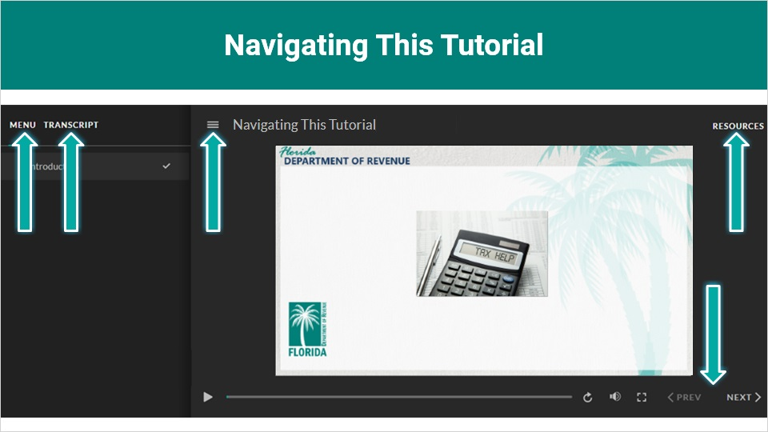
Transcript:
This overview will take approximately 20 minutes to complete. A transcript of the audio is available by clicking on the transcript tab in the top-left corner of your screen.
The following tabs and buttons are available to help you navigate throughout this overview.
Menu Tab
The menu tab displays by default when the overview is viewed on a computer. It allows you to navigate through the overview by clicking on the topic name on the menu. When viewing this overview on a tablet or smartphone, the menu does not display by default and must be accessed using the menu symbol.
Resources Tab
The resources tab is found on the right side of the top bar. When clicked, it displays the list of links to useful forms, documents, and webpages.
Previous and Next Buttons
The previous and next buttons are located at the bottom-right corner of your screen. These buttons allow you to move either back or forward.

1.3 Topics Slide
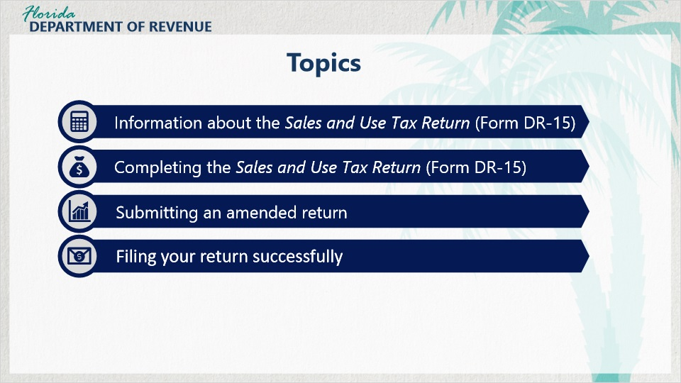
Transcript:
Topics for this tutorial include information about the Sales and Use Tax Return (Form DR-15), the process for completing the return, the process for submitting an amended return, and tips for filing your return successfully.

2. Tax Return Overview

2.1 What is the DR-15?
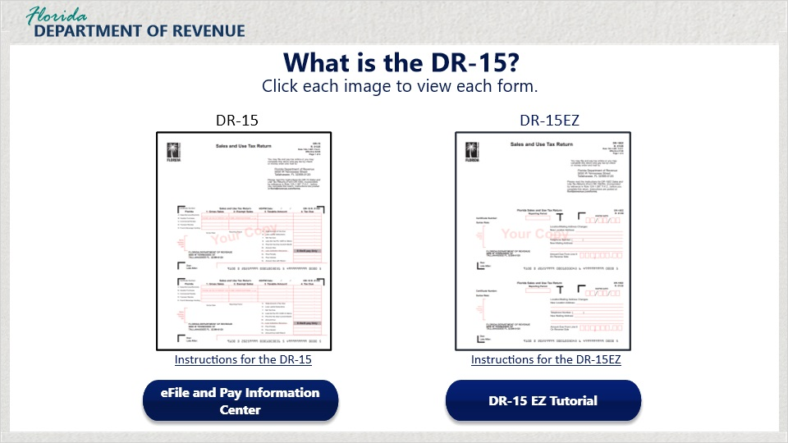
Transcript:
Let’s begin by discussing the DR-15. Sales and use tax and discretionary sales surtax are reported using the Sales and Use Tax Return.
There are two options for completing your return.
The DR-15 is the form most business owners complete.
The DR-15EZ is a simplified version of the DR-15.
Click on each image to view each form.
You have the option to use the DR-15EZ if your business meets all the criteria.
Click on the link, “Instructions for the DR-15EZ” for an explanation of these requirements. If your business qualifies to use the DR-15EZ, you may learn more about it by clicking on the link DR-15EZ Tutorial.
The tutorial you are watching only covers how to complete the paper-based version of the DR-15.
However, you as a business owner may also take advantage of filing your return electronically.
In fact, Florida law requires businesses that paid $5,000 or more in sales and use tax between July 1 and June 30 to file and pay electronically during the next calendar year. If this describes your situation, you are required to file electronically.
Click on the blue button labeled “eFile and Pay Information Center” to access resources such as help guides, tutorials, and videos to help you.
Otherwise, keep watching this tutorial to learn how to complete the paper-based DR-15.

2.2 Due Dates
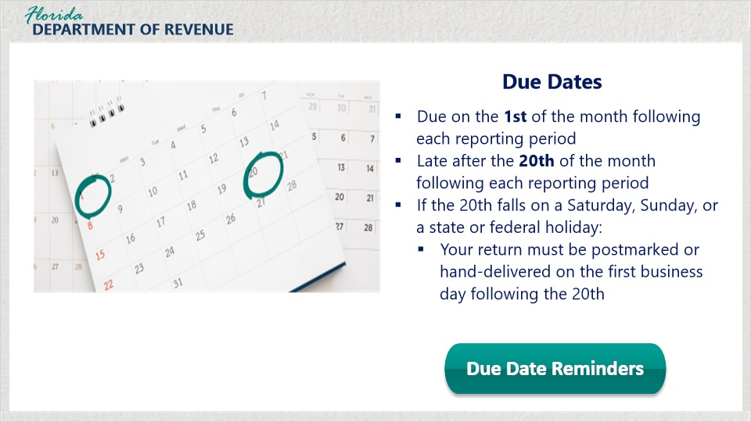
Transcript:
Tax returns and payments are due on the 1st and late after the 20th day of the month following each reporting period. If the 20th falls on a Saturday, Sunday, or a state or federal holiday, your return must be postmarked or hand-delivered on the first business day following the 20th.
You may sign up to receive an email every reporting period to remind you of the upcoming due date to file your return timely.
To sign up, click on the button labeled, “Due Date Reminders.”

2.3 State Sales Tax Rates
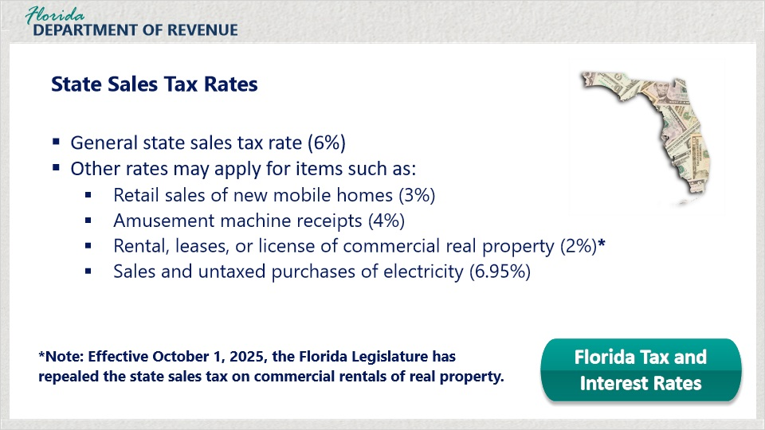
Transcript:
Florida imposes a general state sales tax rate of 6% on sales and purchases of items, services, and transient rentals. However, other rates may apply for items such as retail sales of new mobile homes at 3%, amusement machine receipts at 4%, rental leases, or licenses of commercial real property at 2%, and sales and untaxed purchases of electricity at 6.95%.
For a list of current sales and use tax rates, click on the button labeled “Florida Tax and Interest Rates.”
Note: Effective October 1, 2025, the Florida Legislature has repealed the state sales tax on commercial rentals of real property.

2.4 Discretionary Sales Surtax
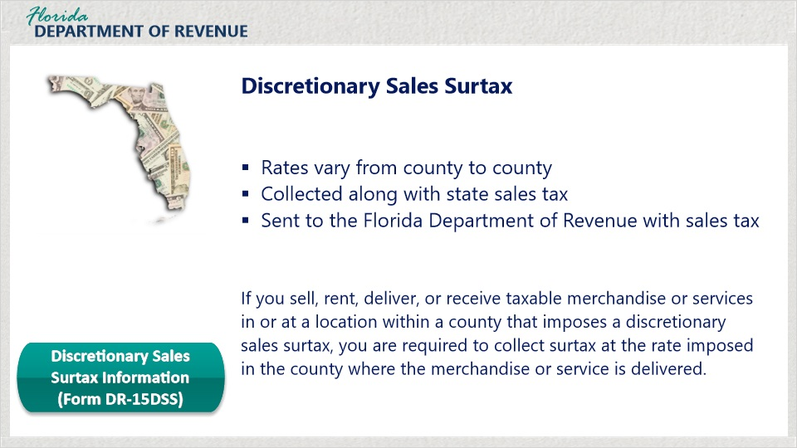
Transcript:
In addition to the state sales and use tax rate, Florida counties may impose a discretionary sales surtax. For a list of discretionary sales surtax rates, review Discretionary Sales Surtax Information (Form DR-15DSS) by clicking on the button.
Discretionary sales surtax rates vary from county to county. Surtax is collected along with the state sales tax. It is sent to the Florida Department of Revenue with sales tax.
If you sell, rent, deliver, or receive taxable merchandise or services in or at a location within a county that imposes a discretionary sales surtax, you are required to collect surtax at the rate imposed in the county where the merchandise or service is delivered.

2.5 Rounding Algorithm
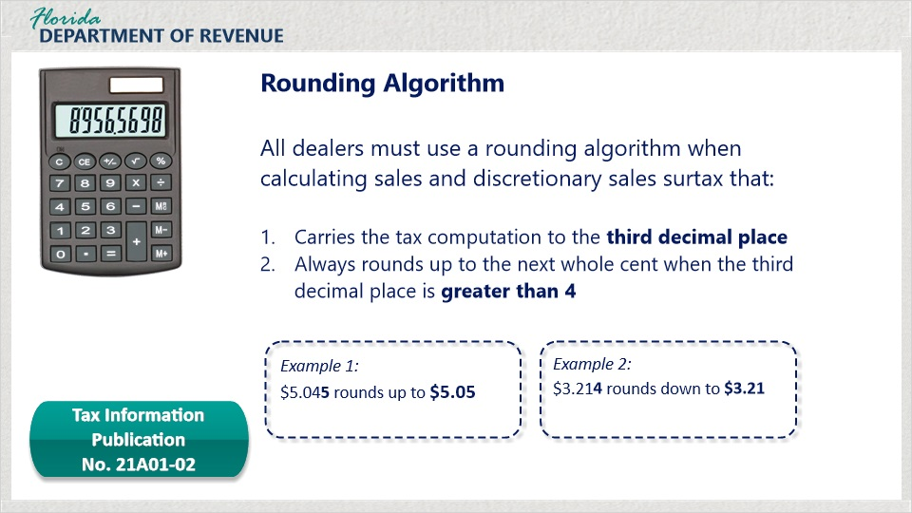
Transcript:
All dealers must use a rounding algorithm when calculating sales tax and discretionary sales surtax.
Dealers must use a rounding algorithm that carries the tax computation to the third decimal place, and always rounds up to the next whole cent when the third decimal place is greater than 4.
For instance, in the first example, $5.045 rounds up to $5.05.
In the second example, $3.214 rounds down to $3.21.
For more information about the rounding algorithm, click on the button.
Dealers may compute the tax by applying the rounding algorithm to the combined taxable amount on an invoice or to individual taxable items on an invoice.
For more details, refer to the Tax Information Publication No. 21A01-02.

3. Completing the Sales and Use Tax Return: Columns 1-4

3.1 Sales and Use Tax Return (Form DR-15)
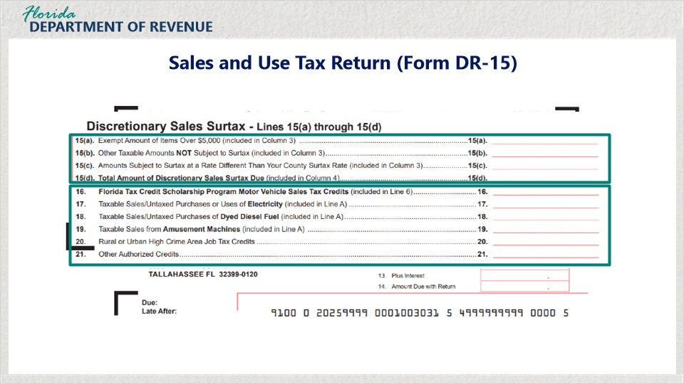
Transcript:
Let’s take a look at the actual DR-15. The form is double-sided.
Sales and use tax return information is on the front.
Featured on the back are lines for calculations for discretionary sales surtax.
You will also see lines for tax credits, along with lines to calculate taxes that are different from the standard 6% sales tax rate.

3.2 Sales and Use Tax Return (Form DR-15)
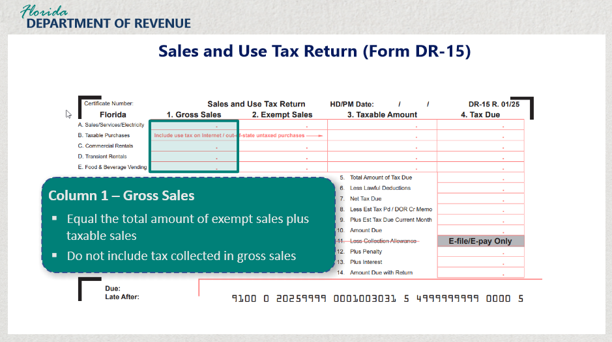
Transcript:
Let’s define a few of the terms for Columns 1 through 4 on the front of Form DR-15.
In Column 1, Gross Sales equal the total amount of exempt sales plus taxable sales. Do not include tax collected in gross sales.
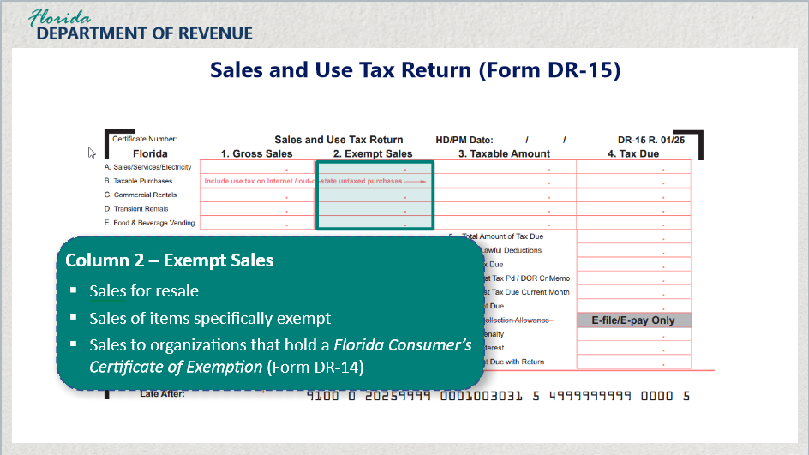

Transcript:
In Column 2, Exempt Sales include sales for resale, sales of items specifically exempt, and sales to organizations that hold a Florida Consumer’s Certificate of Exemption (Form DR-14).

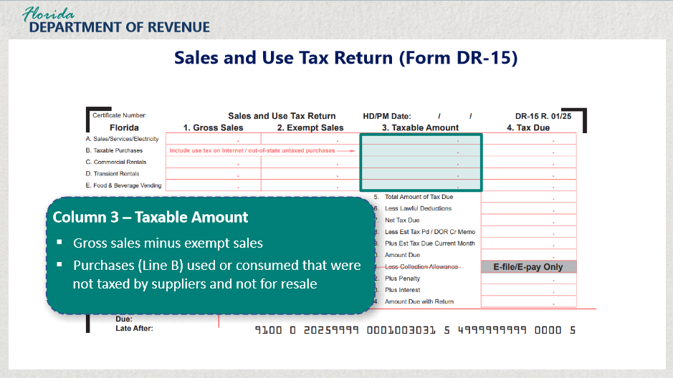

Transcript:
In Column 3, the Taxable Amounts are gross sales minus exempt sales and purchases found on Line B, used or consumed that were not taxed by suppliers and were not for resale.

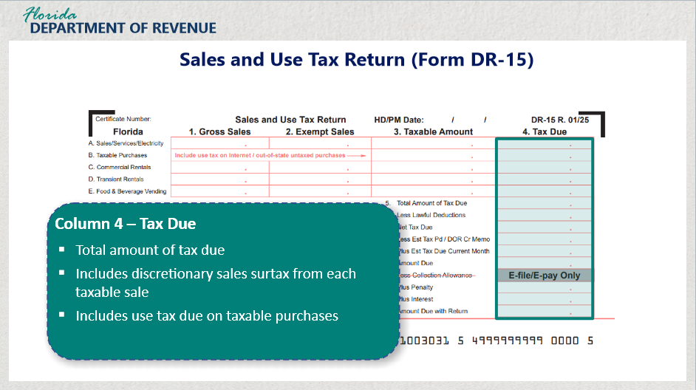

Transcript:
Finally, in Column 4, Tax Due is the total amount of tax due, including discretionary sales surtax due from each taxable sale and the use tax due on taxable purchases.
-----------------------------------------
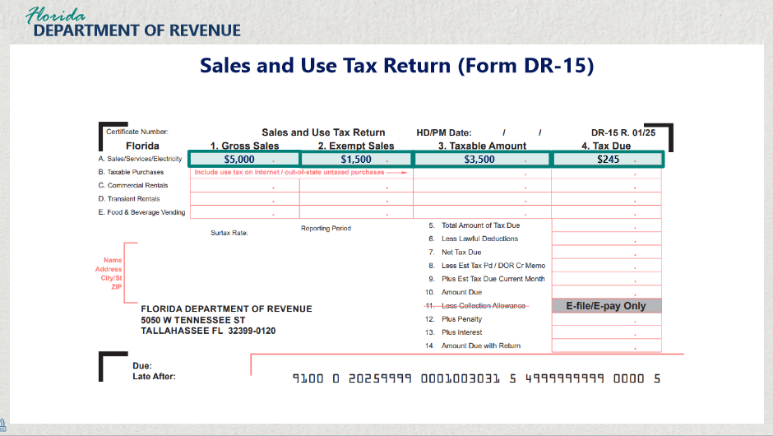

Transcript:
For example, a taxpayer in a 1% county has total sales of $5,000 for his business. $1,500 of that amount is exempt from tax. The taxable amount is equal to gross sales minus exempt tax or $3,500. $210 in state sales and use tax and $35 discretionary sales surtax was collected. The tax due is $245.

3.3 Knowledge Check
(Multiple Choice, 10 points, 2 attempts permitted)
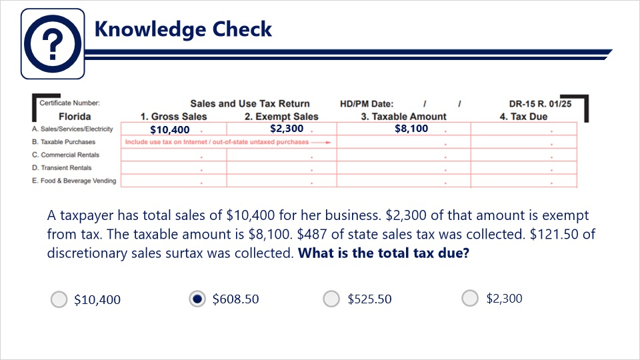
Transcript:
Question: A taxpayer has total sales of $10,400 for her business. $2,300 of that amount is exempt from tax. The taxable amount is $8,100. $487 of state sales tax was collected. $121.50 of discretionary sales surtax was collected. What is the total tax due?
Answers:
- $10,400
- $608.50
- $525.50
- $2,300
Correct Answer: $608.50

4. Completing the Sales and Tax Return: Lines A-E

4.1 Line A: Sales/Services/Electricity
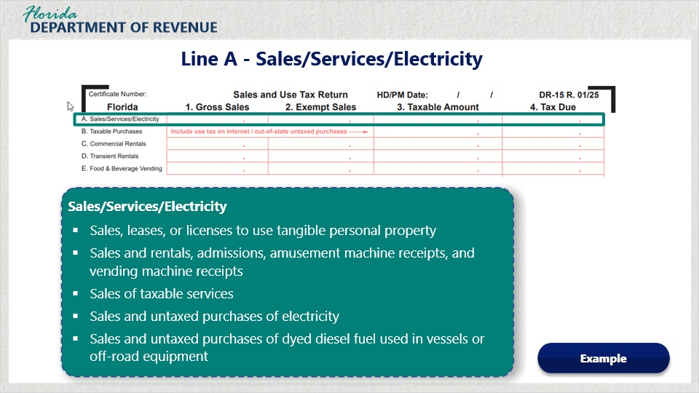
Transcript:
Now that we have discussed Columns 1 through 4, let’s take a closer look at Lines A through E.
Line A focuses on sales, services, and electricity. Transactions in this line include, sales, leases, or licenses to use tangible personal property, sales and rentals, admissions, amusement machine receipts, and vending machine receipts, sales of taxable services, sales and untaxed purchases of electricity, and sales and untaxed purchases of dyed diesel fuel used in vessels or off-road equipment.
To view an example of entering the amounts for Line A, click on the Example button.
----------------------------------------
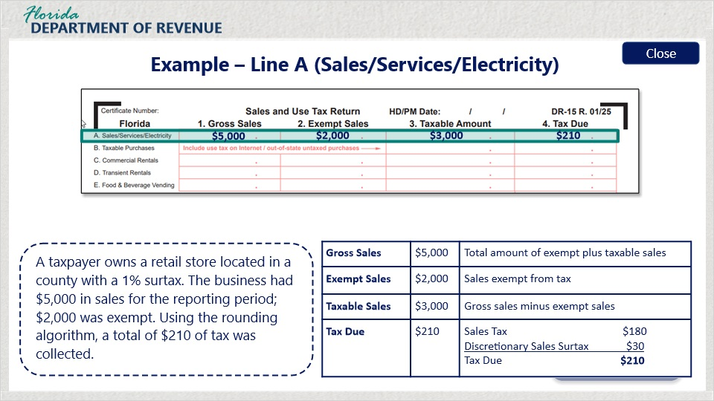
Transcript:
A taxpayer owns a retail store located in a county with a 1% surtax. The business had $5,000 in sales for the reporting period. $2,000 was exempt. Using the rounding algorithm, a total of $210 of tax was collected.

4.2 Line B: Taxable Purchases
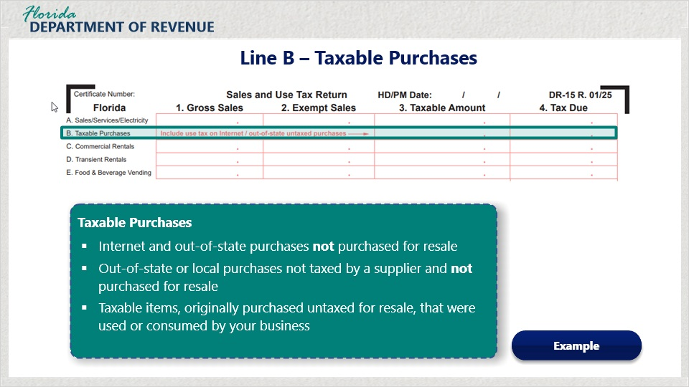
Transcript:
Line B consists of the calculations of all taxable purchases. In Column 3 of Line B, the taxpayer adds up all of the taxable purchases, putting the tax due for those purchases in Column 4 of Line B.
Taxable purchases consist of internet and out-of-of state purchases not purchased for resale, out-of-state or local purchases not taxed by a supplier and not purchased for resale,
and taxable items, originally purchased untaxed for resale that were used or consumed by your business.
To view an example of entering the amounts for Line B, click on the Example button.
--------------------------------------------
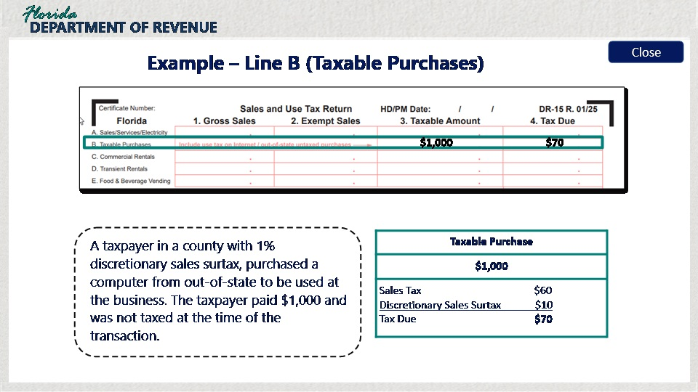
Transcript:
A taxpayer in a county with 1% discretionary sales surtax purchased a computer from out of state to be used at the business. The taxpayer paid $1,000 and was not taxed at the time of the transaction.

4.3 Line C: Commercial Rentals
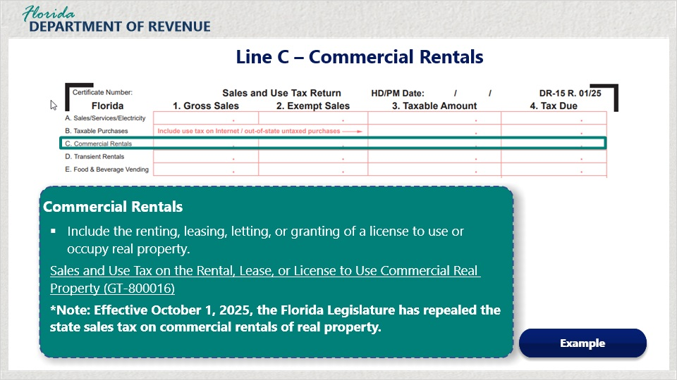
Transcript:
Line C is where you enter information on any commercial rentals your business may be involved in.
Commercial rentals include the renting, leasing, letting, or granting of a license to use or occupy real property.
For more information on sales and use tax on commercial rent, visit Sales and Use Tax on the Rental, Lease, or License to Use Commercial Real Property (Form GT-800016).
Note: Effective October 1, 2025, the Florida Legislature has repealed the state sales tax on commercial rentals of real property.
To view an example of entering the amounts for Line C, click on the Example button.
---------------------------------------------
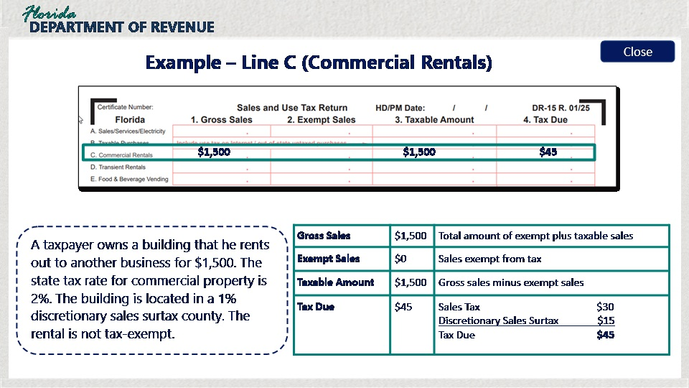

For example, a taxpayer owns a building that he rents out to another business for $1,500. The state tax rate for commercial property is 2%. The building is located in a 1% discretionary sales surtax county. The rental is not tax-exempt.
In this example, gross sales equal $1,500. There are no exempt sales therefore, the taxable amount is $1,500. Sales tax equals $30. Discretionary sales surtax equals $15. These two amounts added together determine that the tax due amount is $45.

4.4 Line D: Transient Rentals
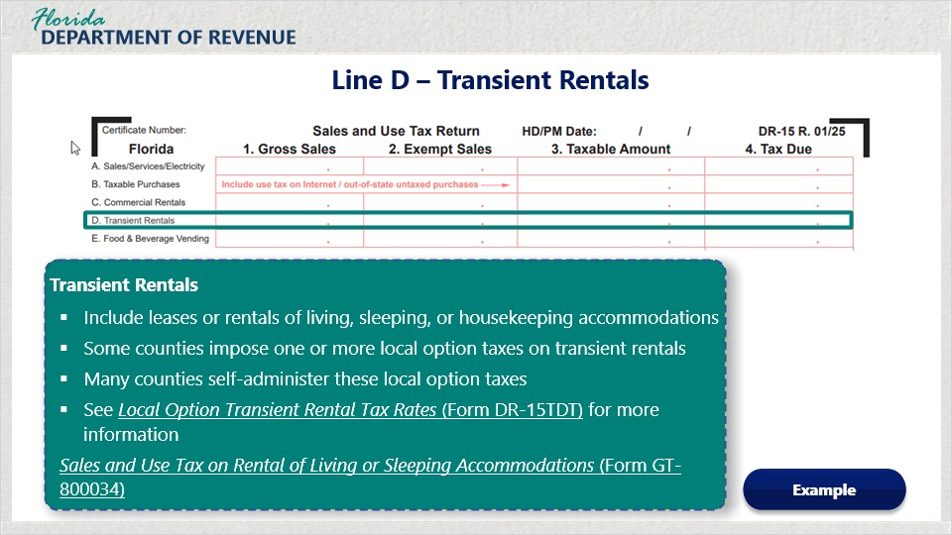
Transcript:
Line D is where you will enter the information concerning transient rentals.
These include leases or rentals of living, sleeping, or housekeeping accommodations.
Some counties impose one or more local option taxes on transient rentals. Many, but not all, counties self-administer these local option taxes.
Local Option Transient Rental Tax Rates (Form DR-15TDT) provides a listing of rates and whether the local option tax is collected by the county or by the Florida Department of Revenue.
For more information on sales and use tax on transient rent, view Sales and Use Tax on Rental of Living or Sleeping Accommodations (Form GT-800034).
To view an example of entering the amounts for Line C, click on the Example button.
--------------------------------------------
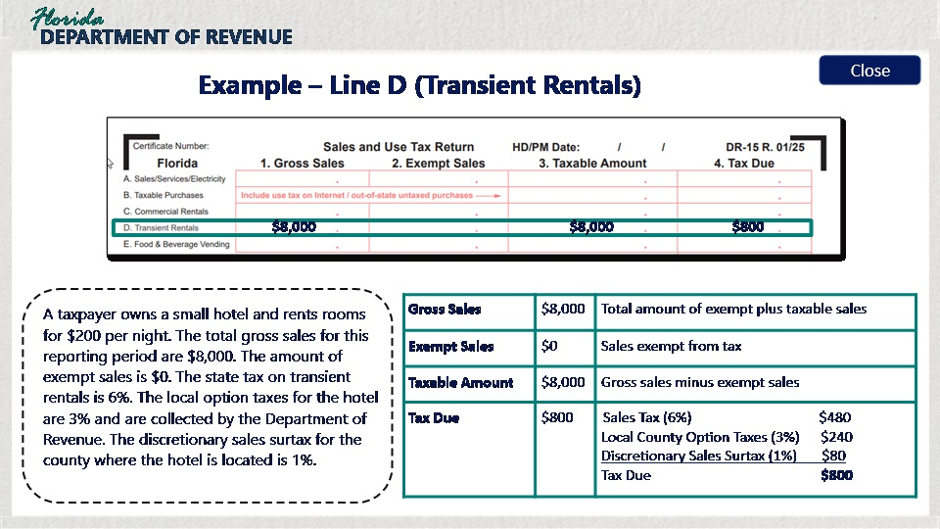
A taxpayer owns a small hotel and rents rooms for $200 per night. The total gross sales for this reporting period are $8,000. The amount of exempt sales is $0. The state tax on transient rentals is 6%. The local option taxes for the hotel are 3% and are collected by the Department of Revenue. The discretionary sales surtax for the county where the hotel is located is 1%.

4.5 Line E: Food/Beverage Vending
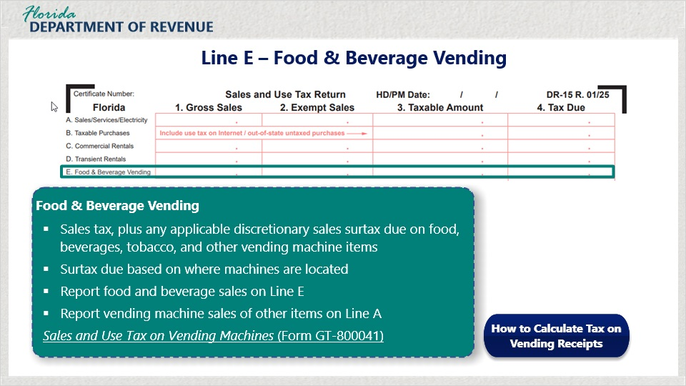
Transcript:
On Line E, you will include calculations concerning funds received from food and beverage vending machines.
Sales tax, plus any applicable discretionary sales surtax, is due on food, beverages, tobacco, and other items sold through vending machines.
Surtax is due at the rate imposed by the county where the machines are located.
Report sales from food and beverage machines on Line E. Report vending machine sales of items other than food and beverage on Line A.
For more information on food and beverage vending machines, visit Sales and Use Tax on Vending Machines (Form GT-800041).
There is a specific formula for calculating tax on food and beverage vending. For further instructions, click on the button “How to Calculate Tax on Vending Receipts.”
-------------------------------------------
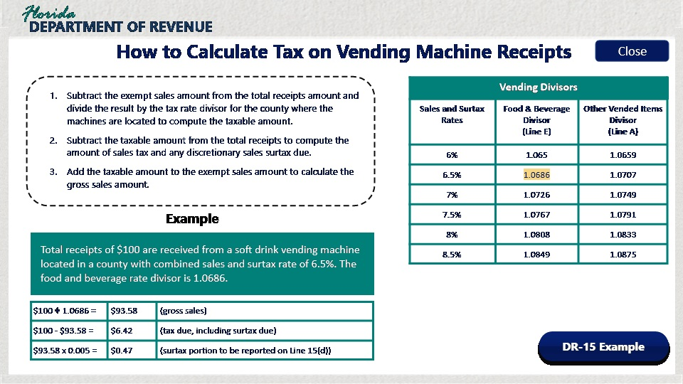

Transcript:
To calculate the sales tax and any applicable discretionary sales surtax on sales from vending machines with exempt items:
First, subtract the exempt sales amount from the total receipts amount and divide the result by the tax rate divisor for the county where the machines are located to compute the taxable amount.
Next, subtract the taxable amount from the total receipts to compute the amount of sales tax and any discretionary sales surtax due.
Finally, add the taxable amount to the exempt sales amount to calculate the gross sales amount.
In this example, the total receipts of $100 are received from a soft drink vending machine located in a county with a combined sales and surtax rate of 6.5%. The food and beverage rate divisor is 1.0686.
First, divide the total receipts of $100 by the divisor of 1.0686. The total amount of gross sales is $93.58.
Then subtract exempt sales made through the vending machines. In this example, no sales were exempt.
Subtract taxable sales from the total receipts to compute the amount of sales tax and surtax due. $100 minus the gross sales amount of $93.58 equals $6.42, which is the total tax due.
On Line 15(d) on the back of the return, you will need to enter the surtax portion. To calculate the surtax, multiply the gross sales amount of $93.58 by the discretionary sales surtax rate of 0.5% or 0.005. The total to enter on Line 15(d) is $0.47.
Click on the button labeled “DR-15 Example” for an example of how these calculations would appear on a Sales and Use Tax Return (Form DR-15).
----------------------------------------------------
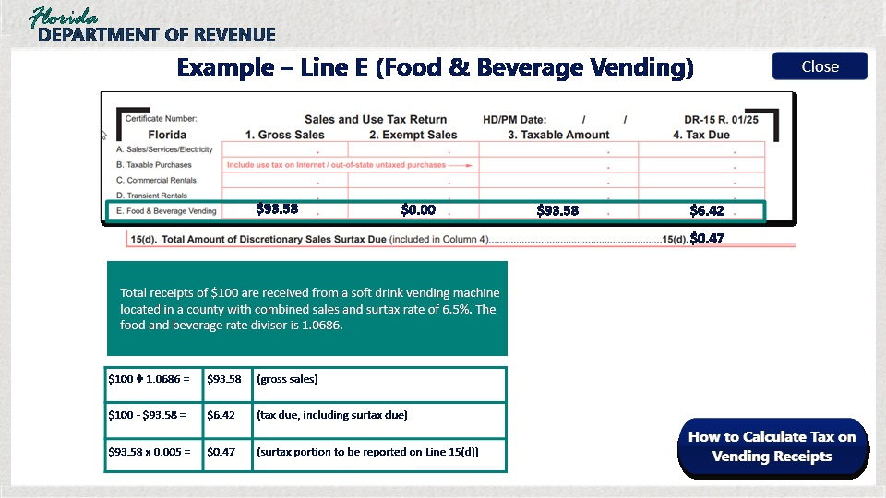
Transcript:
Total receipts of $100 are received from a soft drink vending machine located in a county with combined sales and surtax rate of 6.5%. The food and beverage rate divisor is 1.0686.

4.6 Knowledge Check
(Multiple Choice, 10 points, 2 attempts permitted)
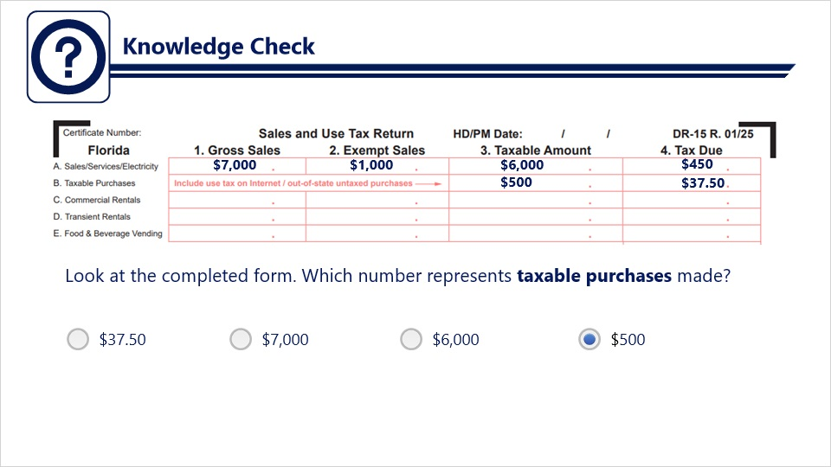
Transcript:
Question: Look at the completed form. Which number represents taxable purchases made?
Answers:
- $37.50
- $7,000
- $6,000
- $500
Correct Answer: $500

5. Completing the Sales and Use Tax Return: Lines 5-14

5.1 Line 5 – Total Amount of Tax Due
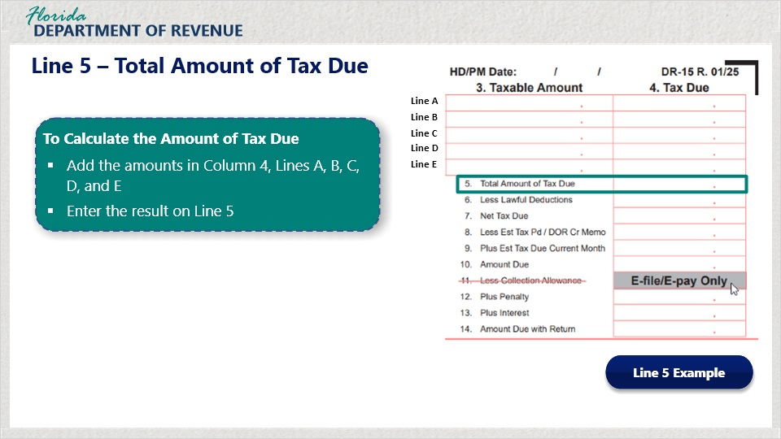
Transcript:
Now that we have reviewed Columns 1 through 4, let’s move on to Lines 5 through 14 going down the right side of the return.
Line 5 is where you calculate the amount of tax due. Add the amounts in Column 4, Lines A, B, C, D, and E. Enter the result on Line 5.
To see an example, select the button labeled “Line 5 Example.”
-----------------------------------------
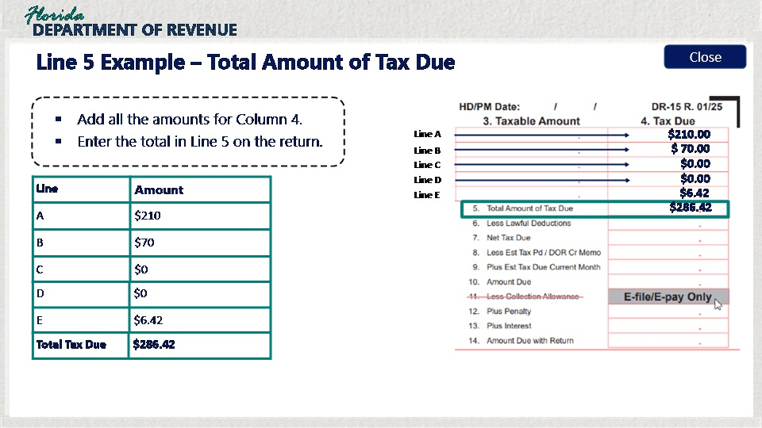

Transcript:
To calculate the total amount of tax due on Line 5, begin by entering all of the totals in column 4 in Lines A, B, C, D, and E.
The total tax due after adding these amounts together is $286.42.

5.2 Line 6 – Less Lawful Deductions
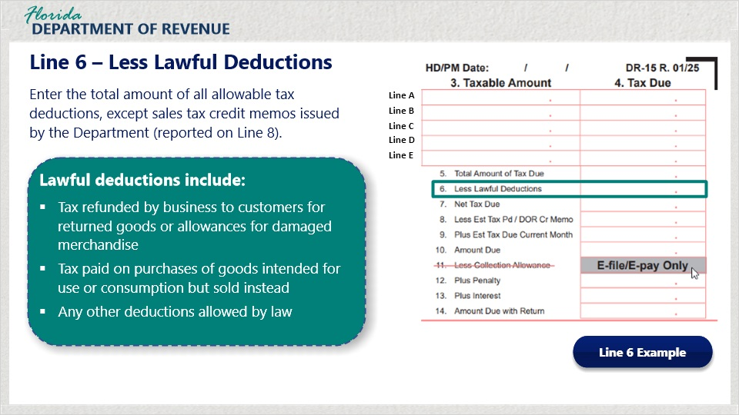
Transcript:
Line 6 is where you enter the total of all allowable tax deductions, except sales tax credit memos issued by the Department. These will be entered on Line 8.
Do not include documentation with your return. Keep complete and accurate records for all of your tax returns for at least three years.
To see an example, select the button labeled Line 6 Example.
--------------------------------
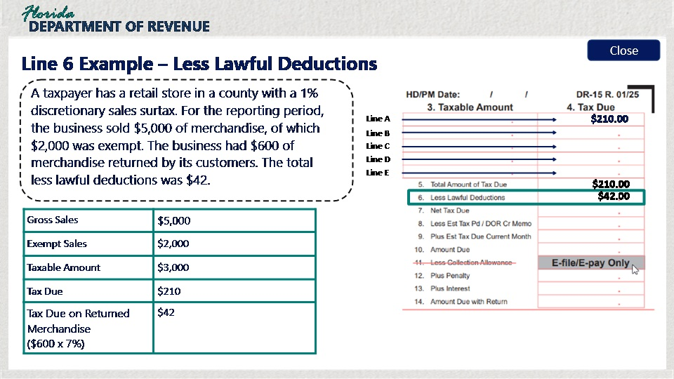

Transcript:
In this example, a taxpayer has a retail store in a county with a 1% discretionary sales surtax. For the reporting period, the business sold $5,000 of merchandise, of which $2,000 was exempt. The business had $600 of merchandise returned by its customers. The total less lawful deductions was $42.
For this example, gross sales equal $5,000.
Exempt sales equals $2,000.
The taxable amount after deducting exempt sales from gross sales is $3,000.
The tax due equals $210.
The tax due on the returned merchandise is $42.

5.3 Line 7 – Net Tax Due
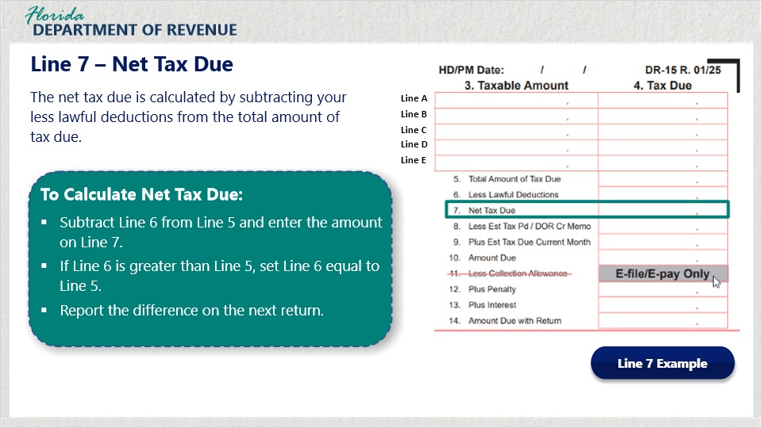
Transcript:
Line 7 is where you will enter the net tax due. To calculate this amount, subtract Line 6 from Line 5 and enter the amount on Line 7.
If Line 6 is greater than Line 5, reduce Line 6 equal to the amount of Line 5. Report the remaining amount of Line 6, (not to exceed the total amount of tax due) on the next return.
Click on the button labeled “Line 7 Example” to view an example of how to calculate the net tax due.
----------------------------------------
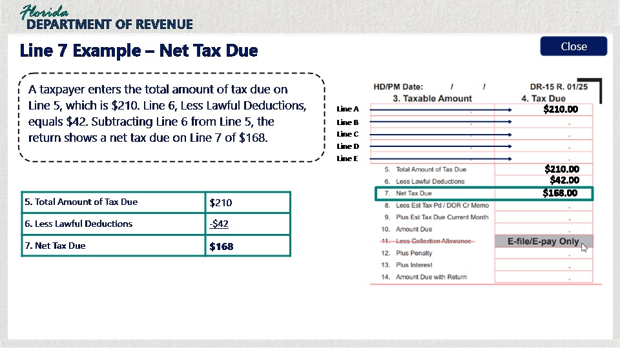

Transcript:
A taxpayer enters the total amount of tax due on Line 5, which is $210. Line 6, Less Lawful Deductions, equals $42. Subtracting Line 6 from Line 5, the return shows a net tax due on Line 7 of $168.

5.4 Lines 8 and 9 – Estimated Tax
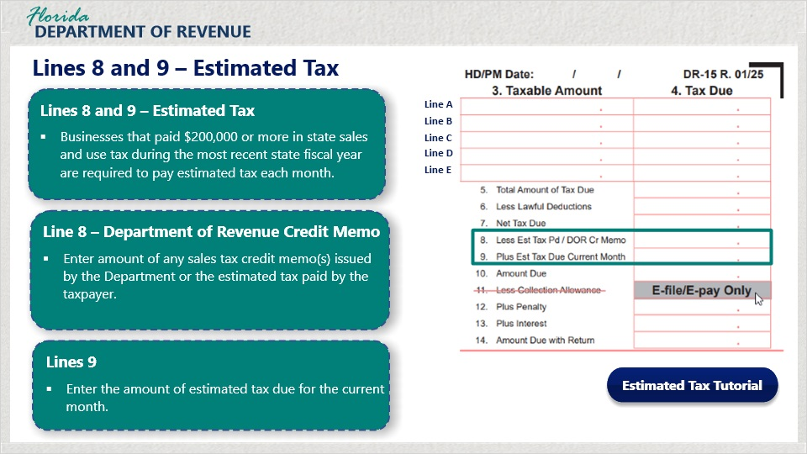
Transcript:
Lines 8 and 9 on the return concern estimated sales tax.
Line 8 is for the estimated tax that has been paid or may refer to a credit memo issued to the taxpayer by the Department or the estimated tax paid by the taxpayer.
Businesses that paid $200,000 or more in state sales and use tax during the most recent state fiscal year are required to pay estimated tax each month.
On Line 8, enter the amount of any sales tax credit memos issued by the Department or the estimated tax paid by the taxpayer.
On Line 9, enter the amount of estimated tax due for the current month.
To view the Department’s tutorial “How to Calculate and Pay Estimated Sales and Use Tax,” click on the blue button labeled “Estimated Tax Tutorial.”

5.5 Line 10 – Amount Due
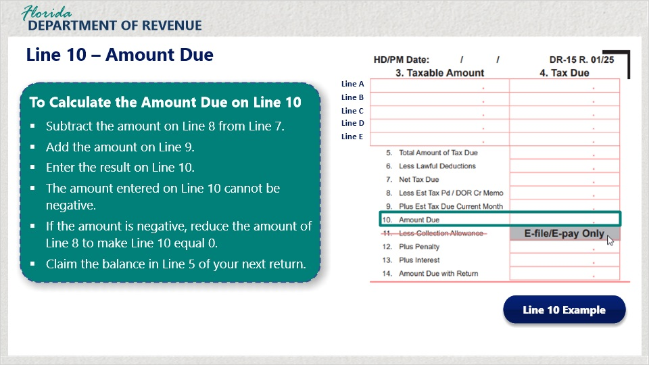
Transcript:
To calculate the Amount Due field on Line 10, subtract the amount on Line 8 from Line 7. Add the amount on Line 9. Enter the result on Line 10.
The amount entered on Line 10 cannot be negative. If the amount is negative, reduce the amount of Line 8 to make Line 10 equal 0. Claim the balance in Line 5 of your next return.
Select the button labeled “Line 10 Example” for an example of how to calculate this amount.
------------------------------------------------------------------------------
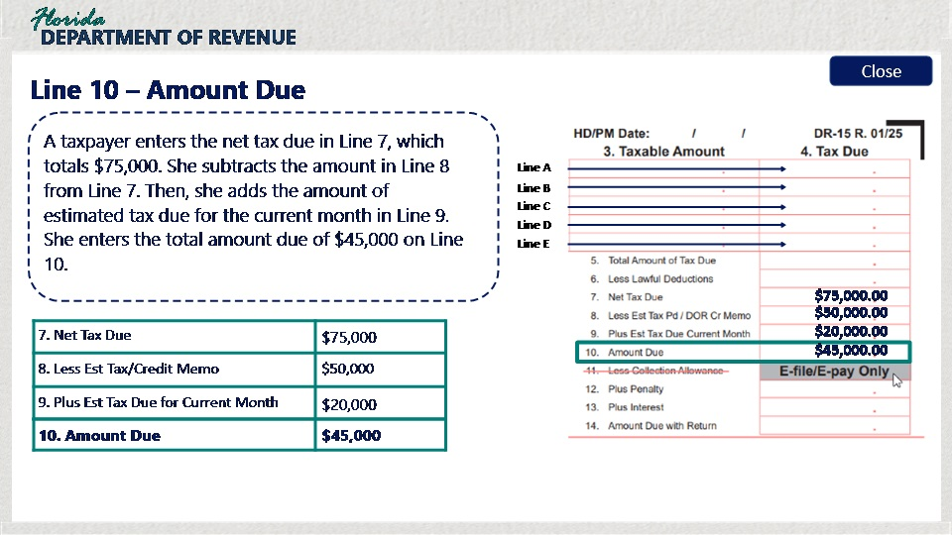

Transcript:
A taxpayer enters the net tax due in Line 7, which totals $75,000. She subtracts the amount in Line 8 from Line 7. Then, she adds the amount of estimated tax due for the current month in Line 9. She enters the total amount due of $45,000 on Line 10.

5.6 Lines 12, 13, and 14
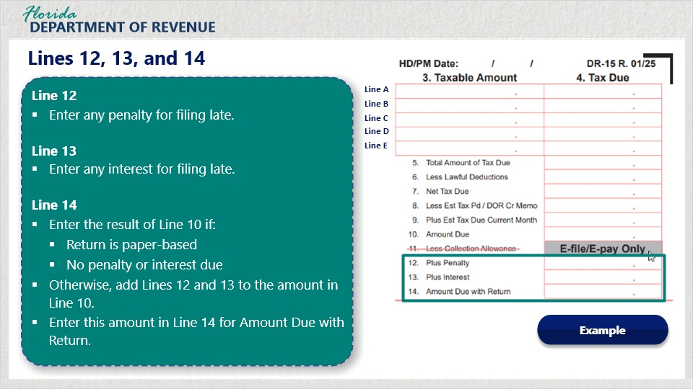
Transcript:
If you are filing a paper-based return, you do not qualify to receive a collection allowance; therefore, you do not need to enter anything in Line 11.
In Line 12, enter any penalty you owe for filing and paying your return late.
In Line 13, enter any interest accrued as a result of filing and paying your return late.
In Line 14, enter the final amount due with your return. If you are submitting your paper-based return on time, enter the result of Line 10 into Line 14.
If you file your return late, enter the result of line 10 plus penalty and interest on Line 14.
To see an example, click the “Example” button.
-----------------------------------------------------------
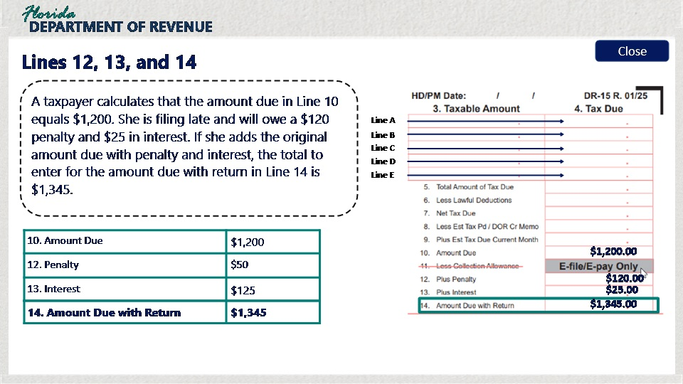

Transcript:
A taxpayer calculates that the amount due in Line 10 equals $1,200. She is filing late and will owe a $120 penalty and $25 in interest. If she adds the original amount due with penalty and interest, the total to enter for the amount due with return in Line 14 is $1,345.

6. Completing the Sales and Use Tax Return: Lines 15(a) - 15(d)

6.1 Line 15(a) – Exempt Amount of Items Over $5,000
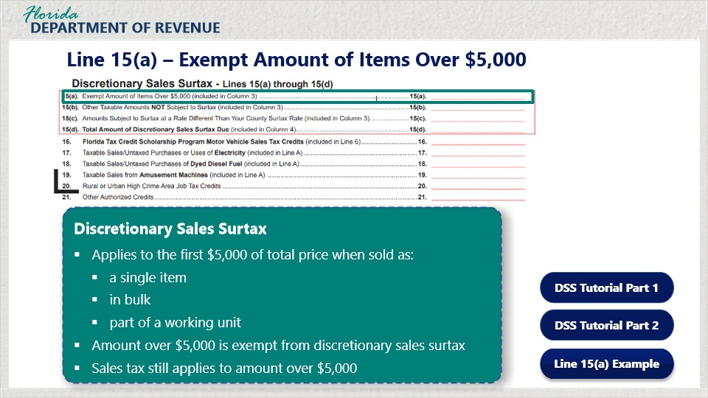
Transcript:
Lines 15(a) through 15(d) are used to report discretionary sales surtax information. To learn more about discretionary sales surtax and how to calculate it correctly, choose from one of the DSS Tutorial buttons. Part 1 consists of a basic overview of discretionary sales surtax. Part 2 shows you how to calculate and report it properly.
Discretionary sales surtax applies to the first $5,000 on the sale, use, lease, or rental of any item of tangible personal property when the property is sold as a single item, in bulk, or as a working unit or part of a working unit. You do not have to pay discretionary sales surtax for purchases over $5,000. However, sales tax is applied to the entire amount of the purchase.
On Line 15(a), you will enter all amounts in excess of $5,000 on each single sale.
Click on the Line 15(a) Example button for more details on Line 15(a).
------------------------------------
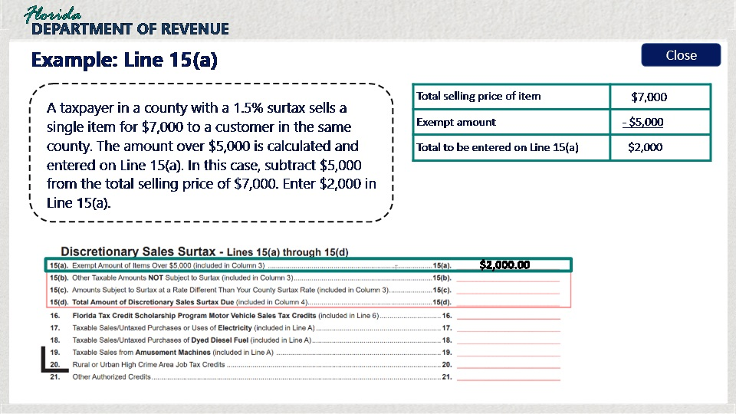

Transcript:
A taxpayer in a county with a 1.5% surtax sells a single item for $7,000 to a customer in the same county.
The amount over $5,000 is calculated and entered on Line 15(a). In this case, subtract $5,000 from the total selling price of $7,000. Enter $2,000 in Line 15(a).

6.2 Knowledge Check #1
(Multiple Choice, 10 points, 2 attempts permitted)
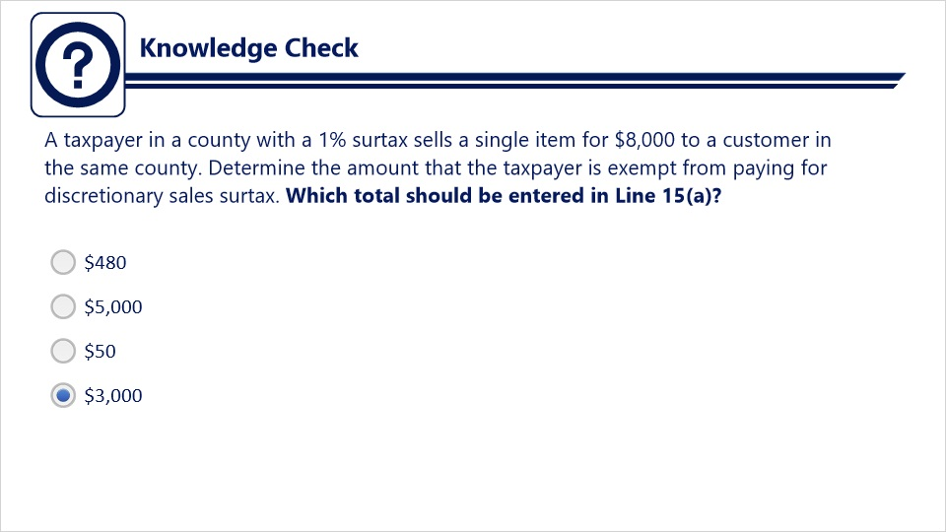
Transcript:
Question: A taxpayer in a county with a 1% surtax sells a single item for $8,000 to a customer in the same county. Determine the amount that the taxpayer is exempt from paying for discretionary sales surtax. Which total should be entered in Line 15(a)?
Answers:
- $480
- $5,000
- $50
- $3,000
Correct Answer: $3,000

6.3 Line 15(b) – Other Taxable Amounts Not Subject to Surtax
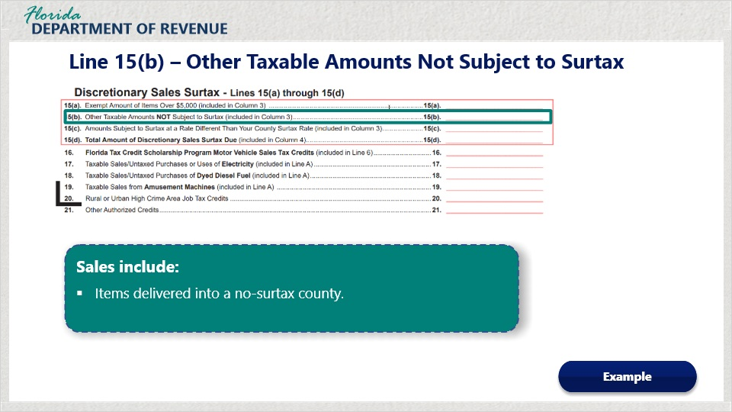
Transcript:
In Line 15(b), enter the other taxable amounts not subject to surtax. These include sales where the county being delivered into does not have a surtax.
Select the “Example” button to learn more.
-----------------------------------
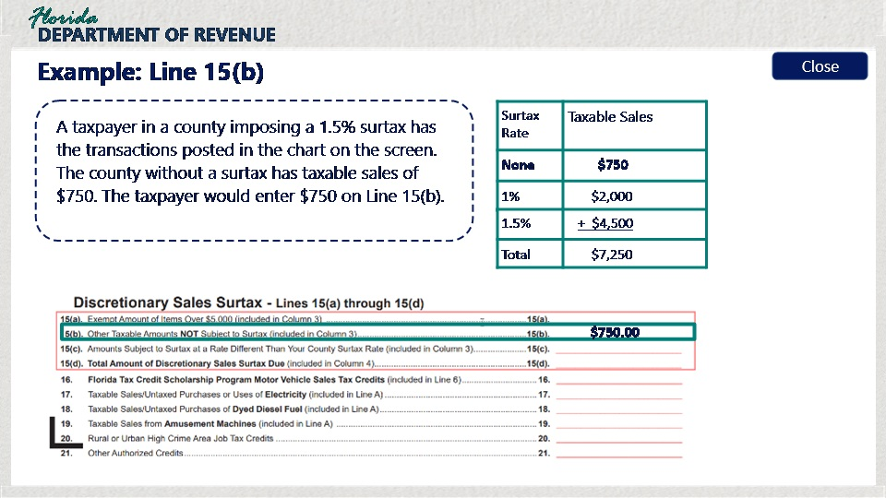

Transcript:
A taxpayer in a county imposing a 1.5% surtax has the following transactions:
Sales to counties with no surtax, taxable sales are $750.
Sales to counties with a 1% surtax rate, taxable sales are $2,000.
Sales to counties with a 1.5% surtax rate, taxable sales are $4,500.
The total amount of taxable sales for all counties combined taxable sales are $7,250.
The taxpayer would enter $750 on Line 15(b).

6.4 Line 15(c) – Amount Subject to Surtax at a Different Rate
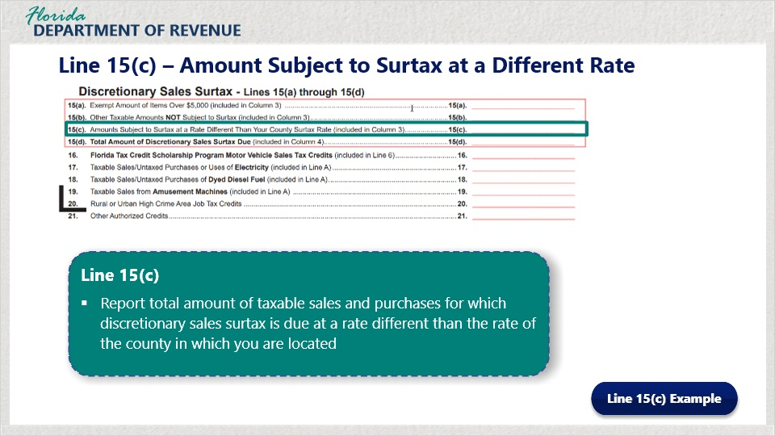
Transcript:
Line 15(c) is where you report amounts subject to surtax at a rate different than your county surtax.
Report the total amount of taxable sales and purchases for which discretionary sales surtax is due at a rate different than the rate of the county in which you are located.
Select the “Line 15(c) Example” button to learn more.
----------------------------------------
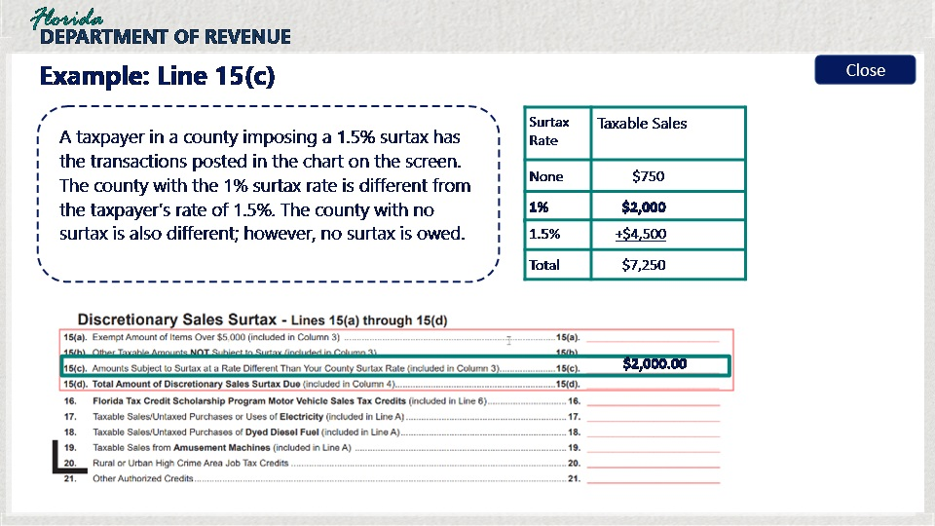

Transcript:
For example, a taxpayer in a county imposing a 1.5% surtax has the following transactions:
Sale to counties with no surtax, taxable sales are $750.
Sales to counties with a 1% surtax rate, taxable sales are $2,000.
Sales to counties with a 1.5% surtax rate, taxable sales are $4,500.
The total amount of taxable sales for all counties combined taxable sales are $7,250.
The county with the 1% surtax rate is different from the taxpayer’s rate of 1.5%. The county with no surtax is also different; however, no surtax is owed.
The taxpayer would enter the taxable sales for the 1% county, which is $2,000.

6.5 Line 15(d) – Total Discretionary Surtax Due
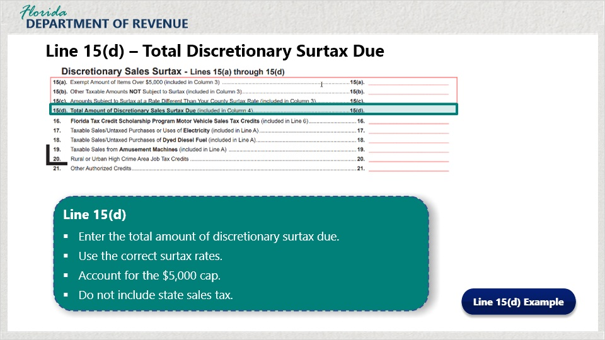
Transcript:
On Line 15(d), enter the total amount of discretionary sales surtax due.
Here are a few reminders about calculating discretionary sales surtax:
First, when doing your calculations, make sure you are using the correct county surtax rate for each transaction.
Also, be sure to account for the $5,000 cap when making your calculations if it applies.
Finally, do not include state sales tax in this amount.
Select the “Line 15(d) Example” button to see an example.
------------------------------------------------
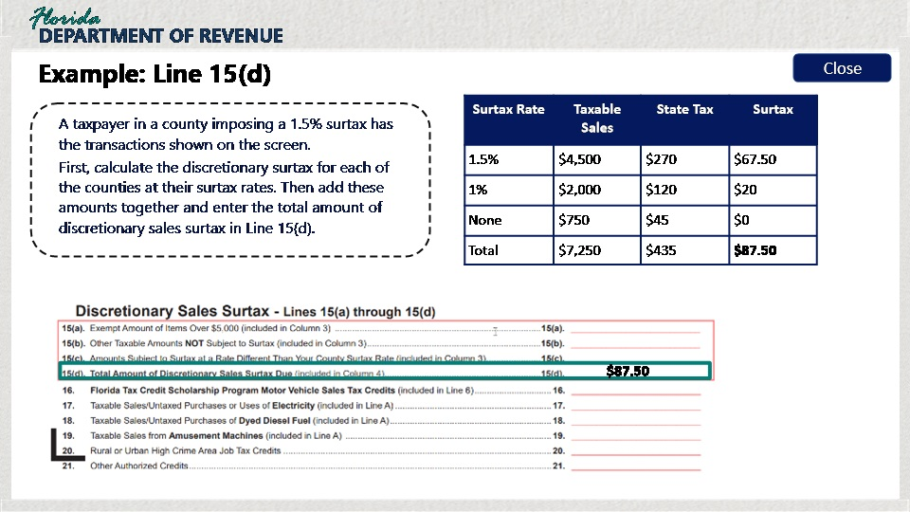

Transcript:
First, calculate the discretionary surtax for each of the counties at their surtax rates. Then add these amounts together and enter the final total amount of discretionary sales surtax due in Line 15(d).
In this example, a taxpayer in a county imposing a 1.5% surtax has the following transactions:
Taxable sales for counties with a 1.5% surtax rate equaled $4,500. Surtax is equal to $67.50.
Taxable sales for counties with a 1% surtax rate equal $2,000. Surtax is equal to $20.
Taxable sales for counties with no surtax equal $750. No surtax is owed.
For all counties, the surtax owed added together is $87.50.

6.6 Knowledge Check #2
(Multiple Choice, 10 points, 2 attempts permitted)
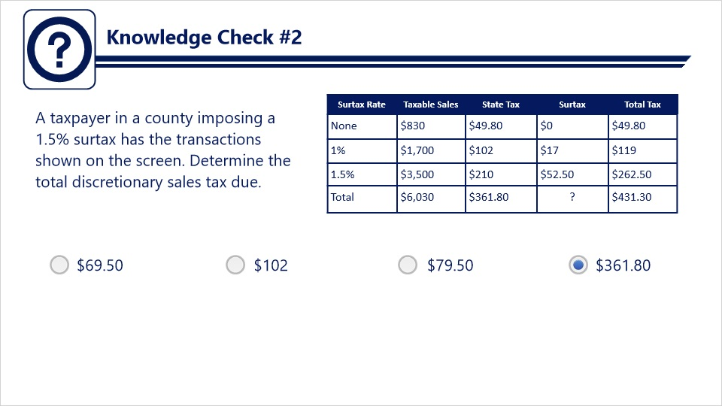
Transcript:
Question: A taxpayer in a county imposing a 1.5% surtax has the transactions shown on the screen. Determine the total discretionary sales tax due.
Answers:
- $69.50
- $102
- $79.50
- $361.80
Correct Answer: $361.80

7. Completing the Sales and Use Tax Return: Credits

7.1 Credits – Lines 16, 20, and 21
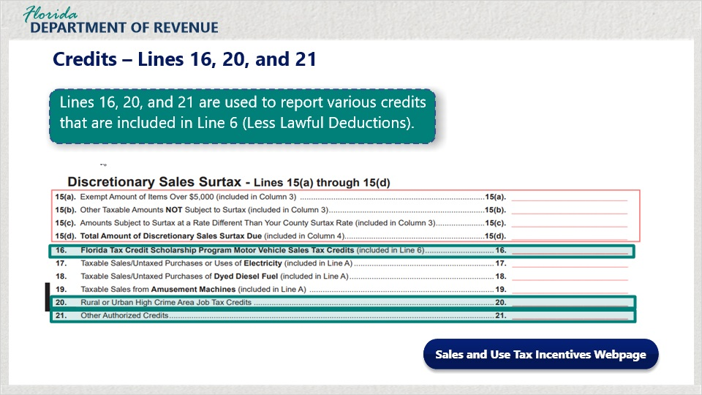
Transcript:
The DR-15 contains credits for taxpayers to report. These can be found on Lines 16, 20, and 21. Note that entries made in these lines will also be reflected on other lines of the return.
On Line 16, enter the total Florida Tax Credit Scholarship Program Motor Vehicle Sales Tax Credits and include the total amount of credits in the amount entered on Line 6, Less Lawful Deductions.
On Line 20, enter the amount of Rural or Urban High Crime Area Job Credits for which you have received a letter of approval from the Department. This information should also be entered as part of the calculations for Line 8.
On Line 21, enter only credits specifically authorized by the Department. Follow the instructions sent to you from the Department in the Credit Memo.
More information on sales and use tax incentives is available by clicking on the button labeled “Sales and Use Tax Incentives Webpage.”

8. Completing the Sales and Use Tax Return: Lines 17-19

8.1 Lines 17-19
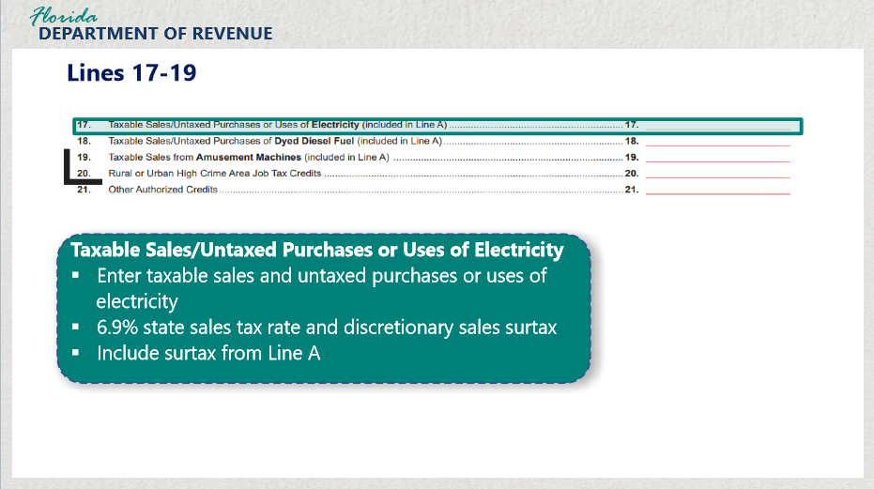
Transcript:
In Lines 17 through 19, you will enter information regarding the taxable sales of electricity, dyed diesel fuel, and amusement machines.
In Line 17, enter the taxable amount of sales and untaxed purchases or uses of electricity subject to the 6.95% tax rate, plus surtax.

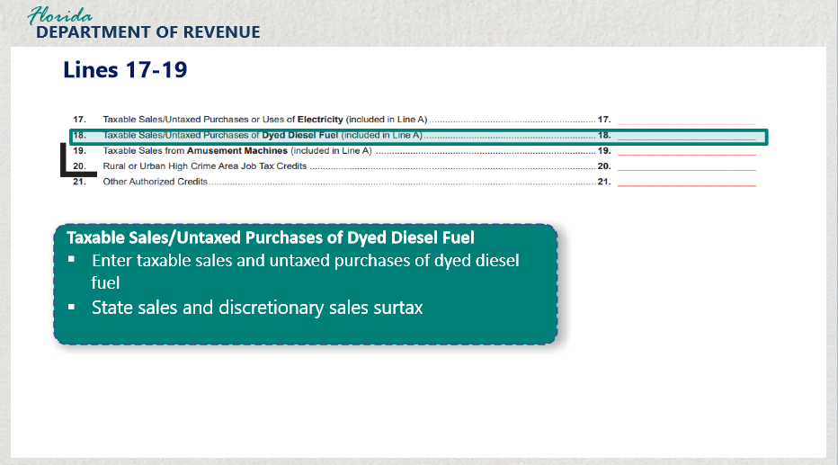

Transcript:
In Line 18, enter the total amount of taxable sales and untaxed purchases of dyed diesel fuel used in vessels or off-road equipment. If the sale or purchase of dyed diesel fuel occurred in a county that imposes discretionary sales surtax, sales tax plus the applicable discretionary sales surtax is due.

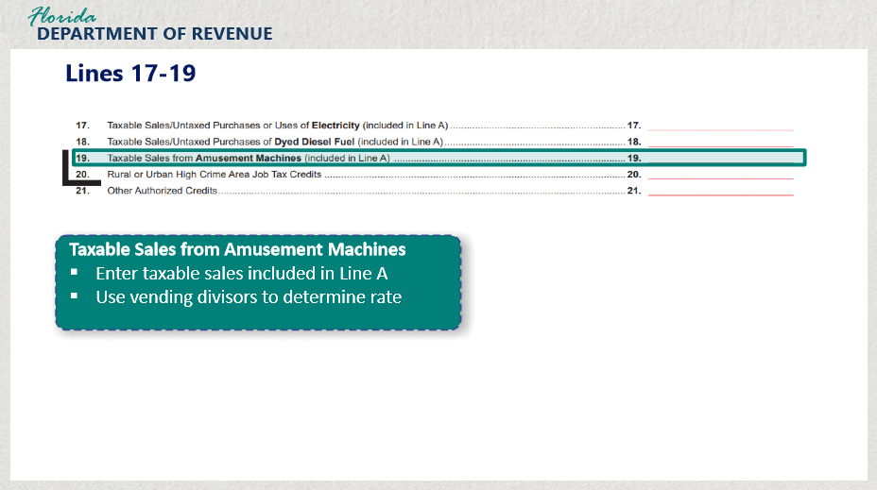

Transcript:
In Line 19, enter the amount of taxable sales from amusement machines included in Line A. For more information, visit Sales and Use Tax on Amusement Machines (Form GT-800041) by clicking on the button.

8.2 Amended Returns
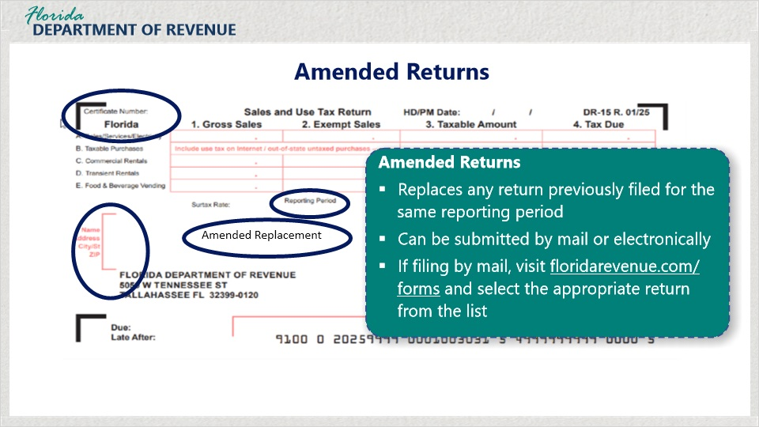
Transcript:
An amended return will replace any return previously filed for the same reporting period. It can be completed and submitted by mail or electronically. Please note that the quickest way to amend a return is online.
If filing by mail, visit floridarevenue.com/forms and select the appropriate return from the list. For our example, we will use Form DR-15.
Write on the return the certificate number, the reporting period, the business name and address, and amended replacement.
The amended return must show all lines as corrected, not merely the differences. The amended return will replace the original return in its entirety.

9. Review: Completing the Return

9.1 Instructions
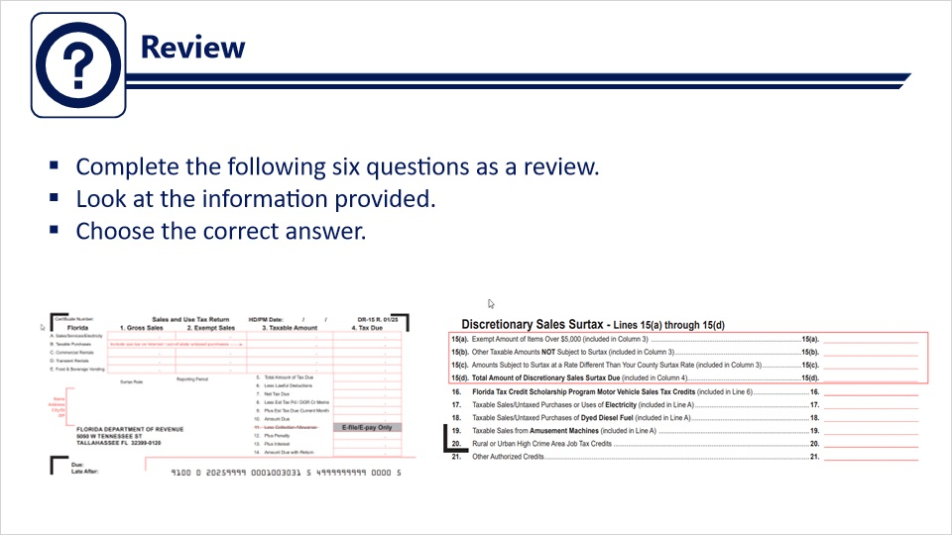
Transcript:
Please complete the following six questions as a review of what you have learned.
It is best if you have a calculator available.

9.2 Review #1
(Multiple Choice, 10 points, 2 attempts permitted)
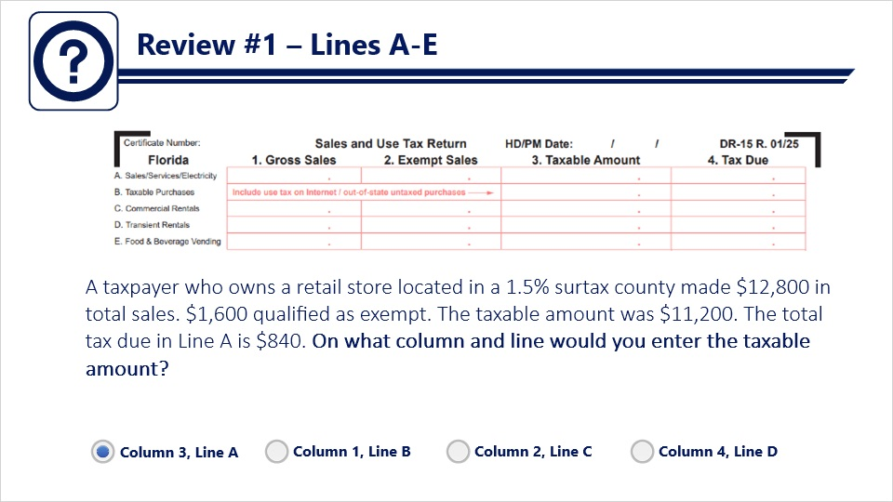
Transcript:
Question: A taxpayer who owns a retail store located in a 1.5% surtax county made $12,800 in total sales. $1,600 qualified as exempt. The taxable amount was $11,200. The total tax due in Line A is $840. On what column and line would you enter the taxable amount?
Answers:
- Column 3, Line A
- Column 1, Line B
- Column 2, Line C
- Column 4, Line D
Correct Answer: Column 3, Line A

9.3 Review #2
(Multiple Choice, 10 points, 2 attempts permitted)
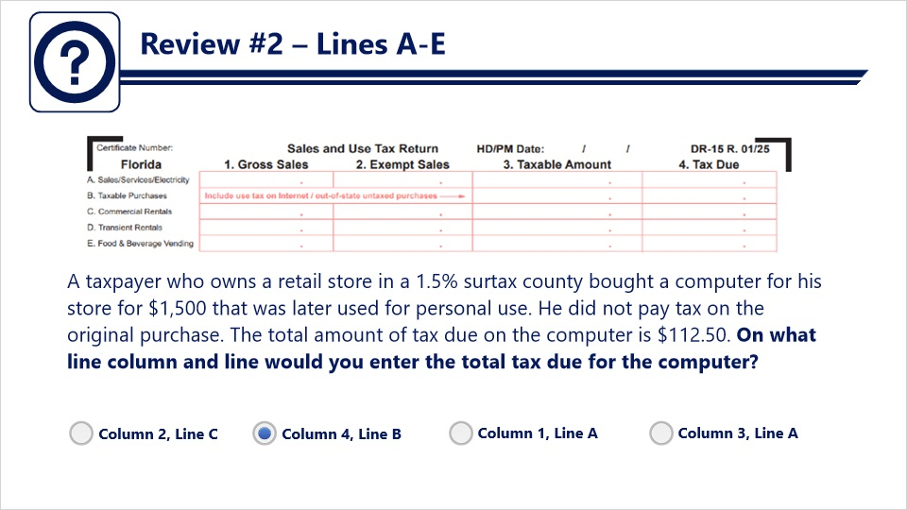
Transcript:
Question: A taxpayer who owns a retail store in a 1.5% surtax county bought a computer for his store for $1,500 that was later used for personal use. He did not pay tax on the original purchase. The total amount of tax due on the computer is $112.50. On what line column and line would you enter the total tax due for the computer?
Answers:
- Column 2, Line C
- Column 4, Line B
- Column 1, Line A
- Column 3, Line A
Correct Answer: Column 4, Line B

9.4 Review #3
(Multiple Choice, 10 points, 2 attempts permitted)
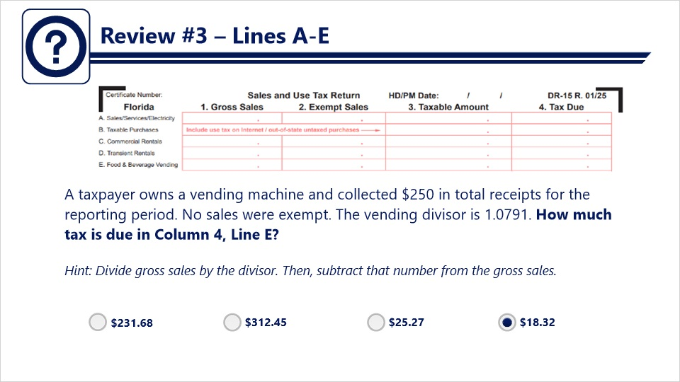
Transcript:
Question: A taxpayer owns a vending machine and collected $250 in total receipts for the reporting period. No sales were exempt. The vending divisor is 1.0791. How much tax is due in Column 4, Line E?
Hint: Divide gross sales by the divisor. Then, subtract that number from the gross sales.
Answers:
- $231.68
- $312.45
- $25.27
- $18.32
Correct Answer: $18.32

9.5 Review #4
(Multiple Choice, 10 points, 2 attempts permitted)
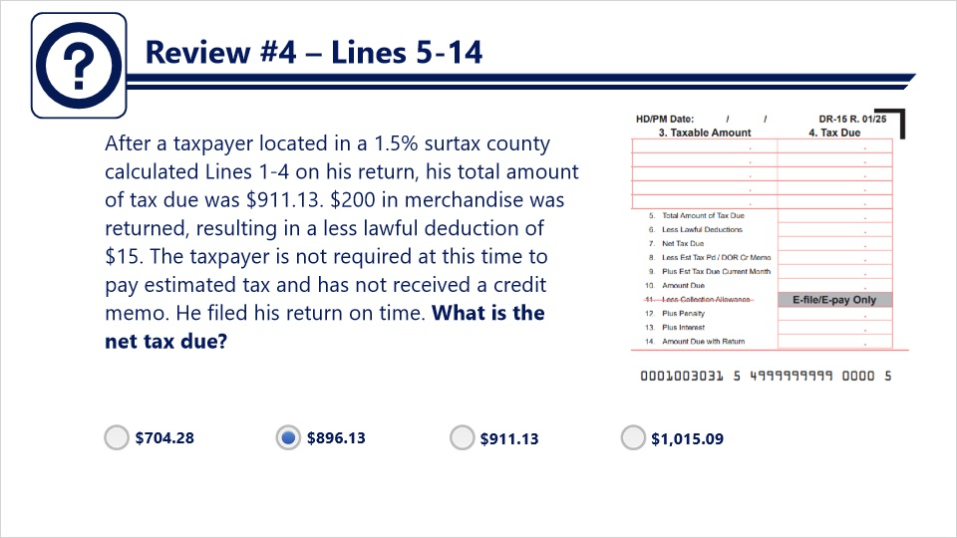
Transcript:
Question: After a taxpayer located in a 1.5% surtax county calculated Lines 1-4 on his return, his total amount of tax due was $911.13. $200 in merchandise was returned, resulting in a less lawful deduction of $15. The taxpayer is not required at this time to pay estimated tax and has not received a credit memo. He filed his return on time. What is the net tax due?
Answers:
- $704.28
- $896.13
- $911.13
- $1,015.09
Correct Answer: $896.13

9.6 Review #5
(Multiple Choice, 10 points, 2 attempts permitted)
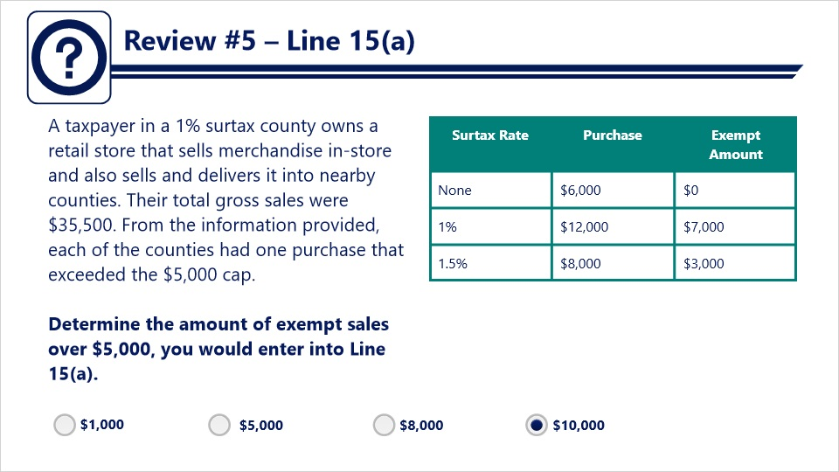
Transcript:
Question: A taxpayer in a 1% surtax county owns a retail store that sells merchandise in-store and also sells and delivers it into nearby counties. Their total gross sales were $35,500. From the information provided, each of the counties had one purchase that exceeded the $5,000 cap.
Determine the amount of exempt sales over $5,000, you would enter into Line 15(a).
Answers:
- $1,000
- $5,000
- $8,000
- $10,000
Correct Answer: $10,000

9.7 Review #6
(Multiple Choice, 10 points, 2 attempts permitted)
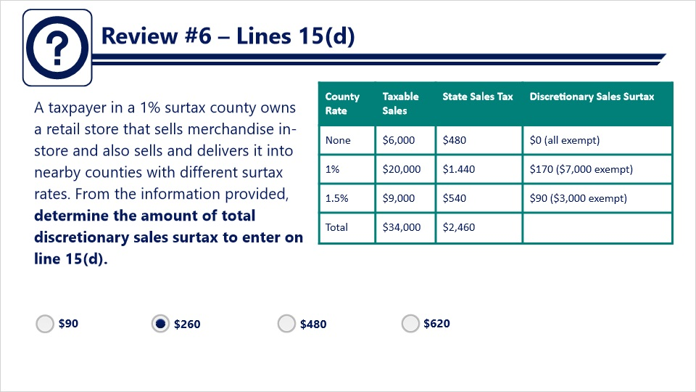
Transcript:
Question: A taxpayer in a 1% surtax county owns a retail store that sells merchandise in-store and also sells and delivers it into nearby counties with different surtax rates. From the information provided, determine the amount of total discretionary sales surtax to enter on line 15(d).
Answers:
- $90
- $260
- $480
- $620
Correct Answer: $260

10. Tips for Successful Filing

10.1 Tips for Successful Filing
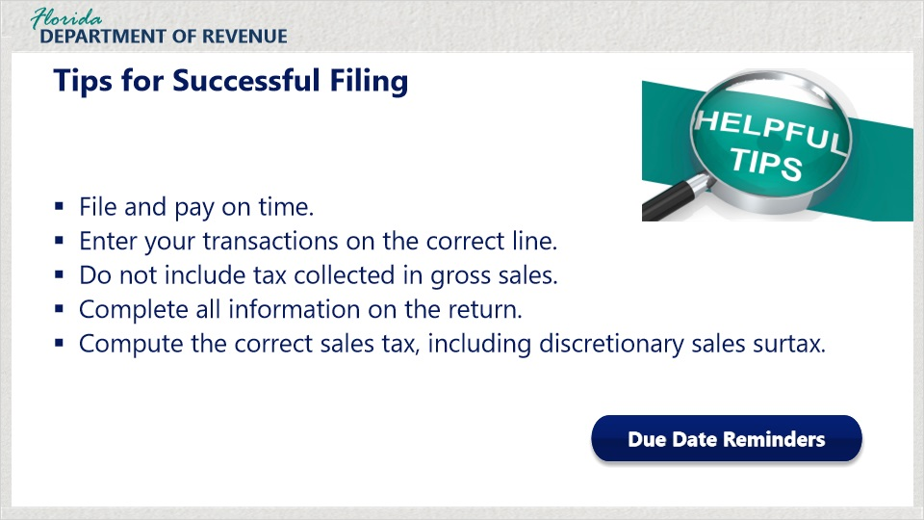
Transcript:
Here are some helpful tips for successfully filing your DR-15.
First, be sure to file and pay on time. Sign up for helpful due date reminders at floridarevenue.com or click on the “Due Date Reminders” button.
Next, be sure to enter your transactions on the correct line on the return. It can be easy to make a mistake. Always double-check your return!
Do not include tax collected in gross sales. This will result in overpayment of tax.
Be sure to complete all information on the return. Incomplete information may cause delays in processing.
Also, compute the correct sales tax, including discretionary sales surtax. Make sure to charge the correct discretionary sales surtax rate.

10.2 Online Resources
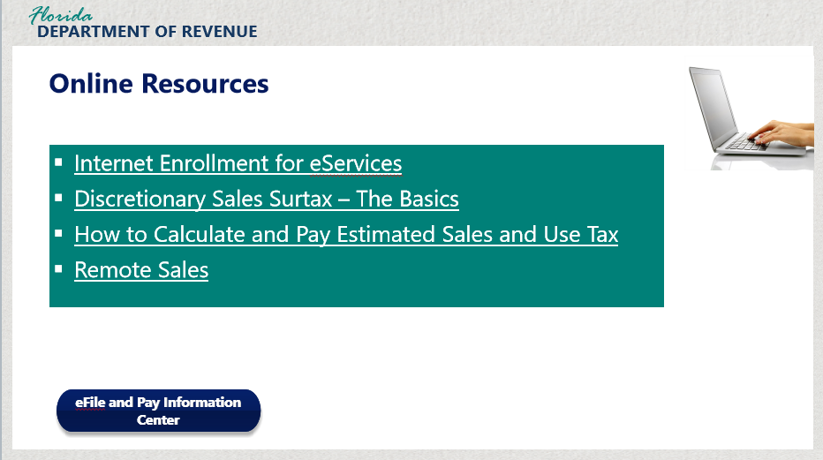

Transcript:
A variety of tutorials are available on our website including Internet Enrollment for eServices; Discretionary Sales Surtax – The Basics; How to Calculate and Pay Estimated Sales and Use Tax; and Remote Sales
Click on the blue button labeled “eFile and Pay Information Center” to access additional resources such as help guides, tutorials, and videos.

11. Conclusion

11.1 Tax Page and Social Media
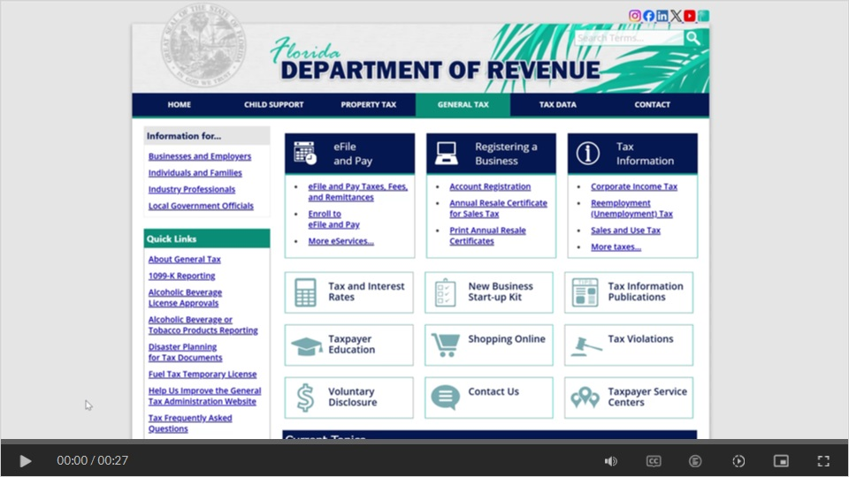
Transcript:
Visit floridarevenue.com/taxes for business resources such as forms, publications, and information on all tax types.
Check out our Taxpayer Education webpage for new business guides, tutorials, and other helpful tools.
And follow us on YouTube, X, Instagram, and LinkedIn using the icons at the top of our website to stay up to date on tax topics, alerts, and more.

11.2 Survey
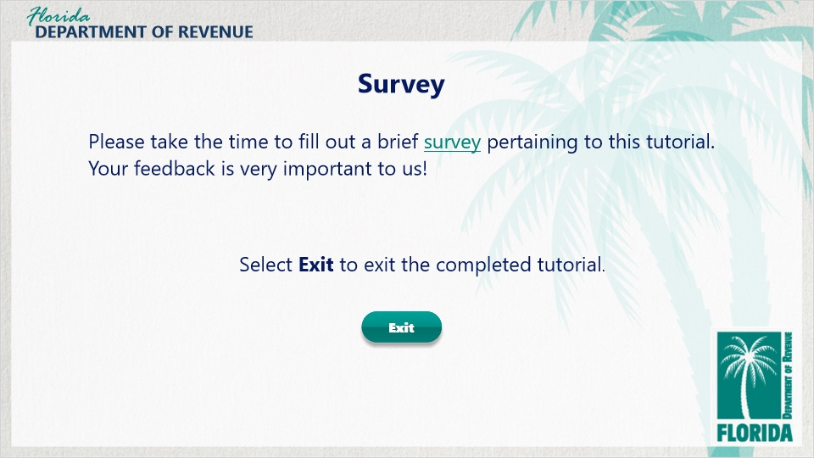
Transcript:
This concludes “How to Complete the Paper-Based Sales and Use Tax Return (Form DR-15).
For more information, check out the resources available within this overview by clicking on the Resources tab in the upper-right corner of your screen.
In addition, there are several helpful guides and tutorials available on a variety of tax-related topics on the Department’s website at floridarevenue.com.
Please take the time to fill out a brief survey pertaining to this tutorial. Your feedback is very important to us.
To exit this tutorial, click on the Exit button.
Thank you.

