Prepaid Wireless Tutorial - Accessibility Outline

1. Overview

1.1 Title Slide
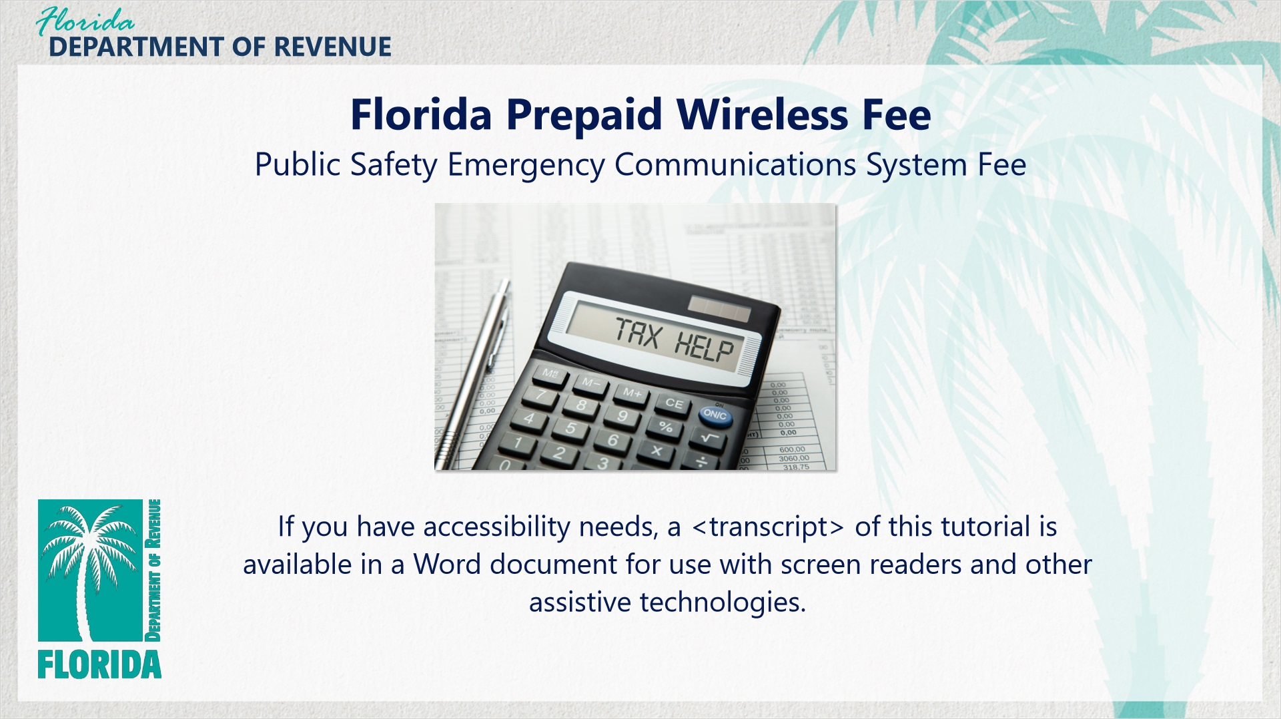
Transcript:
Florida Prepaid Wireless (Public Safety Emergency Communications System Fee) Tutorial

1.2 Navigating This Tutorial
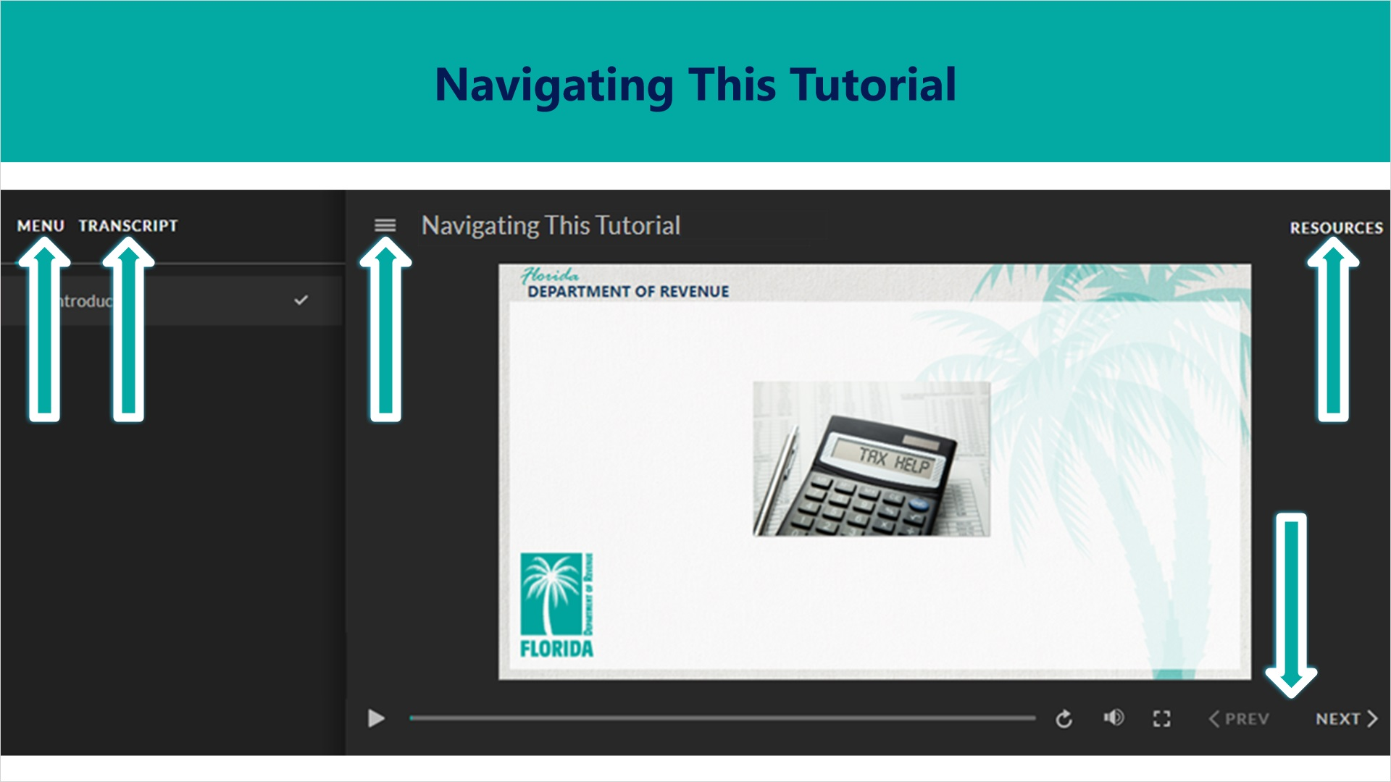
Transcript:
This tutorial will take approximately 20 minutes to complete. A transcript of the audio is available by clicking on the transcript tab in the top-left corner of your screen.
The following tabs and buttons are available to help you navigate throughout this tutorial.
Menu Tab
The menu tab displays by default when the overview is viewed on a computer. It allows you to navigate through the tutorial by clicking on the topic name on the menu. When viewing this tutorial on a tablet or smartphone, the menu does not display by default and must be accessed using the menu symbol.
Resources Tab
The resources tab is found on the right side of the top bar. When clicked, it displays the list of links to useful forms, documents, and webpages.
Previous and Next Buttons
The previous and next buttons are located at the bottom-right corner of your screen. These buttons allow you to move either back or forward.

1.3 Topics Slide
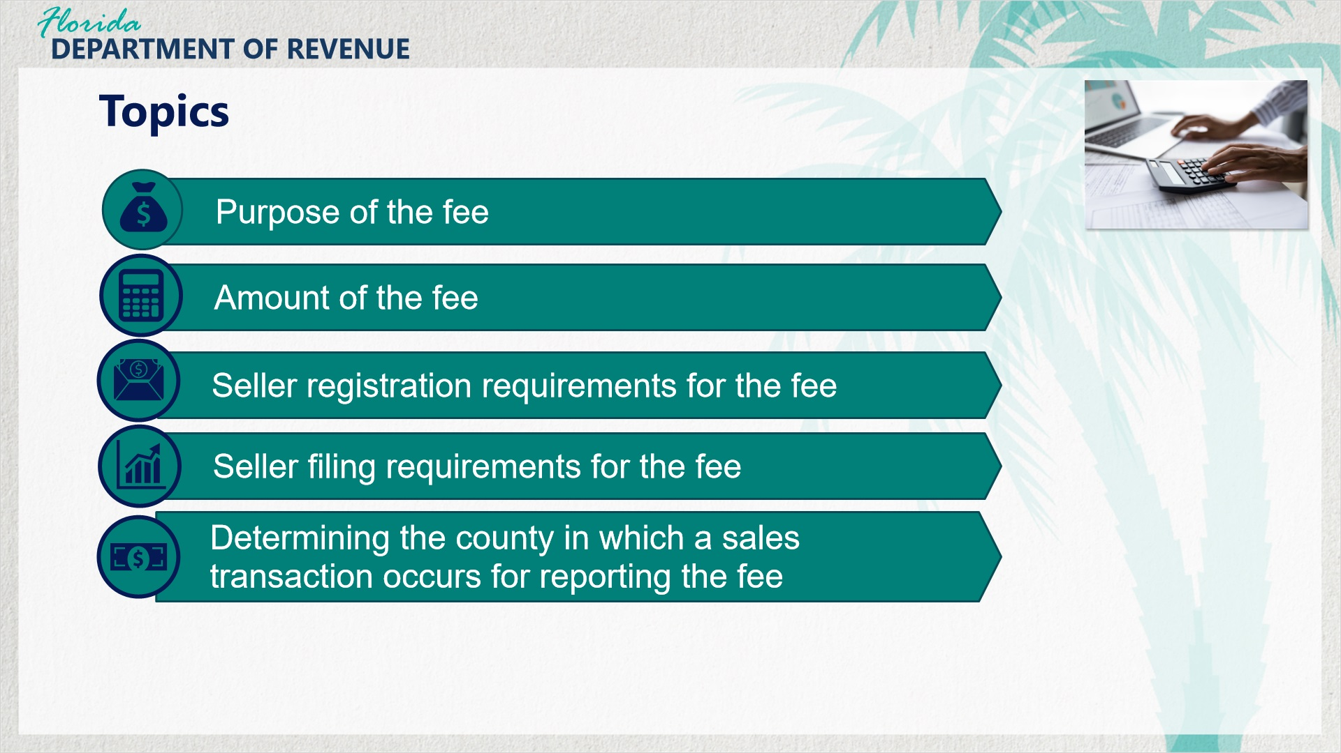
Transcript:
This tutorial aims to help you understand Florida’s Prepaid Wireless Public Safety Emergency Communications Systems Fee (Prepaid Wireless Fee).
This tutorial includes the following topics: the purpose of the fee, the amount of the fee, seller registration requirements for the fee, seller filing requirements for the fee, and determining the county in which a sales transaction occurs for reporting the fee.

1.4 Prepaid Wireless Fee Overview
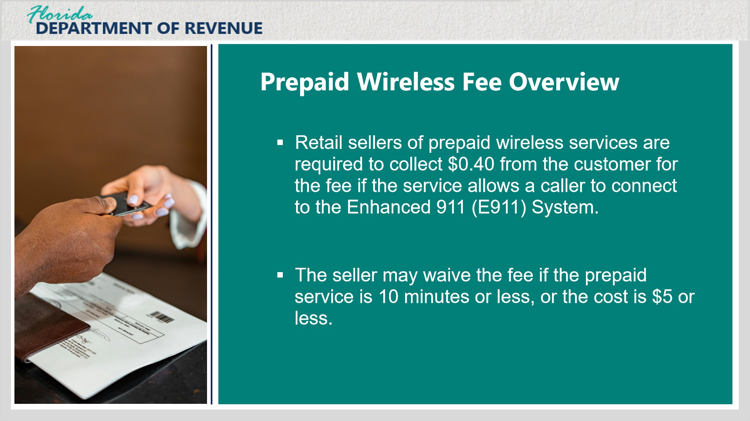
Transcript:
Florida law imposes a prepaid wireless fee on each retail sale of prepaid wireless service occurring in Florida.
Retail sellers of prepaid wireless services are required to collect 40 cents for the prepaid wireless fee on the sale of each prepaid wireless service that allows a caller to connect to, and interact with, the Enhanced 911 (or E911) System.
The fee is collected by the seller from the consumer. If a prepaid device is sold with prepaid wireless service of 10 minutes or less, or for a sale price of $5 or less, the seller may elect not to apply the prepaid wireless fee to the transaction.

1.5 Prepaid Wireless Fee Definition
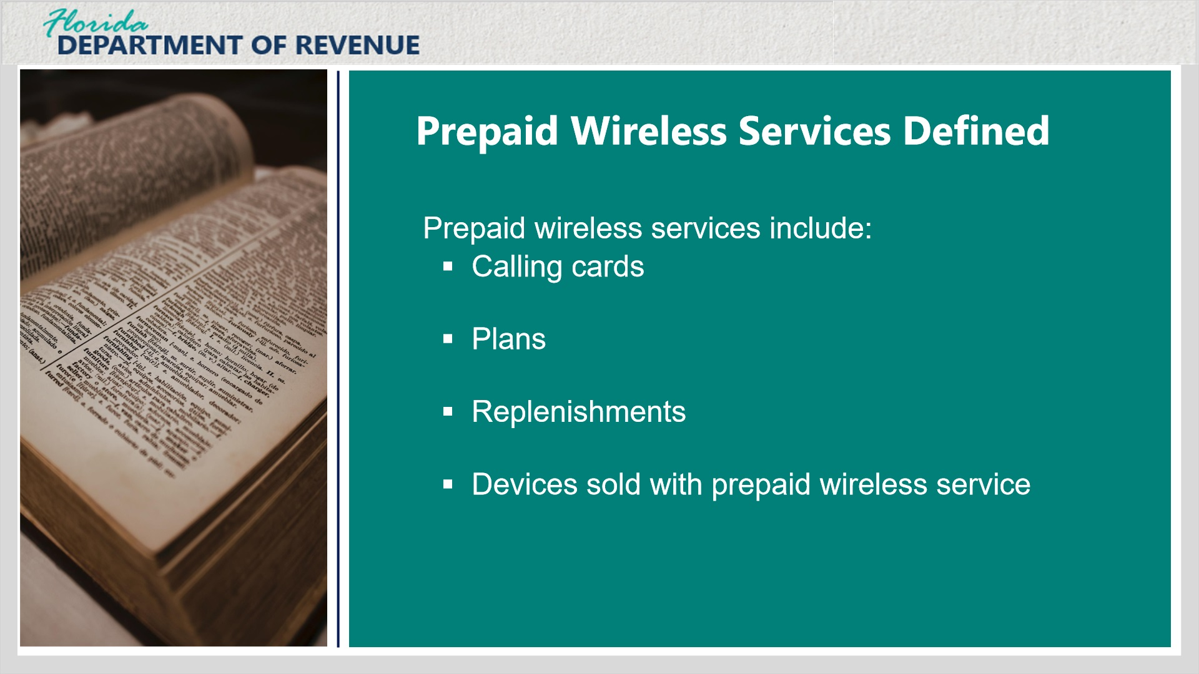
Transcript:
Prepaid wireless services are wireless services that are paid for in advance and sold in predetermined units or dollars. They must expire on a predetermined schedule or decrease on a predetermined basis.
Examples of prepaid wireless services include calling cards, plans, replenishments, and devices sold with prepaid wireless service.

1.6 Collection of Prepaid Wireless Fee
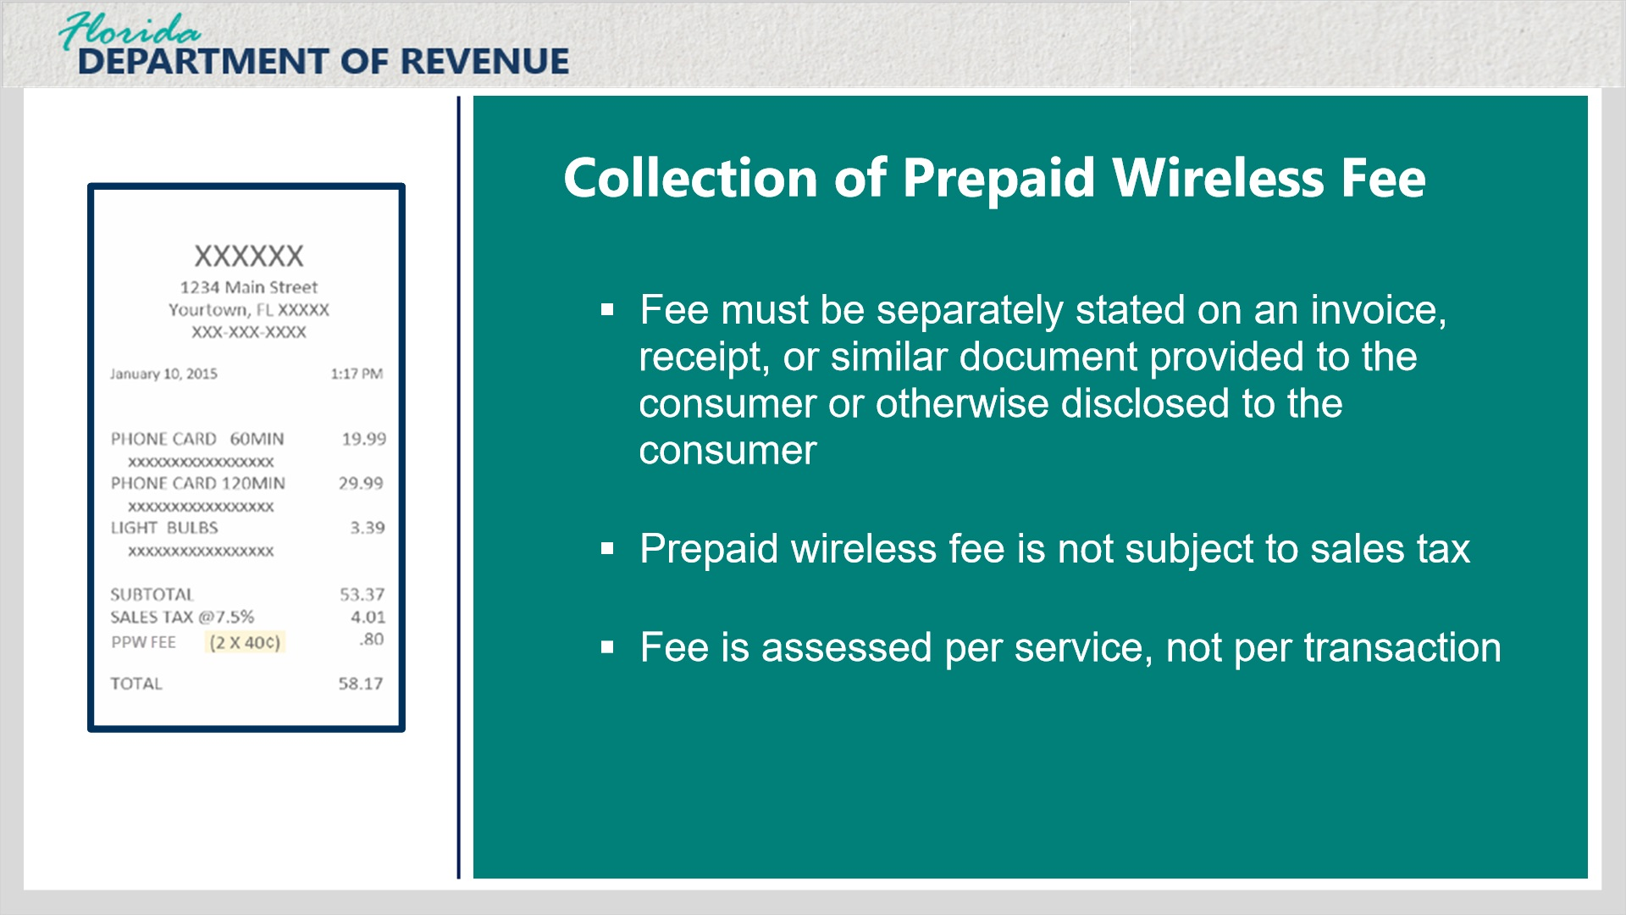
Transcript:
The prepaid wireless fee must be separately stated on an invoice, receipt, or similar document provided to the consumer, and the fee is not subject to sales tax.
Suppose a customer makes a purchase of multiple prepaid wireless services in a single transaction. In that case, each individual prepaid wireless service is to be considered a separate retail transaction for the purpose of calculating the prepaid wireless fee. Click on the receipt image on the left to view more information.

Sample Receipt (Slide Layer)
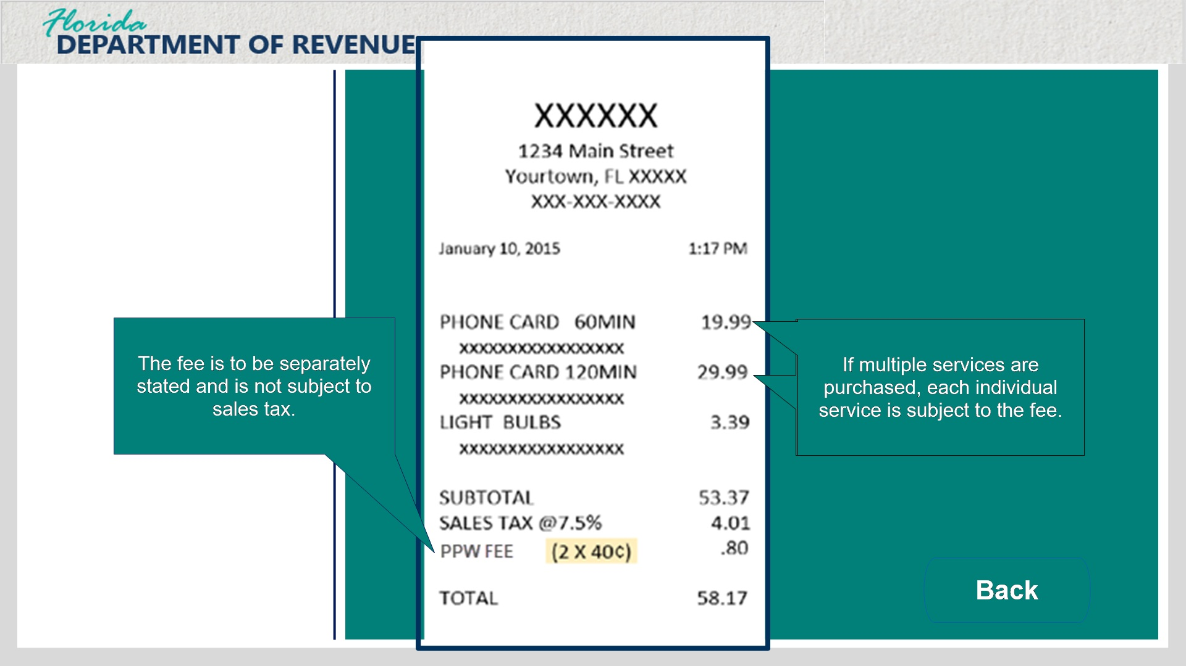
Transcript:
The receipt shows that the customer is purchasing two prepaid wireless services. The first service is a 60-minute phone card, and the second is a 120-minute phone card. The prepaid wireless fee is calculated for each purchased service separately, and the fee is separated into a labeled fee line at the bottom of the receipt. As a reminder, the prepaid wireless fee is not subject to sales tax.

1.7 Registration
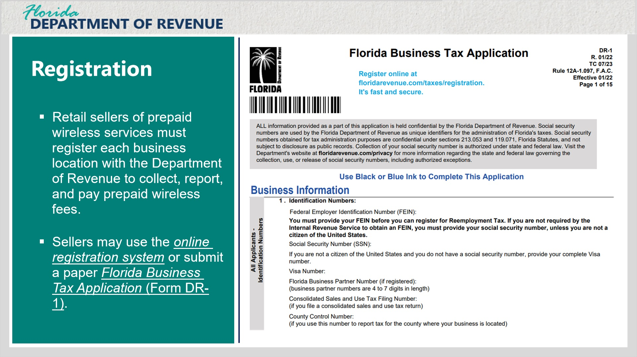
Transcript:
All retail sellers of prepaid wireless services must register each business location with the Department of Revenue to collect, report, and pay prepaid wireless fees and sales and use tax.
Sellers of prepaid wireless services may use the online registration system or submit a paper Florida Business Tax Application (Form DR-1).

1.8 Filing Requirements
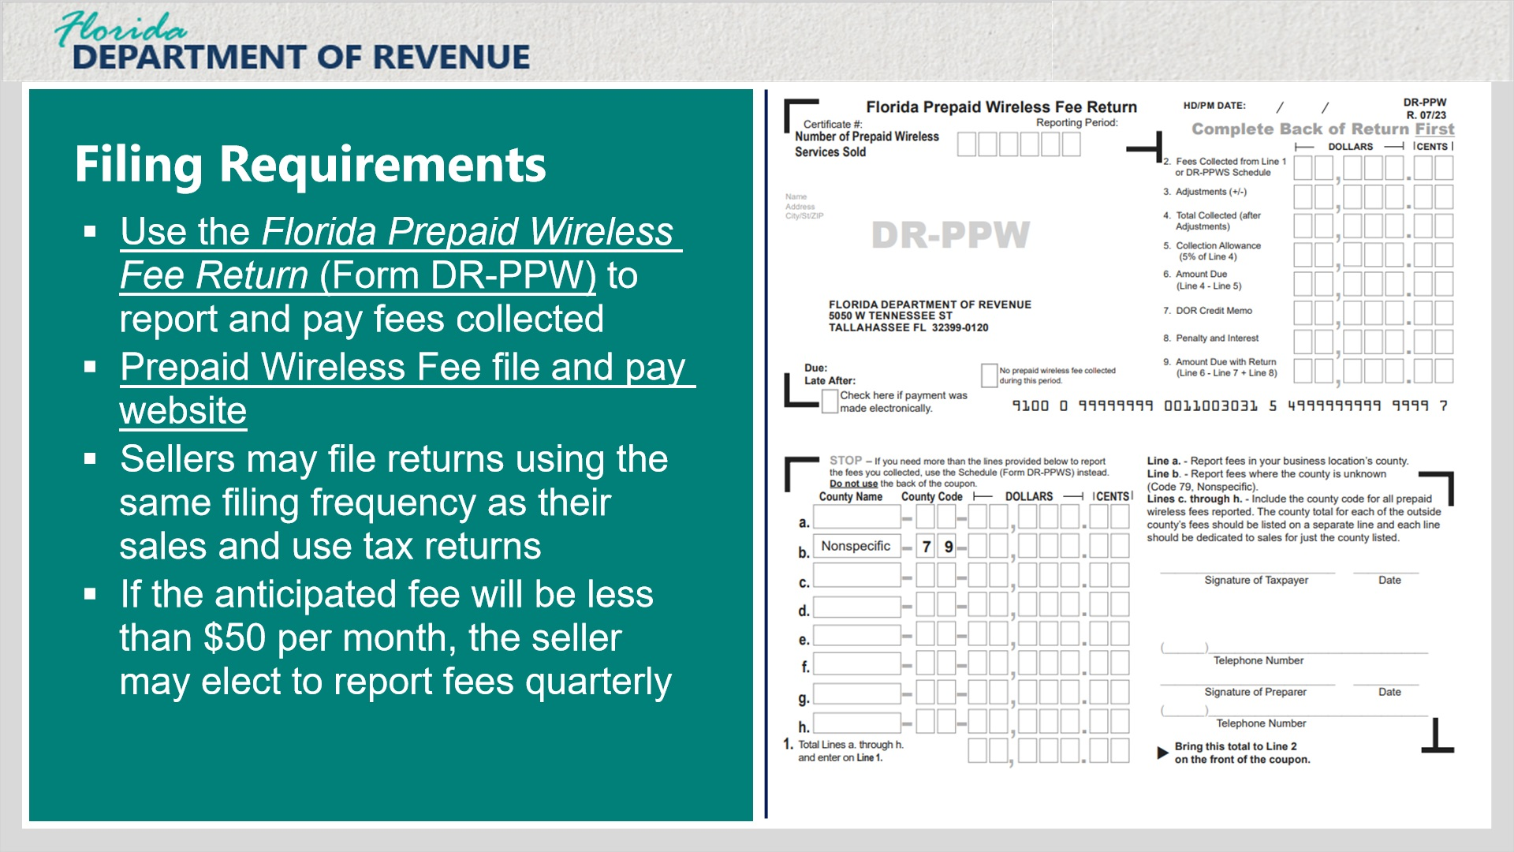
Transcript:
Registered sellers are required to use the Florida Prepaid Wireless Fee Return (Form DR-PPW) to report and pay the fees collected from prepaid wireless service transactions. The easiest way to report and pay the prepaid wireless fees is to use the Department’s convenient, free, and secure file and pay website.
Additionally, sellers may file prepaid wireless fee returns using the same filing frequency as their sales and use tax returns - for example, monthly or quarterly. However, if the anticipated fee will be less than $50 per month, the seller may elect to report the fees quarterly.
This is an example image of the Florida Prepaid Wireless Fee Return. We will do a few sample calculations using this form later in the tutorial, but you may click on the Form images to expand them on your screen.

DR PPW Front (Slide Layer)
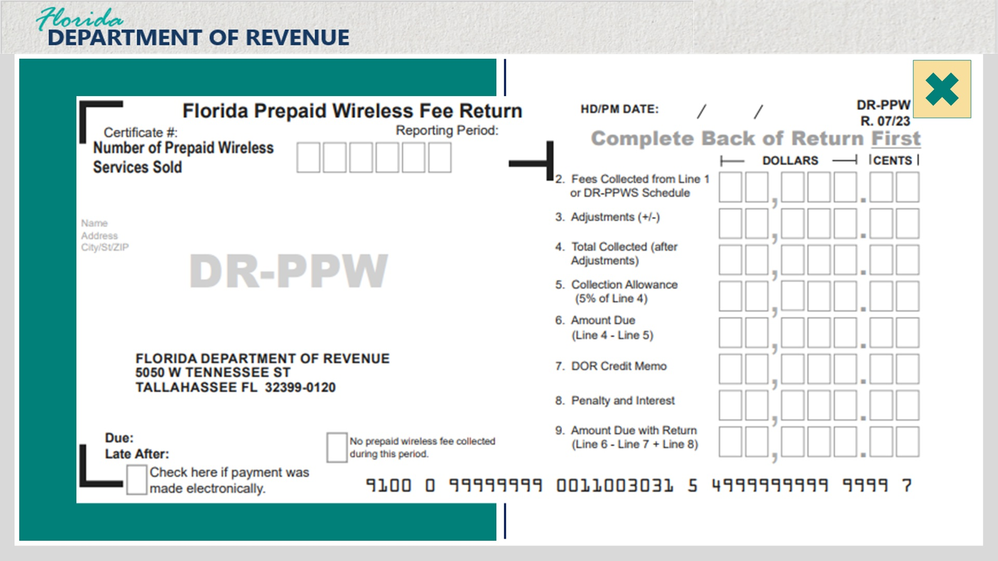
Transcript:
This slide presents a larger view of the front of Form DR-PPW.

DR PPW Back (Slide Layer)
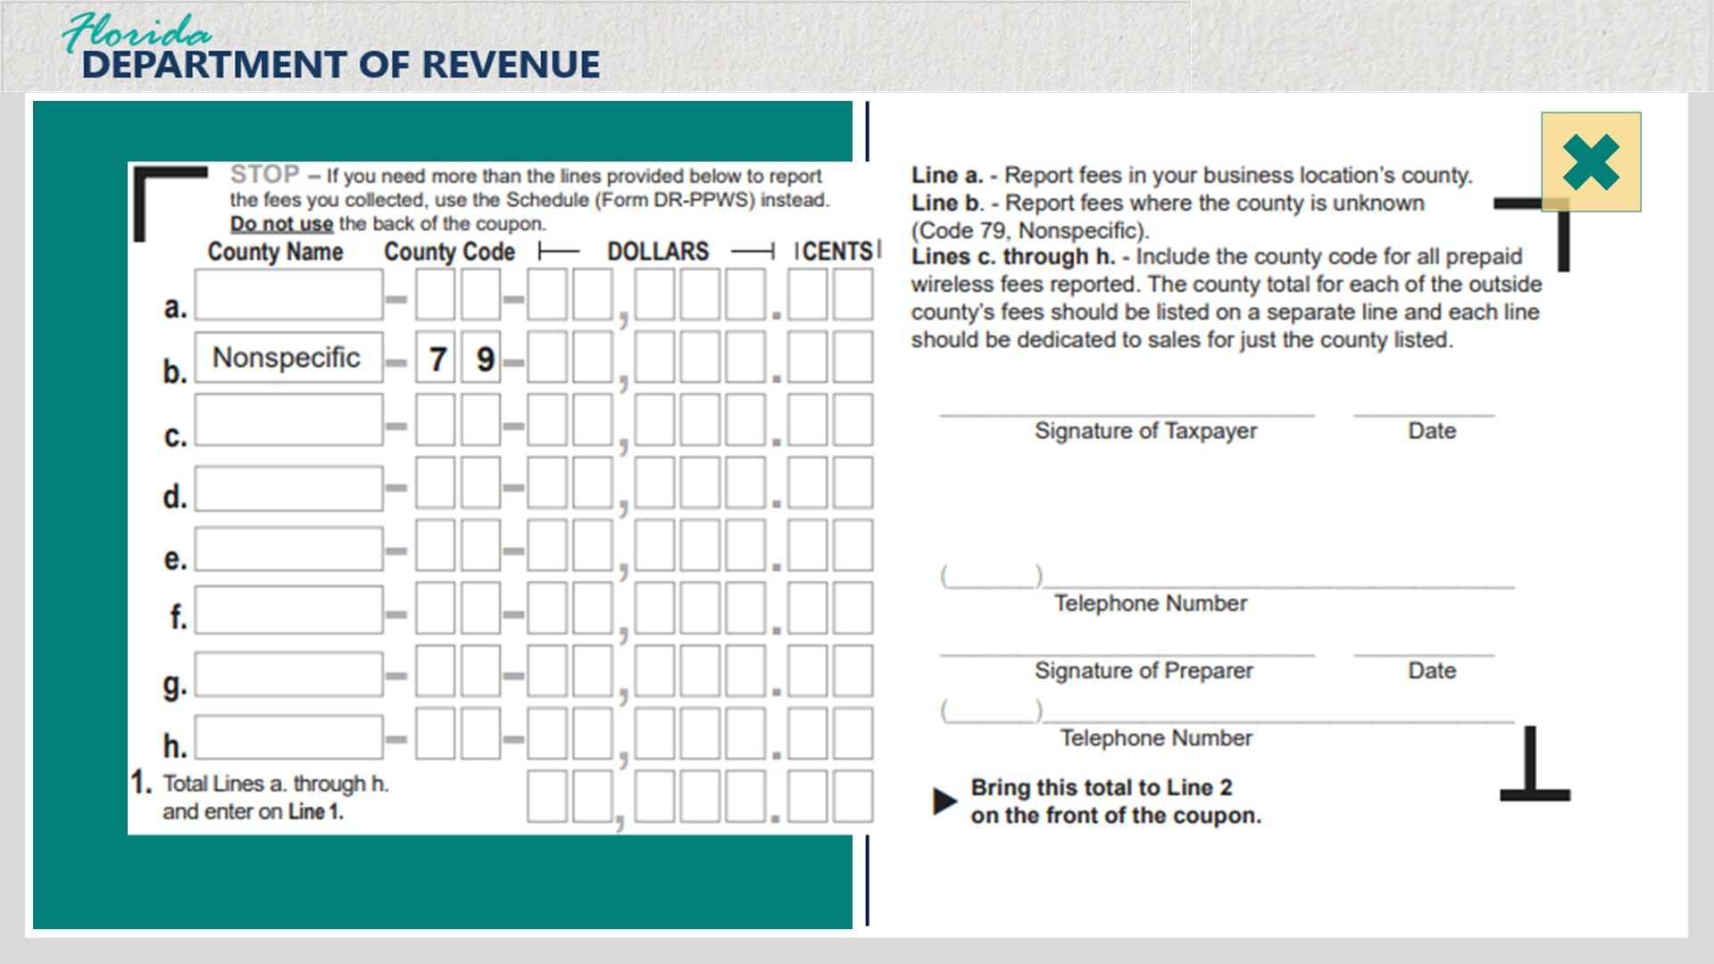
Transcript:
This slide presents a larger view of the back of Form DR-PPW.

1.9 Filing and Payment Dates
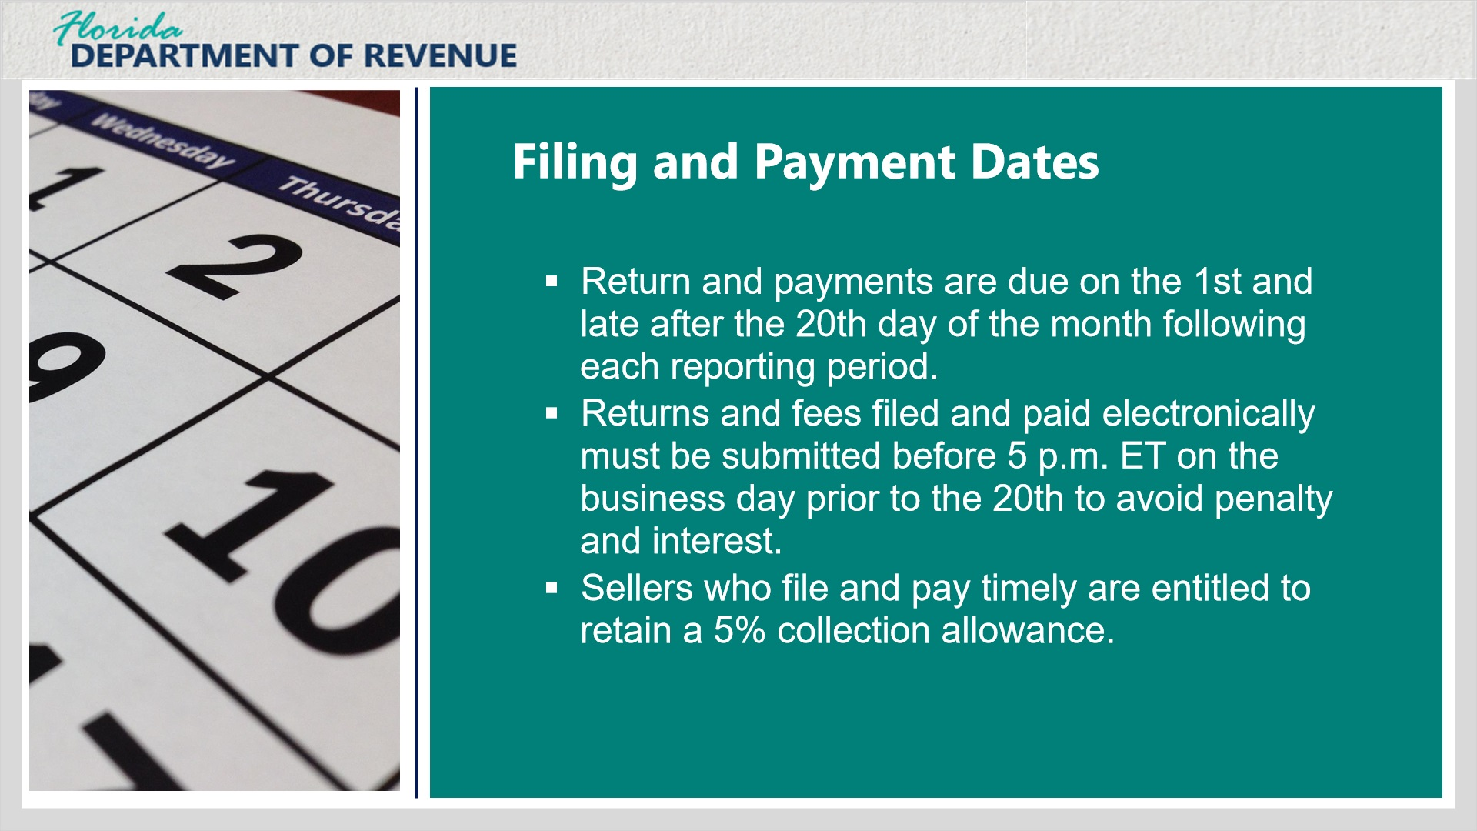
Transcript:
The Florida Prepaid Wireless Fee Return and payments are due on the 1st and late after the 20th day of the month following each reporting period. Returns and fees filed and paid electronically must be submitted before 5 p.m. Eastern Time on the business day prior to the 20th to avoid penalty and interest.
Sellers who file and pay timely are entitled to retain a 5% collection allowance.

1.10 Determing the County Where Sale Occurred
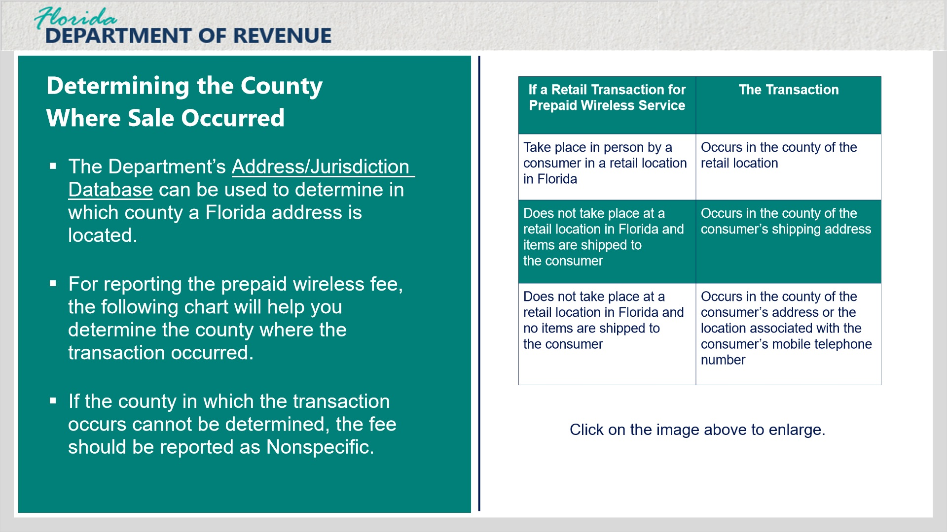
Transcript:
Sellers are required to report the prepaid wireless fees by the county in which the sales transaction occurs. The Department’s Address/Jurisdiction Database can be used to determine in which county a Florida address is located.
For reporting the prepaid wireless fee, the following chart will help you determine the county where the transaction occurred.
If the county in which the transaction occurs cannot be determined, the fee should be reported as Nonspecific.

Chart Layer (Slide Layer)
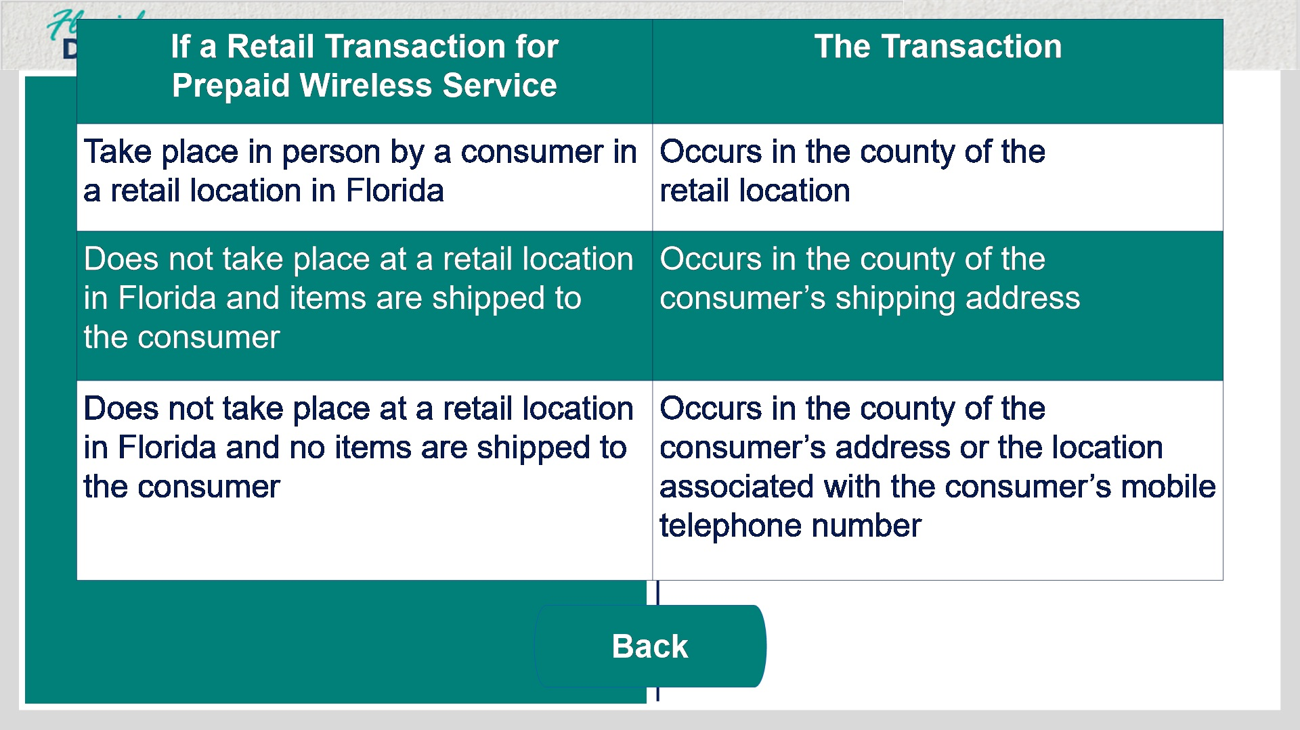
Transcript:
If a retail transaction for prepaid wireless service takes place in person by a consumer in a retail location in Florida, the transaction occurs in the county of the retail location.
If a retail transaction for prepaid wireless service does not take place at a retail location in Florida and items are shipped to the consumer, the transaction occurs in the county of the consumer’s shipping address.
If a retail transaction for prepaid wireless service does not take place at a retail location in Florida and no items are shipped to the consumer, the transaction occurs in the county of the consumer’s address or the location associated with the consumer’s mobile telephone number.

2. Form DR-PPW

2.1 Determing the County Where Sale Occurred
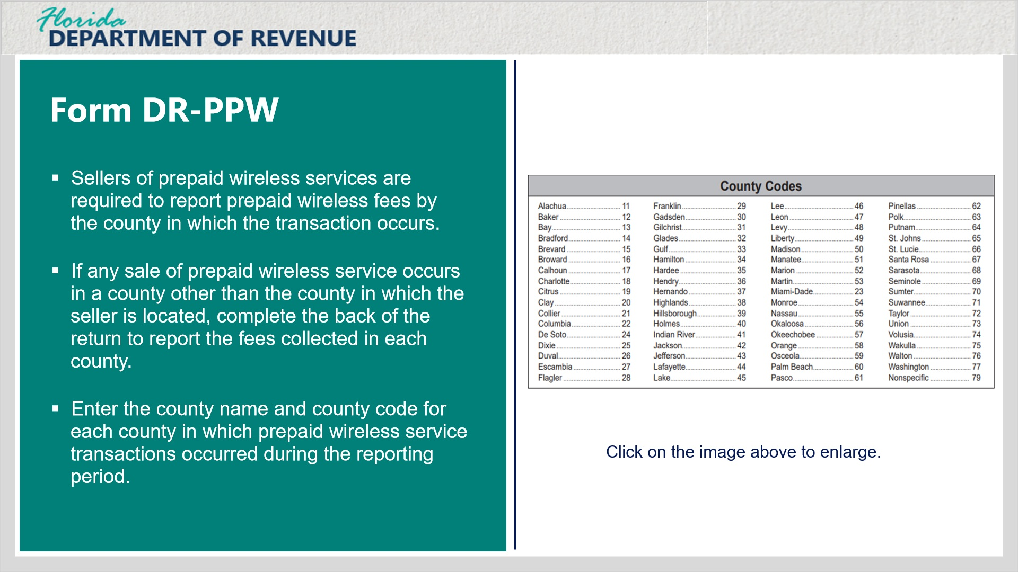
Transcript:
As we covered in earlier, sellers of prepaid wireless services are required to report prepaid wireless fees by the county in which the transaction occurs.
If any sale of prepaid wireless service occurs in a county other than the county in which the seller is located, complete the back of the return to report the fees collected in each county.
Enter the county name and county code for each county in which prepaid wireless service transactions occurred during the reporting period. A list of all Florida counties and their corresponding county codes is provided with paper returns or coupon books and is available on our website under the Prepaid Wireless Fee forms section.

Chart Layer (Slide Layer)
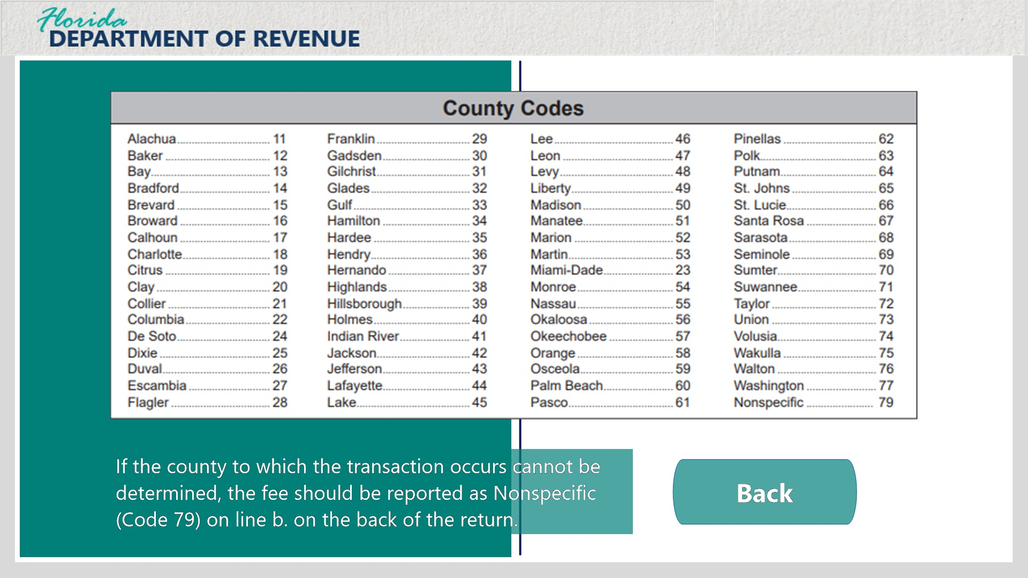
Transcript:
If the county to which the transaction occurs cannot be determined, the fee should be reported as Nonspecific (Code 79) on Line B. on the back of the return.

2.2 Form DR-PPW (Back of Form)
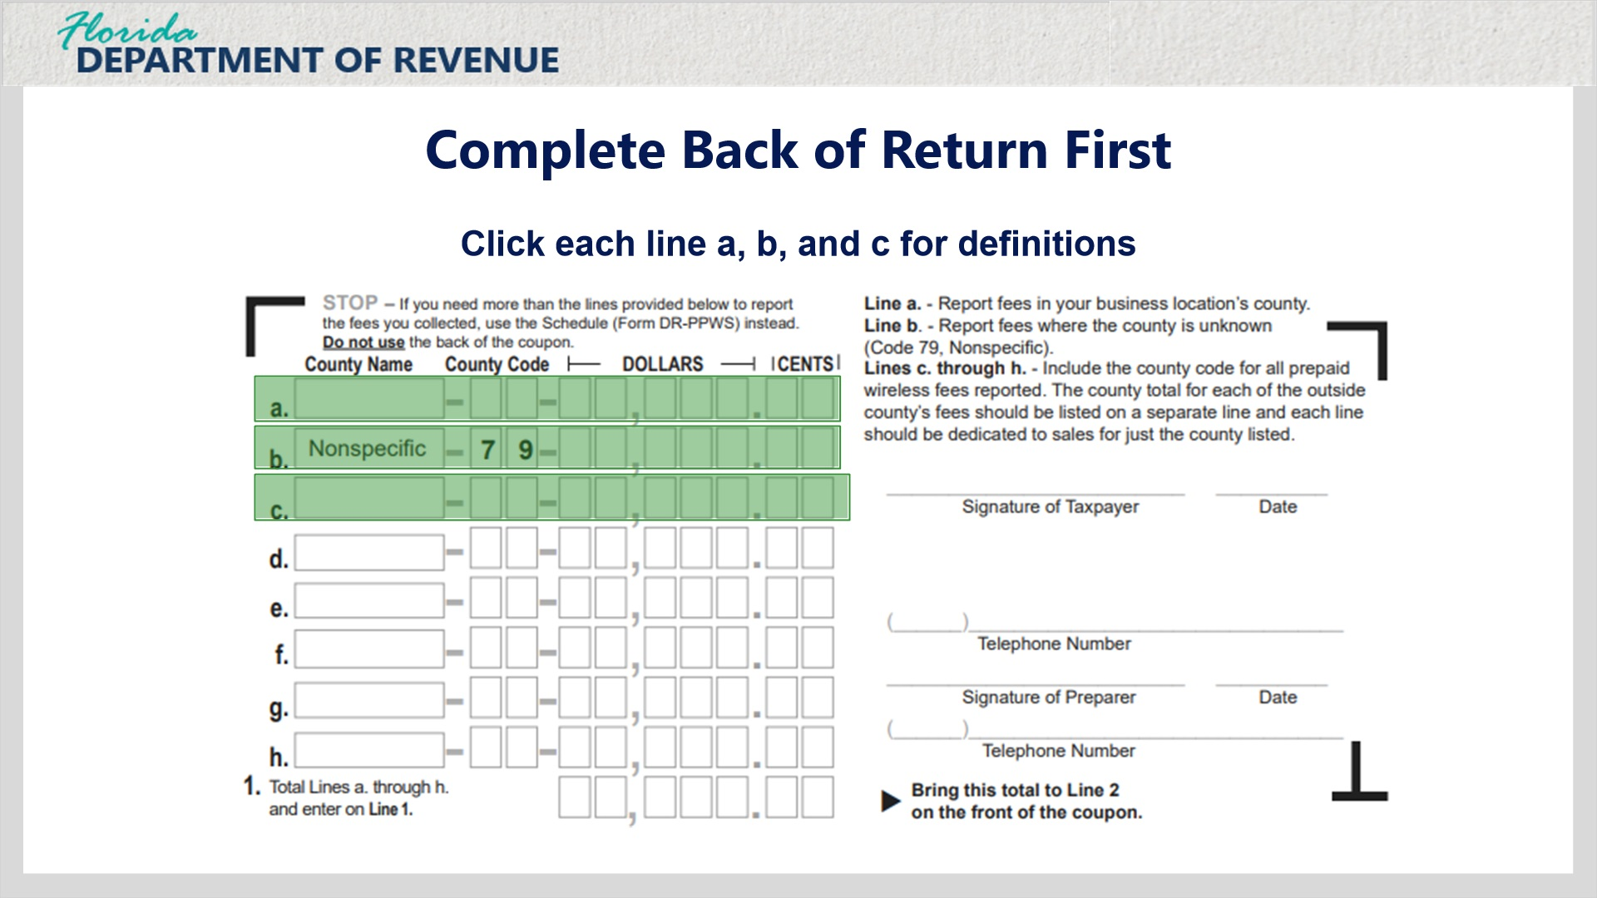
Transcript:
Now let’s take a look at the back of Form DR-PPW. Click each line, a. through c., for definitions. The next button will appear at the bottom-right corner of your screen once all lines are viewed.

Line A (Slide Layer)
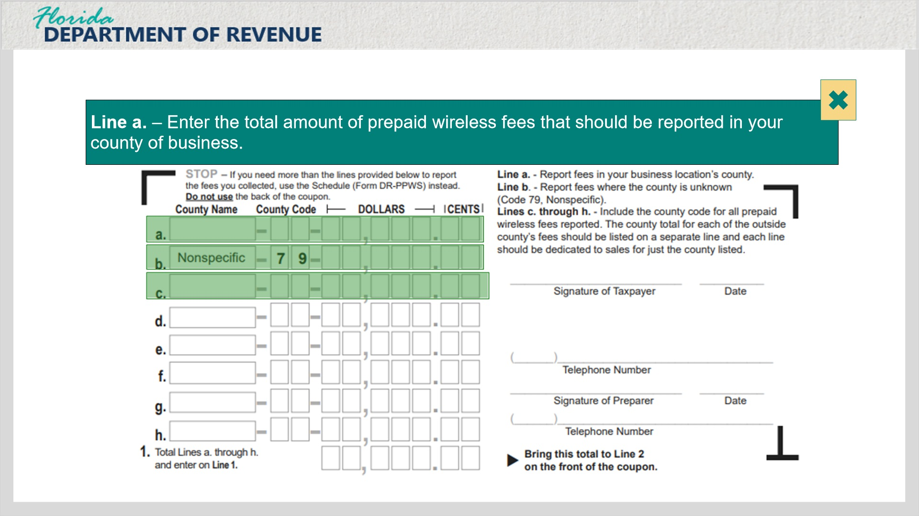
Transcript:
Line A – enter the total amount of prepaid wireless fees that should be reported in your county of business.

Line B (Slide Layer)
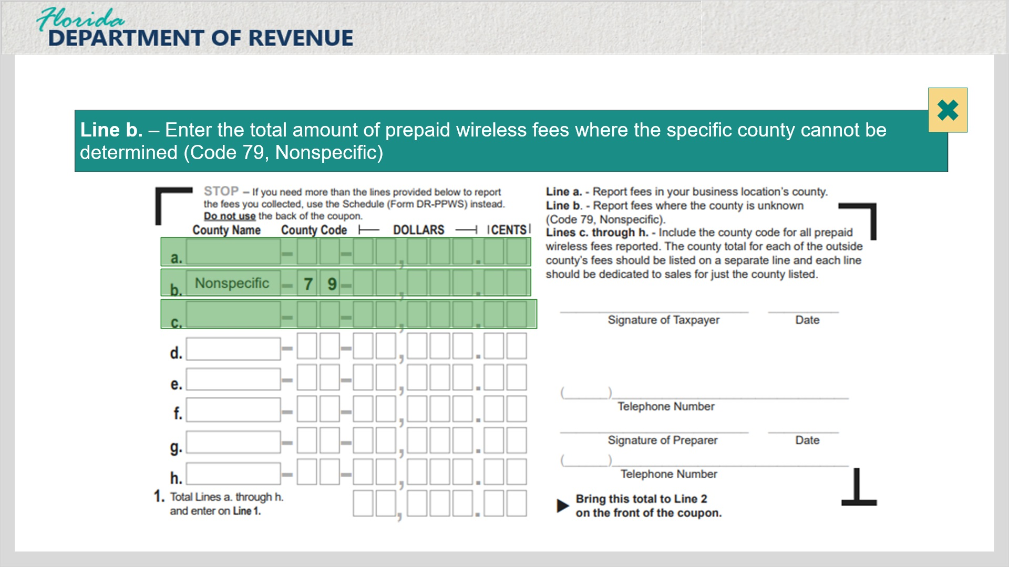
Transcript:
Line B – enter the total amount of prepaid wireless fees where ethe specific county cannot be determined (Code 79, Nonspecific).

Line C (Slide Layer)
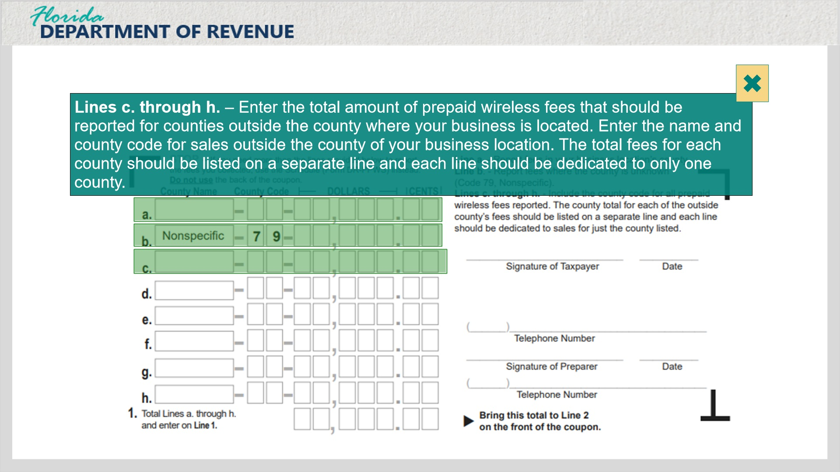
Transcript:
Lines C through H – enter the total amount of prepaid wireless fees that should be reported for counties outside the county where your business is located. Enter the name and county code for sales outside the county of your business location. The total fees for each county should be listed on a separate line and each line should be dedicated to only one county.

2.3 Form DR-PPW (Front of Return)
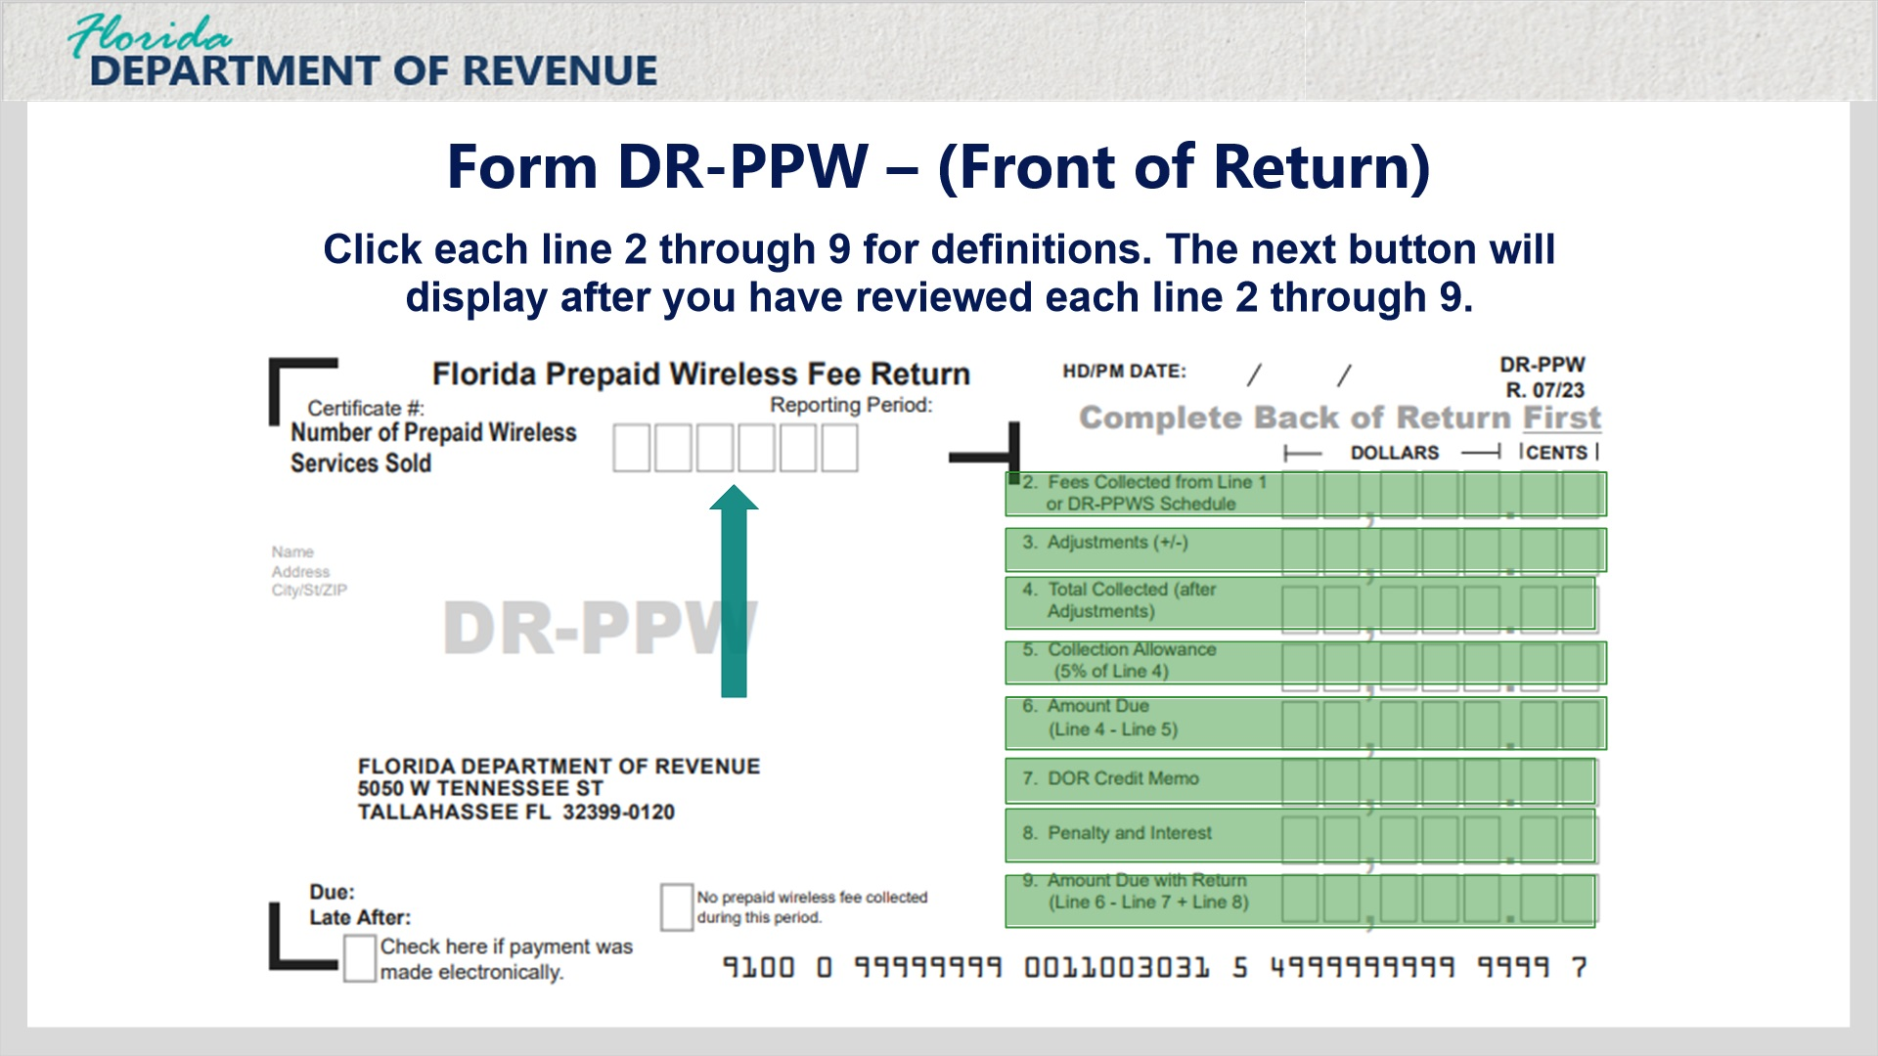
Transcript:
Now we will cover the front of the return for Form DR-PPW. The first step on this side of the form is to fill in the number of devices sold box at the top. Next, click each line, 2 through 9, for definitions. The next button will appear at the bottom-right corner of your screen once all lines are viewed.

Line 2 (Slide Layer)
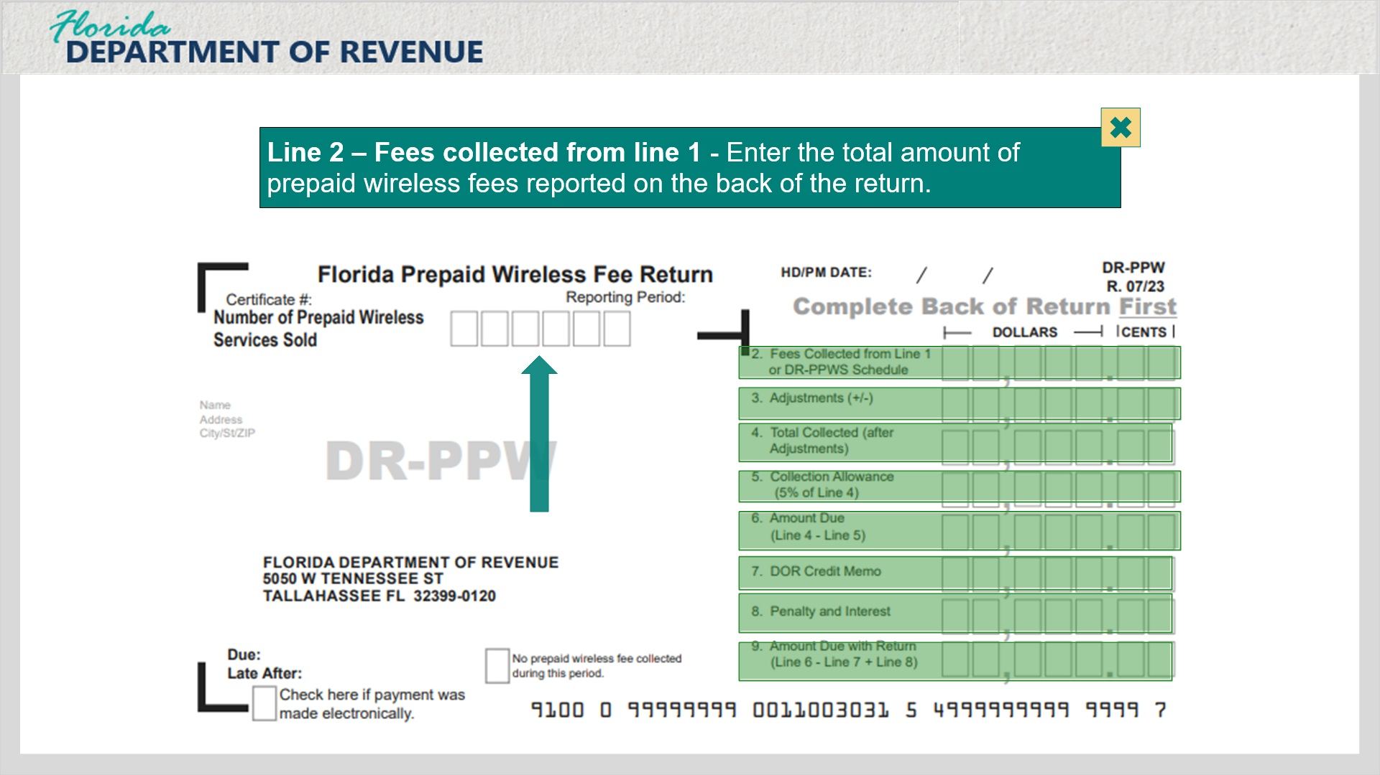
Transcript:
Line 2 – Fees Collected from Line 1 – enter the total amount of prepaid wireless fees reported on the back of the return.

Line 3 (Slide Layer)
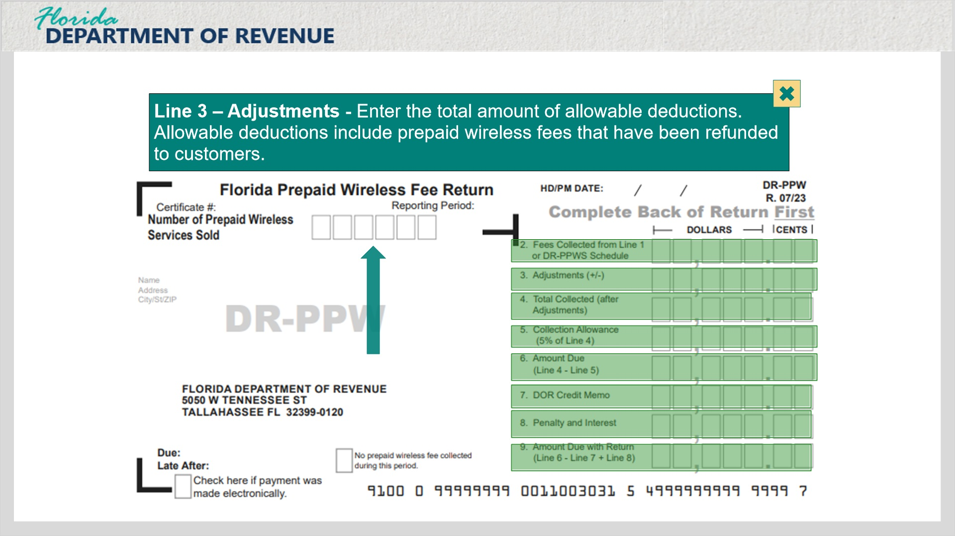
Transcript:
Line 3 – Adjustments – enter the total amount of allowable deductions. Allowable deductions include prepaid wireless fees that have been refunded to customers.

Line 4 (Slide Layer)
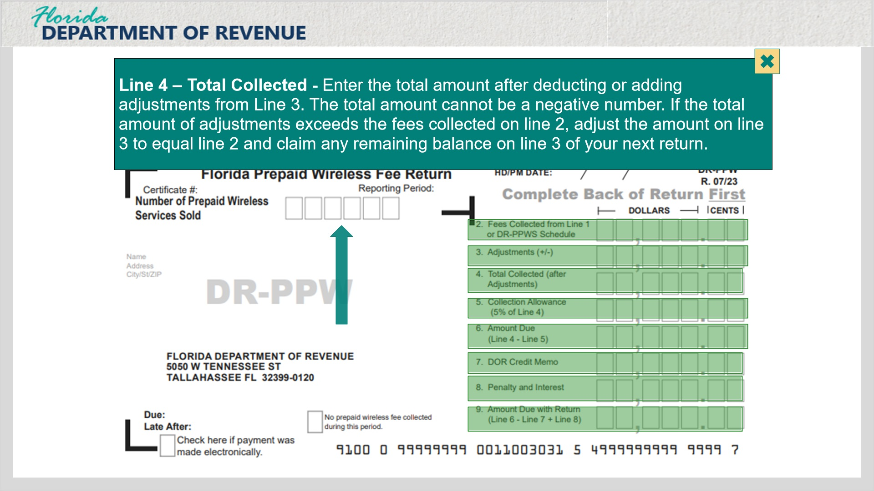
Transcript:
Line 4 – Total Collected – enter the total amount after deducting or adding adjustments from Line 3. The total amount cannot be a negative number. If the total amount of adjustments exceeds the fees collected on Line 2, adjust the amount of Line 3 to equal Line 2 and claim any remaining balance on Line 3 of your next return.

Line 5 (Slide Layer)
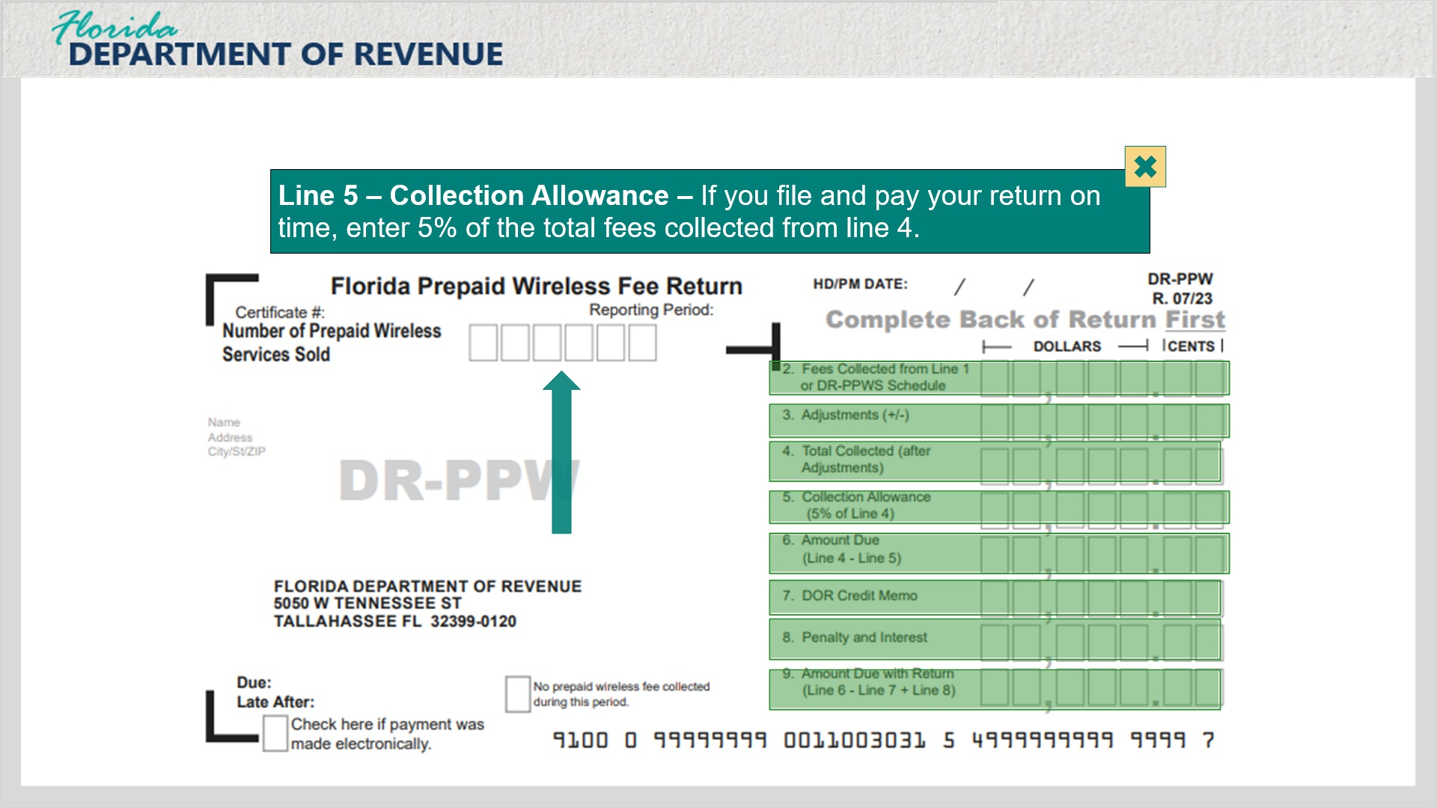
Transcript:
Line 5 – Collection Allowance – if you file and pay your return on time, enter 5% of the total fees collected from Line 4.

Line 6 (Slide Layer)
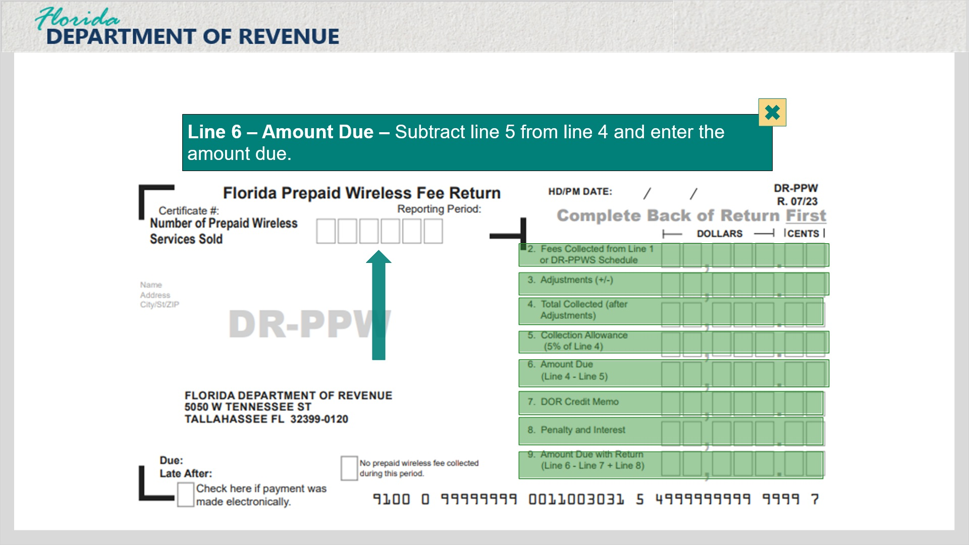
Transcript:
Line 6 – Amount Due – subtract Line 5 from Line 4 and enter the amount due.

Line 7 (Slide Layer)
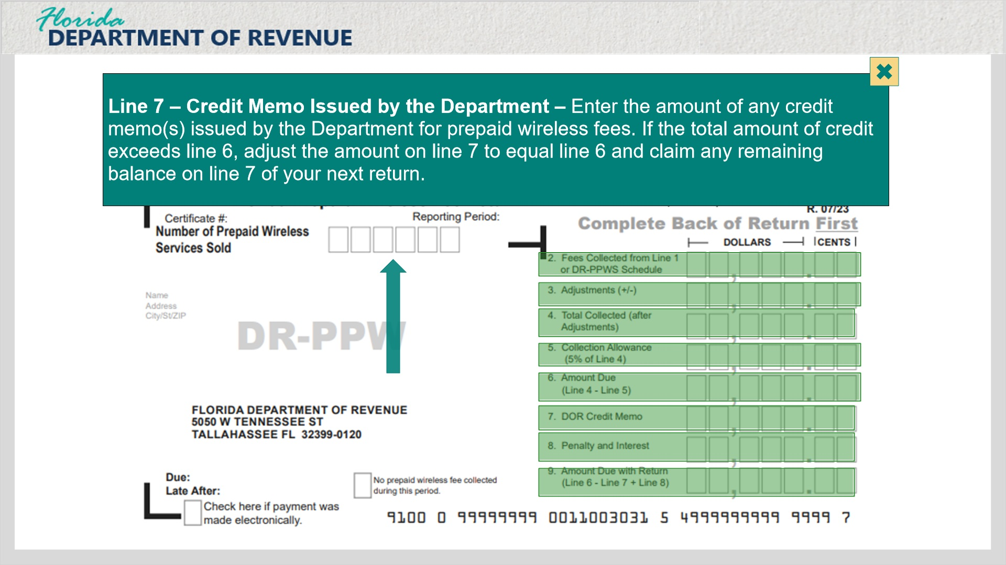
Transcript:
Line 7 – Credit Memo Issued by the Department – enter the amount of any credit memo(s) issued by the Department for prepaid wireless fees. If the total amount of credit exceeds Line 6, adjust the amount on Line 7 to equal Line 6 and claim any remaining balance on Line 7 of your next return.

Line 8 (Slide Layer)
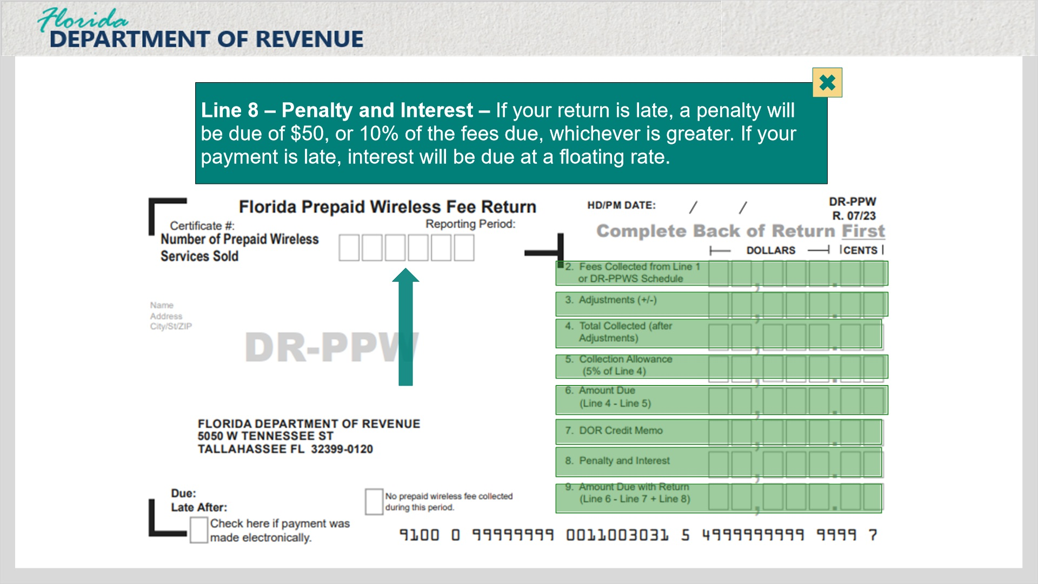
Transcript:
Line 8 – Penalty and Interest – if your return is late, a penalty will be due of $50, or 10% of the fees due, whichever is greater. If your payment is late, interest will be due at a floating rate.

Line 9 (Slide Layer)
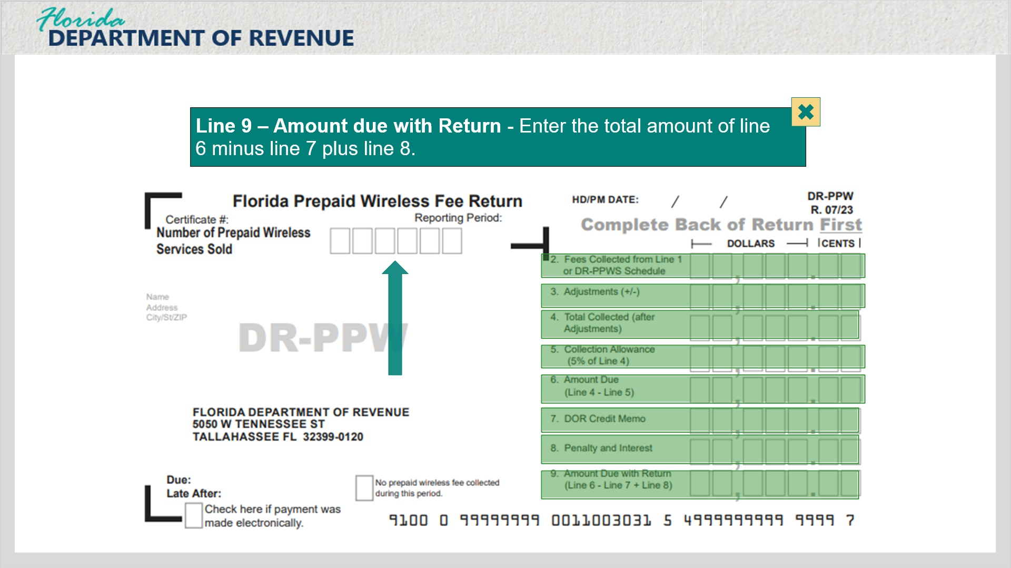
Transcript:
Line 9 – Amount Due with Return – enter the total amount of Line 6 minus Line 7 plus Line 8.

2.4 Form DR-PPWS
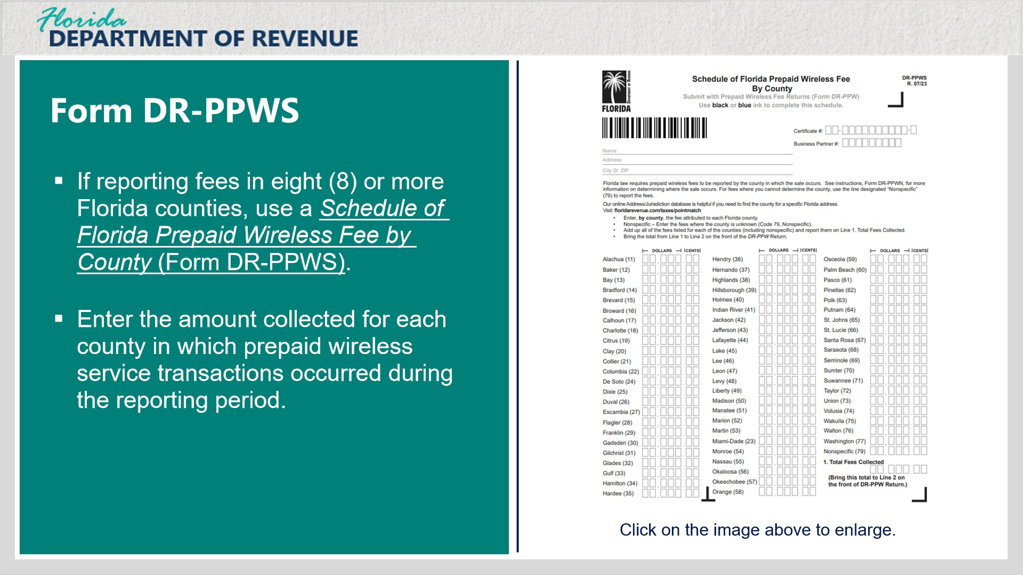
Transcript:
Taxpayers who are reporting fees in eight (8) or more Florida counties must use the Schedule of Florida Prepaid Wireless Fee by County (Form DR-PPWS).
Enter the amount collected for each county in which prepaid wireless service transactions occurred during the reporting period.
Click on the image on the right for a larger view.

Chart Layer (Slide Layer)
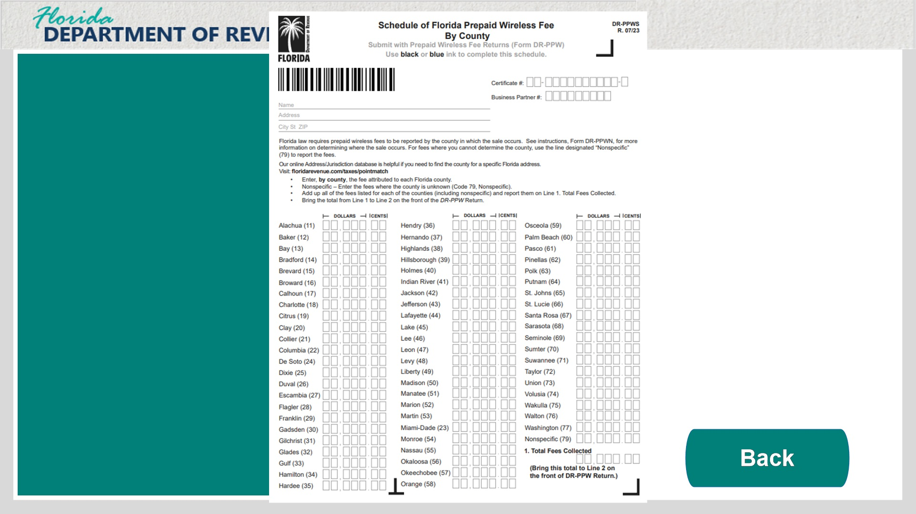
Transcript:
Enlarged image for the Schedule of Florida Prepaid Wireless Fee by County (Form DR-PPWS).

3. Examples

3.1 Example 1 - Sales in One County
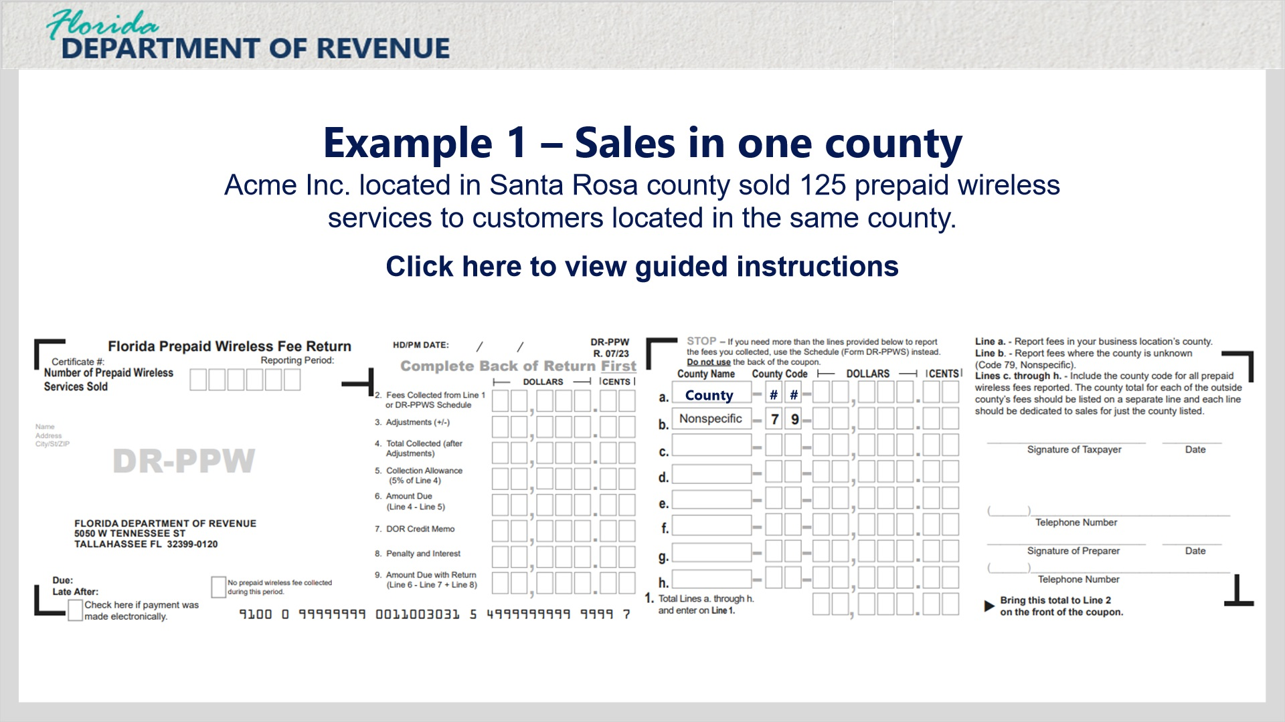
Transcript:
Example 1 Sales in one county. Acme Inc. located in Santa Rosa County sold 125 prepaid wireless services to customer located in the same county.

Example 1 Back (Slide Layer)
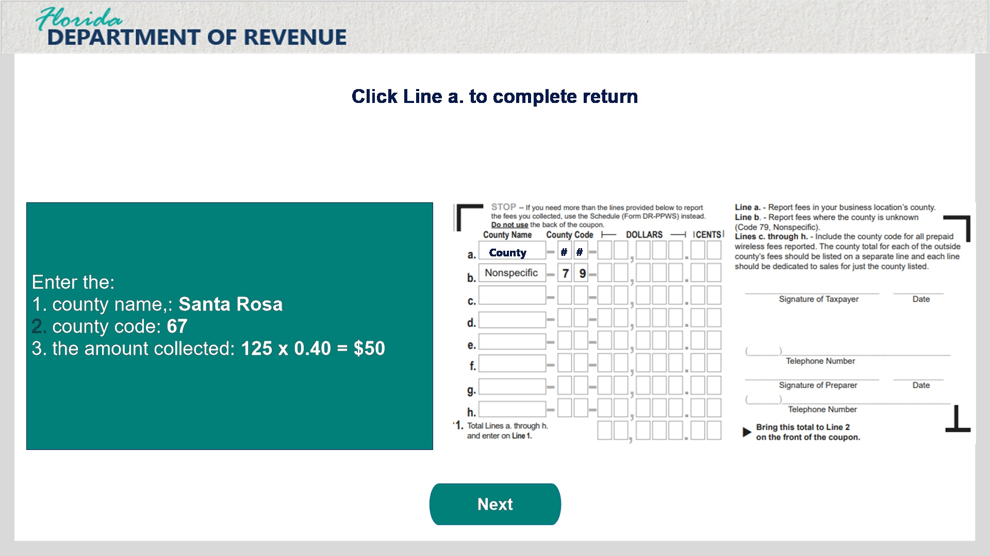
Transcript
Click Line a. to complete the return. Enter the county name, Santa Rosa, in Line a. Enter the county code, 67, in the County Code box. Enter the amount collected, 125 multiplied by 0.40 for a total of $50. Enter $50 in the dollars box.

Example 1 Front (Slide Layer)
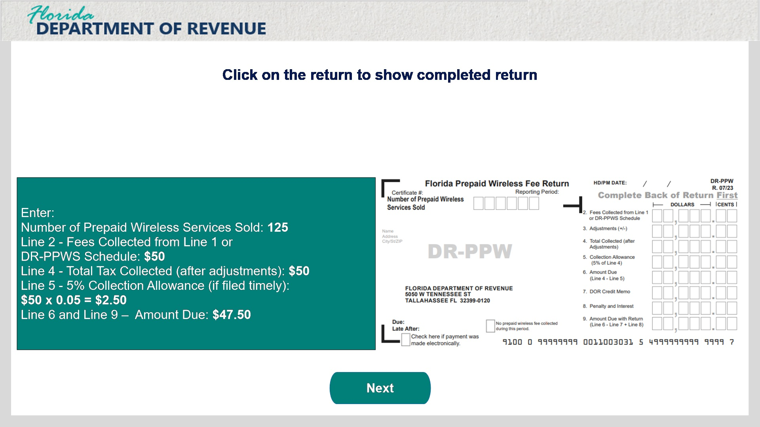
Transcript
Enter 125 in the Number of Prepaid Wireless Services Sold box. Next, transfer the total from Line 1 on the back of the form, and enter $50 into Line 2. Now update Line 4 – Total Tax Collected (after adjustments) with a total of $50. Update Line 5 – 5% Collection Allowance (if filed timely) with $50 multiplied by 0.05 for a total of $2.50. Finally, update Lines 6 – Amount Due and Line 9 – Amount Due with Return with a total of $47.50.

3.2 Example 2 - Sales in Two Counties
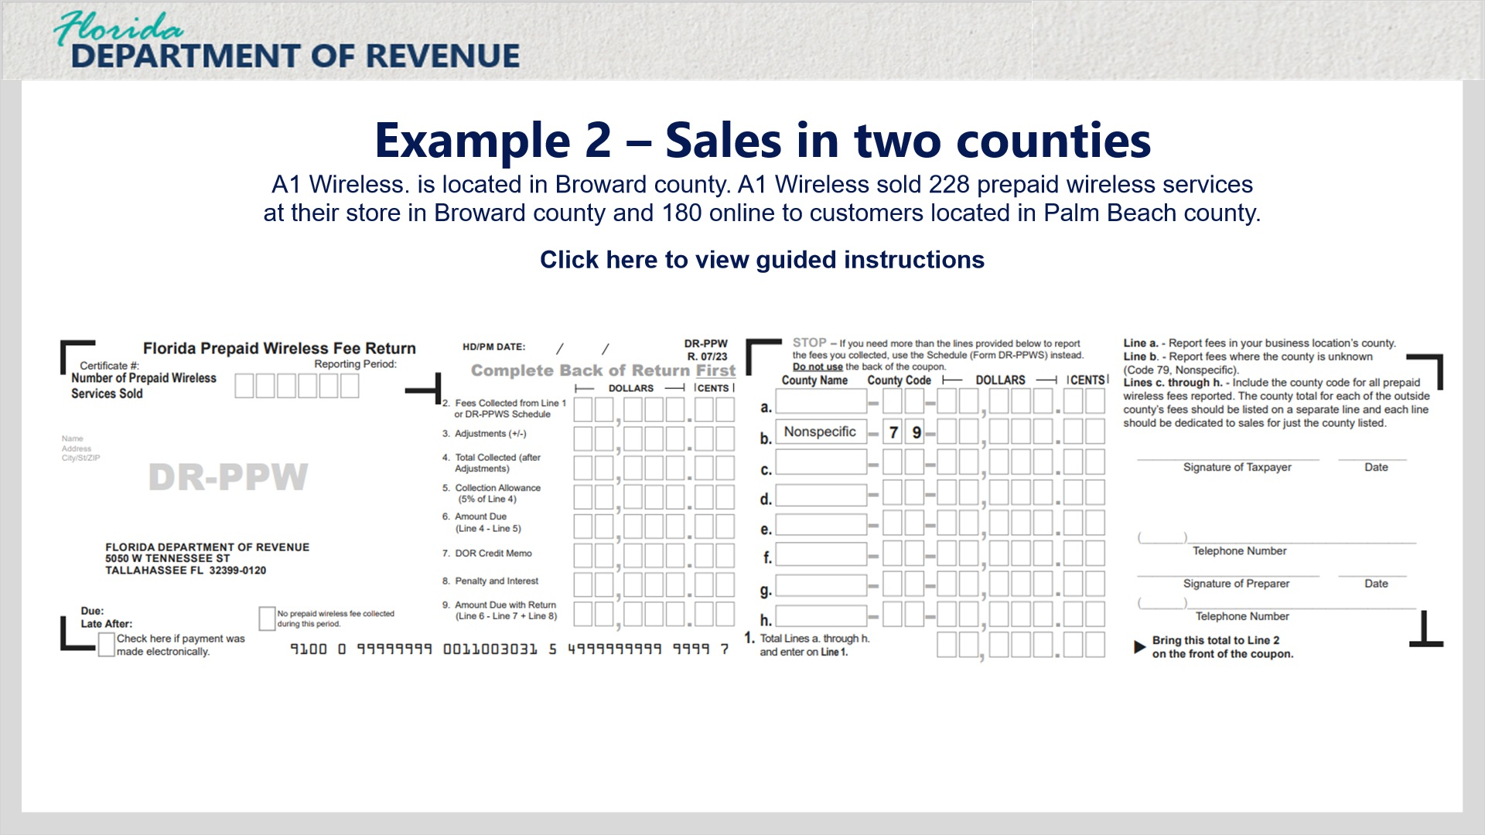
Transcript:
Example 2 – Sales in two counties. A1 Wireless is located in Broward county. A1 Wireless sold 228 prepaid wireless services at their store in Broward county and 180 online to customers located in Palm Beach county.

Example 2 Back (Slide Layer)
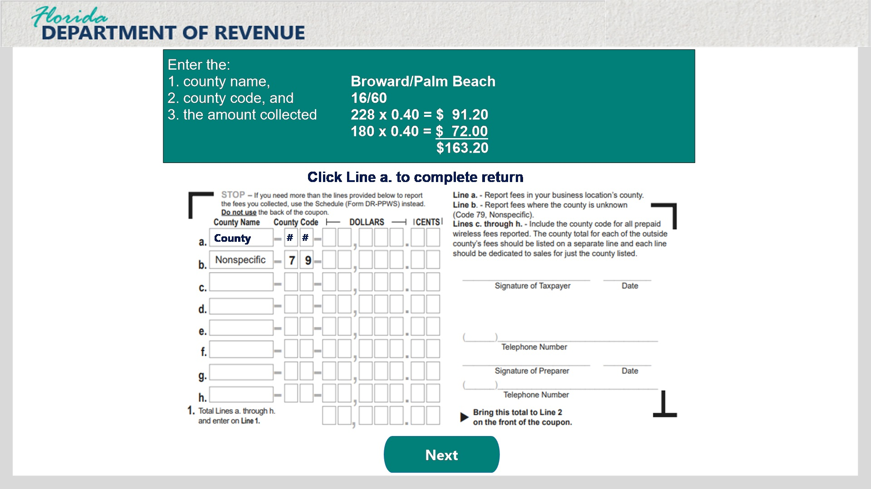
Transcript
Enter the county name, Broward, in the Line a county name box. Next, enter the county code, 16, in the Line a county code box. Enter the amount collected, 228 multiplied by 0.40 for a Line a dollar amount of $91.20. Next, enter the county name, Palm Beach, in the Line b county name box, and enter the county code, 60, in the Line b county code box. Enter the collected amount, 180 multiplied by 0.40 for a Line b dollar amount of $72.00.
This results in a Total Lines a through h amount of $163.20.

Example 2 Front (Slide Layer)
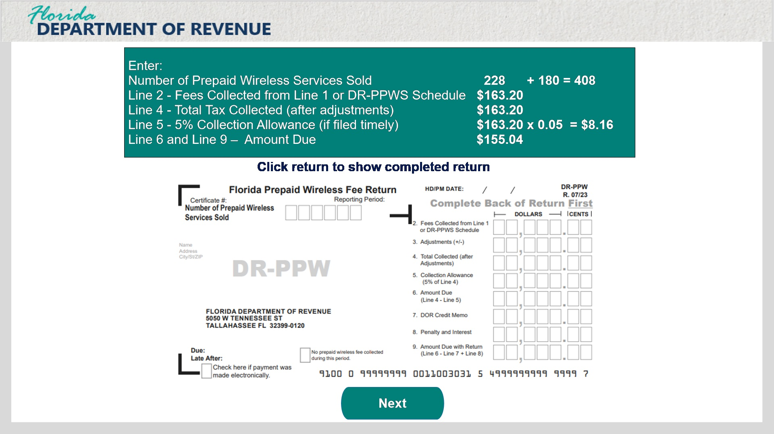
Transcript
First, add the number of prepaid wireless devices sold by combining the totals for each county. 228 plus 180 equals 408. Enter 408 in the Number of Prepaid Wireless Devices Sold box. Next, transfer the total from the back of Form DR-PPW, $163.20, to the Line 2 – Fees Collected from Line 1 or DR-PPWS Schedule box on the front of the form. We will populate Line 4 with the same amount because there are no adjustments in our example. Next, multiple $163.20 by .05 for a Line 5 – 5% Collection Allowance (if filed timely) of $8.16. Subtract Line 5 from Line 4 for a Line 6 – Amount Due and Line 9 – Amount Due with Return total of $155.04.

3.3 Example 3 - Sales in Multiple Counties
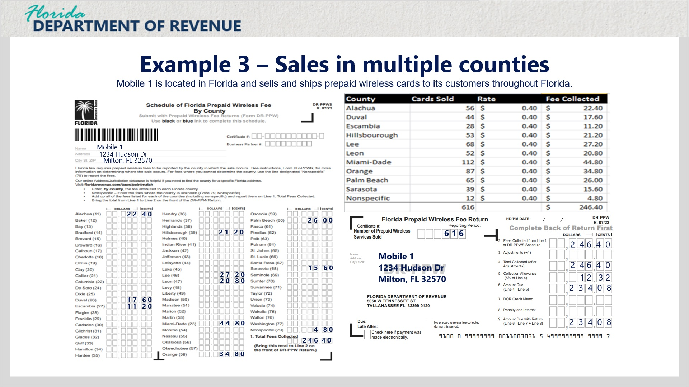
Transcript:
Use Form DR-PPWS for sales that occur in multiple counties. First, populate the name and address information at the top left of the form. Next, populate the sales amount for each county by multiplying the number of prepaid wireless services sold by the county rate. Enter the fee collected total for each county in the dollar boxes by each county on the form. Now, add up the total of all wireless services sold and update the Number of Prepaid Wireless Services Sold box. Next, populate Line 2 with the Total Fees Collected in Line 1. If there are no adjustment, transfer the total from Line 2 to Line 4. Next, multiple the total by 5% for a Line 5 Collection Allowance total. Subtract Line 5 from Line 4 and enter the total in Line 6 – Amount Due and Line 9 - Amount Due with Return.

4. Exit

4.1 Survey
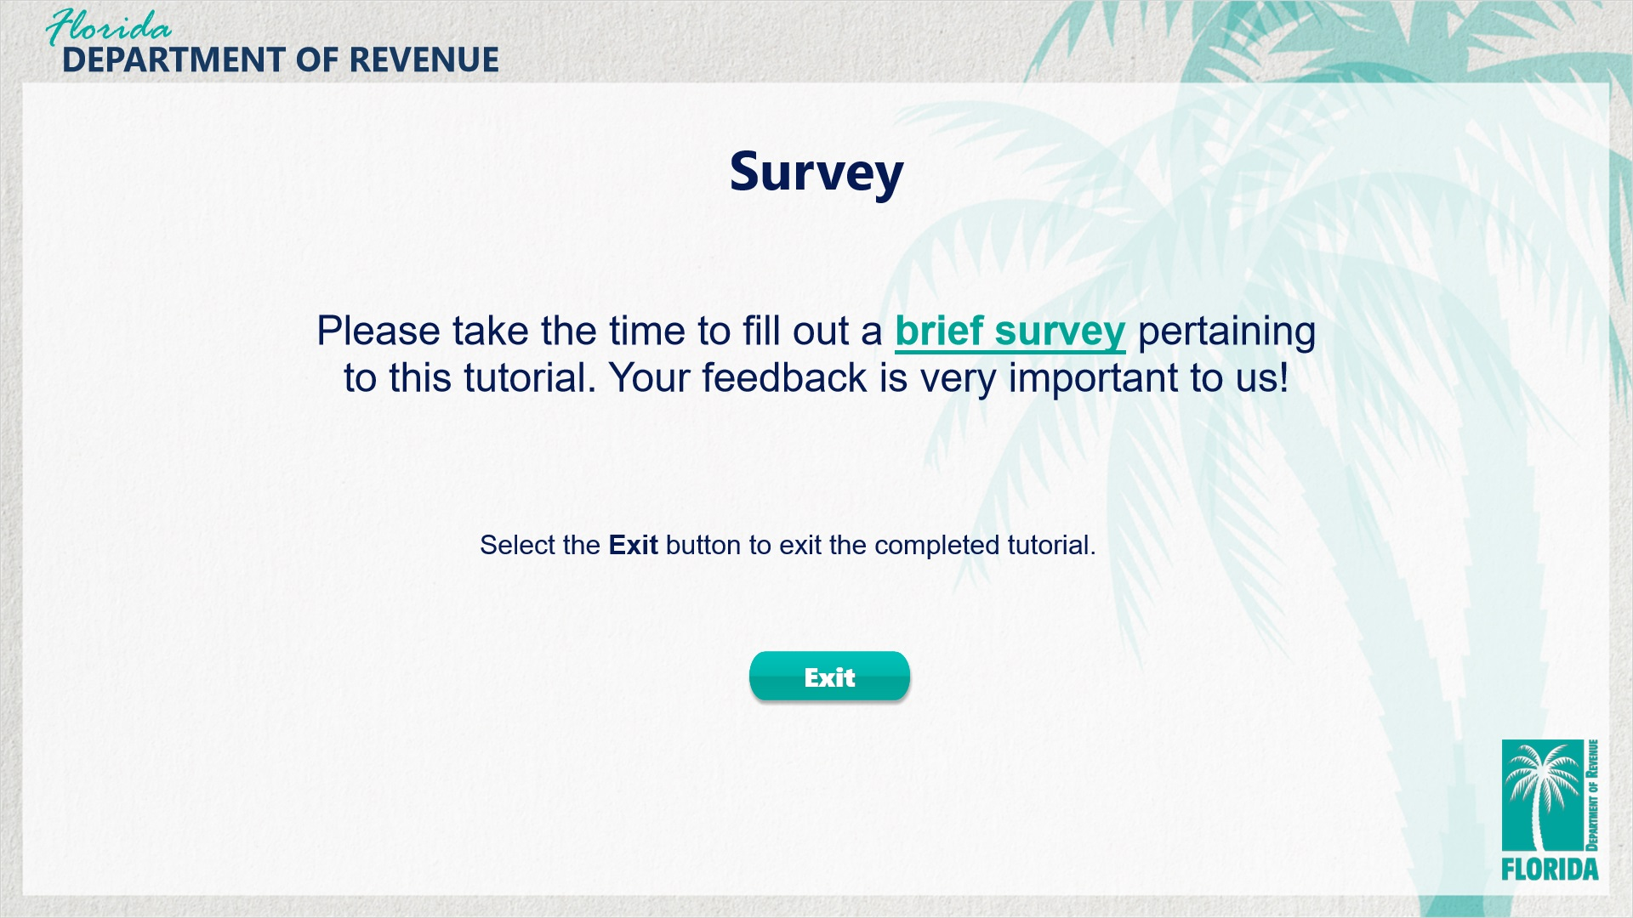
Transcript:
This concludes the Prepaid Wireless Public Safety Emergency Communications Systems Fee (Prepaid Wireless Fee) tutorial. We hope that you now have a better understanding of how to accurately collect and report prepaid wireless fees using the Florida Prepaid Wireless Fee Return.
For more information, check out the resources available within this overview by clicking on the Resources tab in the upper-right corner of your screen.
In addition, there are several helpful guides and tutorials available on a variety of tax-related topics on the Department’s website at floridarevenue.com.
Please fill out a brief survey pertaining to the tutorial. Your feedback is very important to us.
To exit this tutorial, click on the Exit button.
Thank you.

