Reemployment Tax Part 1: The Basics - Accessibility Outline

1. Introduction

1.1 Welcome
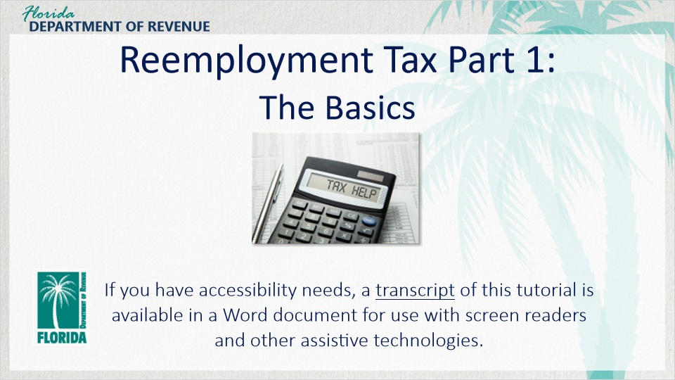
Transcript:
Welcome to Reemployment Tax: The Basics. In this course, we will be discussing the Reemployment Assistance Program and how it affects your business and your tax liability as a business owner.
If you have accessibility needs, a transcript of this tutorial is available in a Word document for use with screen readers and other assistive technologies.

1.2 Navigating This Tutorial
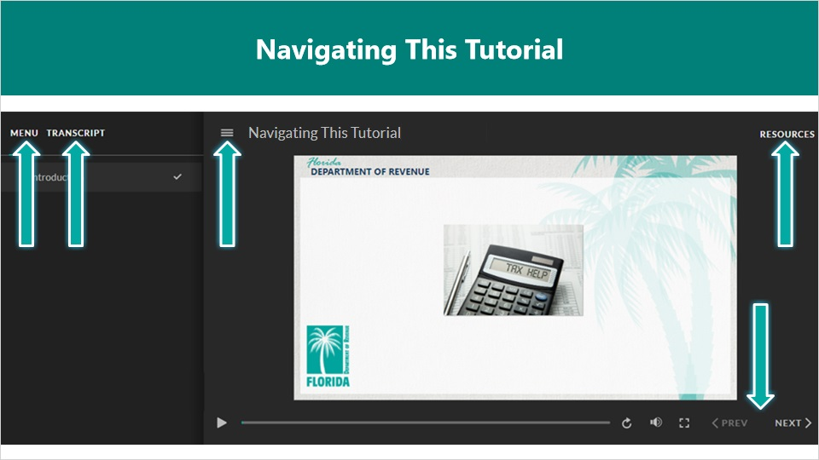
Transcript:
This tutorial will take approximately 15 minutes to complete. A transcript of the audio is available by clicking on the Transcript tab in the top-left corner of your screen. The following tabs and buttons are available to help you navigate through this tutorial.
Menu Tab
The Menu tab displays by default when the tutorial is viewed on a computer. It allows you to navigate through the tutorial by clicking on the topic name in the menu. When viewing this tutorial on a tablet or smartphone, the menu does not display by default and must be accessed using the menu symbol.
Resources Tab
The Resources tab is found to the right side of the top bar. When clicked, it displays a list of links to useful forms, documents, and webpages.
Previous and Next Buttons
The Previous and Next buttons are located at the bottom-right corner of your screen. These buttons allow you to move either back or forward.

1.3 Topics
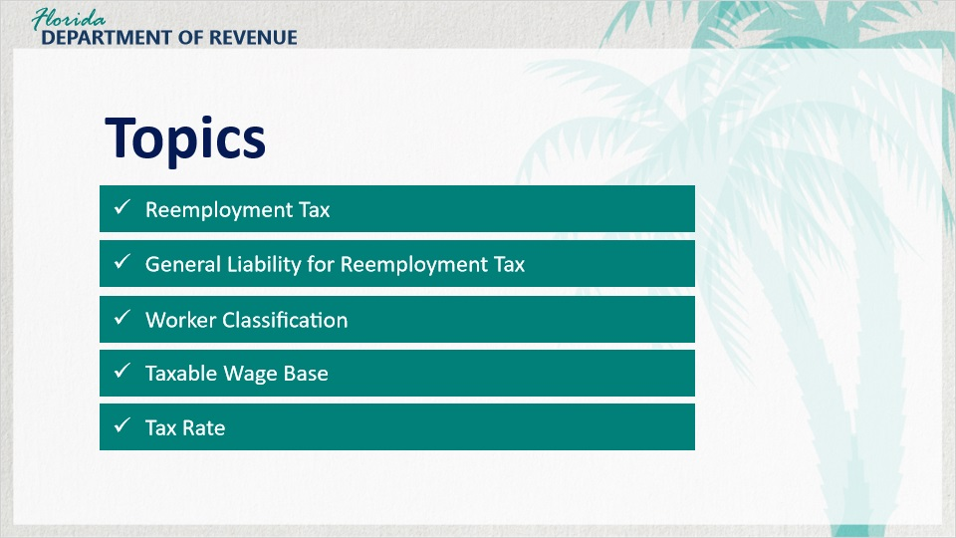
Transcript:
Topics for this tutorial include Reemployment Tax, General Liability for Reemployment Tax, Worker Classification, Taxable Wage Base, and Tax Rate.

2. Reemployment Basics

2.1 Let's Meet Olivia!
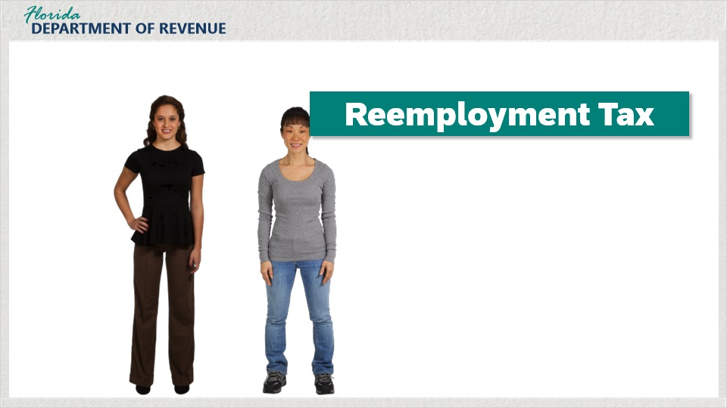
Transcript:
Let’s say hello to Olivia. Olivia just started her own business a year ago working as a seamstress out of her home. Her business is booming, and she can barely keep up with her workload. She decided that she needed to hire an assistant - someone to help her out with the day-to-day administrative tasks she doesn’t have time to do anymore.
She soon found out that she might be responsible for something called reemployment tax. Understandably, she has many questions and concerns.
[Olivia]: What is reemployment tax? What is it for? And why do I need to pay it?

2.2 What is the Reemployment Assistance Program?
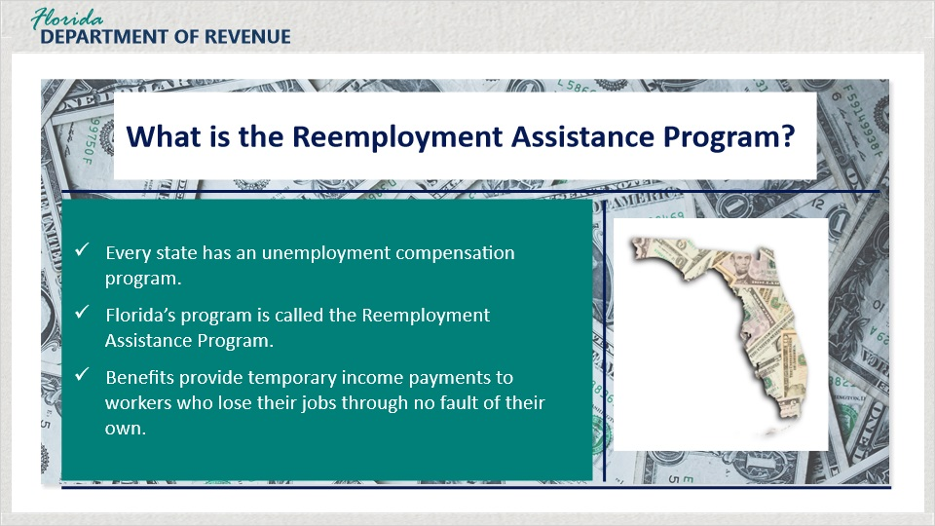
Transcript:
Most people have heard of unemployment compensation. But what is reemployment assistance?
Every state has an unemployment compensation program. Florida has one too, except legislation was passed in 2012, that changed the name of Florida’s Unemployment Compensation Law to the Reemployment Assistance Program Law.
Reemployment assistance provides temporary income to workers who lose their jobs through no fault of their own, and who are able and available for work.

2.3 More About the Program
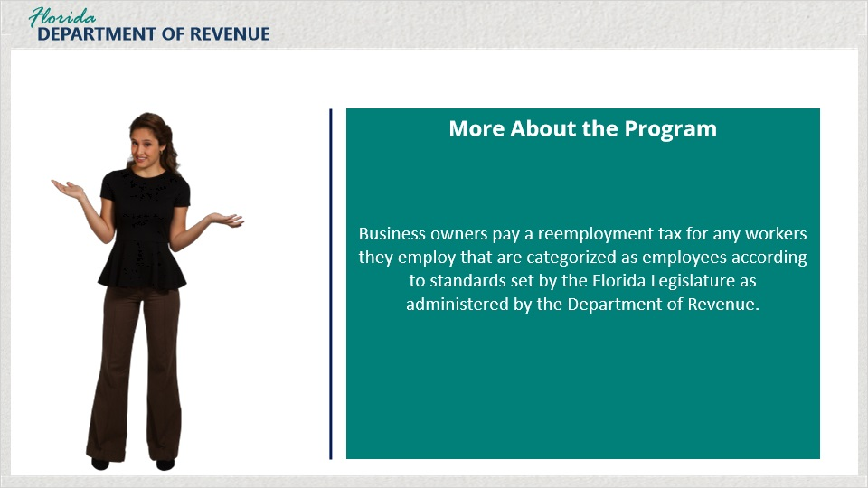
Transcript:
[Olivia]: I lost my job at a department store due to layoffs, and I received unemployment checks for a little while. So, I guess I know something about reemployment after all.
It sounds like you do!
[Olivia]: Since I’ve started my own business, would I be paying for that program?
Yes, you would.
[Olivia]: How does it all work?
Well, business owners like you pay a reemployment tax for any workers you employ that are categorized as employees according to standards set by the Florida Legislature, and as administered by the Department of Revenue. We will go over those in a bit.

2.4 State Unemployment Tax Act (SUTA)
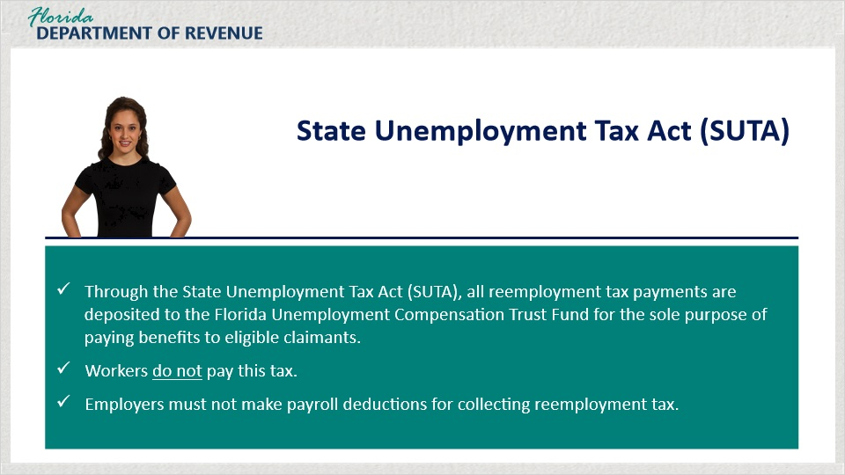
Transcript:
Through the State Unemployment Tax Act (SUTA), all reemployment tax payments are deposited to the Florida Unemployment Compensation Trust Fund for the sole purpose of paying benefits to eligible claimants. The employer pays for this Reemployment Assistance Program as a cost of doing business.
[Olivia]: So, workers don’t have to pay this tax?
Workers don’t pay anything, and employers must not make payroll deductions for this purpose.

2.5 Federal Unemployment Tax Act (FUTA)
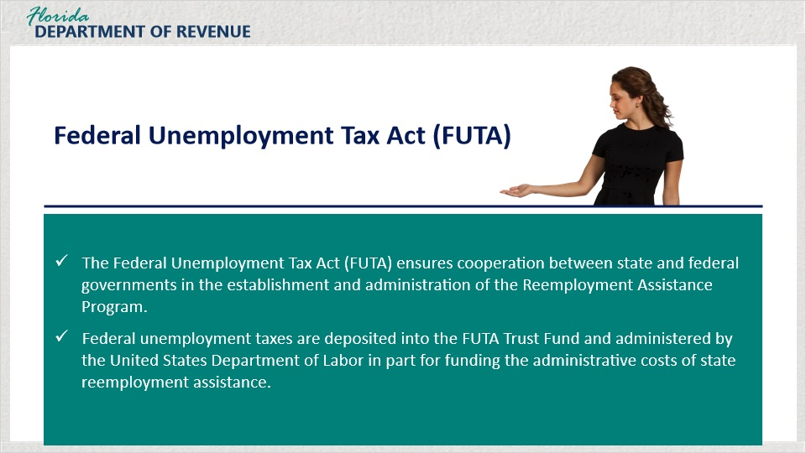
Transcript:
The Federal Unemployment Tax Act (FUTA) ensures cooperation between state and federal governments in the establishment and administration of the Reemployment Assistance Program. Federal unemployment taxes are deposited into the FUTA Trust Fund and administered by the United States Department of Labor in part for funding the administrative costs of state reemployment assistance.
[Olivia]: So, there are federal unemployment taxes too?
Yes, but for the purposes of this tutorial, we are going to focus on Florida’s reemployment tax.

2.6 Knowledge Check #1
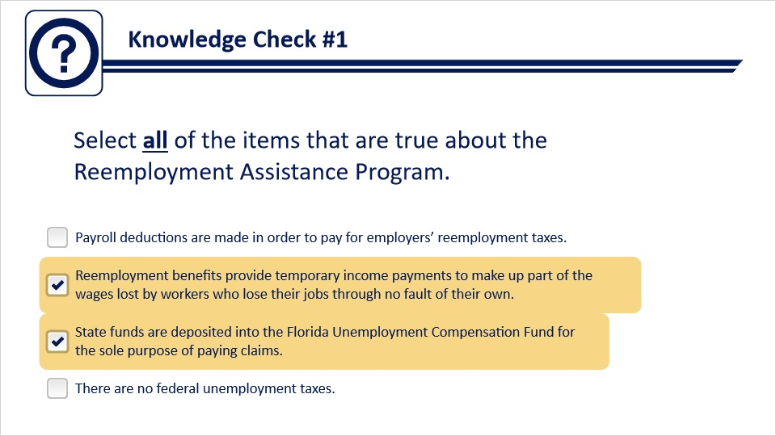
Transcript:
Question text:
Select all of the items that are true about the Reemployment Assistance Program.
Answer options:
Payroll deductions are made in order to pay for employers’ reemployment taxes.
Reemployment benefits provide temporary income payments to make up part of the wages lost by workers who lose their jobs through no fault of their own.
State funds are deposited into the Florida Unemployment Compensation Fund for the sole purpose of paying claims.
There are no federal unemployment taxes.
Feedback when correct:
That's right! You selected the correct response.
Feedback when incorrect:
Reemployment benefits provide temporary income payments to make up part of the wages lost by workers who lose their jobs through no fault of their own. State funds are deposited into the Florida Unemployment Compensation Fund for the sole purpose of paying claims.

3. General Liability Requirements

3.1 Requirements
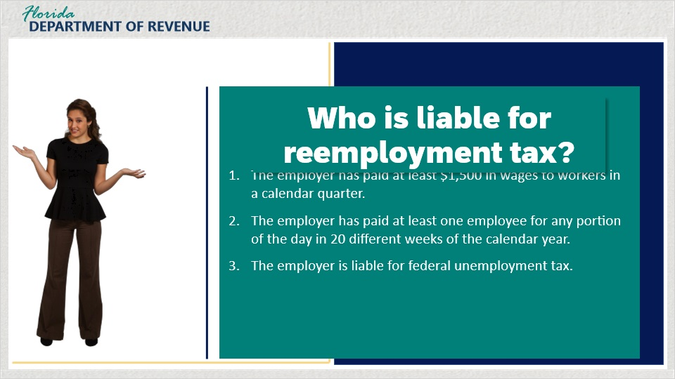
Transcript:
[Olivia]: How do I know for sure if I have to pay reemployment tax? I only have one employee!
That’s a great question. Who is liable for paying reemployment tax? Well, there are some set criteria available from the Department of Revenue.
An employer is liable for reemployment tax if they meet any one of these three criteria:
The employer has paid at least $1,500 in wages to workers in a calendar quarter. This could be $1,500 to a single worker or to a combination of workers.
The employer has paid at least one employee for any portion of the day in 20 different weeks within the calendar year. It is important to know that this doesn’t have to be the same employee for the 20 weeks.
Finally, if you are liable for federal unemployment tax, you are also liable for state reemployment tax.
[Olivia]: I’m sorry, did you say I have to meet all three criteria? Or just one?
You only have to meet one. Let’s look at Michelle’s situation.

3.2 Requirements Continued
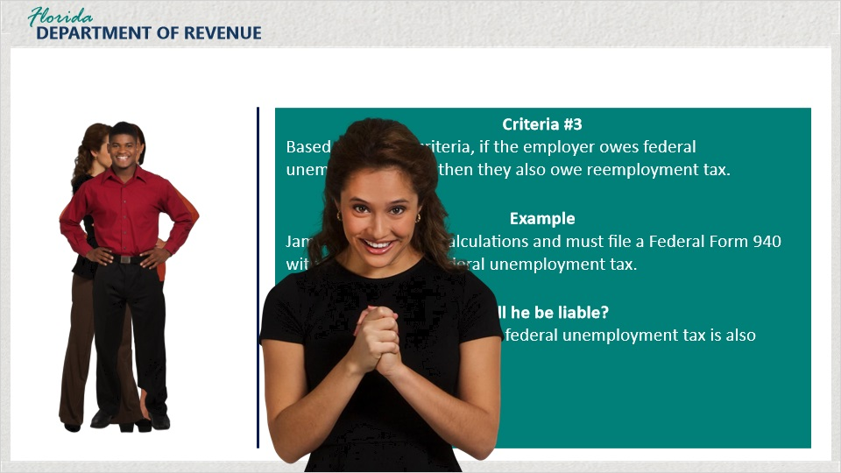
Transcript:
Michelle hired one employee on January 1st and paid the employee $100 per week.
The business would not meet the first criteria of paying out $1,500 because there are only 13 weeks in a quarter.
[Olivia]: I’ve had my assistant for eight weeks this quarter and pay her around $100 as well. So under that criteria, I wouldn’t have to pay.
Not under that criteria. But let’s look at the next one. You have had your employee for eight weeks, right? This means that your business would meet the second criteria once your assistant has been employed by you and working for 20 weeks.
[Olivia]: So as of right now, I don’t owe anything, but I will if I employ someone for at least 20 weeks this year.
Yes, you would. Finally, let’s take a look at James’ situation. James has done the calculations and must file a Federal Form 940 with the IRS to pay federal unemployment tax. James is liable because anyone who is liable for federal unemployment tax is also liable for reemployment tax.
[Olivia]: Okay, I think I get it.

3.3 Knowledge Check #2
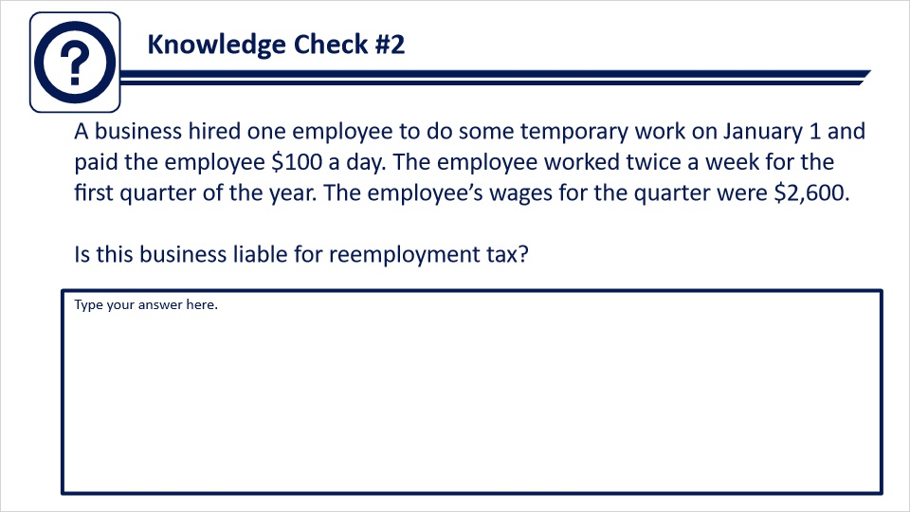
Transcript:
A business hired one employee to do some temporary work on January 1 and paid the employee $100 a day. The employee worked twice a week for the first quarter of the year. The employee’s wages for the quarter were $2,600. Is this business liable for reemployment tax?
Feedback:
The business would be liable. The worker was paid more than $1,500 in a calendar quarter.

3.4 Knowledge Check #3
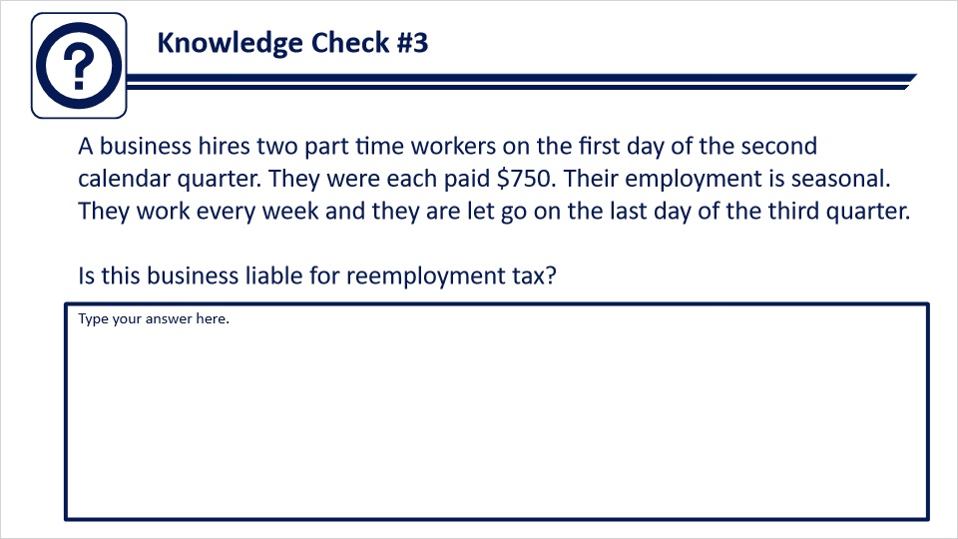
Transcript:
A business hires two part time workers on the first day of the second calendar quarter. They were each paid $750. Their employment is seasonal. They work every week and they are let go on the last day of the third quarter. Is the business liable for reemployment tax?
Feedback:
The business would be liable. At least one employee was paid for two full quarters adding up to more than 20 weeks of employment. It does not matter whether the workers are full or part time when determining the 20 week requirement.

3.5 Liability Criteria for Other Industries
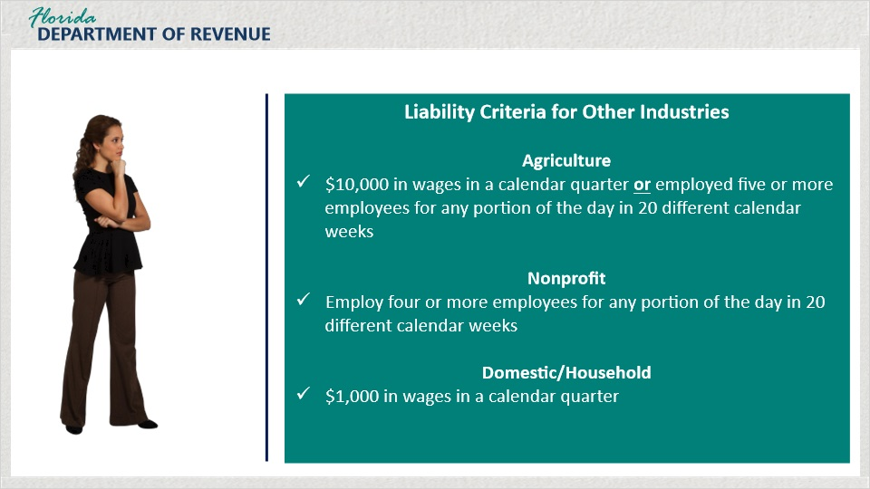
Transcript:
There are other liability criteria that apply to specific industries.
If you are an employer in the agricultural industry, and you paid $10,000 in wages in a calendar quarter or employed five or more employees for any portion of the same day during any 20 calendar weeks, you are liable.
If your business is a nonprofit, and you employed four or more employees for any portion of the day during any 20 calendar weeks, you are liable.
If you have any domestic employees, such as a maid, butler, or house manager, and paid them $1,000 in a calendar quarter, you are liable.

3.6 Employment Not Covered
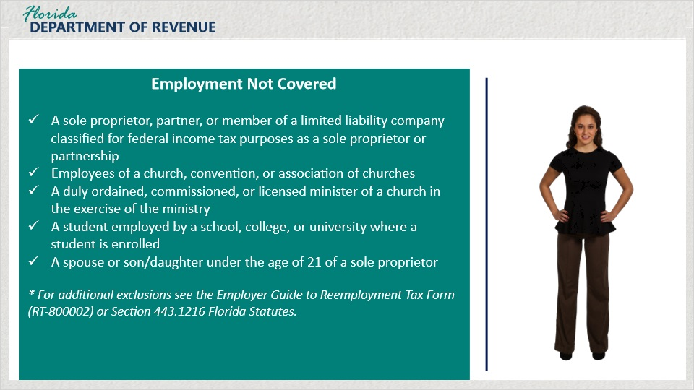
Transcript:
Several types of employment are not covered for reemployment assistance purposes, and these workers are not considered in determining an employer’s liabilities. These include but are not limited to a sole proprietor, partner, or member of a limited liability company classified for federal income tax purposes as a sole proprietor or a partnership, employees of a church, convention, or association of churches, a duly ordained, commissioned, or licensed minister of a church in the exercise of the ministry, a student employed by a school, college, or university where the student is enrolled and attending classes, a spouse or son or daughter under the age of 21 of a sole proprietor.
For additional exclusions, see the Employer Guide to Reemployment Tax Form (RT-800002) or Section 443.1216 of the Florida Statutes.
In your situation, you started out working alone as a sole proprietor. This means that you had no employees and did not have to register as an employer. Now that you have hired an employee, and you meet the criteria we discussed, you are an employer and must register and file quarterly reports.

3.7 Knowledge Check #4
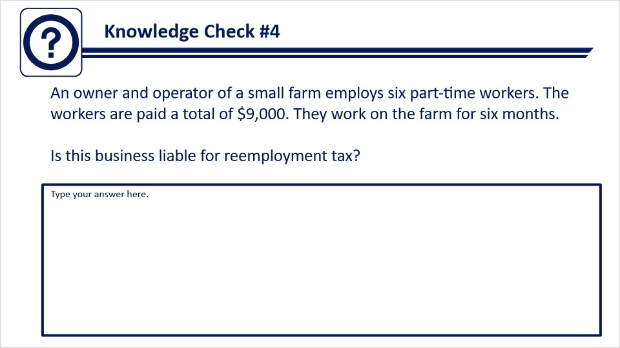
Transcript:
An owner and operator of a small farm employs six part-time workers. The workers are paid a total of $9,000. They work on the farm for six months. Is this business liable for reemployment tax?
Feedback:
The business would be liable. At least one person is employed for a total of 20 calendar weeks.

4. Worker Classification

4.1 Worker Classification
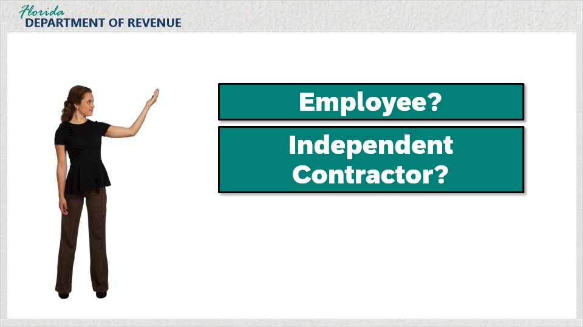
Transcript:
Another factor that can affect your tax liability is how your employees are classified. Employers must be able to classify a worker as either an employee or an independent contractor to determine their tax liability.
[Olivia]: My friend Carlos has a business, and he hires independent contractors. Doesn’t he save money on taxes doing this?
If he follows the criteria for determining who is an employee and who is an independent contractor, then yes, he probably would.

4.2 Types of Employees
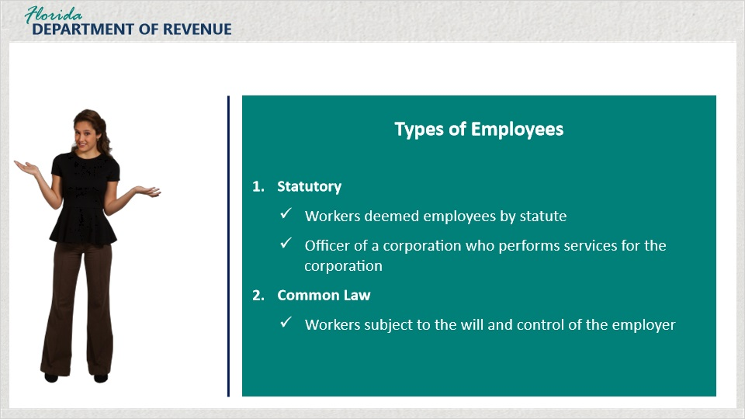
Transcript:
Let’s examine the difference between employees and independent contractors. There are two types of employees: statutory and common law. Statutory employees are workers deemed as employees by statute. An officer of a corporation who performs services for the corporation is an example of a statutory employee, regardless of whether the officer receives a salary or other compensation.
The second type of employee is referred to as common law. This is someone who’s subject to the will and control of the employer. The employer decides what work the employee will do and how the employee will do it.
In comparison, an independent contractor is not subject to the will and control of the employer. The employer can decide what results are expected from the independent contractor but cannot control the methods used to accomplish those results.

4.3 Employee vs. Independent Contractor
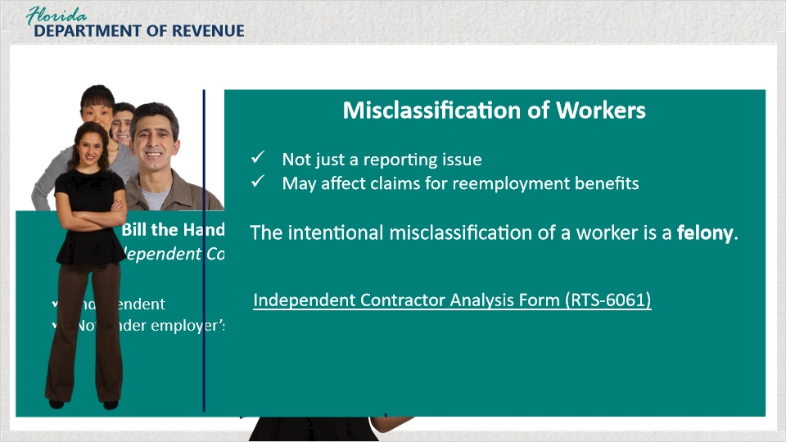
Transcript:
[Olivia]: Can you give me an example of what you mean by being subject to the will and control of the employer?
Sure. Let’s say you hire Bill, a handyman, to come to your shop to fix a door. You have an expectation that the door will be fixed when he is done, but you don’t tell him what tools to use or how to make the repair. He uses his prior knowledge, experience, and skill to do the job. You don’t exercise control over how he gets the job done.
As for your assistant Emily, you probably have set responsibilities for her. You probably want her to file your records or answer the phone in a certain way and want her to come in at specific hours. If so, you are exerting your will and control over her for the sake of getting the job done.
[Olivia]: So let me see if I have this straight. In the example with the handyman, he is independent and not under my control. I can’t dictate to him how to do his job. Therefore, he would be an independent contractor. As for my assistant, however, I do have control. She does have to listen to me concerning details of how I want her to perform her duties. She is an employee.
Exactly. You’re getting it.
It’s also important to note that the misclassification of workers is not just a tax reporting issue; it also affects claims for reemployment assistance benefits. If a person files a claim for benefits and the employer has not been including the person on the quarterly report, this can cause a delay in benefit payments. In addition, the intentional misclassification of a worker is a felony.
[Olivia]: What happens if I’m just not sure if the person is an employee or an independent contractor?
You should complete and submit the Independent Contractor Analysis Form (RTS-6061) to the Department as directed by the DR-1. This checklist will provide you with the insight you need to make a clear decision of a worker’s status.

4.4 Common Law Factors
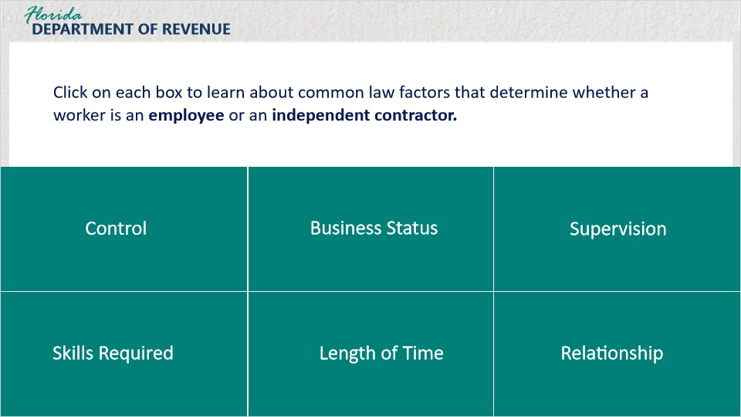
Transcript:
Common law factors include Control, Business Status, Supervision, Skills Required, Length of Time, and Relationship. Click on each box to learn about common law factors that determine whether a worker is an employee or an independent contractor.

Control (Slide Layer)
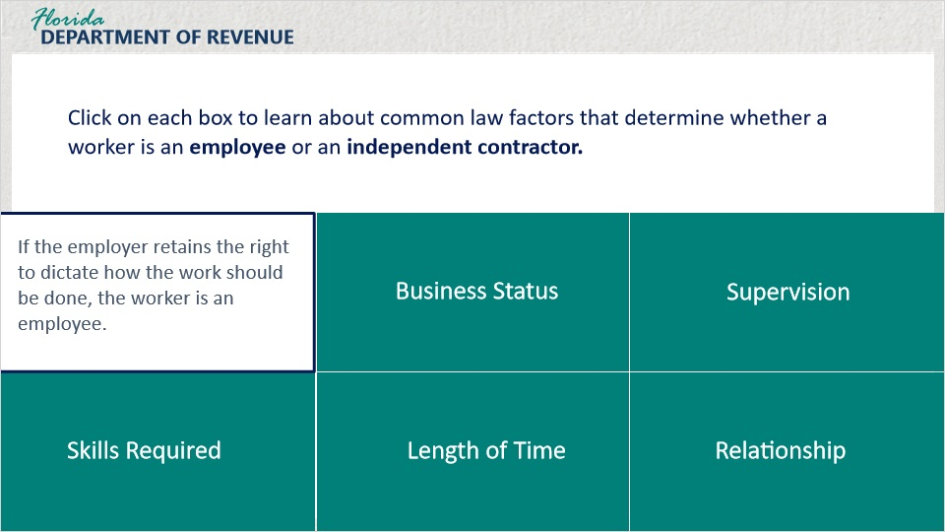
Transcript:
If the employer retains the right to dictate how the work should be done, the worker is an employee.

Business Status (Slide Layer)
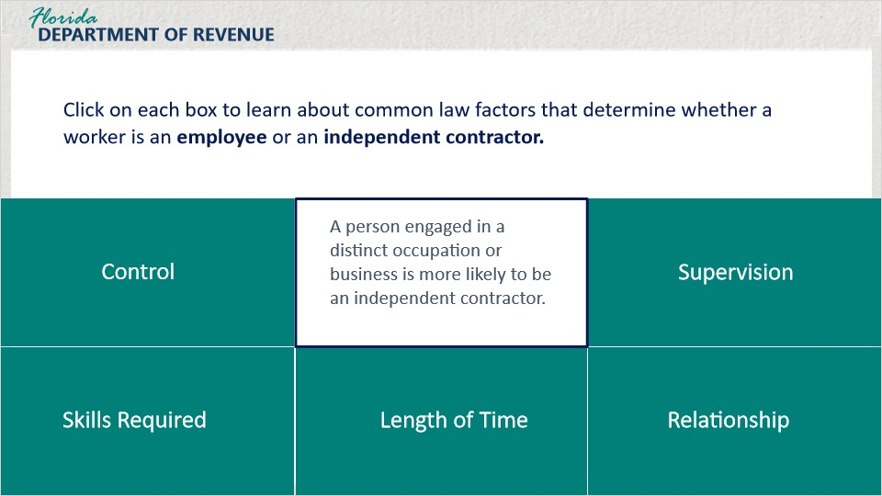
Transcript:
A person engaged in a distinct occupation or business is more likely to be an independent contractor.

Supervision (Slide Layer)
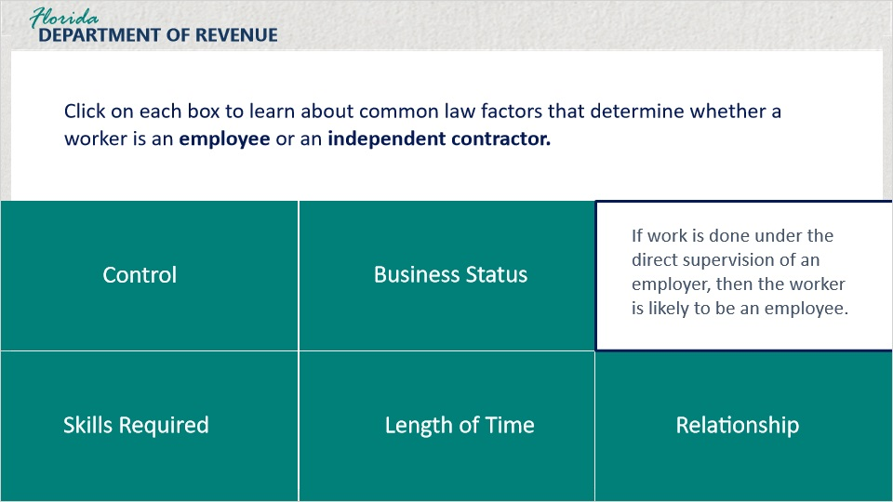
Transcript:
If work is done under the direct supervision of an employer, then the worker is likely to be an employee.

Skills Required (Slide Layer)
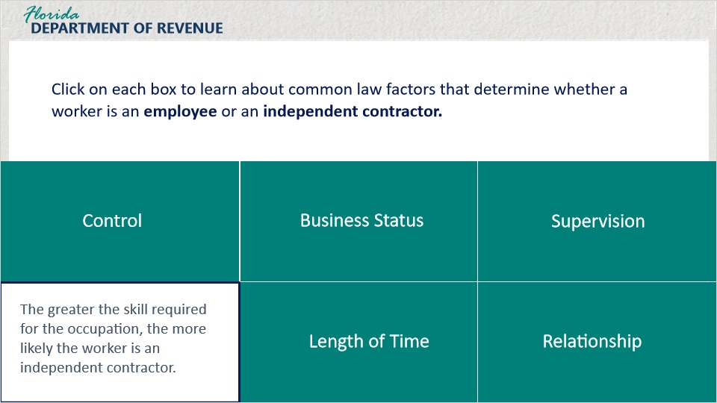
Transcript:
The greater the skill required for the occupation, the more likely the worker is an independent contractor.

Length of Time (Slide Layer)
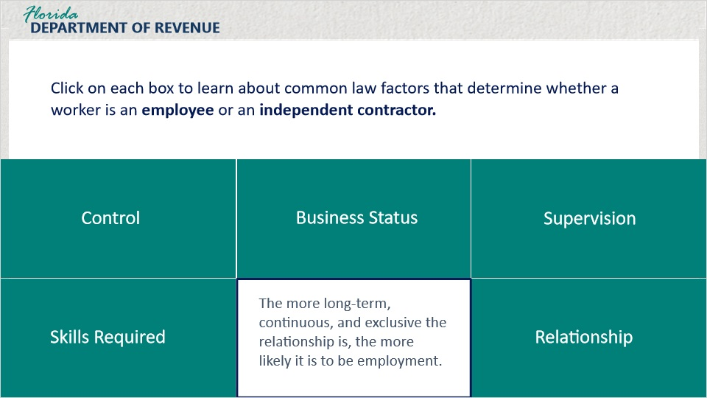
Transcript:
The more long-term, continuous, and exclusive the relationship is, the more likely it is to be employment.

Relationship (Slide Layer)
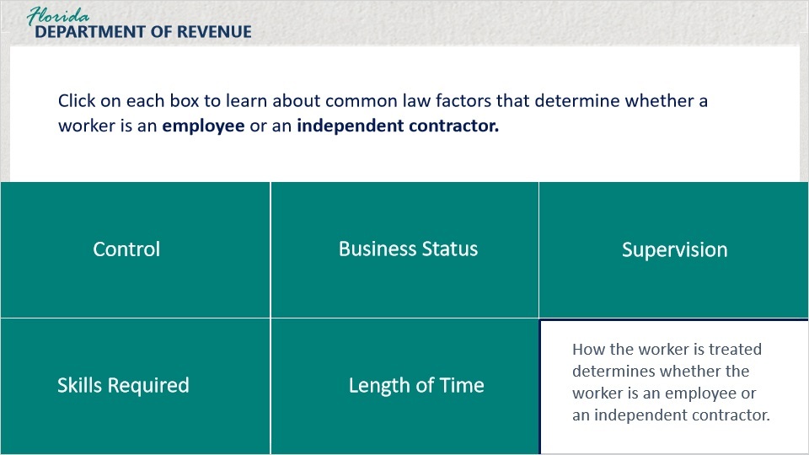
Transcript:
How the worker is treated determines whether the worker is an employee or an independent contractor.

4.5 Common Law Factors Continued
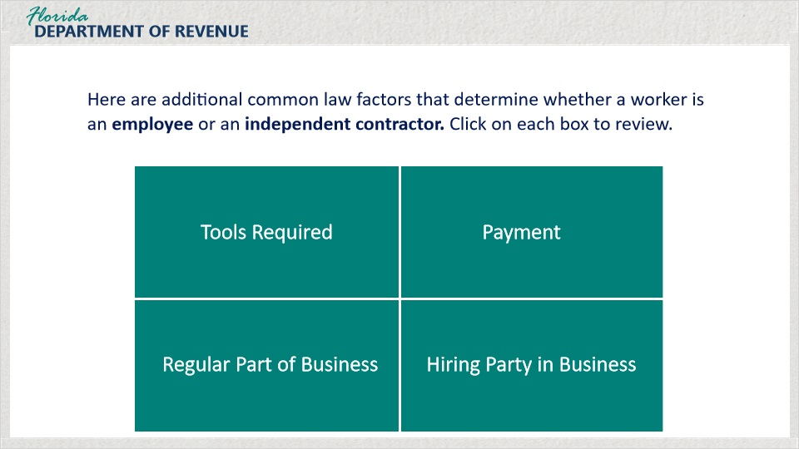
Transcript:
Here are additional common law factors that determine whether a worker is an employee or an independent contractor. These factors include Tools Required, Payment, Regular Part of a Business, and Hiring Party in Business. Click on each box to review.

Tools Required (Slide Layer)
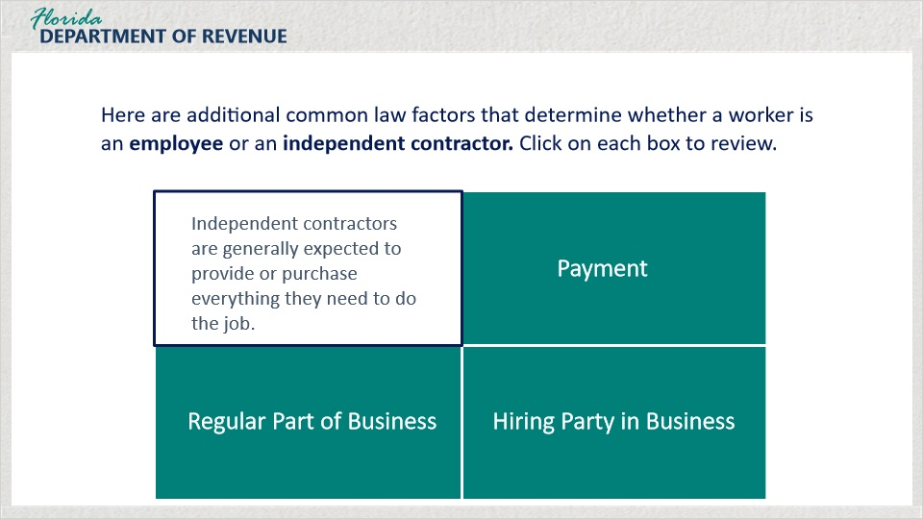
Transcript:
Independent contractors are generally expected to provide or purchase everything they need to do the job.

Payment (Slide Layer)
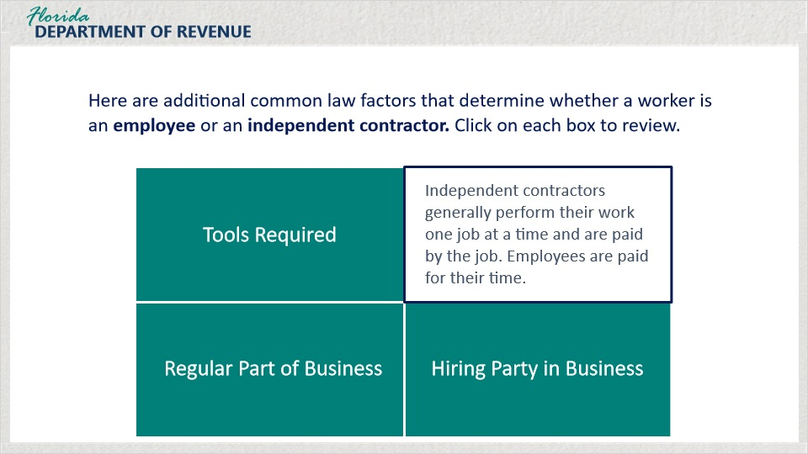
Transcript:
Independent contractors generally perform their work one job at a time and are paid by the job. Employees are paid for their time.

Regular Part of Business (Slide Layer)
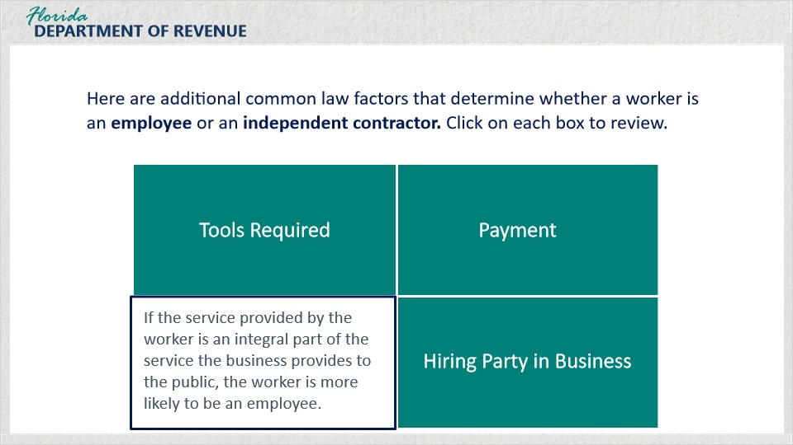
Transcript:
If the service provided by the worker is an integral part of the service the business provides to the public, the worker is more likely to be an employee.

Hiring Party in Business (Slide Layer)
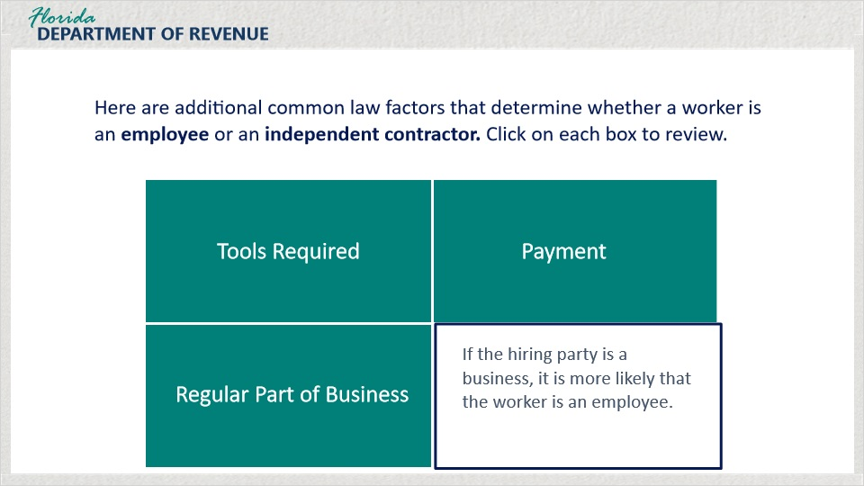
Transcript:
If the hiring party is a business, it is more likely that the worker is an employee.

4.6 Knowledge Check #5
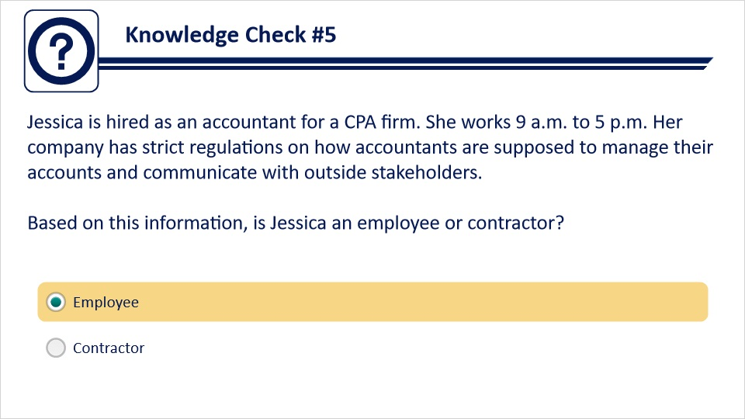
Transcript:
Jessica is hired as an accountant for a CPA firm. She works 9 a.m. to 5 p.m. Her company has strict regulations on how accountants are supposed to manage their accounts and communicate with outside stakeholders. Based on this information, is Jessica an employee or contractor?
Employee
Contractor
Feedback when correct:
That's right! You selected the correct response.
Feedback when incorrect:
Based on the company setting a required work schedule and standard policies, Jessica would be considered an employee.

4.7 Knowledge Check #6
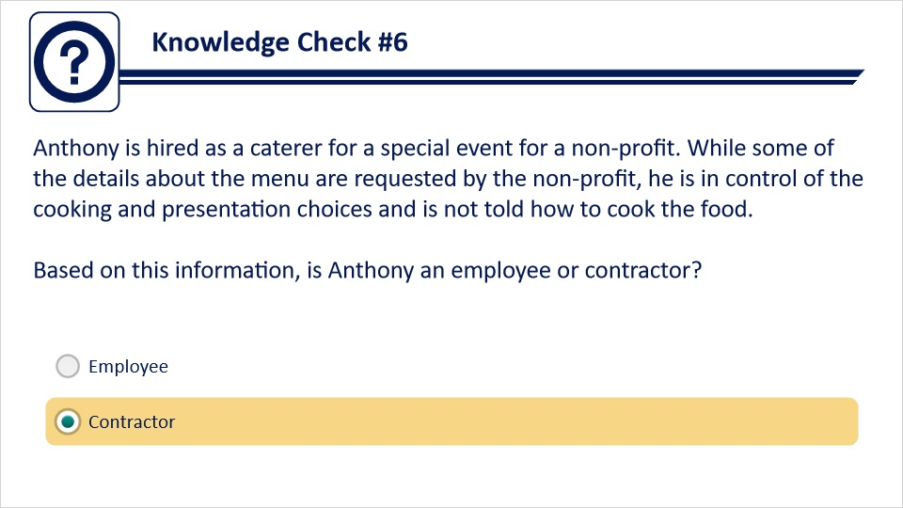
Transcript:
Anthony is hired as a caterer for a special event for a non-profit. While some of the details about the menu are requested by the non-profit, he is in control of the cooking and presentation choices and is not told how to cook the food. Based on this information, is Anthony an employee or contractor?
Employee
Contractor
Feedback when correct:
That's right! You selected the correct response.
Feedback when incorrect:
Since Anthony has control over the product/deliverables, process, and business decisions, they are considered to a contractor.

4.8 Knowledge Check #7
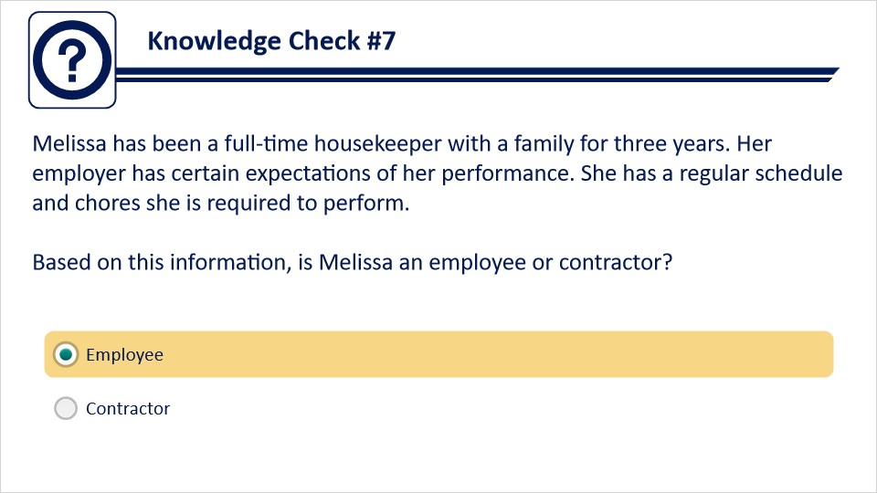
Transcript:
Melissa has been a full-time housekeeper with a family for three years. Her employer has certain expectations of her performance. She has a regular schedule and chores she is required to perform. Based on this information, is Melissa an employee or contractor?
Employee
Contractor
Feedback when correct:
That's right! You selected the correct response.
Feedback when incorrect:
Based on the employer setting a regular schedule and performance expectations, Melissa would be considered an employee.

4.9 Knowledge Check #8
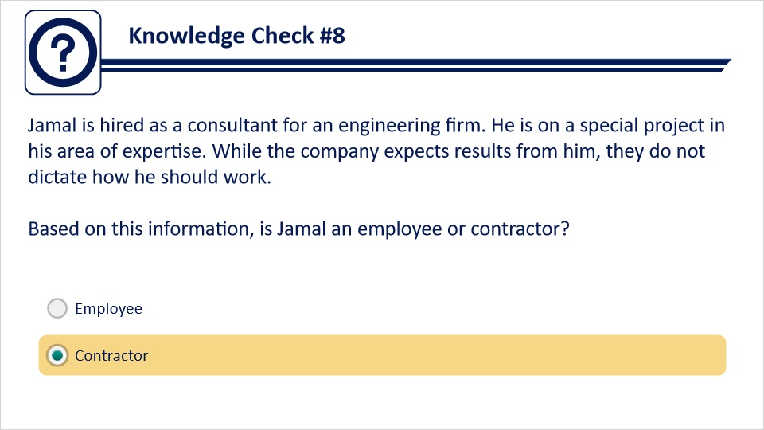
Transcript:
Jamal is hired as a consultant for an engineering firm. He is on a special project in his area of expertise. While the company expects results from him, they do not dictate how he should work. Based on this information, is Jamal an employee or contractor?
Employee
Contractor
Feedback when correct:
That's right! You selected the correct response.
Feedback when incorrect:
Since Jamal works in a specific area of expertise, does project based work, and the company does not dictate how he works, Jamal would be considered a contractor.

5. Taxable Wage Base

5.1 Taxable Wage Base
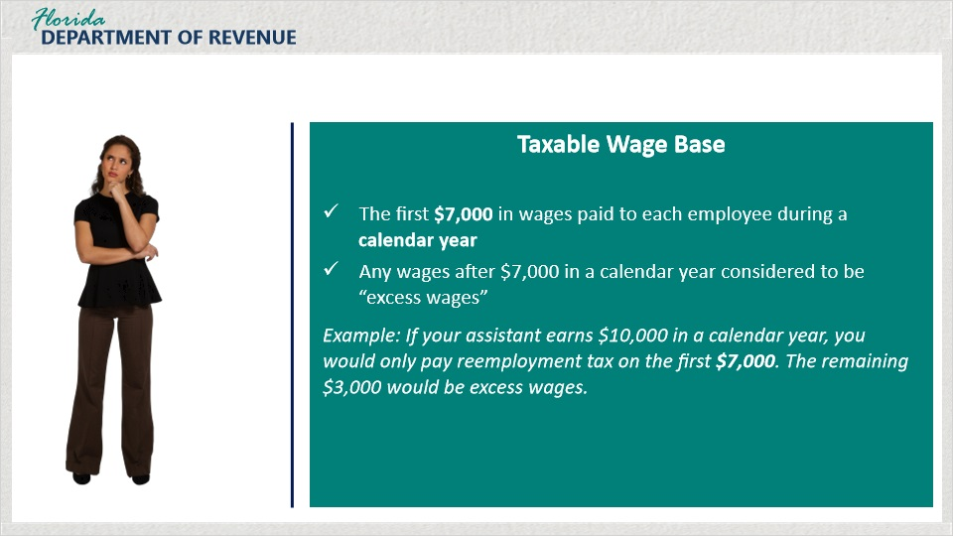
Transcript:
So far, we’ve covered what reemployment tax is, the general liability requirements, and worker classification. Now, let’s talk a bit about how much tax you will have to pay.
[Olivia]: So how does the state figure that out, anyway?
The first $7,000 in wages paid to each employee during a calendar year is taxed at a tax rate that is given to you based on your experience rating. I’ll go into that in a minute. Any wages earned beyond the first $7000 are considered excess wages and are not subject to tax.
So, if your assistant earns $10,000 in a calendar year, you would only pay reemployment tax on the first $7,000. The remaining $3,000 would be excess wages.

5.2 Taxable Wages
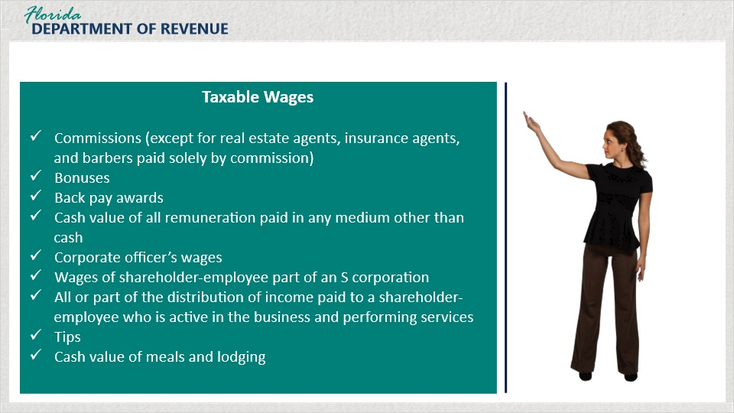
Transcript:
There are taxable wages and exempt wages. Taxable wages are broadly defined as all remuneration for employment including but not limited to: commissions (except for real estate agents, insurance agents, and barbers who are paid solely by commission), bonuses, back pay awards, cash value of all remuneration paid in any medium other than cash, corporate officer’s wages - compensation other than dividends on shares of stock and board of director fees is presumed payment for services performed, wages of a shareholder-employee of an S corporation, all or part of the distribution of income paid to a shareholder-employee who is active in the business and performing services for the business may be considered wages, tips, the cash value of meals and lodging.

5.3 Exempt Wages
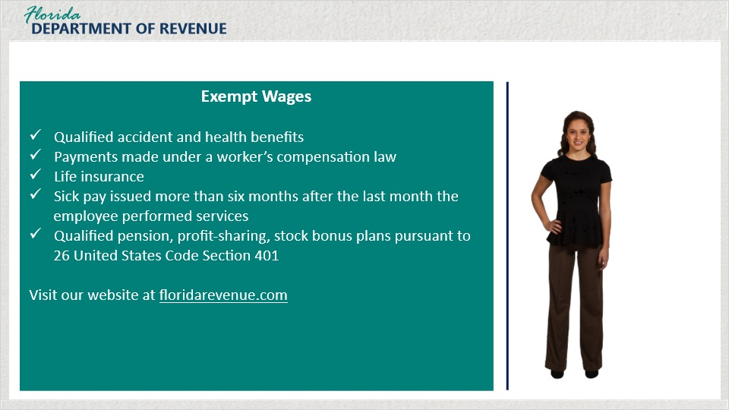
Transcript:
Exempt wages include: qualified accident and health benefits, payments made under a worker’s compensation law, life insurance, sick pay issued more than six months after the last month the employee performed services, qualified pension, profit-sharing, stock bonus plans pursuant to 26 United States Code Section 401.
For an all-inclusive list, visit the Department’s website.

5.4 Knowledge Check #9
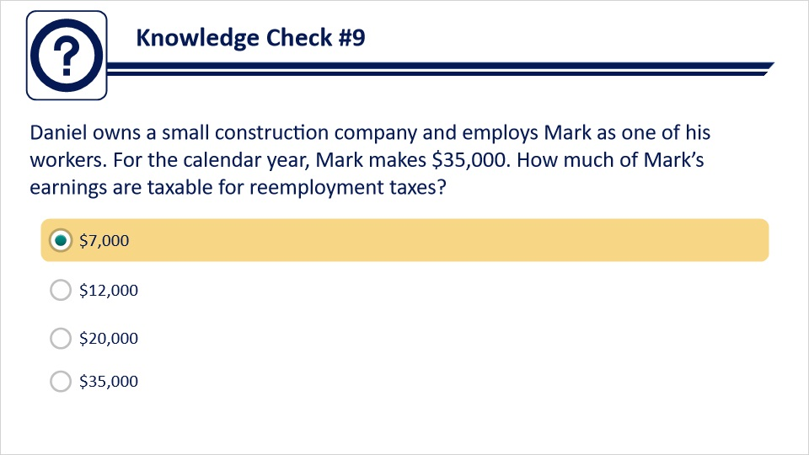
Transcript:
Daniel owns a small construction company and employs Mark as one of his workers. For the calendar year, Mark makes $35,000. How much of Mark’s earnings are taxable for reemployment taxes?
$7,000
$12,000
$20,000
$35,000
Feedback when correct:
That's right! You selected the correct response.
Feedback when incorrect:
Mark’s taxable wages for determining reemployment tax are capped at $7,000.

6. Tax Rate

6.1 Tax Rate for New Businesses
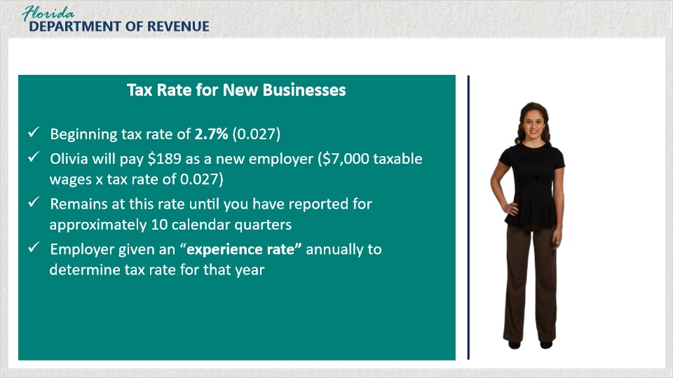
Transcript:
Once it has been determined what wages are taxable, you calculate the owed tax based on the tax rate. When an employer first becomes liable for payment of reemployment taxes, the beginning tax rate is 2.7 percent.
If you pay your assistant at least $7,000 per year, as a new employer, you should expect to pay $189 in reemployment tax.
Once you have reported for approximately 10 quarters, depending on the quarter of the year you as the employer established liability, you will be given an experience rate annually.

6.2 Tax Rate for Established Businesses
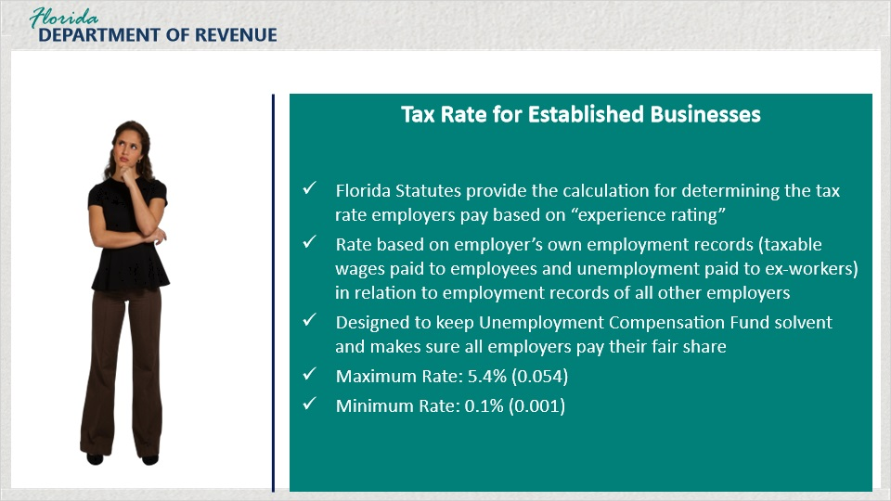
Transcript:
[Olivia}: You said beginning tax rate. So, the rate changes?
Yes, it does. The Florida Statutes provide the calculation for determining the tax rate employers pay based on an experience rating. Under reemployment assistance program law, an employer’s experience rating is based on the employer’s own employment records or taxable wages paid to employees and unemployment paid to ex-workers in relation to the employment records of all other employers.
This system is designed to keep the Unemployment Compensation Trust Fund solvent and ensures that employers pay their fair share based on their own experience rating. An employer’s tax rate may vary each year according to their employment experience. The maximum tax rate is 5.4%. The minimum is 0.1%.

6.3 Knowledge Check #10
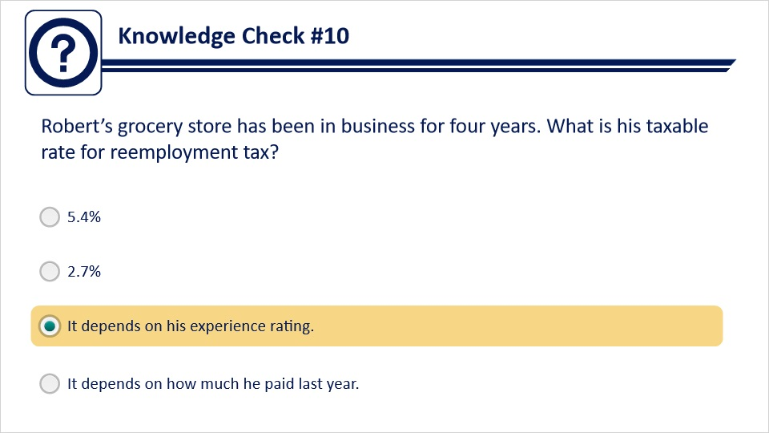
Transcript:
Robert’s grocery store has been in business for four years. What is his taxable rate for reemployment tax?
5.4%
2.7%
It depends on his experience rating.
It depends on how much he paid last year.
Feedback when correct:
That's right! You selected the correct response.
Feedback when incorrect:
Robert’s tax rate is dependent upon his experience rating given to him by the Department of Revenue.

7. Conclusion

7.1 Summary
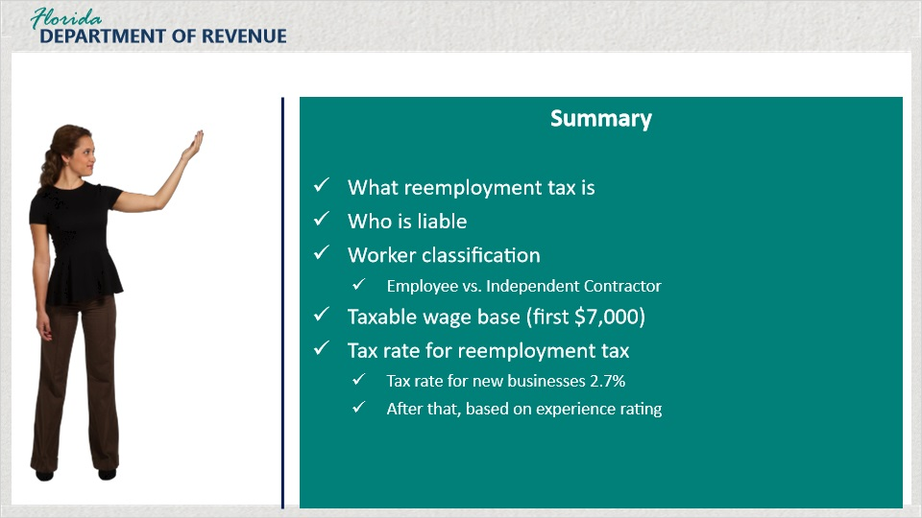
Transcript:
So, Olivia, we have gone over a lot of information today. Could you give a summary of what we’ve talked about?
[Olivia]: Sure, I think I can do that.
First, we talked about what reemployment tax is and who is liable for paying reemployment tax. We discussed the criteria for making this determination.
Then, we discussed worker classification and the difference between employees and independent contractors.
We went over the taxable wage base. Only the first $7,000 of wages for an employee are taxed. The rest are considered excess wages.
Finally, you told me about the tax rate for reemployment tax. At first, a new business is given a rate of 2.7% until approximately 10 calendar quarters. Then they are given an experience rating and a new rate is assigned to them annually.
Very good, Olivia! I’m impressed!
[Olivia]: Thank you! I feel better now about understanding reemployment tax.
And remember, if you need additional assistance, take a look at the guides and tutorials on the Florida Department of Revenue’s website. There are a lot of resources available to help you.
[Olivia]: OK, I’ll remember that. Thanks!

7.2 Tax Page and Social Media
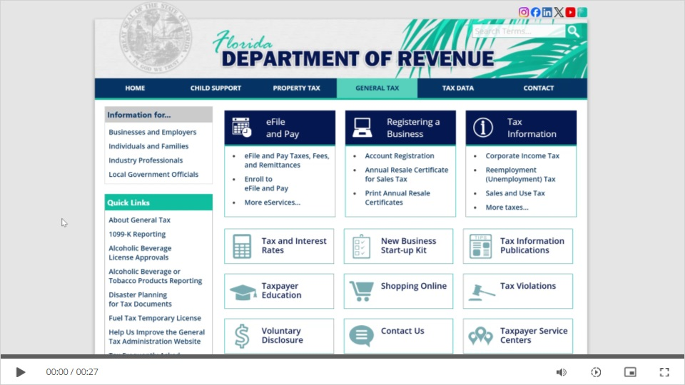
Transcript:
Visit Florida’s General Tax Administration webpage for business resources such as forms, publications, and information on all tax types.
Check out our Taxpayer Education webpage for new business guides, tutorials, and other helpful tools.
And follow us on YouTube, X, Facebook, Instagram, and LinkedIn using the icons at the top of our website to stay up to date on tax topics, alerts, and more.

7.3 Survey
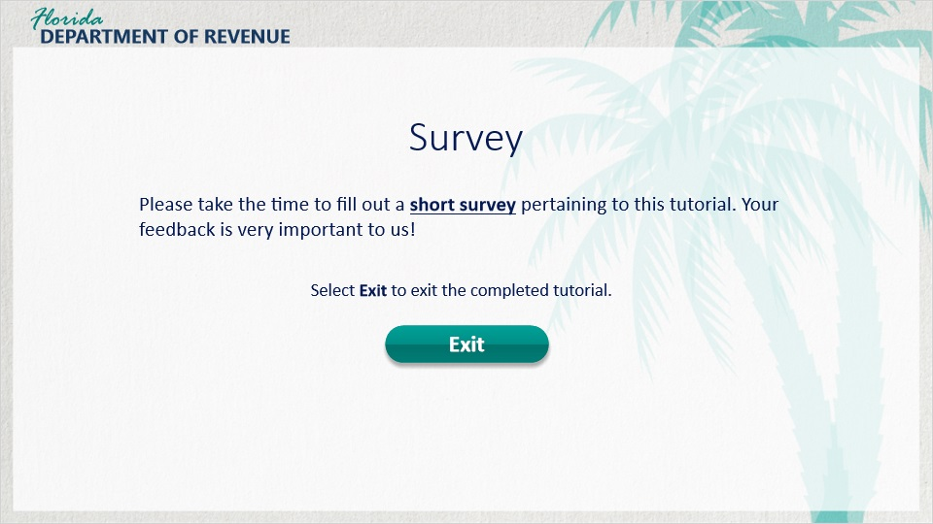
Transcript:
This concludes Reemployment Tax: The Basics. For additional resources, use the Resources link in the upper-right corner for more information.
Please take the time to fill out a short survey pertaining to this tutorial. Your feedback is very important to us!
To exit this tutorial, click on the Exit button.
Thank you.

