Reemployment Tax Part 2: Employers' Responsibilities

1. Introduction

1.1 Welcome
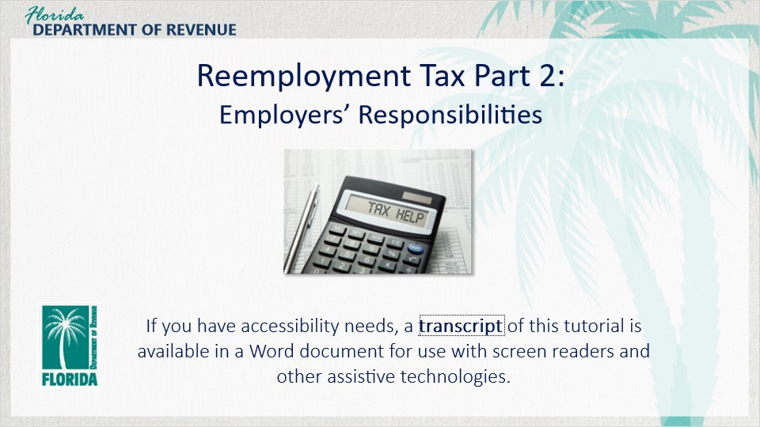
Transcript:
Welcome to Reemployment Tax: Employers’ Responsibilities. In this tutorial, you will learn about the responsibilities you have as an employer in terms of filing and paying reemployment tax in Florida.
If you have accessibility needs, a transcript of this tutorial is available in a Word document for use with screen readers and other assistive technologies.

1.2 Navigating This Tutorial
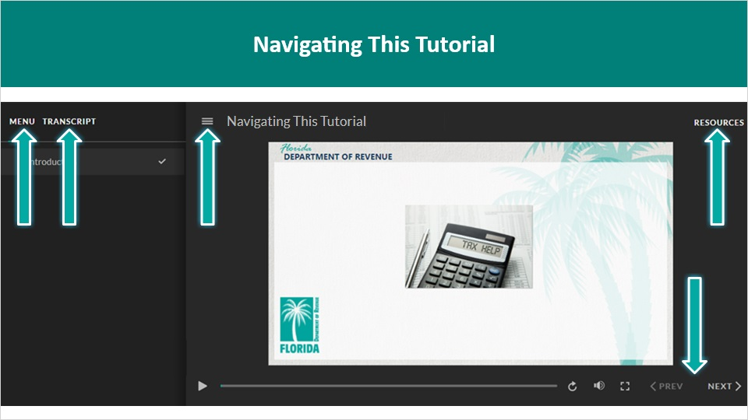
Transcript:
This tutorial will take approximately 15 minutes to complete. A transcript of the audio is available by clicking on the Transcript tab in the top-left corner of your screen. The following tabs and buttons are available to help you navigate through this tutorial.
Menu Tab
The Menu tab displays by default when the tutorial is viewed on a computer. It allows you to navigate through the tutorial by clicking on the topic name in the menu. When viewing this tutorial on a tablet or smartphone, the menu does not display by default and must be accessed using the menu symbol.
Resources Tab
The Resources tab is found to the right side of the top bar. When clicked, it displays a list of links to useful forms, documents, and webpages.
Previous and Next Buttons
The Previous and Next buttons are located at the bottom-right corner of your screen. These buttons allow you to move either back or forward.

1.3 Topics
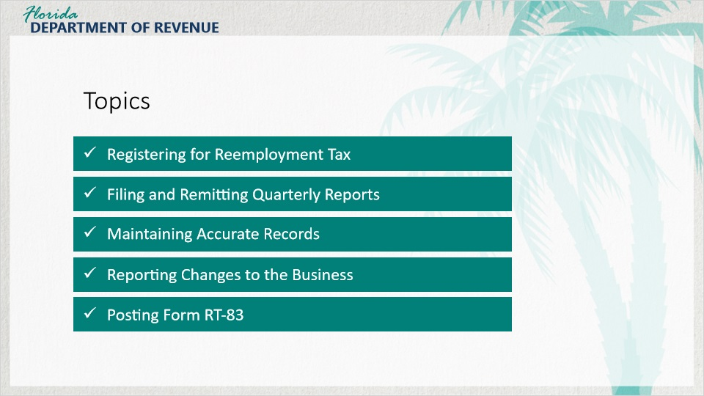
Transcript:
Topics for this tutorial include: registering for reemployment tax, filing and remitting quarterly reports, maintaining accurate records, reporting changes to the business, and posting Form RT-83.

1.4 Review Part 1
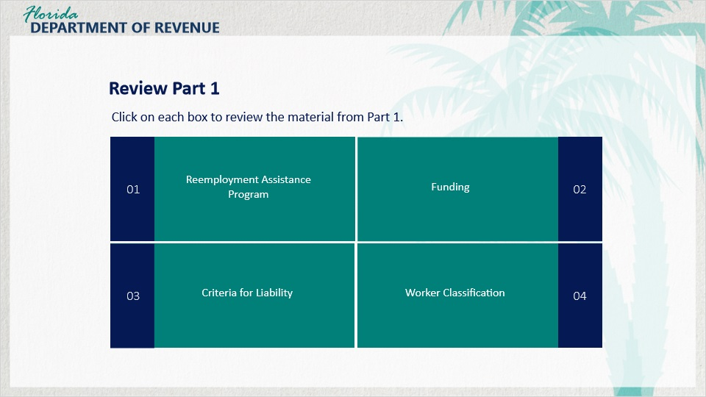
Transcript:
The review of Part 1 covers the Reemployment Assistance Program, funding, criteria for liability, and worker classification.

1 Reemployment Assistance Program (Slide Layer)
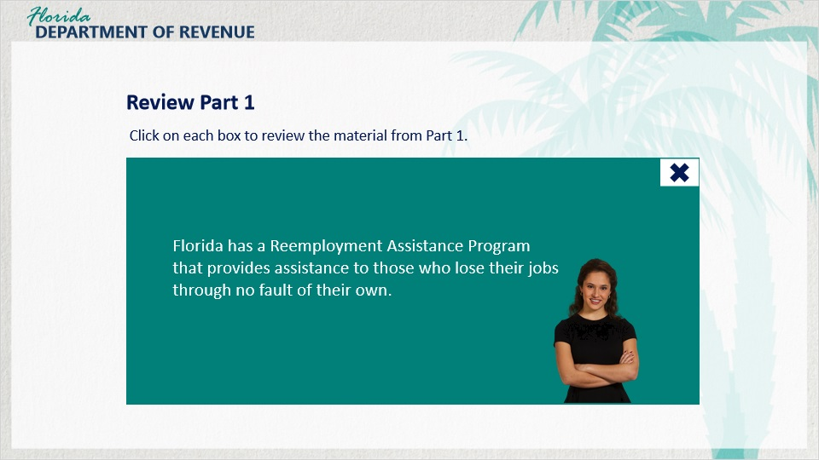
Transcript:
Florida has a Reemployment Assistance Program that provides assistance to those who lose their jobs through no fault of their own.

2 Funding (Slide Layer)
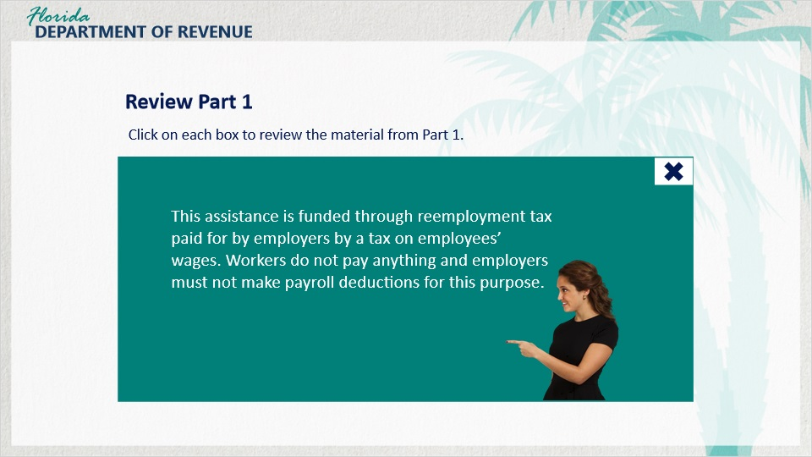
Transcript:
This assistance is funded through reemployment tax paid for by employers by a tax on employees’ wages. Workers do not pay anything and employers must not make payroll deductions for this purpose.

3 Criteria for Liability (Slide Layer)
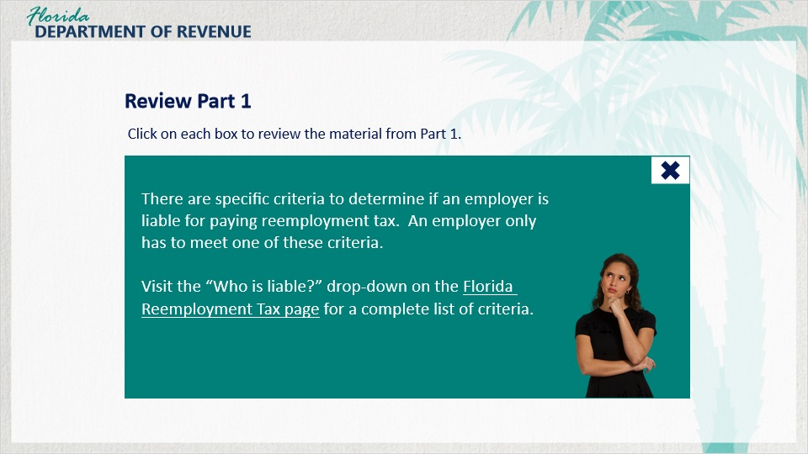
Transcript:
There are specific criteria to determine if an employer is liable for paying reemployment tax. An employer only has to meet one of these criteria.
Visit the “Who is liable?” drop-down on the Florida Reemployment Tax webpage for a complete list of criteria.

4 Worker Classification (Slide Layer)
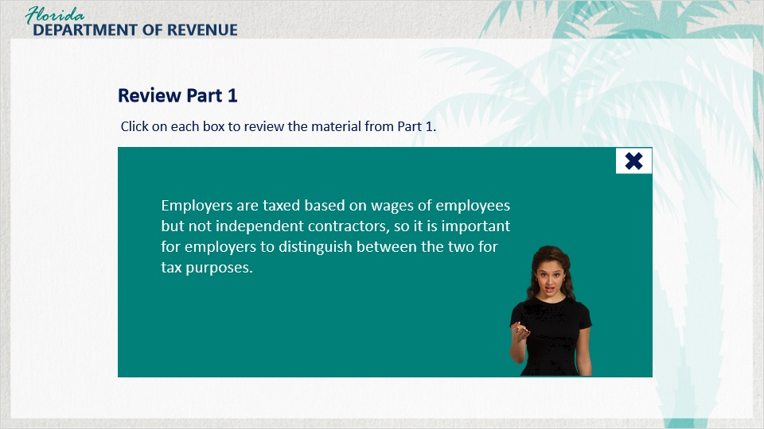
Transcript:
Employers are taxed based on wages of employees but not independent contractors, so it is important for employers to distinguish between the two for tax purposes.

2. Registering for Reemployment Tax

2.1 Welcome Back Olivia!

Transcript:
Earlier in this series, we met Olivia.
[Olivia]: Hi everyone! Remember me?
Olivia had questions about reemployment tax. She wanted to know if she was liable and how much she would have to pay. How have you been doing with reemployment tax, Olivia?
[Olivia]: Well, my assistant has been with me for more than 20 weeks now, so I am now liable for reemployment tax. I guess I do need a little help with the next steps.
Okay. We can help with that in this course.
[Olivia]: Great! So what are my next steps?

2.2 Registering for Reemployment Tax
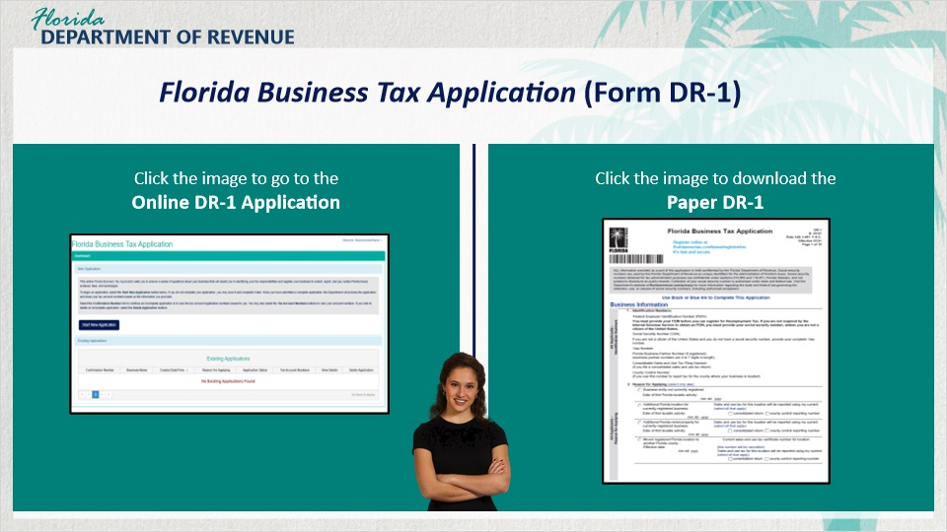
Transcript:
All Florida businesses are required to complete the Florida Business Tax Application (Form DR-1). This can be done online or through a paper application. The Department’s online Florida Business Tax Application uses an interactive wizard to determine tax registration requirements.
The application guides you by asking questions about your business including those pertinent to your employees. It then assesses based on certain criteria if you are liable for reemployment tax.
[Olivia]: I completed the DR-1 when I started my business. Do I have to fill it out again?
If you recall when you filled out the application, you filled out a section about reemployment tax. Now that you decided to hire an employee, that information has changed. Therefore, you do need to fill out a new application because you are registering for your business to pay a new tax.

2.3 Knowledge Check #1
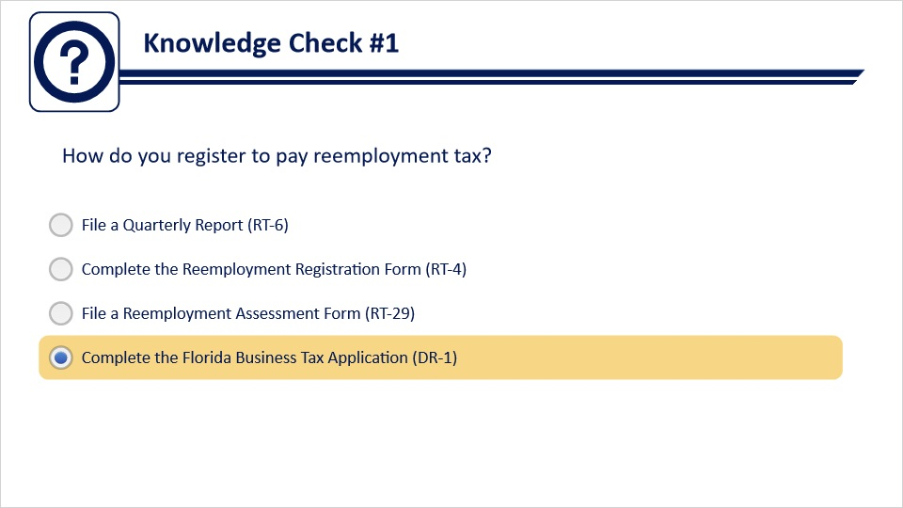
Transcript:
Question text:
How do you register to pay reemployment tax?
Answer options:
File a Quarterly Report (RT-6)
Complete the Reemployment Registration Form (RT-4)
File a Reemployment Assessment Form (RT-29)
Complete the Florida Business Tax Application (DR-1)
Feedback when correct:
That's right! You selected the correct response.
Feedback when incorrect:
To register for reemployment tax, you must complete the Florida Business Tax Application (DR-1).

3. Filing and Remitting Quarterly Reports

3.1 Due Dates for Quarterly Report
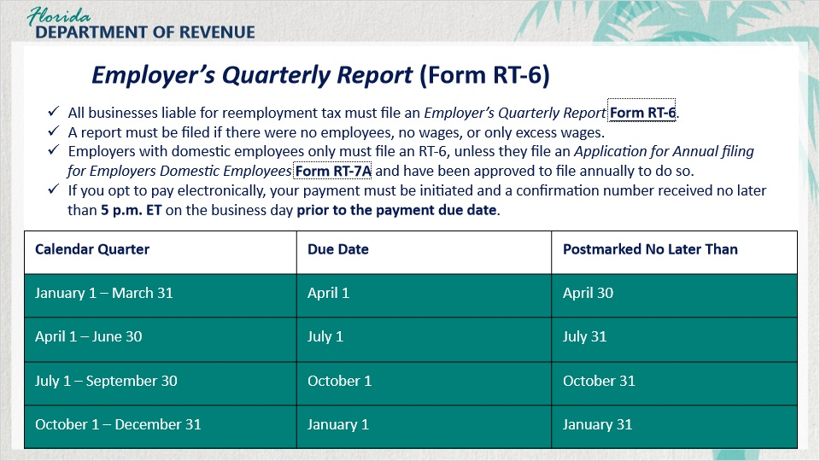
Transcript:
[Olivia]: Once I have filled out a DR-1, what do I need to do to file and pay reemployment taxes?
All businesses that are liable for paying reemployment tax must file an Employer’s Quarterly Report (RT-6) at the end of every quarter. Employers who employed 10 or more employees in any quarter during the preceding state fiscal year are required, to file quarterly reports, including corrections to those reports, electronically. The report must be submitted by the end of the month following the quarter being reported on.
A report must be filed even if there were no employees, no wages, or all wages were excess wages.
For example, if you are filing and paying reemployment tax for the first quarter of the year, your report and payment would be due by the end of the following month on April 30.
Employers with individuals who only perform domestic services must file an RT-6, unless they have been approved to file annually. If they are approved, they are mailed a personalized Employer’s Reemployment Tax Annual Report for Employers of Domestic Employees Only (RT-7) in December of each year. The RT-7 is due January 1 and is late after January 31.
If you opt to pay electronically, your payment must be initiated and a confirmation number received no later than 5 p.m. ET on the business day prior to the payment due date to be considered timely. Corrections to data originally reported on a quarterly report should be filed on a Correction to Employer’s Quarterly or Annual Domestic Report (RT-8A).

3.2 Knowledge Check #2
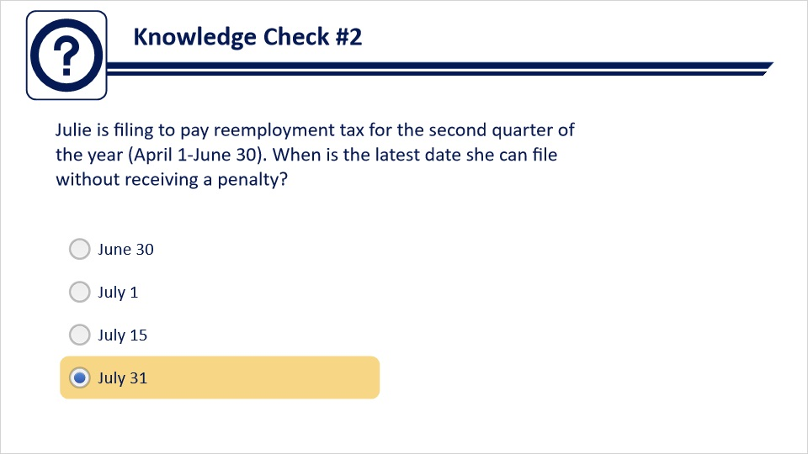
Transcript:
Question text:
Julie is filing to pay reemployment tax for the second quarter of the year (April 1 – June 30). When is the latest date she can file without receiving a penalty?
Answer options:
June 30
July 1
July 15
July 31
Feedback when correct:
That's right! You selected the correct response.
Feedback when incorrect:
The report and payment are due at the end of the following the quarter being reported on. For the second quarter, it would be July 31.

4. Maintaining Accurate Records

4.1 Maintaining Accurate Records
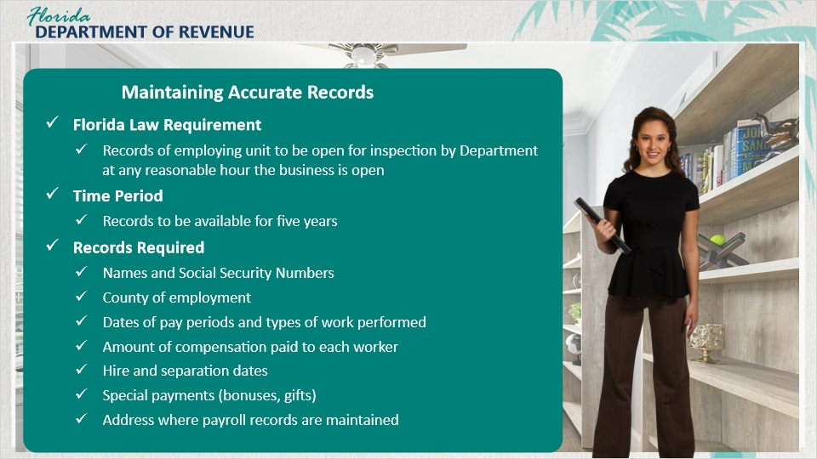
Transcript:
Let’s talk about your next responsibility as a business owner, Olivia - maintaining accurate payroll records.
[Olivia]: OK.
Florida law requires the records of an employing unit to be open for inspection by the Department any reasonable hour when the firm’s business is normally conducted.
The employer must maintain true and accurate work records for a period of five years following the calendar year in which the services were rendered. The Florida Administrative Code has outlined the specific information an employer is required to maintain in the payroll records. These are the types of records you would need in an audit.
The records required include names and social security numbers, county of employment, dates of pay periods and types of work performed by employees, the amount of compensation paid to each worker, hire and separation dates, special payments such as bonuses and gifts, and the address where payroll records are maintained.
[Olivia]: So, I need to be prepared for an audit? That makes me nervous.
There’s nothing to be nervous about if you follow the law, stay organized, and maintain accurate records.

4.2 Records to Keep
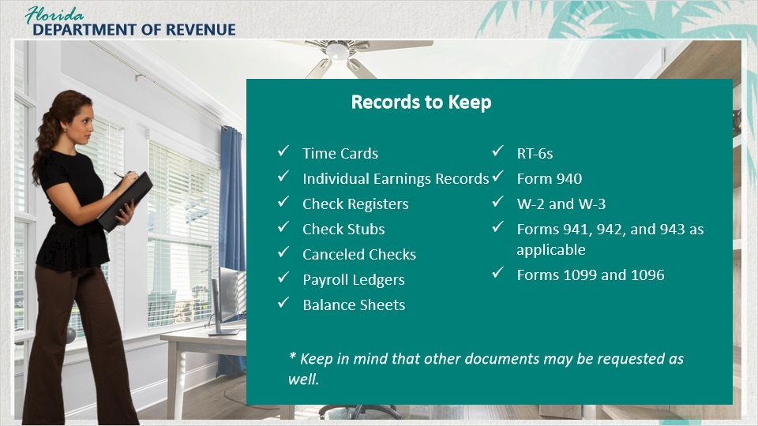
Transcript:
[Olivia]: What records do I need to keep?
Examples of what you would need to keep are: timecards, individual earning records, check registers, check stubs, canceled checks, payroll ledgers, balance sheets, RT-6s, Form 940, W-2 and W-3, Forms 941, 942, and 943 as applicable, and Forms 1099 and 1096.
Keep in mind that other documents may be requested as well.
Adequate payroll records will indicate whether the employer has or has not met liability criteria for the payment of reemployment taxes.

4.3 Knowledge Check #3
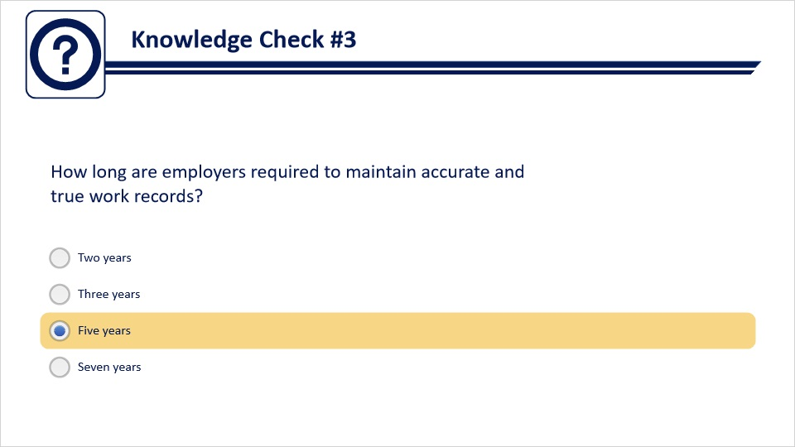
Transcript:
Question text:
How long are employers required to maintain accurate and true work records?
Answer options:
Two years
Three years
Five years
Seven years
Feedback when correct:
That's right! You selected the correct response.
Feedback when incorrect:
Employers are required to keep records for 5 years.

5. Reporting Changes to the Business

5.1 Reporting Changes to the Business
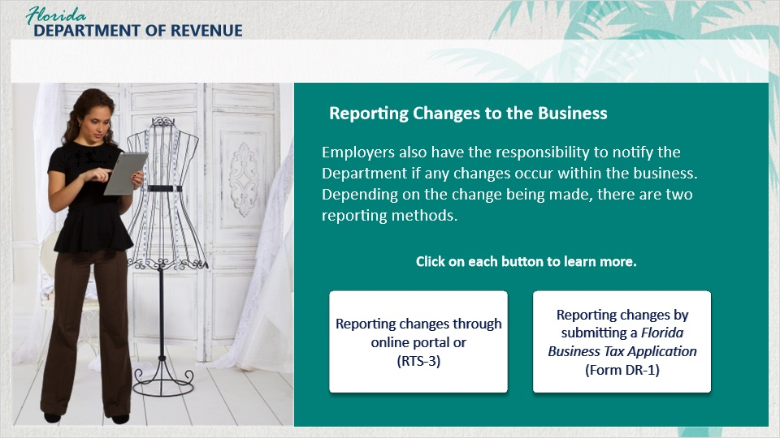
Transcript:
Employers also have the responsibility to notify the Department if any changes occur within the business. Depending on the change being made, there are two reporting methods. Some changes only require you to update your information online or by completing and submitting an Employer Account Change Form (RTS-3). Instances involving legal changes to the business require the employer to fill out a new Florida Business Tax Application (Form DR-1).
[Olivia]: I’m considering bringing in my friend as a business partner. Would this be an example of a change within the business?
Absolutely. You are changing the structure of a business to a partnership meaning that you would need to complete a new Florida Business Tax Application (Form DR-1).
Click on each button to learn more.

Online Portal or RTS-3 (Slide Layer)
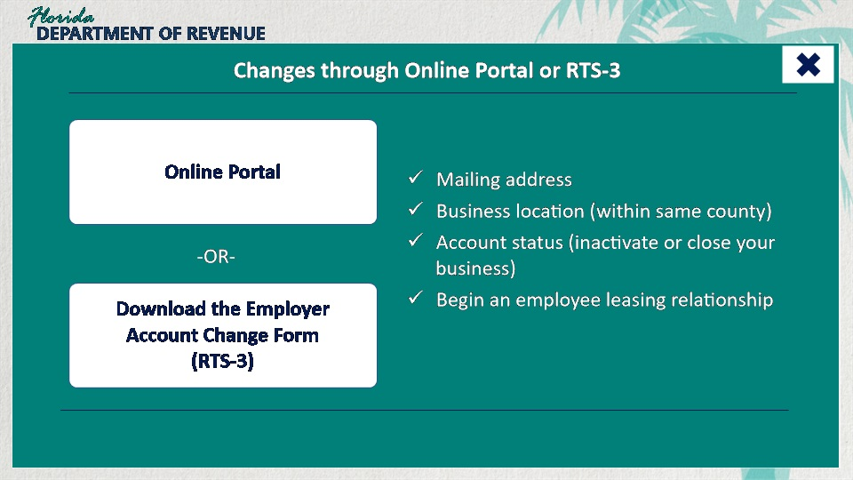
Transcript:
Some changes can be made through the online portal or by completing and submitting an Employer Account Change Form (RTS-3). These include mailing address, business location (within the same county), account status (such as inactivating your account or closing the business), beginning an employee leasing relationship.
Access the online portal for changing your account details, or download the Employer Account Change Form (RTS-3).

DR-1 (Slide Layer)
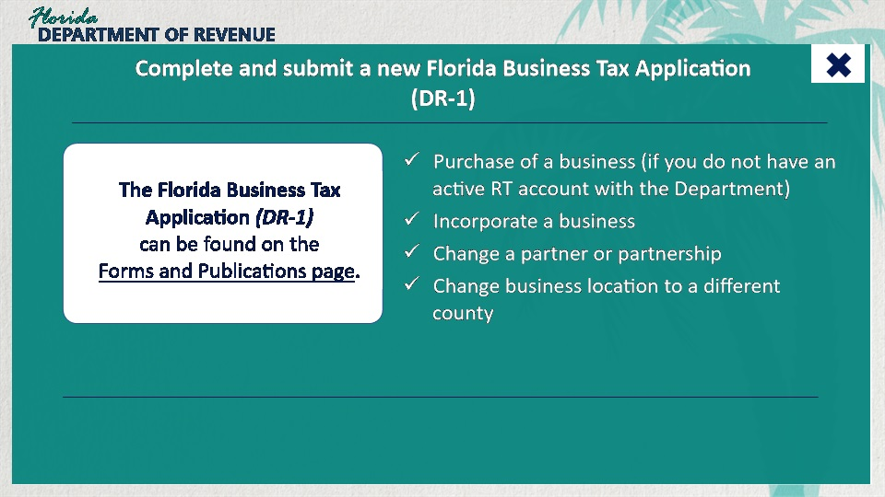
Transcript:
Keep in mind that changes to legal business structure or changes in ownership require the employer to complete a new Florida Business Tax Application (Form DR-1). These changes include purchase of a business if you do not have an active RT account with the Department, incorporating a business, changing a partner or partnership, changing the business location to a different county.

5.2 Reporting New Employees
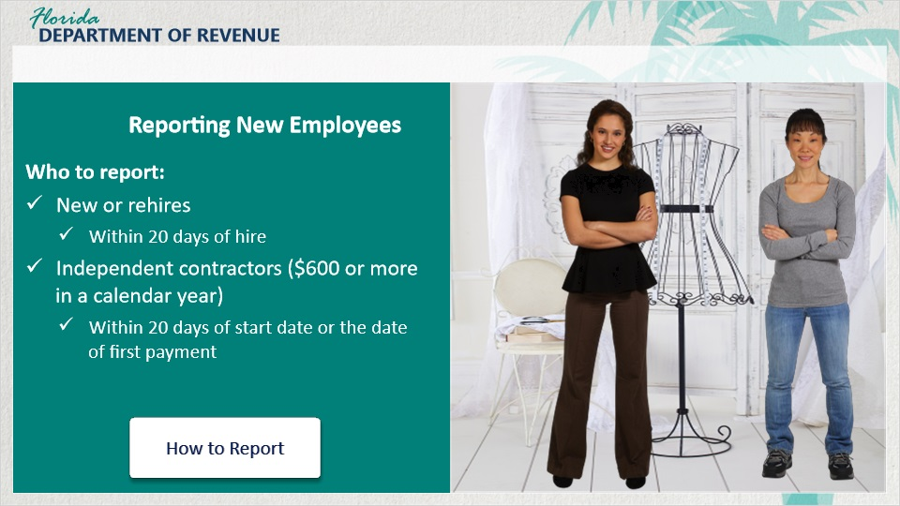
Transcript:
Employers must also report new hires and rehires within 20 days of the date of hire. Independent contractors who make $600 or more during a calendar year should be submitted within 20 days of the date of their start date or the date of their first payment.
To learn more about how to report employees and independent contractors, visit the Child Support Services for Employers webpage.

How to Report (Slide Layer)
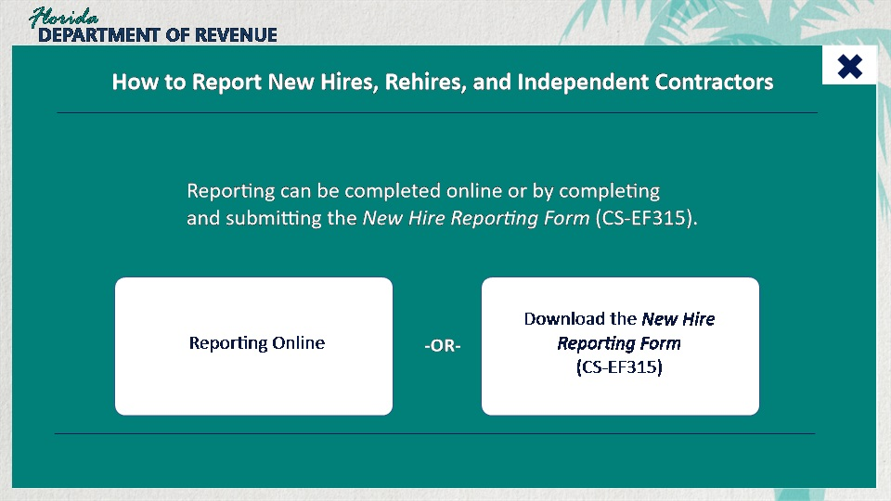
Transcript:
How to Report
Reporting can be completed online or by completing and submitting the New Hire Reporting Form (CS-EF315).

5.3 Knowledge Check #4
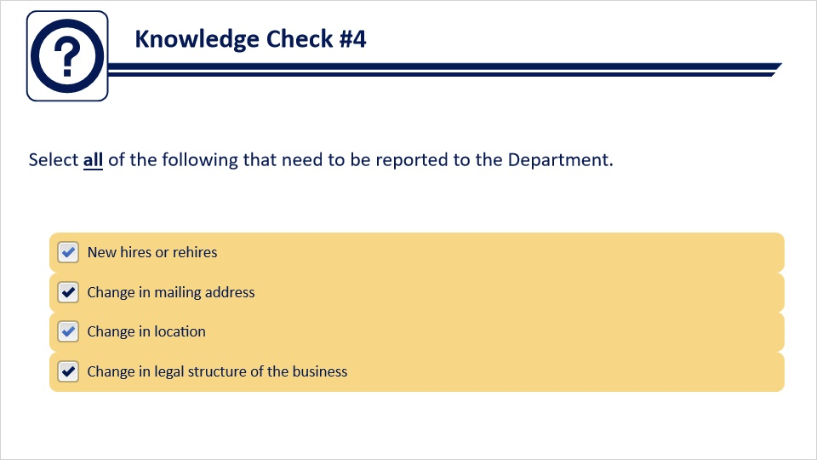
Transcript:
Question text:
Select all of the following that need to be reported to the Department.
Answer options:
New hires or rehires
Change in mailing address
Change in location
Change in legal structure of the business
Feedback when correct:
That's right! You selected the correct responses.
Feedback when incorrect:
All of the answers should be selected.

6. Posting Form RT-83

6.1 Posting Form RT-83
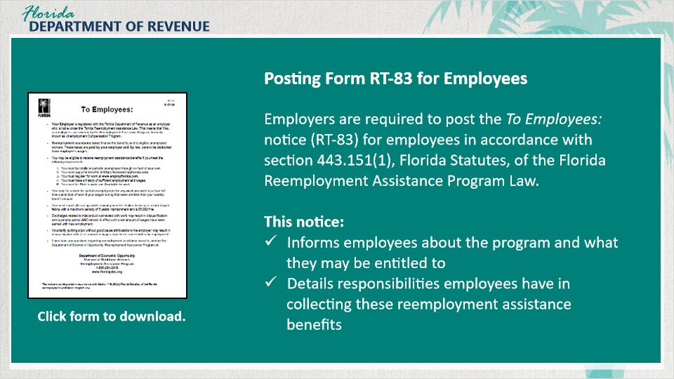
Transcript:
Finally, as an employer, you are required to post the To Employees: Notice (RT-83) for your employees in accordance with the Florida Statutes.
This notice informs employees about the program and what they may be entitled to if they lose their job through no fault of their own. It also details the responsibilities they have in collecting these reemployment assistance benefits.
This form is available on the Department’s Forms and Publications webpage.

6.2 Knowledge Check #5
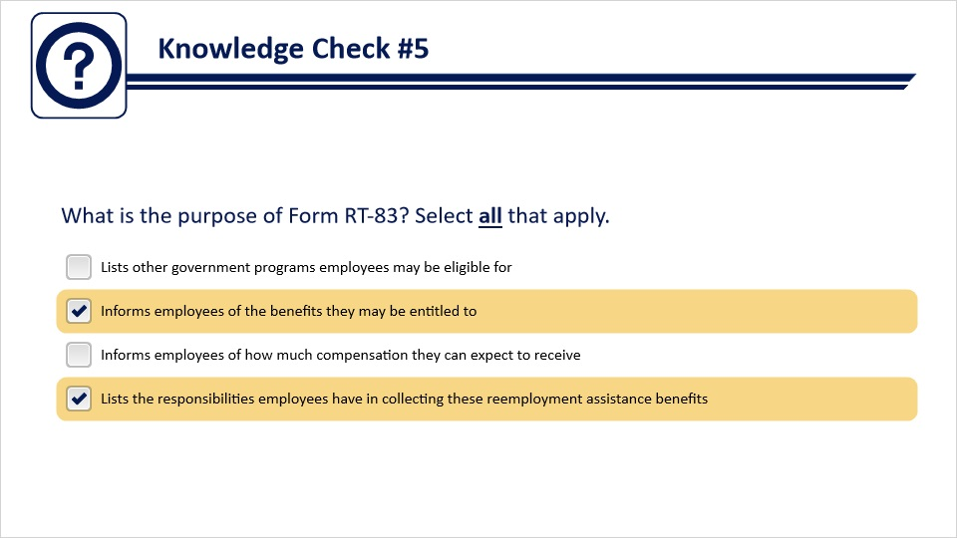
Transcript:
Question text:
What is the purpose of Form RT-83? Select all that apply.
Answer options:
Lists other government programs employees may be eligible for
Informs employees of the benefits they may be entitled to
Informs employees of how much compensation they can expect to receive
Lists the responsibilities employees have in collecting these reemployment assistance benefits
Feedback when correct:
That's right! You selected the correct response.
Feedback when incorrect:
You did not select the correct response. Form RT-83 informs employees of the benefits they may be entitled to and lists the responsibilities employees have in collecting these reemployment assistance benefits.

7. Conclusion

7.1 Summary
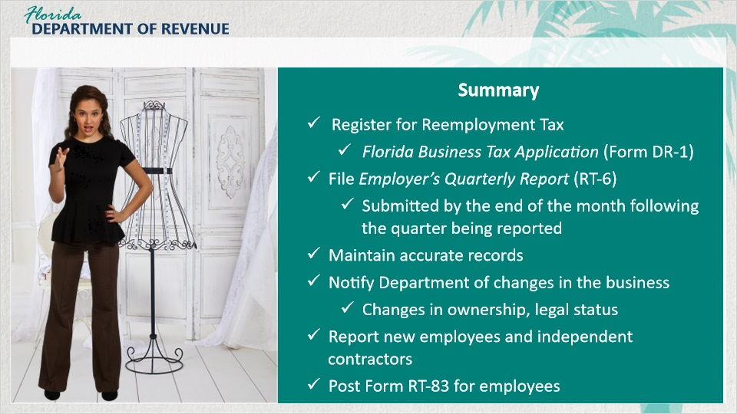
Transcript:
Olivia, do you think you’ve got all that?
[Olivia]: I think so. Let me do a recap just to be sure.
First, you need to register for reemployment tax by completing the Florida Business Tax Application (Form DR-1). You can file this online or download a paper form from the Department’s website.
If you are liable for paying reemployment tax, you must file an Employer’s Quarterly Report (RT-6) at the end of every quarter. The report must be submitted by the end of the month following the quarter being reported.
You are also required to maintain true and accurate work records for a period of five years. Florida law requires the records of an employing unit to be open for inspection by the Department any reasonable hour when the firm’s business is normally conducted.
Another responsibility employers have is to notify the Department if any changes occur within the business. Examples of this include any changes in ownership, location, or type of business activity.
Employers are also required to report new hires and rehires within 20 days of the beginning of their employment.
Finally, employers are required to post the To Employees: notice (RT-83) where their employees can read it. This gives them information about reemployment assistance and outlines their responsibilities in order to receive benefits.
I think that sums it all up, Olivia. Great job!
[Olivia]: Thanks for your help!
You’re welcome. And remember, if you need additional assistance, take a look at the guides and tutorials on the Florida Department of Revenue’s website. There are a lot of resources available to help you.

7.2 Tax Page and Social Media
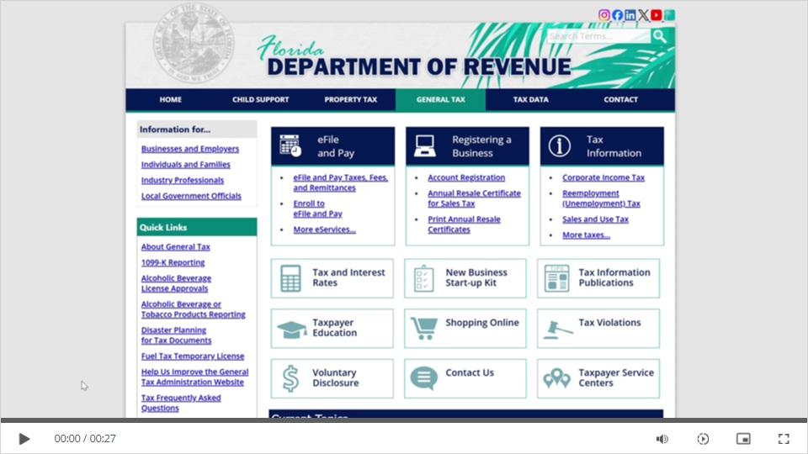
Transcript:
Visit Florida’s General Tax Administration website for business resources such as forms, publications, and information on all tax types.
Check out our Taxpayer Education webpage for new business guides, tutorials, and other helpful tools.
And follow us on YouTube, X, Facebook, Instagram, and LinkedIn using the icons at the top of our website to stay up to date on tax topics, alerts, and more.

7.3 Survey
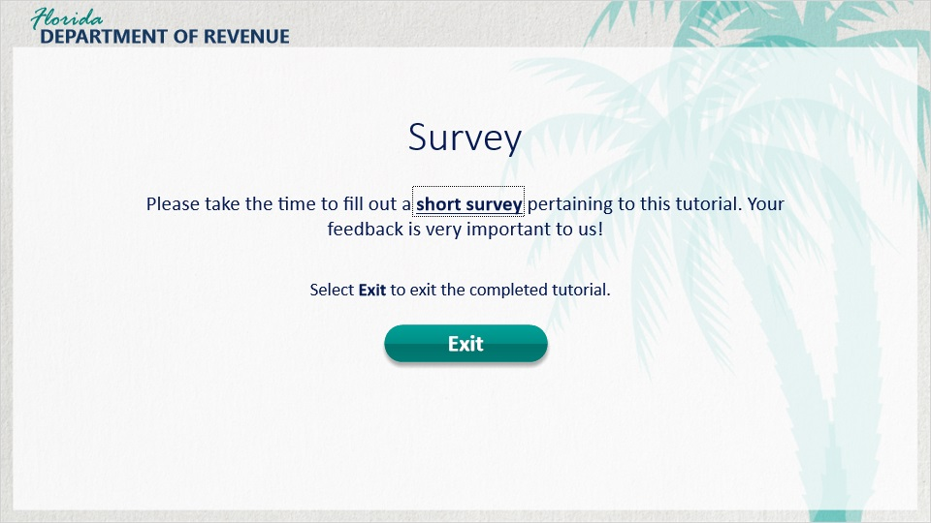
Transcript:
This concludes Reemployment Tax: The Basics.
Please take the time to fill out a short survey pertaining to this tutorial. Your feedback is very important to us!
Thank you.

