An Overview of Sales and Use Tax for Business Owners – Part 2

1. Introduction

1.1 Welcome
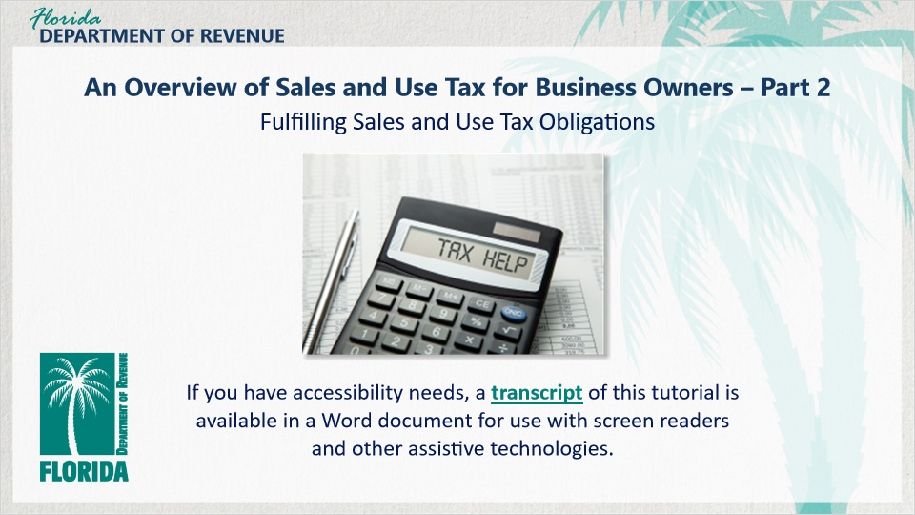
Transcript:
Welcome to An Overview of Sales and Use Tax for Business Owners: Fulfilling Sales and Use Tax Obligations.

In this tutorial, we discuss the business owner’s obligation to collect sales tax and discretionary sales surtax from customers and calculating the amount of tax owed.

If you have accessibility needs, a transcript of this tutorial is available in a Word document for use with screen readers and other assistive technologies.

1.2 Navigating This Tutorial
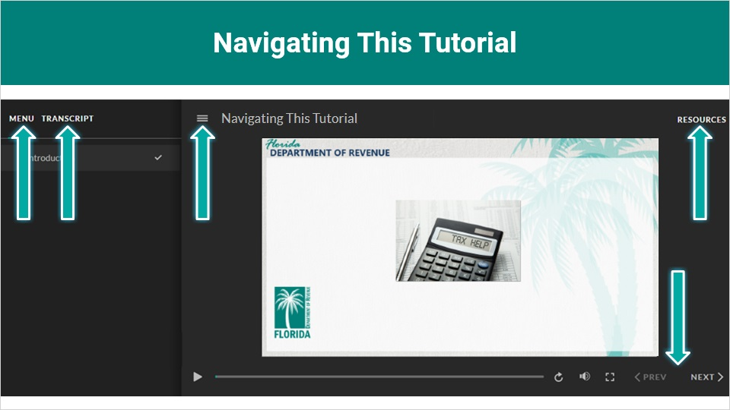
Transcript:
This overview will take approximately 20 minutes to complete. A transcript of the audio is available by clicking on the transcript tab in the top-left corner of your screen.
The following tabs and buttons are available to help you navigate throughout this overview.
Menu Tab
The menu tab displays by default when the overview is viewed on a computer. It allows you to navigate through the overview by clicking on the topic name on the menu. When viewing this overview on a tablet or smartphone, the menu does not display by default and must be accessed using the menu symbol.
Resources Tab
The resources tab is found on the right side of the top bar. When clicked, it displays the list of links to useful forms, documents, and webpages.
Previous and Next Buttons
The previous and next buttons are located at the bottom-right corner of your screen. These buttons allow you to move either back or forward.

1.3 Topics
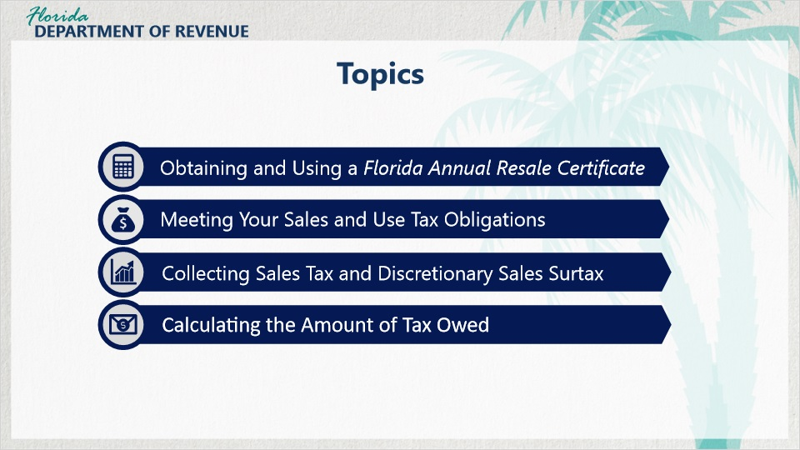
Transcript:
Topics for this tutorial include obtaining and using a Florida Annual Resale Certificate, meeting your sales and use tax obligations, collecting sales tax and discretionary sales surtax, and calculating the amount of tax owed.

1.4 Review of Part 1
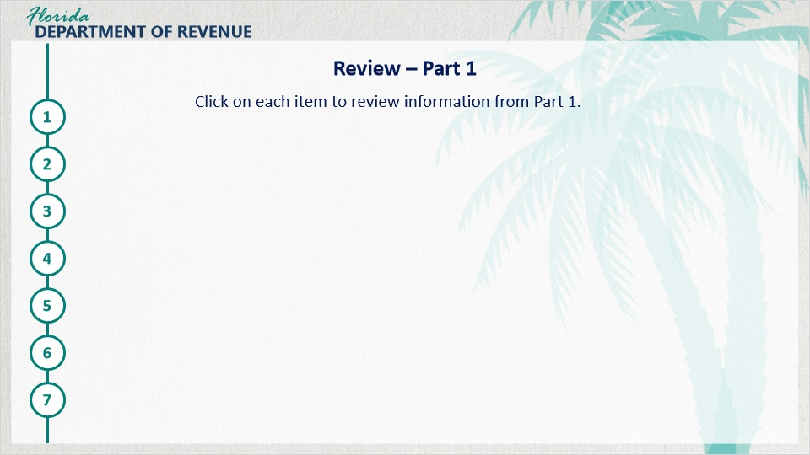
Transcript:
Click on each item to review information from Part 1.
If your business is going to take part in a taxable business activity, you must register to collect and remit state sales and use tax.
You register by completing the Florida Business Tax Application (Form DR-1). This can be done online at floridarevenue.com, or by paper application.

Once you have registered, you will receive some important documents, including a Certificate of Registration (Form DR-11) and a Florida Annual Resale Certificate for Sales Tax (Form DR-13).
As a business owner, you are responsible for collecting sales tax and discretionary sales surtax.
You are responsible for paying use tax on items intended for resale but used for the business instead, and on items purchased from an out-of-state business when no sales tax is collected. This also applies to items purchased for the business’s own use from an out-of-state business.
You are expected to remit all tax collected to the Department.
It is required that you keep specific, accurate records and maintain them for at least three years.

2. Florida Annual Resale Certificate

2.1 Hello, Meredith!

Transcript:
In Part 1 of the Overview of Sales and Use Tax for Business series, we met Meredith, an entrepreneur opening her own old-fashioned pharmacy.

[Meredith]: Hi, remember me?

Hi, Meredith. Have you registered your business yet?

[Meredith]: Yes, I completed my Florida Business Tax Application (Form DR-1) online. Didn’t you say I was supposed to receive some documents?

I’m glad to hear it! And yes, you should have. I’d like to talk with you a little bit more about one of those documents in particular, the Florida Annual Resale Certificate for Sales Tax (Form DR-13).

[Meredith]: Sounds good!

2.2 Florida Annual Resale Certificate
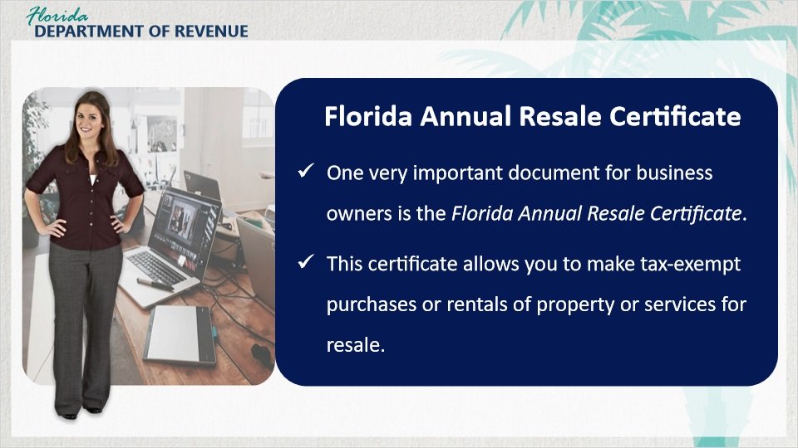
Transcript:
One very important document that business owners will receive after registering to collect and remit sales and use tax is the Florida Annual Resale Certificate.

[Meredith]: What makes this document so important?

This certificate allows you to make tax-exempt purchases or rentals of property or services for resale.

2.3 Examples of Using the Resale Certificate
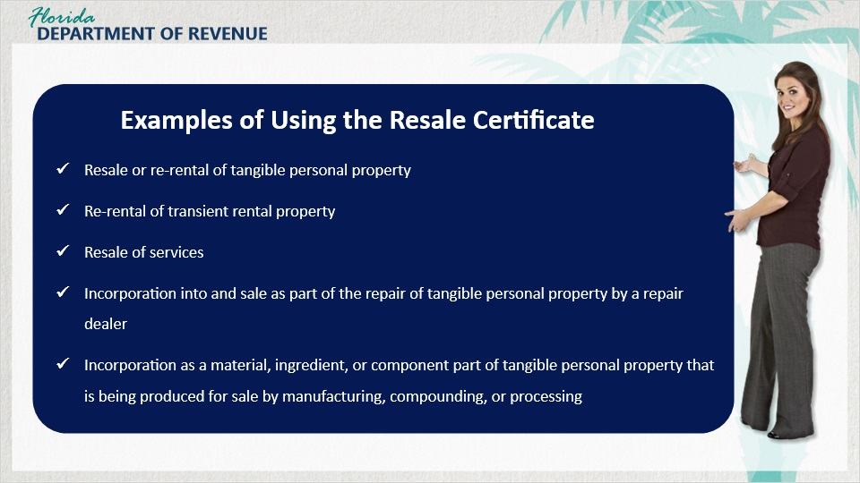
Transcript:
Examples of purchases or rentals you can make tax-exempt include the resale or re-rental of tangible personal property, the re-rental of transient rental property, the resale of services, the incorporation of items into and sale as part of the repair of tangible personal property by a repair dealer, and the incorporation of materials, ingredients, or component parts into tangible personal property that is being produced for sale through manufacturing, compounding, or processing.

2.4 Annual Resale Certificate Continued
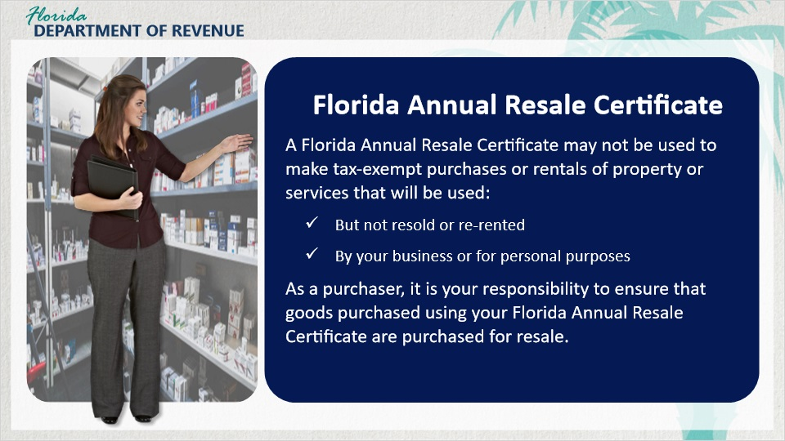
Transcript:
[Meredith]: I am still waiting on my Florida Annual Resale Certificate, but I have vendors calling and offering to sell me inventory. If I’m going to receive it soon anyway, can I save some time and just go ahead and buy the inventory?

Unfortunately, you can’t. You must wait until your Florida Annual Resale Certificate is approved and you have received it to purchase items tax-exempt.

[Meredith]: OK, I’ll wait.

A Florida Annual Resale Certificate may not be used to make tax-exempt purchases or rentals of property or services that will be used but not resold or re-rented.

You also cannot use an Annual Resale Certificate on items to be used by your business or for personal purposes. To make tax-exempt purchases of items or services you will resell, provide a copy, paper or electronic, of your Annual Resale Certificate or your certificate number to the seller.

As a purchaser, it is your responsibility to ensure that goods purchased using your Florida Annual Resale Certificate are purchased for resale. If the goods purchased for resale are later used by the business and not resold, you are responsible for reporting and paying use tax and surtax on the items.

2.5 Accepting a Florida Annual Resale Certificate
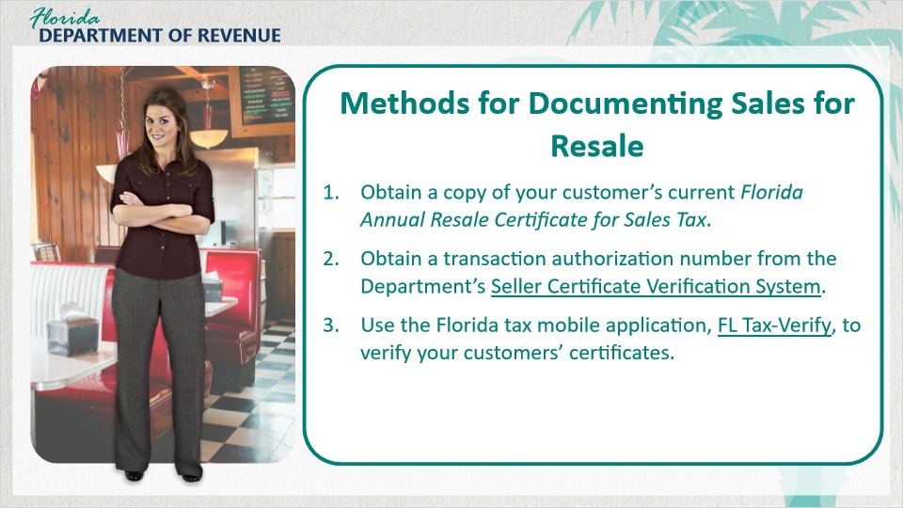
Transcript:
[Meredith]: So, if I can buy things tax-exempt from other businesses, does that mean they can buy taxable items tax-exempt from me?

Yes. Other businesses may buy items or services from you tax-exempt for resale by providing you with a copy of their current Florida Annual Resale Certificate.

All of these sales must all be documented. There are several methods for documenting sales for resale.

The first way is that you can obtain a paper or electronic copy of your customer’s current Florida Annual Resale Certificate. Maintain copies of the certificates for three years.

Secondly, you can obtain a transaction authorization number from the Department of Revenue’s Seller Certificate Verification System on the Department’s website. Keep a record of all verification response reports to document your tax-exempt sales.

Another way to get transaction authorization numbers is to do a batch upload through the system by obtaining an authorization number for your regular customers using the Department’s Seller Certificate Verification System. Results can be retrieved within 24 hours.

You do not need to save a copy of your customer’s Florida Annual Resale Certificate when you maintain transaction authorization or vendor authorization numbers for tax-exempt sales for resale.

Finally, you can use the Florida tax mobile application, Florida Tax-Verify, to verify your customers’ certificates. This application is available on Apple and Android devices.

Use this app to verify that your customers’ Florida Sales and Use Tax Resale or Exemption Certificates are valid before making tax exempt sales.
If you use this option, you can send an email of the records of verification from your phone.

2.6 Scenario #1
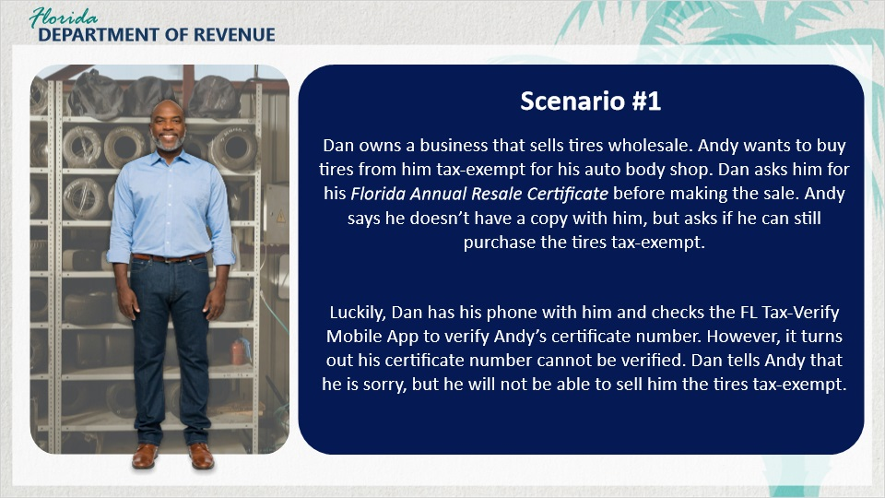
Transcript:
Here’s an example for you.

Dan owns a business that sells tires wholesale. Andy wants to buy tires from him tax-exempt for his auto body shop.

Dan asks him for his Florida Annual Resale Certificate before making the sale. Andy says he doesn’t have a copy with him, but asks if he can still purchase the tires tax-exempt.

Luckily, Dan has his phone with him and checks the FL Tax-Verify Mobile App to verify Andy's certificate number. However, it turns out his certificate number cannot be verified. Dan tells Andy that he is sorry, but he will not be able to sell him the tires tax-exempt.

2.7 Use Tax
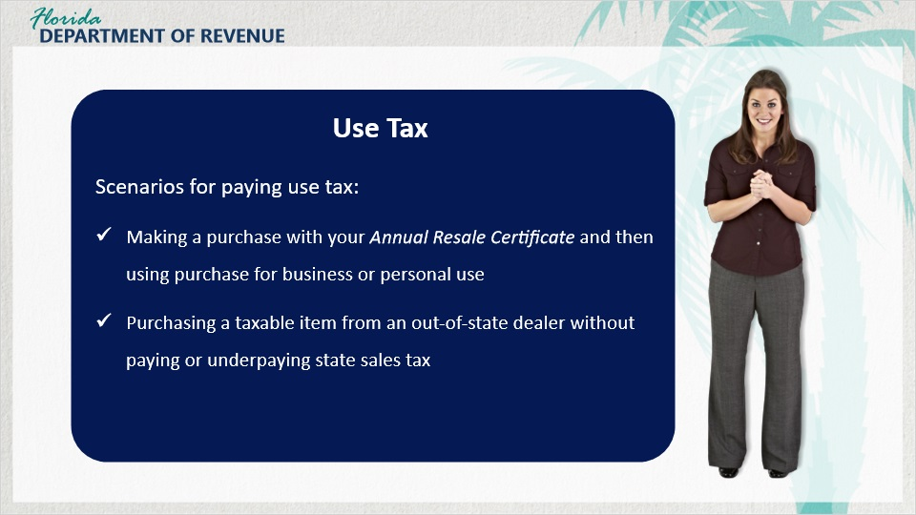
Transcript:
[Meredith]: I have a question. I have heard you mention something called “use tax.” What is that exactly? And when do I have to pay it?

Use tax is tax due on the use or consumption of taxable goods or services when Florida sales tax was not paid at the time of purchase.

For example, if you make a purchase using your Florida Annual Resale Certificate to re-sell or re-rent to other consumers and then use the items bought for your business or for personal use, you owe use tax.

Another common scenario is when a business purchases a taxable item outside Florida and brings it into, or has it delivered into, Florida. If they did not pay sales tax equal to Florida’s sales tax rate, they may owe use tax.

2.8 How to Reprint Your Resale Certificate
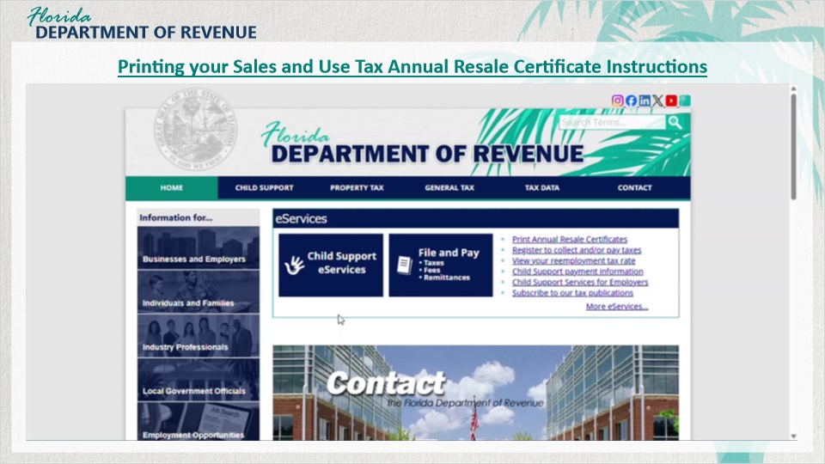
Transcript:
There may be times when you need to reprint your Florida Annual Resale Certificate. This video will walk you through how to do that step by step.

Start at the Department of Revenue’s website, On the right-hand side of the homepage, click Print Annual Resale Certificates from the list of blue links.

You’ll be taken to a page titled Print Annual Resale Certificates. If you want extra guidance, you can select Instructions to open a PDF that walks through the process with screenshots. Once you’re ready to continue, close the PDF and click Print Sales Tax Annual Resale Certificate.

Next, select Sales and Use Tax. You’ll see a Terms and Conditions page. Review the Privacy Notice and check the box confirming you agree to the terms, then select Next.

Complete all required fields, check the “I’m not a robot” box, and select Next.

Enter your Business Partner Number and Certificate Number, then select Next again.

Select the checkbox for the certificate you want to print, then choose Print Selected Certificates.

Your resale certificate will open as a PDF. From there, you can use the PDF tools to print or save a copy for your records.

2.9 Knowledge Check #1
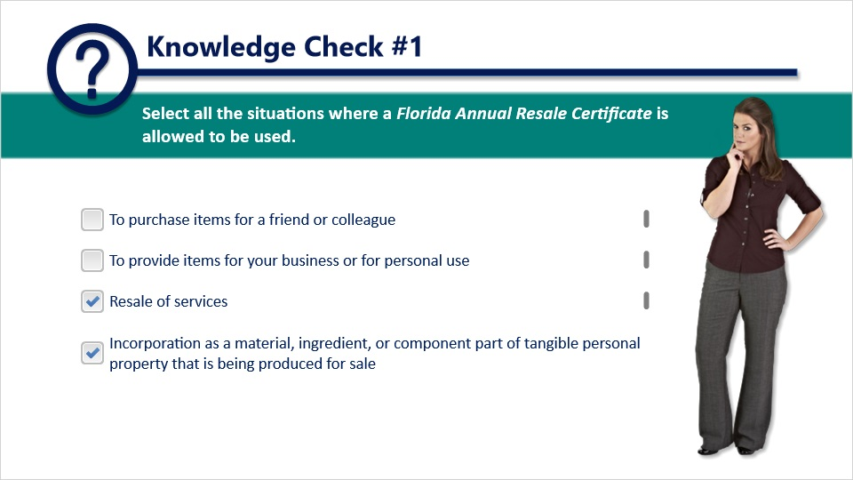
Question: Select all the situations where a Florida Annual Resale Certificate is allowed to be used.

Answer choices:
Choice one: To purchase items for a friend or colleague.
Choice two: To provide items for your business or for personal use.
Choice three: Resale of services.
Choice four: Incorporation as a material, ingredient, or component part of tangible personal property that is being produced for sale.

The correct choices are: Resale of services; and Incorporation as a material, ingredient, or component part of tangible personal property that is being produced for sale.

Feedback when correct: That’s right! You selected the correct response.

Feedback when incorrect: If you engage in a business activity subject to sales and use tax, you need to register.

3. Collecting Sales Tax and Discretionary Surtax

3.1 Sales Tax Rates
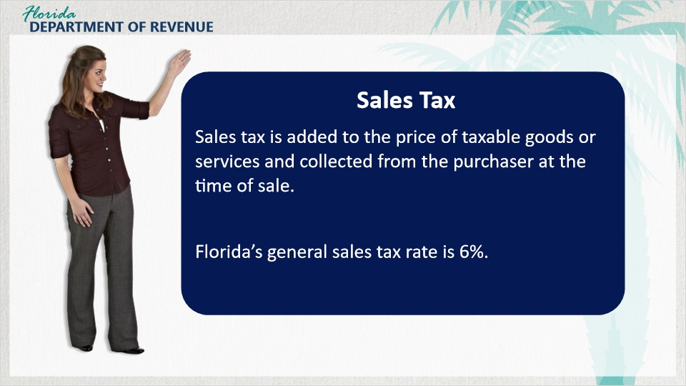
Transcript:
[Meredith]: I have registered, received my Certificate of Registration and my Annual Resale Certificate. I also bought my inventory. Now I am officially about to open my business. So, what’s next?

That’s a great question. Once you have opened your business, you must collect and remit sales tax. Sales tax is added to the price of taxable goods or services and collected from the purchaser at the time of sale.

Tax must be separately stated on the invoice or receipt and is collected based on sales price.

Each sale, admission, storage, or rental in Florida is taxable, unless the transaction is exempt.

Florida’s general state sales tax rate is 6%.

3.2 Florida Tax Rates
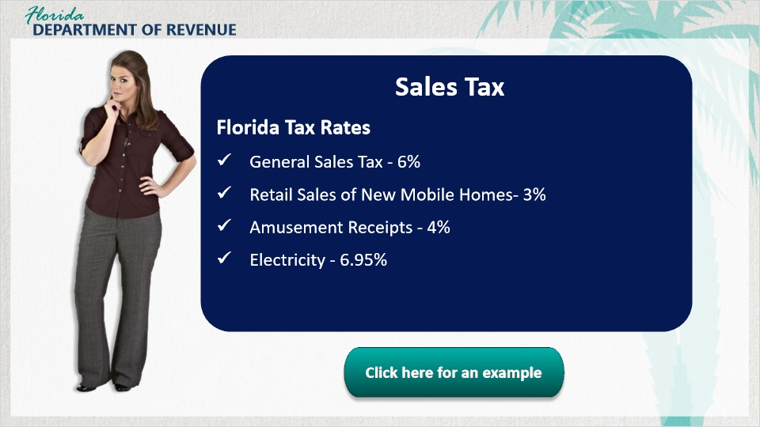
Transcript:
There are a few exceptions to items taxed at the general 6% rate: 3% applies to the sale of new mobile homes, 4% applies to amusement receipts such as coin-operated games or jukeboxes, and 6.95% applies to electricity. Please note that depending on the Florida county in which you operate, discretionary sales surtax (DSS) may also be due in addition to the state sales tax, which will be covered shortly. For example, if you sell a family five milkshakes for $20, you would collect $1.20 in sales tax, since the general tax rate in Florida is 6% (0.06), and $20 multiplied by 0.06 equals $1.20.

3.3 Proper Collection of Tax
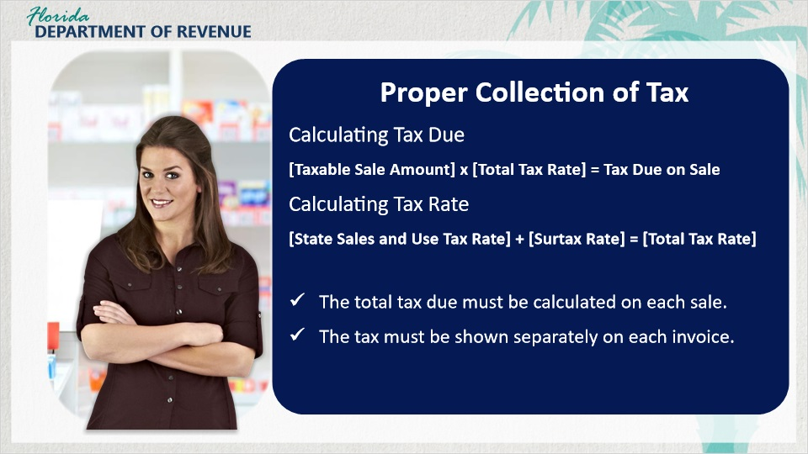
Transcript:
[Meredith]: I’m a little nervous about collecting taxes. I want to make sure I do everything right.

You don’t need to be nervous. I’m sure you’ll do fine. However, collecting the right amount of tax is important because mistakes may cost you money. Business owners must calculate the total tax due by multiplying the taxable sale amount by the total tax rate.

[Meredith]: How do you determine the tax rate?

The tax rate is calculated by adding the applicable state sales and use tax rate to the discretionary sales surtax rate.

The total tax due must be calculated on each sale. The tax must be shown separately on each invoice and may be calculated on either the combined taxable amount or the individual taxable amounts on an invoice.

3.4 Knowledge Check #2
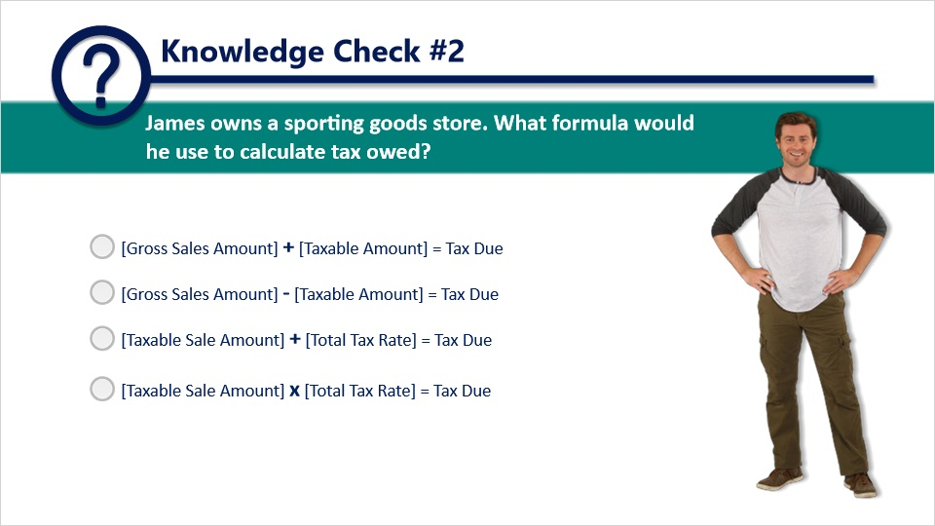
Question: James owns a sporting goods store. What formula would he use to calculate tax owed?

Answer choices:
Choice one: [Gross Sales Amount] plus [Taxable Amount] equals Tax Due.
Choice two: [Gross Sales Amount] minus [Taxable Amount] equals Tax Due.
Choice three: [Taxable Sale Amount] plus [Total Tax Rate] equals Tax Due.
Choice four: [Taxable Sale Amount] multiplied by [Total Tax Rate] equals Tax Due.

The correct choice is: [Taxable Sale Amount] multiplied by [Total Tax Rate] equals Tax Due.

Feedback when correct: That’s right! You selected the correct response.

Feedback when incorrect: The correct response is: [Taxable Sale Amount] multiplied by [Total Tax Rate] equals Tax Due.

3.5 Discretionary Sales Surtax
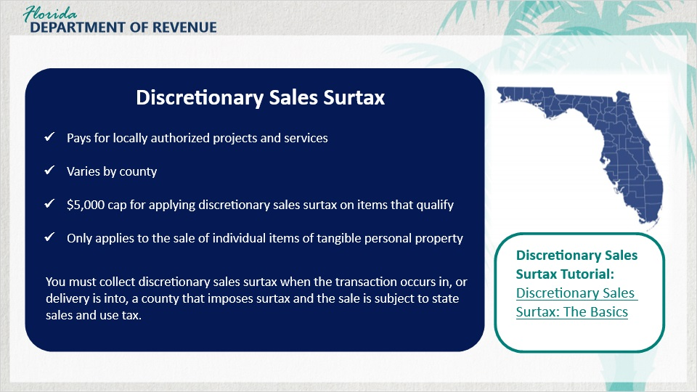
Transcript:
[Meredith]: You just mentioned discretionary sales surtax. What is that?

Many counties have elected to impose a discretionary sales surtax. These funds pay for locally authorized projects and services such as transportation systems, school construction projects, and emergency fire and rescue facilities.

This surtax varies from county to county.

There is a $5,000 cap for applying discretionary sales surtax on items that qualify. This cap only applies to the sale of individual items of tangible personal property.

If you recall, discretionary sales surtax was previously mentioned as part of the calculations to determine the tax rate.

You must collect discretionary sales surtax when the transaction occurs in, or delivery is into, a county that imposes surtax and the sale is subject to state sales and use tax.

To learn more about discretionary sales surtax, see the Department’s tutorial called “Discretionary Sales Surtax: The Basics.”

3.6 Scenario #2
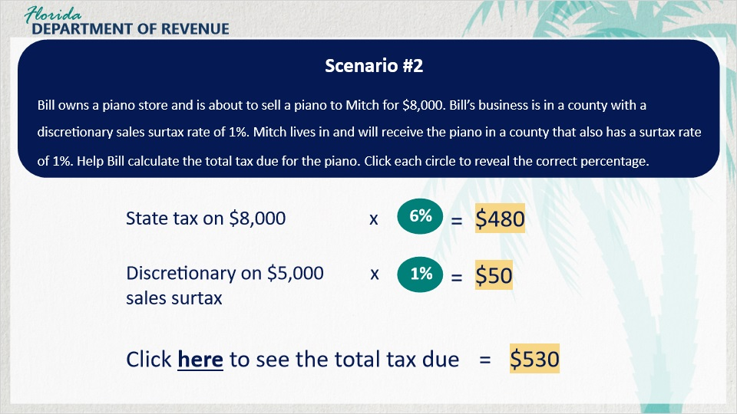
Transcript:
Let’s see what you remember about calculating sales tax and discretionary sales surtax.

Bill owns a piano store and is about to sell a piano to Mitch for $8,000. Bill’s business is in a county with a discretionary sales surtax rate of 1%.

Mitch lives in and will receive the piano in a county that also has a surtax rate of 1%.

Help Bill calculate the total tax due for the piano.

3.7 Scenario #3
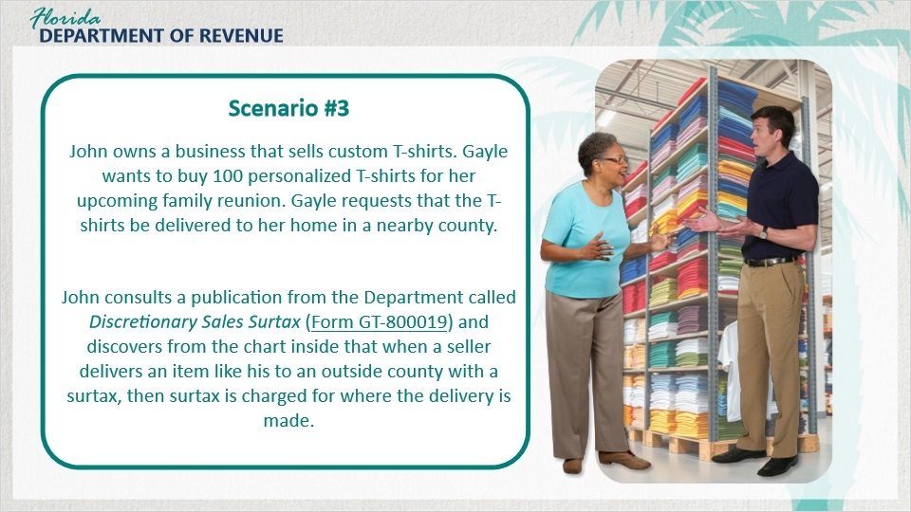
Transcript:
In a different case, John owns a business that sells custom T-shirts. Gayle wants to buy 100 personalized T-shirts for her upcoming family reunion.

Gayle requests that the T-shirts be delivered to her home in a nearby county.

John consults a publication from the Department called Discretionary Sales Surtax (Form GT-800019) and discovers from the chart inside that when a seller delivers an item like his to an outside county with a surtax, then surtax is charged for where the delivery is made.

3.8 Scenario #4
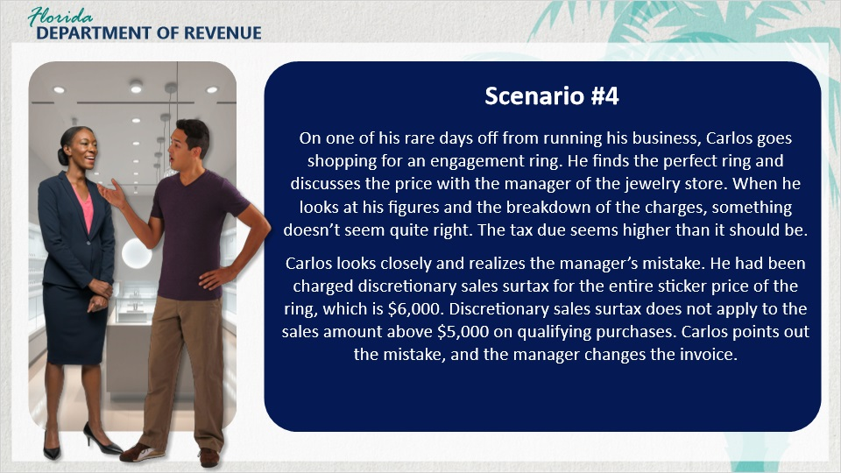
Transcript:
Here is an additional example.

On one of his rare days off from running his business, Carlos goes shopping for an engagement ring. He finds the perfect ring and discusses the price with the manager of the jewelry store. When he looks at his figures and the breakdown of the charges, something doesn’t seem quite right. The tax due seems higher than it should be.

Carlos looks closely and realizes the manager’s mistake. He had been charged discretionary sales surtax for the entire sticker price of the ring, which is $6,000. Discretionary sales surtax does not apply to the sales amount above $5,000 on qualifying purchases. Carlos points out the mistake, and the manager changes the invoice.

4. Calculating Tax Owed

4.1 Calculating Tax Owed
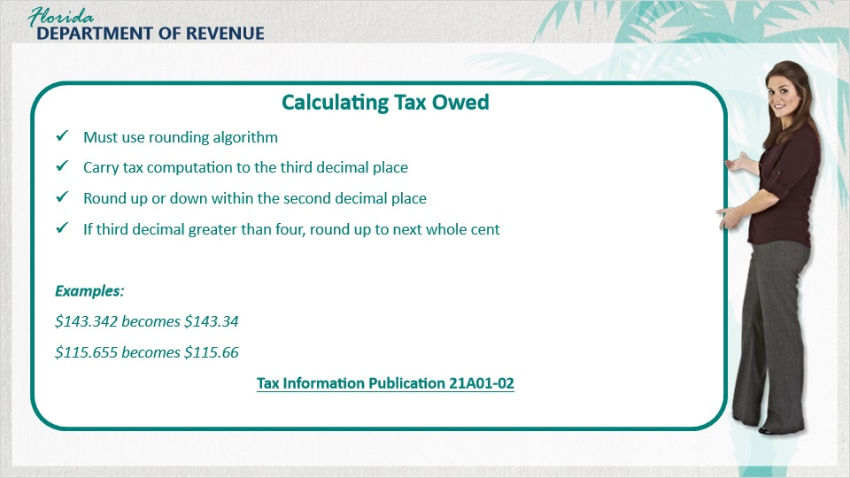
Transcript:
Now that we have discussed the proper collection of tax, let’s talk about how to calculate it.
When calculating tax owed, all business owners must use a rounding algorithm to compute the correct amount of sales tax and discretionary sales surtax.

This algorithm carries the tax computation to the third decimal place. It is then rounded up or down within the second decimal place. If the number in the third decimal place is greater than four, round up to the next whole cent.

For example, a dollar amount of $143.342 becomes $143.34.
A dollar amount of $115.655 becomes $115.66.

4.2 Scenario #5
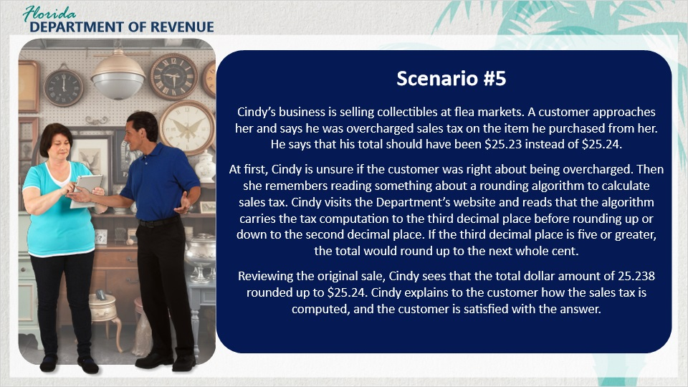
Transcript:
Let’s check out Cindy’s situation.

Cindy’s business is selling collectibles at flea markets. A customer approaches her and says he was overcharged sales tax on the item he purchased from her. He says that his total should’ve been $25.23 instead of $25.24.

At first, Cindy is unsure if the customer was right about being overcharged. Then she remembers reading something about a rounding algorithm to calculate sales tax. Cindy visits the Department’s website and reads that the algorithm carries the tax computation to the third decimal place before rounding up or down to the second decimal place.

If the third decimal place is five or greater, the total would round up to the next whole cent.

Reviewing the original sale, Cindy sees that the total dollar amount of 25.238 rounded up to $25.24. Cindy explains to the customer how the sales tax is computed, and the customer is satisfied with the answer.

4.3 Knowledge Check #3
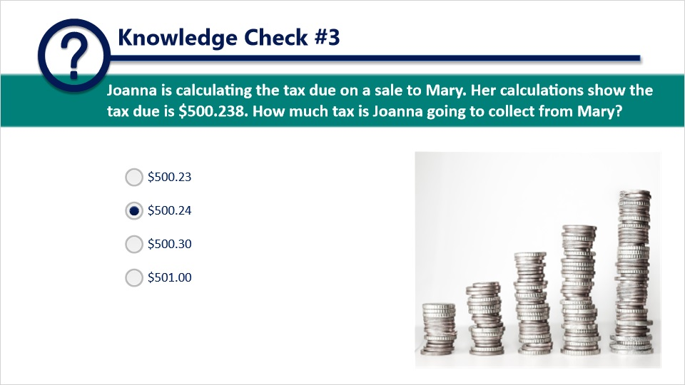
Question: Joanna is calculating the tax due on a sale to Mary. Her calculations show the tax due is 500 dollars and 238 thousandths of a dollar. How much tax is Joanna going to collect from Mary?

Answer choices:
Choice one: 500 dollars and 23 cents.
Choice two: 500 dollars and 24 cents.
Choice three: 500 dollars and 30 cents.
Choice four: 501 dollars and 0 cents.

The correct choice is: 500 dollars and 24 cents.

Feedback when correct: That’s right! You selected the correct response.

Feedback when incorrect: The correct amount is 500 dollars and 24 cents.

5. Conclusion Survey

5.1 Summary
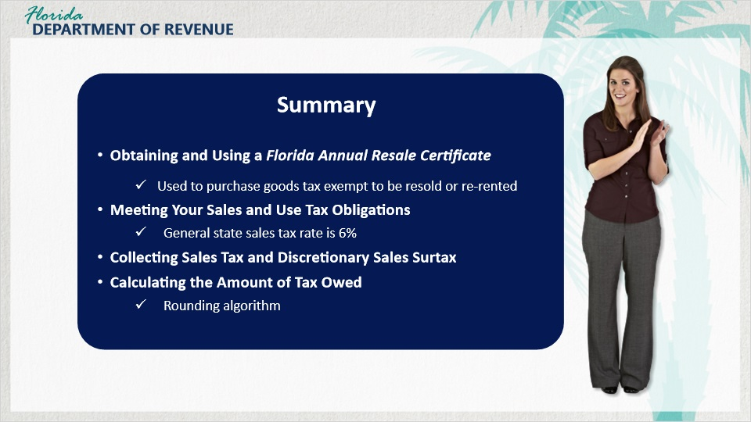
Transcript:
[Meredith]: This is a lot of information. Let me do a recap to make sure I’ve got it.

Sure. Go ahead.

[Meredith]: First, we discussed obtaining your Florida Annual Resale Certificate and the requirements for when and how to use it. For example, the Florida Annual Resale Certificate can be used to purchase goods tax-exempt that will be resold by your business. However, if you end up using those goods for your business, you must pay use tax.

Then we discussed meeting your sales and use tax obligations through the proper collection of tax. The general state sales tax rate is 6%, with exceptions for other items such as electricity, amusement machines, and new mobile homes.

We talked about collecting sales tax and discretionary sales surtax. Discretionary sales surtax is collected for the benefit of Florida counties. It’s used for projects and services such as school improvement and emergency services.

Finally, we discussed calculating the amount of tax owed. In Florida, business owners use a rounding algorithm to determine the final amount of sales and discretionary sales surtax.

Sounds like you’ve got it!

5.2 Tax Page and Social Media
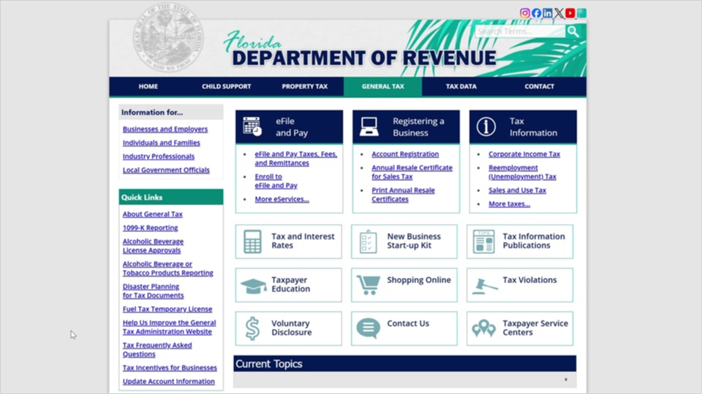
Transcript:
Visit Florida’s General Tax Administration website for business resources such as forms, publications, and information on all tax types.

Check out our Taxpayer Education webpage for new business guides, tutorials, and other helpful tools.

And follow us on YouTube, X, Instagram, Facebook, and LinkedIn using the icons at the top of our website to stay up to date on tax topics, alerts, and more.

5.3 Survey
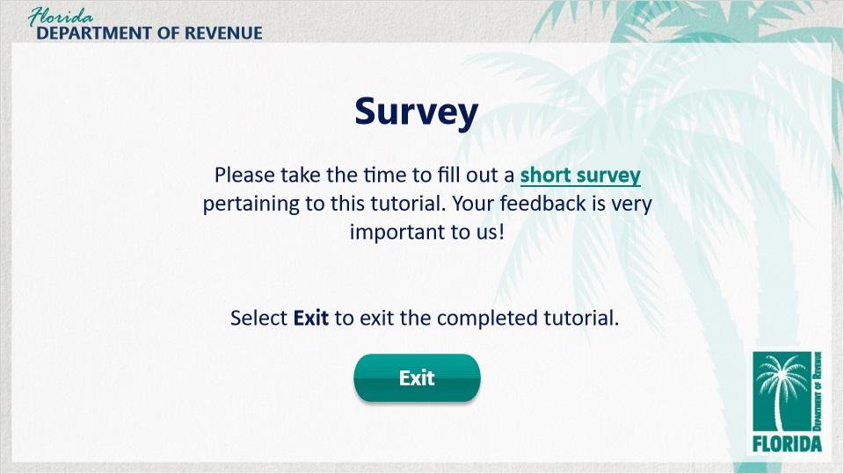
Transcript:
This concludes An Overview of Sales and Use Tax for Business Owners: Fulfilling Sales and Use Tax Obligations.

For more information, check out the resources available within this tutorial by clicking on the Resources tab in the upper-right corner of your screen.

In addition, there are several helpful guides and tutorials available on a variety of tax-related topics on the Department’s website at floridarevenue.com.

Please take the time to fill out a brief survey pertaining to this tutorial. Your feedback is very important to us.

To exit this tutorial, click on the Exit button.

Thank you.

