An Overview of Sales and Use Tax for Business Owners – Part 3

1. Introduction

1.1 Welcome
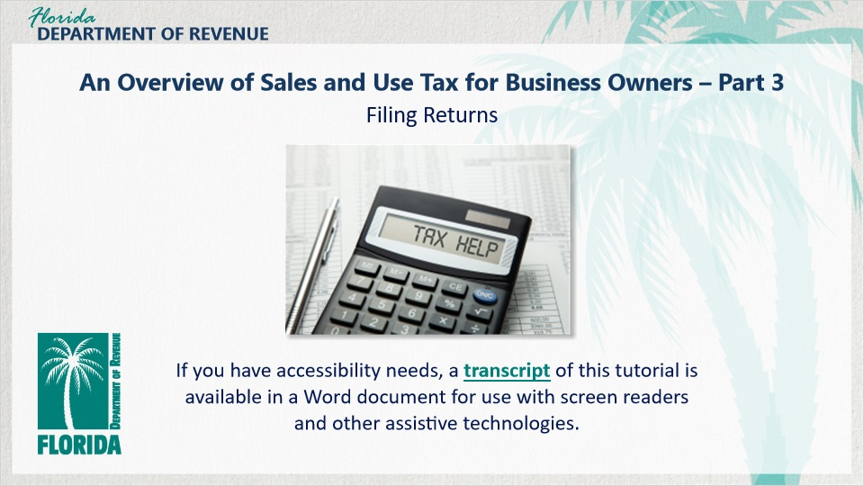
Transcript:
Welcome to An Overview of Sales and Use Tax for Business Owners: Filing Returns.
In this tutorial, we discuss filing returns with the Department.

If you have accessibility needs, a transcript of this tutorial is available in a Word document for use with screen readers and other assistive technologies.

1.2 Navigating This Tutorial
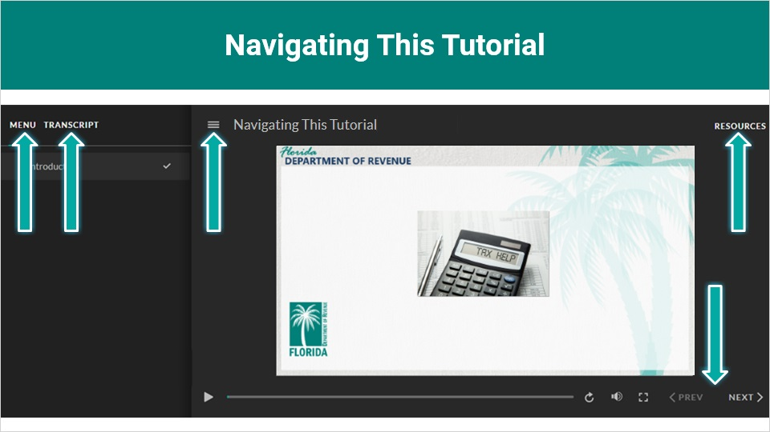
Transcript:
This overview will take approximately 20 minutes to complete. A transcript of the audio is available by clicking on the transcript tab in the top-left corner of your screen.
The following tabs and buttons are available to help you navigate throughout this overview.
Menu Tab
The menu tab displays by default when the overview is viewed on a computer. It allows you to navigate through the overview by clicking on the topic name on the menu. When viewing this overview on a tablet or smartphone, the menu does not display by default and must be accessed using the menu symbol.
Resources Tab
The resources tab is found on the right side of the top bar. When clicked, it displays the list of links to useful forms, documents, and webpages.
Previous and Next Buttons
The previous and next buttons are located at the bottom-right corner of your screen. These buttons allow you to move either back or forward.

1.3 Topics
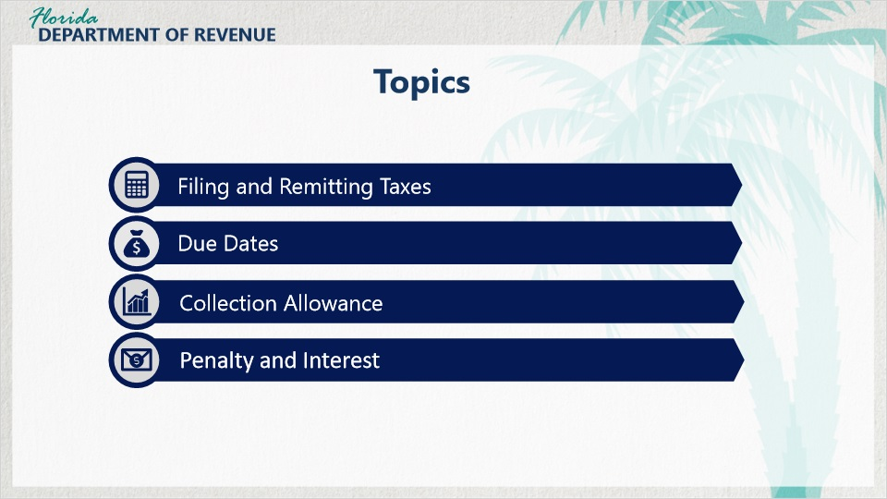
Transcript:
Topics for this tutorial include: filing and remitting taxes, due dates, collection allowance, and penalties and interest.

1.4 Review of Part 2
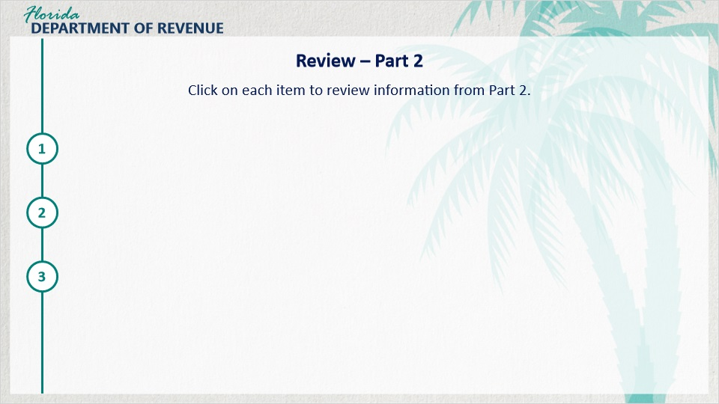
Transcript:
Here is a quick review of the information from Part 2.
Florida Annual Resale Certificate
The Florida Annual Resale Certificate for Sales Tax (Form DR-13) can be used to purchase goods tax-exempt that will be resold or re-rented by your business. However, if you end up using these goods for your business, you must pay use tax.
Meeting Tax Obligations
You are required to collect and remit state sales tax and discretionary sales surtax on each taxable good or service that you sell.

The general tax rate in Florida is 6%. Some exceptions include retail sales of new mobile homes at 3%, amusement machine receipts at 4%, and electricity at 6.95%.

Discretionary sales surtax is used for projects and services such as school improvement and emergency services to benefit Florida counties.

Collecting and Calculating Tax
When calculating tax owed, business owners use a rounding algorithm to determine the final amount of sales tax and discretionary sales surtax.

2. Filing and Remitting Taxes

2.1 Welcome Back!

Transcript:
Welcome back, Meredith!

[Meredith]: Thanks. It’s good to be back. I got a lot out of that last tutorial. I have a better understanding of what my tax obligations are and how to collect and calculate tax properly.

I’m glad to hear it. Let’s go ahead and get started with filing and remitting taxes. We’ve got a lot to cover.

2.2 Filing Frequency
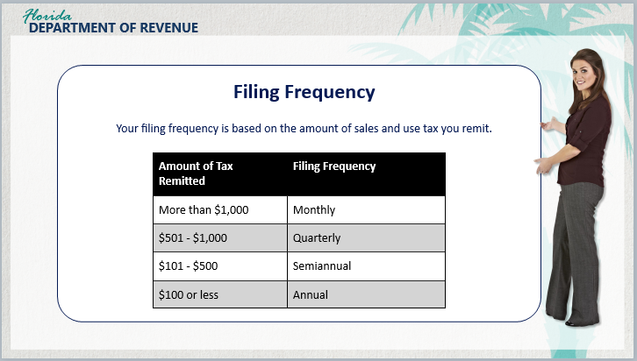
Transcript:
As a business owner, you are responsible for reporting and remitting the sales tax and discretionary sales surtax due on the sales you make.

[Meredith]: Does everyone file monthly?

No, they don’t. Your filing frequency is based on the amount of sales and use tax you remit. Initially, your filing frequency is set up as monthly or quarterly depending on your business type. You can request for it to be changed to a different frequency if necessary.

If you remit more than $1,000 in tax, your filing frequency is monthly. If you remit $501 to $1,000 in tax, your filing frequency is quarterly. If you remit $101 to $500 in tax, your filing frequency is semiannual. If you remit under $100 in tax, your filing frequency is annually.

[Meredith]: So, this filing frequency can change based on taxes remitted?

Yes. The Department reviews each sales and use tax account annually to determine the correct filing frequency for the next calendar year. Letters are mailed notifying the business owner of the filing frequency change that will begin the following calendar year.

2.3 Due Dates
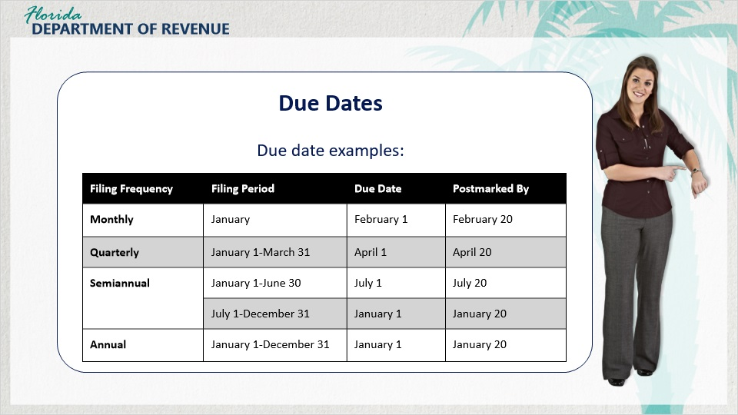
Transcript:
As a business owner, you are responsible for filing and remitting state sales tax and discretionary sales surtax. You are also expected to file and pay these returns on time.

[Meredith]: I definitely want to file and remit all of my taxes on time. Do I need to have my accountant file for me and my business, or can I do it myself?

That’s a good question. You can have an accountant file for you or do it yourself. Regardless of your choice, your due dates will be the same, so it’s good to be aware of them.

Returns and payments are due on the 1st and late after the 20th day of the month following each reporting period.

If the 20th falls on a Saturday, Sunday, or state or federal holiday, returns are timely if filed electronically without payment, postmarked, or delivered in person on the first business day following the 20th.

[Meredith]: Can you give me an example?

Sure. If the sale took place in your pharmacy during January and you file returns monthly, your tax return is due February 1 and late after February 20; however, if you file quarterly, your return is due April 1 and late after April 20.

If you file semi-annually, you file a return every six months. Your return for the first half of the calendar year will be due on July 1 and late after July 20. Your return for the second half of the calendar year will be due on January 1 and late after January 20.

If you file annually, you file a return once a year. Your return is due on January 1 and late after January 20.

2.4 Due Dates for Electronically Filing Returns
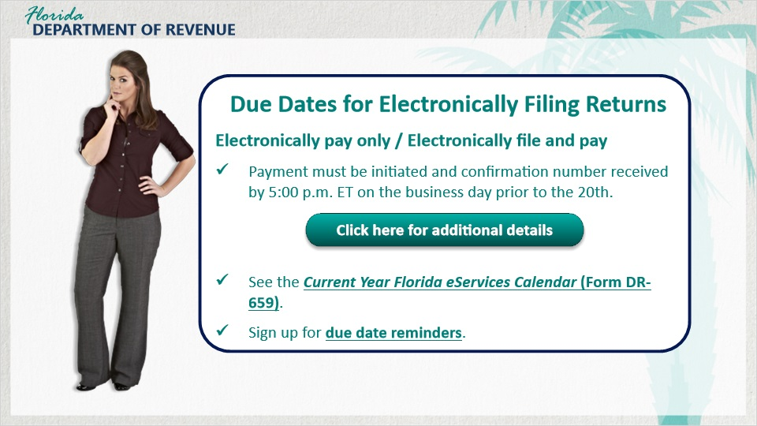
Transcript:
[Meredith]: Is there an option to file electronically?

Yes, there is. When you electronically pay only, or you electronically file and pay at the same time, you must initiate your electronic payment and receive a confirmation number no later than 5:00 p.m. ET on the business day prior to the 20th to avoid penalty and interest.

For a list of payment deadlines, visit the Department’s Forms webpage and select Current Year Florida eServices Calendar of Electronic Payment Deadlines (Form DR-659) under the eServices section. Keep a record of your confirmation numbers.

You can also sign up to receive due date reminders by going to the Department’s Subscribe to Receive Updates by Email webpage.

Receiving these reminders will also help you keep track of deadlines for paying other taxes such as reemployment tax.

Below is an explanation of due dates.

File Only - Your return may be submitted or postmarked on the 20th.

Pay Only - Payment is due no later than the business day before the 20th at 5 p.m. ET, to avoid penalty and interest.

File and Pay - Your return may be submitted or postmarked on the 20th. Payment is due no later than the business day before the 20th at 5 p.m. ET, to avoid penalty and interest.

If you are required to file electronically, you must also pay electronically.

2.5 Filing and Paying Tax
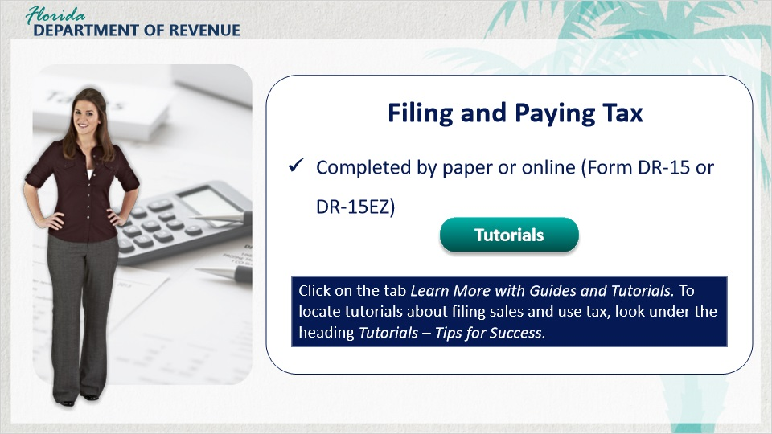
Transcript:
[Meredith]: How do I complete my return?

Sales and Use Tax Returns can be completed using either a paper-based return (Form DR-15), a paper-based DR-15 EZ for those who qualify, or by filing online.

For more information on submitting your return, view the tutorials for filing both paper-based and online returns on the Department’s Taxpayer Education webpage. Select the tab Learn More with Guides and Tutorials. To locate tutorials about filing Sales and Use Tax, select the heading Tutorials – Tips for Success.

2.6 Filing and Paying Tax
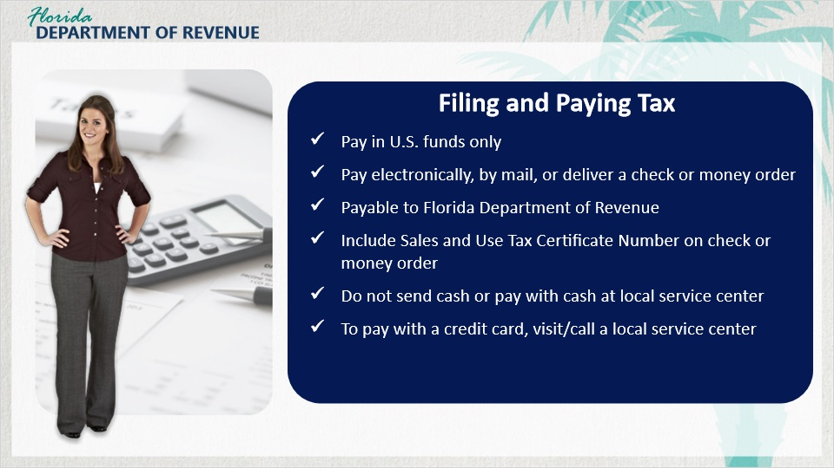
Transcript:
Tax must be paid in U.S. funds only. If you are not paying electronically, mail or deliver in person a check or money order payable to the Florida Department of Revenue. Be sure to write your complete sales and use tax certificate number on the check or money order.

Do not send cash in the mail or pay with cash at your local service center. To pay with a credit card, visit or call a local service center.

2.7 Knowledge Check #1
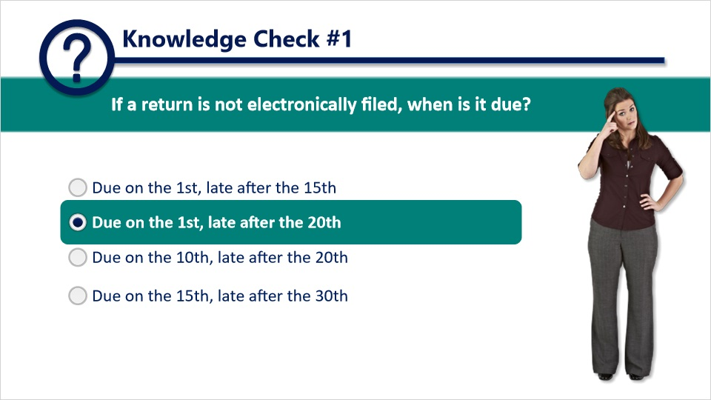
Question: If a return is not electronically filed, when is it due?
Answer choices: Due on the 1st and late after the 15th; Due on the 1st and late after the 20th; Due on the 10th and late after the 20th; and Due on the 15th and late after the 30th.
The correct answer is Due on the 1st and late after the 20th.

2.8 Collection Allowance
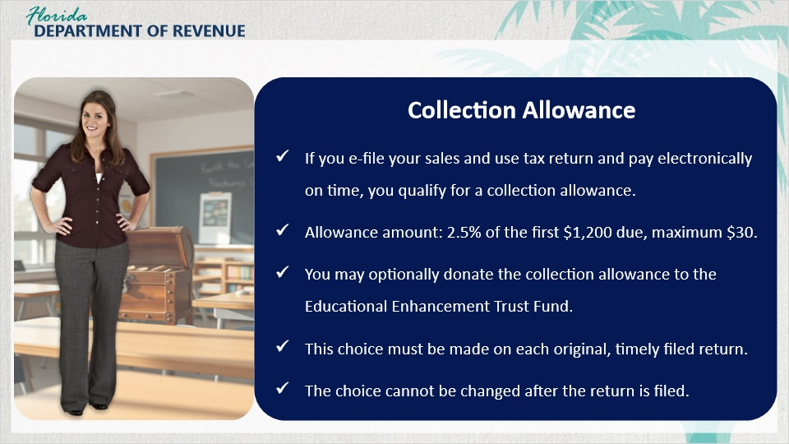
Transcript:
There is a perk of filing and paying electronically that you should know about, Meredith - the collection allowance.

[Meredith]: I’m listening.

When you electronically file your sales and use tax return and electronically pay timely, you are entitled to take a collection allowance. The collection allowance is 2.5% of the first $1,200 of tax due, not to exceed $30.

If you are entitled to a collection allowance, you may elect to donate the collection allowance to the Educational Enhancement Trust Fund. You must make this election on each original and timely filed electronic return. You cannot make this choice after your electronic return is filed.

2.9 No Tax Due
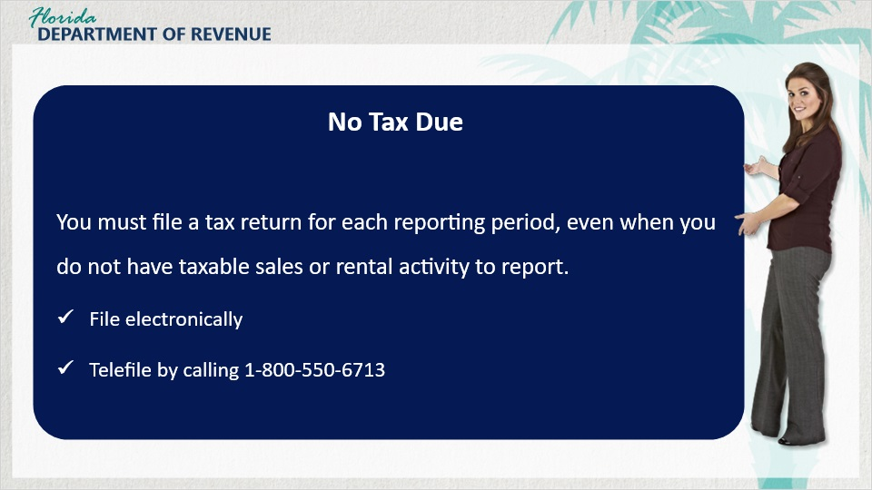
Transcript:
[Meredith]: Just out of curiosity, what happens if you don’t owe any tax for a filing period?

Good question. You must file a tax return for each reporting period, even when you do not have taxable sales or rental activity to report. If you file electronic returns, you will need to electronically file a tax return to report that you do not owe tax for the reporting period.

You also have the option to telefile a zero return by calling 1-800-550-6713.

2.10 Penalty and Interest
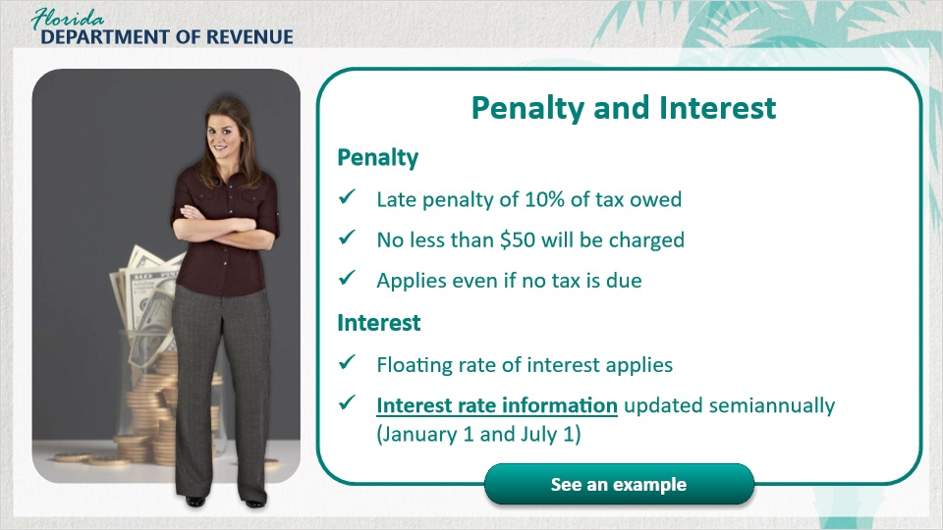
Transcript:
[Meredith]: What happens if I’m late filing my return or paying?

If you file your return or pay late, a late filing penalty of 10% of the amount of tax owed, but not less than $50, will be charged. The $50 penalty applies even if no tax is due.

A floating rate of interest also applies to late payments and underpayments of tax. Interest rate information is updated semiannually on January 1st and July 1st.

Here are the steps you should take to calculate the interest due with your tax return.

First, get the daily interest rate factor(s) for the filing period(s) from the appropriate Tax Information Publication.

Second, calculate the number of days your return is late by counting the number of days from the “late after” date on the return through the date the return and payment are postmarked by the U.S. Postal Service or hand-delivered to the Florida Department of Revenue.

Finally, multiply the amount of tax due by the number of days late and then by the appropriate daily interest rate factor.
Here is an example featuring Miranda.

Miranda has her own part-time business selling cosmetics door-to-door. She forgot to file her June 2022 Sales and Use Tax Return, which was due no later than July 20th, 2022. She owed $1,250, and filed and paid on August 15th, 2022, which is 26 days late.

Miranda reviewed the Florida Tax and Interest Rates webpage and determined the daily interest rate factor is 0.000191781. Here is how she calculated the interest due:

She multiplied the amount of tax due, $1,250, by the number of days late, 26, and then multiplied that number by the daily interest rate factor of 0.000191781. The total interest due equals $6.23.

2.11 Scenario #1
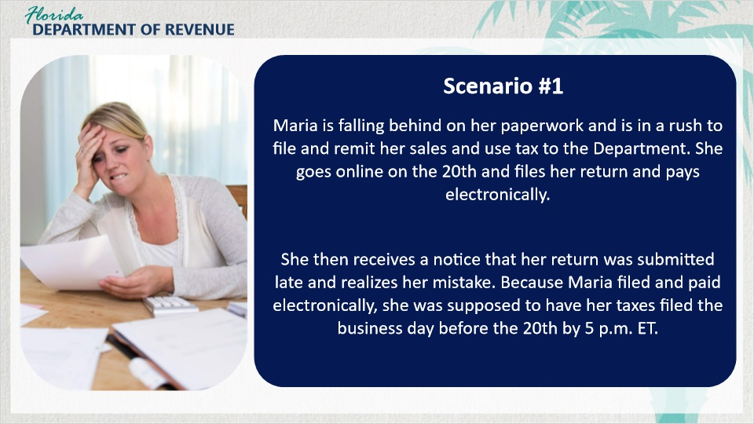
Transcript:
Let’s take a look at Maria, who electronically filed and paid her return.

Maria is falling behind on her paperwork and is in a rush to file and remit her sales and use tax to the Department. She goes online on the 20th and files her return and pays electronically.

She then receives a notice that her return was submitted late and realizes her mistake. Because Maria filed and paid electronically, she was supposed to have her taxes filed the business day before the 20th by 5:00 p.m. ET.

2.12 Knowledge Check #2
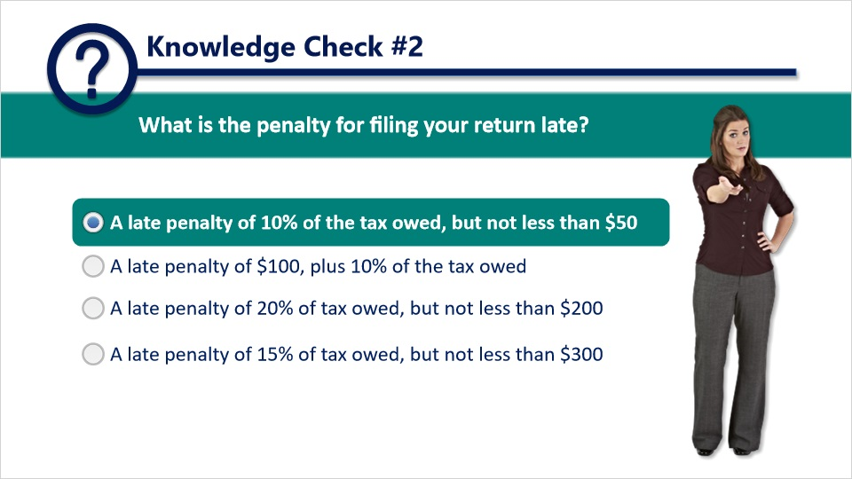
Question: What is the penalty for filing your return late?
Answer choices: A late penalty of 10% of the tax owed, but not less than $50; A late penalty of $100 plus 10% of the tax owed; A late penalty of 20% of the tax owed, but not less than $200; and a late penalty of 15% of the tax owed, but not less than $300.
The correct answer is a late penalty of 10% of the tax owed, but not less than $50.

3. Conclusion and Survey

3.1 Summary
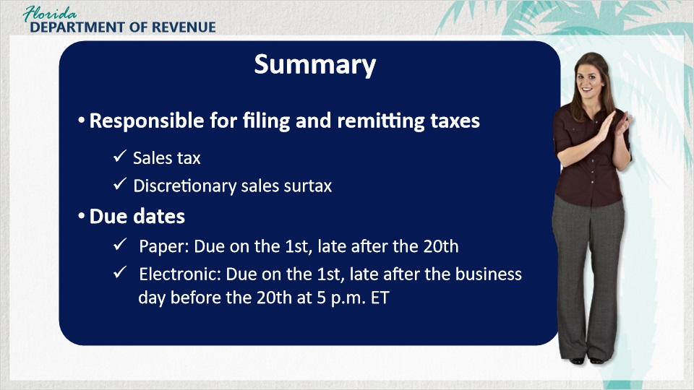
Transcript:
Well, we’ve covered a lot of information in this tutorial. Would you like to do a summary for us, Meredith?

[Meredith]: I’d be happy to.

As a business owner, you are responsible for reporting and remitting the sales tax and discretionary sales surtax due on the sales you make.

We discussed due dates for remitting returns. Returns and payments are due on the 1st and late after the 20th day of the month following each reporting period.

When you electronically pay only, or you electronically file and pay at the same time, you must initiate your electronic payment and receive a confirmation number no later than 5 p.m. ET on the business day prior to the 20th to avoid penalty and interest.

3.2 Summary Continued
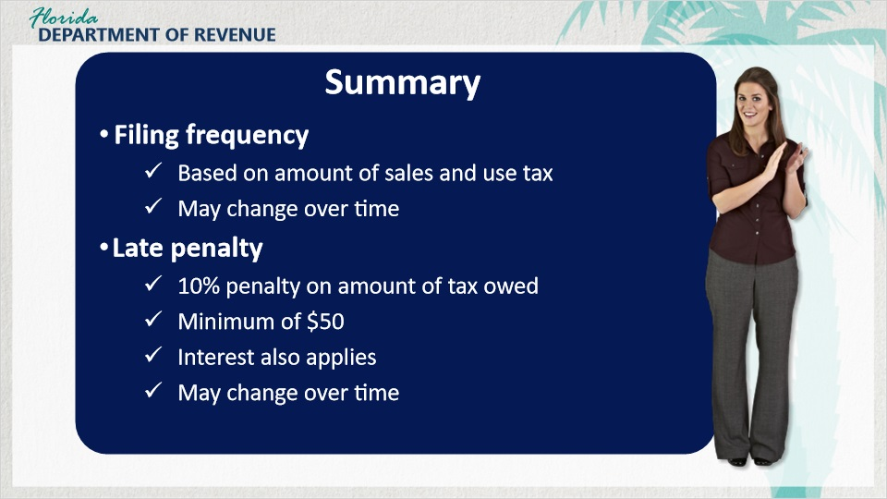
Transcript:
Your filing frequency is based on the amount of sales and use tax you remit. Most new businesses are initially set up on a quarterly filing frequency, but this may change as the business makes more taxable sales.

If you file your return or pay tax late, a late filing penalty of 10% of the amount of tax owed, but not less than $50, will be charged. The $50 penalty applies even if no tax is due. A floating amount of interest also applies.

3.3 Tax Page and Social Media
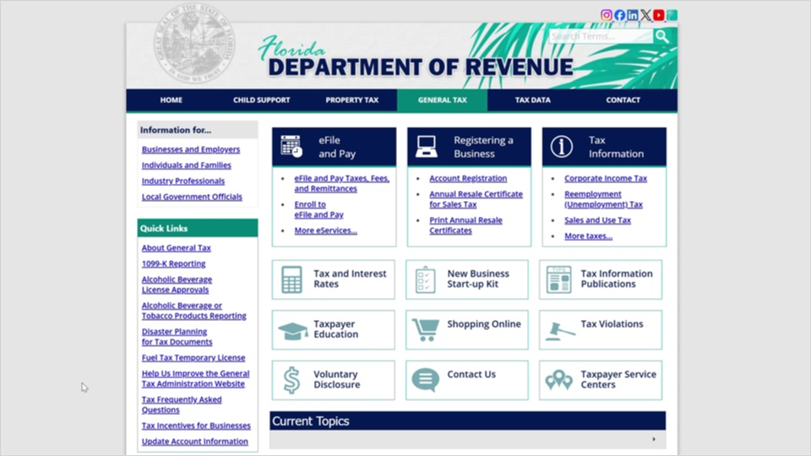
Transcript:
Visit Florida’s General Tax Administration website for business resources such as forms, publications, and information on all tax types.

Check out our Taxpayer Education webpage for new business guides, tutorials, and other helpful tools.

And follow us on YouTube, X, Instagram, Facebook, and LinkedIn using the icons at the top of our website to stay up to date on tax topics, alerts, and more.

3.4 Survey
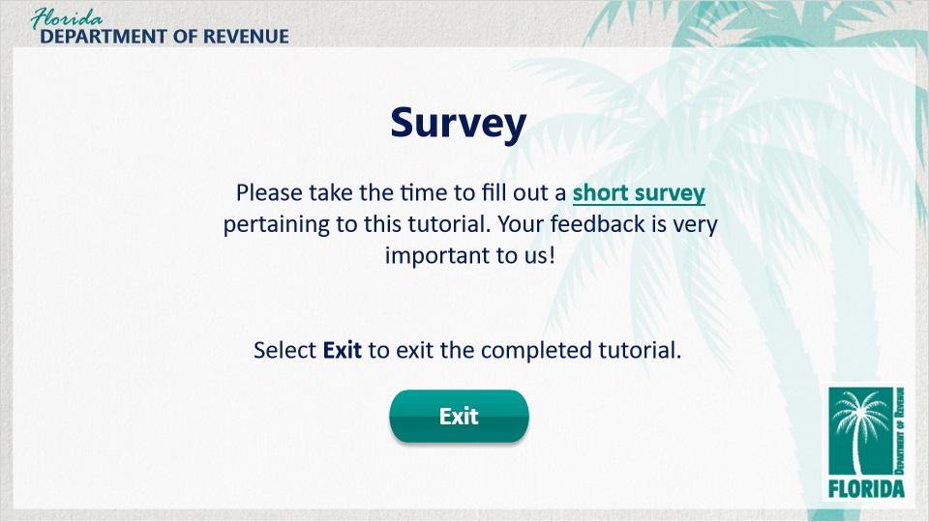
Transcript:
This concludes An Overview of Sales and Use Tax for Business Owners: Filing Returns.

There are several helpful guides and tutorials available on a variety of tax-related topics on the Department’s website.

Please take the time to fill out a brief survey pertaining to this tutorial. Your feedback is very important to us.

Thank you.

