An Overview of Sales and Use Tax for Business Owners – Part 4

1. Introduction

1.1 Welcome
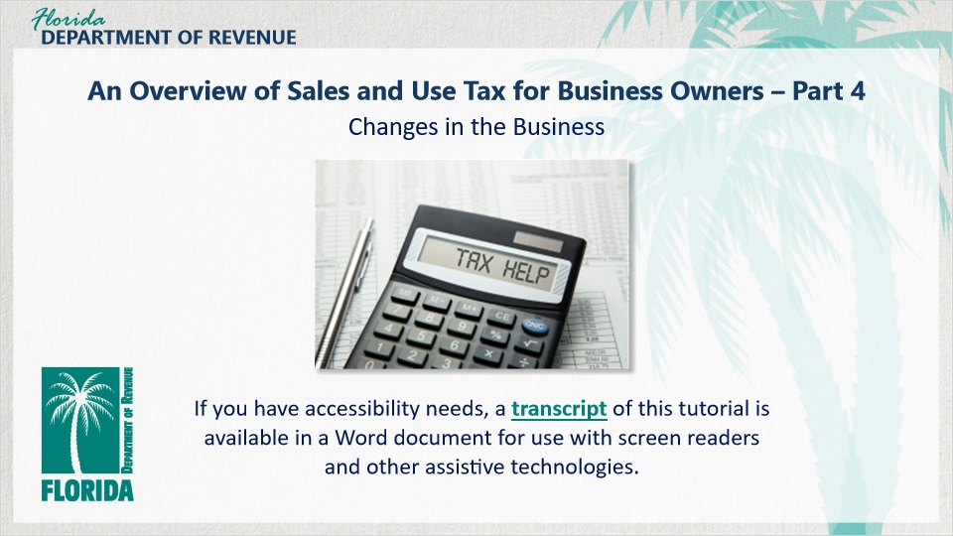
Transcript:
Welcome to An Overview of Sales and Use Tax for Business Owners: Changes in the Business.

In this tutorial, we discuss changes in your business, changes to your legal status as a business, and changing locations.

1.2 Navigating This Tutorial
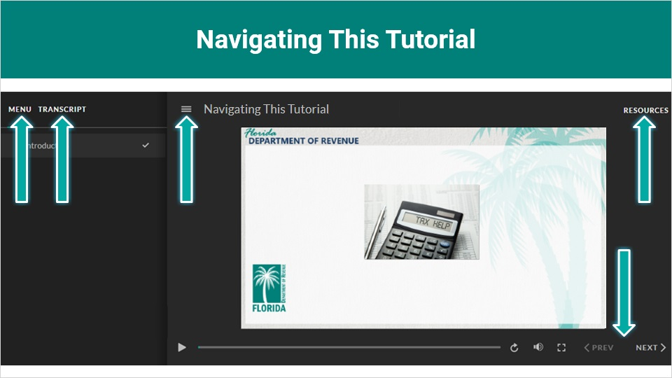
Transcript:
This overview will take approximately 20 minutes to complete. A transcript of the audio is available by clicking on the transcript tab in the top-left corner of your screen.
The following tabs and buttons are available to help you navigate throughout this overview.
Menu Tab
The menu tab displays by default when the overview is viewed on a computer. It allows you to navigate through the overview by clicking on the topic name on the menu. When viewing this overview on a tablet or smartphone, the menu does not display by default and must be accessed using the menu symbol.
Resources Tab
The resources tab is found on the right side of the top bar. When clicked, it displays the list of links to useful forms, documents, and webpages.
Previous and Next Buttons
The previous and next buttons are located at the bottom-right corner of your screen. These buttons allow you to move either back or forward.

1.3 Topics
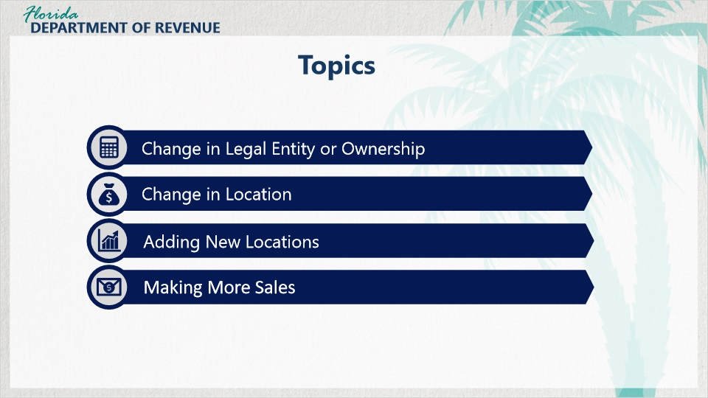
Transcript:
Topics for this tutorial include: Change in Legal Entity or Ownership; Change in Location; Adding New Locations; and Making More Sales.

1.4 Review of Part 3
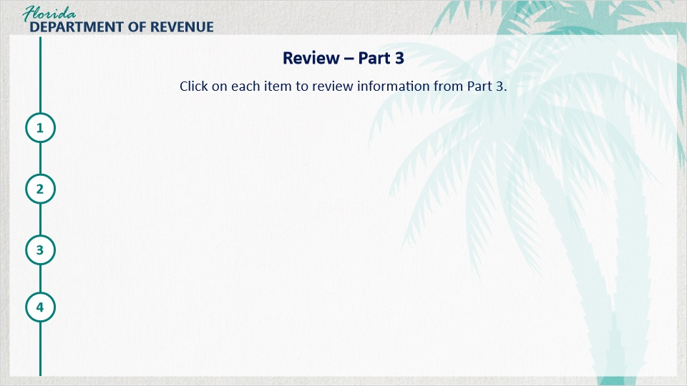
Transcript:
Review information from Part 3.

Responsibilities
Business owners are responsible for filing and remitting sales tax and discretionary sales surtax.
Due Dates
Paper returns are due on the 1st, and late after the 20th.
Electronic returns with payment are due on the 1st, and late after the business day before the 20th at 5:00 p.m. ET.
Filing Frequency
Your filing frequency is based on the amount of sales and use tax collected and remitted.
The Department reviews each sales and use tax account annually to determine the correct filing frequency for the next calendar year.
Late Penalty
If your return and payment are late, a 10% penalty on the amount of tax owed will be assessed with the minimum penalty being $50.
Interest also applies, and the interest rate information can be found on the Department’s website.

2. Changes in Your Business

2.1 Changes in Your Business
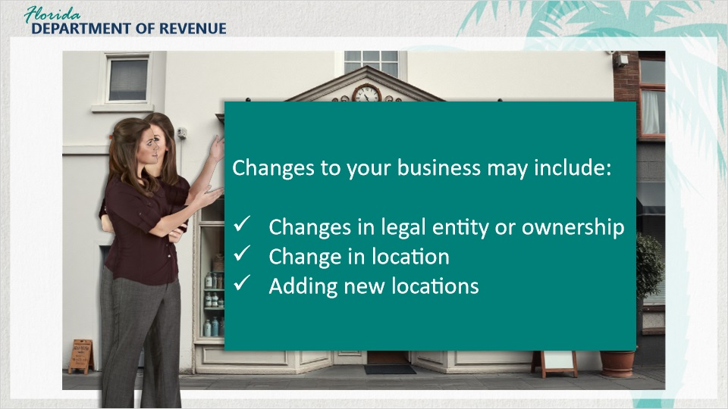
Transcript:
Let’s check back with Meredith to see how she’s doing.
Meredith, what is your vision for your business? Do you plan on keeping it small, or do you want to open more locations?

[Meredith]: I would eventually like to open more locations and create a statewide chain of old-fashioned pharmacies. Then, who knows? The sky is the limit!

That sounds like a great plan! As your business grows, it will continue to experience changes. Some of these changes may include, but are not limited to: Changes in legal entity or ownership; Change in location, and; Adding new locations.

Let’s discuss these changes, along with the requirements for handling them.

2.2 Changes in Legal Entity or Ownership
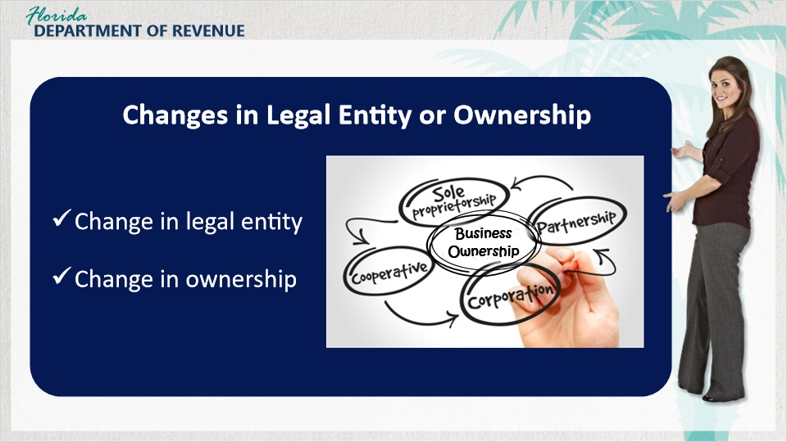
Transcript:
At some point, you may want to change the legal structure of your business. For example, you may decide to take on a business partner and change your business from a sole proprietorship to a partnership.
This change would require you to complete a new Florida Business Tax Application (Form DR-1). If your business changes owners, you must also complete a new DR-1.

2.3 Knowledge Check #1
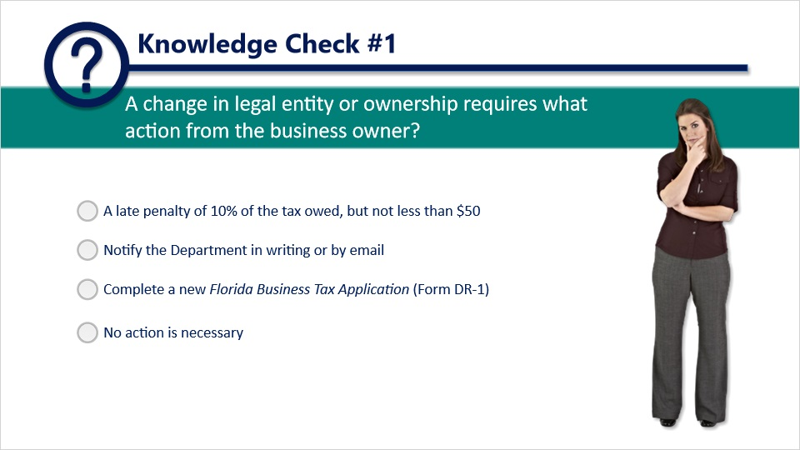
Question: A change in legal entity or ownership requires what action from the business owner?
Answer choices: A late penalty of 10% of the tax owed, but not less than $50; Notify the Department in writing or by email; Complete a new Florida Business Tax Application (Form DR-1); or no action is necessary.
Correct answer: Complete a new Florida Business Tax Application (Form DR-1).

2.4 Change in Location - Same County
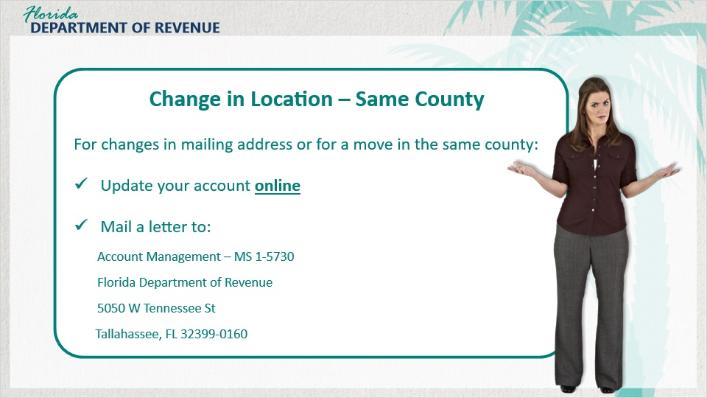
Transcript:
[Meredith]: What happens if my store outgrows its current location and I have to move to a new location?

It depends on whether that move is within the same county, or to another county.

Some changes, such as a change in address within the same county simply require you to notify the Department. You can do so by going online or you may notify the Department in writing by mailing a letter to:
Account Management – MS 1-5730
Florida Department of Revenue
5050 W Tennessee St
Tallahassee, FL 32399-0160

2.5 Change in Location - Different County
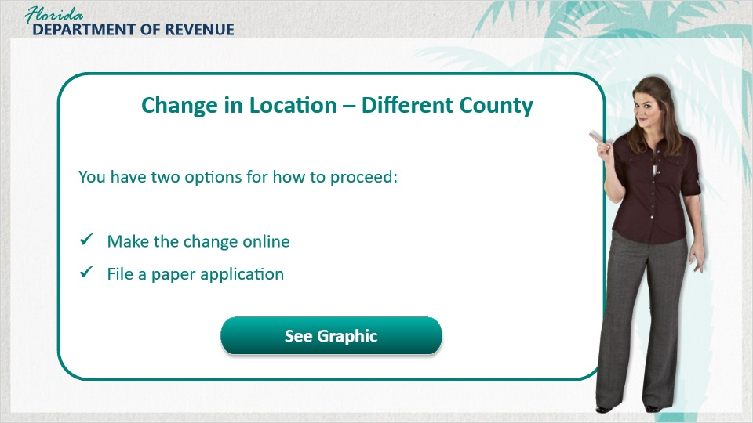
Transcript:
If the move is to another county, you have two choices of how you may proceed.

The first option is to make the change online by signing in to the Florida Business Tax Application (Form DR-1). On question three, you will be asked for your reason for applying. If you select “Moved registered Florida location to another Florida county,” you will automatically be directed to complete the Application for Registered Businesses to Add a New Florida Location (Form DR-1A).

The second option is to file a paper Application for Registered Businesses to Add a New Florida Location (Form DR-1A).

Also, Meredith, if you move to a new county, you will need to check on the discretionary sales surtax rate for that county. It may be different from your current county.
----------------------------------------

Graphic Layer
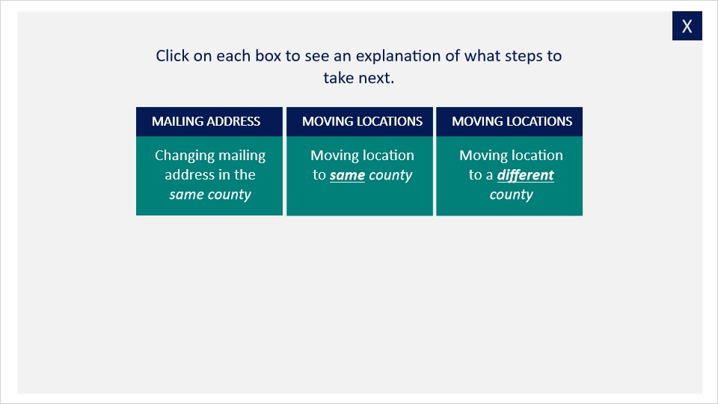
Transcript:
Here are the steps to take next depending on the changes that will be made to your location.

If you are changing your mailing address to a different one in the same county, you may update it online or by mail.

If you are moving your location to a different one in the same county, you may update it online or by mail.

If you are moving your location to a different one in a different county, you must complete a new Florida Business Tax Application (Form DR-1) or complete an Application for Registered Businesses to Add a New Florida Location (Form DR-1A).

2.6 Adding New Locations
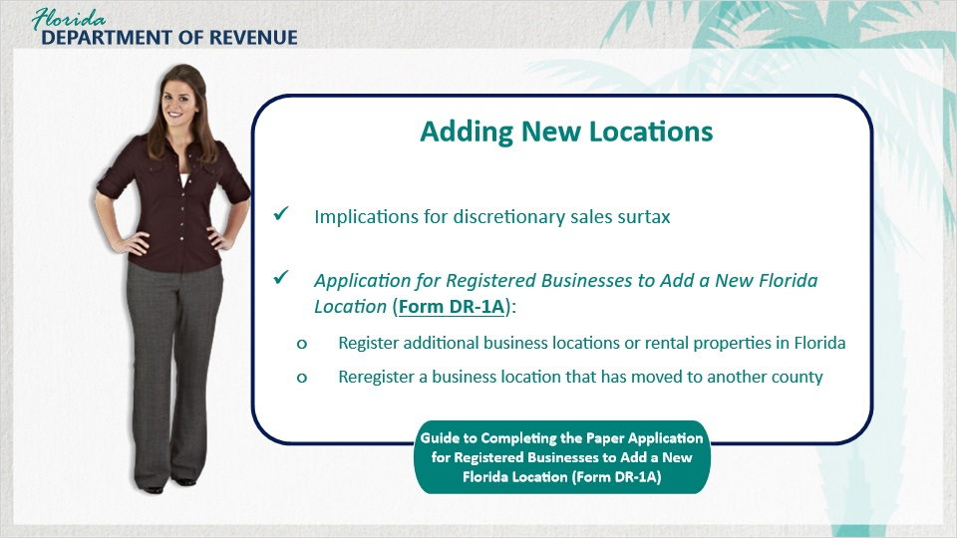
Transcript:
Meredith, you said you were interested in expanding your business by opening additional locations, right? If these locations will be in other counties, there will be implications for collecting discretionary sales surtax. You will need to find out the rates for the counties of each of your new locations.

If you’ve previously submitted a Florida Business Tax Application (Form DR-1) and have an active Certificate of Registration or reemployment tax account issued by the Department, you can use an online or paper Application for Registered Businesses to Add a New Florida Location (Form DR-1A) to: Register additional business locations or rental properties in Florida; Reregister a business location that has moved to another county.

You can view the Department’s tutorial on how to complete the paper version of this application here.

2.7 Closing or Selling Your Business
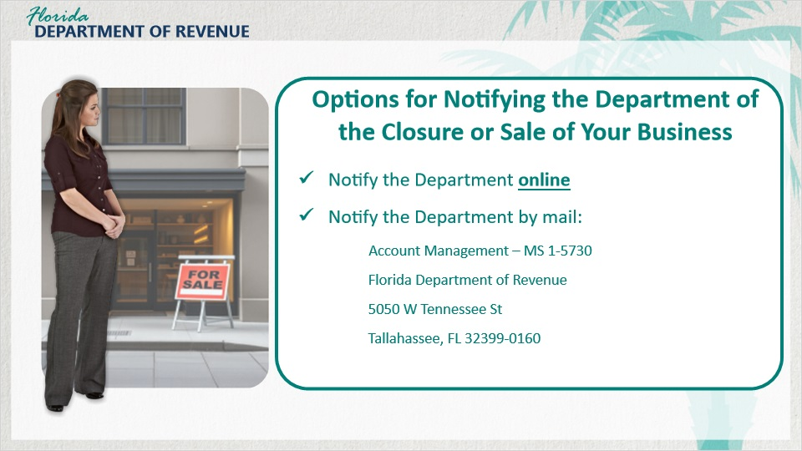
Transcript:
If for some reason, you were to sell or close your business, you would need to contact the Department. You can do so online or by mail.

Keep in mind that if you close your business, you are still going to owe a final return. You are required to file and pay your final return.

2.8 Filing for Multiple Locations
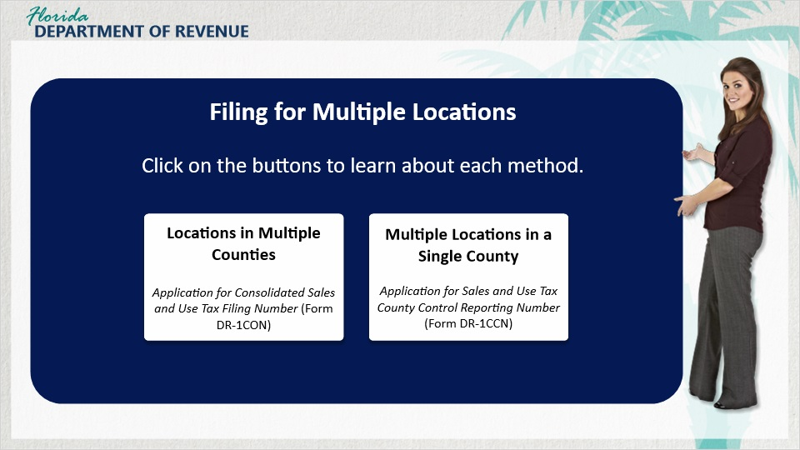
Transcript:
[Meredith]: I know I won’t need to worry about this for a while, but how would I manage filing and paying returns with multiple locations?

If you have multiple locations, it may be easier to file all of your returns under one certificate number, instead of filing multiple returns for multiple locations.

There are two methods for doing so depending on the circumstances.

If a business owner has locations in multiple counties, they can elect to file a consolidated return by completing the Application for Consolidated Sales and Use Tax Filing Number (Form DR-1CON).

Once they have completed the Form DR-1CON, they will be required to complete a tax return for each location (Form DR-7), as well as the Consolidated Summary Sales and Use Tax Return (Form DR-15CON) which summarizes the returns for each DR-7 submitted. Consolidated returns are required to file and pay electronically. When filing electronically, the totals for each DR-7 will be pre-populated in the DR-15CON summary tax return.

All locations are linked to a consolidated account number.

All locations must be owned by the same entity with the same Federal Employer Identification Number (FEIN).

If a business owner has multiple locations in a single county, they can elect to file a County Control Return by completing the Application for Sales and Use Tax County Control Reporting Number (Form DR-1CCN). This will allow them to file a single return, using a Sales and Use Tax Return (Form DR-15) with the total taxable sales and tax due for all locations within that county.

All other locations in that same county are made active but are not required to file separately.

All business locations must be owned by the same entity with the same Federal Employer Identification Number (FEIN).

2.9 Making More Sales
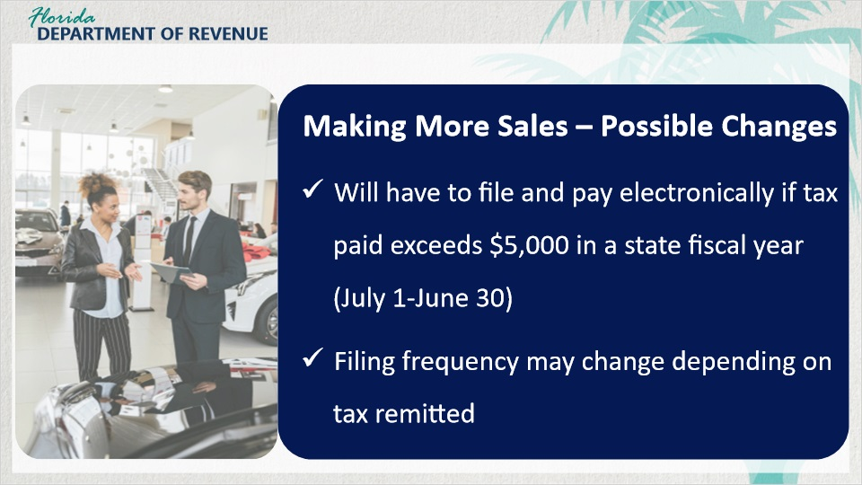
Transcript:
[Meredith]: While I do want my business to be successful, I’m sure it comes with more responsibilities. What are some things I need to be aware of?

I’m sure your business will be successful, Meredith.

That being said, with newfound success comes new tax implications for your business.

[Meredith]: Like what?

For example, effective January 1, 2023, taxpayers must file and pay electronically if the amount of tax paid during the prior state fiscal year (July 1-June 30) exceeds $5,000.

Your filing frequency may also change when you start making more taxable sales. Most business accounts are set up with a quarterly filing frequency. During the annual review of tax accounts, those accounts that remitted $1,000 or more in sales and use tax will be switched to a monthly filing frequency.

2.10 Estimated Sales Tax
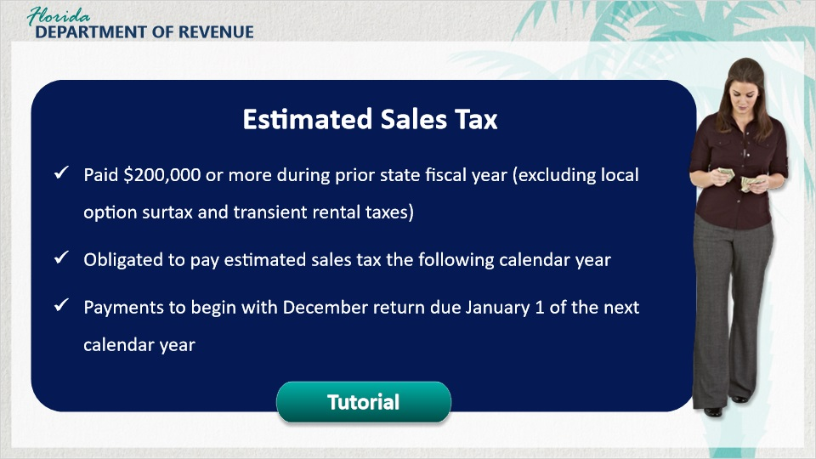
Transcript:
Another implication of making more taxable sales is the possibility of having to make estimated tax payments.

Business owners who paid sales and use tax of $200,000 or more, excluding local option surtax and transient rental taxes, from July 1 through June 30 of the prior state fiscal year must make estimated sales tax payments during the next calendar year.

For a more detailed explanation of estimated sales tax, visit the Department’s tutorial How to Calculate and Pay Estimated Sales and Use Tax.

2.11 Scenario #1
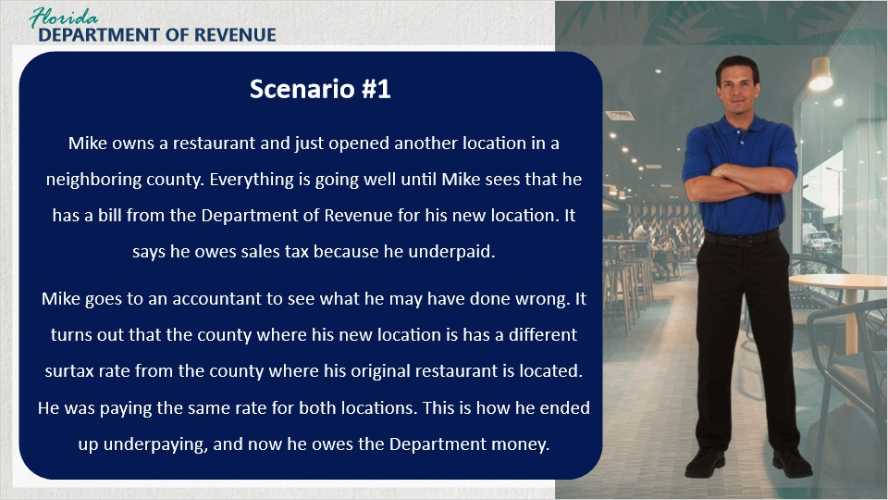
Transcript:
Let’s look at Mike’s situation.
Mike owns a restaurant and just opened another location in a neighboring county. Everything is going well until Mike sees that he has a bill from the Department of Revenue for his new location. It says he owes sales tax because he underpaid.
Mike goes to an accountant to see what he may have done wrong. It turns out that the county where his new location is has a different surtax rate from the county where his original restaurant is located. He was paying the same rate for both locations. This is how he ended up underpaying, and now he owes the Department money.

2.12 Knowledge Check #2
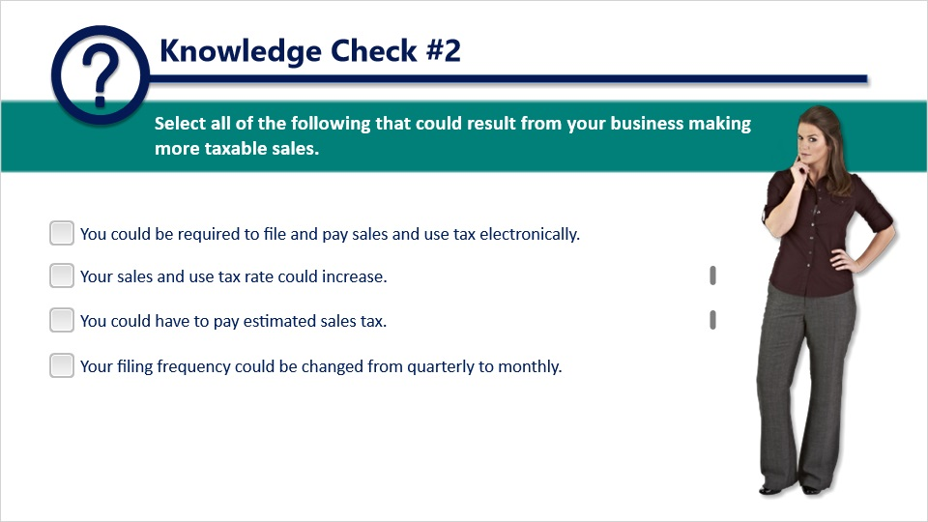
Question: Select all of the following that could result from your business making more taxable sales.
Answer choices: You could be required to file and pay sales and use tax electronically. Your sales and use tax rate could increase. You could have to pay estimated sales tax. Your filing frequency could be changed from quarterly to monthly.
Correct answers: You could be required to file and pay sales and use tax electronically, You could have to pay estimated sales tax, and Your filing frequency could be changed from quarterly to monthly. Your sales and use tax rate will not increase.

3. Conclusion and Survey

3.1 Summary
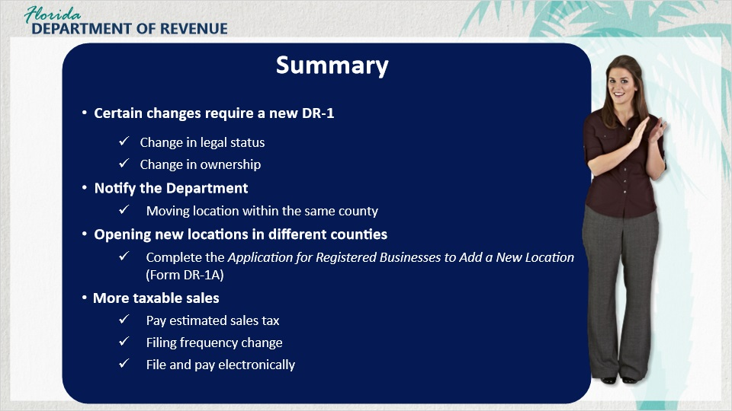
Transcript:
[Meredith]: This is a lot of information. Let me do a recap to make sure I’ve got it.

Go for it, Meredith.

[Meredith]: First, we talked about how changes to the business such as a change in legal status or change in ownership require you to complete a new DR-1. Other changes like moving your location within the same county simply require you to notify the Department online or by mail.

If you are opening new locations in other counties, you are required to complete the Application for Registered Businesses to Add a New Location (Form DR-1A).

If you are opening multiple locations in other counties, you have the option of obtaining a consolidated filing number for filing your returns.

We also discussed how making more taxable sales and collecting more tax may have implications for filing and paying returns.

If taxable sales increase, you may have to start paying estimated sales tax. You may also have to file and remit tax more frequently. You will also be required to file and pay electronically if tax paid for the prior state fiscal year exceeds $5,000.

3.2 Tax Page and Social Media
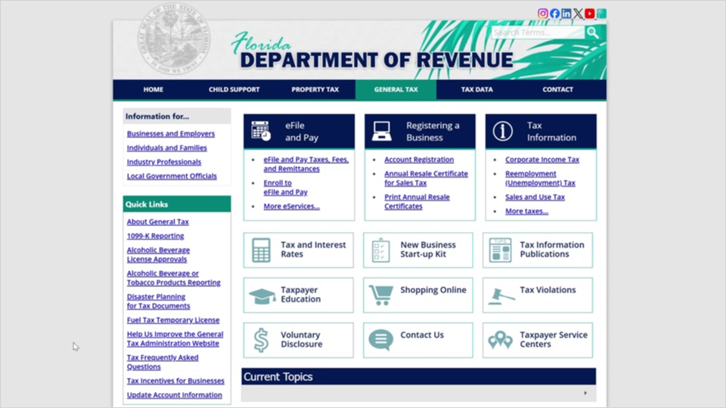
Transcript:
Visit Florida’s General Tax Administration website for business resources such as forms, publications, and information on all tax types.

Check out our Taxpayer Education webpage for new business guides, tutorials, and other helpful tools.

And follow us on YouTube, X, Instagram, Facebook, and LinkedIn using the icons at the top of our website to stay up to date on tax topics, alerts, and more.

3.3 Survey
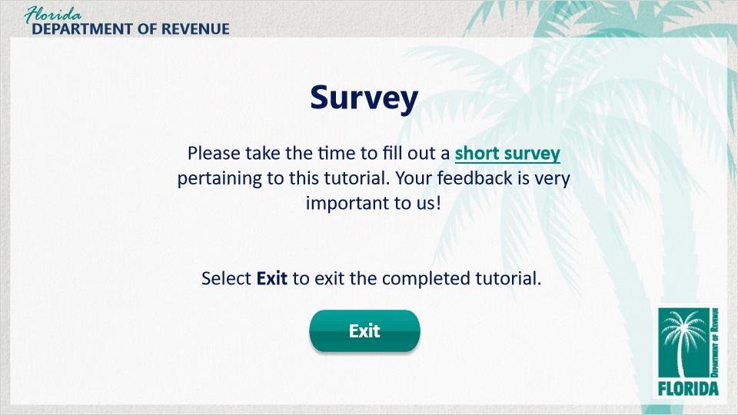
Transcript:
This concludes An Overview of Sales and Use Tax for Business Owners: Changes in the Business.

In addition, there are several helpful guides and tutorials available on a variety of tax-related topics on the Department’s website.

Please take the time to fill out a brief survey pertaining to this tutorial. Your feedback is very important to us.

Thank you.

