An Overview of Sales and Use Tax for Business Owners – Part 5

1. Introduction

1.1 Welcome
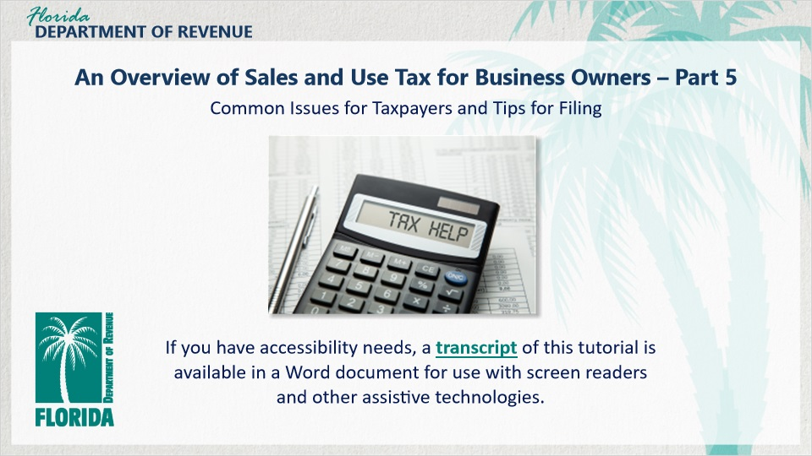
Transcript:
Welcome to An Overview of Sales and Use Tax for Business Owners: Common Issues for Taxpayers and Tips for Filing.

In this tutorial, we discuss common issues many taxpayers have collecting, filing, and paying sales and use tax. We also provide tips for successfully filing your return.

1.2 Navigating This Tutorial
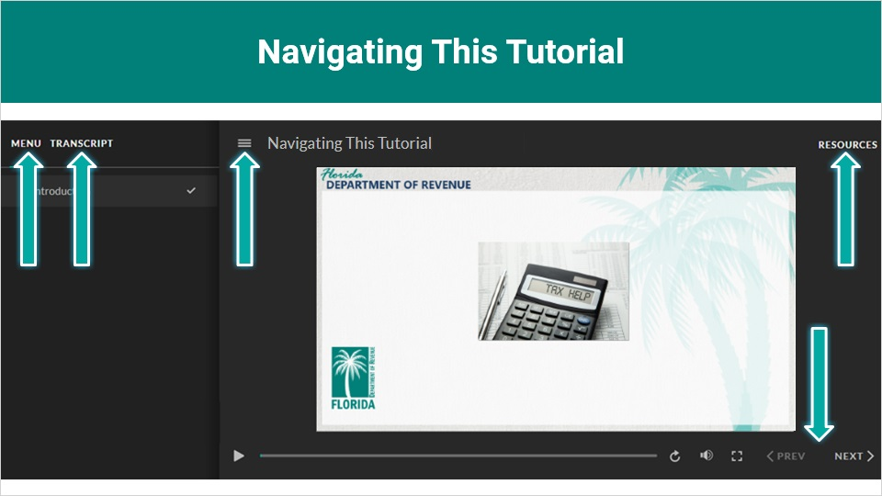
Transcript:
This tutorial will take approximately 15 minutes to complete. A transcript of the audio is available by clicking on the transcript tab in the top-left corner of your screen.
The following tabs and buttons are available to help you navigate throughout this overview.
Menu Tab
The menu tab displays by default when the overview is viewed on a computer. It allows you to navigate through the overview by clicking on the topic name on the menu. When viewing this overview on a tablet or smartphone, the menu does not display by default and must be accessed using the menu symbol.
Resources Tab
The resources tab is found on the right side of the top bar. When clicked, it displays the list of links to useful forms, documents, and webpages.
Previous and Next Buttons
The previous and next buttons are located at the bottom-right corner of your screen. These buttons allow you to move either back or forward.

1.3 Topics
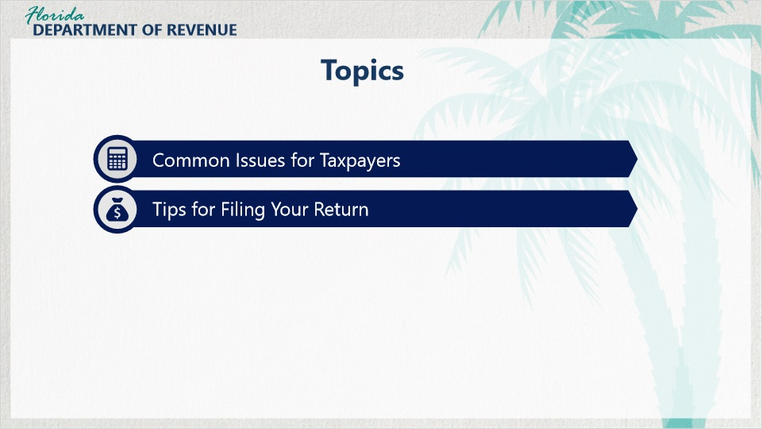
Transcript:
Topics for this tutorial include common issues for taxpayers and tips for filing your return.

1.4 Review of Part 4
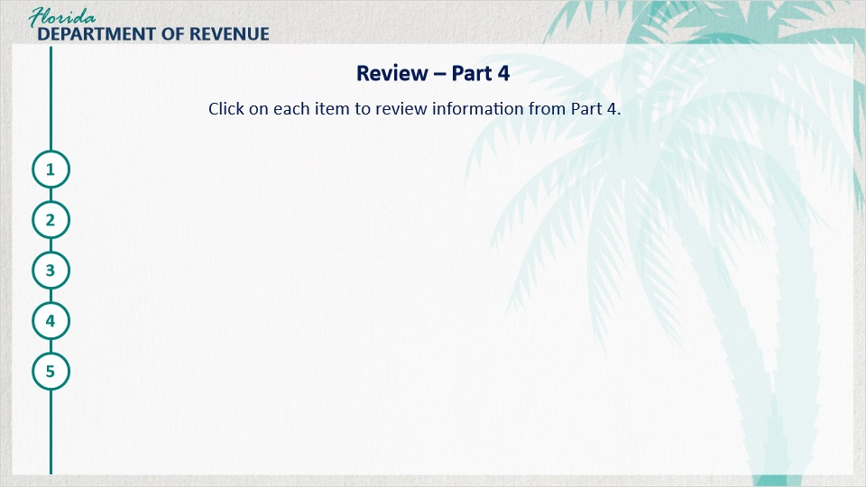
Transcript:
Here is a quick review of the information from Part 4.

Changes to Legal Status
If you change the legal status of your business to a new type of legal entity such as a corporation or partnership, you are required to complete a new Florida Business Tax Application (Form DR-1).

Moving to a New Location (same county)
A move to a new location within the same county requires the taxpayer to contact the Department either online or by mail.

Moving to a New Location (different county)
If you move your location to a different county, you will need to complete a new Florida Business Tax Application (Form DR-1).

Opening Additional Locations in Florida
If you are opening additional locations in Florida, you will need to complete the Application for Registered Businesses to Add a New Florida Location (Form DR-1A).

Changes in Amount of Tax Collected
If you paid more than $200,000 in sales tax (minus discretionary sales surtax and transient rental tax), you will have to pay estimated tax.
Your filing frequency may change.
If you paid $5,000 or more in sales tax during the previous year, you will be required to file and pay electronically.

2. Changes in Your Business

2.1 Hi Everyone

Transcript:
[Meredith]: Hi everyone! It’s good to be back. So, what are we learning about today?

Hello Meredith. This tutorial is going to be a bit different. We’re going to meet some of the other business owners in your building.

[Meredith]: That should be fun. They are really great people.

They will help us explore common issues that business owners have when filing and remitting sales and use tax.

[Meredith]: OK. Sounds interesting.

Well then, let’s get started.

2.2 Common Issue #1
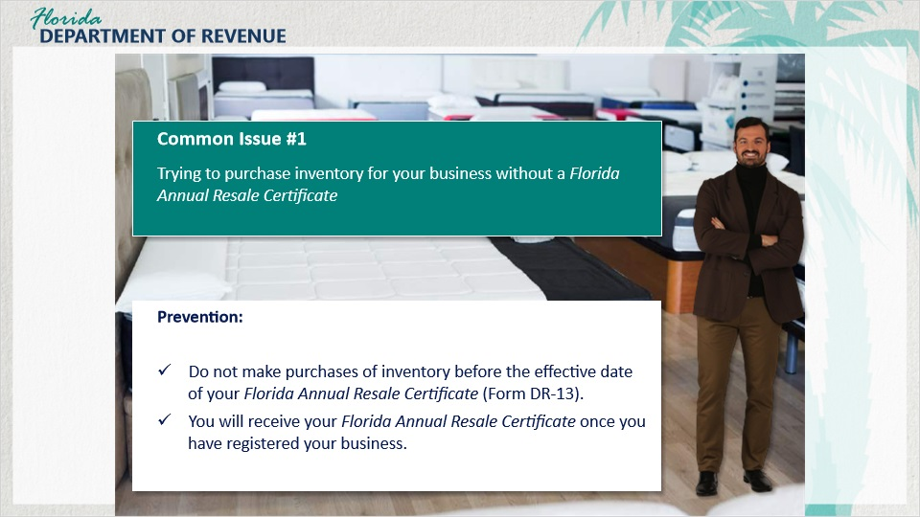
Transcript:
Manny has opened a mattress store called Manny’s Mattress Center. Before he registered with the Department, he purchased several mattresses and bed frames from a distributor. Since he was not registered and did not have a valid resale certificate at the time of purchase, he was charged and paid sales tax.

Manny did not realize he had the option to buy items tax-exempt until it was too late. This cost him a few thousand dollars, which he did not budget for.

To prevent this situation from happening to you, be sure to register with the Department and do not make purchases of inventory before the effective date of your Florida Annual Resale Certificate (Form DR-13).

You will receive your Annual Resale Certificate once you have registered your business by completing the Florida Business Tax Application (Form DR-1).

2.3 Common Issue #2
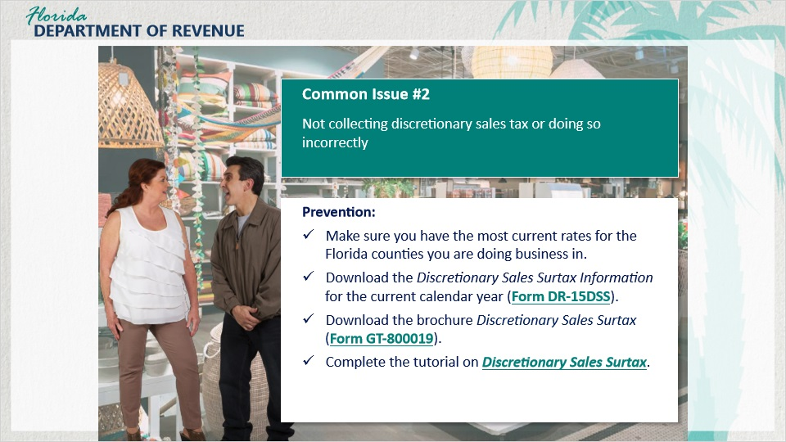
Transcript:
Jerry and his wife, Linda, own a home décor store called Taste of Home. They received a bill from the Department indicating they owed additional tax.

A discretionary sales surtax rate increase became effective on January 1 in his county. It turns out Jerry had collected and remitted discretionary sales surtax of 1% instead of 1.5%, the new rate for his county. They now owe the difference to the Department, along with penalty and interest on the additional tax due.

To prevent this mistake, make sure you have the most current discretionary sales surtax rates. Discretionary Sales Surtax Information (Form DR-15DSS) contains the discretionary sales surtax rates by county and is published for each calendar year.

For more information about discretionary sales surtax, see the brochure Discretionary Sales Surtax (Form GT-800019).

You may also want to check out the Department’s tutorial on Discretionary Sales Surtax.

2.4 Common Issue #3
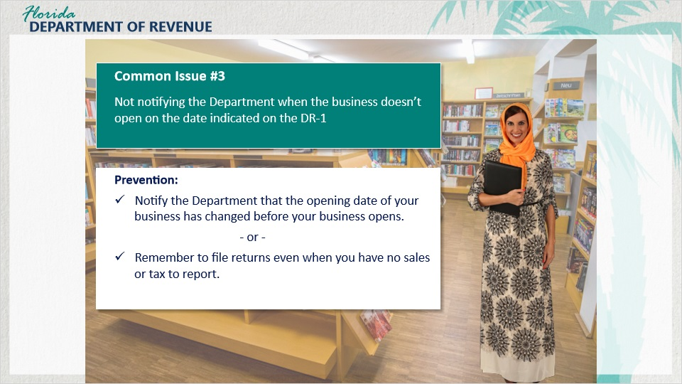
Transcript:
Lisa opened her bookstore, Lisa’s Library, which sells new and vintage books. When she registered her business, she indicated she would open in January; however, she was unable to open until February.

Lisa didn’t notify the Department of the change and received a delinquency notice. As a result, Lisa is obligated to file returns based on the opening date she provided on the DR-1 and will receive delinquency notices if she doesn’t file zero returns.

To avoid this problem, notify the Department that the opening date of your business has changed before your business opens or remember to file returns even when you have no sales or tax to report. This will save you the effort of resolving delinquency notices.

2.5 Common Issue #4
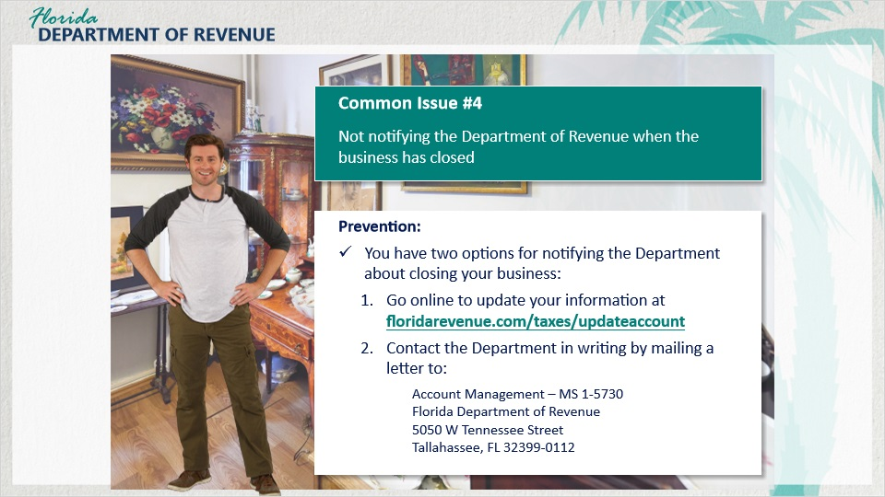
Transcript:
Ken recently closed his store, Ken’s Collectibles. Since he was no longer making sales, he didn’t have taxes to remit, so he didn’t file. Ken also neglected to notify the Department of his business closure.

Later, he received a delinquency notice because he didn’t file.

If you close your business, you must notify the Department. Until you do, you are obligated to file returns, even if they are zero returns. Remember, you must also file and pay your final return for your business.

Notifying the Department is easy. You can notify the Department online by visiting our website.

You may also notify the Department in writing by mailing a letter to:
Account Management – MS 1-5730
Florida Department of Revenue
5050 W Tennessee Street
Tallahassee, FL 32399-0112

2.6 Common Issue #5
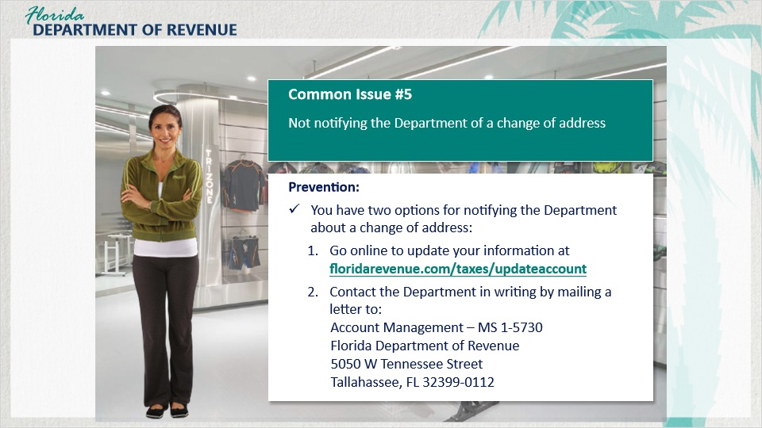
Transcript:
Kayla recently moved her sporting goods store, Sports World, into the building, which is within the same county as her old location. In the chaos of the move, she forgot to notify the Department of her new business location, which is also her new mailing address.

As a result, she did not receive important notices from the Department, one of them having to do with a delinquency on her account that cost her money. Additionally, Kayla’s Certificate of Registration (Form DR-11) and Annual Resale Certificate (Form DR-13) do not reflect her current address.

It is important to notify the Department of address changes. Notifying the Department about your move within the same county can be done by visiting our website.

You also have the option to write a letter to the Department to inform them of the change. Send the letter to:
Account Management – MS 1-5730
Florida Department of Revenue
5050 W Tennessee Street
Tallahassee, FL 32399-0112

2.7 Common Issue #6
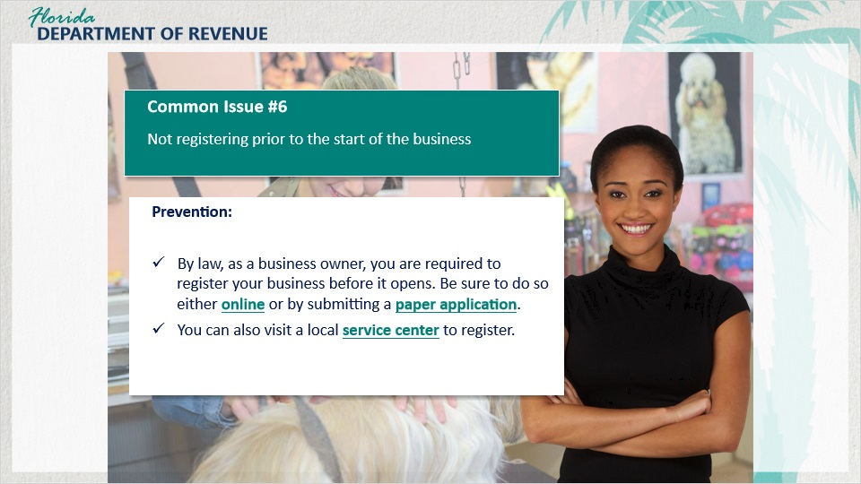
Transcript:
Laney opened Laney’s Pampered Pets last month. Her store offers dog-grooming services and sells shampoos and other products for dogs.

Laney neglected to register her business before it opened. This meant she didn’t receive an Annual Resale Certificate and couldn’t buy items in her store tax-exempt.

Because she was late registering, she was also delinquent in filing her sales and use tax return and owes penalties and interest.

By law, as a business owner, you are required to register your business before it opens. To avoid any problems, be sure to do so either online or by submitting a paper application. You can also visit a Service Center to register.

2.8 Common Issue #7
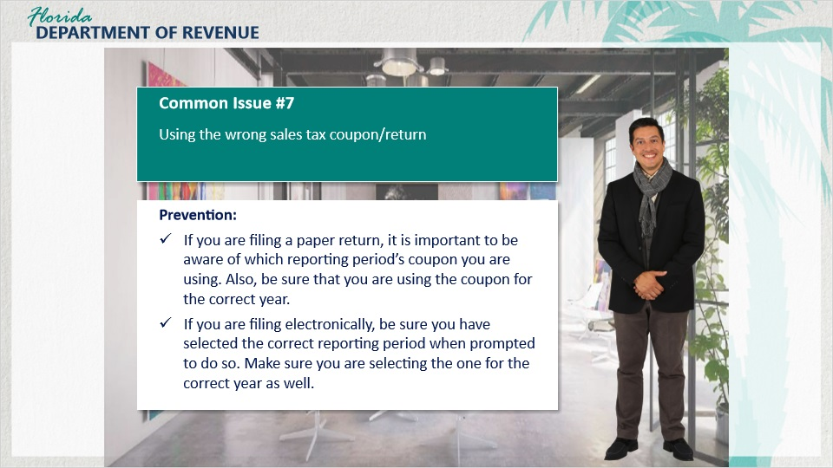
Transcript:
George owns Artistic Creations, an art store and gallery. He sells both his art and the work of other local artists. For the month of March, George filed his monthly return on time.

When he went to file the April return, he realized that the coupon to file was missing. After looking through his records, George realized his mistake. He previously used the April coupon to submit the March return.

When April rolled around, he received a delinquency notice from the Department for the month of March.

As a result, George had to contact the Department and have the return transferred to the correct period.

If you are filing a paper return, it is important to be aware of which reporting period’s coupon you are using. Also, be sure that you are using the coupon for the correct year.

If you are filing electronically, be sure you have selected the correct reporting period when prompted to do so. Make sure you are selecting the correct year as well.

2.9 Common Issue #8
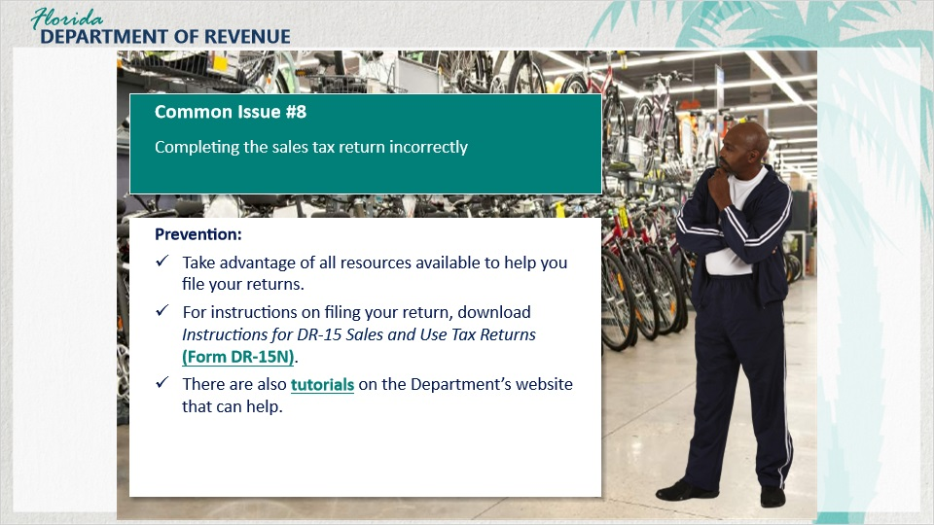
Transcript:
Larry has a store selling bicycles, Larry’s Bikes, which is located in a county with a combined 7.5% sales tax rate. Larry has submitted his returns on time since he started his business but is unsure if he has done so correctly. He hired a bookkeeper to look over his records, and sure enough, he had made several mistakes. Larry didn’t realize the discretionary sales surtax information had to be completed and didn’t fill out the sales tax return correctly.

He later received a bill from the Department showing additional tax due. Larry realized that he shipped an order to a different county, so only 6.5% sales tax was collected, and he didn’t complete Line 15c of the DR-15 to report a sale at a different rate than his county. Larry had to file an amended return in order to resolve the bill that was received.

To ensure that you complete your sales tax return correctly, be sure to take advantage of all the resources available to help you file your returns.

For instructions on filing your return, download Instructions for DR-15 Sales and Use Tax Returns (Form DR-15N).

There are also tutorials on the Department’s website that can walk you through the filing process.

2.10 Recap
Transcript:
[Meredith]: Learning about the issues the other tenants had was helpful. I now know how to avoid some of the same mistakes they made.

That’s good. And remember, you are human. If you collect and remit tax in good faith and you make a mistake, there is usually a way to correct the mistake without too much trouble.

[Meredith]: That’s good to know. What’s next?

In the next section of the tutorial, we will discuss some tips for filing your return.

3. Tips for Filing Your Return

3.1 Helpful Tips
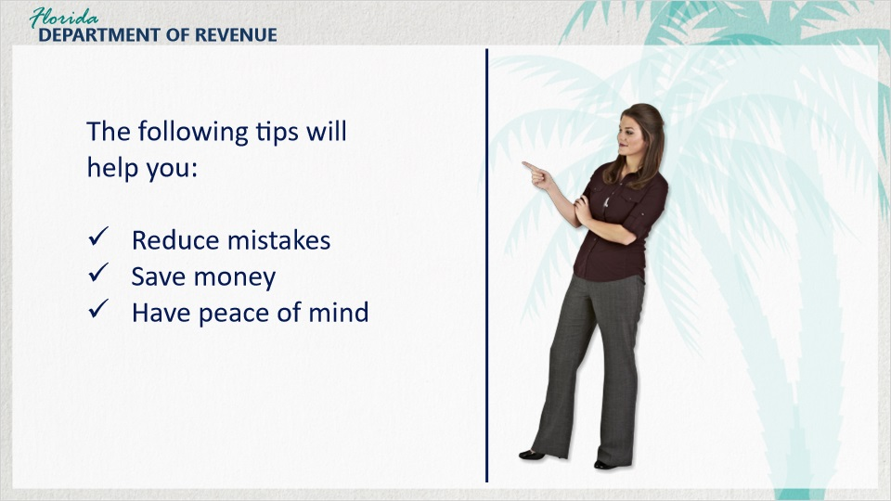
Transcript:
The following tips for filing your returns will help reduce mistakes and ultimately save you money in fees, penalties, and interest.

Most important of all, following these helpful tips will give you peace of mind that you are successfully fulfilling your obligations to the Department.

3.2 Filing and Paying On Time
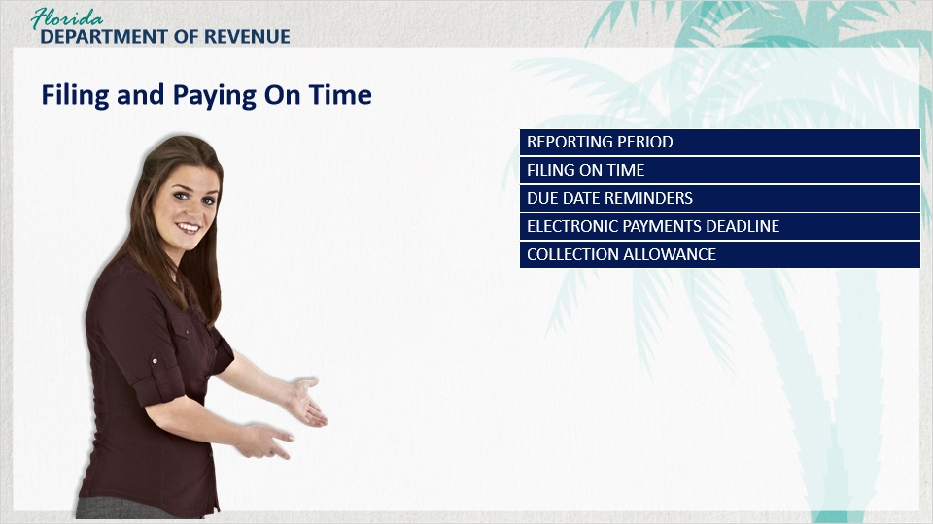
Transcript:
Below are tips for filing your return.

Reporting Period
Report and pay all taxes collected or due during the reporting period.

Filing on Time
File on time for each reporting period, even if no tax is due. Do not skip reporting periods or add a partial reporting period to the next return.

Due Date Reminders
You can sign up to receive a due date reminder email for each reporting period at floridarevenue.com/dor/subscribe.

Electronic Payments Deadline
If you remit tax payments electronically, you must initiate electronic payments and receive a confirmation number no later than 5 p.m. ET on the business day before the 20th day of the month.

Collection Allowance
When you electronically file and pay on time, you may take a collection allowance. Be sure to calculate it correctly.

The collection allowance is 2.5% of the first $1,200 of tax due, not to exceed $30 for each reporting location.

If you have less than $1,200 in tax due, your collection allowance will be less than $30.

3.3 Filing and Paying Correctly
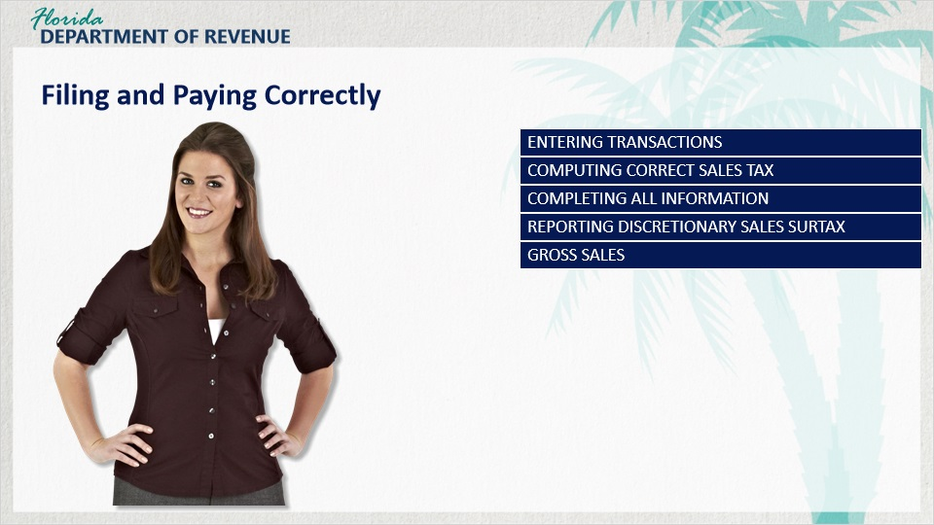
Transcript:
Below are more tips for filing your return.

Entering Transactions
Sales reported on Lines A through E of the Sales and Use Tax Return (Form DR-15) may have different tax rates. Enter your transactions on the correct lines so no additional tax is due.

Computing Correct Sales Tax
Compute the correct sales tax, including discretionary sales surtax, if any. Use the rounding algorithm to determine the correct tax amount.

Completing All Information
Complete all information on your return, including the front and back of the paper return. Be sure to include your signature and your preparer’s signature, if applicable.

Reporting Discretionary Sales Surtax
You must complete the back of the paper return even if you have not collected any discretionary sales surtax.

Complete Line 15b, Not Subject to Surtax, if you are registered in a county with a discretionary sales surtax rate but make a sale in a county without a surtax rate.

Gross Sales
Do not include tax collected in gross sales. If you include the tax collected in gross sales, it will increase the amount of tax due, and you will receive a bill for additional tax due.

4. Conclusion

4.1 Summary
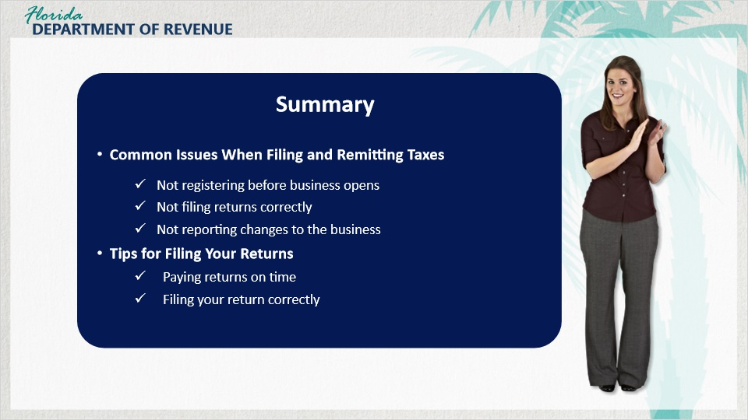
Transcript:
Well, Meredith, this is the very last tutorial for this series. Do you think you could give one final summary?

[Meredith]: I would be happy to.

For the first part of this tutorial, we discussed common issues business owners have when filing and remitting sales and use tax. Some of these issues include not registering before opening the business, not filing returns correctly, and not reporting changes to the business such as a move within the same county or closing or selling the business.

In the second part, we provided tips for filing your returns. The first set of tips covered paying on time. For example, taking advantage of due date reminders will be very helpful. The second set covered filing your return correctly. For instance, it is important to enter the correct amounts on the correct lines of the return. It is also important to calculate what is owed correctly.

4.2 Tax Page and Social Media
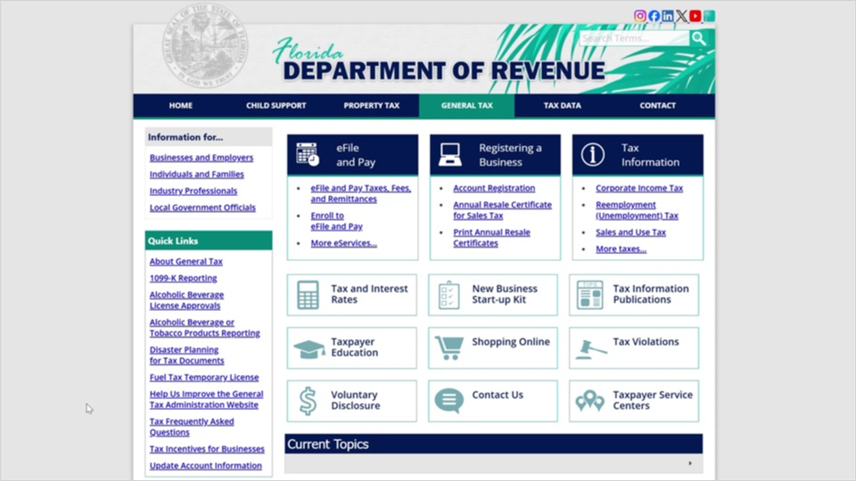
Transcript:
Visit the Florida’s General Tax Administration website for business resources such as forms, publications, and information on all tax types.

Check out our Taxpayer Education webpage for new business guides, tutorials, and other helpful tools.

And follow us on YouTube, X, Instagram, and LinkedIn using the icons at the top of our website to stay up to date on tax topics, alerts, and more.

4.3 Survey
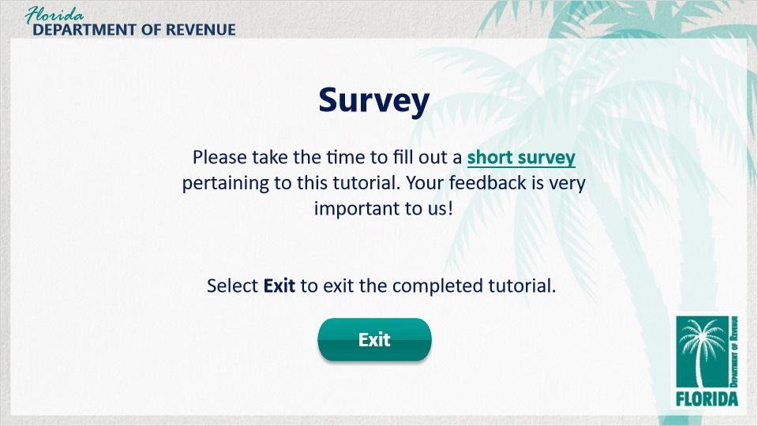
Transcript:
This concludes An Overview of Sales and Use Tax for Business Owners: Filing Returns.

There are several helpful guides and tutorials available on a variety of tax-related topics on the Department’s website.

Please take the time to fill out a brief survey pertaining to this tutorial. Your feedback is very important to us.

Thank you.

