Voluntary Disclosure

1. Introduction

1.1 Voluntary Disclosure
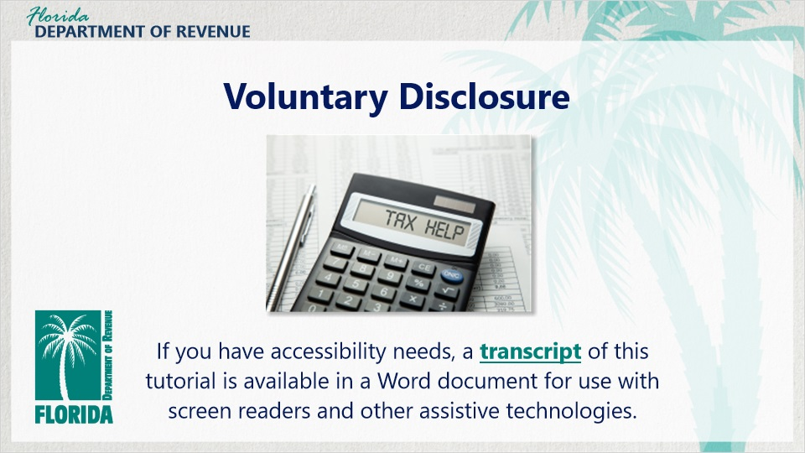
Transcript:
Welcome and thank you for joining us for the Florida Department of Revenue’s Voluntary Disclosure Program tutorial.
If you have accessibility needs, a transcript of this tutorial is available in a Word document for use with screen readers and other assistive technologies.

1.2 Navigating This Tutorial
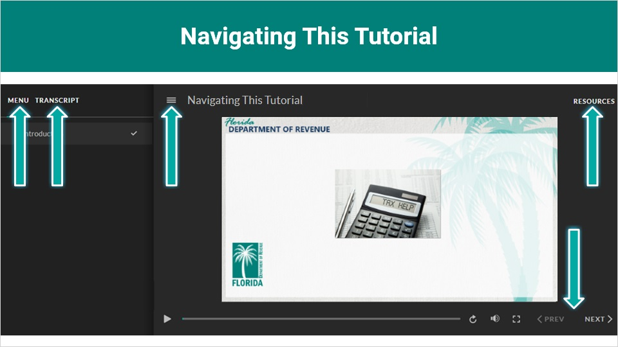
Transcript:
This overview will take approximately 20 minutes to complete. A transcript of the audio is available by clicking on the transcript tab in the top-left corner of your screen.
The following tabs and buttons are available to help you navigate throughout this overview.

Menu Tab

The menu tab displays by default when the overview is viewed on a computer. It allows you to navigate through the overview by clicking on the topic name on the menu. When viewing this overview on a tablet or smartphone, the menu does not display by default and must be accessed using the menu symbol.

Resources Tab

The resources tab is found on the right side of the top bar. When clicked, it displays the list of links to useful forms, documents, and webpages.
Previous and Next Buttons
The previous and next buttons are located at the bottom-right corner of your screen. These buttons allow you to move either back or forward.

1.3 General Tax Administration
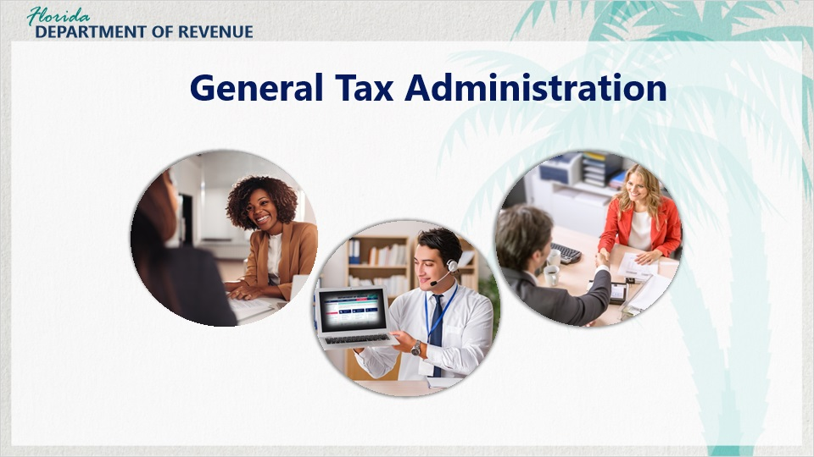
Transcript:
The Department of Revenue is dedicated to professional and efficient tax administration promoting the highest level of voluntary compliance, enhanced customer service, and fair and effective enforcement of Florida tax laws.

The goal of the Department is to ensure that all taxpayers doing business in Florida are registered, collecting, and paying the taxes they are obligated to pay.

1.4 Topics Covered
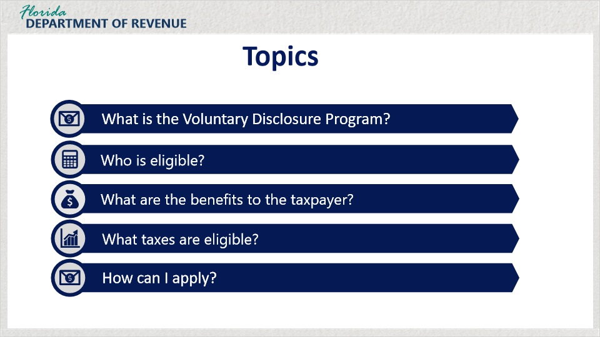
Transcript:
The topics covered will be:
what is Florida’s Voluntary Disclosure Program, who is eligible for the program, what are the benefits of the program for a taxpayer or a business, what taxes are eligible, and how can I apply.

2. Voluntary Disclosure

2.1 Voluntary Disclosure
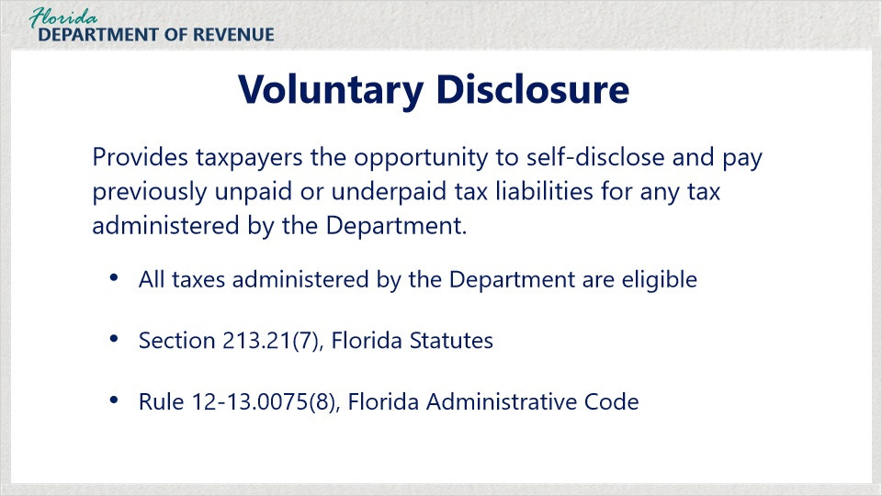
Transcript:
In an effort to make it easier for taxpayers to comply, the Voluntary Disclosure Program provides taxpayers the opportunity to self-disclose and pay previously unpaid tax liabilities for any tax administered by the Department, including (but not limited to):
Sales and Use tax, Corporate Income tax, Documentary Stamp tax, Communications Services Tax, Reemployment Tax, and Fuel Taxes.

In most cases, penalties are waived.

This program is authorized by Section 213.21(7), Florida Statutes, and Rule 12-13.0075(8), Florida Administrative Code.

The voluntary disclosure program offers a one-stop service. Our specialists will work to make sure that all of a business’s filing and payment requirements have been fulfilled. Taxpayers emerge from the program with a clean conscience and on the right track.

3. Who is Eligible

3.1 Who is Eligible
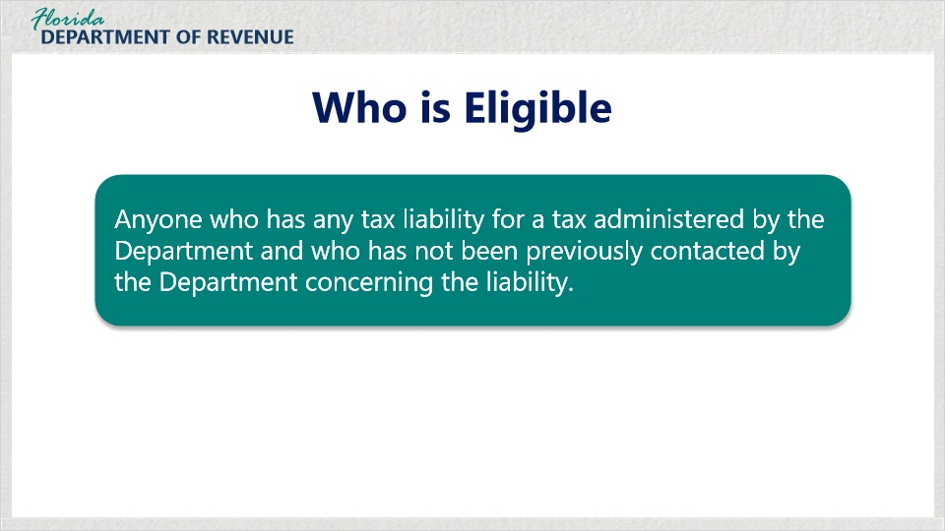
Transcript:
Who is eligible to participate in Florida’s Voluntary Disclosure Program?

Anyone who has any tax liability for a tax administered by the Department and who has not been previously contacted by the Department concerning the liability.

For example, let’s say your business just received a notice from the Department of its intent to audit for sales and use tax.
Since the Department has just contacted you about an upcoming audit, you would not be eligible to disclose a sales and use tax liability that you know will be uncovered during the audit period.

3.2 Who is Not Eligible
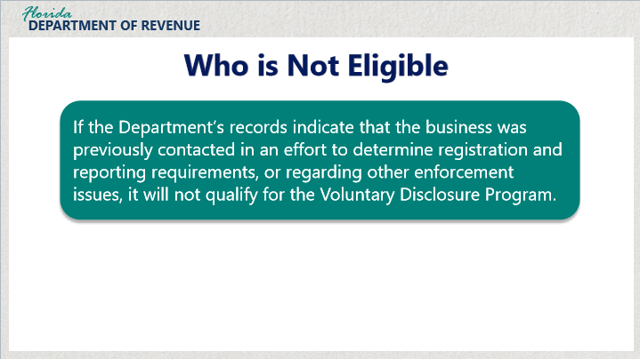
Transcript:
If the Department’s records indicate that the business was previously contacted in an effort to determine registration and reporting requirements, or regarding other enforcement issues, it will not qualify for the Voluntary Disclosure Program.

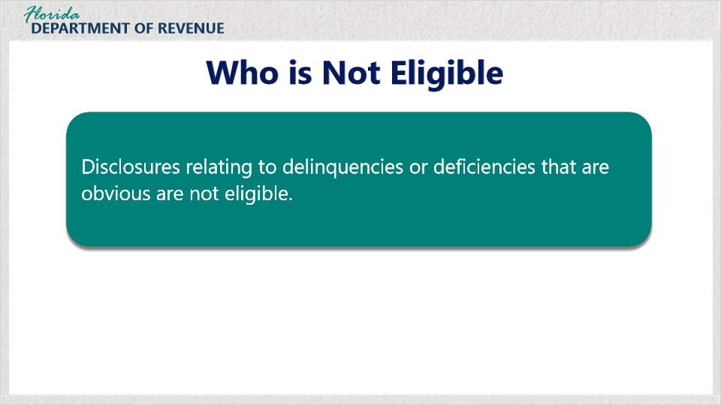
Transcript:

Disclosures relating to delinquencies or deficiencies that are obvious and would routinely generate a billing if not otherwise self-disclosed are not eligible for the program.

For example, if my business is registered with the Department and I just forgot to file and pay my Sales and Use tax return, I would receive a delinquency notice because my failure to file and pay would automatically generate a delinquency notice. I could not file the late return under the Voluntary Disclosure Program.

3.3 Examples
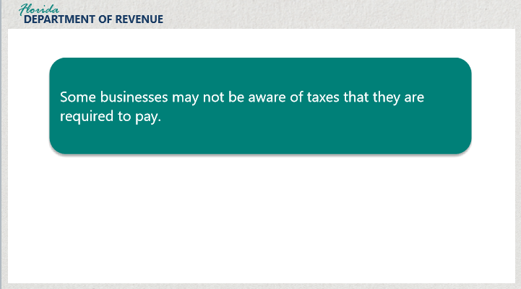
Transcript:
Some businesses may not be aware of taxes they are required to pay. Delinquency or deficiency in paying these taxes may make a business eligible to participate in the Voluntary Disclosure Program.


Transcript:
For example, you may owe state taxes if you are a contractor who has brought materials into the state,
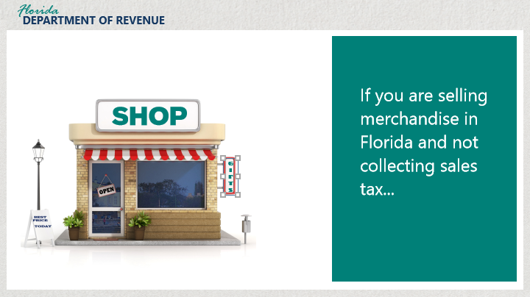
Transcript:
If you’re selling merchandise in Florida and not collecting sales tax or collecting the tax and not remitting,
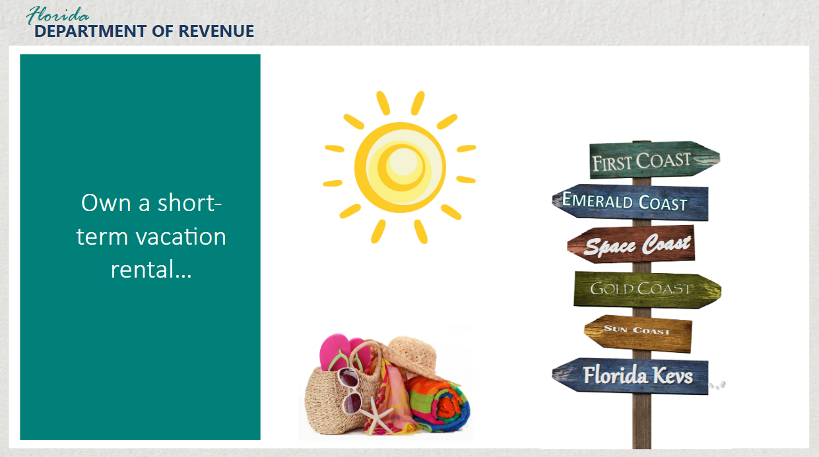
Transcript:
Or on a short-term vacation rental and find out that you should have been collecting tax.
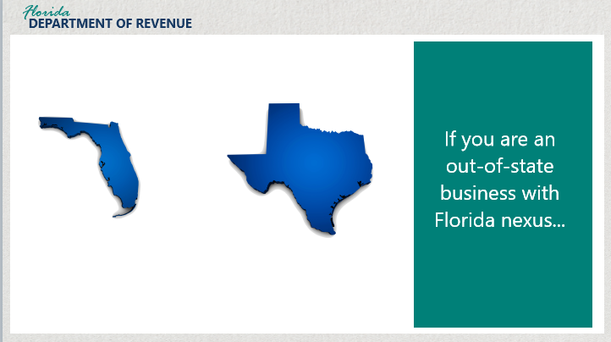
Transcript:
Also, if you’re an out of state business with Florida nexus.

3.4 Florida Nexus
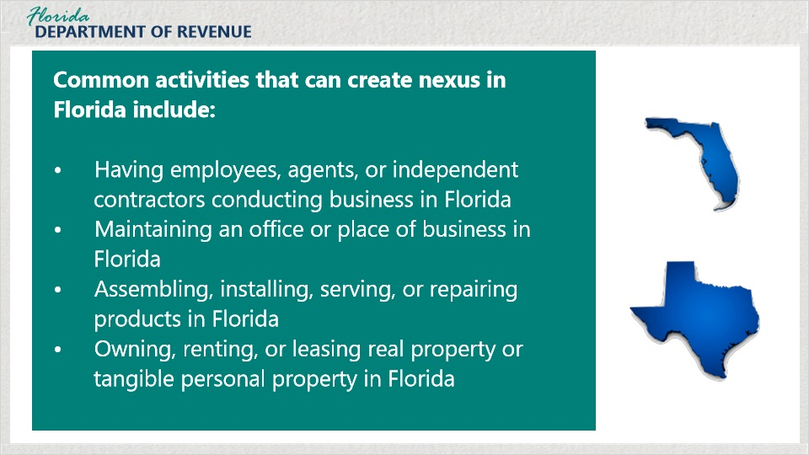
Transcript:
Some common activities that create a business connection (also called nexus) in Florida include, but are not limited to: having employees, agents, or independent contractors conducting sales or other business activities in Florida, maintaining an office or other place of business in Florida, assembling, installing, servicing, or repairing products in Florida, owning, renting, or leasing real property or tangible personal property in Florida.
If you think you have any unpaid or underpaid tax liabilities and the Department has not already contacted you about these liabilities, you may pay them through our Voluntary Disclosure Program.

4. Look-Back Period

4.1 Look-Back Period
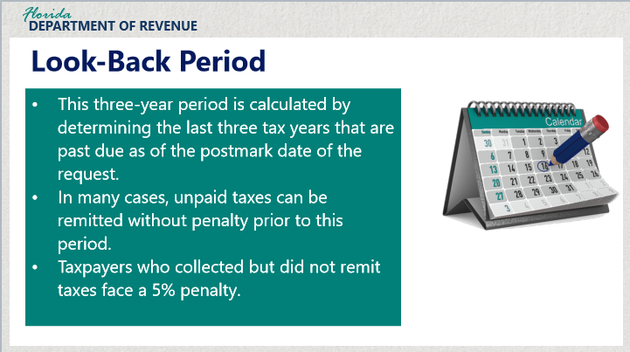
Transcript:
In addition to the penalty waiver, other benefits include a three-year look-back period.

The three-year look-back period is calculated by determining the last three tax years that are past due as of the postmark date of the request.

Many people ask…. So, with the three-year look-back, is anything prior to that period forgiven?

In the majority of cases, yes. An exception is for taxes that were collected but not remitted to Florida. In those instances, we encourage taxpayers to disclose additional years in which tax was collected and not remitted.

In those instances, a 5% penalty will be imposed, unless reasonable cause is provided.

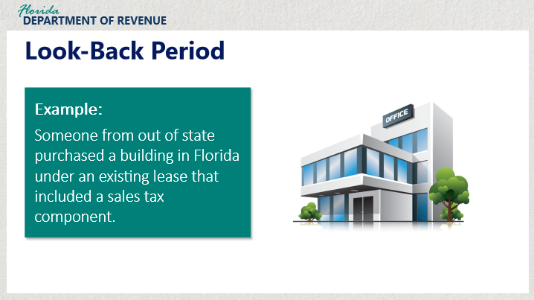

Transcript:
For example, four years ago, someone from out of state purchased a building in Florida under an existing lease that included a sales tax component.
They found out well after the fact about their sales-tax liability exposure. They were unaware of the sales tax included in the monthly rental payments.

This is one of those instances in which the look-back period would begin when the landlord started receiving the rental payments that included the sales tax.

We encourage taxpayers to disclose additional years in cases where tax was collected and not remitted.

5. Particular Matter Disclosures

5.1 Particular Matter
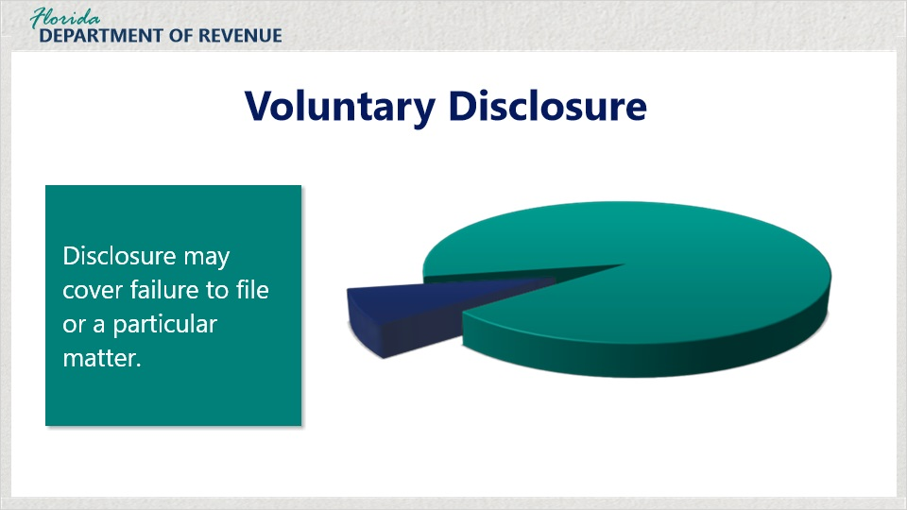
Transcript:
The taxpayer’s disclosure may cover failure to file or a particular matter.

As mentioned earlier, if you are registered and have found that you have unpaid or underpaid tax liabilities, we can help.

5.2 Example - Particular Matter
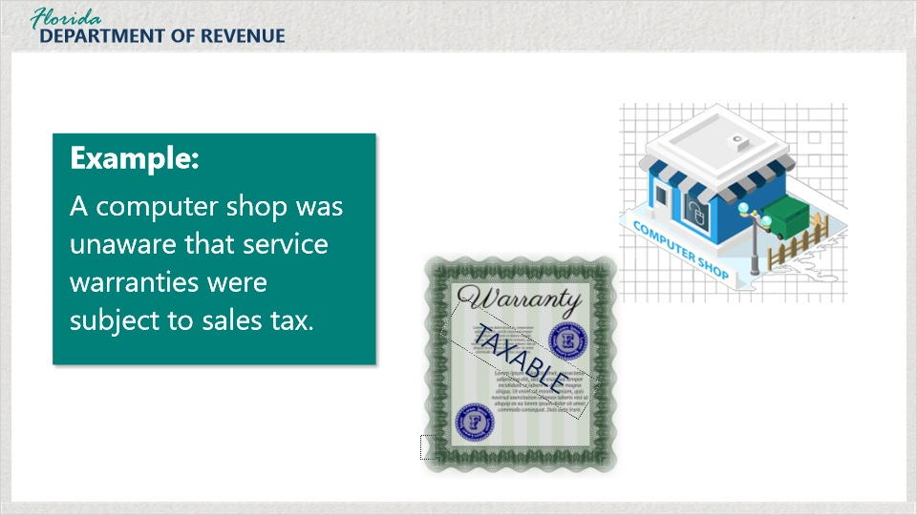
Transcript:
Let’s say you have a store that sells computer products. You are registered and collect and remit tax on the sales of the computer products.

A few years later, you find out that you should have taxed the service warranties that you sold covering those products.
Even though you are registered and remitting, you can enter the Voluntary Disclosure Program on that particular matter.

6. Online Information

6.1 Getting to Webpage
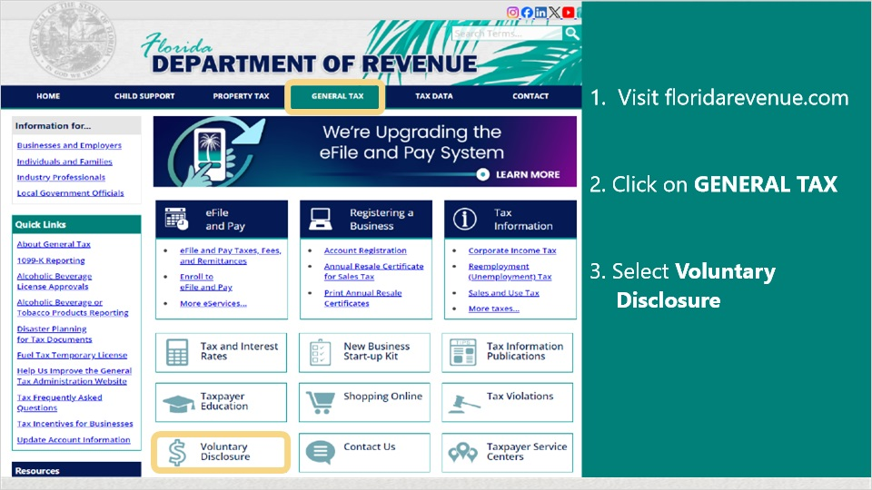
Transcript:
For more information on voluntary disclosure, visit the Florida Department of Revenue’s website. From our home page, click on General Tax.
Then select Voluntary Disclosure.

6.2 Webpage
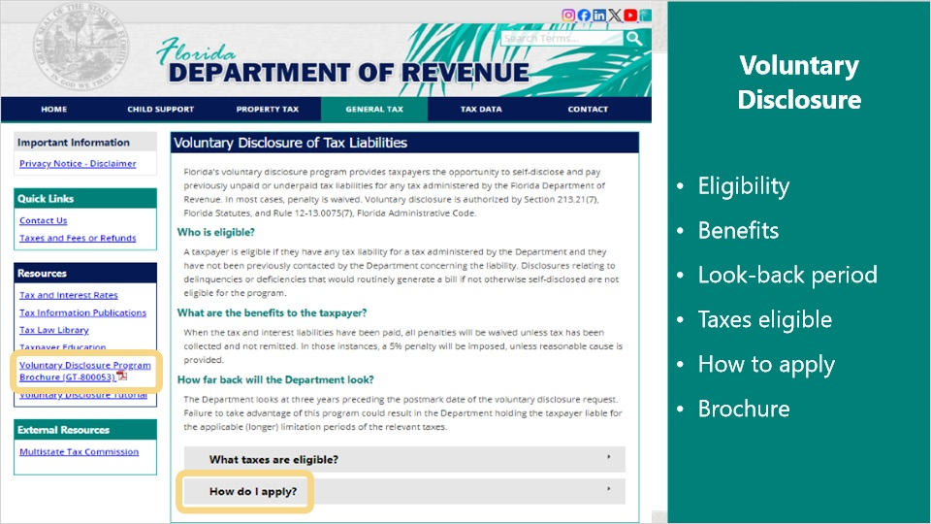
Transcript:
The Voluntary Disclosure button takes you to this page that includes the details of the program, including: who is eligible, benefits, look-back period, a list of eligible taxes, and the address to send your request to participate - this is under the “How do I apply?” pull-down.

Under the resources box to the left is a link to the Voluntary Disclosure Program Brochure.

6.3 Brochure
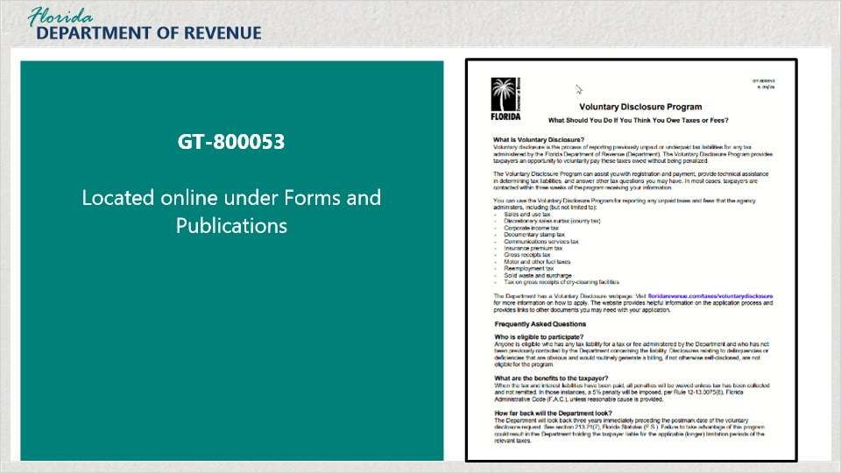
Transcript:
This is the Voluntary Disclosure Program Brochure, publication GT-800053. It covers many of the frequently asked questions about the program.

7. How to Apply

7.1 Example - How to Apply
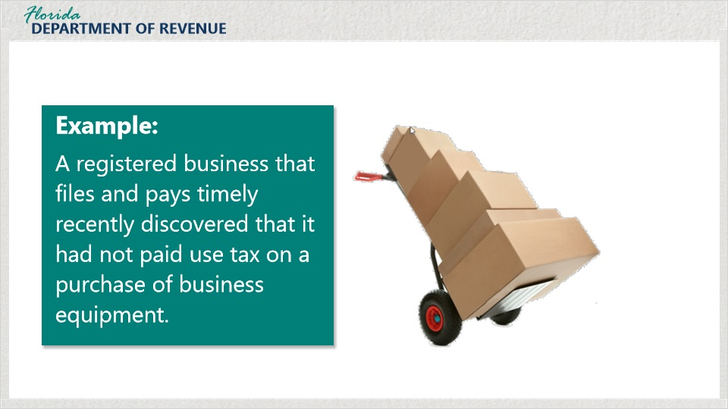
Transcript:
Here is an example of business that could apply for voluntary disclosure.

A registered business that files and pays timely recently discovered that it had not paid use tax on a purchase of business equipment.

If you purchase business equipment such as computers, furniture, display cases, or supplies from outside the state of Florida and do not pay the sales tax rate imposed by Florida for the county in which your business is located, then you would owe tax on those purchases. This is commonly referred to as use tax.

The business has not been contacted by the Department about this purchase, so the business would be able to disclose this purchase and pay the use tax without penalty.

7.2 How to Apply
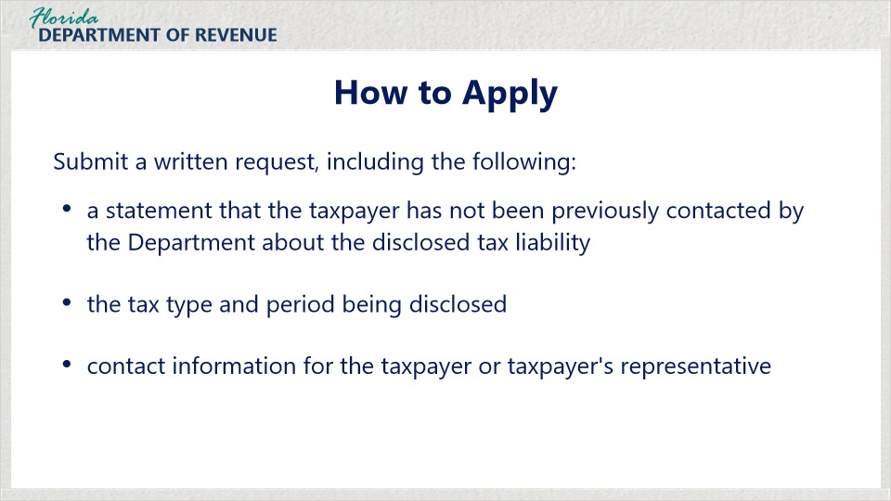
Transcript:
Let’s go through the application process.

Taxpayers wishing to enter the program must apply in writing with the following information: a statement that you or your client has not been previously contacted by the Florida Department of Revenue about the disclosed tax liability, the tax type and period being disclosed, and contact information for the taxpayer or the taxpayer’s representative.

7.3 Where to Send Request
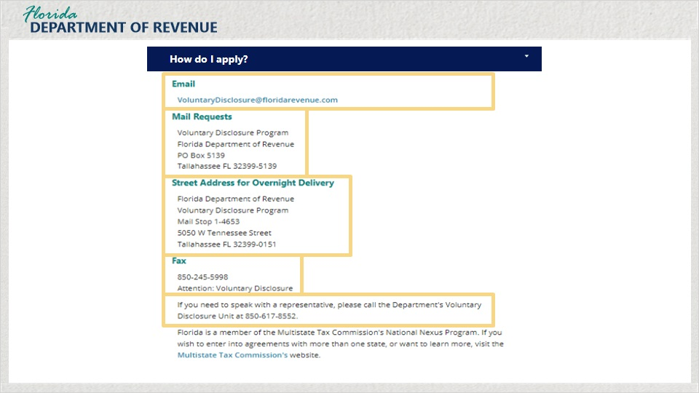
Transcript:
When you click on the “How do I apply?” tab on the Voluntary Disclosure webpage, you will see a list of the different ways to send your request.

To mail your request, the address is:
Voluntary Disclosure Program, Florida Department of Revenue, PO Box 5139, Tallahassee FL 32399-5139

For overnight delivery, the address is:
Florida Department of Revenue, Voluntary Disclosure Program, Mail Stop 1-4653, 5050 W. Tennessee St., Tallahassee FL 32399-0151

You can fax it to 850-245-5998, Attention: Voluntary Disclosure

Email it to:
VoluntaryDisclosure@floridarevenue.com.

If you have any questions, call 850-617-8552.

7.4 What to Send
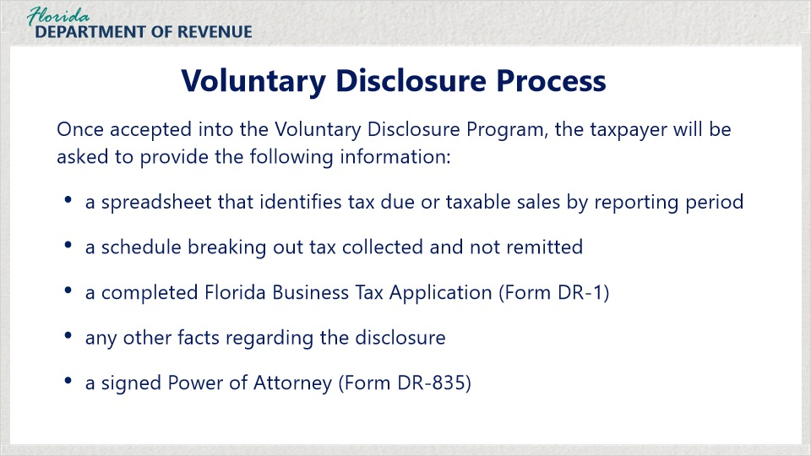
Transcript:
Once accepted into the Voluntary Disclosure Program, the taxpayer will be asked to provide: a spreadsheet that identifies the tax due or taxable sales by reporting period, a schedule breaking out tax collected and not remitted, if applicable, a completed Florida Business Tax Application (Form DR-1) if the taxpayer needs to register.

Do not register online. Doing so will create automated billings. The DR-1 should be completed and sent directly to the Voluntary Disclosure unit. If the taxpayer is already registered for the tax they are disclosing, they do not need to register again.

Any other facts regarding the disclosure that the taxpayer thinks are important for us to know, and

For anyone speaking to the Department on the taxpayer’s behalf, a signed Power of Attorney, Form DR-835.

7.5 Tax-Specific Information
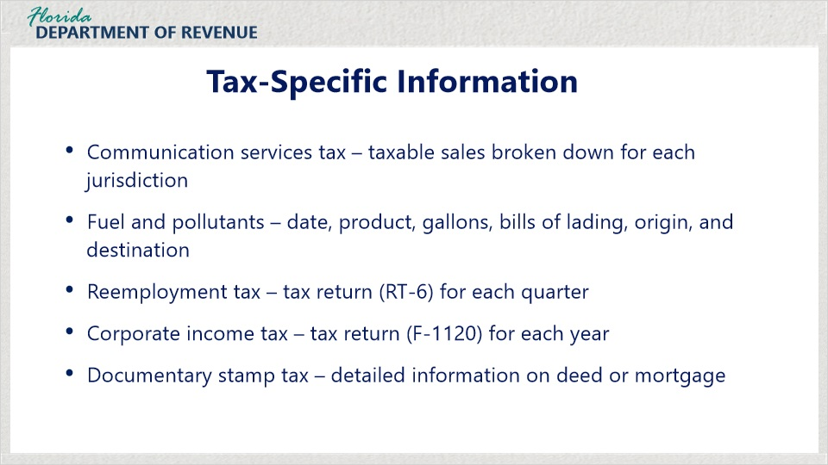
Transcript:
Some additional tax-specific information we will need includes:
for Communications Services Tax - the taxable sales broken down by all of the taxing jurisdictions in Florida, for Fuel and Pollutants Taxes - transaction date, product type, gallons or barrels, bills of lading, origin, and destination, for Reemployment Tax - a tax return, Form RT-6, for each quarter, for Corporate Income Tax - a tax return, Form F-1120, for each tax year, and for Documentary Stamp Tax, detailed information on the deed or mortgage.

8. Conclusion

8.1 Multistate Tax Commission
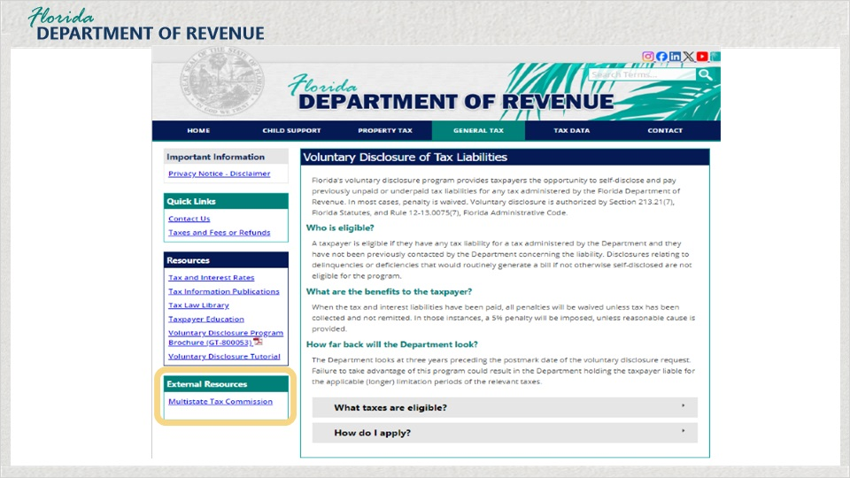
Transcript:
If a taxpayer has liability in more than one state, they may consider applying for multi-state voluntary disclosure through the Multistate Tax Commission. There is a link on our page over on the left that will take you to the Multistate Tax Commission’s website.

8.2 Tax Page and Social Media
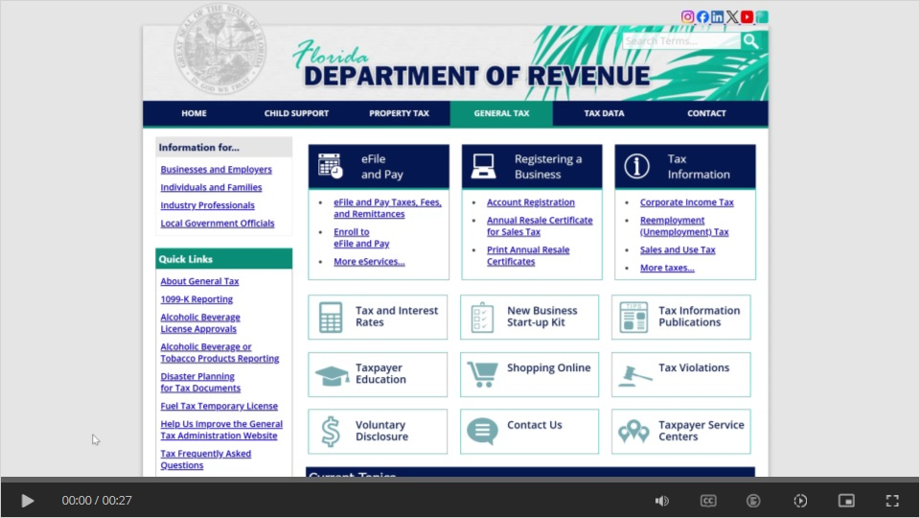
Transcript:
Visit Florida’s General Tax Administration webpage for business resources such as forms, publications, and information on all tax types.

Check out our Taxpayer Education webpage for new business guides, tutorials, and other helpful tools.

And follow us on YouTube, X, Instagram, and LinkedIn using the icons at the top of our website to stay up to date on tax topics, alerts, and more.

8.3 Thank You
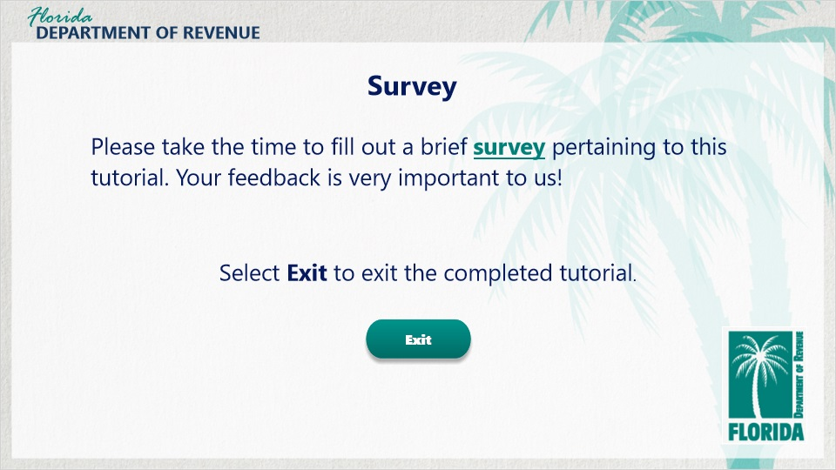
Transcript:
Thank you for completing this tutorial on Voluntary Disclosure.
Remember, there are a great deal of resources available to you by clicking on the Resources link in the upper-right corner of your screen. You can also find many other helpful resources on the Florida Department of Revenue’s website.

Please click on the survey link to take a short survey about the content and quality of this tutorial. The Department greatly appreciates your feedback and will use it to develop future tutorials.

To exit this tutorial, click on the Exit button.

